The Spies Report
Remember the twelve men Moses sent out to see what the new land was like? Did they find that it was a good land? Why, yes! It was just as God had said…rich and green, with rivers, pretty trees, and delicious fruit. The twelve spies found a bunch of grapes so large they had to carry it…how? Between two men on a pole!

After forty days, the twelve men returned to the camp of the children of Israel. That was a happy time for all. They saw the huge cluster of grapes, the figs and the pomegranates, and maybe they even got to taste some of them. “Tell us all about the Land," they said.

The twelve men told what they had seen: that the country to which you sent us is a wonderful place. It is just as God said it would be. The people live in cities with thick walls around them.
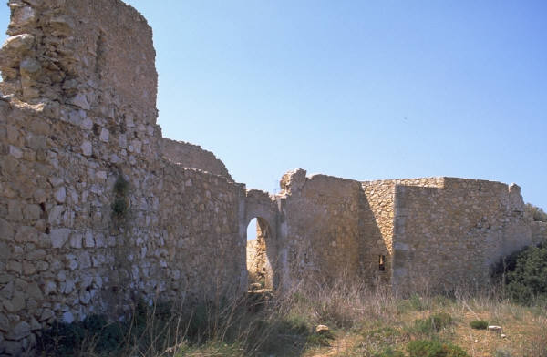

There is just one thing, though…there are giants in the Land. Numbers 13:27-39 tells us the story. Giants in the Land! What
a terrible thing to stand between the people and the gift God had for them! All the people of Israel were afraid…all of them…that is except Joshua and Caleb. Didn’t they see the giants? Yes, they did, but they remembered what God promised them.

Can you remember what God said to them? He told them that He would give them the Land if they would go in and take it. He told them not to be afraid, but to trust and believe Him. That meant the people must know that God would not let the giants hurt them. All they needed to do was to believe God and take the Land. Did they? No, they were frightened so badly that they did not even want to hear what Caleb said, “We should surely go up and take possession of the Land, for we will surely overtake it.” Caleb reminded the people of God’s words in Numbers 13:30. Joshua also told the children of Israel to take the Land and not be afraid, but trust the Lord. Let’s read it in Numbers 14:6-9.

