The Jr. Tree of Life
Lesson 32 LCYM
The Secret of the Mystery
Part 4


John 13
Ephesians 5:28-32
August 7, 2005

URGENT INFORMATION...

BEFORE we begin, if you are a believer in the Lord Jesus Christ, take a moment to name your sins to God the Father. This will allow you to be filled with the power of the Holy Spirit as you study or read this Bible lesson.
(I John 1:9) (Eph 5:18).
IF YOU HAVE never believed in the Lord Jesus Christ as your personal Savior, you have that opportunity right now to have eternal life. We sin and cannot have a relationship with God so God's Son, Jesus, who is God, came down to earth to become a human being just like us. He did this because He loved us so much. He lived His entire life on earth without sinning once! That qualified Him to go the cross and die in our place and He paid the penalty for sin as a substitute for us. After His death He rose again and is alive right now in heaven. He opened the door for you and me to get into heaven with Him by simply believing in Him and what He did for us on the cross. So simply tell God the Father that you believe in His son Jesus Christ as your Lord and Savior and you will be saved. If you make that decision, you are now saved and a believer and will always be a child of God. When you die, you will spend eternity with Him in heaven (Acts 16:31) (John 3:16).

"For the natural man (the unbeliever) does not accept the things of the Spirit of God; they are foolishness to him, and he cannot understand them, because they are spiritually understood" (1 Cor. 2:14)
"He who believes in the Son has eternal life but he who does not obey the command to believe the Son shall not see life, but the wrath of God abides on him" (John. 3:36)
Today we continue our study in John 13:27. Let’s read verse: “And after the morsel, Satan then entered into him. Jesus therefore said to him, ‘What you do, do quickly.’” The word “DO” shows up 2 times in this verse.
 | You will clearly see how important it is to have a Pastor-Teacher who studies from the original languages of the Bible. It makes it much easier to understand what is being taught right here in this lesson. The English uses the same word, “DO”. But the Greek uses 2 different FORMS of the word. The first word is POIEO which means what you have been doing. The second word is POIEI which means DO IT NOW! See how different the meanings are.
Jesus commands Judas, who is now under the control of Satan himself, “To go do what he had originally planned and to go and do it quickly.” See, Jesus knew all along what the plan for His life and His death included because He is God, too, and that means He’s omniscient…He knows all things as God. You see as a man, He went to the Temple and He studied His Bible. His human nature had to LEARN what His GOD nature knew in Eternity Past. (Those kinds of things just hurt my head, how bout you?)
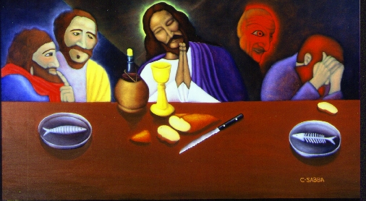
When Judas left the room, Satan who entered Judas’ body also left the room. Now Jesus is ready to teach His disciples some secrets and mysteries that He had never taught before! Satan will miss out on the secrets that Jesus will tell His followers. Jesus will tell them these truths so that they may be prepared for the next period of time in human history called the CHURCH AGE! The Church Age is the most intense period of time in the INVISIBLE angelic conflict.

You don’t know what the Angelic Conflict is yet but we will study it in more detail at a latter time. For today I’ll explain it to you very quickly…back before human history, there were Angels who CHOSE to follow Satan instead of God. Satan wanted to be just like GOD! He was Jesus Christ’s #1 Angel. He wasn’t happy with being #2 to Jesus Christ! Satan wanted to be GOD! So, Satan convinced 1/3 of the angels to follow him. That’s how it all began…and it’s been Satan against the Lord Jesus Christ ever since. And the invisible battle continues on even today and it won’t stop until Jesus stops it when He comes again.
The Church Age is right now! It’s the period of time that comes BETWEEN the death, burial, resurrection, ascension and session (seated at God’s right hand) of the Lord JESUS CHRIST and the TIME when HE will RETURN for us which is called the RAPTURE (sometime in the future.) Read that sentence a few times so you really understand it. Remember the battle rages on!
So now Jesus will tell His disciples the secrets that they will NEED to be winners during this INTENSE period of time. The first thing that Jesus tells the disciples is how the Angelic Conflict is going to INTENSIFY (that means get worse and worse)!! There are still a lot of demons in the room, but Satan has left because he is inside the body of Judas. These demons were paying close attention to what Jesus was saying so they could report back to their leader, Satan. Let’s see what Jesus said, “Now is the Son of Man glorified, and God is glorified in Him; if God is glorified in Him, God will also glorify Him in Himself, and will glorify Him immediately. Little children, I am with you a little while longer. You shall look for me; and as I said to the Jews, I now say to you also, where I am going you cannot come. A new commandment I give to you, that you love one another, even as I have loved you, that you also love one another. By this all men will know that you are my disciples, if you have love for one another.”
The term “Son of Man” is talking about Jesus’ humanity. Remember Jesus Christ is 100% MAN and 100% GOD united in one person forever. His deity always has been, and always will be “glorified”. Here He is referring to His humanity being “glorified!” Concentrate now because this sounds difficult but this is amazing stuff. If you need to read these sentences over a few times DO IT! This is what makes YOUR GOD that YOU LOVE and BELIEVE in the GOD of the UNIVERSE! This is what makes HIS NAME the ONLY name by which MAN CAN BE SAVED! And at the NAME of JESUS every knee shall bow and every tongue will confess that JESUS CHRIST IS LORD! It’s time to concentrate and not give up!
The Church Age is INVISIBLE! How hard is it to fight an invisible battle? The real battle in the Church Age goes on in your HEAD! Remember all of those times you fought with yourself in your head on whether or not to make good or bad decisions? Well, that’s the battleground in your soul! What you put in that brain of yours is your ammunition to FIGHT the MOST INTENSE INVISIBLE battles ever fought in human history. Think about this, God chose you to be born in this period of time! He knew that you would have the best opportunities in THIS PERIOD of time than any other period of time in history! If He thought you’d do better in the Old Testament times, or the Period of Time when Jesus walked the earth, HE WOULD HAVE ALLOWED YOU TO BE BORN THEN! Remember, this is God we are talking about here! He’s the ONE that chose WHEN you would be born, to which parents you would be born, and every single other detail about you! So, He allowed you to be born during the Church Age! You better gear up! You’ve got some heavy battles to fight in your life but HE WILL SEE YOU THROUGH THEM!
 | When you watch a football game or a baseball game or even play a video game, is it any fun when the game is EASY and you win all of the time? The right answer here kids is NO! When you are challenged to think and use your SKILLS and come really close to LOSING and then you WIN, isn’t that exciting? Well, read Ephesians chapter 6 so you can get on your GEAR to fight the battles of a lifetime.  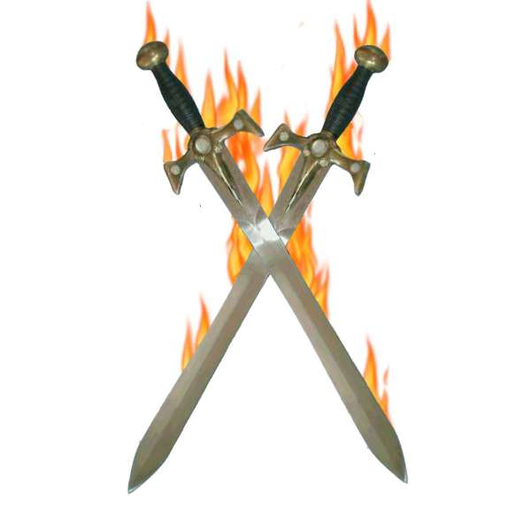
The best part about these battles are that when you do it God’s way, you lay up your treasures in heaven and your rewards will last forever and ever and ever and ever! If you read the Book of Revelation at the end of the Bible, you will see that WE WIN! Because of the work of Jesus Christ on the cross and our faith in HIM, we can’t lose!
However, we have our own personal OPPORTUNITIES to fight these battles and experience that victory in our own lives! This brings glory to God and get this, WE GET THE REWARDS! How exciting! Just think, God is letting you play the most intense battle game of your life! He gives you EVERYTHING you will need to be an invisible hero in the Church Age. So gear up and be ready…because, ”Greater is HE that is in you than he that is in the world!!!”

Close in Prayer
Grace Bible Church Pastor-Teacher Robert McLaughlin, P. O. Box 128, 802 Riverside Avenue, Somerset, MA 02726, (508) 324-9900, Prep@gbible.org www.gbible.org

