The Jr. Tree of Life
The Secret of the Mystery
Lesson 41 LCYM
Part 13

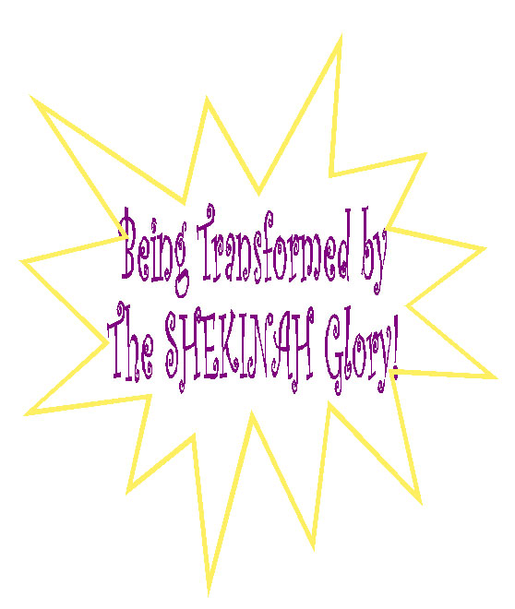
2Corinthians 3:12-18
2Corinthians 13:5
December 2, 2005
URGENT INFORMATION...
 | BEFORE we begin, if you are a believer in the Lord Jesus Christ, take a moment to name your sins to God the Father. This will allow you to be filled with the power of the Holy Spirit as you study or read this Bible lesson.  (I John 1:9) (Eph 5:18). |  | 
 | IF YOU HAVE never believed in the Lord Jesus Christ as your personal Savior, you have that opportunity right now to have eternal life. We sin and cannot have a relationship with God so God’s Son, Jesus, who is God, came down to earth to become a human being just like us. He did this because He loved us so much. He lived His entire life on earth without sinning once! That qualified Him to go the cross and die in our place and He paid the penalty for sin as a substitute for us. After His death He rose again and is alive right now in heaven. He opened the door for you and me to get into heaven with Him by simply believing in Him and what He did for us on the cross. So simply tell God the Father that you believe in His son Jesus Christ as your Lord and Savior and you will be saved. If you make that decision, you are now saved and a believer and will always be a child of God. When you die, you will spend eternity with Him in heaven (Acts 16:31) (John 3:16).
"For the natural man (the unbeliever) does not accept the things of the Spirit of God; they are foolishness to him, and he cannot understand them, because they are spiritually understood" (1 Cor. 2:14)
"He who believes in the Son has eternal life but he who does not obey the command to believe the Son shall not see life, but the wrath of God abides on him" (John. 3:36)
Let’s read 2 Corinthians 3:12-14. “Having therefore such a hope or confidence, we use great boldness in our speech, and are not like Moses, who used to put a veil over his face so that the sons of Israel (the Jews) might not look intently at the end of what was fading away (the glory of the Lord). But their minds were hardened; for until this very day at the reading of the Old Testament, the same veil remains unlifted, because it is removed in Christ.”
The word for “REMOVED” in the Greek (KATAGEO) means to have something removed, abolished or to put an END to something! Because the Jews rejected Jesus Christ as their Messiah over and over and over again, their unbelief put a VEIL over their eyes. It’s like a bridal veil that goes over their eyes so that they can’t see what they are looking at clearly!
The Jews read their prayers in the temple to this day (or synagogue as it is called today) and they refer to Jesus Christ in the original Hebrew language as they read, but they CAN’T SEE IT that it is HIM, the Savior! They chose not to see it over and over, so now God has made it that they CAN’T see it anymore or in other words understand the meaning of Messiah. This is called “hardness of the heart!” God is very patient and He sits and waits and waits for our free will to choose Him. However, after a while, saying “no” for so long causes a scar to build up in the soul and this is known as “scar tissue of the soul.”

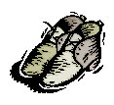 | It’s kind of like wearing a pair of shoes that are too small for your feet. You CHOOSE to put them on every single day even though they don’t fit and even though you know they hurt your feet like crazy. If you keep doing this everyday, eventually a scar or a callous builds up and the area gets really hard and unfeeling and you might never be able to get those shoes back on your feet again. Then you go and try to buy a regular pair that fits and you can’t even wear them because you have such BIG bumps on your feet. Okay, I know, it’s a silly analogy, but you get the picture don’t you? The Jews said NO to Jesus Christ for thousands of years! They said NO to Him when they were taught about Him in their Old Testament books through the prophets. They said NO to Him when He appeared alive and in person. And, they continue to say NO to Him to this very day! Those scars are so thick they can’t see through them. Eventually God allows us to reap what we sow. That means that when an unbeliever whenever repeatedly rejects the Lord Jesus Christ, he or she may be lost forever or it means that as a believer if you reject His Word daily, you will get disciplined by God, suffer pain, and maybe if you do it long enough, lose your treasure on earth and in heaven. Whatever you do comes back at you, good or bad. His Grace cannot violate our free will choices. This means also that if you choose to obey Jesus and study His Word daily, stay filled with the Spirit most of the time and apply the Word in everyday decisions and actions, God will reward you with abundant blessings on earth and in heaven…TREASURE!
You can learn a good lesson from this, kids! It’s not enough for you to just go to church because Mom and Dad make you go. You have to choose Jesus Christ as your Lord and Savior and from that day forward, make choices in your own soul to live in His plan for your life! You can do the actions of going to church, but God looks on your mental attitude and how you think. If you continue to make decisions against Bible Doctrine, God will wait patiently, but your scars are building up. Eventually those scars will take control and God will turn you over to your own bad decisions. He is a gentleman! He cannot violate your free will choices. His love keeps knocking on the door of your soul to get your attention. He allows discipline in your life because He loves you. You either learn from that discipline, or you get angry and continue to make bad decisions. The choice is yours! That’s why I repeat myself all the time when teaching you these things. It is so you will learn God’s will and Word and obey it.
 |  |  | 
But if you don’t obey it, eventually those bad decisions will in a sense, tell God to get lost! That’s right. Your mental attitude rejected Him long enough that the scars on your soul are so thick that you CAN’T EVEN HEAR HIS GRACIOUS CALL TO YOU! You now have a veil over your soul just like the Jews do. Jewish believers read from their Bible in Psalm 34:20, “He keeps all His bones; not one of them is broken.” They know History, they are very smart. They know that it was a miracle that after all of the beatings Jesus Christ received, NOT A BONE WAS BROKEN! This Psalm is describing their Messiah that was to come. This is the very book that they study day in and day out to read about their COMING Messiah. When they read Psalm 22:16, “For dogs have surrounded Me; a band of evildoers has encompassed Me; they PIERCED MY HANDS AND MY FEET.” do you think they say, “OH, THAT’S TALKING ABOUT JESUS!”? No, they are blind from the scar tissue on their soul and the blackout that has caused their blindness not to see HIM! How about this one in Isaiah 53:5, “But He was pierced through for our sins, He was crushed for our iniquities; the punishment for our well-being fell upon Him, and by His scourging we are healed.” And, Isaiah 53:7, “He was oppressed and He was afflicted, yet He did not open His mouth, like a lamb that is led to slaughter, and like a sheep that is silent before its shearers, so He did not open His mouth!” This was all written hundreds of years before Jesus lived on the earth!

Mark 15:5 clearly answers that verse by saying, “And Pilate was questioning Him (Jesus) again saying, ‘Why don’t you answer? See how many charges they bring against you!!’ BUT JESUS MADE NO FURTHER ANSWER.”

You see kids, this looks crystal clear to us because we have the power of the Holy Spirit within us. Without that power, the Jews CANNOT see! Once they change their minds and become positive to the Gospel of Jesus or want to get to know Him and His Word, the Holy Spirit makes it clear to them, BUT until then, these books in the Old Testament that they study over and over again every Saturday in the synagogue and temple just becomes knowledge about their culture and their history as a people and NOTHING more…not about salvation! Isn’t that sad?
All of the “symbols” in the Old Testament were clearly teaching aids to let them know when their Messiah would come, and what He would be like. Yet, to them it’s just words on a page. To the unbelieving the wisdom of God is foolishness! The human mind CANNOT understand the things of God. 2 Corinthians 3:18 says that “We all with UNVEILED face beholding as in a mirror the glory of the Lord, are being transformed into the same image from glory to glory, just as from the Lord, the Spirit.” We go from the Glory of Salvation when we believe in Jesus Christ to the glory of growing spiritually by the power of the Holy Spirit (through rebound or confession). Our face is unveiled and we understand the things of God because of the wonderful gift God gave us; the filling of the Holy Spirit. Lots of times we forget to acknowledge the Holy Spirit. We pray to God in Jesus’ name but it’s the power of the Holy Spirit that makes it even possible for us to approach God the Father! If we do not rebound/confess before we pray, our prayers aren’t heard by God…they hit the ceiling! It’s your job to make sure that you are making positive choices to do God’s will as Jesus Christ did in such a powerful way.

II Corinthians 13:5 says, “Test yourselves to see if you are in the faith; examine yourselves! Or do you not recognize this about yourselves that Jesus Christ is in you— unless you fail the test?” | 

Grace Bible Church
Pastor-Teacher Robert McLaughlin
P.O. Box 128, 802 Riverside Avenue, Somerset, MA 02726
(508) 324-9900
www.gbible.org Prep@gbible.org www.lighthousechristianyouth.org

