Fourth Part of the Fruit of the Spirit
PATIENCE

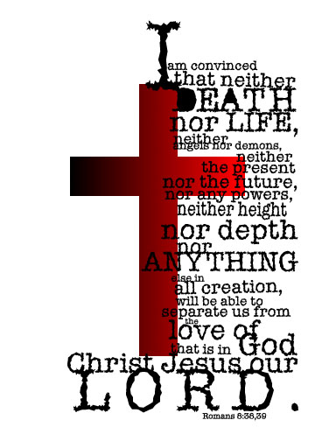

Rom 12:12 “Be joyful in hope, PATIENT in suffering, faithful in prayer.”

PATIENCE is putting up with pain or trouble without complaining. The Lord Jesus Christ put up with a lot of pain and trouble in being our Savior and NEVER complained. Sometimes we are pain and trouble! God has perfect PATIENCE with us. Can you imagine that? No one but God can have perfect PATIENCE with us. He can because He is all powerful and all loving. Also, God deals with us in grace* because of what our Savior did on the cross.

*Grace is all that God is free to do for us because of the work of Jesus Christ on the cross.

1 Cor 13:4 “Love is PATIENT, love is kind.”
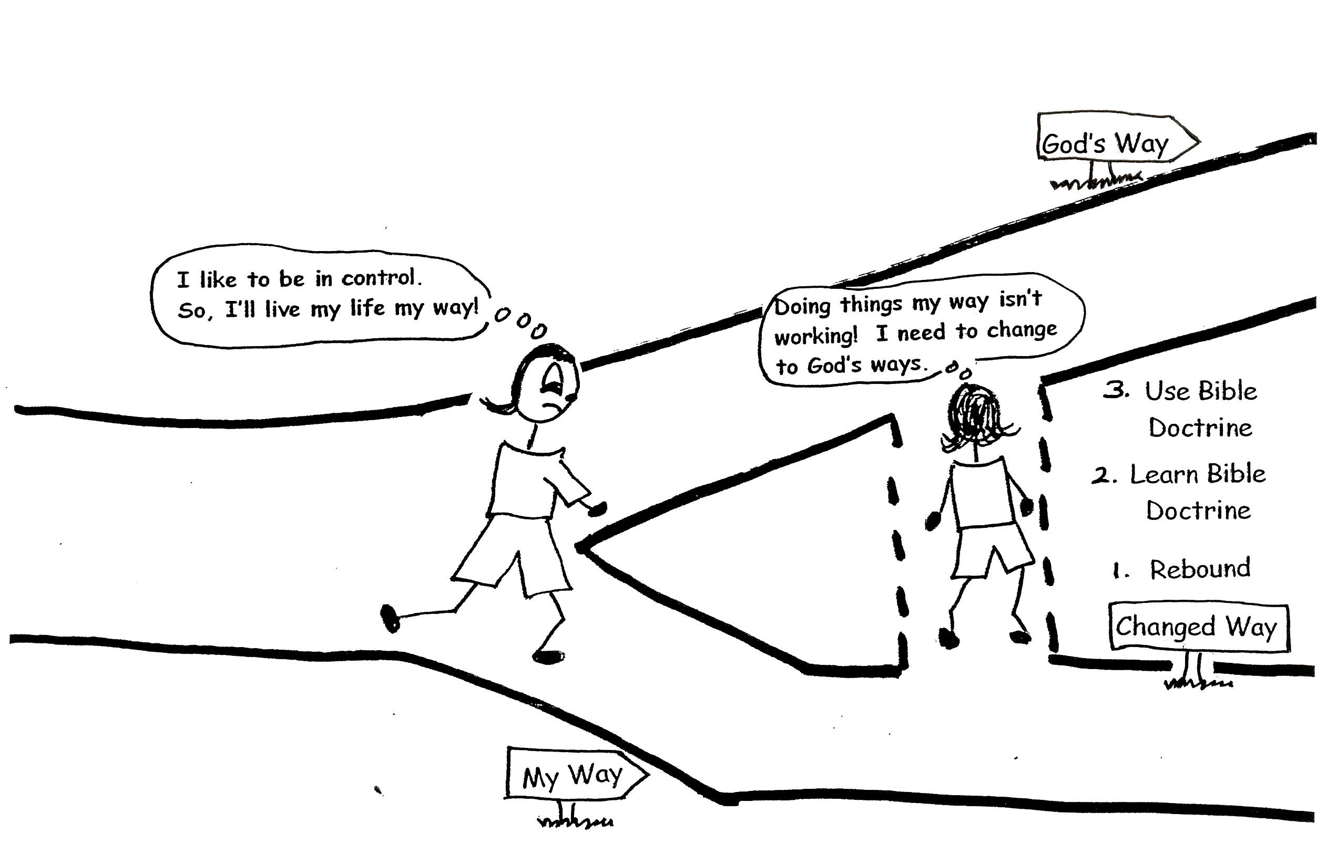
Another word for PATIENCE is longsuffering. This means being PATIENT for a long time. God tolerates and endures our sinful ways, waiting for us to wake up! This doesn’t mean that He thinks that our ways are okay. It means that God is waiting for us to change our ways. Sometimes this takes a long time! God is longsuffering!

1 Timothy 1:16 “And yet for this reason I found mercy, in order that in me as the foremost, Jesus Christ might demonstrate His perfect PATIENCE, as an example for those who would believe in Him for eternal life.” (Paul talking)
God wants to help us to become PATIENT. He is PATIENT with us, and we can learn from His Word to be PATIENT with ourselves and others. If we live in the Vine, being filled with the Holy Spirit, the Holy Spirit will produce PATIENCE in us along with the other eight parts of the fruit of the Spirit!

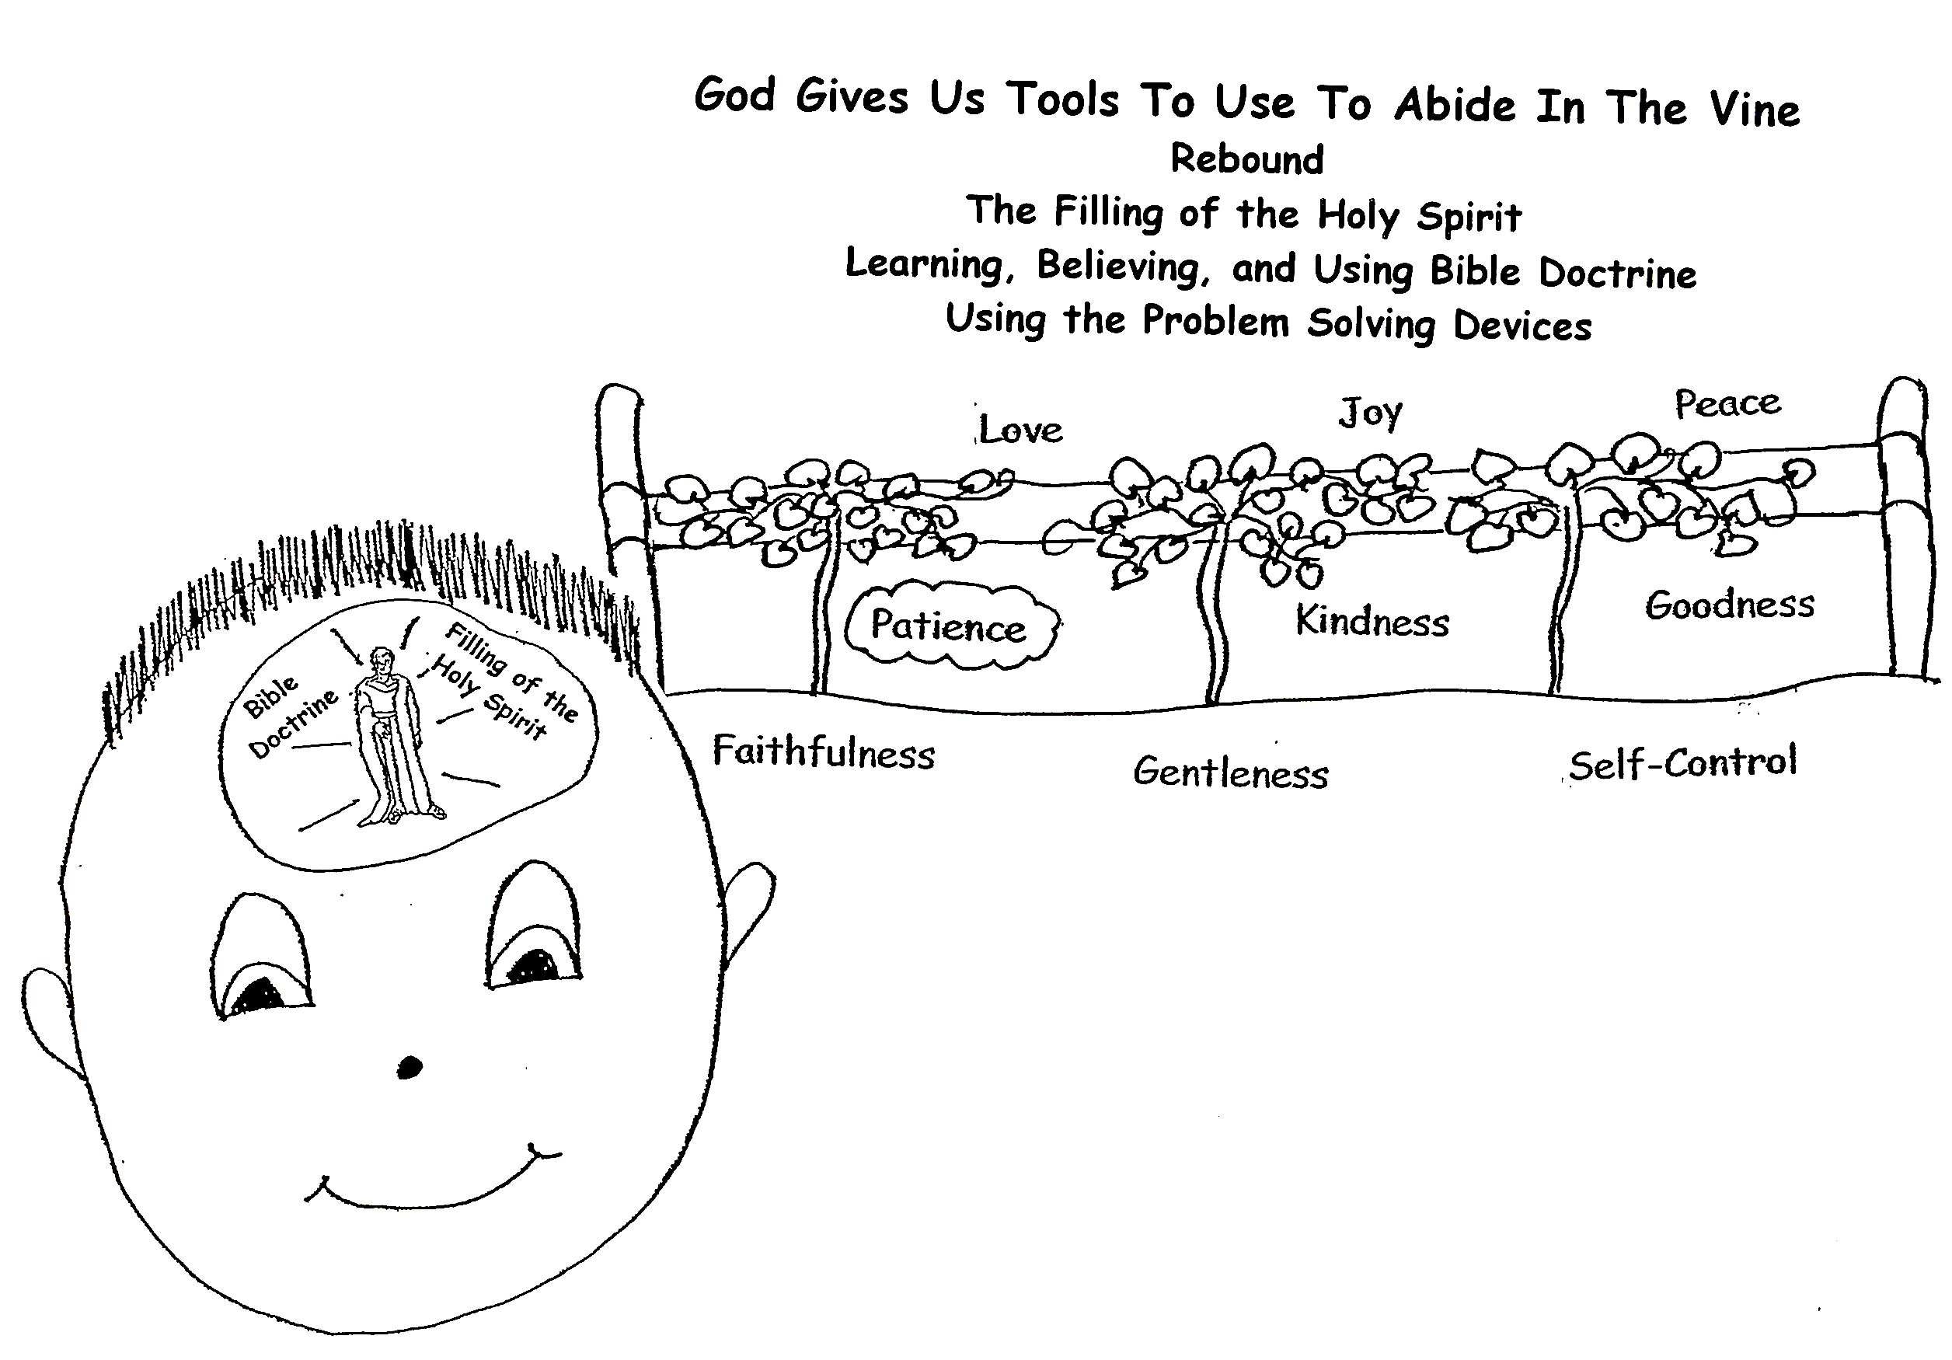
Colossians 1:11 “…being strengthened with all power according to His glorious power so that you may have great endurance and PATIENCE…”

If we have PATIENCE, we will not get so angry. We will be slow to anger. We’ll take time to cool down if something upsets us. We won’t say something that can hurt someone else. That is good for ourselves and those around us. It’s not fun to be around an angry person!
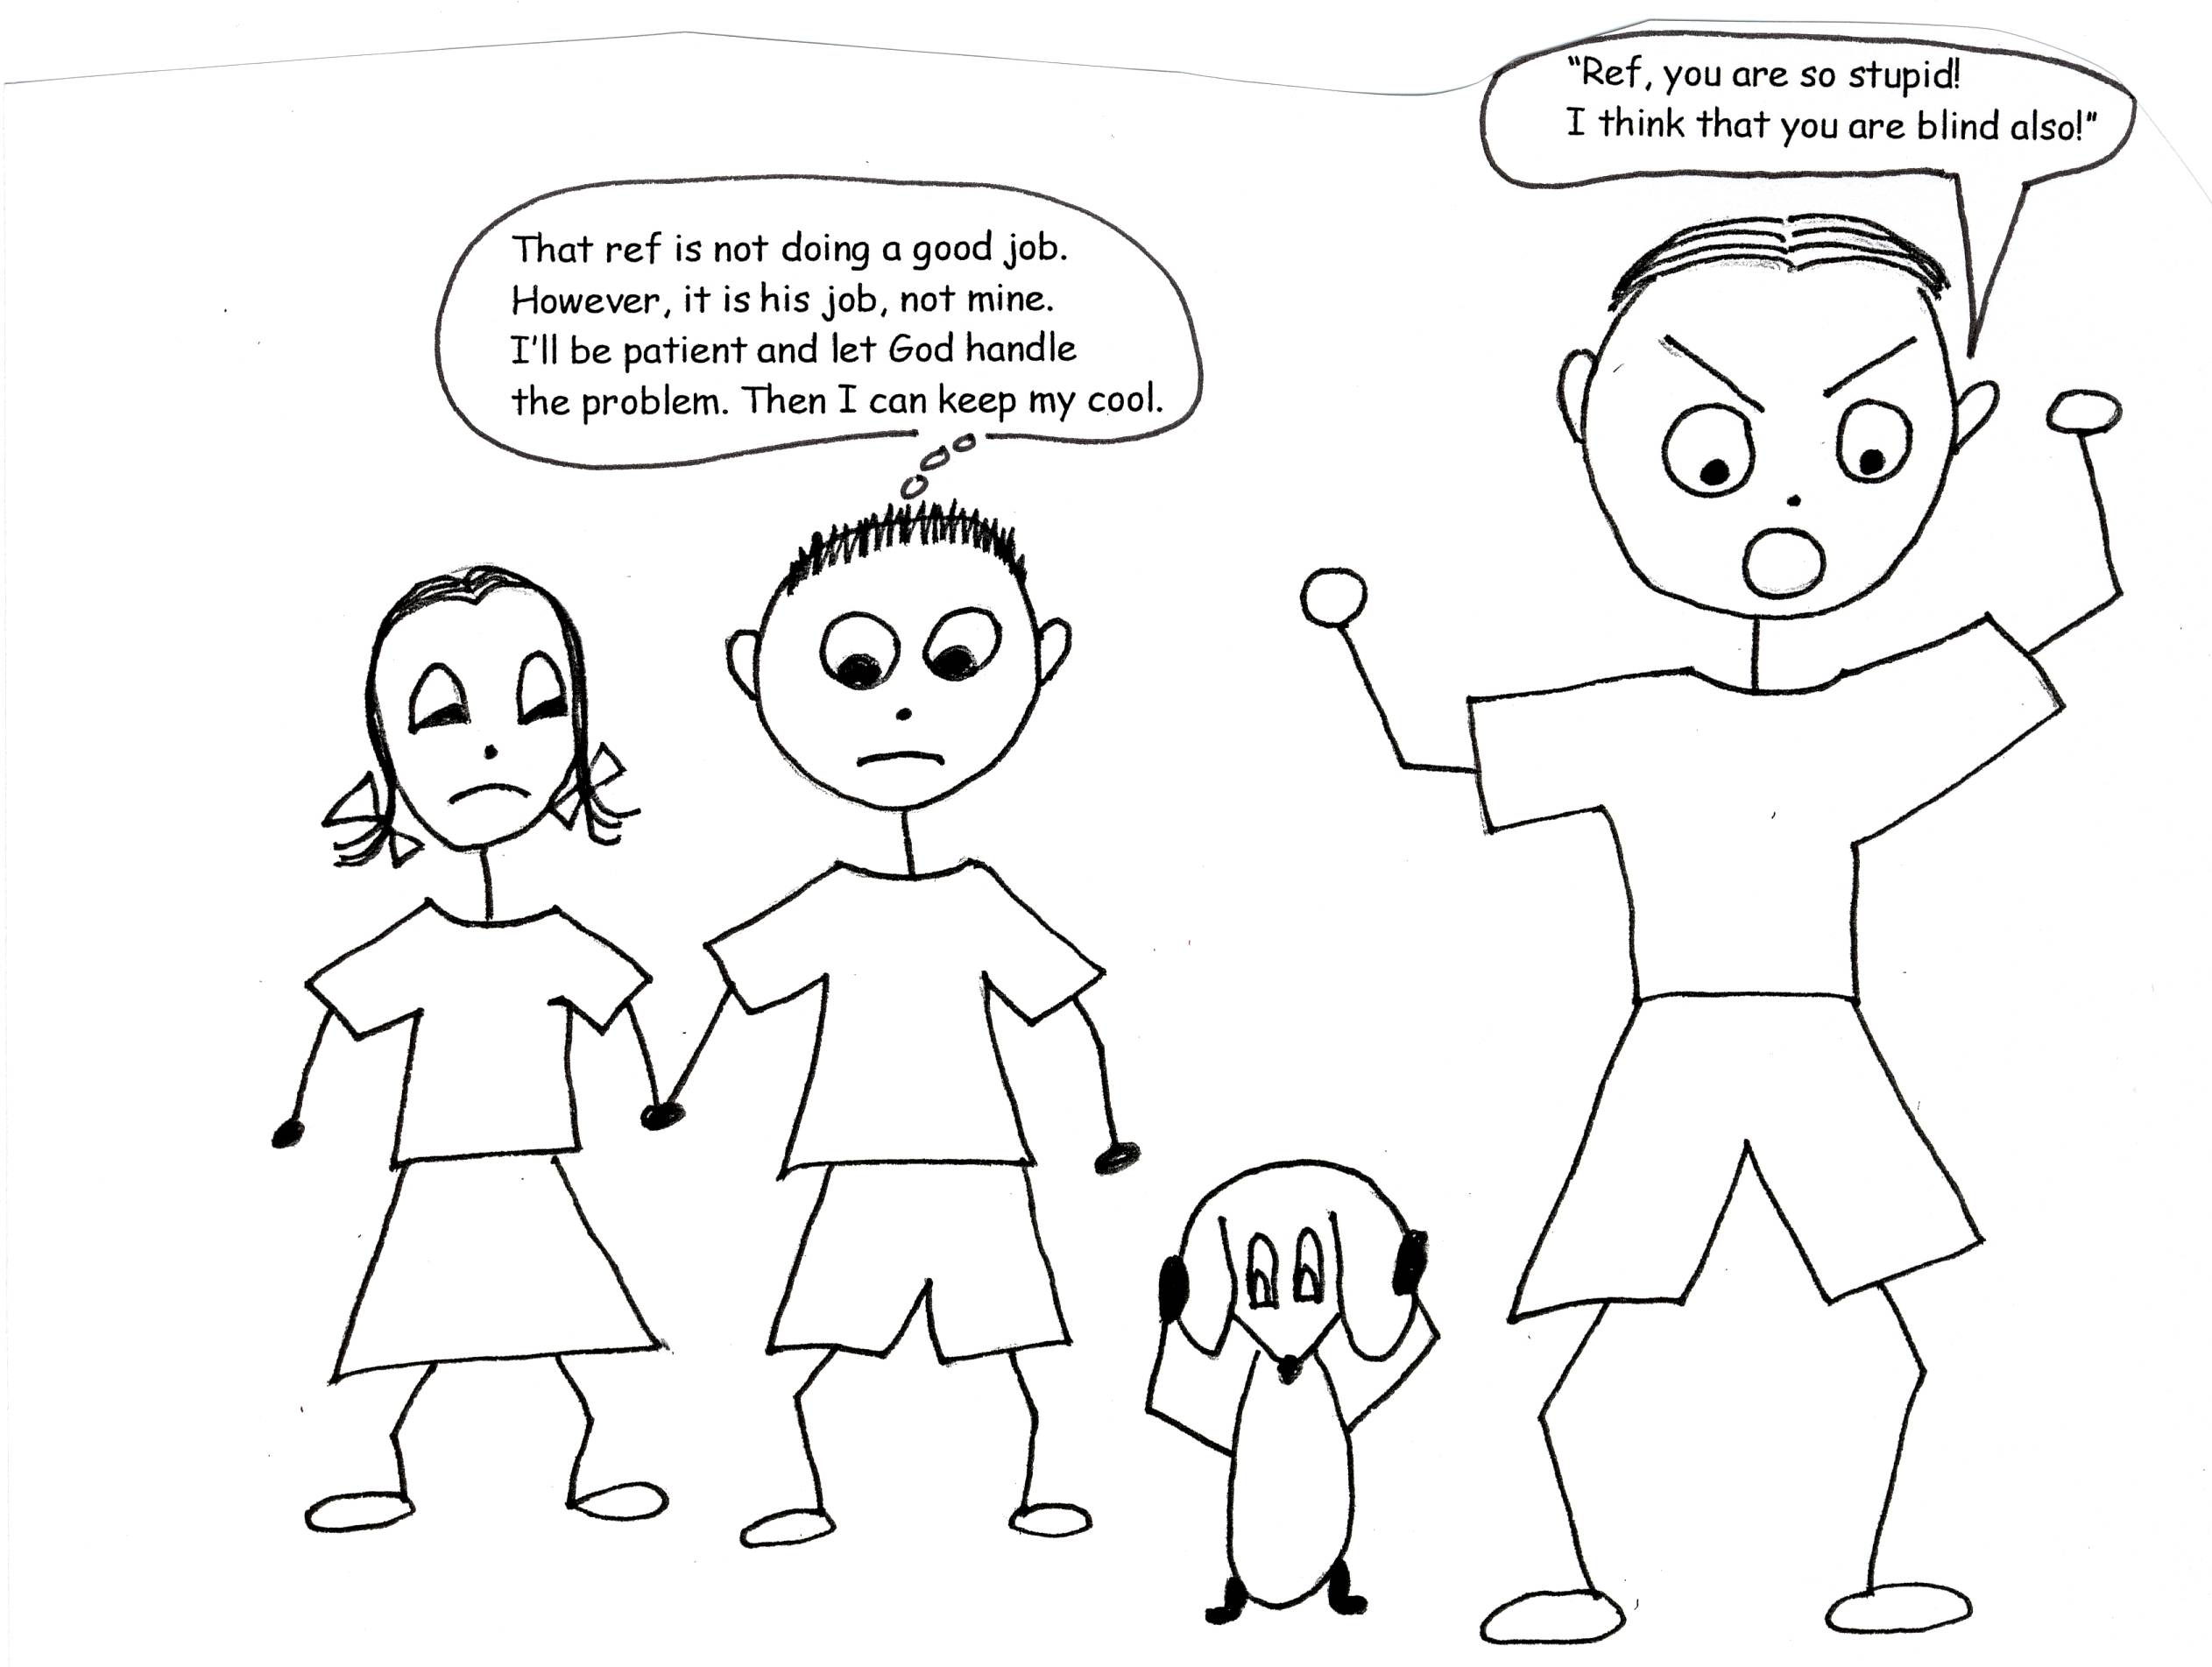

Psalm 103:8 “The Lord is compassionate and gracious, slow to anger, abounding in love.”
God is sooo gentle with us. When we get off track He doesn’t say, “Well, that’s it for you.” God doesn’t blow His top! He gives us what we need to get back on track. His gentleness makes us want to grow in His ways. To grow in God’s ways we need to change our minds to think the way God thinks. You know how to do that: learn Bible doctrine! Learn God’s PATIENCE!
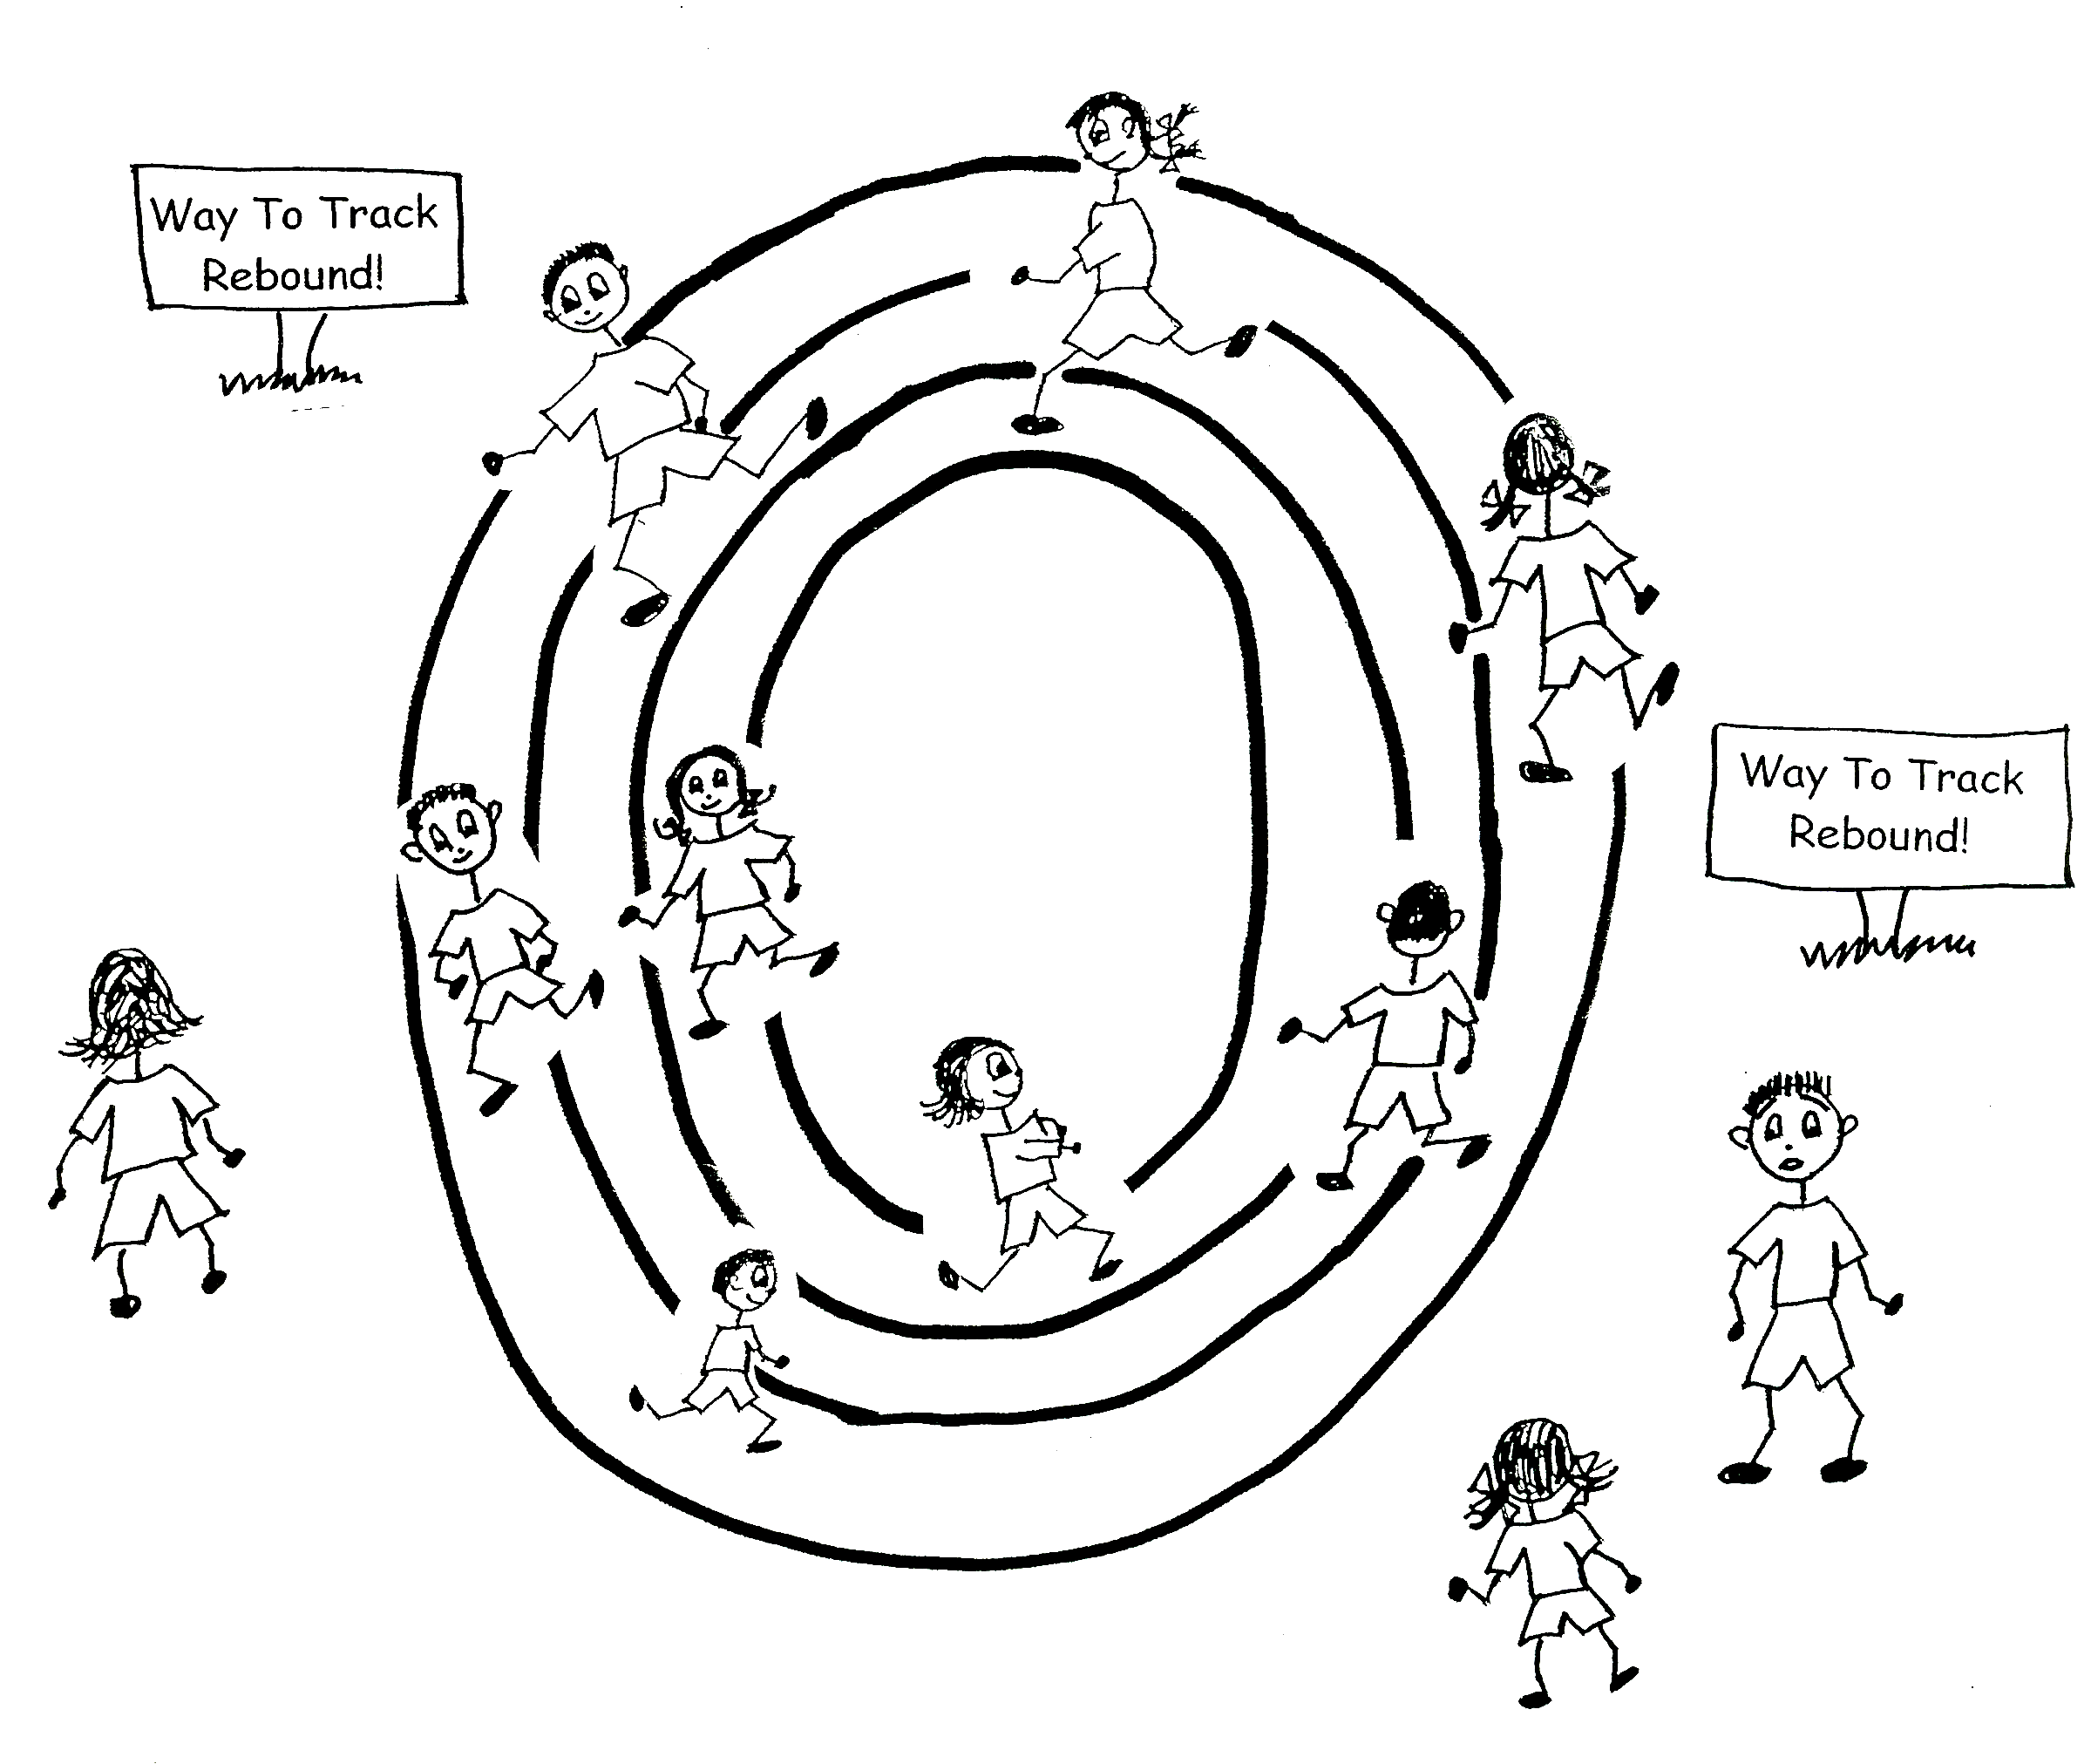
Romans 2:4 “Or do you show contempt for the riches of His kindness, tolerance and PATIENCE, not realizing that God’s kindness leads you toward repentance [change of mind]?”

Eph 4:1-3 “As a prisoner for the Lord, then, I urge you to live a life worthy of the calling you have received. (2) Be completely humble and gentle; be PATIENT, bearing with one another in love. (3) Make every effort to keep the unity of the Spirit through the bond of peace.”

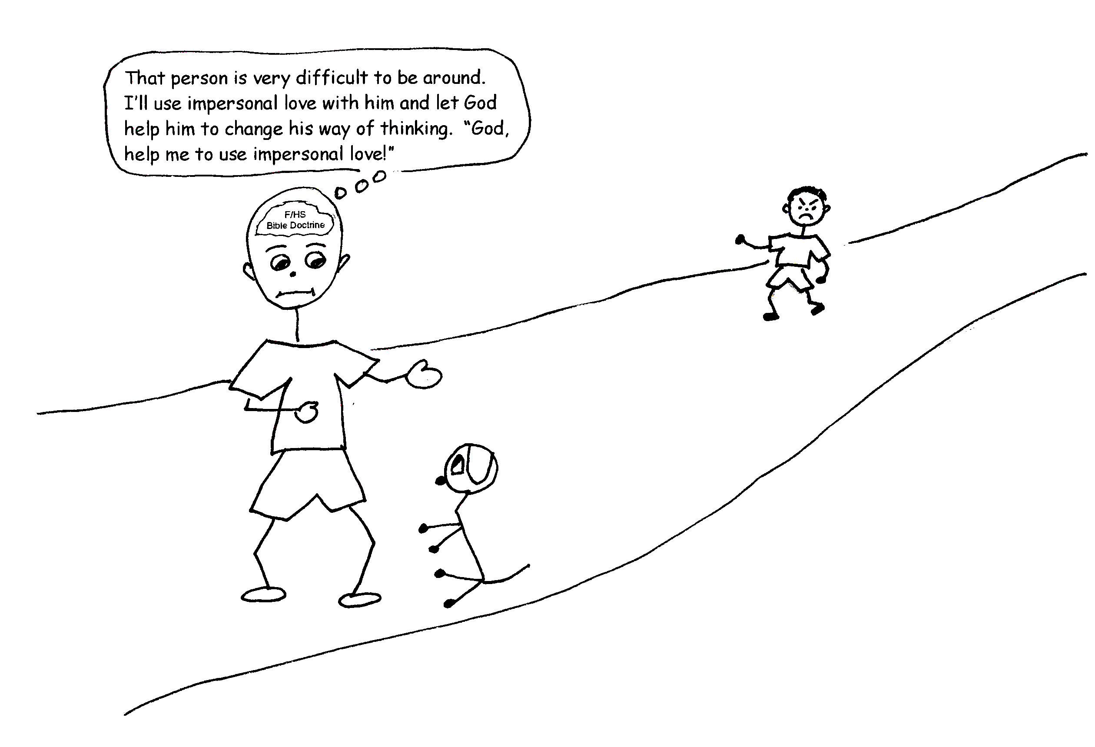
Because God has been gentle with us, we can be gentle with others. God treats us with grace and gives us room to grow and we learn to treat others with grace. We give them room to change their minds and grow in the knowledge and grace of God.

Psalm 18:35 “You have also given me the shield of your salvation, and your right hand holds me up; and your gentleness makes me great.”

For us to be PATIENT, we have to have the power of God. We have to live in the Vine, which means that we have the filling of the Holy Spirit. The Holy Spirit will develop PATIENCE in us if we learn Bible doctrine and use it. God will give us a lot of power, His power! Let’s be PATIENT!

Nahum 1:3 “The Lord is slow to anger (PATIENT) and great in power…”

1 Cor 13:4 “Love is PATIENT, love is kind. It does not envy, it does not boast, it is not proud.”

2 Cor 1:6 “If we are distressed, it is for your comfort and salvation; if we are comforted, it is for your comfort, which produces in you PATIENT endurance of the same sufferings we suffer.”

1 Thess 5:14 “And we urge you, brothers, warn those who are idle, encourage the timid, help the weak, be PATIENT with everyone.”

James 5:8 “You, too, be PATIENT and stand firm, because the Lord's coming is near.”

Grace Bible Church www.gbible.org
&
Lighthouse Christian Youth Ministry, 2900 NE 33rd St., Lighthouse Point, FL 33064
Phone 954-943-5633, email lcyministry@comcast.net or website lighthousechristianyouth.org

