LCYM
Lesson 43d

The Fifth Part of the Fruit of the Spirit
Kindness

February 26, 2005

Galatians 5:22 “But the fruit of the Spirit is love, joy, peace, patience, kindness, goodness, faithfulness, gentleness and self-control. Against such things there is no law.”

We can’t get these by works; we study Bible doctrine and the Holy Spirit changes us or develops these qualities in us.

The fifth part of the fruit of the Spirit is kindness. Other words for kindness are courteous, loving, considerate, understanding, gentle, helpful, patient, and generous. When we are kind, we are not self-centered. We are sensitive or tender to others.
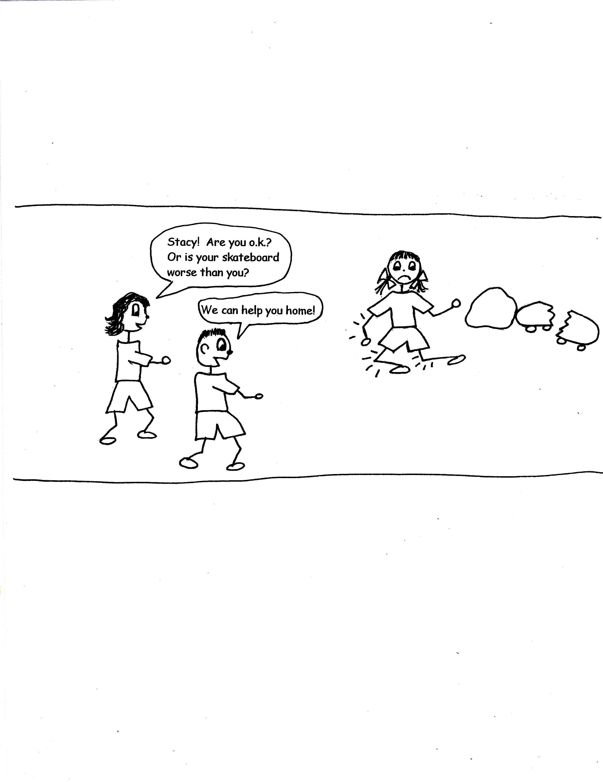

Galatians 5:22-23 “But the fruit of the Spirit is virtue love, joy, peace, patience, kindness, goodness, faithfulness, gentleness, self-control; against such things there is no law.”

Again, we can’t do works to gain them. We learn Bible doctrine and the Holy Spirit changes us.

Kindness also means being gracious and acting with grace orientation. What? What is grace orientation? Grace orientation is when we recognize all that God has freely given to us. We haven’t earned it and we don’t deserve it. God can freely give to us because of the work of the Lord Jesus Christ on the cross. All that we have leads back to the cross.

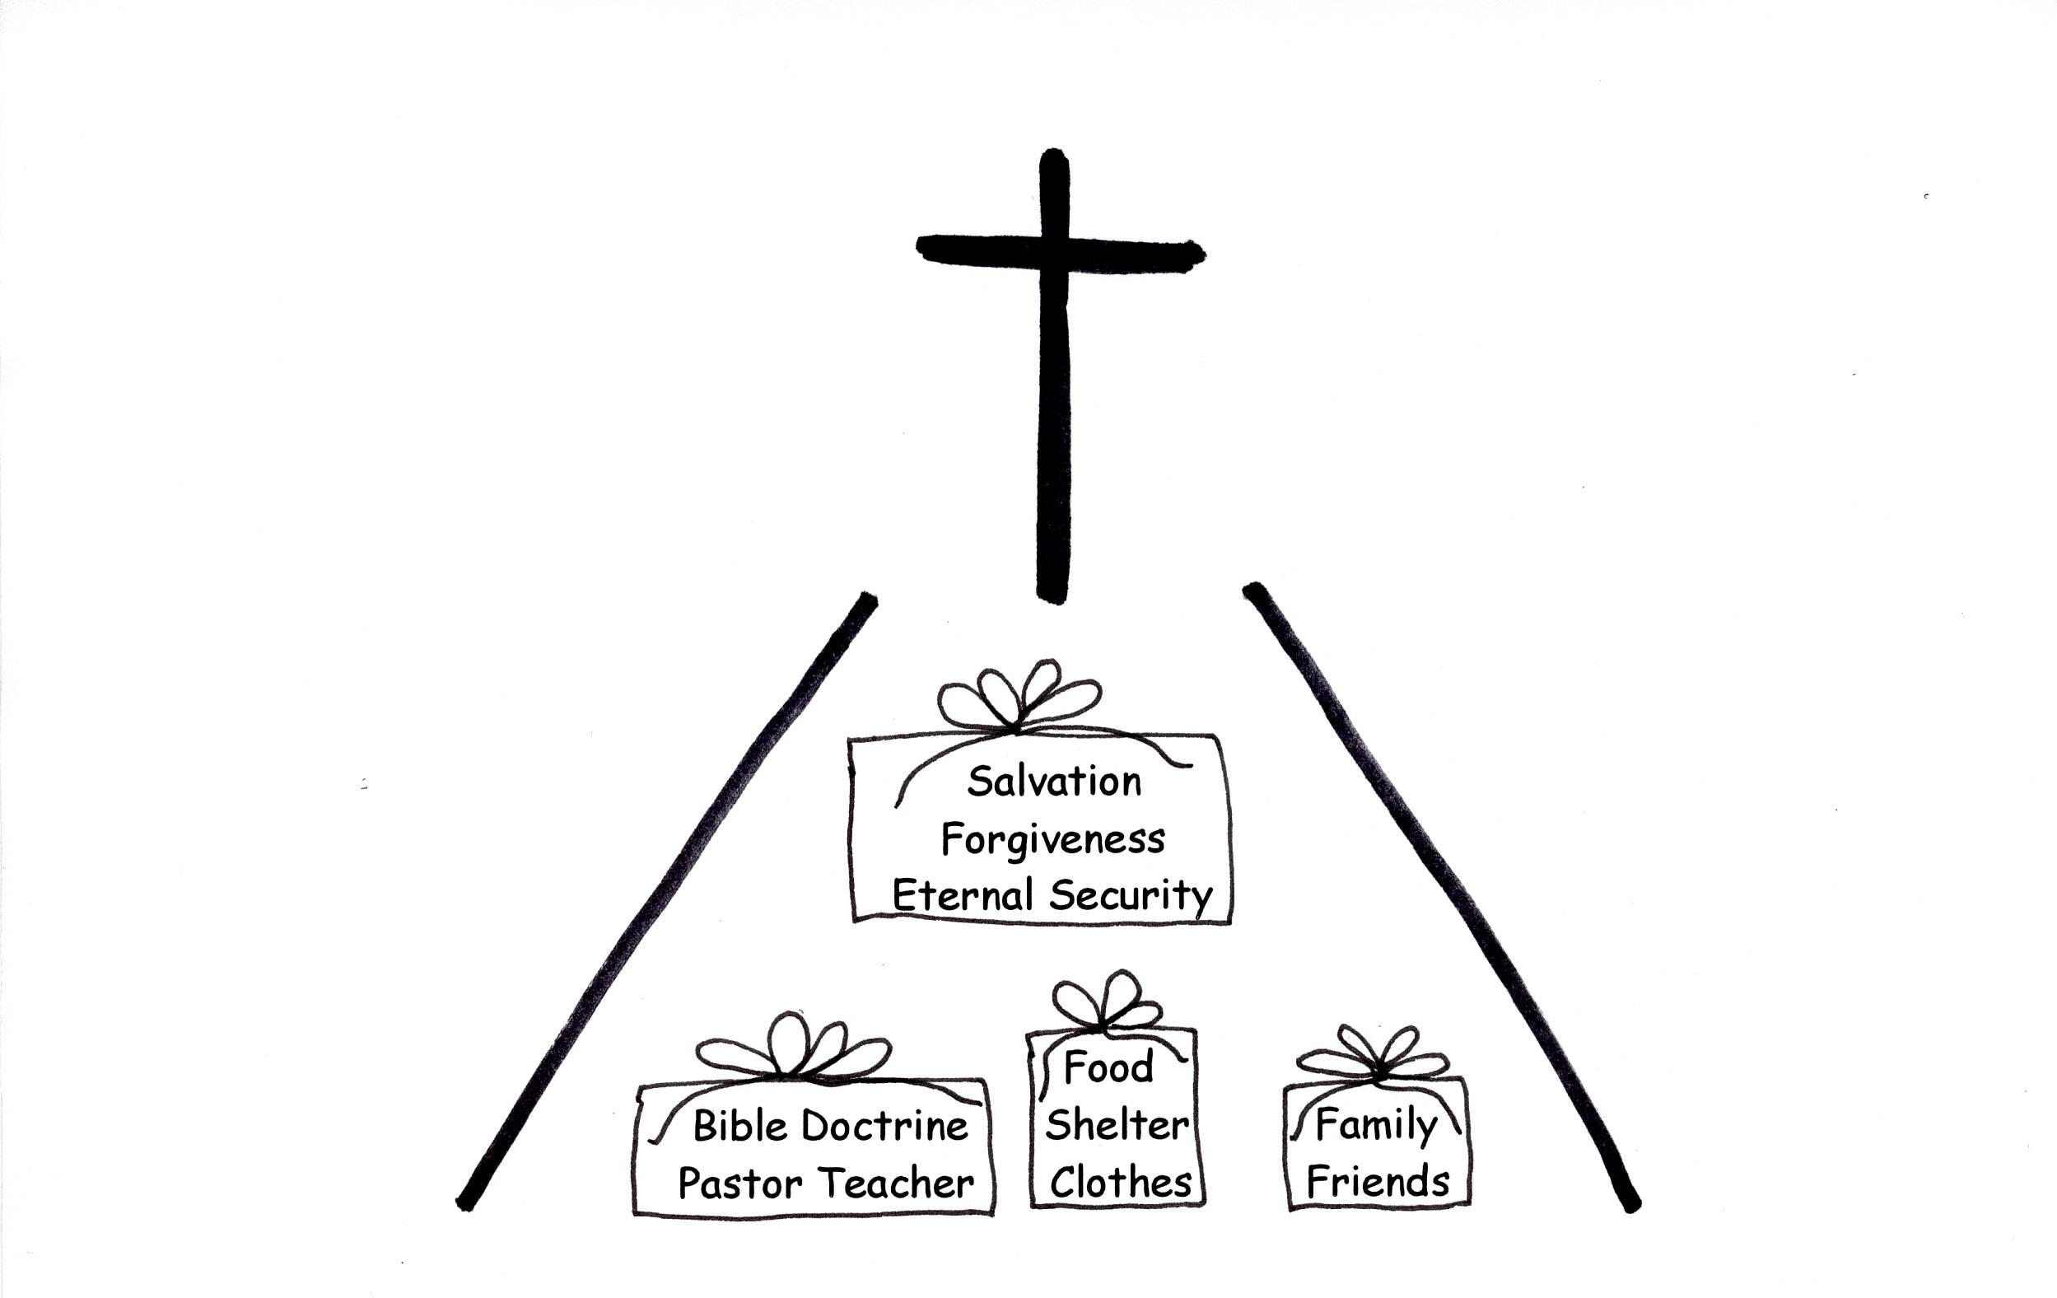

Romans 8:32 “He Who did not spare His own Son, but gave Him up for us all…how will He not also, along with Him, graciously give us all things?”

We can never match God’s kindness to us. He gave His own Son to become our Savior. That is matchless grace! We have been graced out, so to speak! What a kind, loving, patient, gentle, considerate, understanding, and generous Father we have! Let us never forget who has given us all things. “Thank You, God!”
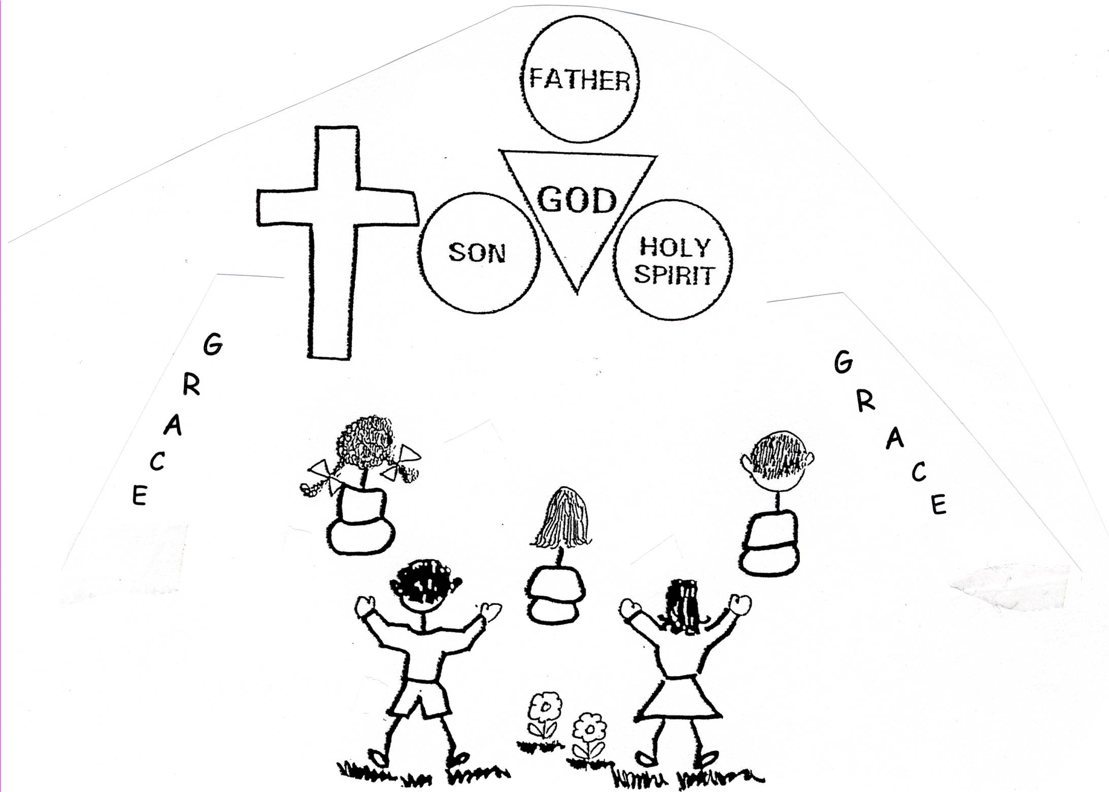

Colossians 1:12 “Giving thanks to the Father, Who has qualified us to share in the inheritance of the saints in light.”

God wants us to be kind to others, or to be gracious to others. He has shown us the way and teaches us in the Bible. We learn that we have nothing that isn’t from God. He just gives, gives, and gives to us. In turn, we learn to give to others of our time, talent, or treasure. We learn to be kind to others.
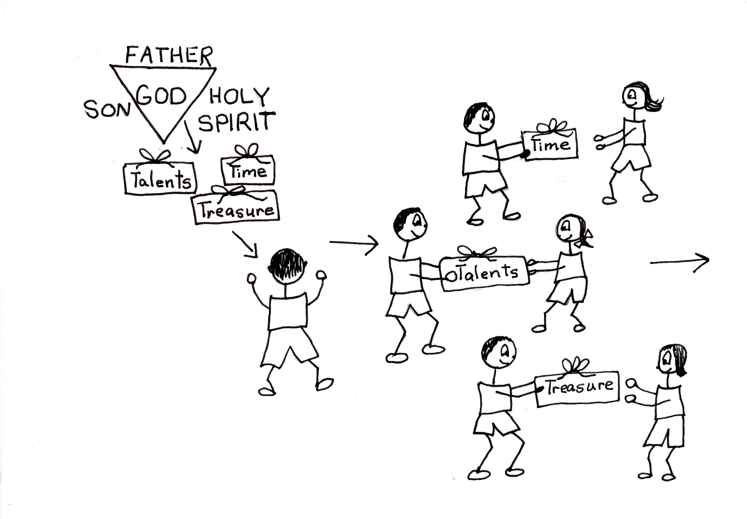

John 3:27 "To this John replied, “A man can receive nothing except it be given him from heaven.”

Our Lord Jesus Christ was the kindest person on earth. He did not come to condemn us or make us feel guilty. He came to save and free us from guilt. When using kindness we don’t make others feel guilty. We don’t judge others; we are tolerant of others. We let them live their lives. We march with them in the plan of God.

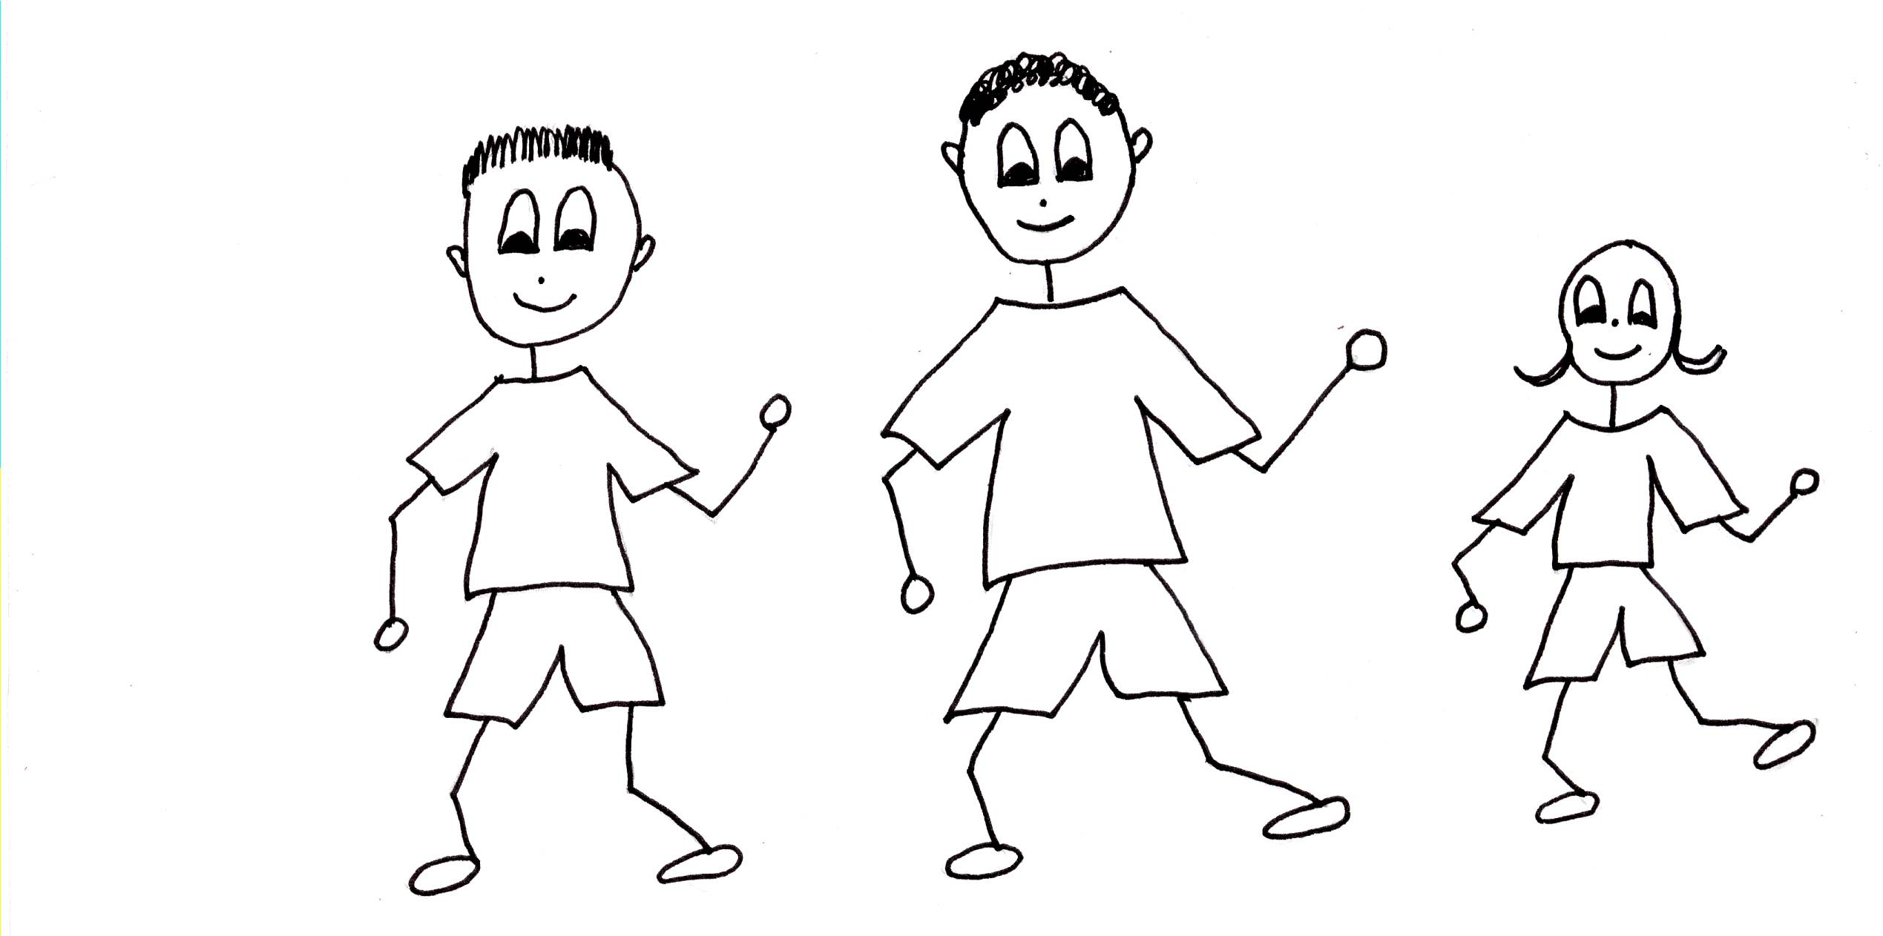
MARCH IN THE PLAN OF GOD.

Galatians 6:1-2 “Brothers, if someone is caught in a sin, you who are spiritual should restore him gently. But watch yourself, or you also may be tempted. Carry each other’s burdens, and in this way you will fulfill the law of Christ. If anyone thinks he is something when he is nothing, he deceives himself [being arrogant].”

God knows all of our faults but He doesn’t tell anyone about them. He could probably tell some pretty good stories about us! God knows that would be harmful to us. He doesn’t want to harm us. God wants us to grow in His grace and wisdom, not to be pushed down with our faults. God loves us and we need to love people in the same way, with virtue love. We need to encourage them, not bring up their sins to others. That would not be kind!
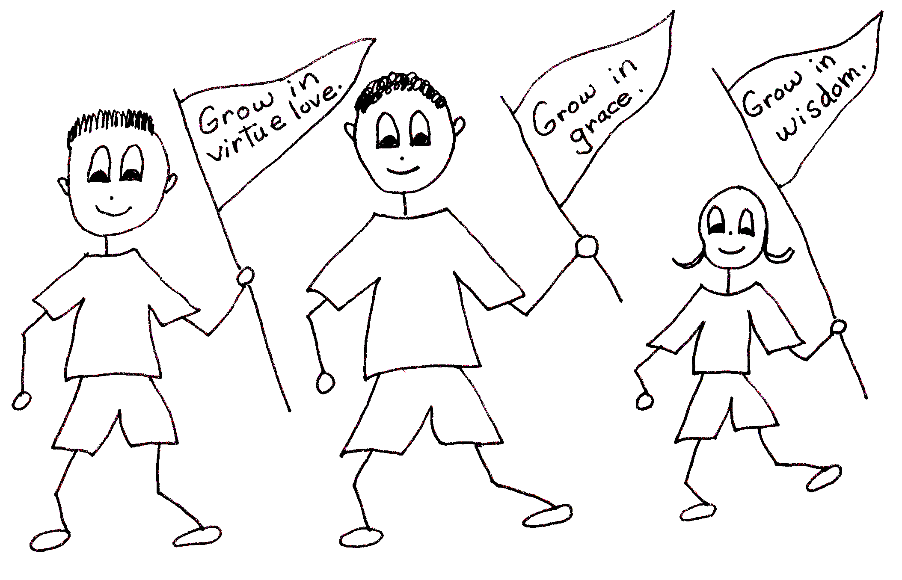
Proverbs 17:9 “He who covers a transgression [sin] seeks love, but he who repeats a matter [maligns, gossips] separates intimate friends.”

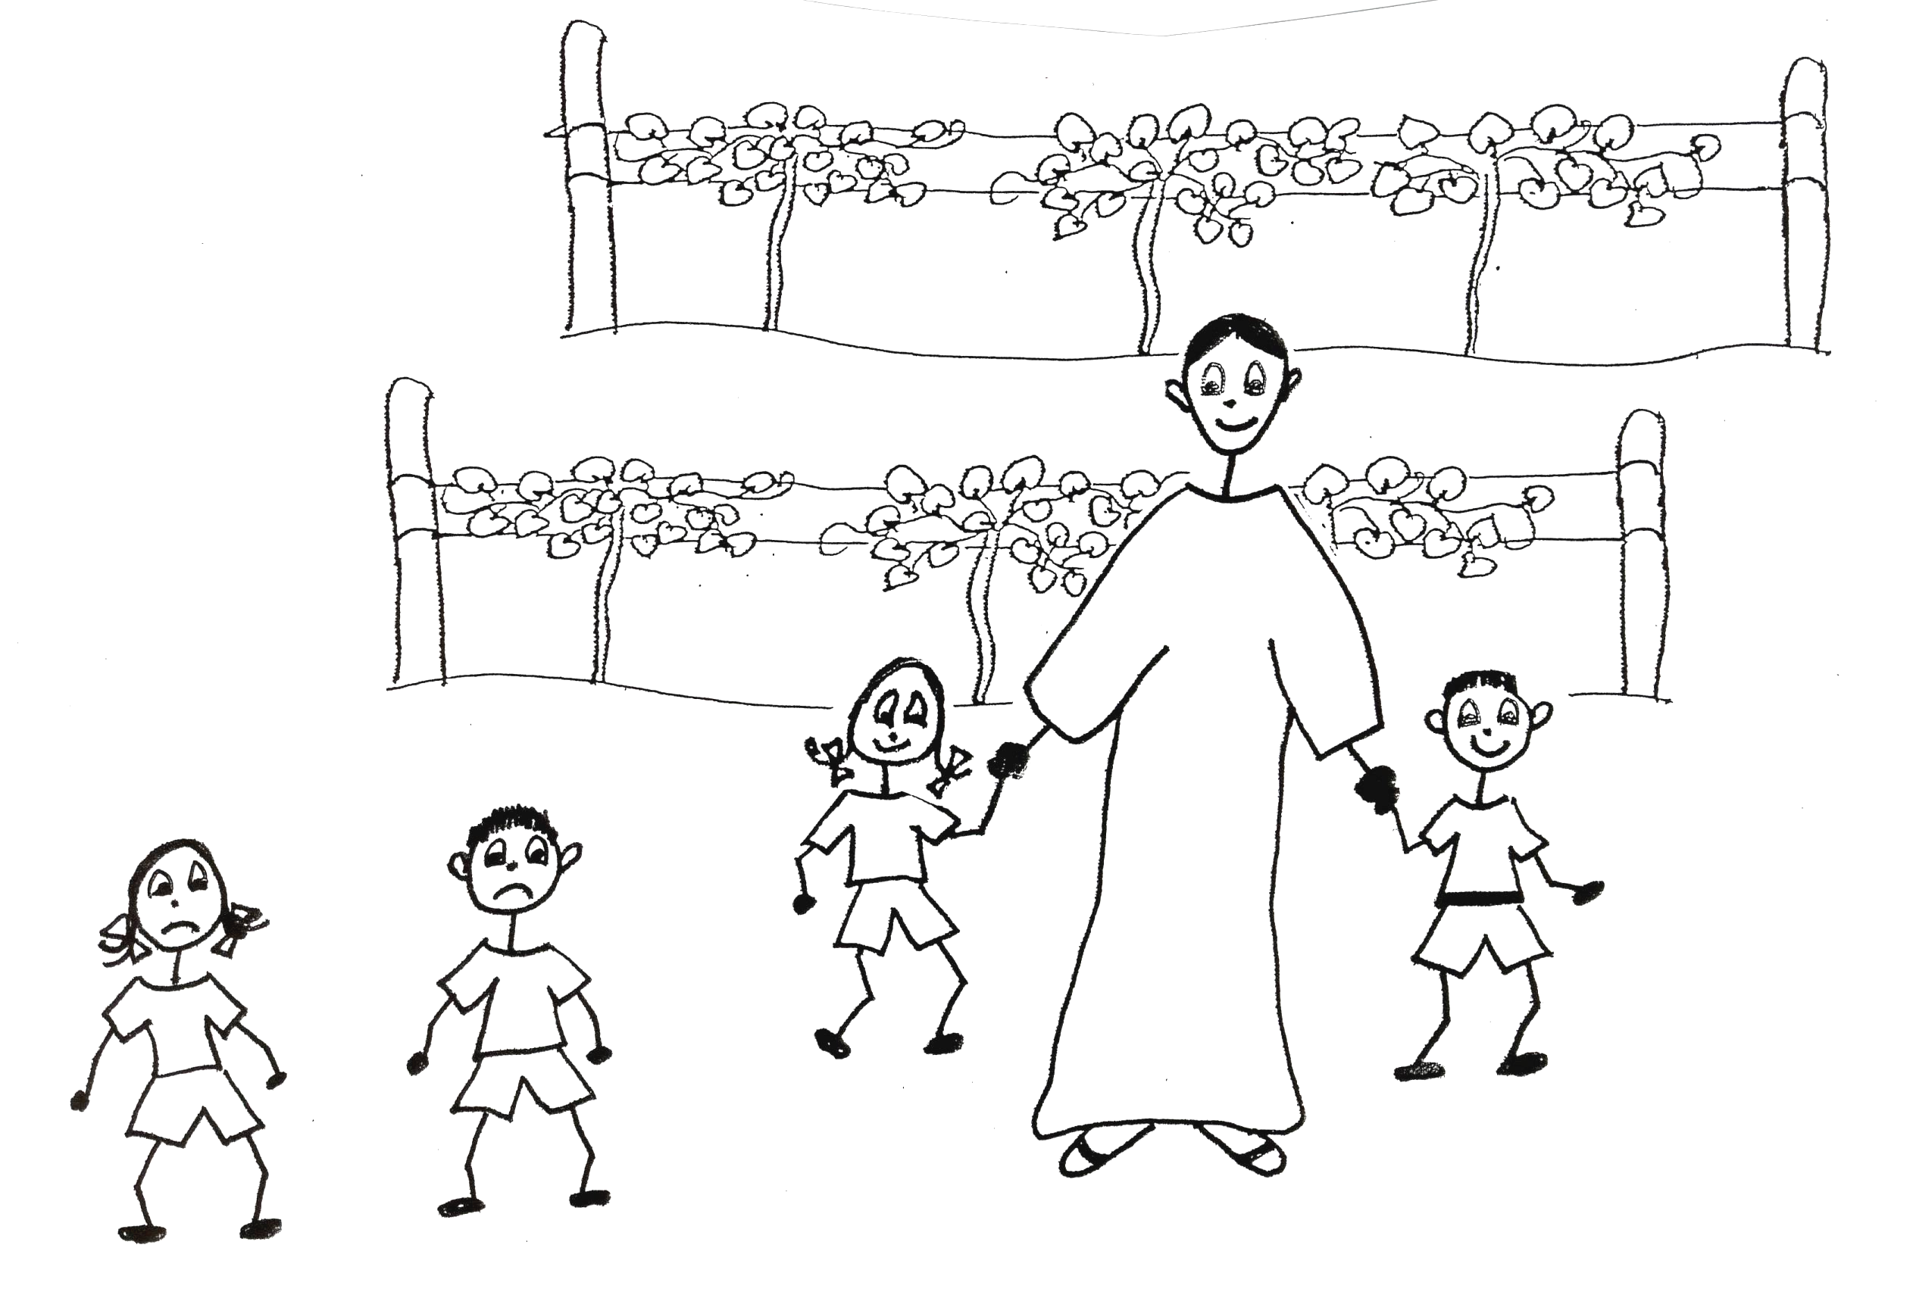
We couldn’t be abiding (living) in a better place than in the Vine, the Lord Jesus Christ. He is always kind. He will never leave us alone. He will never put us down. He will always be our friend. We will always have a home with the Lord Jesus Christ! It’s our job to stay in that place with the Vine! If we leave that safe home we need to rebound, privately tell God the Father our sins, so that we can be filled with the Holy Spirit and living in the Vine!
Hebrews 13:5-6 "Keep your lives free from the love of money and be content with what you have, because God has said, ‘Never will I leave you; never will I forsake you.’ So we say with confidence, ‘The Lord is my helper; I will not be afraid. What can man do to me?’”

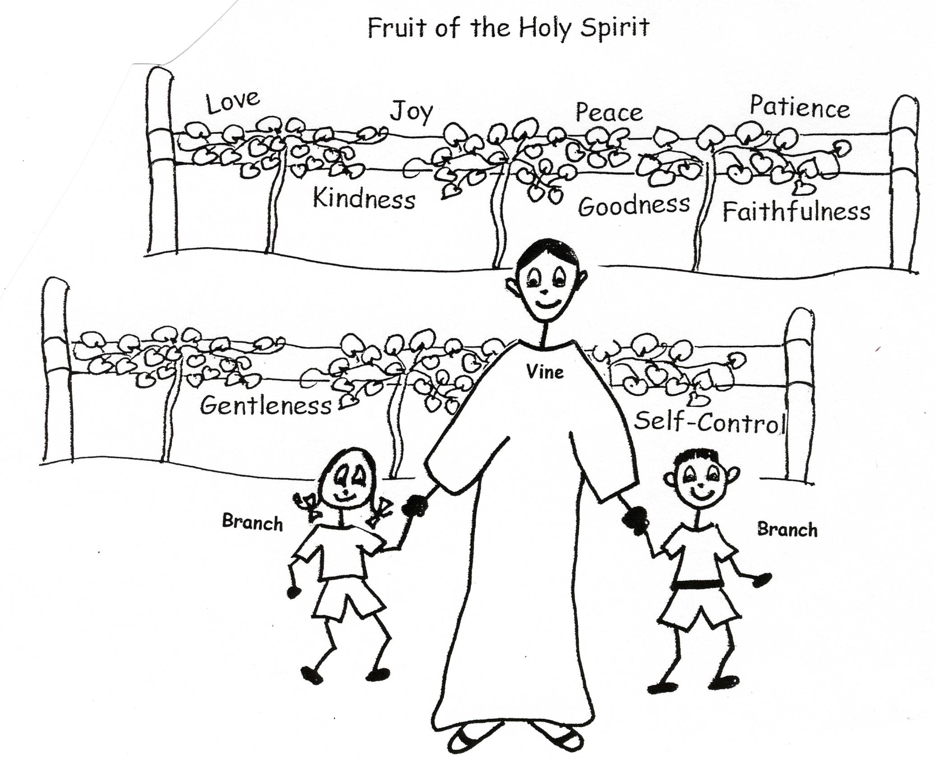
When we are abiding in the Vine, being filled with the Holy Spirit, the Holy Spirit will teach us to be kind along with the other eight parts of the fruit. We won’t be pretending to be kind, loving, etc. We’ll have the real thing! We just have to learn, know, and apply Bible doctrine and the Holy Spirit will make the fruit of the Spirit grow in us! Our lives will manifest or show the fruit of the Spirit.
2 Peter 3:18 “But grow in the grace and knowledge of our Lord and Savior Jesus Christ. To Him be glory both now and forever…” Amen

Matthew 23:23 “Woe to you, teachers of the law and Pharisees, you hypocrites [pretenders, phonies]! You give a tenth of your spices – mint, dill, and cumin. But you have neglected the more important matters of the law – justice, mercy, and faithfulness. You should have practiced the latter, without neglecting the former.”

Robert McLaughlin Bible Ministries
www.gbible.org www.lighthousechristianyouth.org
lcyministry@comcast.net

