Lighthouse Christian Youth Ministry

Lesson 52a

A Very Special Grace

(A Conversation with God)
Grace is all that God is free to do for mankind because of Jesus Christ’s work on the cross.
Grace means favor, kindness, and mercy.



Hosea 2:20 “I will be faithful to you and make you Mine, and you will finally know me as Lord.”



His strength is perfect when our strength is gone. He’ll carry us when we can’t carry on. Raised in His power the weak become strong.

God, I want to talk to you about your perfect strength and power. So often I forget about it and TRY to rely on my strength and power. You have told me that your grace is all that I need. I REALLY get myself in a jam when I don’t believe that and use my human viewpoint. I use up all my strength and become exhausted! When I do that, I’m walking in darkness instead of in your light. Here are some situations in my life that are real challenges.

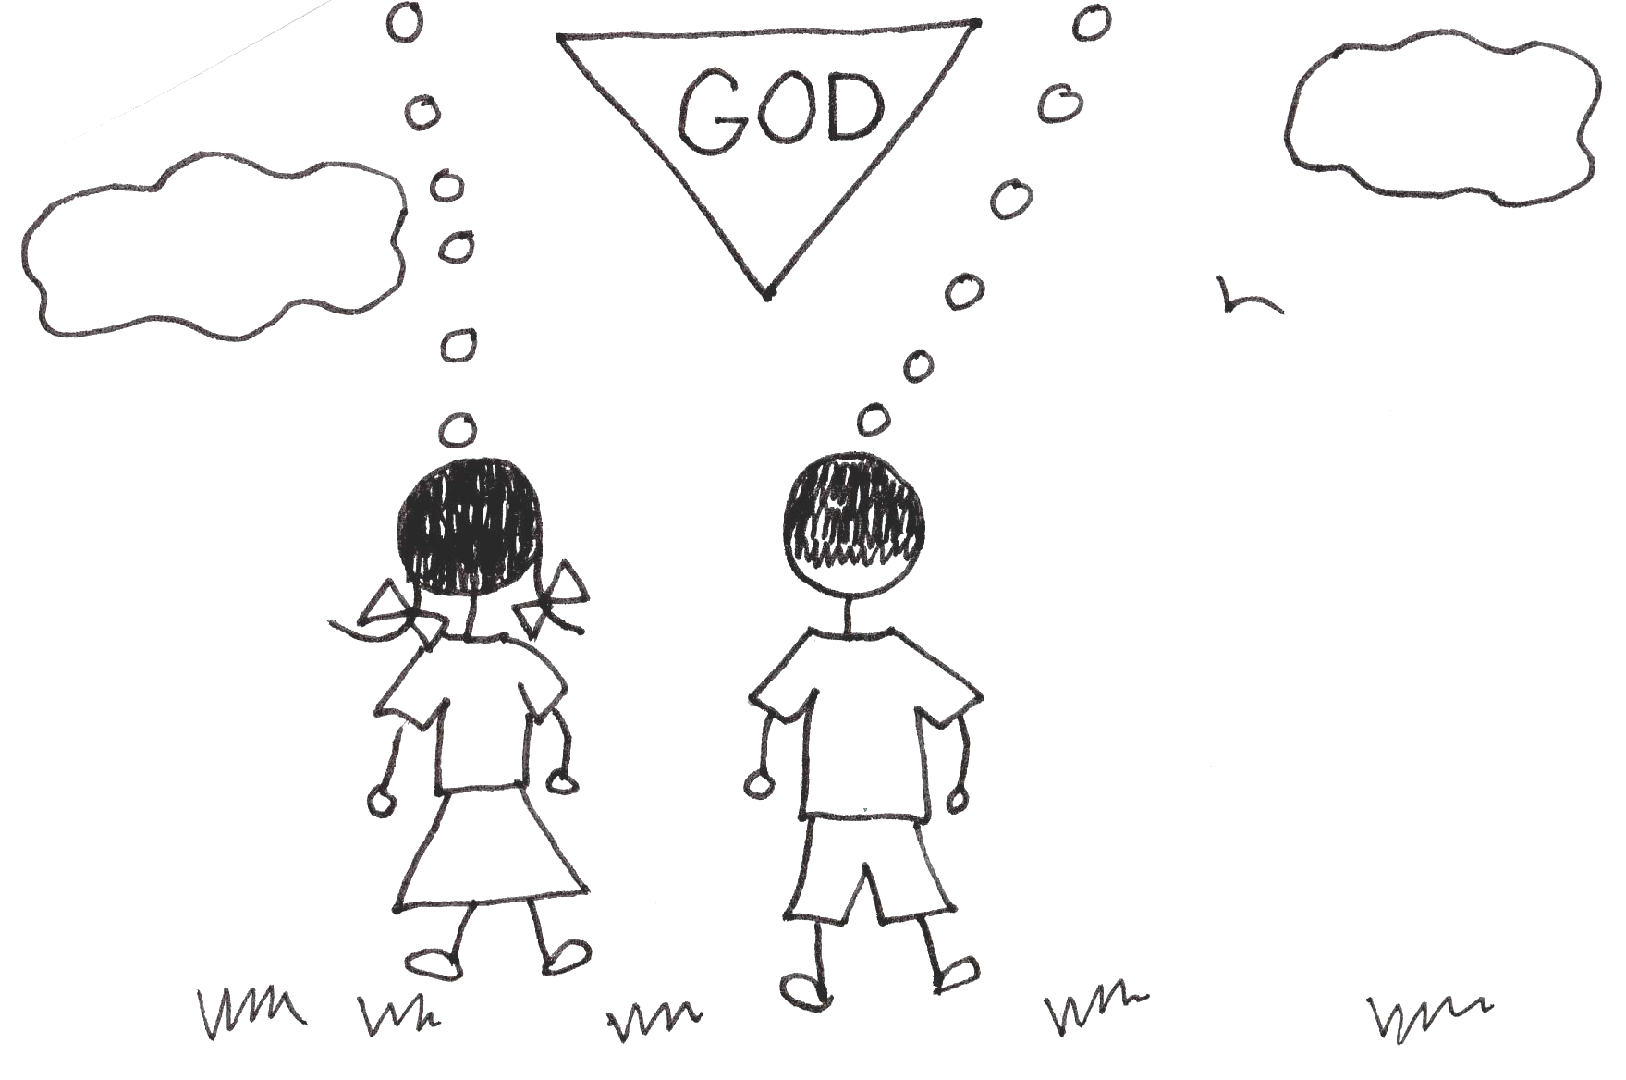


When my life is tested by some bitter

trial, when the tempter tries to tempt
me in life’s ways, and when darkness
dreary falls across my journey, then
Jesus gives a very special grace.

Father, I know that no matter how old we are, we all have times of testing. One of these tests is concerning authority. You gave authority to certain people so that there could be order. I know that, but sometimes it is sooo hard. Sometimes my teacher, coaches, and even mom and dad tell me to do things that I don’t want to do. You have perfect wisdom, and you put them in charge of me, so I know that you have a perfect plan. I will obey their authority. Your very special grace will get me through.

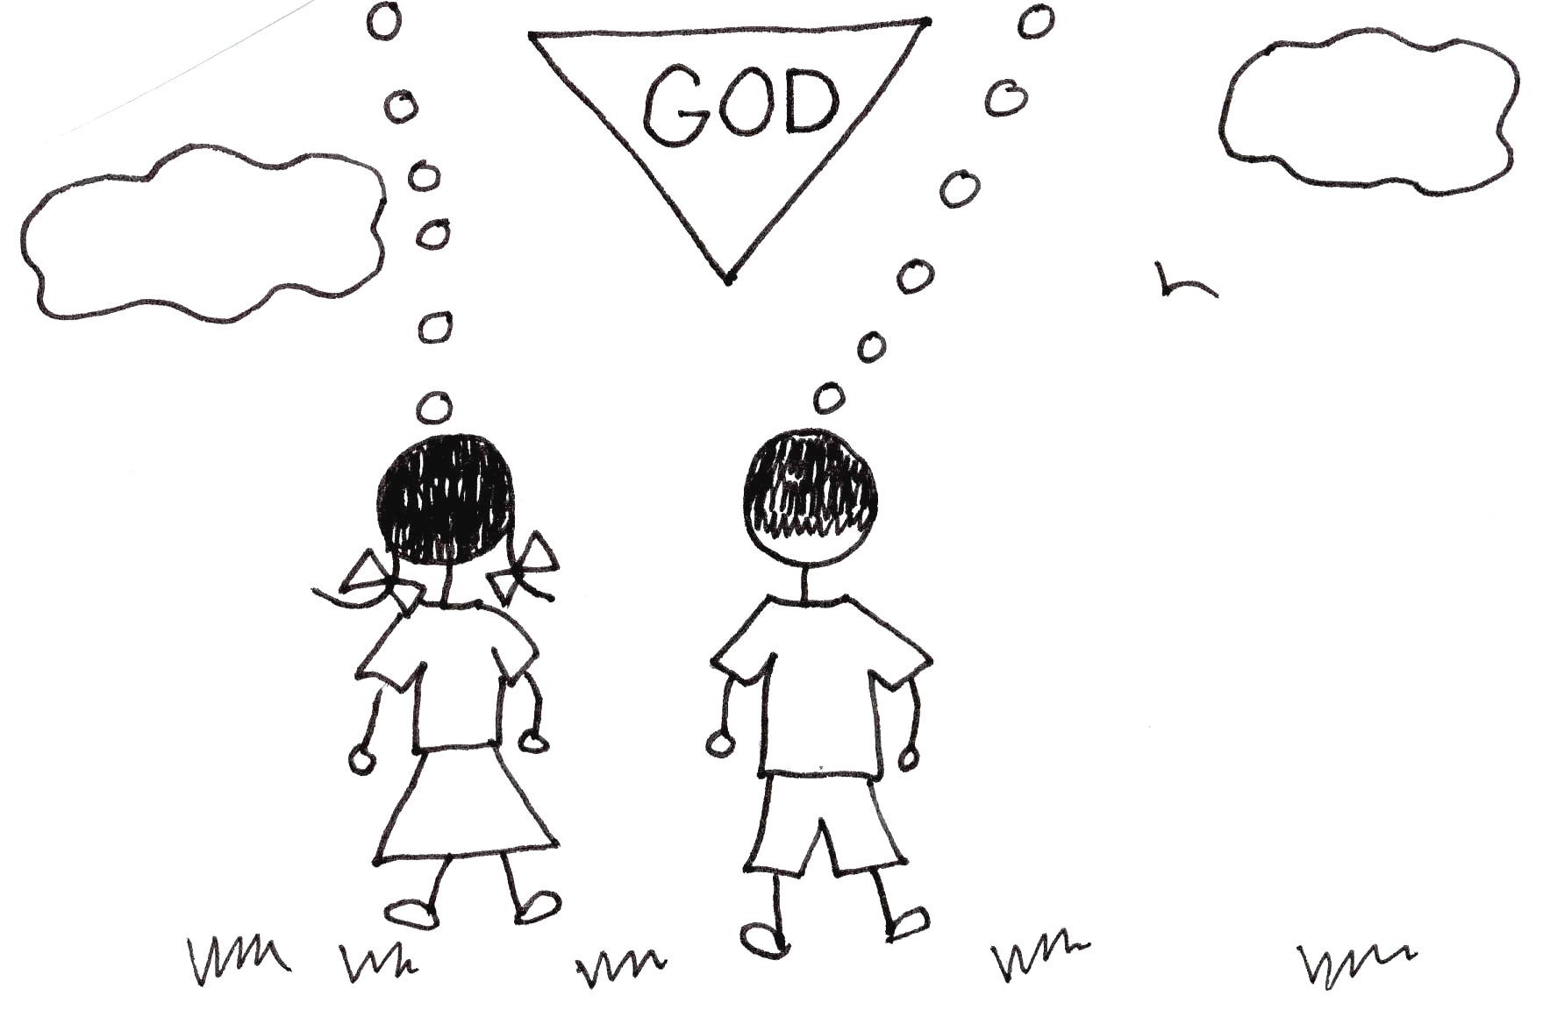



A very special grace in times of trouble, a very
special grace to see me through. A very special
grace just to heal all my heartaches. Now Jesus
wants to give His special grace to you.

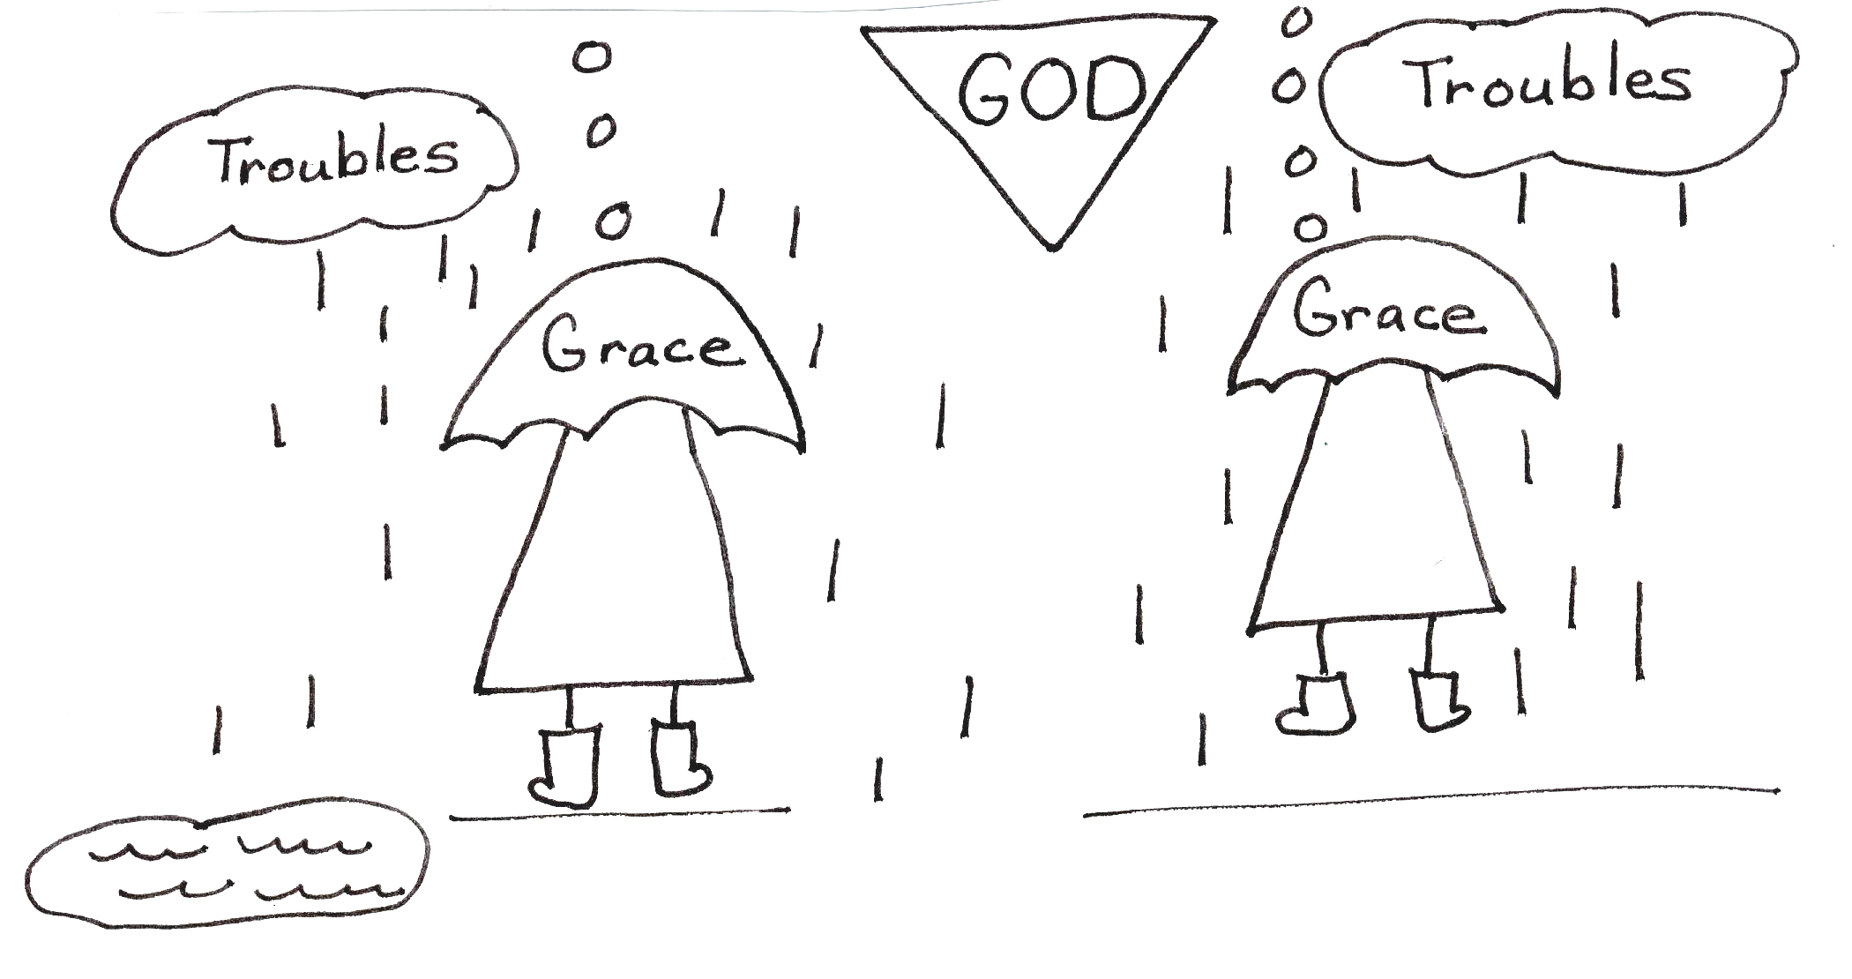
Father I want Jesus to hear this, also. Since He’s my best friend, He will understand my heartaches. There are times when my friends don’t act like friends. They tell lies about me. There are times when they lie about me or make fun of me. Then they leave me out of their fun. This hurts! I’m telling you that this hurts? What about all the pain you went through for me? Oh well, I still need to tell you. Because of your pain, you can understand mine. I probably go through pain so that I can understand other people’s pain. If only they could understand that we are all what we are by your very special grace.



A very special grace in times of
trouble, a very special grace to see me
through, a very special grace to heal all
my heartaches . Now Jesus wants to
give His special grace to you.

Father, you have told me that it is for my benefit that I’m tested. Adversity or difficulties will make me strong if I stay in your perfect plan. You will deliver me from troubles and heartaches. How would I know this if I didn’t go through spiritual battles and see how you deliver me? I believe you, but my old sin nature gets in the way many times. I need your help, your grace! Everything depends on your ability, not on my ability. You can make me grow through adversity!
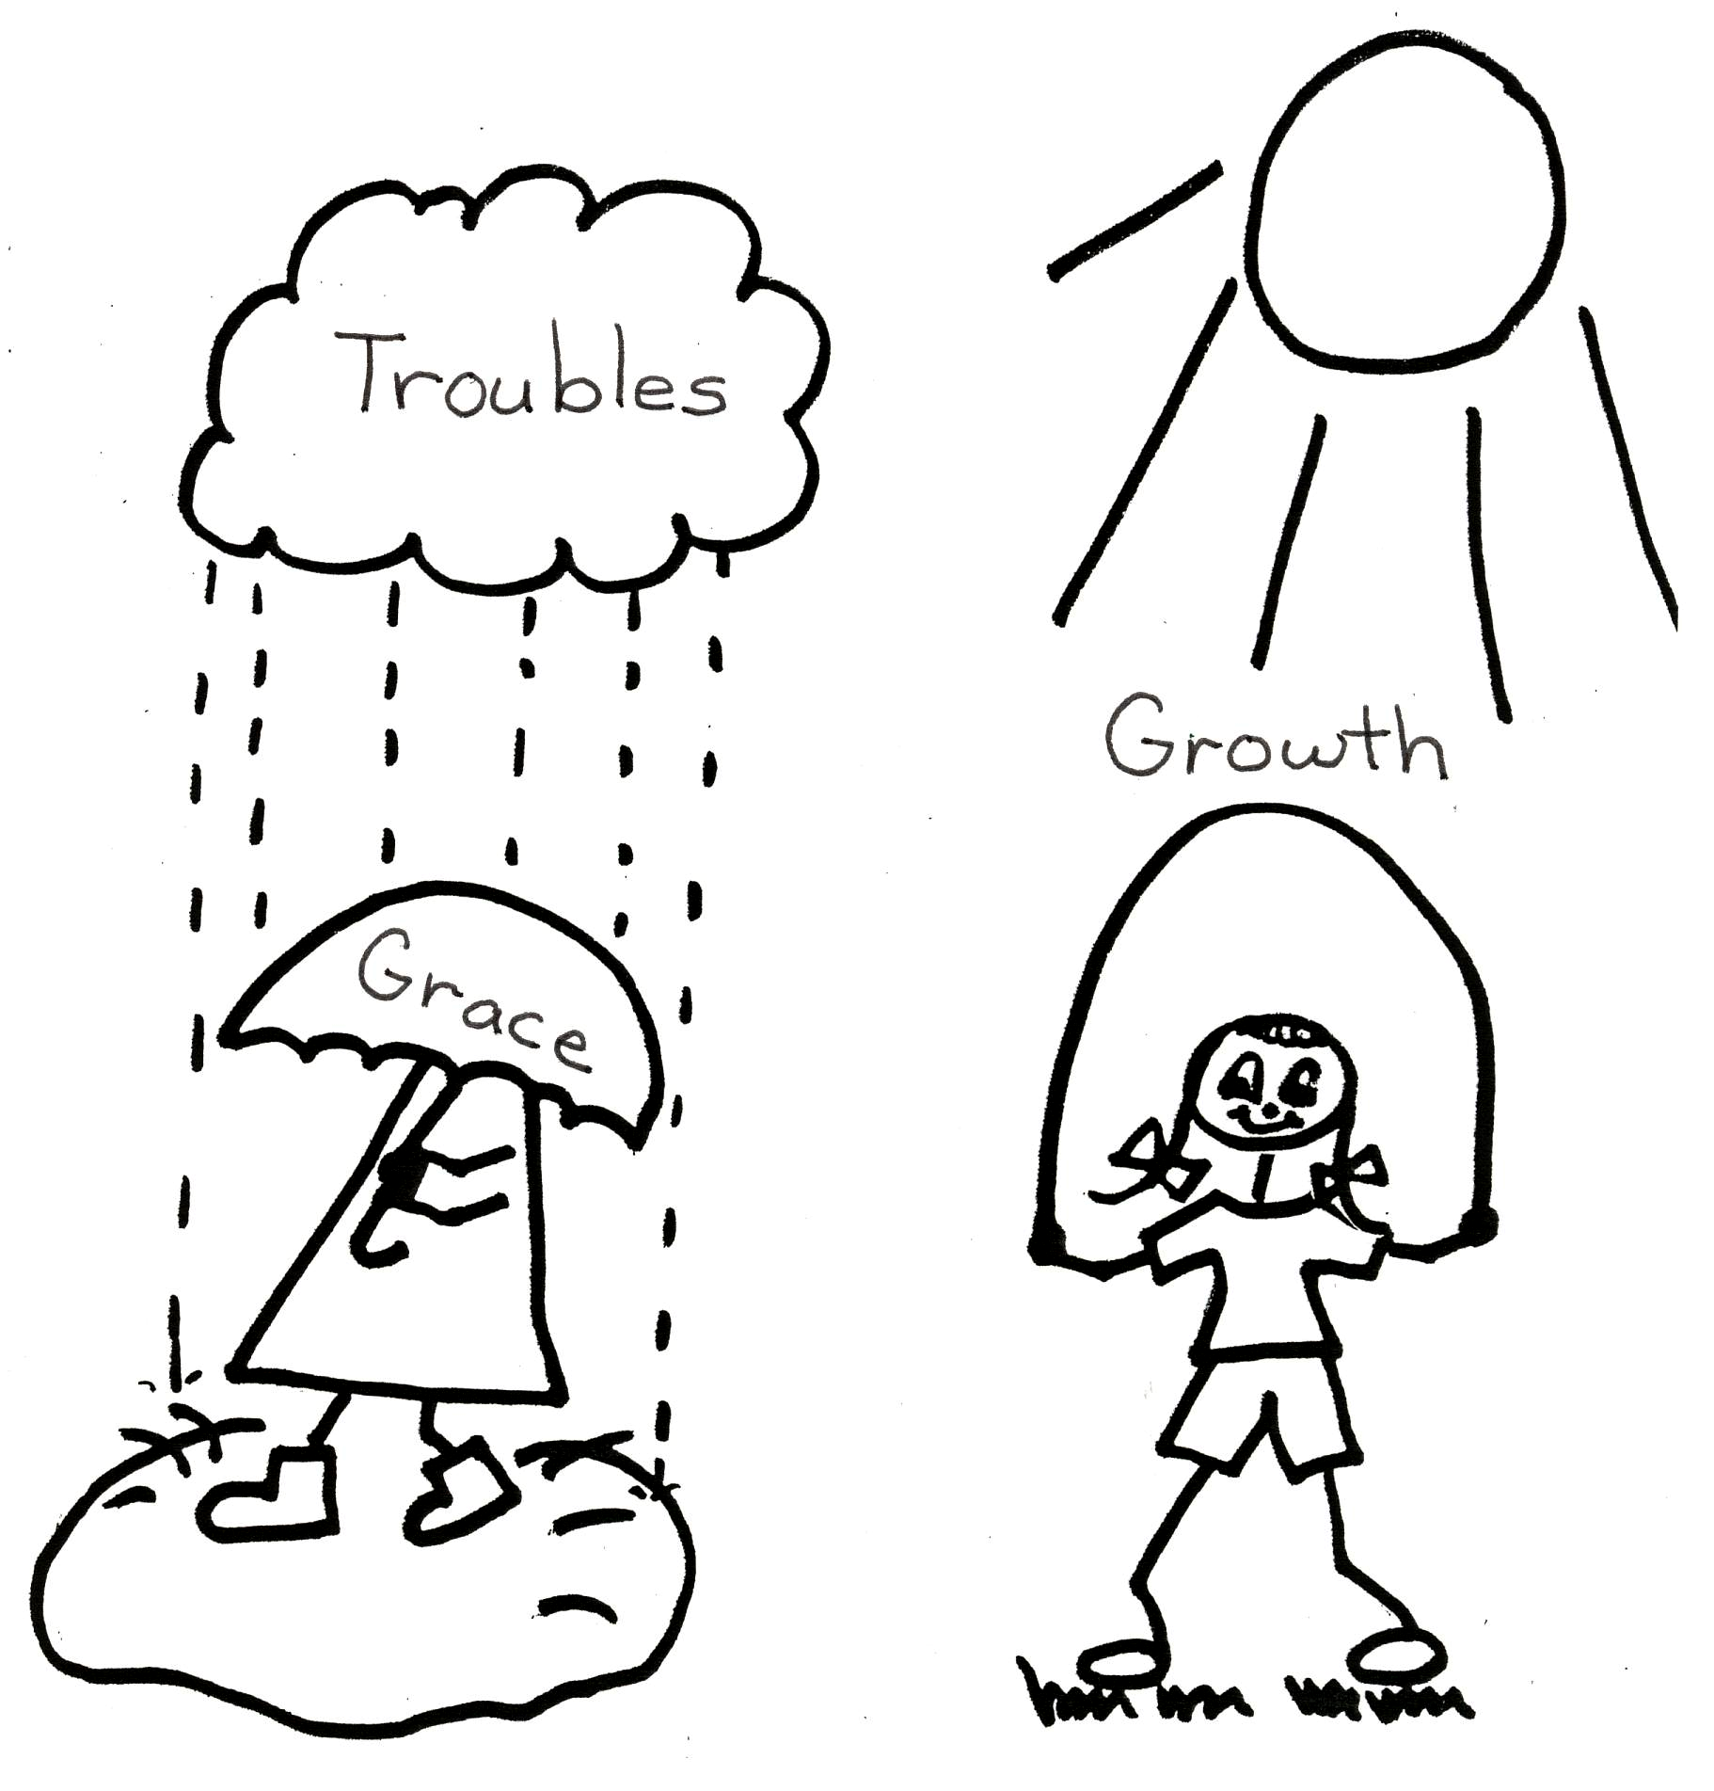

James 1:12 “Happiness to the man who perseveres under trial, because when he has stood the test, he will receive the crown of life that God has promised to those who love Him.”


His strength is perfect when our

strength is gone, He’ll carry us when
we can’t carry on. Raised in His power
the weak become strong. His strength is
perfect!!! His strength is perfect!!!

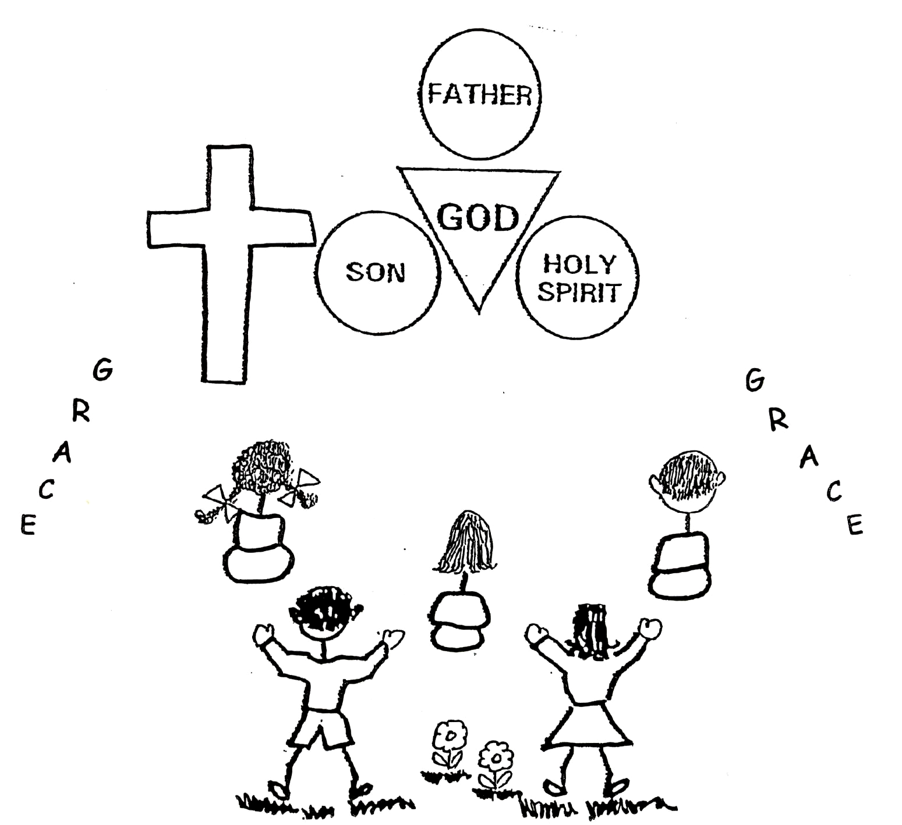
Father, I know that Satan hates the cross. Because of the cross, you are free to give us your grace, mercy, and love. When I go through trials and troubles, you show your grace, mercy, and love to me. You carry me. Satan can’t stand this because you get the glory and he doesn’t. It is through your strength that I become strong. Your strength is perfect!! You deserve the glory!



With all my heart, I want to love You Lord and live my life each day to know You more, all that is in me is yours completely, I’ll serve you only, with all my heart.

The Lord Jesus Christ speaking:
“I know that you want to know me more. Because you make yourself available to Me, I will give you what you need to know me more. The Holy Spirit will help you. Study your Bible lessons everyday either with your mom or dad, your Bible school teacher, or your pastor-teacher. The Holy Spirit will let them know what you need to know. I love you, ____________ . Let your little light shine!”

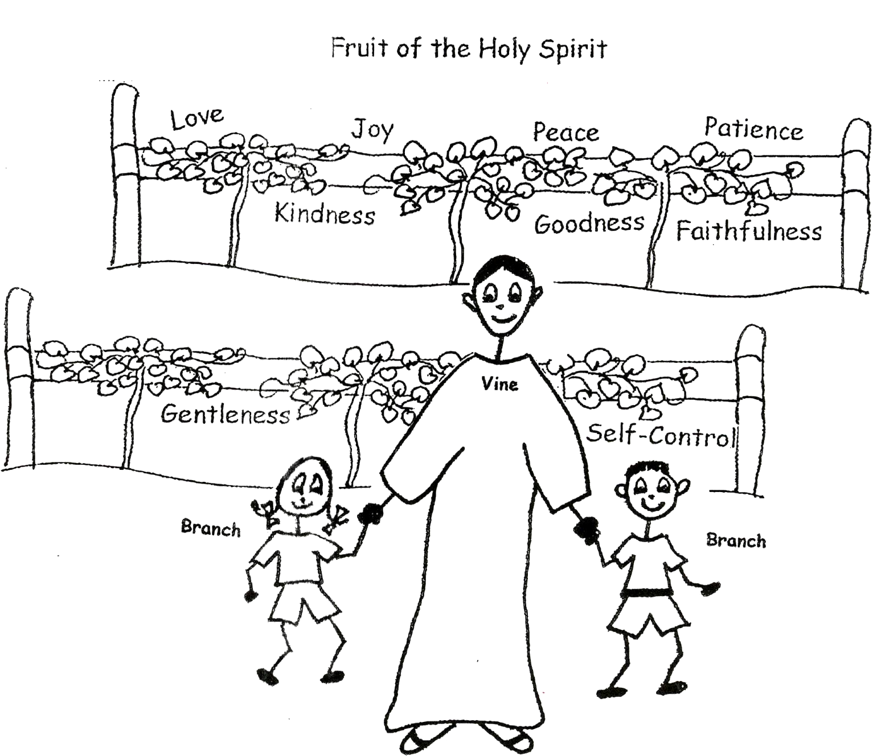


This little light of mine, I’m going to

let it shine, this little light of mine,
I’m going to let it shine, This little
light of mine, I’m going to let it shine,
Let it shine, let it shine, let it shine!!!

I love you too, Lord. Help me to keep my priorities straight; this means to put you first. There are times when I think that I’m too busy to study and learn more about you. Big mistake! That’s when I get myself in trouble and lose peace of mind. You knew billions of years ago that I would have that problem, and you have the perfect way to get me back on track. You are my light. You know how to get my light shining again: being filled with the Holy Spirit and having Bible doctrine in my soul. THANK YOU, LORD.
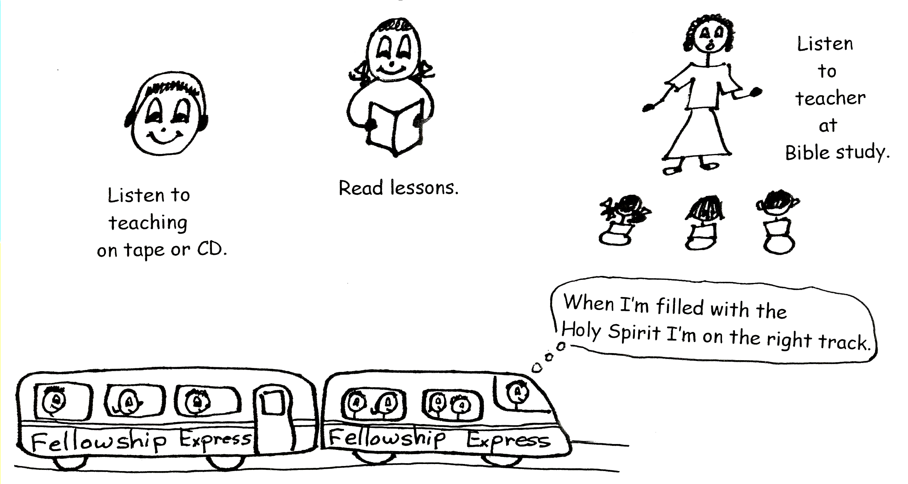

1 John 2:10-11 “This is the message we have heard from Him and announce to you, that God is light, and in Him there is no darkness at all.”



I stand, I stand in awe of you, I stand, I
stand in awe of you. Holy God to Whom all
praise is due; I stand in awe of you.

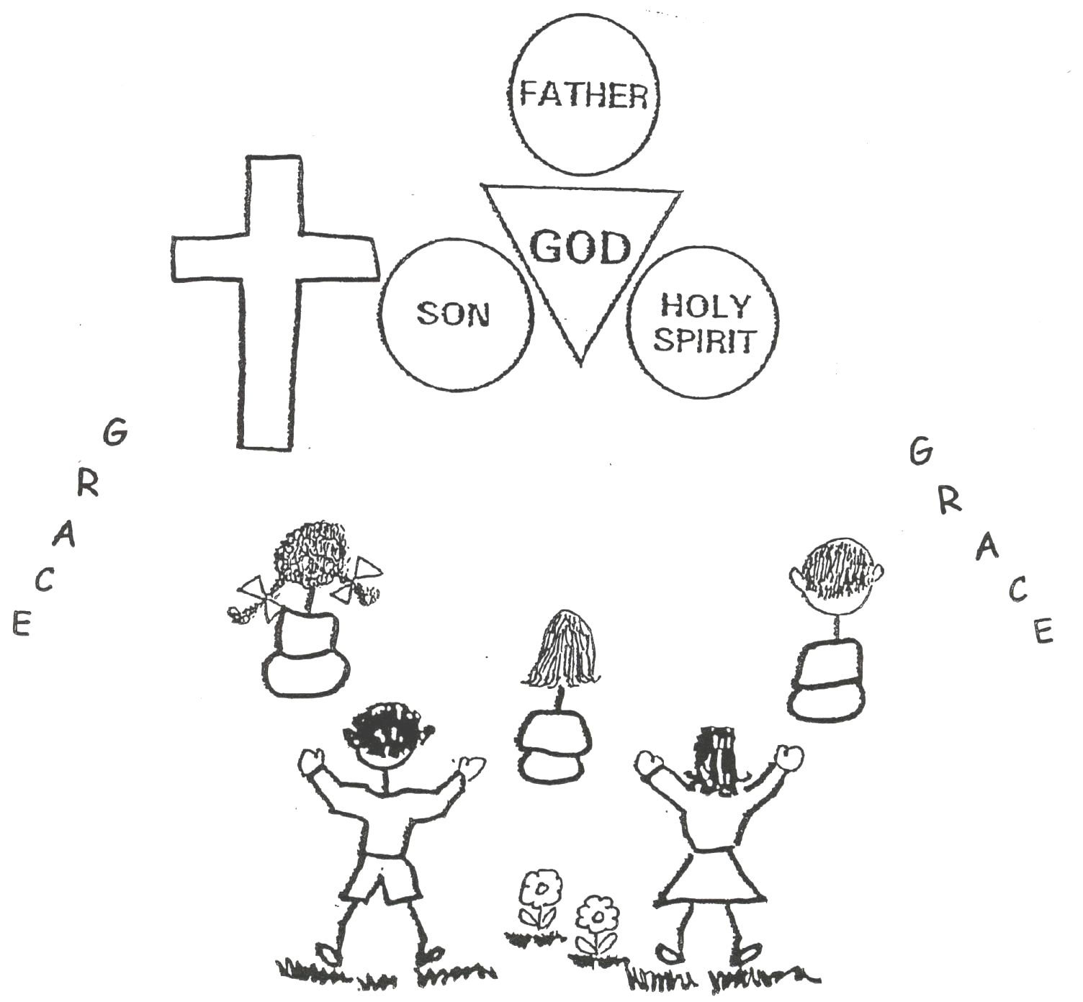

A Very Special Grace, (A Conversation with God)

CD by Ellen Woods, “Amazing Grace”
Song sung by George Amaral, “I Stand in Awe of You”

For more Bible lessons for children, go to:
www.allaboardgodstrain.org

Robert McLaughlin Bible Ministries
www.gbible.org

&
Lighthouse Christian Youth Ministries
www.lighthousechristianyouth.org

From the Jr. Tree of Life

