Lighthouse Christian Youth Ministry
Lesson 52c

LOOKING AT HISTORY WITH GOD’S TIME LINE



June 9, 2006

Genesis 1:1-2 “In the beginning God created the heavens and the earth. Now the earth was [became] formless and empty, darkness was over the surface of the deep, and the Spirit of God was hovering over the waters.”


Our God is an awesome God.
He reigns from heaven above, with wisdom, power, and love.
Our God is an awesome God!

God has always been our Ruler and will always be. He is Sovereign…that means Ruler. A long, long time ago, God, in His wisdom, power, and love, created angels. He created the earth for the angels to enjoy. They could enjoy both heaven and earth. Sounds like fun, doesn’t it? They could zoom back and forth! God gave them a wonderful existence!

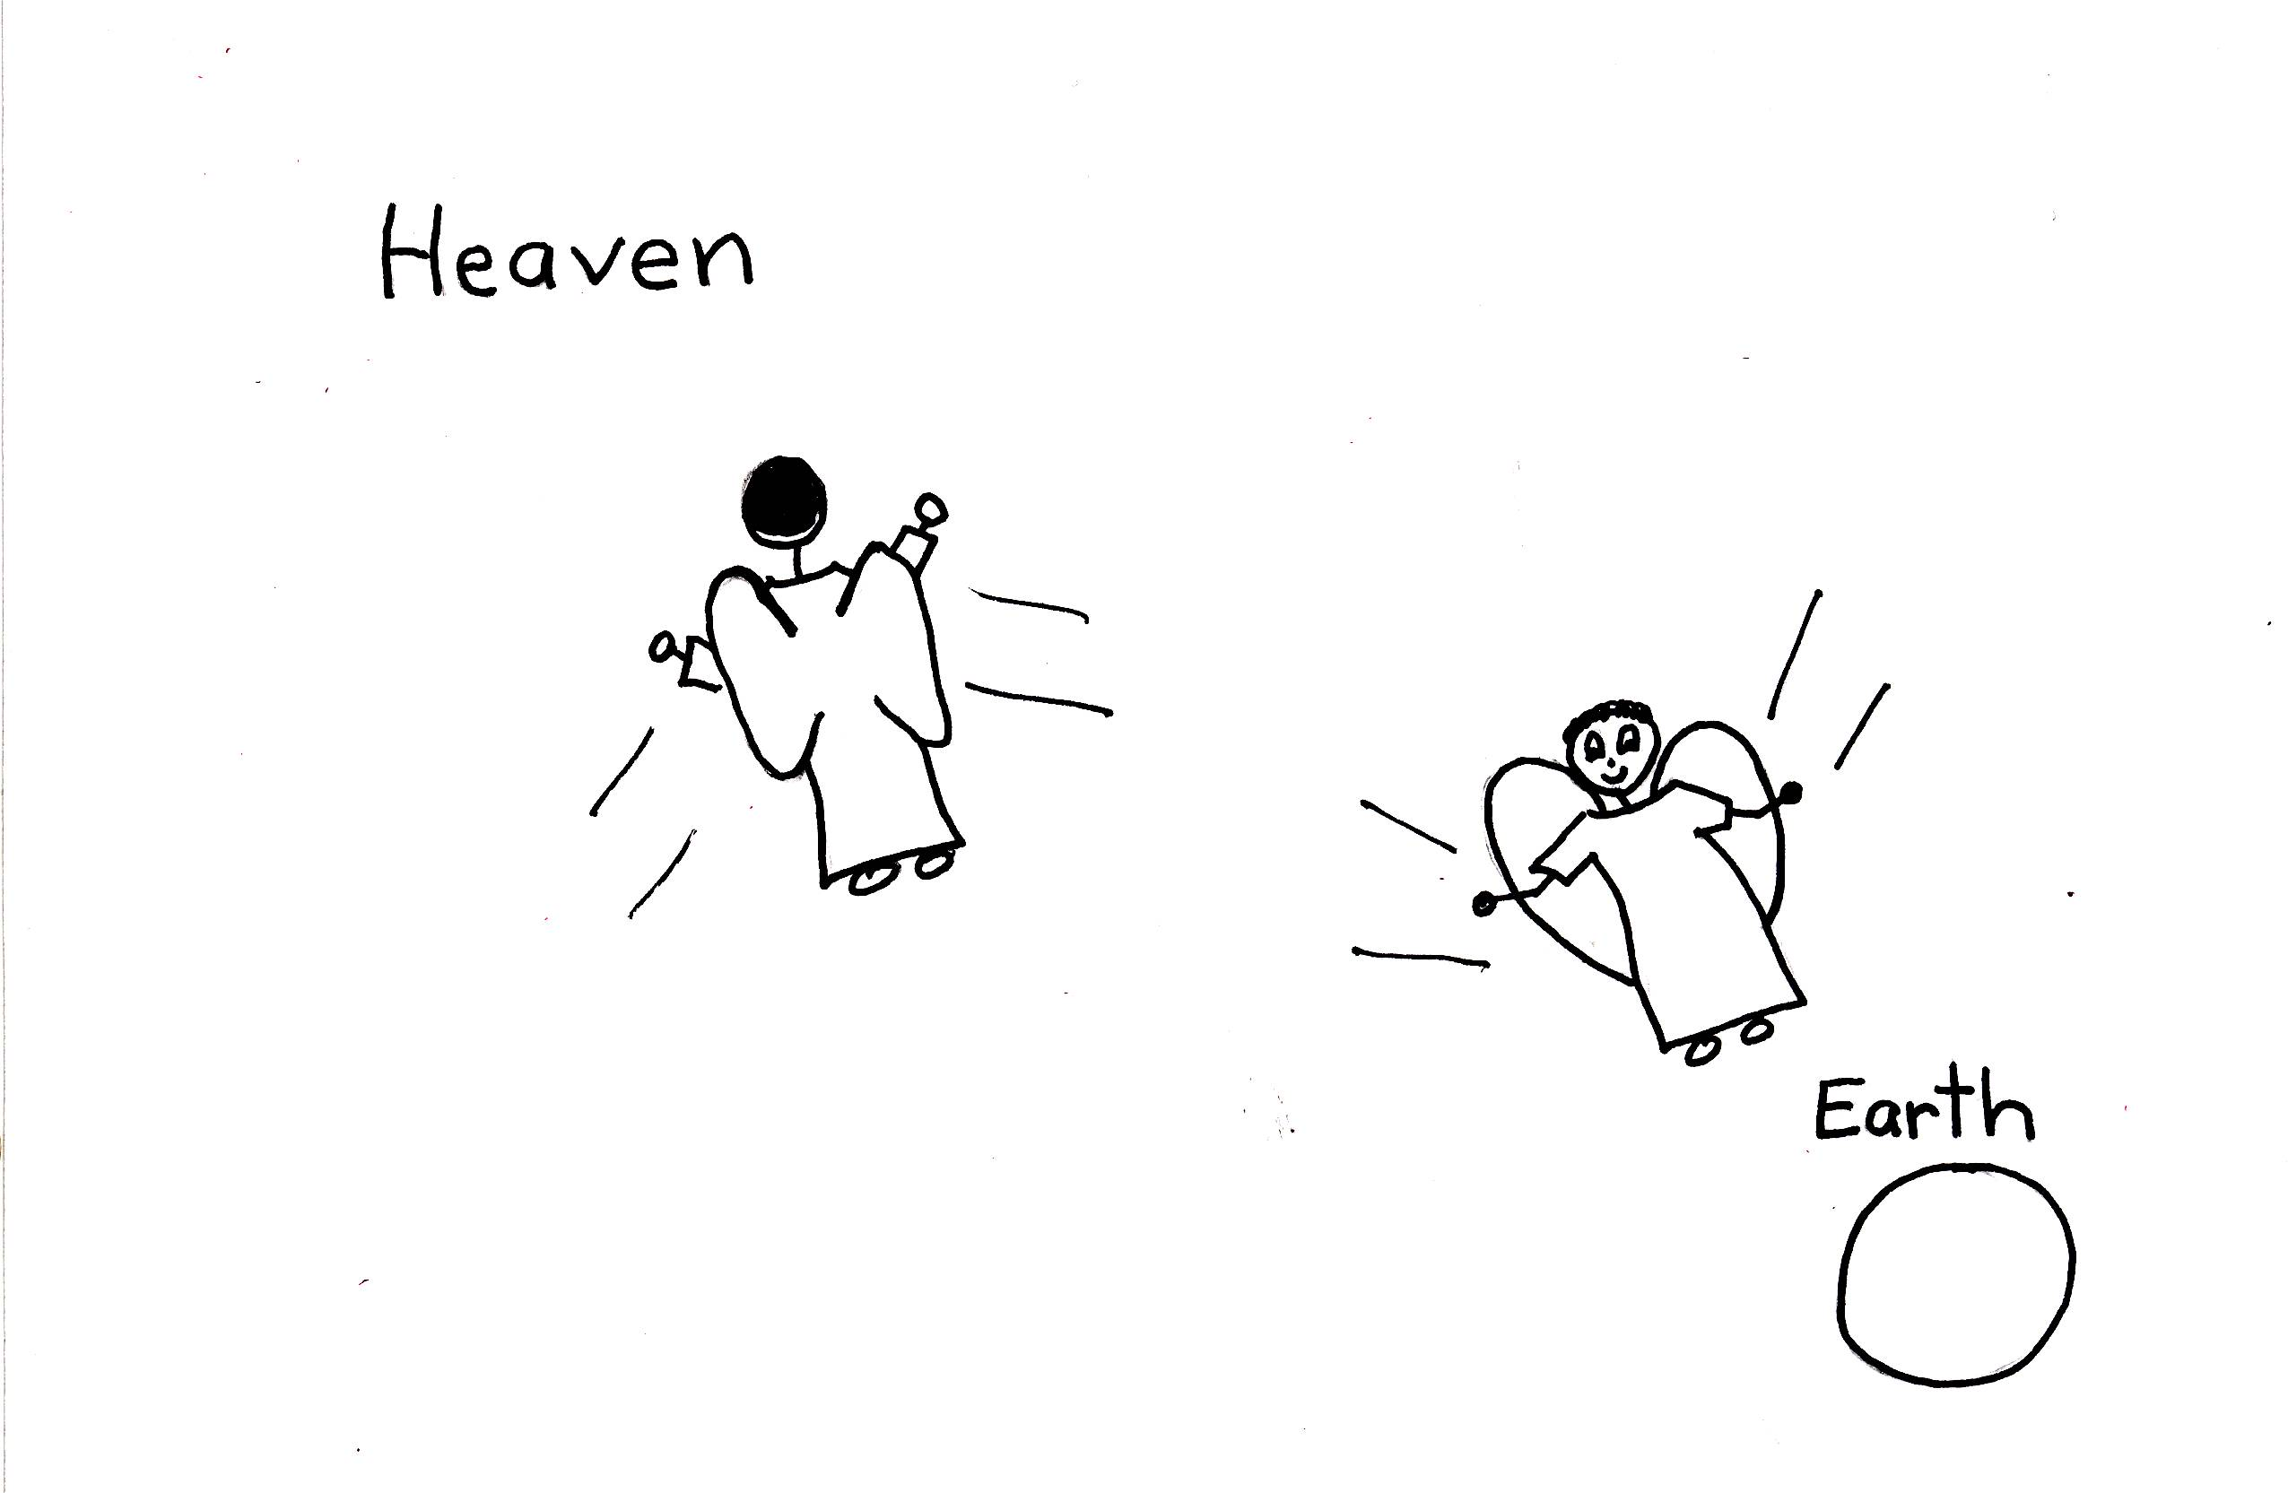

Genesis 1:1 “In the beginning God created the heavens and the earth.”

The angels, with Satan as their leader, did not appreciate what they had. After they had lived for awhile on the earth, their leader, Satan, got very arrogant. He became very self-centered. He wanted to be like God and he thought he could do a much better job than God in ruling the world. This is when he rebelled against God. This is called arrogance…a great sin. And so Satan committed the first sin against God! Satan wanted to be independent of God and he convinced a third of the other angels to join him in his independence from God also! They rebelled against God! Not a good idea!

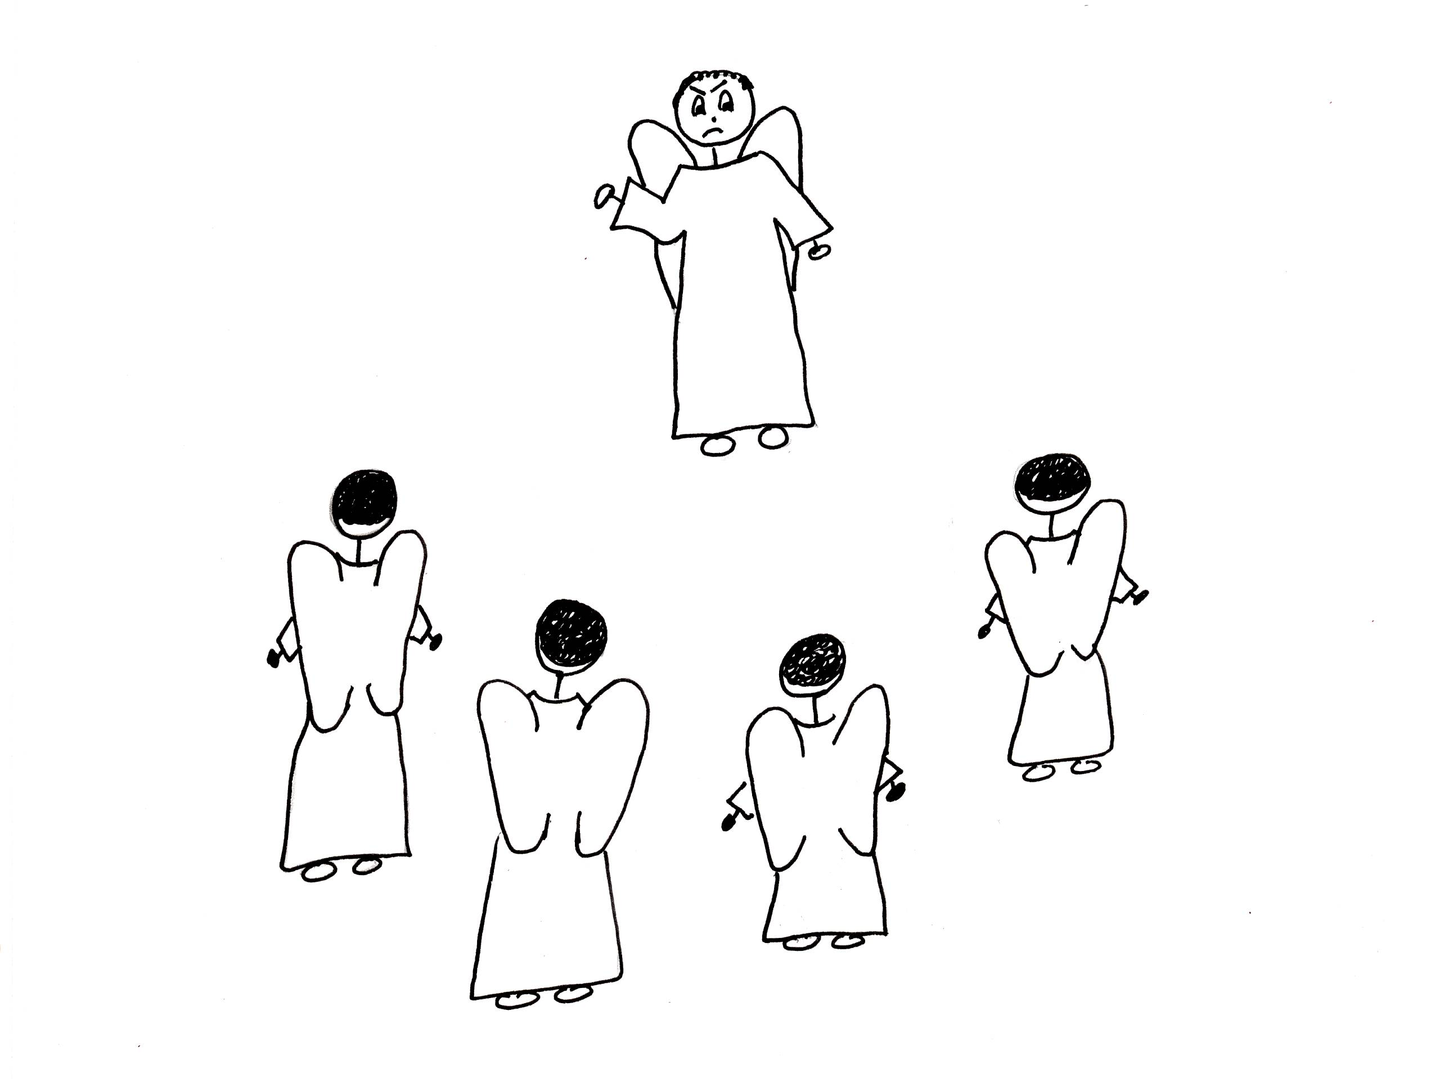

God, in His grace, offered Satan and the fallen angels a way out of this awful situation they were in. This may have been their moment of salvation but we don’t know for sure if this was in fact their salvation because the Bible doesn’t tell us exactly. Two thirds of the angels decided to side with God’s and His plan. But Satan and the rest of the angels didn’t! Bad mistake and bad news for them! Because of their rebellion they were sentenced to the Lake of Fire forever! The angels rebelled against this sentence and make a mess of Planet Earth where they went for a while. God had enough! He stopped their continued rebellion against Him by putting the earth in an ice pack! He took away the sun and nothing could live in the ice pack!
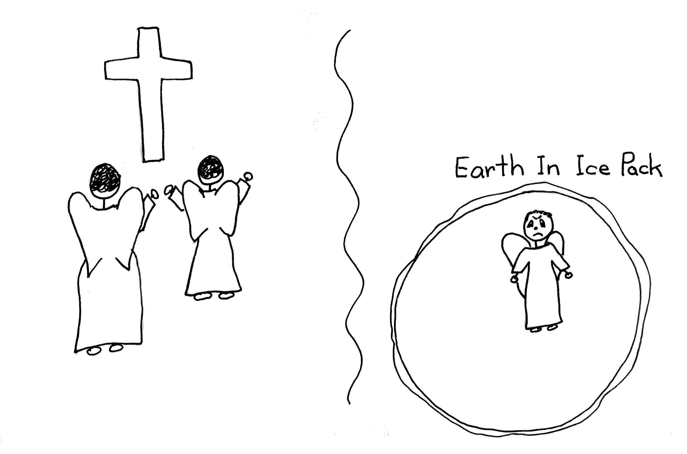

Genesis 1:2 “Now the earth was [became] formless and empty, darkness was over the surface of the deep…”

Satan goofed but he wouldn’t admit that he was wrong. He didn’t accept God’s offer of salvation whatever it was. He didn’t think that he needed God. Believe me, he needed God. God wanted to show that it is impossible for any creature to live, even for a second, independent of God. So to show Satan how wrong he was about God, God took the ice pack off the earth, restored the earth, and created man. God gave Satan another chance to prove his case. This was the “appeal trial” of Satan.
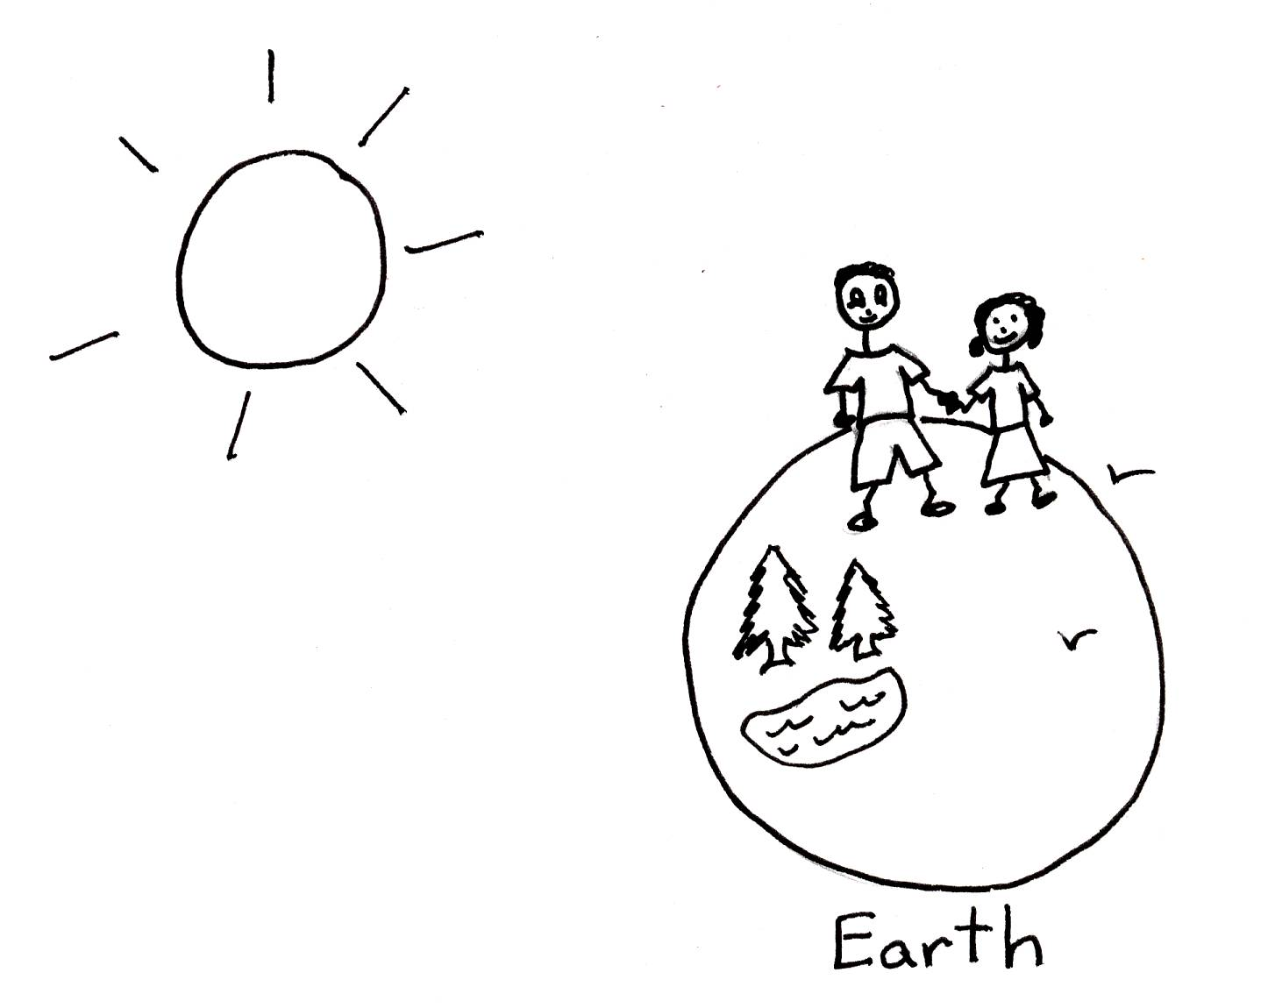

Genesis 1:3 “And God said, “Let there be light,” and there was light.”
Let’s read Genesis 1:4-25

Satan and the fallen angels thought that God was unfair to put them in prison and condemn them to the Lake of Fire. So, God created man, a lesser creature or inferior creature to angels, to show the fallen angels that this lesser creature, man would chose to follow God. God gave man the power to follow Him. Man has to use his volition to choose for or against God. Satan and all the angels had been given the same choice. God is completely fair!
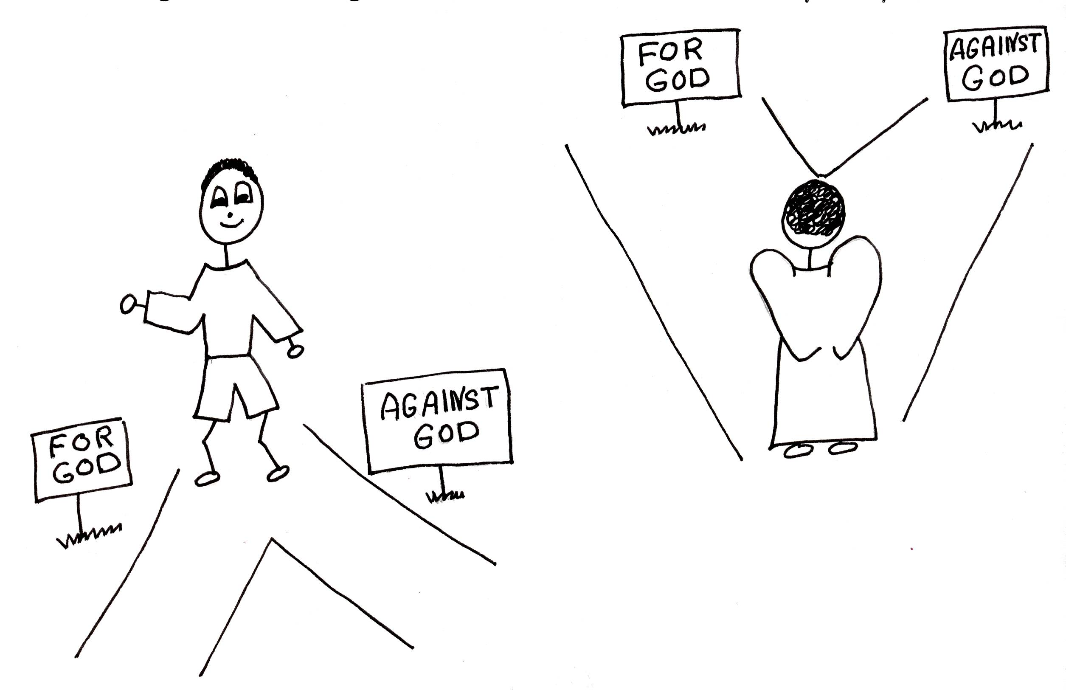

Genesis 1:26 “Then God said, “Let Us make man in Our image, in Our likeness, and let them rule over the fish of the sea and the birds of the air, over the livestock, over all the earth, and over all the creatures that move along the ground.”

When God created man, He also created time. God doesn’t need time, but He thought it would be handy for us. Besides hours, days, months, etc., He created dispensations or time periods on earth. A dispensation, or age, is a period of time when God sets certain rules for each specific period of time and there are several. The dispensations are the divine outline of time and human history. God tells the people of each dispensation exactly how to live and what rules to follow for that age.

God’s Outline of Time - Dispensations

- The Age of the Gentiles: Before the Mosaic Law was written, people served God and were ruled by their consciences.
- The Age of Israel (Age of the Jew): Abraham is chosen as the first Jew and he began the new race…the Jewish race.
- The Hypostatic Union: The time when Jesus Christ lived on the earth…100% God and 100% man.
- The Church Age: The age of grace. Started on the day the Lord Jesus was seated at the right hand of the Father and continues today. It will end at the Rapture.
- The Tribulation: The 7 years of God’s judgment on Israel, the Jews who rejected Christ and all unbelievers. It starts immediately after the Rapture of the church. There will be 3 ½ years of peace and 3 ½ years of pain and destruction…judgment.
- The Millennium: 1000 years of perfect environment where the Lord Jesus Christ comes back and is the Ruler of earth!

The most important thing about dispensations is that they answer the question, “After salvation, what am I supposed to do with my life?” In every period of time the way of salvation is always the same: believe in the Lord Jesus Christ. The part that is different is the plan that believers are to follow. We have to know what dispensation we are in so that we know God’s plan, will, and purpose for our lives.
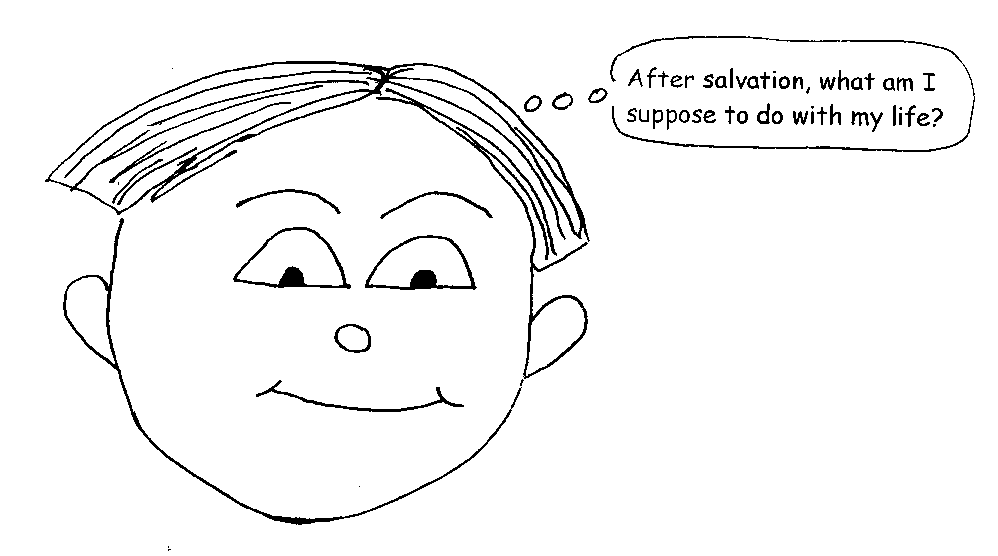

The first dispensation is the Age of the Gentiles. This time goes from the Creation to the Exodus, when Moses led the Jews out of Egypt. The Bible had not been written so the people were to decide what was right or wrong through their consciences. Jesus was and is the Light that lights the way for every man who comes into the world. Even if they have never heard the truth of God, they have a conscience within them that makes it possible to see the Word of God. God always makes it possible for man to know Him. The Gentiles (everyone who wasn’t a Jew) still had to believe in the Lord Jesus Christ for their salvation, but the rules for their life after salvation were different.

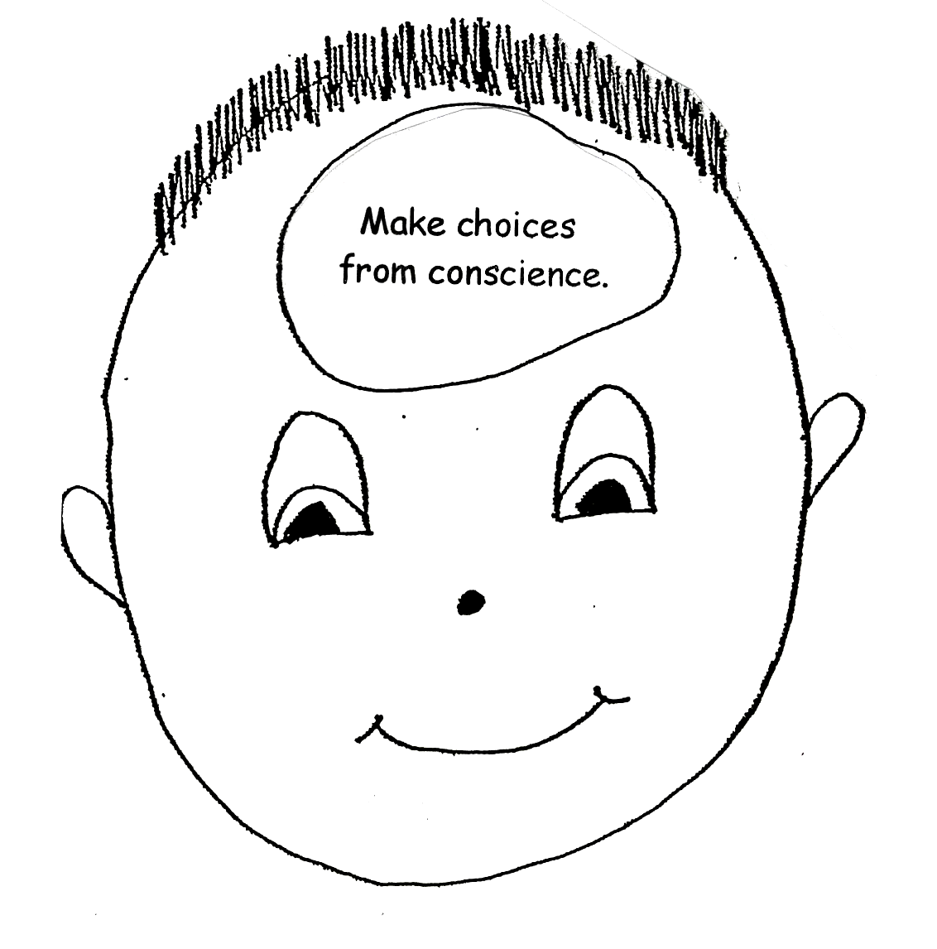
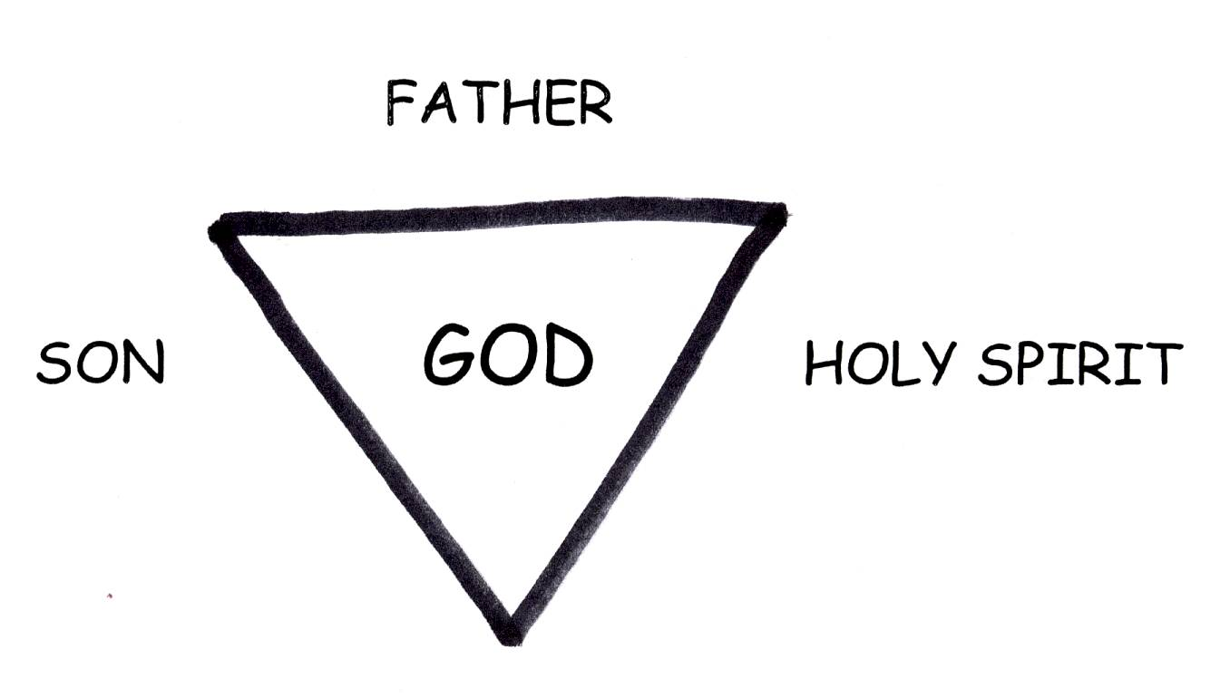

Romans 2:14-15 “Indeed, when Gentiles, who do not have the law, do by nature things required by the law, they are a law for themselves, even though they do not have the law, since they show that the requirements of the law are written on their hearts, their consciences also bearing witness, and their thoughts now accusing, now even defending them.”

Abraham lived during the Age of the Gentiles. He was the first Jew and the Father of all the Jews. God made promises to Abraham. We call these promises “covenants.” These promises were for Abraham’s seed (relatives going all the way to the end of time), and the Gentiles who were associated with him. We’re not going to study all about the covenants now, but God made many wonderful promises to the Jews.

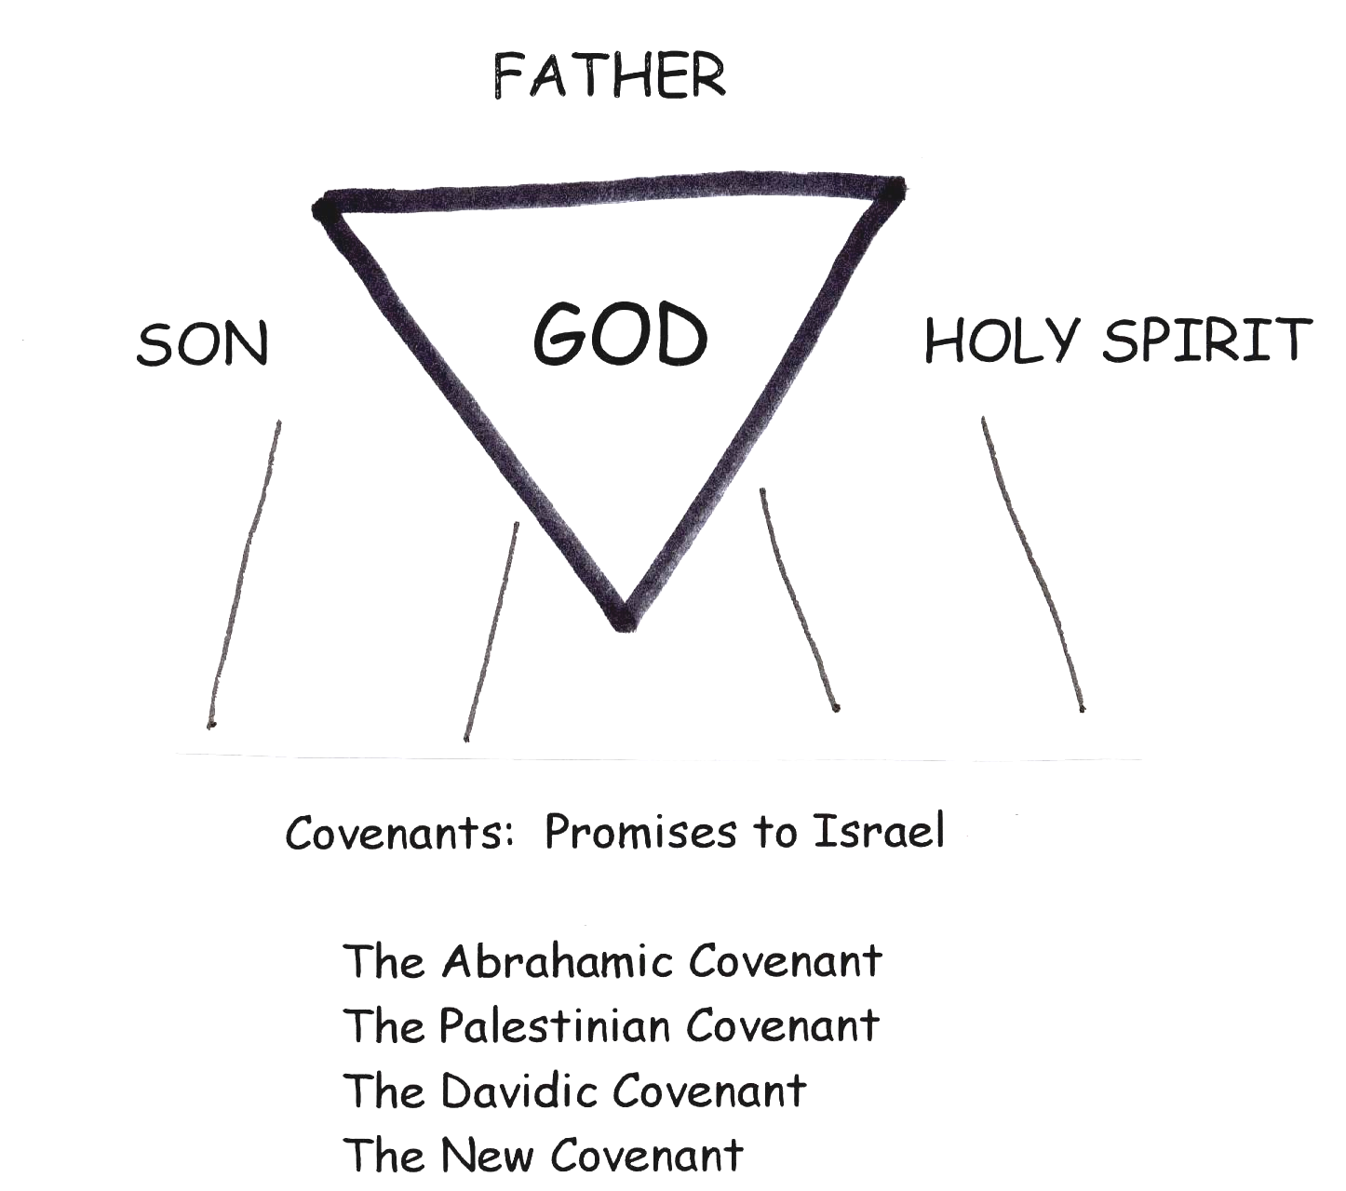

The next dispensation is the Age of Israel. This age goes from the Exodus with Moses to the birth of Jesus Christ. It was a Theocracy. This meant that the authority of the people ruled them spiritually and with governmental authority. During the Age of Israel, God gave the Mosaic Law to Moses. It was given to Israel only. The Mosaic Law was to show people their sinful nature. It taught them to recognize their bad sinful state and to lean on God’s authority and plan, not their own human strength or good. The law was effective only if it drove the sinner to the Messiah who is Christ. It became the way of turning people to God for His mercy and help rather than relying on themselves or trying to please Him. It was not the way of salvation. Salvation was the same as it is now: believe in the Lord Jesus Christ and you will be saved.

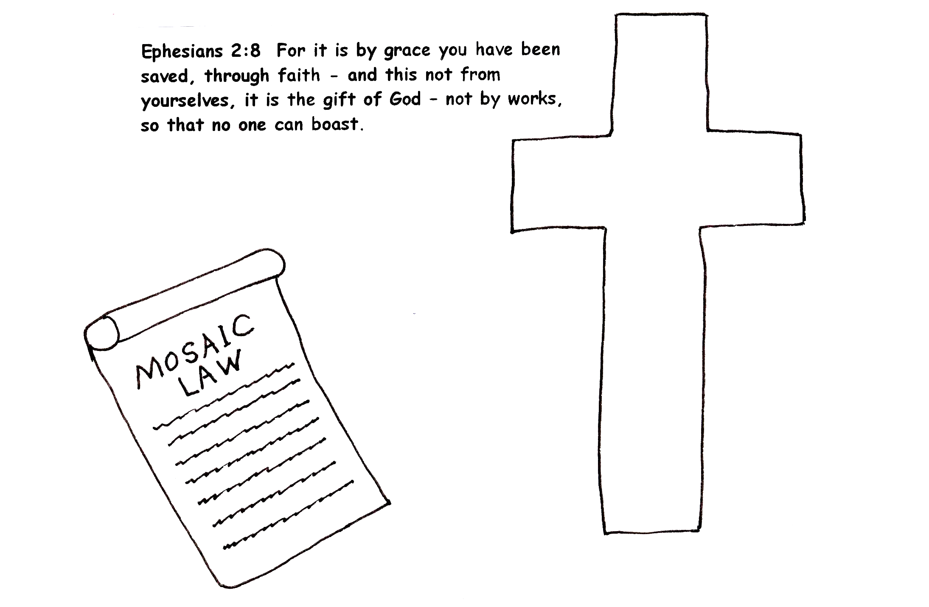

Romans 7:7 “What shall we say then or what shall we conclude; is the law sin? God forbid, on the contrary I had no known sin, but by the law. (The law pointed out the sinful nature, but that was it. It couldn’t be the cause of someone losing his/her salvation).”

The next dispensation is the Hypostatic Union. It was a Christocentric Dispensation, which means that The Lord Jesus Christ was the center of that time. The hypostatic union refers to Jesus Christ and means that He was 100% man and 100% God. It covers the time from Jesus’ birth to His Resurrection, Ascension into heaven, and His Session, being seated at the right hand of God the Father. Sometimes He acted in His humanity, and sometimes He acted in His deity (as God). In His humanity, He provided our so great salvation by receiving the judgment for our sins in His own body on the Cross. As the God/Man He was resurrected from the dead, ascended into heaven, and was seated at the right hand of God the Father. During all of this time, Jesus Christ as God was holding the universe together by the power of His word. Isn’t that amazing? When Jesus was seated by God the Father as the God/Man He was made higher than angels! This really upset Satan! Jesus was victorious!

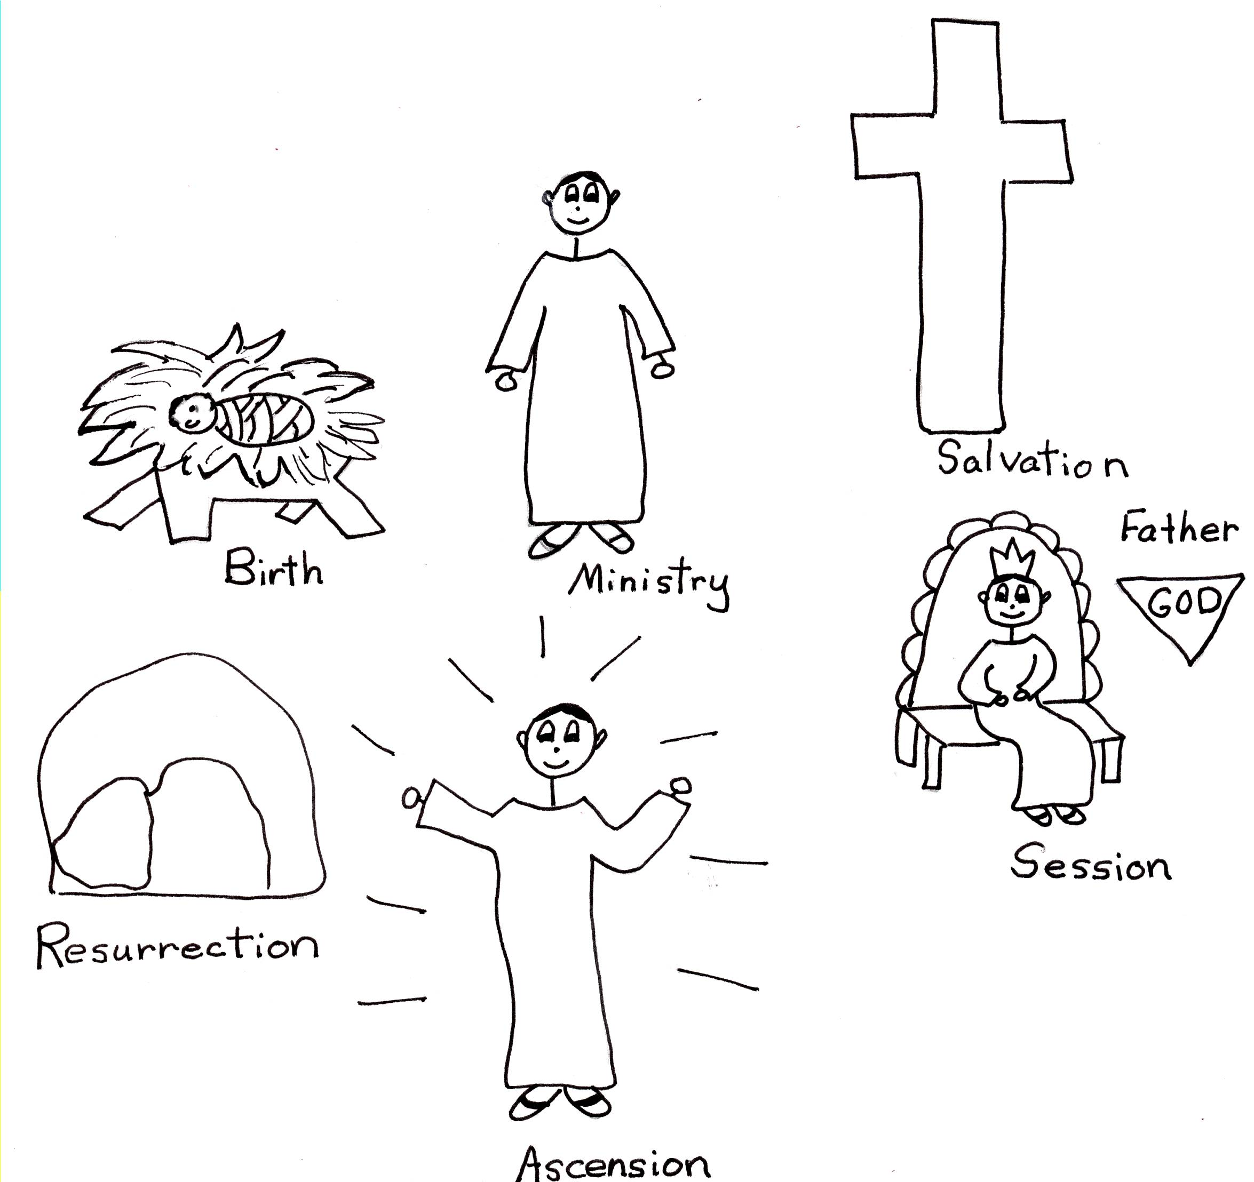

Heb 1:3-4 “The Son is the radiance of God's glory and the exact representation of His being, sustaining all things by His powerful word. After He had provided purification for sins, He sat down at the right hand of the Majesty in heaven. (4) So He became as much superior to the angels as the name He has inherited is superior to theirs.”

Jesus prepared the way for the Church Age, the dispensation in which we live! After Jesus was seated at the right hand of God the Father, He received the title King of kings and Lord of lords. However, He needed a royal family so that He could be its King and Lord. This started the Church Age and the calling out of the Royal family of Jesus! When we become believers, the baptism of the Holy Spirit produces puts us in union with Christ and gives us a new spiritual person inside of us! This never happened before! It is also the first time believers have the indwelling of God the Father, Son, and Holy Spirit. It is the first time that believers can be filled with the Holy Spirit. We never lose the indwelling of the Spirit, but we can lose the filling of the Spirit through sin. However, we know how to regain it again through REBOUND or confession of our sins to God the Father! We are our own priests, so we can rebound and pray directly to God the Father. We have the Bible, the written Word of God. God gave us ten problem solving tools, rebound being one of them. The Church Age has been given great privileges and opportunities! Jesus is our King! Let’s live like royalty, like the royal family of God!

Ephesians 1:22 “And He (God the Father) has subordinated all (angelic creatures) under His feet. Furthermore, He appointed Him (Jesus Christ) ruler over all things to the church (Church Age).

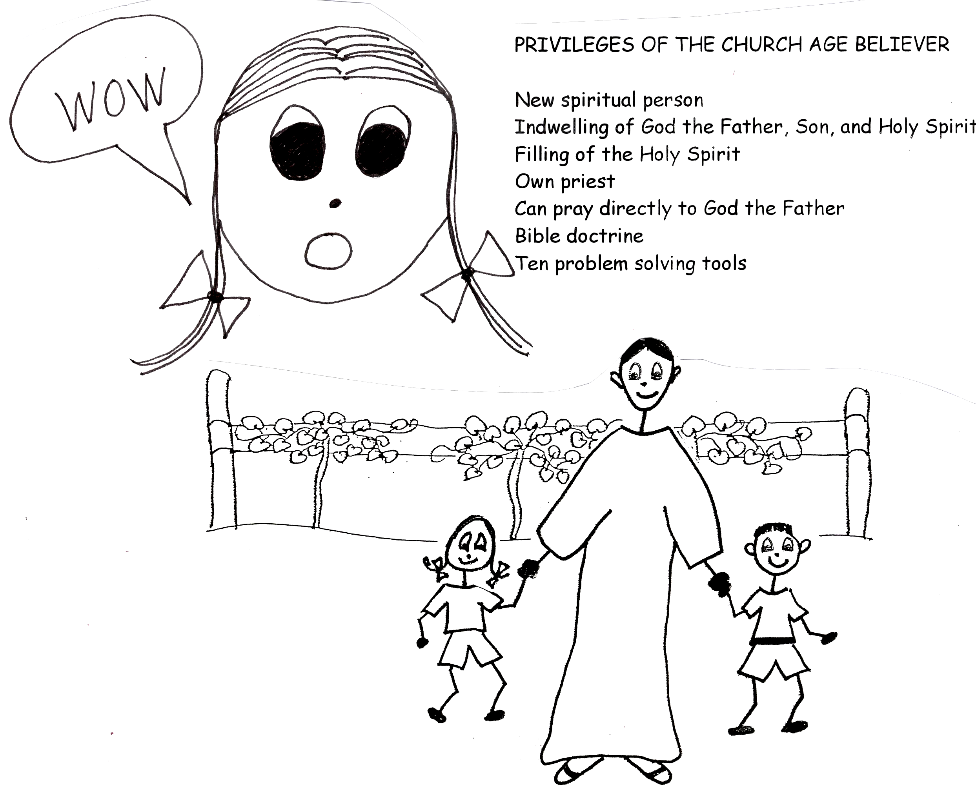
Time is marching forward towards the dispensation of the Age of Tribulation. But before the Tribulation can start, the Rapture must occur first then all believers in the Church Age are taken up very quickly into the clouds to meet The Lord Jesus Christ in the air! Wow, that sounds like fun! Only unbelievers are left on earth and that is the start of the Tribulation. It is the age of the greatest power struggle in all of history. Actually it is part of the second dispensation…remember…the Age of Israel! God owed them 7 years and it involves not only people, but angelic creatures as well! Even though it is really short, 7 years, it is one of the greatest periods of evangelism in all of human history. Millions of people believe in the Lord Jesus Christ in fewer than seven years. However, it is also the WORST time in human history because Satan and his demons are going to torture humans! YIKES! But, since God is sooooo gracious, He gives these unbelievers one more chance to believe in the Lord Jesus Christ and be saved! YEAH!! Of course, because of free will or volition, some will believe and some will not…and THAT is SAD.

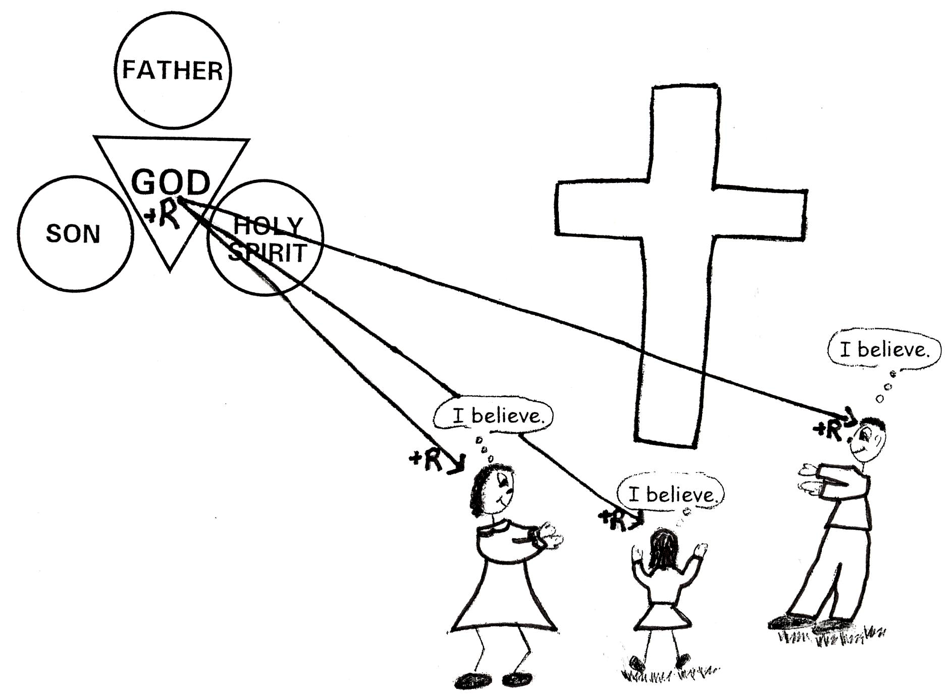

Revelation 3:10 “Since you have kept my command to endure patiently, I will also keep you from the hour of trial (the Tribulation) that is going to come upon the whole world to test those who live on the earth.”

The last dispensation is the Millennium. It begins when The Lord Jesus Christ comes back down to earth at the Second Advent to stop the horrible Tribulation. If Jesus doesn’t come there would be no more people left on earth. Jesus stops the war and destroys all the unbelievers and sends them into the Lake of Fire. Then He will rule earth for 1000 years! When He comes back, Satan and his demons are put into prison for the 1000 years so they can’t deceive anyone for the 1000 years! Yippee! The Lord Jesus Christ, as the King of kings, is going to set up a perfect environment for all the believers who will start be the first to live in the Millennium! However, even in perfect environment, people will STILL sin because they have physical bodies and old sin natures…remember? Also some will not believe in The Lord Jesus Christ as their Savior at that time. Can you believe it? Well, believe it. Even Adam and Eve failed in a perfect environment in the Garden of Eden. And remember Mr. Arrogance himself, Satan? He also failed in a perfect environment. So, it’s not hard to believe that little old humans in the future will also fail. Right after the 1000 years is up, Satan will be released from prison and try one last time to deceive the nations, but God stops him immediately and will have him thrown into the Lake of Fire for ever and ever. Bye, bye, Satan! Then, finally, God will destroy the old heavens…the universe…and the old earth and make a brand new heaven and earth and believers will live with Him in His love for eternity! AMEN!! AMEN!!
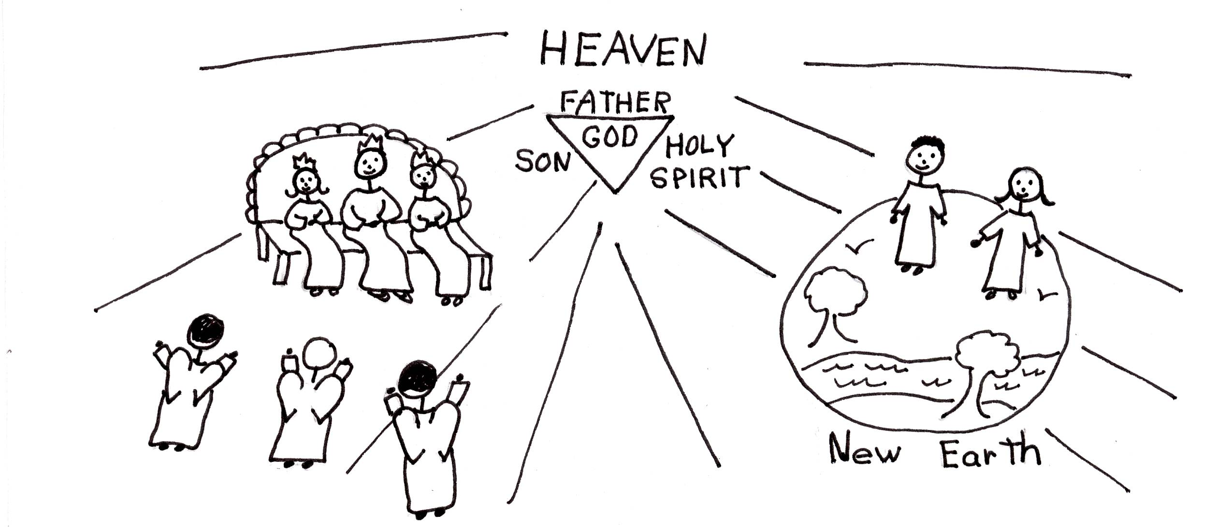

2 Peter 3:13 “But in keeping with His promise we are looking forward to a new heaven and a new earth, the home of righteousness.”

Robert McLaughlin Bible Ministries
www.gbible.org

&
Lighthouse Christian Youth Ministries
www.lighthousechristianyouth.org

2 Pet 1:2 “Grace and peace be yours in abundance through knowledge of God and of Jesus our Lord.”

