Ten Problem-Solving Devices
Lighthouse Christian Youth Ministry
Lesson 54a
PSD # 2 in the Line of Battle
The Filling of the Holy Spirit

August 18, 2006

The Filling of the Holy Spirit is the second problem solving device (PSD) of the 10 God gave us and part of the mystery doctrine of the Church Age. This is the first time in history when all believers are commanded by God to be filled with the Spirit. In other periods of history God did not give believers this gift…only special prophets.

When we are filled with the Holy Spirit, the Spirit is controlling our souls. Just as we had no ability to save ourselves, we have no ability to live in God’s plan in our own energy. We have to be filled with the Holy Spirit and use His POWER before anything we do for God is counted as gold, silver, and precious stones…divine good.

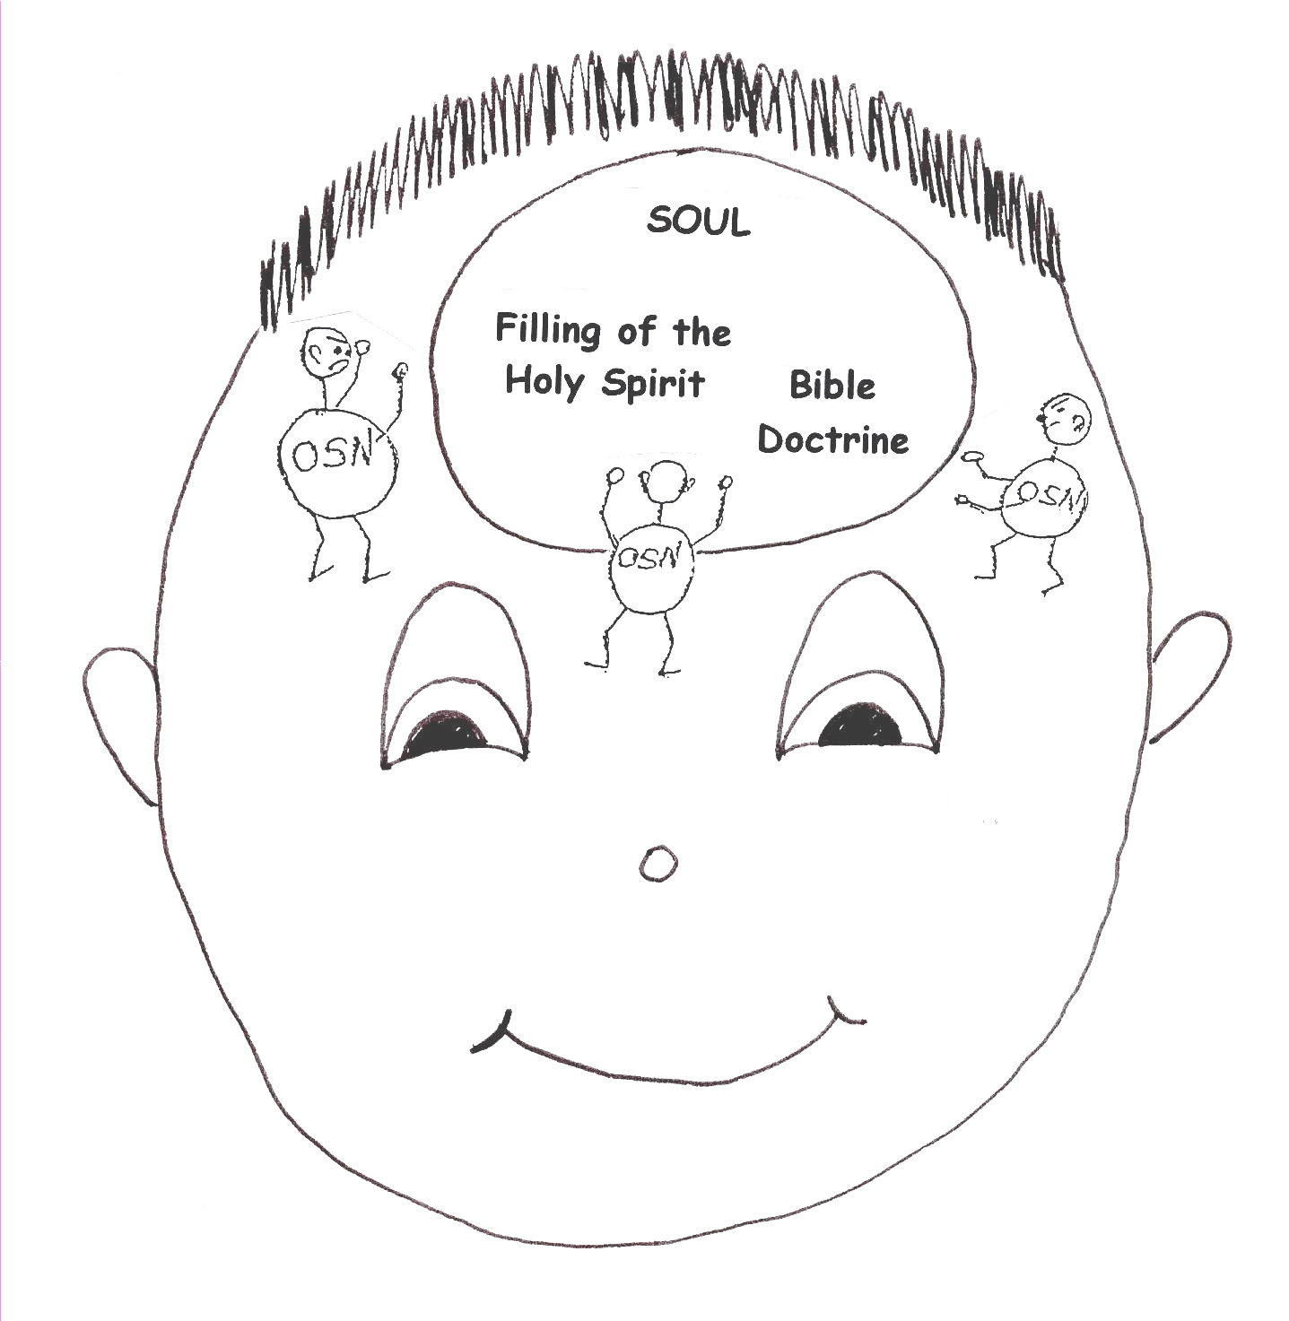

Rom 6:12 “Therefore do not let sin rule in your mortal body so that you obey its evil desires.” Eph 5:18 “Do not get drunk on wine, which leads to bad behavior. Instead, be filled with the Spirit.” In other words…let the filling of the Holy Spirit control your soul.
Holy Spirit is the real secret in understanding Bible doctrine. Without His power, no one can understand the Word of God. It doesn’t matter if we have a high I.Q. or a low I.Q. because we have God’s spiritual I. Q. God, in His grace, made it this way so that everyone would have the same spiritual I. Q. and chance to know Him. It doesn’t depend on who and what we are; it depends on who and what God is!
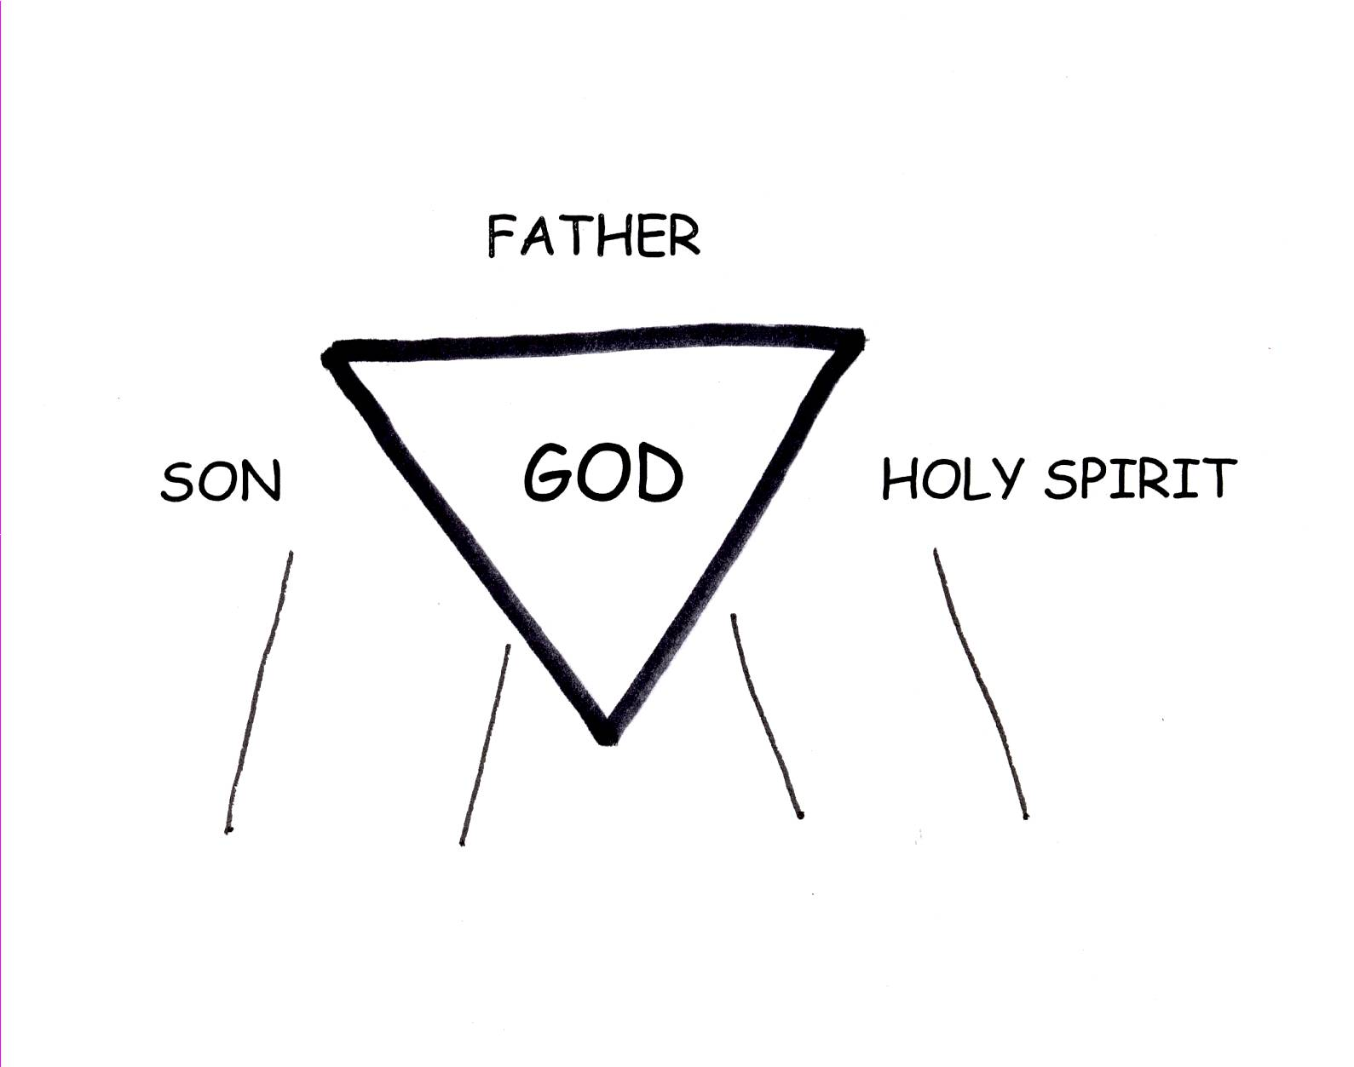

Job 32:8 “But it is the Spirit in a man, the breath of the Almighty, that gives him understanding.”

John 14:26 “But the Counselor, the Holy Spirit, whom the Father will send in my name, will teach you all things and will remind you of everything I have said to you.”

The Holy Spirit helps us in the spiritual battle, too. The body is the headquarters of the old sin nature. So, the Holy Spirit sets up His headquarters in the body to act against the old sin nature. They are enemies. The battlefield is the soul. By the filling of the Holy Spirit, God controls our souls, preparing us for moving forward in the middle of enemy fire from the old sin nature! The battle is constant! We always have the weapons we need to fight this constant war and the greatest weapon of all is the second PSD…the filling of the Holy Spirit! This battle is never over until we die and become absent from the body and face to face with the Lord!
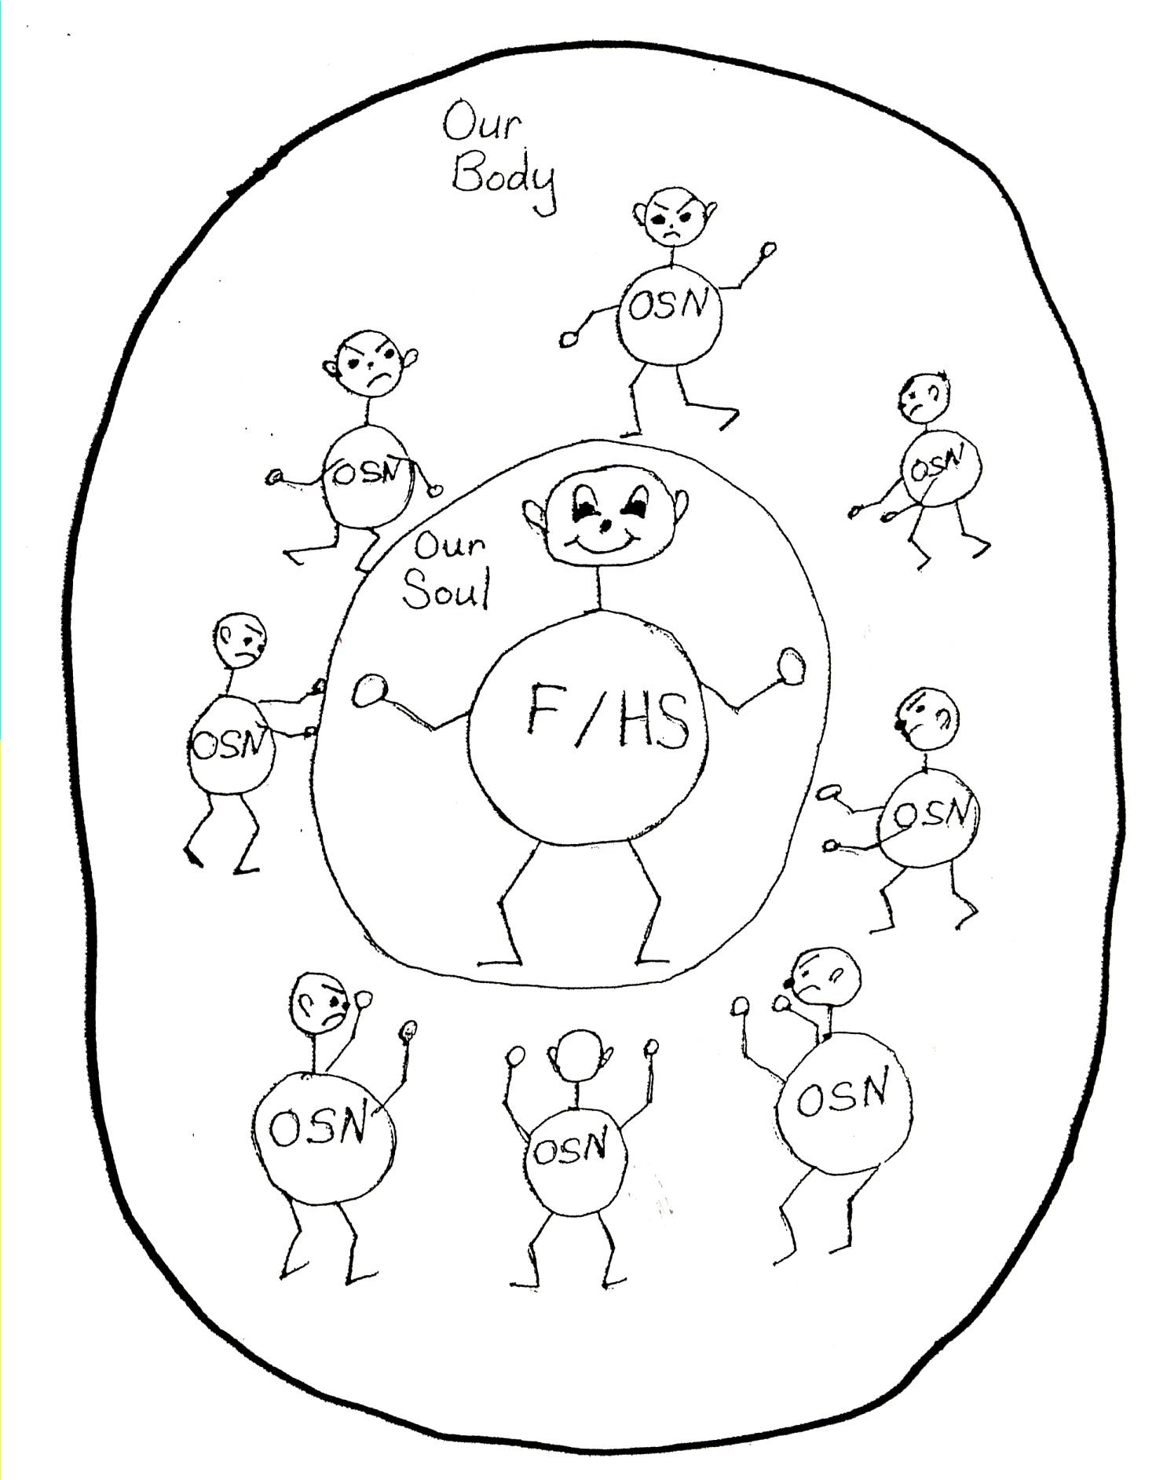

Galatians 5:16-17 “But I say, walk by the Spirit, and you will not carry out the desire of the flesh (old sin nature). For the flesh sets its desire against the Spirit, and the Spirit against the flesh; for these are in opposition to one another, so that you may not do the things that you please.”

In no way could we ever fight this battle alone; in no way could we ever fulfill God’s plan without His supernatural power. This is a war and Satan started it. The filling of the Holy Spirit is absolutely necessary if the Christian is to have any success at all in the spiritual life and become invisible heroes and receive the wonderful blessings God has for us NOW and in HEAVEN. The Christian faces superhuman demands, so he needs superhuman power made available by God the Holy Spirit.
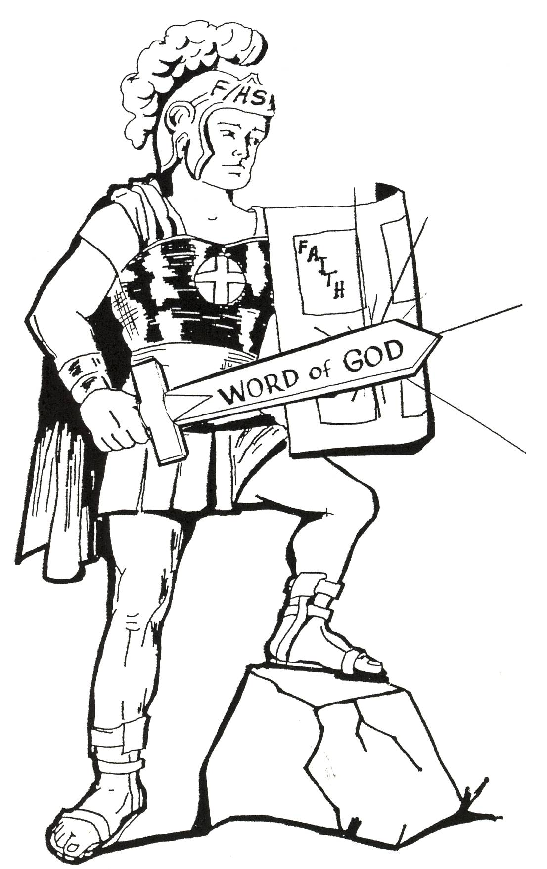

Ephesians 3:16 “That He would grant you, according to the riches of His glory, to be strengthened with power through His Spirit in the inner man.”

We lose the filling of the Holy Spirit when we sin. No problem! God solved the problem. Remember, the Lord Jesus Christ has already been judged on the cross for our sins. All we have to do is rebound (remember that is the first PSD) and we will be filled with the Holy Spirit once again. Now we need to keep moving in God’s plan, and prepare to receive God’s best!
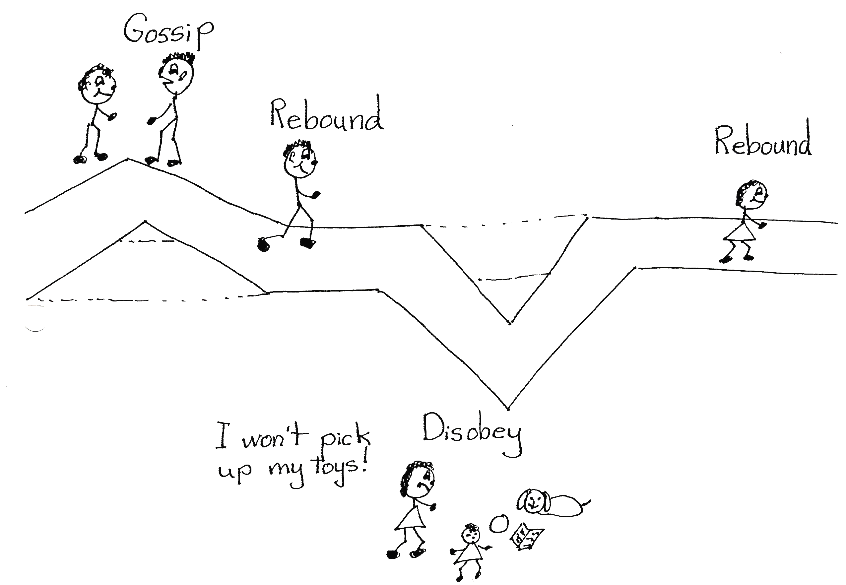

1 John 1:9 “If we confess our sins, He is faithful and just and will forgive us our sins and purify us from all unrighteousness.”
Receiving the best that God has for us depends upon how we allow the Holy Spirit to operate (work) in our lives. Every Christian has equal privilege and equal opportunity to succeed. Remember, though, that God has also given us free will; we all have the freedom to accept or reject His way of doing things. God wants us all to succeed. However, because of free will, some of us will and some of us won’t; some will be winners and some will be losers. It all depends on being filled with the Holy Spirit.
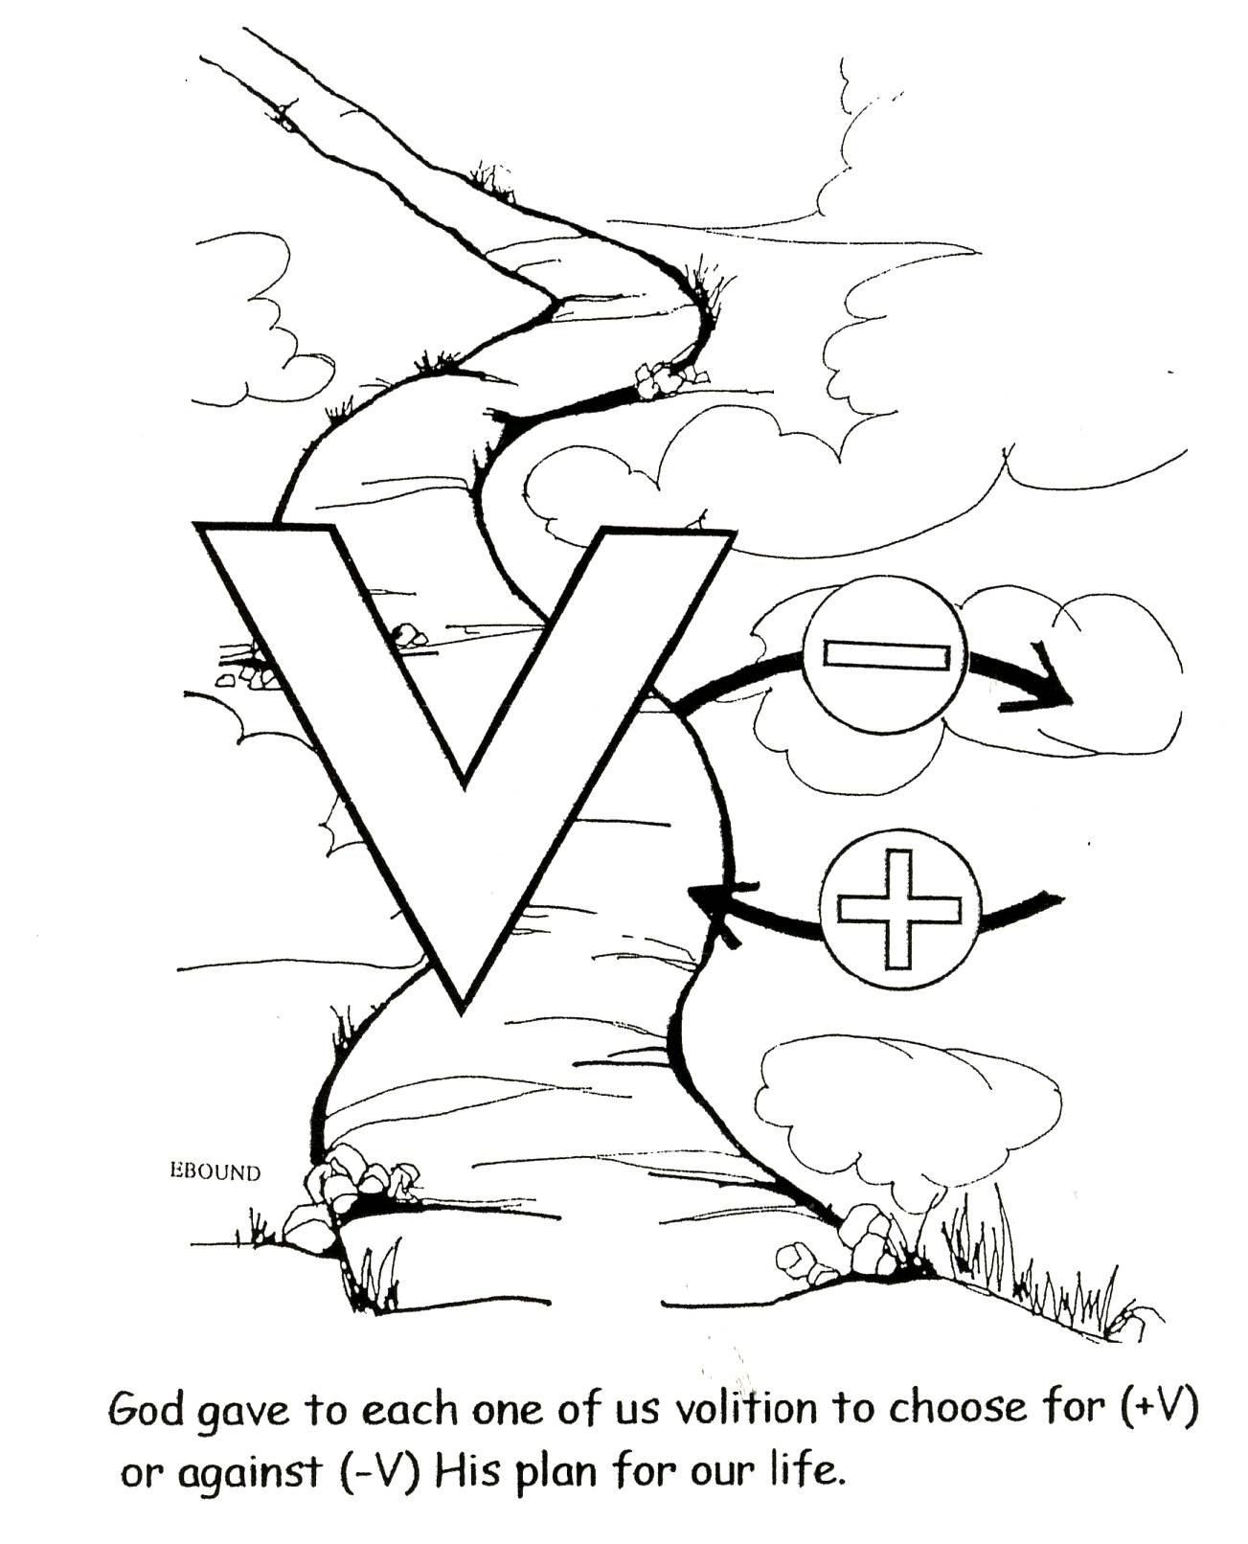

1 John 2:6 “The one who says he lives in Him ought himself to walk in the same manner as He (Jesus) walked.”

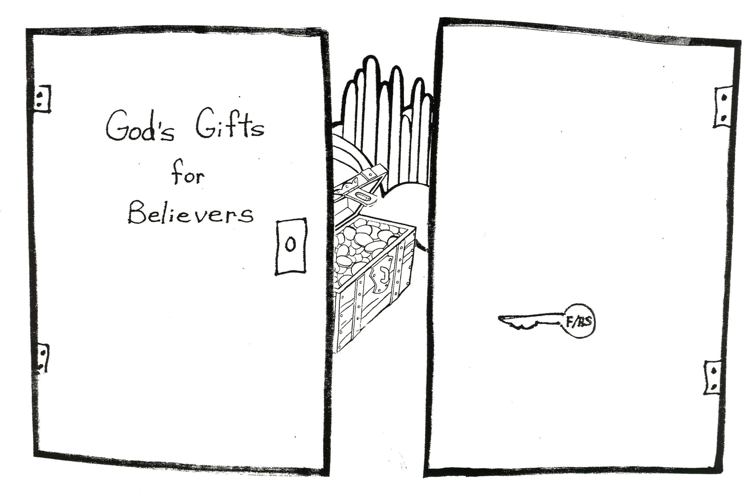
So, each believer must ask the question, “Which way am I going to walk in my daily life? Am I going to depend on my own ability and the old sin nature which will surely take over or on the power of the filling of the Holy Spirit?” The Church Age believer must live his life filled by the Holy Spirit, in tune to the will of the Father, apart from human strength, and living as he was saved, by grace through faith. The filling of the Holy Spirit is the key that unlocks the doors to the best that God has already provided for His children!

Colossians 2:6 “As you therefore have received Christ Jesus the Lord, so walk in Him.”

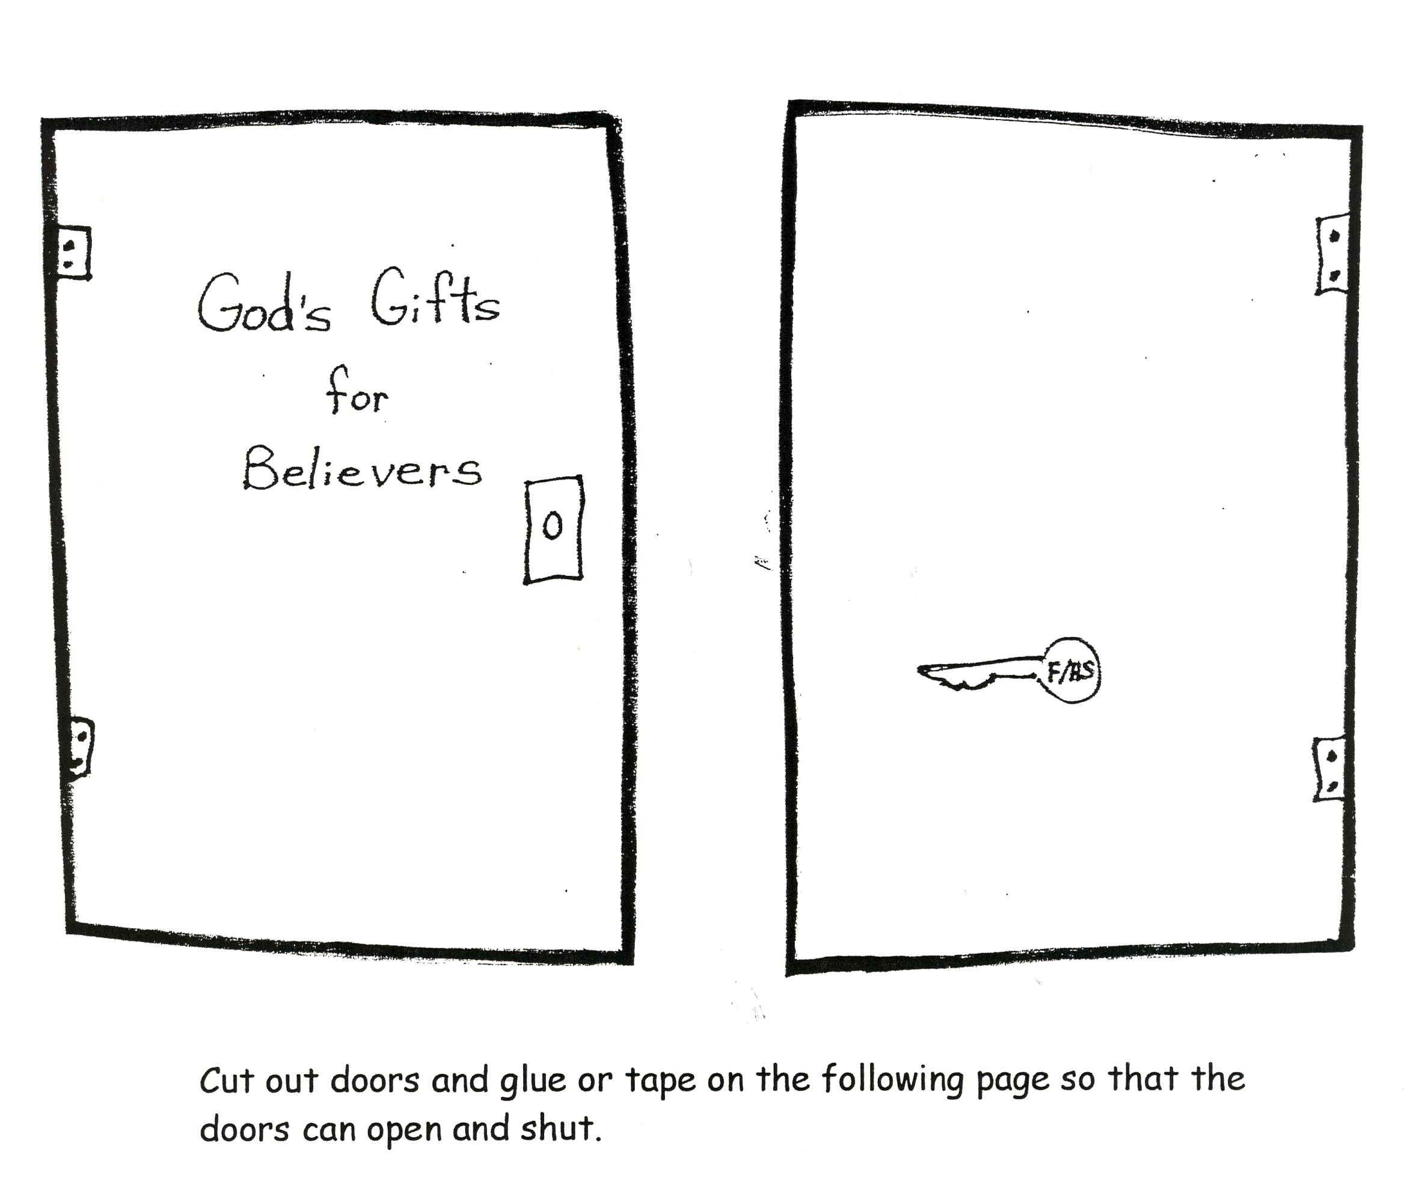

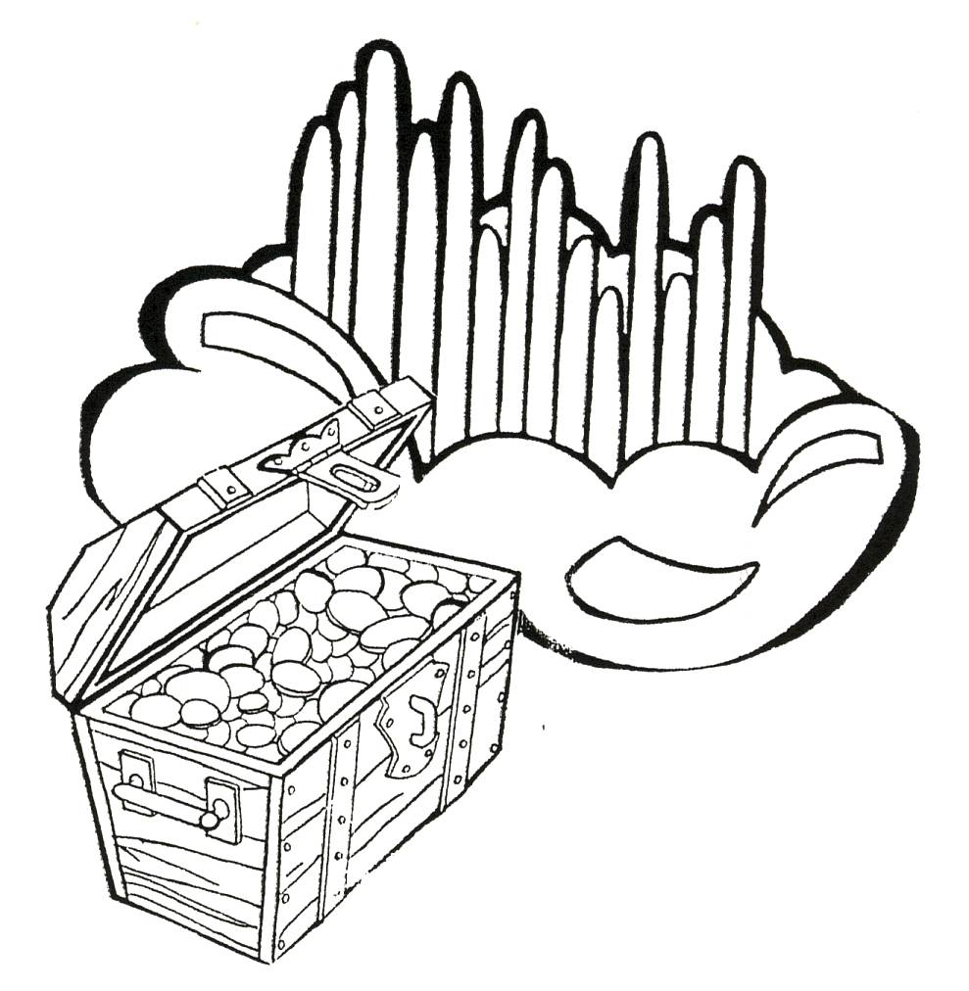

Points to Remember

- The filling of the Spirit is the second problem solving device (PSD).

- The soul is the battleground between the old sin nature and the filling of the Holy Spirit.

- We have superhuman demands placed on us, so we need the superhuman power of the Holy Spirit.

- We have free will, so it is our choice to have the old sin nature or the filling of the Holy Spirit control our souls.

- The filling of the Holy Spirit is the key that unlocks God’s best for us.

The Jr. Tree of Life, Spiritual Metabolism – Part 3,
October 10, 2004

Robert McLaughlin Bible Ministries
www.gbible.org

&

Lighthouse Christian Youth Ministries
www.lighthousechristianyouth.org

