Lighthouse Christian Youth Ministry Lesson 54b
God Gave Us Ten Problem-Solving Devices

PSD # 3 in the Line of Battle is
The Faith-Rest Drill

September 8, 2006

Psalm 27:5 “For in the day of trouble He will keep me safe in His dwelling; He will hide me in the shelter of His tabernacle (promises) and set me high upon a rock.”
The Faith-Rest Drill is the third problem solving device of the 10 PSDs and it’s a tool God gave to us to help us use His promises. We need His promises because everyday, and sometimes every minute, we have things happen to us that can upset us or trouble us. God does not want us to live with unhappiness or upset, but in FAITH-REST. So, He gave us many, many, many promises in the Bible, both in the Old and New Testaments to calm us in times of trouble and sadness. When we see ourselves getting worried, fearful, guilty, or anxious…the list could go on and on…we can use one of God’s promises to start to calm us down and help us think like God. Maybe we’ll need to use more than one! Through the power of the Holy Spirit, the promise will help our minds rest!
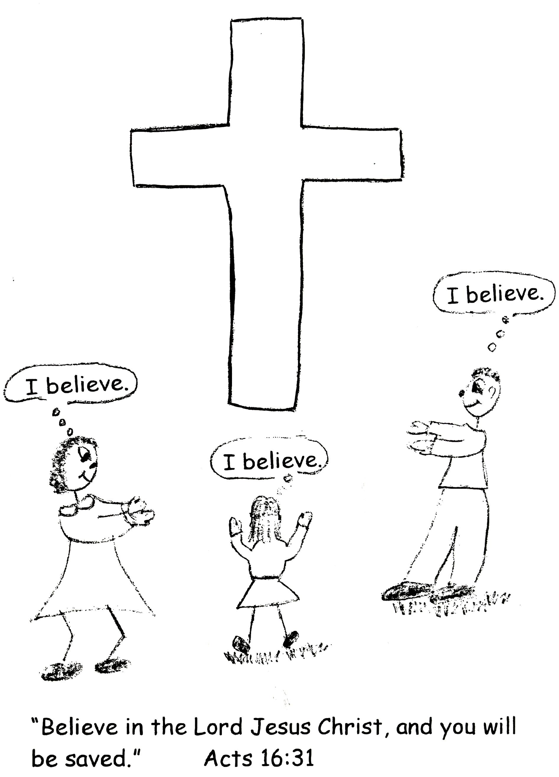

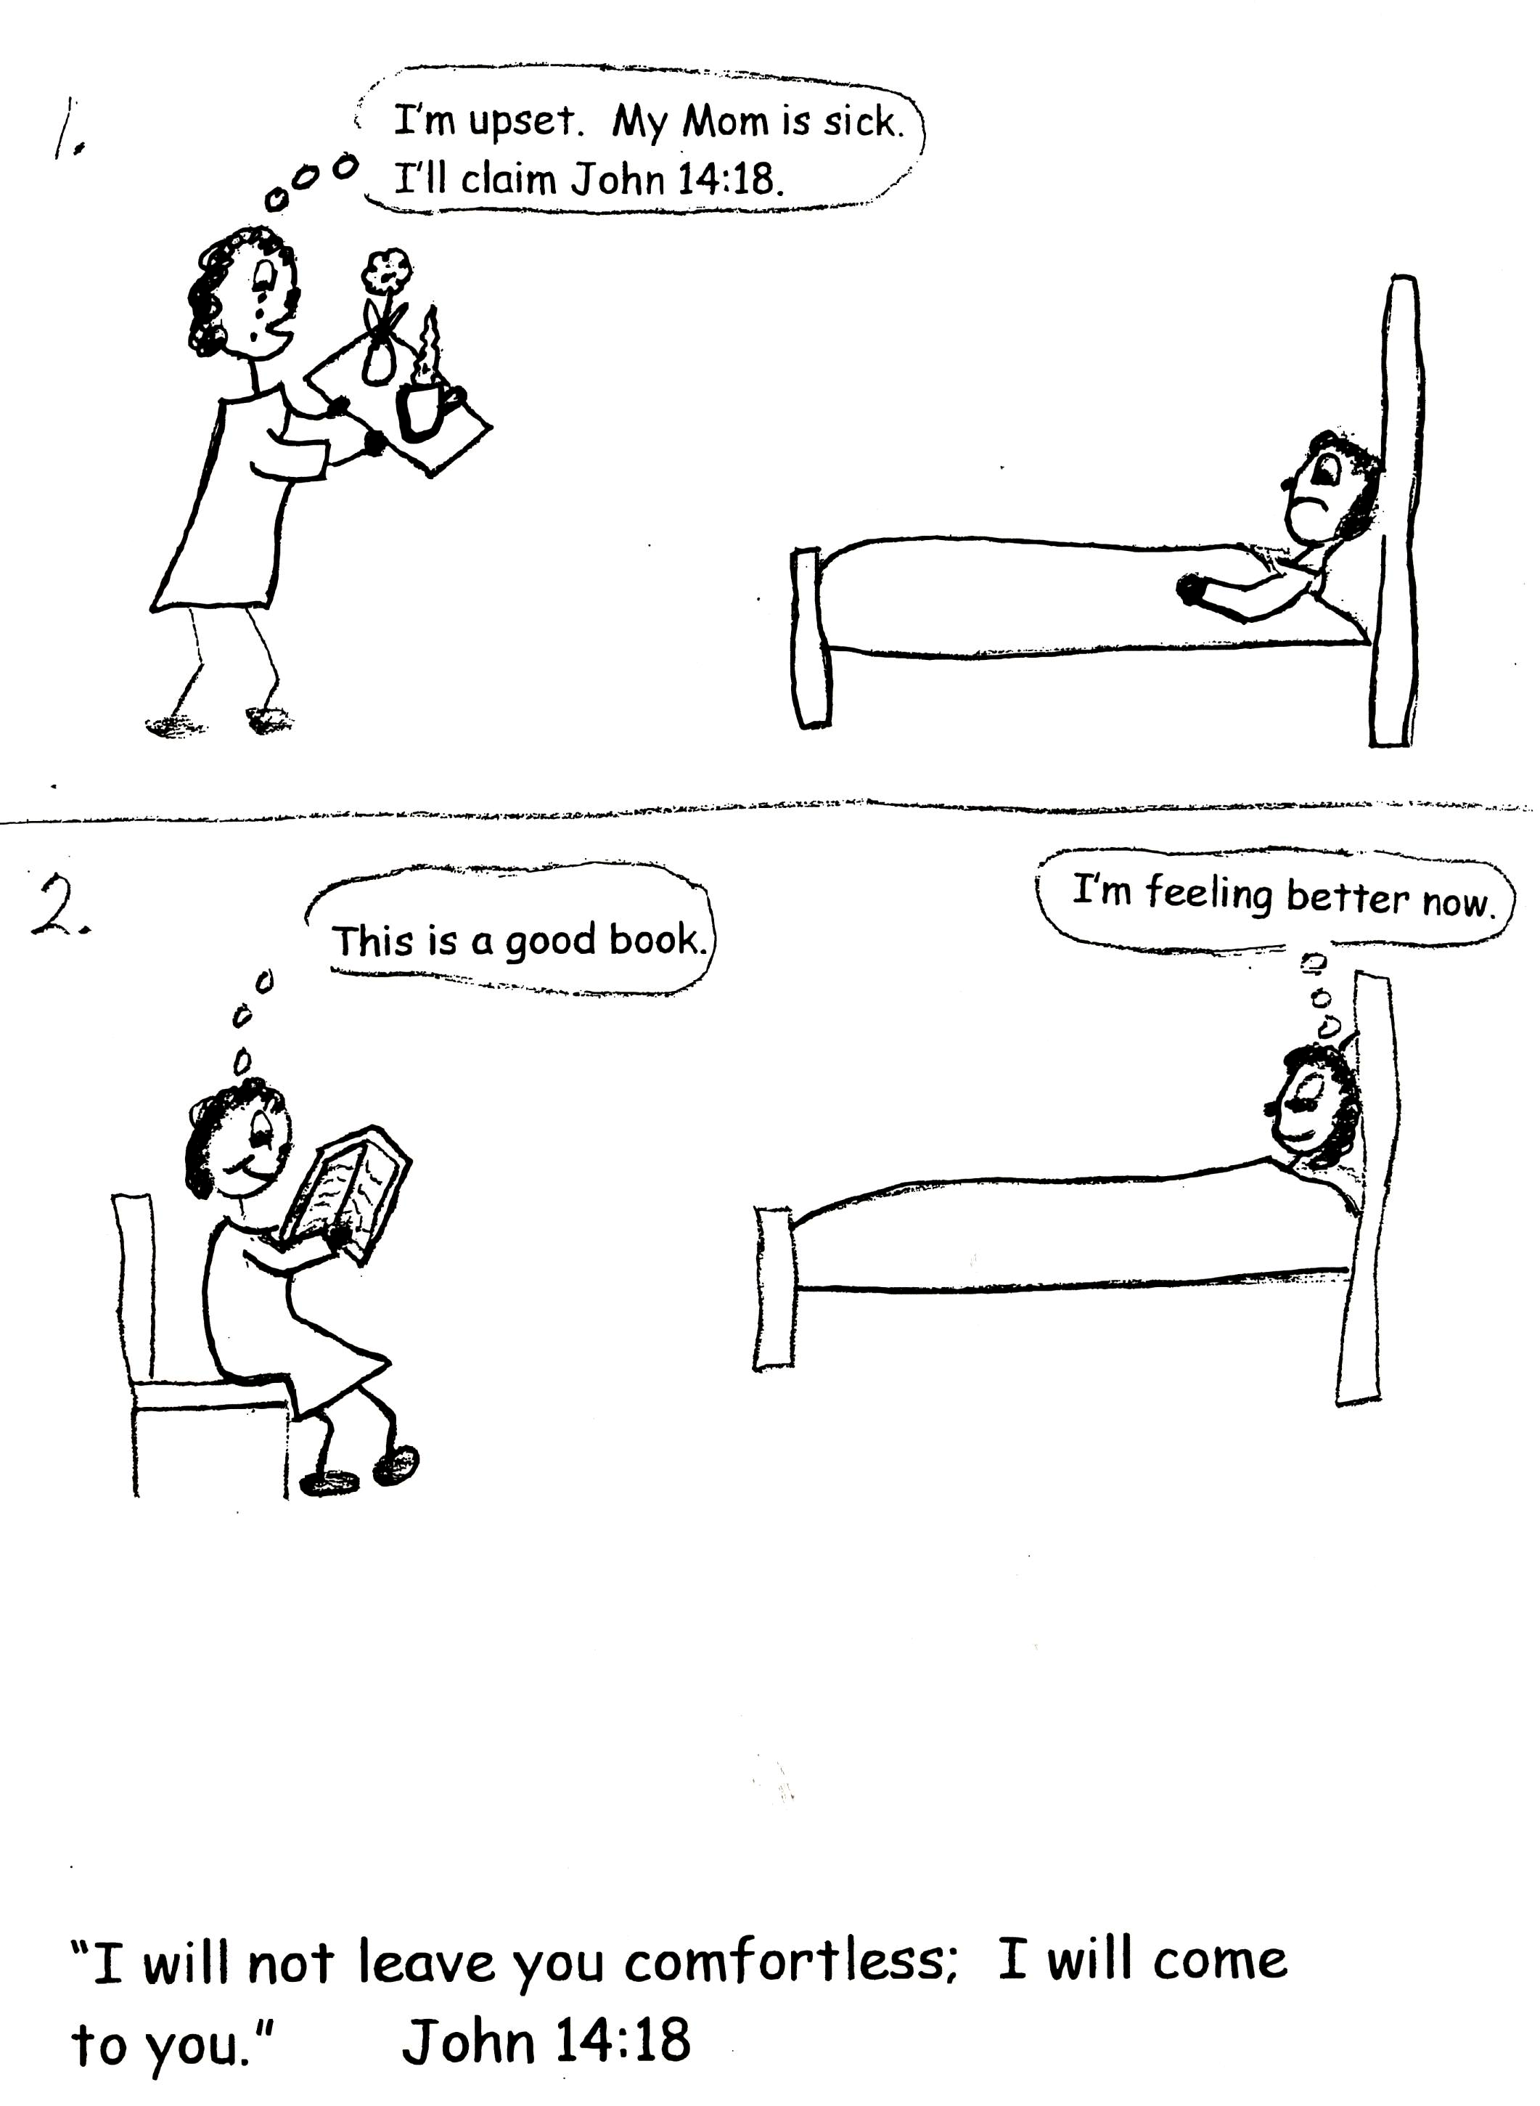

Jesus said in John 16:33 “I have told you these things, so that in me you may have peace. In this world you will have trouble. But be happy! I have overcome the world."

Let’s look at the word FAITH in the PSD…the Faith-Rest Drill. Here faith means that we can believe what God promises us. One of God’s attributes is Veracity, which means TRUTH. He is ALWAYS truthful. We can believe Him and His Word. God never lies to us. So when He gives us promises in the Bible, we can trust that He will do what He promises! WE CAN HAVE FAITH (BELIEVE) IN GOD AND HIS PROMISES! After we rebound (that’s PSD 1) worry or upset about a problem, we then need to claim a promises of God the moment we are hit with trouble or when a bad situation comes our way. We remember that God is there immediately and we need to use His first rebound then a promise to calm us down.

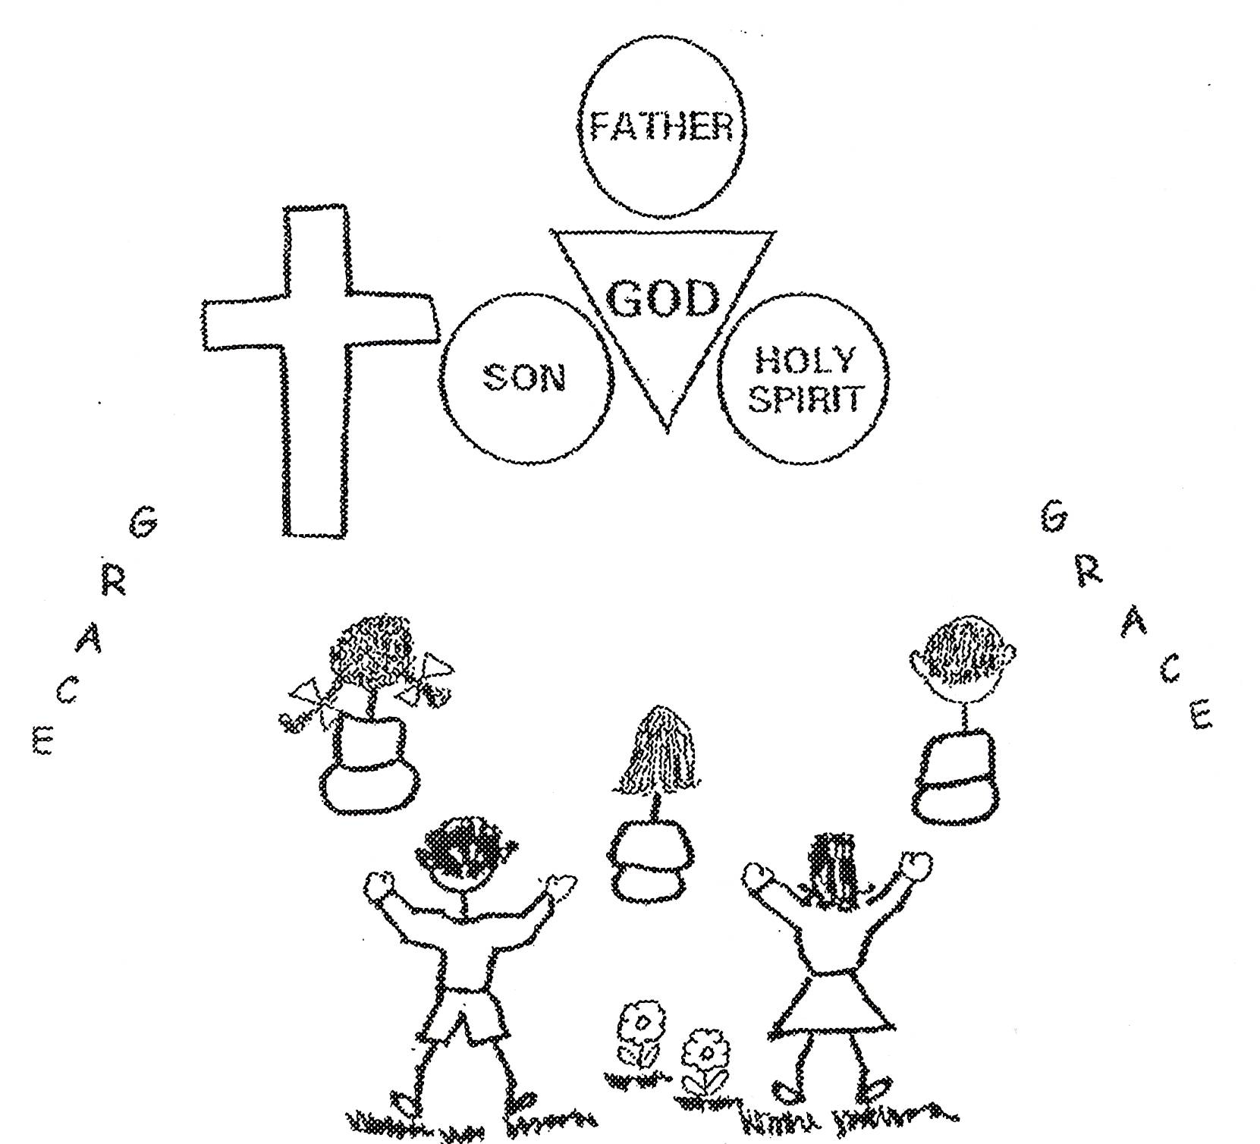
Rom 8:31b “If God is for us, who can be against us?”

Besides having Veracity or Truth, God has nine other characteristics in His divine nature or essence. There are 10 altogether. These characteristics are the reasons why we can believe what He promises. The second one is His Sovereignty: This means that God has supreme authority and is the Ruler over all His creation. He wants the best for all His creatures! He is JUST and FAIR as He rules us. The third one is Righteousness: God is absolute good. He is perfect! God CANNOT sin. The fourth one is Justice: This means it is impossible for God to be unfair or make a wrong decision about anything. The fifth one is Love: God IS love and He has an attitude of great self-esteem and regard toward Himself because He is perfect. In other words He loves Himself and His creatures. He has concern, mercy, and kindness toward His creatures. The sixth is that God is Eternal: This means there never was a time when God did not live. There will never be a time when He stops living. Nothing caused God to come into existence. He has no beginning and no end. The seventh one is Omnipresence: The means God is “everywhere” and He is present in all things. He is an eyewitness to every activity of our lives. He is available to help us immediately! Now that is reassuring isn’t it? The eighth is Omniscience: This means God has complete knowledge of all things or He is all-knowing. The ninth is Omnipotence: This means God is all-powerful or Almighty. He can do anything in His power. The tenth is Immutability: This means that God cannot change and of course He doesn’t need to change since everything about Him is perfect.

When we think about HIS characteristics or HIS essence, we are using the “essence of God” rationale* to solve our problem. *Rationale means reasons for something. The rationales are the conclusions we come to for a solution to our problems and this particular rationale is part of the essence of God rationale.

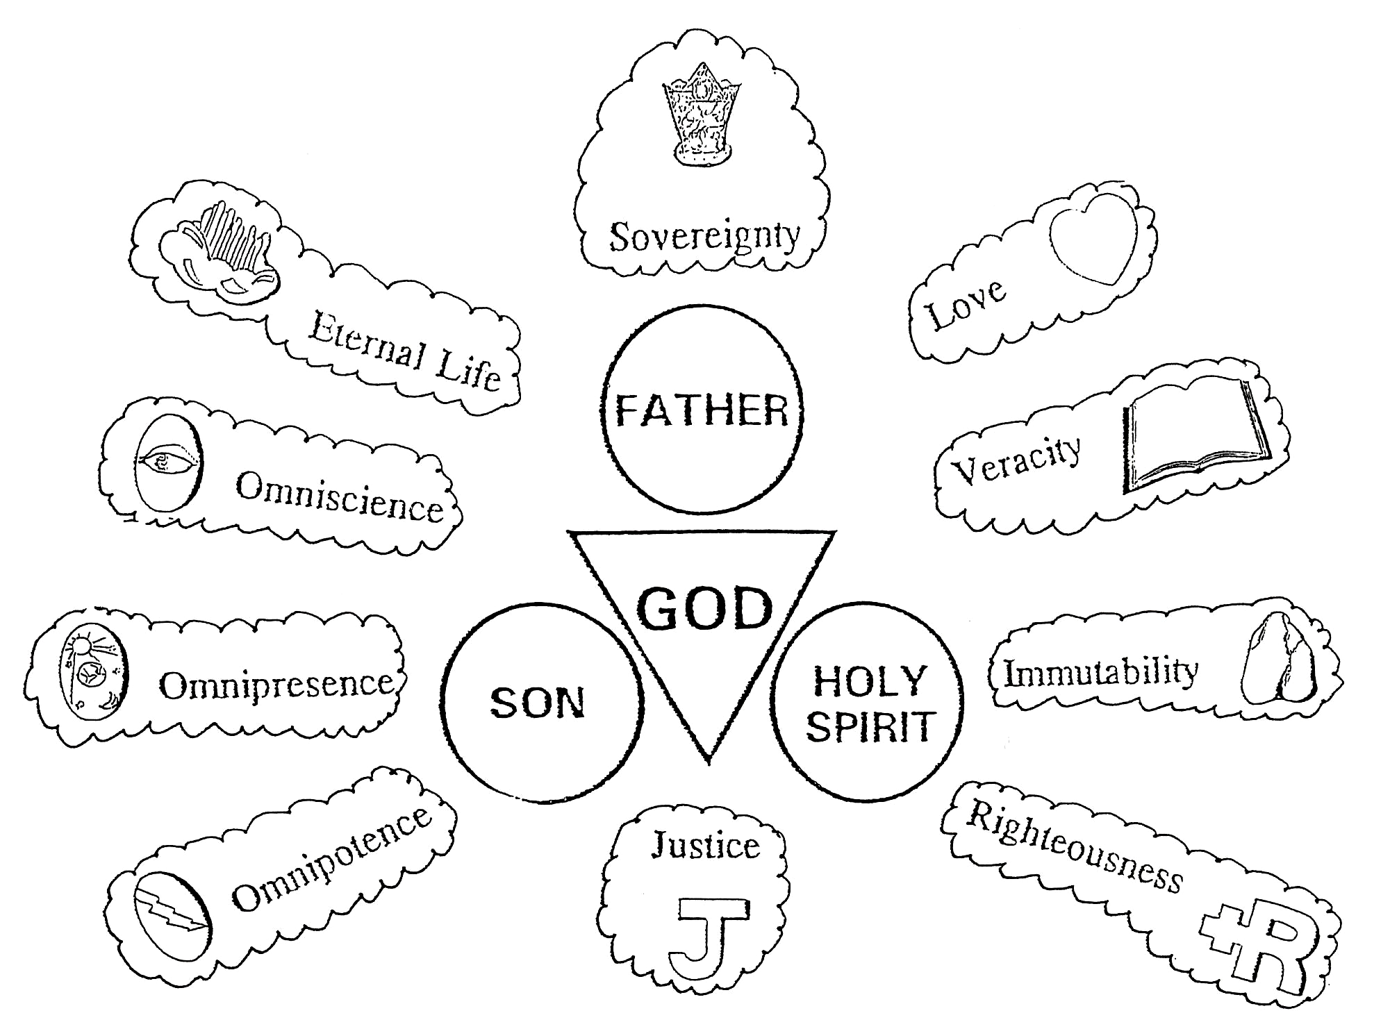

Psalm 47:2 “How awesome is the Lord Most High, the great King over all the earth!”

There are other rationales that we can use besides the “essence of God” rationale to help us in any problem situation. We use these rationales after we have rebounded or confessed our sins and claimed a promise to calm us down in a bad situation.

Here’s another rationale we can use. It’s the “logistical grace” rationale. This means that God has promised to give us everything we need to grow up physically and spiritually in His grace and plan. And He gave us everything we need to get to know Him. We have to have food, shelter, clothing, and recreation for our physical needs. We also have to have a pastor-teacher, a Bible teacher, a Bible, and a place to learn God’s Word. Anything we need for living and learning about God, God will give us! We need to think about this rationale when we are worried about our problems with friends, family, or situations like our parents trying to pay the bills, or trying to buy a house, or if they need a new job…whatever the concern. The Lord has it all under control! He will give us grace gifts and HE will SOLVE our problems of needs! Remember if God allowed the problem or need into your life, HE HAS the SOLUTION already!!!

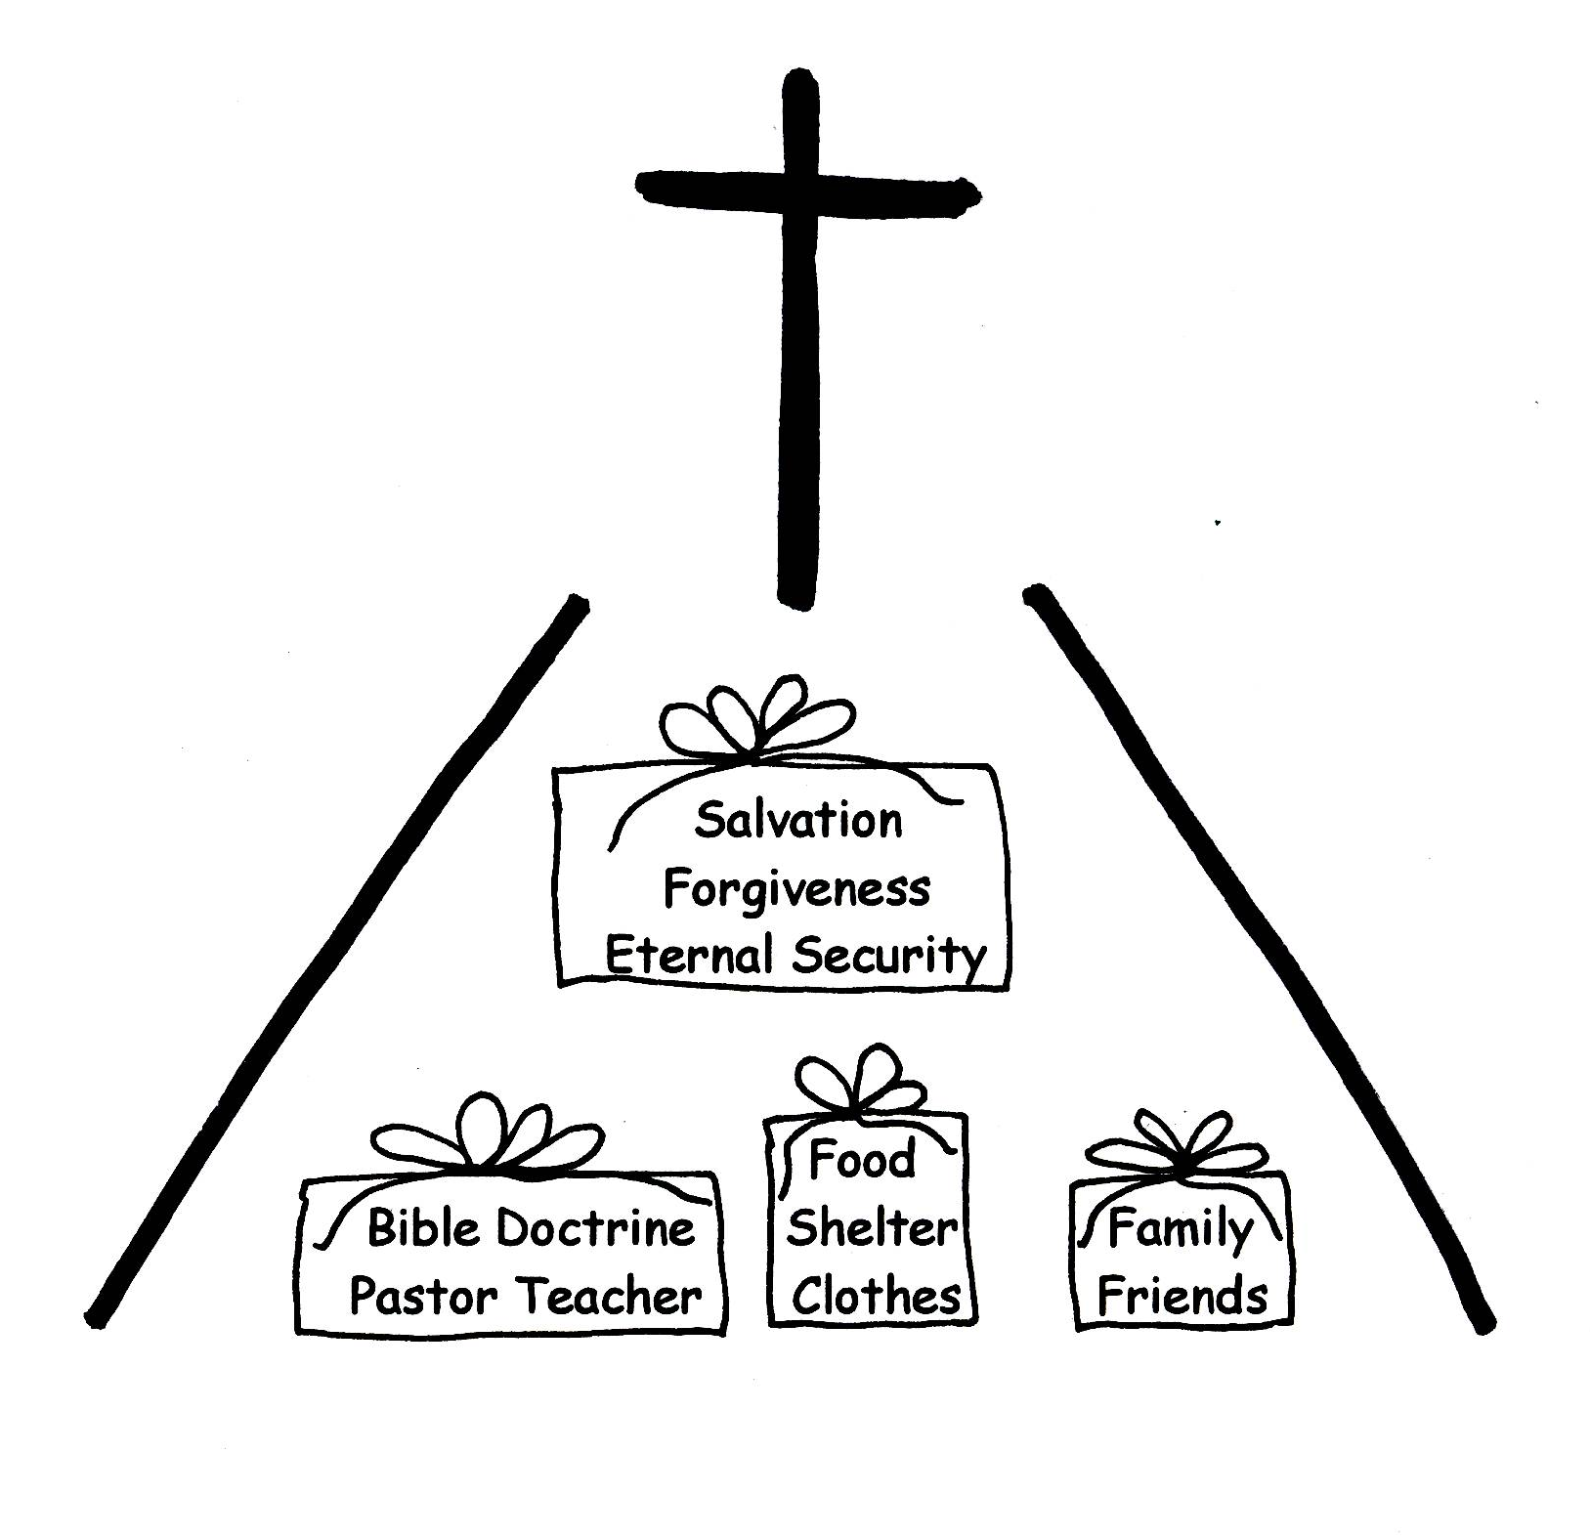
Philippians 4:19 “But my God shall supply all your needs according to His riches in glory by Christ Jesus.”

We have another rationale that we can also use, too called the “plan of God” rationale. We know that God has a special plan for each one of us. We are to use the Word of God, divine viewpoint (that’s God’s thinking), to follow the plan. As long as we are on this earth, He has a purpose and a plan for our lives. In order to accomplish that purpose, God will give us what we need. It may not be what we think we need. However, God knows best. Remember, He is omniscient!
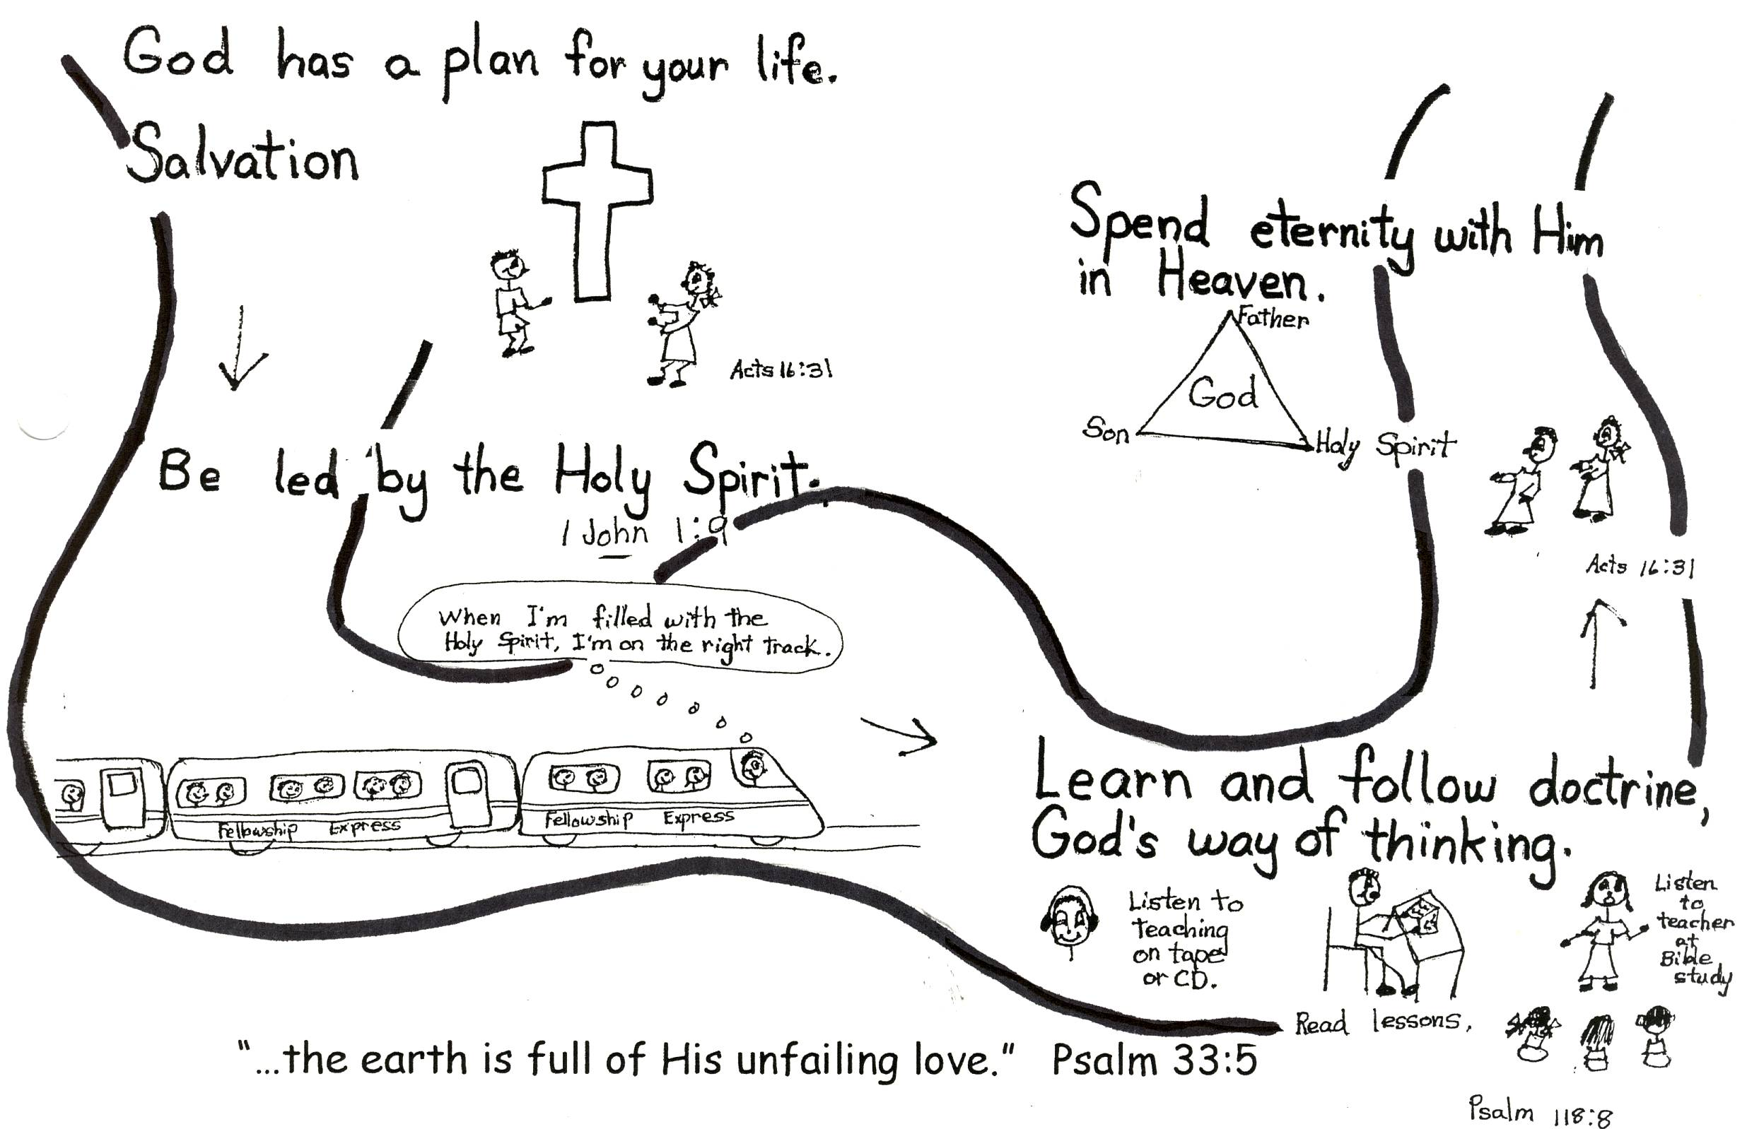

Psalm 37:7 “Rest in the Lord and wait patiently for Him.”
So now that you understand how GOD handles our problems you and I can have FAITH in God and use His promises. We don’t have to worry or fear ANYTHING! We can come to the conclusion that God is for us so who could be against us? God is in control of our troubling situations! He wants His best for us. We can REST, or relax. We can FAITH-REST! We need to keep practicing this kind of rest. The more we do it, the easier it will become, and the more we will faith-rest! We will be using the faith-rest drill every time we have a problem or a bad situation or even what we might think is a hopeless situation!!!

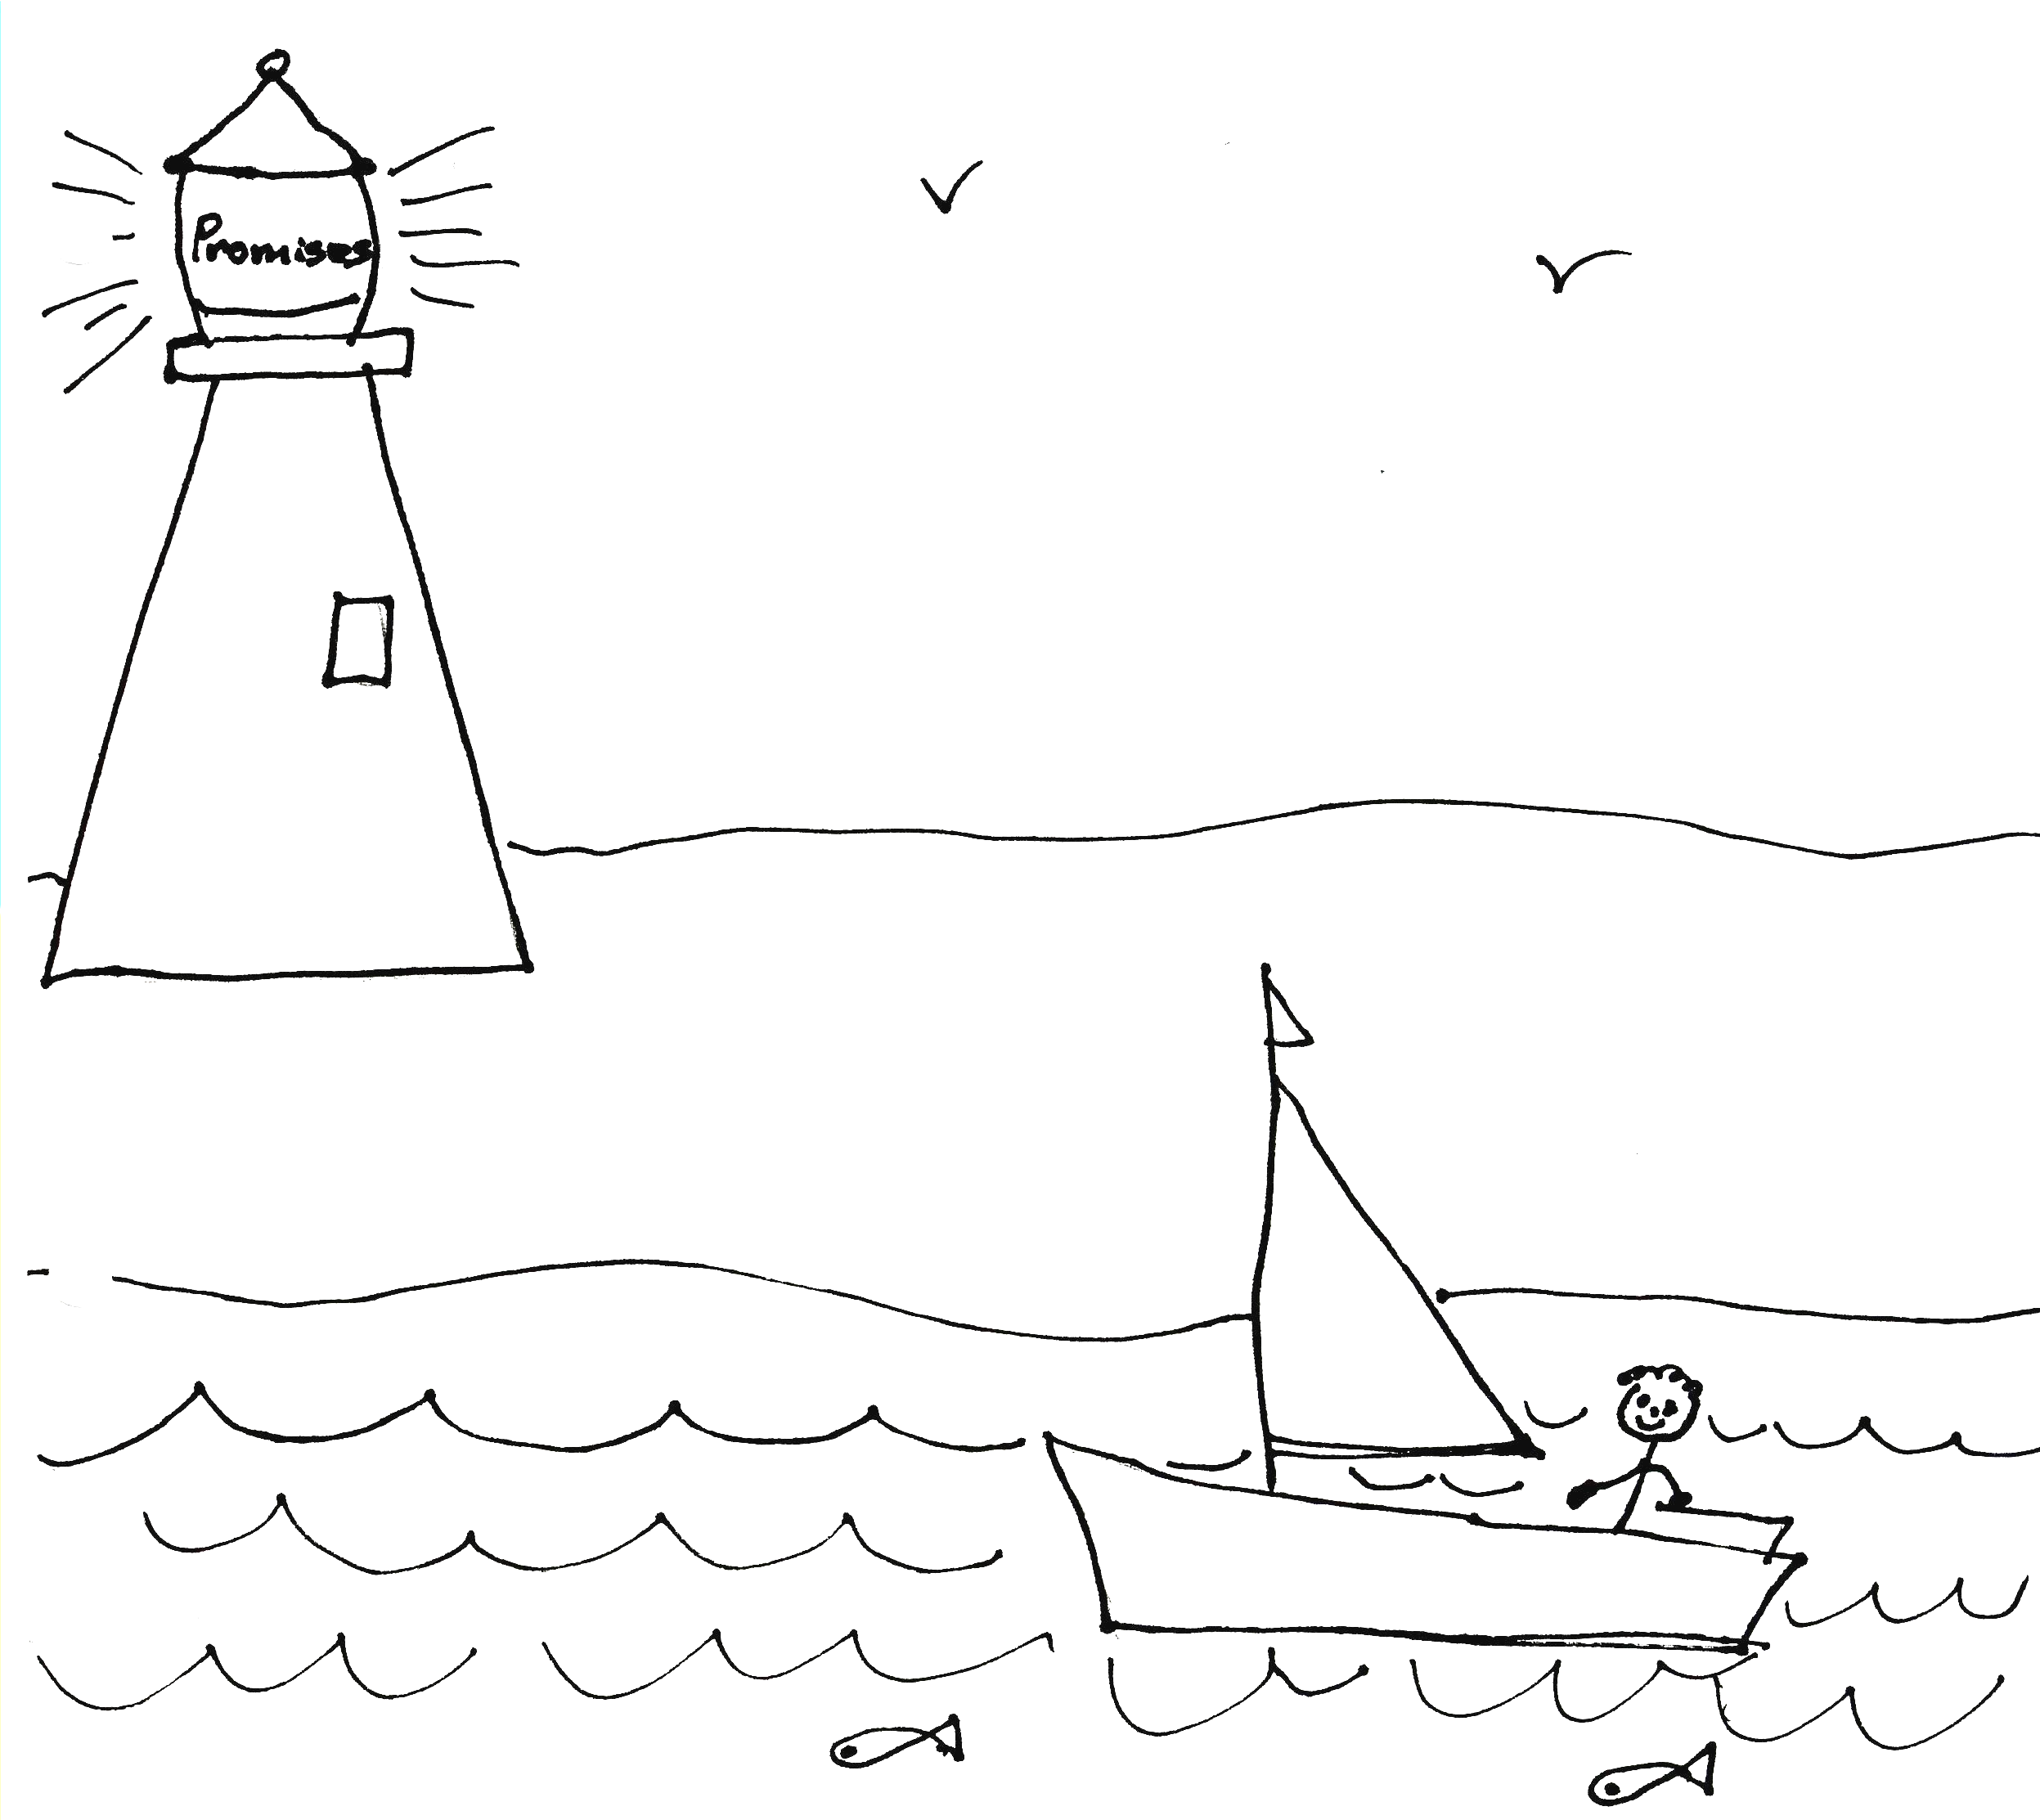

Psalm 56:3 “When I am afraid, I will put my trust in you.”

Let’s review “How to faith-rest?”
1. Rebound, and then claim a promise to calm your soul like Psalm 56:3. “When I am afraid, I will put my trust in you.”
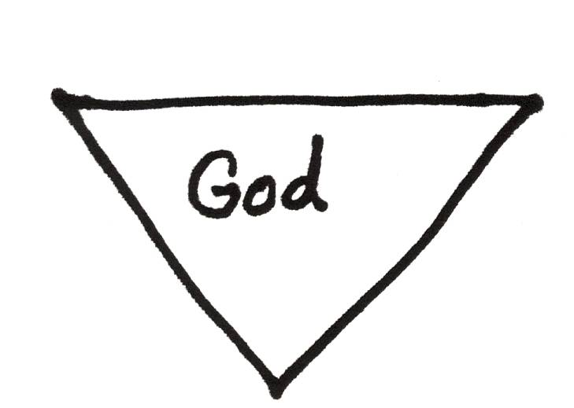
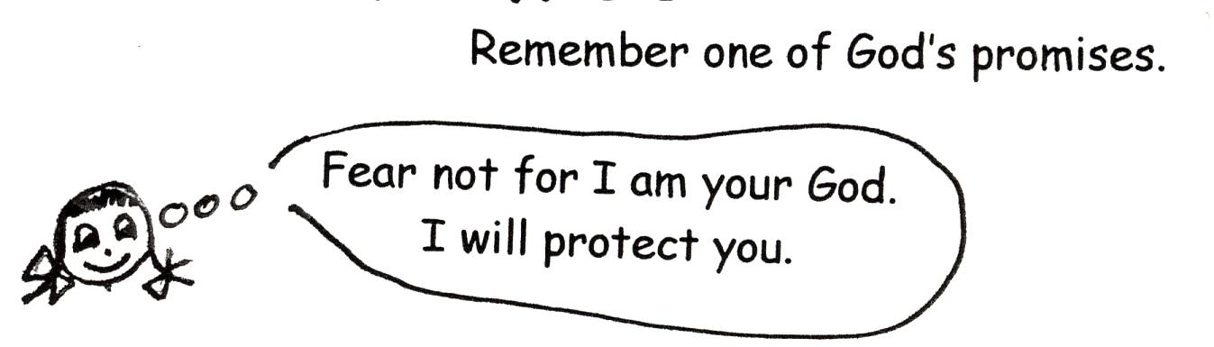

2. Think of a reason from the Bible as to why the promise will work. Philippians 4:19 “But my God will supply all your needs according to His riches in glory by Christ Jesus.”
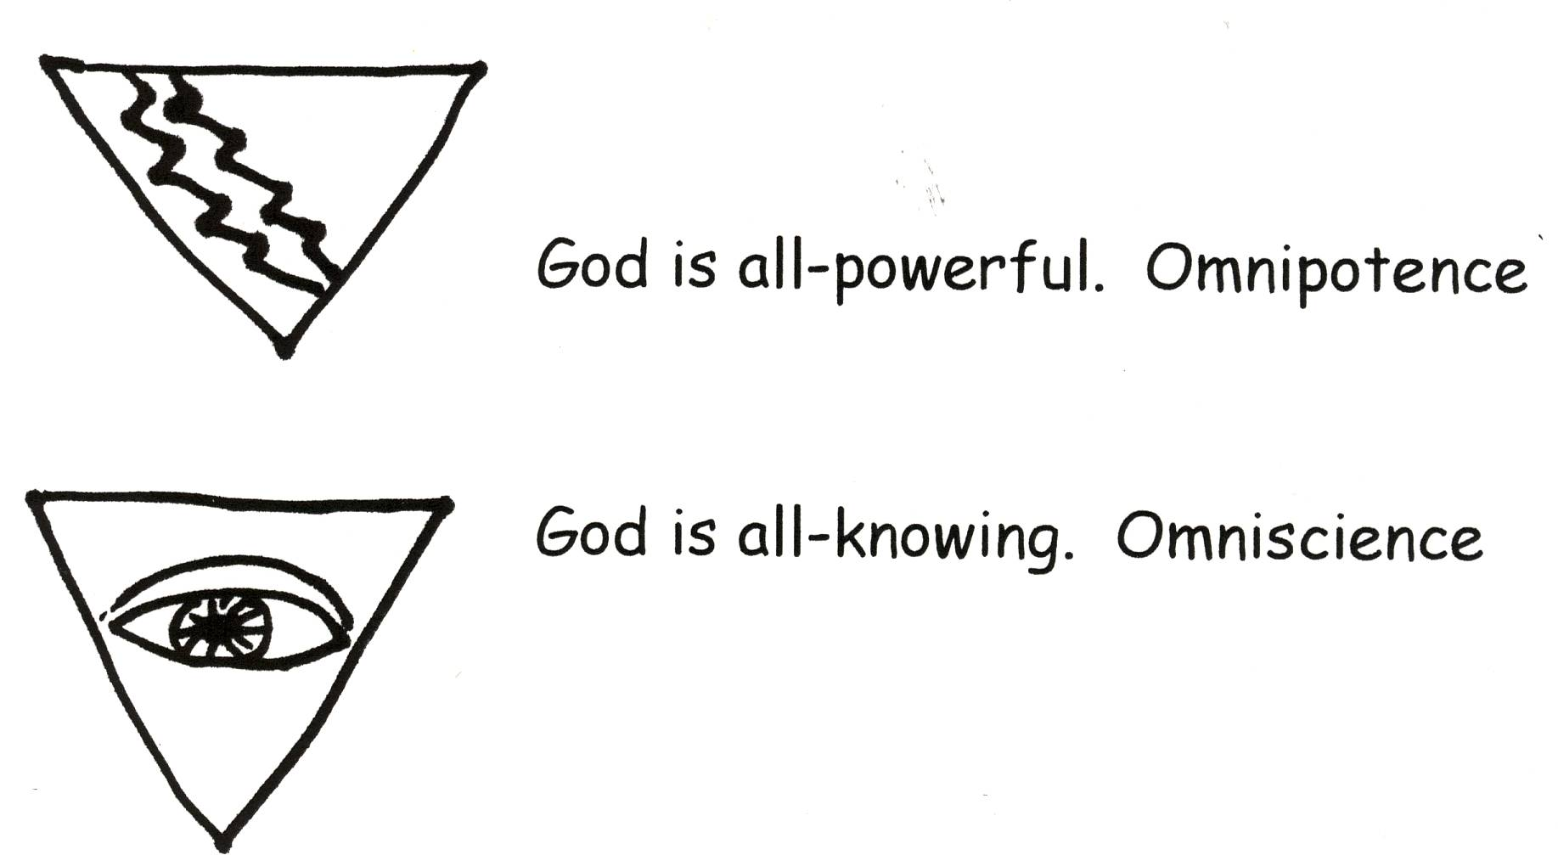


3. Then after we do the first two parts of Faith Rest our minds will start to come around to God’s way of thinking. We relax! Romans 8:31 “What then shall we say to these things? If God is for us, who is against us?”
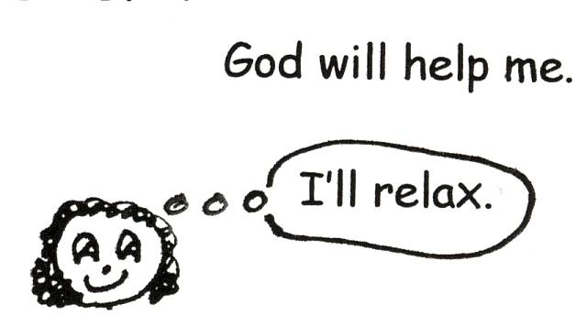


Robert McLaughlin Bible Ministries
www.gbible.org
R. B. Thieme, Jr.’s Book: Christian at Ease
&
Lighthouse Christian Youth Ministries
www.lighthousechristianyouth.org
lcyministry@comcast.net

From the Jr. Tree of Life

2 Pet 1:2 “Grace and peace be yours in abundance through the knowledge of God and of Jesus our Lord.”

