Lighthouse Christian Youth Ministry Lesson 54c
God Gave Us Ten Problem-Solving Devices

PSD # 4 in the Line of Battle Is
Grace Orientation

June 25, 2006
&
September 15, 2006

John 1:16 “From the fullness of His grace we have all received one blessing after another.”
The fourth Problem Solving Device (PSDs) that we are going to study is Grace Orientation. Orient means to adjust to a particular situation. Grace orientation means that man, through the power of the Holy Spirit, understands and adjusts to God’s grace policy. Grace is all that God is free to do for mankind without man having to add to grace. Another way of saying this is that the person brings his thinking in line with the thinking of God and uses all of God’s grace supplies for man. God’s policy is that He freely gives us everything that we need and have. We earn and deserve nothing. We learn that without the grace of God, we would have nothing, not even our lives! We would be nothing! This is a humbling thought! So, we are to adjust or orient our thinking to the grace of God, grace orientation.
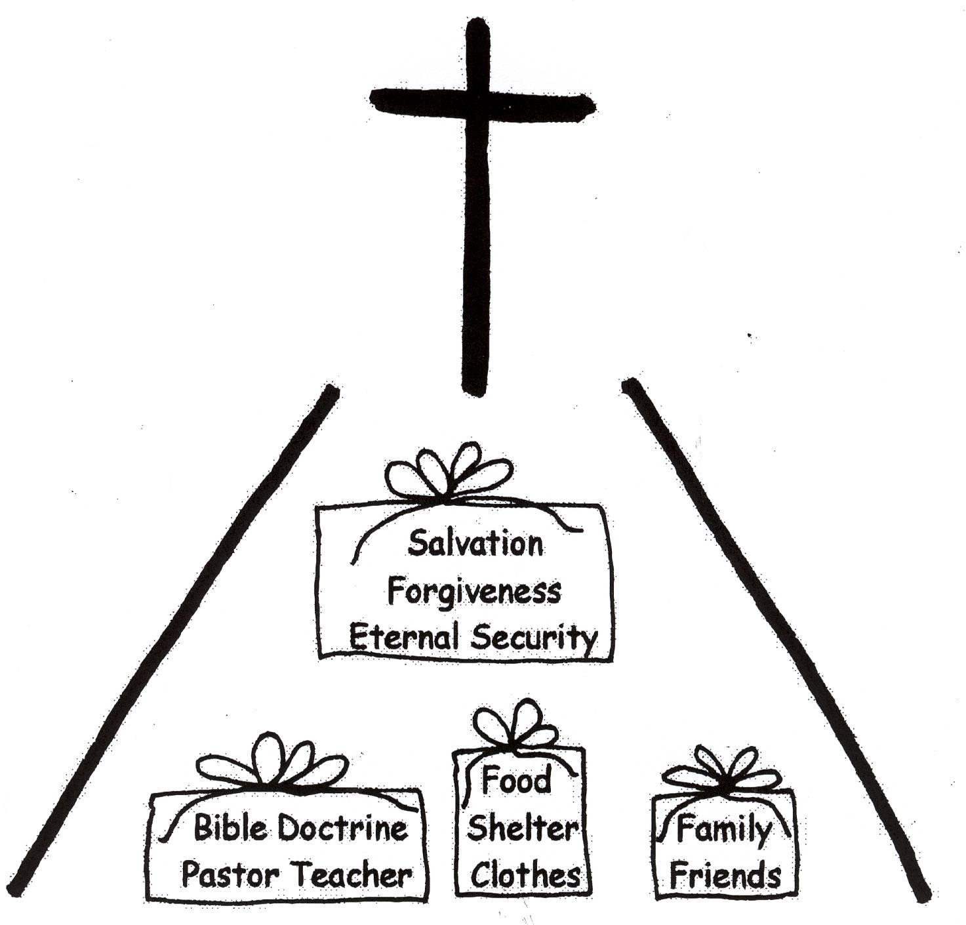






James 1:17 “Every good thing given and every perfect gift is from above, coming down from the Father of lights, with Whom there is no variation, or shifting shadow.”

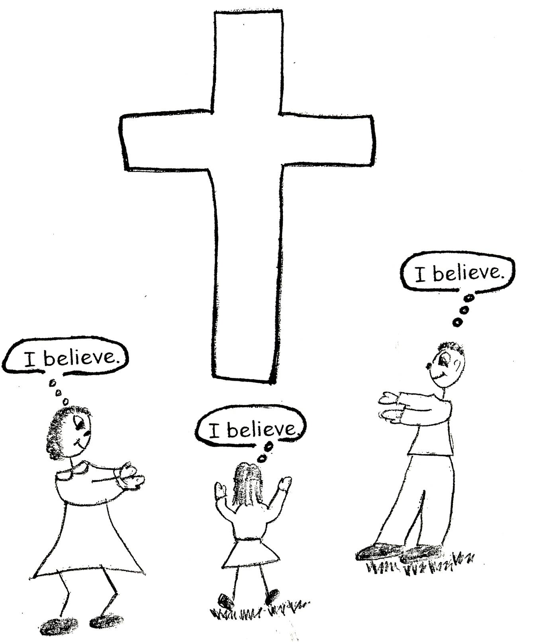
Motivated by His love, God has a plan for our salvation; He offers saving grace to the unbeliever. This can be done because of the salvation work of Jesus Christ on the cross. Jesus Christ paid the debt for our sins! How awesome is that? God is now free to give to mankind. All the unbeliever has to do is to believe in Jesus Christ as his Savior. Our first adjustment to grace comes when we believe in the Lord Jesus Christ as our Savior. When we do that, we adjust our thinking to the grace of God. We accept the grace gift of salvation from God. We will spend eternity with God in heaven! What a gift! SAVING GRACE!

Ephesians 2:8 “For it is by grace you have been saved, through faith – and this not from yourselves, it is the gift of God – not by works, so that no one can boast.”

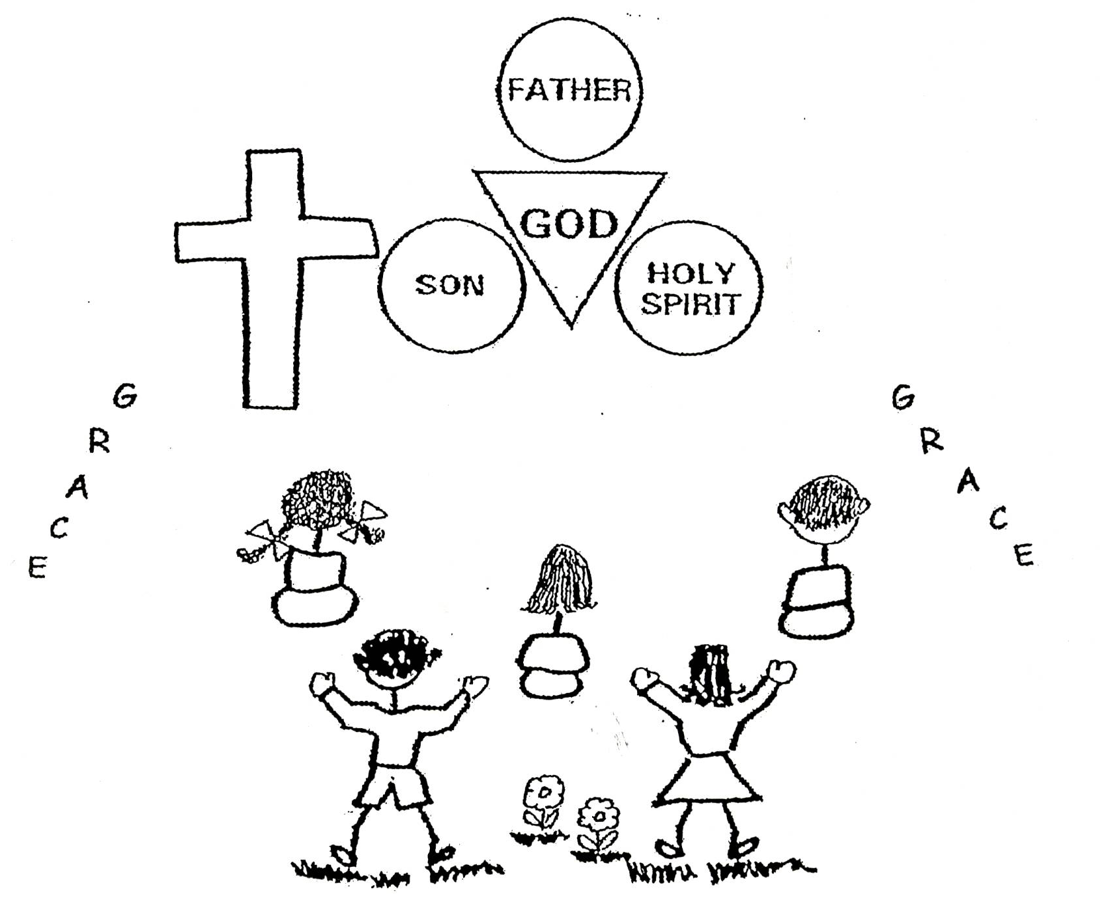
Saving grace is called the total work of God, because each member of the Trinity contributed to salvation. God the Father is the author of the salvation plan. He is also the Judge, for He judged our sins after He imputed or gave them to Jesus Christ on the cross. God the Son is the Savior, the object of faith for salvation. He took our place in being judged for our sins. God the Holy Spirit makes known the work of salvation. This is called the convicting work of the Spirit. This means that He shows us that we need a Savior. We cannot save ourselves. We need God’s saving grace!

Philippians 4:19 “And my God will meet all your needs according to His glorious riches in Christ Jesus.”

God’s love motivated Him to find a way, in His justice, to be able to bless us after salvation. We don’t have any goodness of our own that is pleasing to God. So, at salvation we receive God’s righteousness, God’s goodness, (+R). Then God’s justice can give us grace blessings. God gives from His justice to His righteousness, His goodness. We don’t earn or deserve these blessings. He can now give blessings to the worst and the best believers. We have air to breathe, water to drink, food to eat, clothes to wear, and some kind of shelter, like a house. We have Bible doctrine and someone to teach us that Bible doctrine. These are called logistical grace blessings, things we need so that we can live and learn about God.
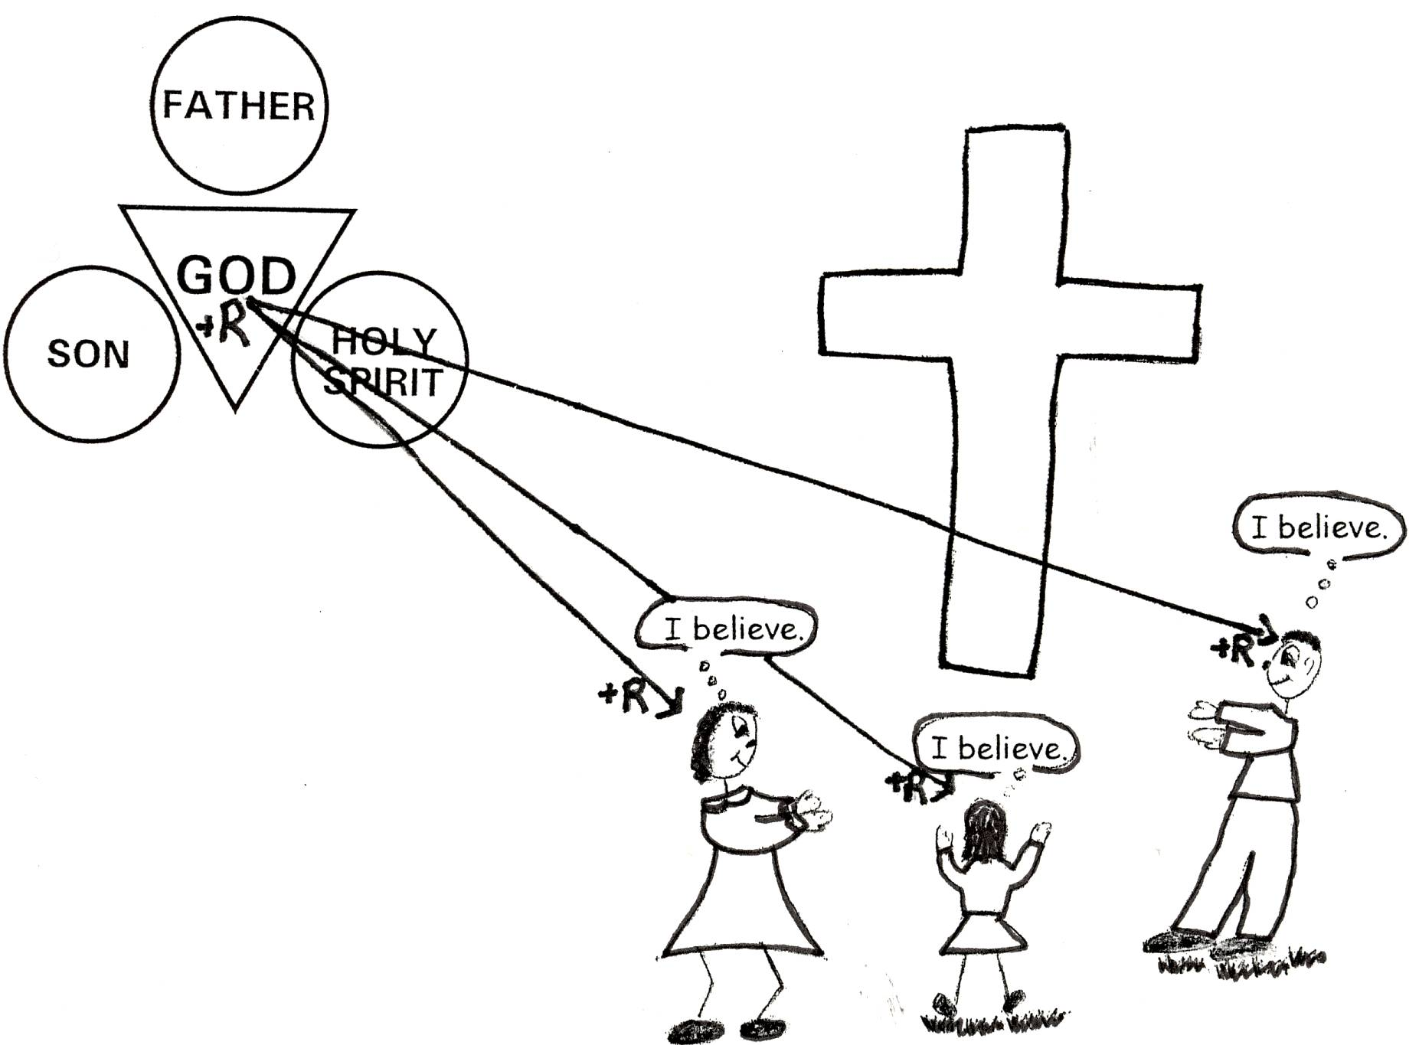

John 1:16 “From the fullness of His grace we have all received one blessing after another.”
In God’s timeline of history, we live in the Church Age. It is an age of grace. Everything we have is because of the grace of God. Our lives, our salvation, our minds, our talents, our treasures, and our time are all some of the gifts from God. God has done all of the work, so He gets all of the glory. Billions of years ago, God knew what would be best for each one of us. He knew the best brain, the best parents, the best place to live, the best personality, and the best pastor-teacher. Then along comes each one of us, and we receive all of these gifts! That’s the grace of God. Glory be to God!
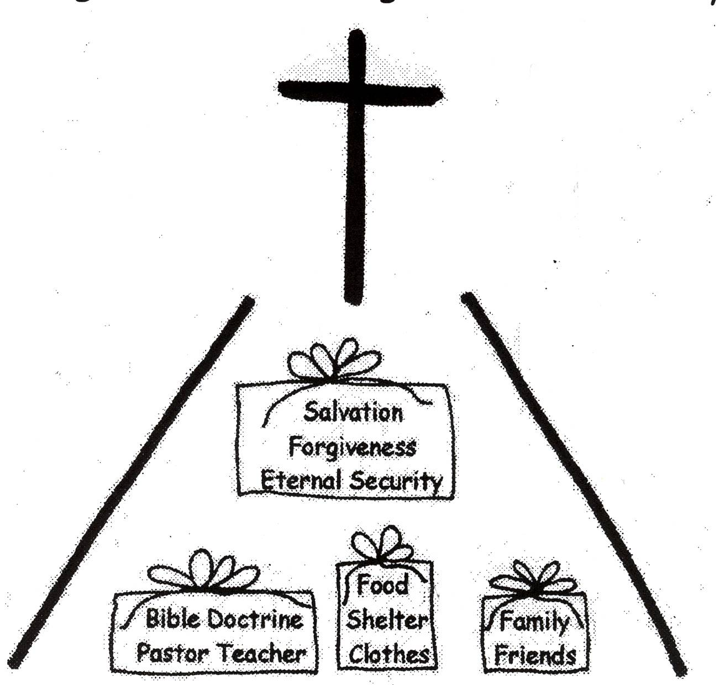







James 1:17 “Every good and perfect gift is from above, coming down from the Father of the heavenly lights, who does not change like shifting shadows.”

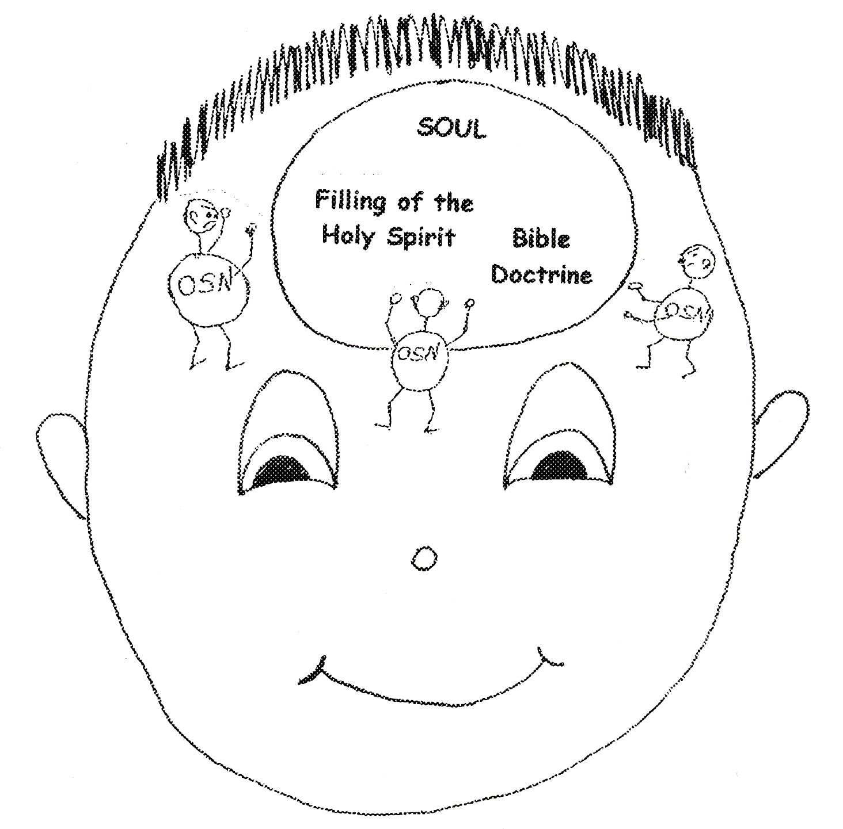
Using grace orientation takes a lot of humility. We have to realize that we are nothing without God. We have to get the old sin nature out of the way and live in our new nature, the nature we receive when we believe in Jesus Christ. Our old sin nature tells us that we have to do human works to please God. Our new nature tells us the God has done all the work! All we have to do is to believe in Jesus Christ as our Savior, rebound when necessary, and learn Bible doctrine. The Holy Spirit will clear the garbage out of our souls, and make us grow spiritually. When we realize that nothing that we do apart from the filling of the Holy Spirit pleases God, we can relax and let the Holy Spirit do His job! We need to be humble!

Ephesians 3:20 “Now to Him Who is able to do exceeding abundantly beyond all that we ask or think, according to the power [of the Holy Spirit] that works within us.”
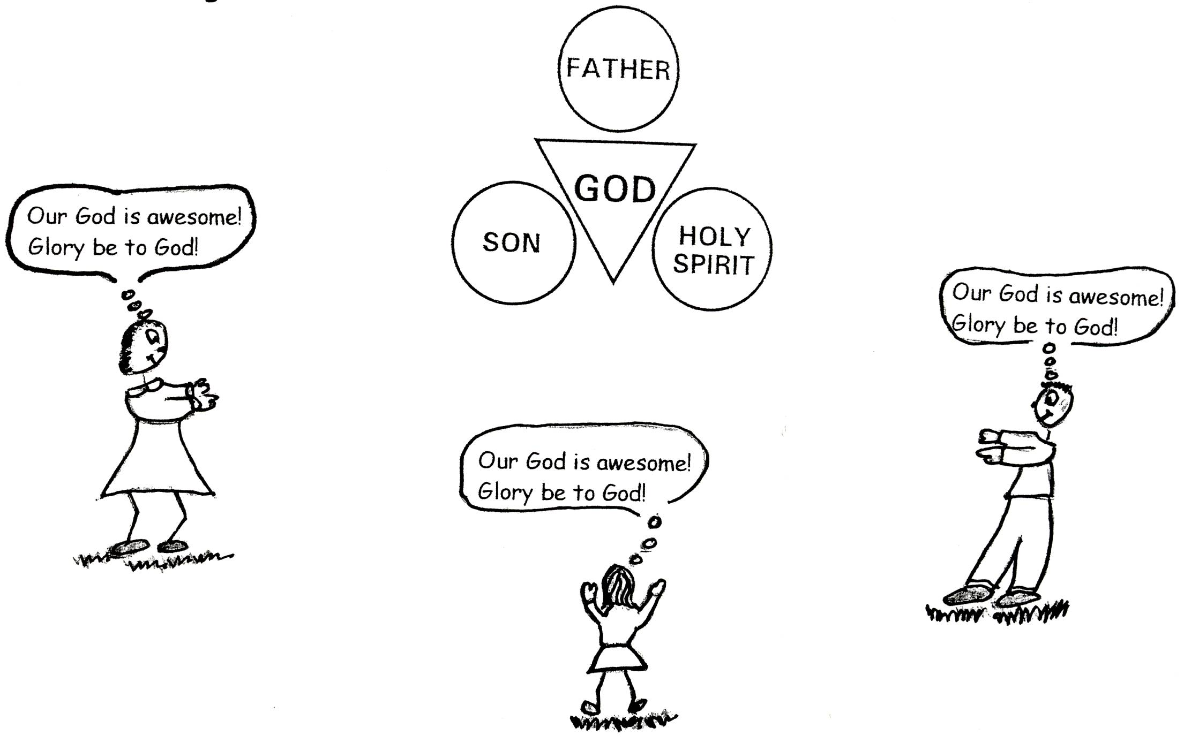
When we act with humility, we free up our minds from arrogance. We become teachable! We are more content with whom God made us to be. We respect authority and have an attitude of gratitude or thankfulness. We are willing to follow God’s plan, His plan of grace for our lives. This brings glory to God! This is grace orientation! It is all about who and what God is!!

Luke 2:14 “Glory to God in the highest, and on earth peace to men on whom His favor rests. [Peace with God is received by faith in Jesus Christ.]”

Psalm 72:19 “Praise be to His glorious name forever; may the whole earth be filled with His glory.” Amen and Amen.

Grace oriented believers do not condemn others. They greatly appreciate that there is no condemnation in Christ Jesus. Jesus Christ came to save and offer mankind forgiveness. When we sin, God treats us with patience and mercy. We need to treat ourselves and others with patience and mercy! When we are using grace orientation, we will not criticize or judge. We will be slow to anger. We will listen to others with tolerance. We will build them up and restore them. That’s real kindness. That’s grace orientation!
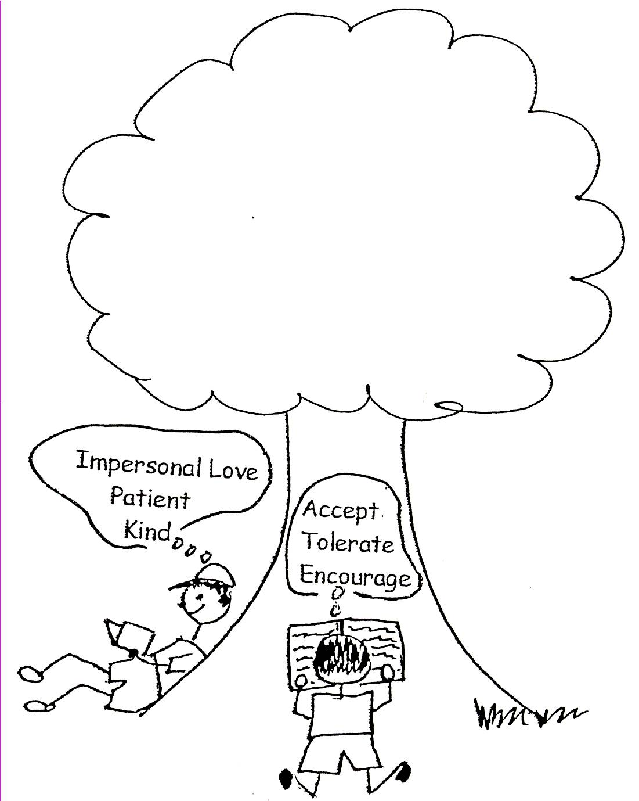

Romans 8:1 “Therefore, there is now no condemnation for those who are in Christ Jesus, because through Christ Jesus the law of the Spirit of life set me free from the law of sin and death.”

Romans 14:4 “Who are you to judge someone else’s servant? To his own master he stands or falls. And he will stand, for the Lord is able to make him stand.”
The more we learn about Who and what God is, the more we realize how much we have been healed in our souls. Then we are energized to tell others how the Lord Jesus Christ will heal their souls! The healing is a free gift. It is grace! When we use grace orientation, we see people as God sees them: helpless, needing grace, and needing the Word of God. We remember when we were blind and had no hope. God helped us and continues to grace us out! THANK YOU, GOD!!! Thank You for grace orientation!
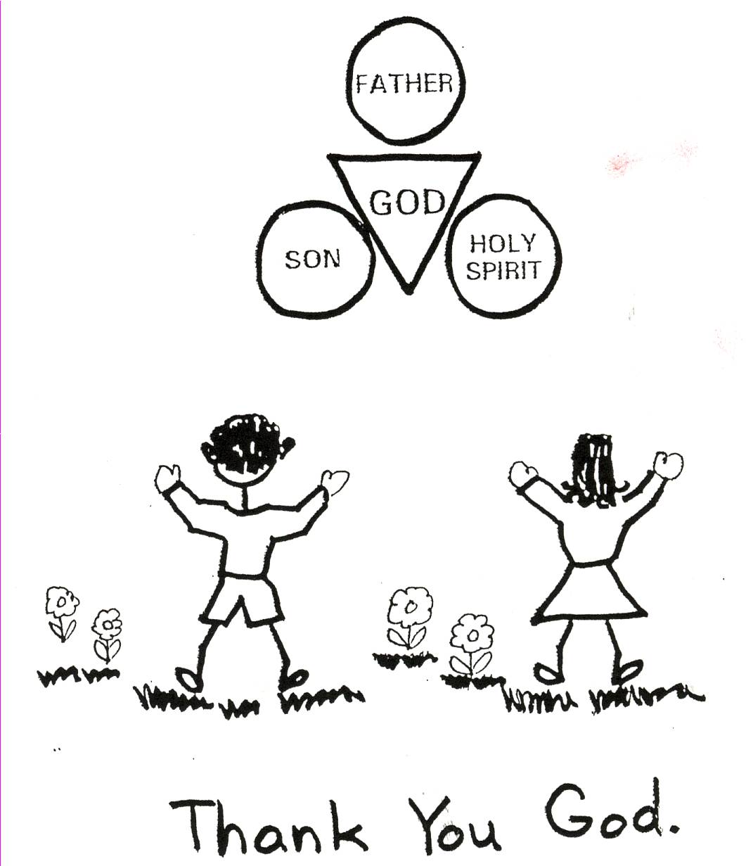

Galatians 6:1-5 “Brethren, if a man is overtaken in any trespass, you who are spiritual should restore him in a spirit of gentleness. [This does not mean to stick your nose into other people’s business. If someone is looking for help, or if we know someone well, we are to help that person with gentleness and kindness.]”

Robert McLaughlin Bible Ministries
www.gbible.org
R. B. Thieme, Jr.’s Book: Christian at Ease
&
Lighthouse Christian Youth Ministries
www.lighthousechristianyouth.org
&
lcyministry@comcast.net

From the Jr. Tree of Life

2 Pet 1:2 “Grace and peace be yours in abundance through the knowledge of God and of Jesus our Lord.”

