Lighthouse Christian Youth Ministry Lesson 54c - Addendum 1
God Gave Us Ten Problem-Solving Devices
PSD # 4 in the Line of Battle Is
Grace Orientation: Humility Vs Arrogance

September 22, 2006

Pro 11:2 “When pride comes, then comes dishonor, but with the humble is wisdom.”

Humility is Teachability
To be teachable is a life long lesson. As believers, we learn to correctly judge ourselves through the Word of God everyday. We admit our mistakes, confess them or rebound, and make changes where they are needed. We don’t hide our talents and virtues. And we do not boast or brag.
Judge Ourselves and Make Changes Where Needed

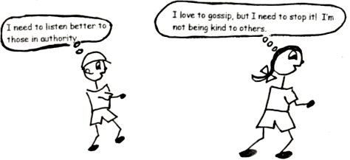

Use Our Talents and Virtues without Boasting and Bragging

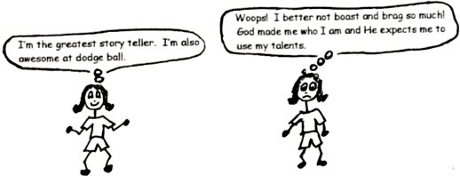
Let’s give all the credit to God and use our talents as if we were doing them for the Lord, Jesus Christ.

Galatians 6:4 “Each one should test his own actions. Then he can take pride in himself, without comparing himself to somebody else, for each one should carry his own load.”

Proverbs 15:14 “The wise, sensible heart [mind] seeks knowledge, but the mouth of a fool feeds on a foolish act or idea.”

The Fool

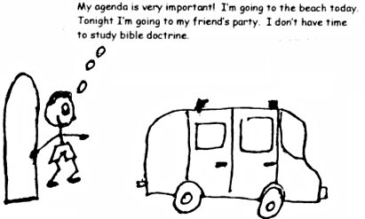

Romans 3:23 “There is no difference, for all have sinned and come short of the glory [greatness, honor] of God…”
1 Peter 5:5 “God opposes the proud but gives grace to the humble.”
Psalm 40:4 “Blessed is the man who makes the Lord his trust, who does not look to the proud, to those who turn aside to false gods.”
Proverbs 3:35 “The wise [humble, teachable] will inherit [receive] honor, but fools get disgrace.”

Humility - Happy or Content
When we have humility, we are happy with who we are because God made us that way.



1 Corinthians 15:10 “But by the grace of God I am what I am…”
Arrogance - Unhappy or Malcontent
When we are arrogant, we are not happy with who we are or how God made us to be. We want to be better looking, smarter, richer, better at sports, better, better, better!



1Peter 5:6-7 “Humble yourselves, therefore, under God’s mighty hand, that He may lift you up in due time. Cast all your cares on Him because He cares for you.”
Humility - Respect Authority -Obey
When we recognize, respect, and obey legitimate authority, we are humble. Legitimate authority is God’s authority and the authority He gives to the people in charge of us. Some of these people are our parents, our pastor, our teachers, our coaches, firemen, and policemen. When we are under the authority of another person, we don’t feel inferior to them [less than] or threatened by them. We follow their directions. We take responsibility for our actions! This is humility!



Ephesians 6:1-3 “Children, obey your parents in the Lord, for this is right. ‘Honor your father and mother’ – which is the first commandment with a promise – ‘that it may go well with you and that you may enjoy long life on the earth.’ ”
Proverbs 15:33 “The respect of the Lord teaches a man wisdom, and humility comes before honor.”
Romans 14:12-133 “So then, each of us will give an account of himself to God. Therefore let us stop passing judgment on one another.”

Arrogance - Disrespect Authority - Disobey
When we disobey those in charge or in authority, we are arrogant. We want to be the ones in charge and do things our way. For example, Mom tells me to study for my test. I don’t want to, so I go to my room and pretend that I’m studying when I’m really playing a game. Woops! Bad consequences!



Nehemiah 9:26 “But they were disobedient and rebelled against you; they put your law behind their backs.”
Nehemiah 9:29 “You warned them to return to your law, but they became arrogant and disobeyed your commands.”

Humility – Gratitude - Thankfulness
We show our gratitude to God and people when we are humble. We know that everything that we have comes from God. God uses people to help us sometimes. He uses us to help others, and with humility we can have a good attitude toward helping them.

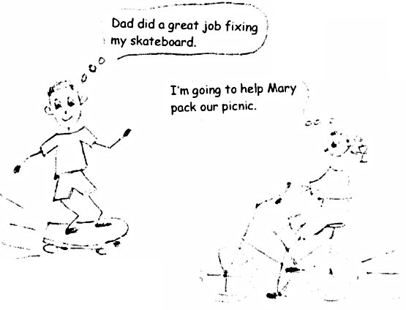

1 Corinthians 4:7 “For who makes you different from anyone else? What do you have that you did not receive?”
Philippians 2:4 “Each of you should look not only to your own interests, but also to the interests of others.”

Arrogance – Ungrateful - Selfish
When we are arrogant, we expect God to do things for us when we want it. We also expect people to do things for us when we want it. We become selfish and ungrateful.

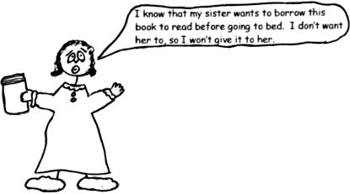

Philippians 2:3 “Do nothing out of selfish ambition or vain conceit [too high of an opinion of yourself], but in humility consider others better than yourselves.” [This does not mean that everyone is more talented or better than you, but that Christian love gives others preferential (chose them first) treatment.]

Humility - Follows God’s Plan
God can only give blessing and deal graciously (with kindness) with those who have true humility. Humility gives us capacity, or makes us able to receive God’s blessings and enjoy them. Under humility, success belongs to God, and happiness belongs to the believer who lives in the plan of God. The amount of happiness depends on how much time is spent in God’s plan. So, if you want to be really happy or content, follow God’s plan!

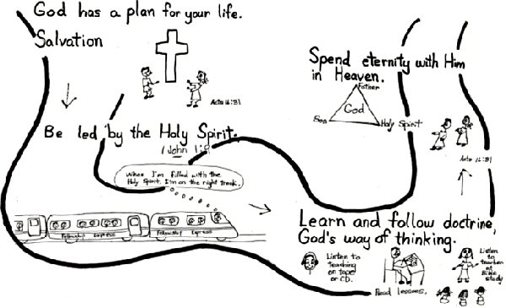

Psalm 33:5 “…the earth is full of His unfailing love.”
Psalm 33:11 “But the plans of the Lord stand firm forever, the purposes of His heart [mind] through all generations.”

Arrogance - Follows Own Plan
The arrogant believer tries to do things through his own ability according to his own rules. Arrogance uses everything in life to promote (advance) self.

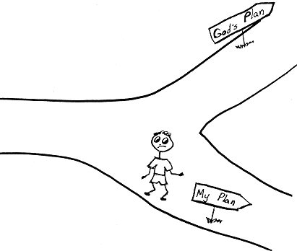

1 Corinthians 13:4-5 “Virtue Love is patient, love is kind. It does not envy, it does not boast, it is not proud. It is not rude, it is not self-seeking [selfish]…”
Romans 2:8 “But for those who are self-seeking [selfish] and who reject the truth and follow evil, there will be wrath [discipline] and anger.”

Humility - Glorifies God
Learning God’s Word and making it a part of our lives gives us the ability to live the Christian life, and results in Christian service (divine good, works or duties). Christian service done using the power God praises God, or glorifies God!

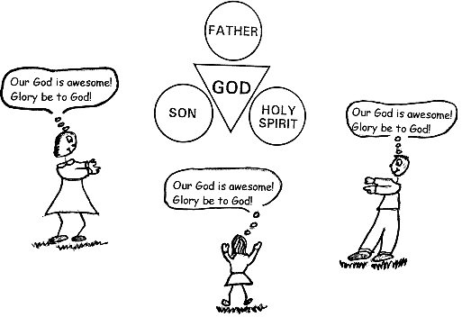

Luke 2:14 “Glory to God in the highest, and on earth peace to men on whom His favor rests.” (Peace with God is received by faith in Jesus Christ.)
Psalm 72:19 “Praise be to His glorious name forever; may the whole earth be filled with His glory. Amen and Amen.”

Arrogance - Glorifies Self
Christian service done in the cosmic system, or Satan’s plan, is human good and glorifies self. The issue is not what YOU do, but whose system you use, God’s or Satan’s. The cosmic system can offer power, human power. It can offer that which we think we want. But God’s plan goes far beyond what you can even dream up or imagine possible. Let’s not get stuck in trying to glorify ourselves!

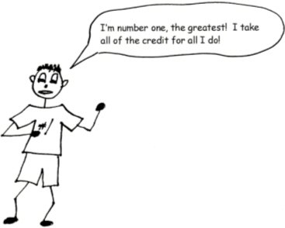

Joshua 7:19 “Then Joshua said to Achan, ‘My son, give glory to the Lord, the God of Israel, and give Him the praise.’”

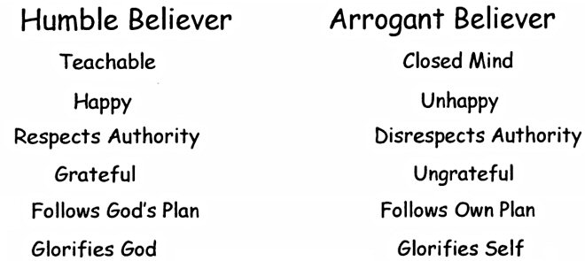



1 Peter 5:5 “…All of you, clothe yourselves with humility toward one another, because ‘God opposes the arrogant but gives grace to the humble.’”

Robert McLaughlin Bible Ministries
www.gbible.org
R. B. Thieme, Jr.’s Book: Christian at Ease
&
Lighthouse Christian Youth Ministries
www.lighthousechristianyouth.org
lcyministry@comcast.net

From the Jr. Tree of Life

2 Pet 1:2 “Grace and peace be yours in abundance through the knowledge of God and of Jesus our Lord.”

