Lighthouse Christian Youth Ministry
Lesson 54d
God has Ten Problem Solving Devices
PSD # 5 in the Line of Battle is
Doctrinal Orientation


The Jr. Tree of Life
October 22, 2006

URGENT INFORMATION...
BEFORE we begin, if you are a believer in the Lord Jesus Christ, take a moment to name your sins to God the Father. This will allow you to be filled with the power of the Holy Spirit as you study or read this Bible lesson.  (I John 1:9) (Eph 5:18). | 
IF YOU HAVE never believed in the Lord Jesus Christ as your personal Savior, you have that opportunity right now to have eternal life. We sin and cannot have a relationship with God so God’s Son, Jesus, who is God, came down to earth to become a human being just like us. He did this because He loved us so much. He lived His entire life on earth without sinning once! That qualified Him to go the cross and die in our place and He paid the penalty for sin as a substitute for us. After His death He rose again and is alive right now in heaven. He opened the door for you and me to get into heaven with Him by simply believing in Him and what He did for us on the cross. So simply tell God the Father that you believe in His son Jesus Christ as your Lord and Savior and you will be saved. If you make that decision, you are now saved and a believer and will always be a child of God. When you die, you will spend eternity with Him in heaven (Acts 16:31) (John 3:16).
"For the natural man (the unbeliever) does not accept the things of the Spirit of God; they are foolishness to him, and he cannot understand them, because they are spiritually understood" (1 Cor. 2:14)
"He who believes in the Son has eternal life but he who does not obey the command to believe the Son shall not see life, but the wrath of God abides on him" (John. 3:36)
The doctrine of DOCTRINAL ORIENTATION is probably one of the most IMPORTANT doctrines that you’ll learn. There are a lot of people who can "talk the talk" but I have found that very few "walk the walk." Everything you’ve learned from Bible Doctrine is WORTHLESS if you don't USE it. To be oriented to doctrine means to adjust to it by thinking like Jesus. Remember the Bible is the MIND OF CHRIST. 1Co 2:16 “For WHO HAS KNOWN THE MIND OF THE LORD, THAT HE WILL INSTRUCT HIM? But we have the MIND OF CHRIST.”
As you can see on the cover, we have two cans of paint. How many times have you seen a room get painted just by BUYING THE PAINT and leaving the unopened cans laying there? Not ONCE!!!! NOT EVER!! The only way you can CHANGE the color of the room is by APPLYING THE PAINT on the walls.
How many times have you seen two things stick together just by BUYING A GLUE STICK? Not ONCE!!! NOT EVER!! You need to APPLY the glue to make the things stick together. Do you see where I am going with this? You can learn Bible Doctrine every single day. You can read every single Bible lesson that you have in your notebooks or on your night tables in your home but until you APPLY IT or USE IT, it DOES NOT stick and it DOES NOT change your life!! It's that simple. Now here’s the good news. ALL YOU HAVE TO DO to apply it or use it is be FILLED WITH THE HOLY SPIRIT and THINK the WAY JESUS THINKS…that’s Bible doctrine thinking. We call it divine viewpoint. We do that by REBOUNDING EVERY TIME WE SIN. Don't wait until bedtime to rebound for all of your sins that you committed during the day. Every single time you sin, that includes thinking bad thoughts; you should name it to God and get that Holy Spirit’s power back! I pray for each of you everyday that you remember to rebound as soon as you sin.
God has made many promises to us and one of them is that He promised to complete His work in us…that is the plan HE has for each of us. Philip 1:6 “Being confident of this very thing, that He (God) which hath begun a good work in you will perform it until the day of Jesus Christ.” That’s right! He will perform or DO IT until the DAY that JESUS COMES BACK FOR US or until WE DIE. The day you believed in Jesus Christ as your Savior you entered a personal plan just for you that God designed before time began! The ONLY way to live in that plan is by the POWER of the Holy Spirit. While you are under the power of the Holy Spirit, you learn Bible Doctrine every day. Then, when the opportunity comes, the Holy Spirit brings that doctrine back to your thinking and you are able to USE it…APPLY it. DO you see a common thing here? Do you see that it is God who saved us, God who gave us the power to believe in Him and God who gives us everything it takes for us to fulfill His plan? That’s GRACE!!!! All we have to do is be available every minute to Him by the filling of the Holy Spirit (via Rebound) and have the doctrine in our soul for the Holy Spirit to use. The Holy Spirit literally launches it like a rocket from our souls.
The biggest distraction in this life is PEOPLE!! Big people, little people, fat people, skinny people, nice people, mean people, beautiful people and ugly people!!! Whenever and wherever people are involved there are the…that’s right…Old Sin Natures of those people involved. Therefore, there are ALWAYS problems!! And therefore…as a believer in the Lord, we need to use our doctrine LAUNCED LIKE A ROCKET in our relationships with those people. Bible doctrine is the ONLY thing that will allow us to handle people and keep our priorities straight. That means that the Lord should be #1 in our life and never what people think of us. The Lord told us in Matt 10 that He didn't come to bring peace but division. Mat 10:34 "Do not think that I came to bring peace on the earth; I did not come to bring peace, BUT A SWORD.” That means TROUBLE between those who love the Lord above all else and those who DO NOT! That means that even if your relationships with people seem to be shaky because you choose Bible doctrine over them that doesn't mean you are doing anything wrong. Don't expect everyone to be at peace with you when you follow the Lord with all of your heart. ARE PEOPLE MORE IMPORTANT TO YOU THAN JESUS? I HOPE NOT! People who don’t care about the Lord will always think you are WEIRD!!! In Matthew 5:11-12 we read, "Blessed are YOU when men cast insults at you and persecute you, and say all kinds of evil against you falsely, on account of ME. Rejoice and be glad, for your reward in heaven is great, for so they persecuted the prophets who were before you."
When you are tested by people, use that IMPERSONAL LOVE or VIRTUE LOVE in your soul and watch how powerful it is. Impersonal love avoids sinful mental attitudes towards people even when they are wrong. When you know you are right with God…YOU DON’T CARE WHAT PEOPLE THINK. The only power that can do that for you is the power of God the Holy Spirit. You are not only tested by people you don't personally like, you are tested by those you like and love very much. If you fail the test and react and get angry at them or the situation, YOU ARE OUT OF FELLOWSHIP and NOT FILLED WITH THE HOLY SPIRIT!!!! But don’t add worry to that…just rebound and try to past the test again, okay?

You will also be tested by God to see if they are more important to you than the Lord. In Mat 8:18, 21-23 the Lord challenged a man who told Him that he would follow Him no matter what. ”Now when Jesus saw a crowd around Him, He gave orders (to the disciples) to depart to the other side of the sea. (21) Another of the disciples said to Him, ’Lord, permit me first to go and bury my father.’ (22) But Jesus said to him, ’Follow Me, and allow the dead (unbelievers) to bury their own dead.’ (23) When He got into the boat, His (true) disciples followed Him.” The Lord told this man who claimed to be one of his followers to follow Him NOW! The man asked if he could go and bury his father FIRST!!! This isn't a bad thing to ask, but the Lord knew that the man was more worried about what his unbelieving family would say if he didn't go to the funeral! He was more concerned about what people would think! The Lord was NOT #1 in the disciple’s APPLICATION. This disciple “talked the talk” BUT DID NOT “walk the walk.”
So you can see that because you will deal with people every minute of every day, you need to keep on rebounding and keep that Holy Spirit power flowing or Satan will use people to keep you from going forward in God's wonderful plan for your life. Be available to the Holy Spirit when He leads you to APPLY the Bible doctrine in your soul! Then you will see your colors change and the truth will STICK!!!
The Bible is the best book that we will ever have. It is the instruction book of how to live the spiritual life. God wrote the Bible using men to put down the words. He has not left us to try to figure life out for ourselves. Bible doctrine tells us what we must do now that we are Christians. It tells us what we need to know to make good decisions. It tells of God’s divine support or help that God has given to each believer, and His directions for using that support.
Psalm 119:105 Thy Word is a lamp to my feet and a light for my path.
Psalm 18:32 God arms me with strength; He has made my way safe.
Since we live in the Church-age, we follow the directions in the Bible for that dispensation, or that period of history in God’s plan. It is the Age of Grace. God has done all of the work; we RECEIVE all of the BENEFITS from God’s work. In fact, we are not to do works by our own strength EVER to gain God’s favor. In grace, He gives us everything we need spiritually and physically. We just have to be available to HIM to learn, believe, and apply Bible doctrine. We have to have doctrinal orientation!
 | Some of the Privileges of the Church Age Believer:  New spiritual person  Filling of the Holy Spirit  Own priest  Can pray directly to God the Father  Ambassador for Christ  Indwelt by God the Father, Son and Holy Spirit  Adopted sons of God in His Royal Family  Bible doctrine  Ten problem solving tools  The Lord Jesus Christ as our Hero!

2 Samuel 22:31 As for God, His way is perfect; the word of the Lord is flawless.
Deuteronomy 10:18 Fix these words of mine [Bible doctrine] in your hearts and mind;

Doctrinal orientation is being oriented to God’s plan. This means that we bring our thinking into line with the thinking of the Lord Jesus Christ. Grace orientation and doctrinal orientation are closely related. The Lord Jesus Christ’s thinking, which is God’s thinking, is in the Bible. Grace is dependence on God’s wisdom and thinking instead of our own thinking and desires and lack of wisdom. Dependence on God’s wisdom is doctrinal orientation.
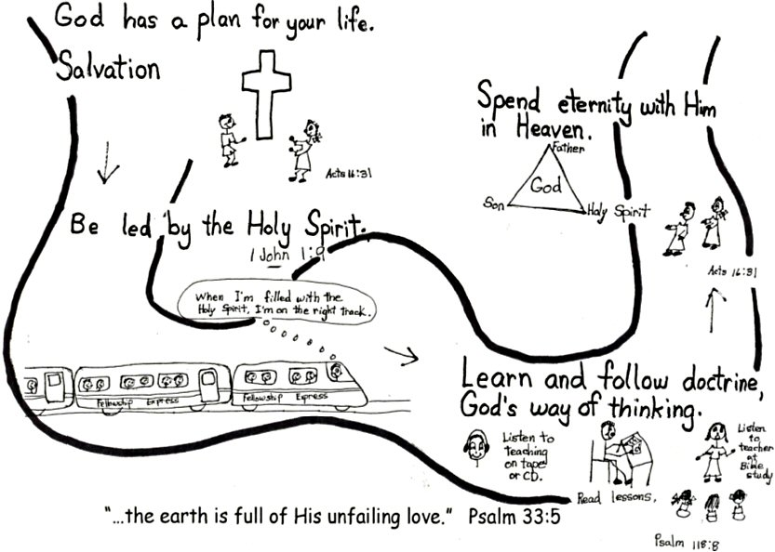
Lamentations 3:21-25 This I recall to mind; therefore, I have hope. The Lord’s gracious functions never cease [grace orientation]; His compassions never fail. They are new every morning. Great is Thy faithfulness. The Lord is my portion, says my soul, therefore I have hope in Him [occupation with Christ]. The Lord is good to those who trust in Him [faith-rest drill], to the soul who seeks Him [doctrinal orientation].

Doctrinal orientation to God’s plan is when we learn, believe, and use Bible doctrine. Believing the Word of God always results in confidence. We can have complete trust that God will do what He tells us in the Bible. We become confident and expect to receive from God what He says we will receive. In GRACE, God does not give us what we want. In GRACE, God gives us what HE WANTS US TO HAVE, something far better than anything we could think of or imagine. We can count on it!!!!
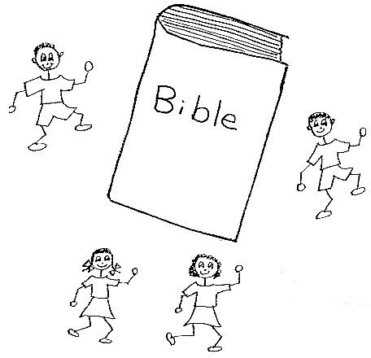
Hebrews 11:1 Now faith is being sure of what we hope for and certain of what we do not see.
Our part is to learn, believe, and apply Bible doctrine. We must have the right pastor-teacher. If we are too young to listen to a pastor-teacher, we need our parents and a Bible teacher to teach us. And remember, we need to make sure that we are filled with the Holy Spirit before we study. So, we take the time to rebound, tell God the Father our sins, if necessary. Then we’ll be set to learn the thinking of the Lord Jesus Christ.
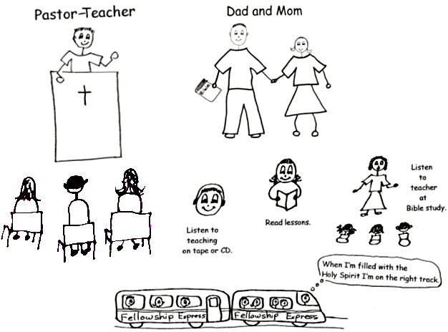
Romans 15:4 For everything that was written in the past was written to teach us, so that through endurance and the encouragement of the Scriptures we might have hope [confidence].
This thinking of the Lord Jesus Christ and our love for HIM through learning Bible doctrine gives us motivation or reasons to apply what we are learning. When we are under pressure, we can think about something we learned in the Bible that will help us. With this knowledge, we can make GOOD DECISIONS. The more we know and believe, the more we will be able to apply, and the more relaxed and confident we will be. We will be using DOCTRINAL ORIENTATION.
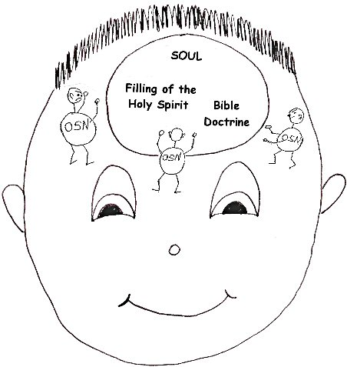
2 Peter 3:18 …but grow in the grace and knowledge of our Lord and Savior Jesus Christ. To Him be glory both now and forever! Amen.
To learn Bible doctrine, we need to be HUMBLE or TEACHABLE. Our old sin natures have such a STRONG tendency to be arrogant or to think too much about ourselves. We want to do things our way. Jesus is the Living Word. If we learn Jesus’ ways, God the Holy Spirit will do the work to change our ways. We need to fill our minds with the Word of God DAILY! The Holy Spirit will store the doctrine in our minds by categories. When we need it, He will go to our “store room” and bring it to our thinking. Then we will have the TRUTH THAT SETS US FREE!! We need DOCTRINAL ORIENTATION.
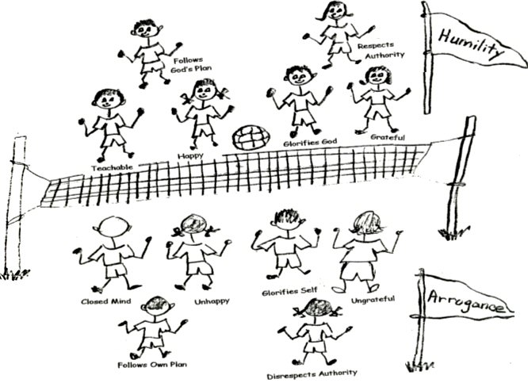
John 8:32 Then you will know the truth, and the truth will set you free.
SATAN DOESN’T CARE IF WE SIN OR NOT! He just doesn’t’ want us depending on God or His Word! He doesn’t want us to learn Bible doctrine. Satan wants us to rely on ourselves rather than on the ministry or teaching of the Holy Spirit. When our Hero, the Lord Jesus Christ, was on earth, He used Bible doctrine and the power of the Holy Spirit. In His humanity, He depended on God to take care of all of His needs. THAT’S HOW HE PASSED ALL THE TESTS SATAN GAVE HIM IN THE DESERT! We know what terrific trials and needs He had! He showed us that having DOCTRINAL ORIENTATION from the Word of God is what powered HIM!
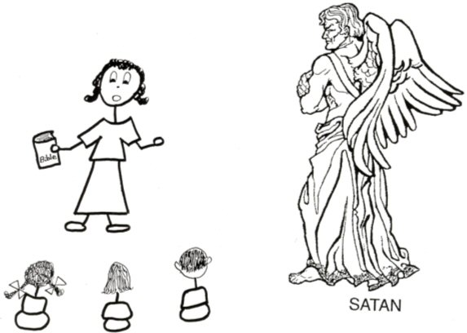
Philippians 4:19 And my God will meet [supply] all your needs according to His glorious riches in Christ Jesus.
To grow up spiritually, we must be led by the Holy Spirit. To be led by the Holy Spirit, we must know the word of God, Bible doctrine. Then we can do the will of God. We need DOCTRINAL ORIENTATION!

Hebrews 4:12-13 For the Word of God is Alive and powerful...sharper than any double-edged sword, it penetrates even to dividing soul and spirit, joints and marrow; it judges the thoughts and intentions of the heart. Nothing in all creation is hidden from God’s sight. Everything is uncovered and lays bare before the eyes of Him to Whom we must give account.
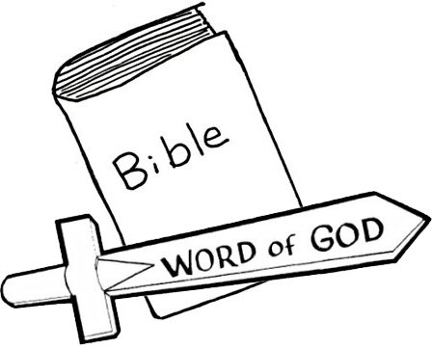

Galatians 6:1-5 Brethren, if a man is overtaken in any trespass, you who are spiritual should restore him in a spirit of gentleness. [This does not mean to stick your nose into other people’s business. If someone is looking for help, or if we know someone well, we are to help that person with gentleness and kindness.]

Robert McLaughlin Bible Ministries
www.gbible.org
R. B. Thieme, Jr.’s Book: Christian at Ease
&
Lighthouse Christian Youth Ministries
www.lighthousechristianyouth.org
&
lcyministry@comcast.net

From the Jr. Tree of Life

2 Pet 1:2 “Grace and peace be yours in abundance through the knowledge of God and of Jesus our Lord.”

