Lighthouse Christian Youth Ministry
Lesson 54d-Addendum 1
God Has Ten Problem Solving Devices
PSD # 5 in the Line of Battle is
Doctrinal Orientation: “We Are What We Think About”

December 1, 2006

Proverbs 23:7 “For as a person thinks within himself (soul), so he is.”

God gave us our minds and our emotions. He gave us our minds so that we can think Bible doctrine, which we should learn daily. He gave us our emotions so that we can respond with the Bible doctrine in our souls to our daily situations. These emotions were designed by God to be a source of enjoyment for us and they will be IF we remain in His plan, that is filled with the Holy Spirit and thinking with doctrinal viewpoint in our mind, which controls our soul where Bible doctrine lives.

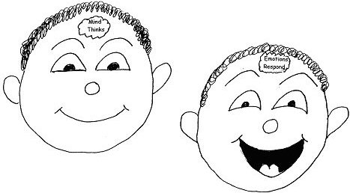

“…for where your treasure is, there will your heart [mind] be also.” Matthew 6:21

However, the mind filled with divine viewpoint, which is Bible doctrine or the Word of God, needs to be in charge of our emotions so we function or act properly. Emotions themselves have NO Bible doctrine. They have NO thought process, NO common sense, and NO ability to reason. Emotions are just responders to what is in our minds and souls. AND it could be a real mess for us if our emotions are in charge!


“And do not be conformed to this world, but be transformed by the renewing
of your mind (with Bible doctrine)…” Romans 12:2

When we are filled with the Holy Spirit, the power of the Spirit in us helps us to use our minds and control our emotions. And that is when we’re on the right road. We can live and love with good thinking…that is the thinking of Christ from the Word of God in your souls. The Holy Spirit helps you to do this. So…………………… How do you think?!

“The doctrine of the Lord is perfect, restoring the soul; the testimony of the Lord is sure, making the wise(those without Bible doctrine but with the viewpoint of the world) the foolish.” Psalm 19:7

Since our emotions CANNOT THINK, when THEY control our mind we’re headed for a crash! We become arrogant. We can also become fearful, anxious, jealous, and angry! What a bunch of miserable garbage that would be!

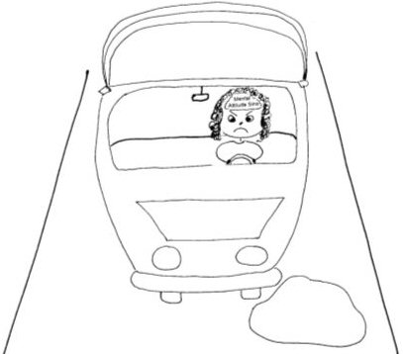

“…so then let us not sleep [spiritual sleep] as others do, but let us be alert and with a clear mind.” 1 Thessalonians 5:6

Living the spiritual life is NOT an emotional feeling…it is a THINKING PROCESS. It is thinking like Christ thinks…Bible doctrine…HIS WORD. It is using the POWER that the Holy Spirit gives us when we are in fellowship with God. However, Satan wants us to think that the Holy Spirit is something we’re supposed to feel. THAT IS NOT TRUE AT ALL!!!!! The Holy Spirit is NOT a feeling…HE is a FACT. And God will test us to see which way we will go…down the road of thought…or down the road of emotion. Which road are we going to take?
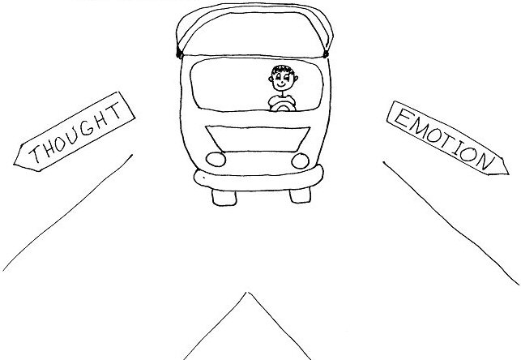
“For the righteous (believers) God tests the right lobes [minds] and the emotions.” Psalm 7:9

In our day-to-day activities we may feel emotional or we may not. As long as we are filled with the Holy Spirit and make decisions based on divine viewpoint (God’s thinking…HIS WORD in our souls), we’re on the right road!

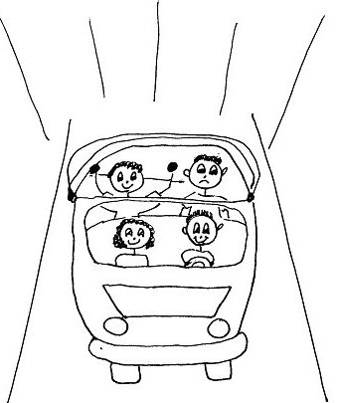
“It is the same God who brings both feast [plenty] and famine [not enough].”
Matthew 5:45

However, if we let our emotions rule our thinking all the time, then we’ll be distracted from living in the plan of God. And if we do this all the time eventually we won’t know how to think like the Jesus because we’ll be constantly out of fellowship from not confessing our sins to God. We will depend on how we feel and we’ll feel really bad from letting our emotions rule us instead of the Word of God in our souls.


“Now I urge you, brothers, keep your eye on those who cause quarrels and troubles contrary to the teaching [Bible doctrine] which you learned, and turn away from them. For such men [believers] are slaves not of our Lord Christ but to their own emotions; and by smooth and flattering speech they deceive the hearts [minds] of the unsuspecting.” Romans 16-17-18

Letting our emotions rule over us instead of our thinking can even stop us from learning (perceiving) Bible doctrine, metabolizing it (understanding and accepting as true), and applying Bible doctrine in our daily lives!

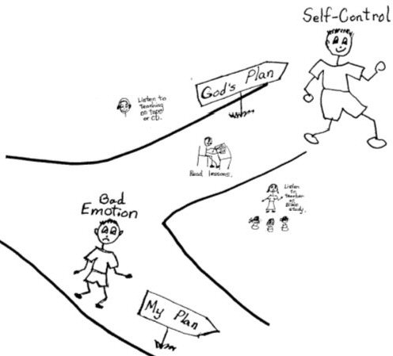
“Our mouths has spoken freely to you, O Corinthians, our heart [mind] is opened wide [metabolized doctrine]. You are not restrained [stopped from learning Bible doctrine] by us, but you are restrained in your own affections [emotions].”
2 Corinthians 6:11-12

Normal use of our emotions and the experiences we have from them happens when our emotions are under the authority of our minds! Remember, emotions were designed by God for our enjoyment and expression. They are to respond to the doctrinal viewpoint controlling the soul from God’s Word. We must ask, “What controls our souls?” and “Do you let your emotions control you?”

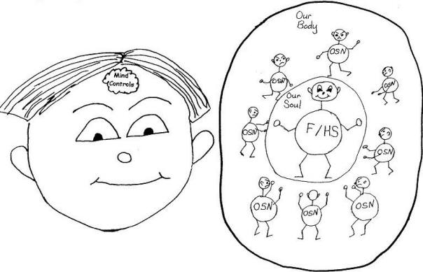

“The doctrine of the Lord is perfect, restoring the soul; the testimony [statement] of the Lord is sure, making the wise (those without Bible doctrine but with the viewpoint of the world) the foolish.” Psalm 19:7

Jesus is our best example of using thought to control emotion. He never let His emotions get in His way or take over His thought. He certainly was not having positive emotional experiences on the cross and yet He used thought to rule Himself His entire life. He led the spiritual life by what He thought!
“…fixing our eyes on Jesus, the author and perfecter of doctrine, who for the joy [+H] set before Him endured the cross, despising [disregarding] the shame, and has sat down at the right hand of the throne of God.” Hebrews 12:2

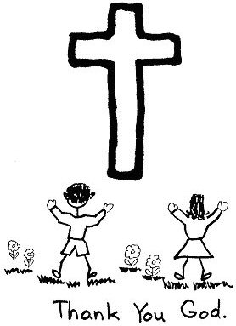
With God controlling our minds, we’ll have a safe trip through life. So, let’s put on our seat belts and speed forward with God at the wheel controlling us all the way!
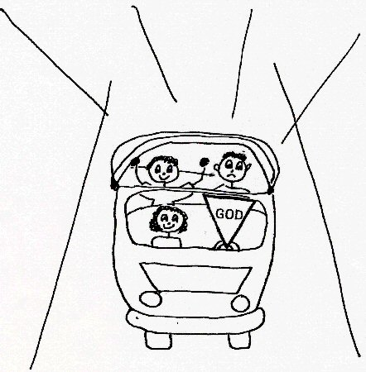

“I guide you in the way of wisdom [Christ’s thinking] and lead you along straight paths.” Proverbs 4:11
“The path of the righteous [those having virtue] is like the first gleam of dawn, shining ever brighter till the full light of day.” Proverbs 4:18

Robert McLaughlin Bible Ministries
www.gbible.org
R. B. Thieme, Jr.’s Book: Christian at Ease
&
Lighthouse Christian Youth Ministries
www.lighthousechristianyouth.org
&
lcyministry@comcast.net

From the Jr. Tree of Life

2 Pet 1:2 “Grace and peace be yours in abundance through the knowledge of God and of Jesus our Lord.”

