Lighthouse Christian Youth Ministry
Lesson 54d-Addendum 2
God has Ten Problem Solving Devices
PSD # 5 in the Line of Battle is
Doctrinal Orientation: “Newness of Life”

January 5, 2007

URGENT INFORMATION...
BEFORE we begin, if you are a believer in the Lord Jesus Christ, take a moment to name your sins to God the Father silently. This will allow you to be filled with the power of the Holy Spirit as you study or read this Bible lesson.  1 John 1:9 “If we confess our sins, He is faithful and righteous to forgive us our sins and to cleanse us from all our unrighteousness.”  Eph 5:18 And do not get drunk with wine, for that is dissipation, but be filled with the Spirit, | 
IF YOU HAVE NEVER BELIEVED IN THE LORD JESUS CHRIST as your personal Savior, you have that opportunity right now to have eternal life. We sin and cannot have a relationship with God so God’s Son, Jesus, who is God, came down to earth to become a human being just like us. He did this because He loved us so much and wanted us to live with HIM forever in heaven after we die. He lived His entire life on earth without sinning once! That qualified Him to go the cross in our place and He paid the penalty for all sin as a substitute for us. After His death He rose again and is alive right now in heaven. He opened the door for you and me to get into heaven with Him by simply believing in Him and what He did for us on the cross. So simply tell God the Father that you recognize that you are a sinner and need the Savior and believe in His son Jesus Christ as your Lord and Savior and you will be saved. If you make that decision, you are now saved and a believer and will always be a child of God. When you die, you will spend eternity with Him in heaven (Acts 16:31) (John 3:16).
"For the natural man (the unbeliever) does not accept the things (the Bible) of the Spirit of God; they are foolishness to him, and he cannot understand them, because they are spiritually understood" (1 Cor. 2:14)
"He who believes in the Son has eternal life but he who does not obey the command to believe the Son shall not see life, but the wrath of God abides on him" (John. 3:36)
We’re going to look at another side of the fifth problem solving device of doctrinal orientation…called “newness of life.” It starts with BAPTISM. Let’s look at it:
Baptism
Baptism means identification or association with something or someone. When we believe in the Lord Jesus Christ we are baptized or identified with Him. The omnipotence (almighty power) of the Holy Spirit puts us into UNION WITH CHRIST, making us a part of the Royal Family of God! We are also part of the body of Christ. What a great identity!
1 Corinthians 12:12-13 “The body is a unit, though it is made up of many parts; and though all its parts are many, they form one body. So it is with Christ. For we were all baptized by one Spirit into one body – whether Jews or Greeks [Greeks meaning anyone who isn’t a Jew], slave or free – and we were all given the one Spirit to drink.”
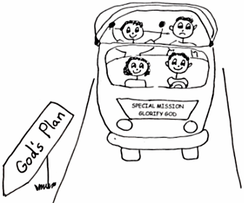
This special and close union with Christ is called positional sanctification. “What?” you say. Well, that means that God set us apart for a special purpose. Each believer has a special goal in the plan of God, in the body of Christ. We are all royal family of God with the same mission, to glorify God.
Galatians 3:28 “There is neither Jew nor Greek, slave nor free, male nor female, for you are all one in Christ Jesus.”
Ephesians 5:29-30 “After all, no one ever hated his own body, but he feeds and cares for it, just as Christ does the church - for we are all members of His body.”
Newness of Life in Christ
When we believe in the Lord Jesus Christ, we become a new person or species in Christ! We still have our old sin nature (the old person), but we can choose to live in the new person. To live in the new person you must be in fellowship or filled with the Holy Spirit. We do this by confessing or rebounding every time we sin (or at least we try to remember to do this all the time). When we do live in the new person, we are thinking like Christ and about Christ and living by His Word, Bible doctrine, our treasure chest.
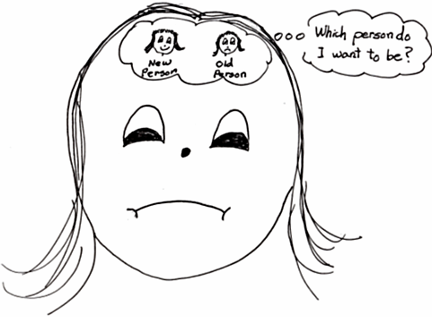
2 Corinthians 5:17 “Therefore, if anyone is in Christ, he is a new [spiritual] species. The old things (old sin nature) have lost their power; behold, new things have come.”
We have the comfort of having the Lord Jesus Christ in us forever! Christ dwells in us whether we succeed or fail. That should make us relax and not feel discouraged! Also, if we keep our eyes on the Light in us, on the King of Glory, Jesus, we won’t have time to focus on our old sin nature. We will take our eyes off of ourselves and our OLD nature. We will put our eyes on the NEW nature in us, the very nature of Jesus Christ, which is perfect and holy and beyond being scolded. What a blessing! What a sight!
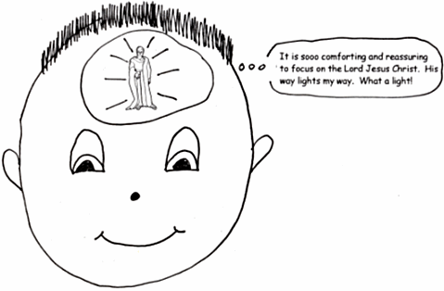
Romans 8:1 “Therefore, there is now no condemnation [guilt] for those who are in Christ Jesus, because through Christ Jesus the law of the Spirit of life set me free from the law of sin and death.”
It is easy to get caught up in the daily activities and lose sight of our #1 priority, the Lord Jesus Christ. We need to put ourselves in a place where we can focus on TLJC. We need to let God, in His almighty power, throught the Holy Spirit in us, make our new person grow up and become a mature believer. How exciting of an adventure is that??
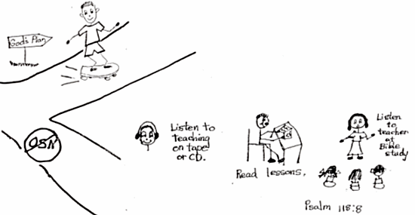
2 Corinthians 2:18 “But we all, with unveiled faces beholding as in a mirror the glory of the Lord, are being transformed into the same image [Jesus] from glory [Shekinah Glory] to glory [momentum of the believer], just as from the Lord, the Spirit [the Holy Spirit enables us to execute the protocol plan of God].”
In our “newness of life” in Christ, we are God’s children and His heirs! Everything belongs to Christ, and because we are IN HIM we share in everything that belongs to Him. Also, since we are in this special family, God has a plan for our lives (personal sense of destiny) that would blow us away if we could see it! And you can see it and experience it by living in God’s personal plan for your life. I’m sure glad that God is our Father!
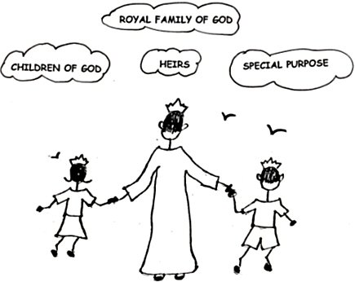
Romans 8:16-17 “The Spirit Himself testifies with our spirit that we are God’s children. Now if we are children, then we are heirs – heirs of God and co-heirs with Christ, if indeed we share in His sufferings in order that we may also share in His glory.”
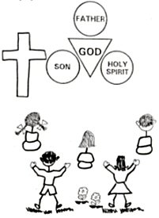
It doesn’t stop there! We have our very own priesthood. We are in the priesthood of the Lord Jesus Christ! Before the Church Age, believers had to have a person (priest), chosen by God, offer prayer and sacrifices to God for them. These rituals (ceremonies) were to teach about the coming of Jesus as the Savior or Messiah of the world in the Old Testament times. Since Jesus, our High Priest, was sacrificed on the cross for all sins, we don’t have to make anymore sacrifices to God. Jesus did it all! He was the supreme sacrifice. We each are now our own priest. We can go directly to God in prayer all by ourselves! God’s help is available to us twenty-four hours a day and He never runs out of what we need! We don’t even have to pay for what He gives us! It’s free! It’s all given by God in grace.
Hebrews 10:11-14 “Day after day every priest stands and performs his religious duties; again and again he offers the same sacrifices, which can never take away sins. But when this Priest (the Lord Jesus Christ) had offered for all time one sacrifice for sins (on the cross), He sat down at the right hand of God. Since that time He waits for His enemies to be made His footstool, because by one sacrifice He has made perfect forever those who are being made holy (that’s us in the Church Age).”
Satan doesn’t want us to know about our position in Christ. He doesn’t want us to know about our “newness of life” in Christ. He knows that if we don’t know about this position, then we will struggle in our condition. It is “having faith” in the doctrines of our position that gives us the momentum and the divine energy to grow in our condition.
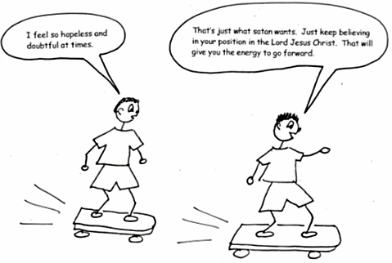
Galatians 2:16 “…know that a man is not justified by observing the law, but by faith in Jesus Christ. So we, too, have put our faith in Christ Jesus that we may be justified by faith in Christ and not by observing the law, because by observing the law no one will be justified.”
The law they are talking about is the Mosaic Law of the Old Testament times which included the Ten Commandments. Most people today think that if they obey all the of these they will go to heaven BUT that is a LIE from Satan himself!!! Everyone has sinned and NO ONE EVER kept all these commandments.
Rom 3:23 “…for all have sinned and fall short of the glory of God.”

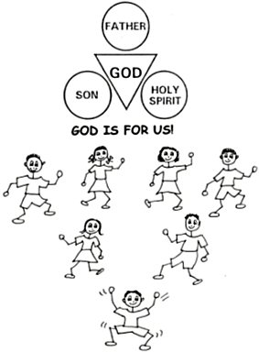
God completely accepts us because of our position in Christ. If we are not aware of this, we get caught up in the struggle, and I mean struggle, to improve our condition in order to feel accepted by God. Then we are working in our own energy instead of in the power of the Holy Spirit, it makes me exhausted just thinking about it. Because of our position in Christ, we have divine energy and divine acceptance and we can produce divine good…the fruit of the Spirit! “If God is for us who can be against us?” Let’s live in the “NEWNESS OF LIFE” IN CHRIST!

John 3:30 “He must increase, but I must decrease.”
We have been made royalty with the Lord Jesus Christ. He is the Shekinah (invisible) Glory and the Lord Jesus Christ is in us. This is a sign to us of our position in Christ, our seat on the throne in heaven. We are kings and queens in Christ! We share Christ’s throne in heaven! Let’s focus on the power of the Shekinah Glory in us, and we will be able to live in this “newness of life” that God has designed for us!!!
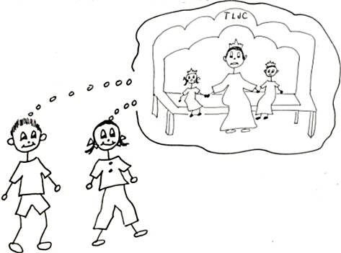
Ephesians 2:6-7 “…and raised us up with Him, and seated us with Him in the heavenly places, in Christ Jesus, in order that in the ages to come He might show the surpassing riches of His grace in kindness toward us in Christ Jesus.”

Robert McLaughlin Bible Ministries
www.gbible.org
R. B. Thieme, Jr.’s Book: Christian at Ease
&
Lighthouse Christian Youth Ministries
www.lighthousechristianyouth.org
&
lcyministry@comcast.net

From the Jr. Tree of Life

2 Pet 1:2 “Grace and peace be yours in abundance through the knowledge of God and of Jesus our Lord.”

