Lighthouse Christian Youth Ministry
Lesson 54d-Addendum 3
God Has Ten Problem Solving Devices
PSD # 5 in the Line of Battle is
Doctrinal Orientation: Living with Virtue and Integrity

January 19, 2007

Living with Virtue and Integrity
versus
Living without Virtue and Integrity:
The Choice Is Ours

VIRTUE means goodness and excellence. It is the visible sign of what is invisible in the believer, Bible doctrine and the power of the Holy Spirit. It can only be manufactured through God’s laws (the laws of divine establishment*), learning Bible doctrine, and living the spiritual life inside of the plan of God.
God has made certain laws for the survival and freedom of the human race during the course of human history.
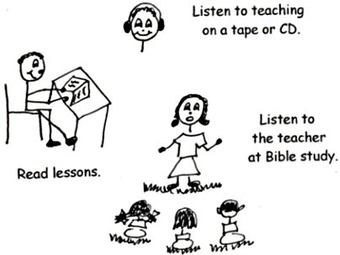
“Behold, You do desire truth in the innermost being, [the inner man] and in the hidden part [inner man] you will make me know wisdom.” Psalm 51:6

When we live with virtue from Bible doctrine in our souls we use impersonal love toward others no matter how they treat us. Impersonal love reflects the inner you, which is your honor and good character that you have developed from studying the word of God daily. Impersonal love doesn’t reflect the character of the person you love. You may not personally love someone at a certain time because of the way he or she acts toward you or others. However, you can love them with impersonal love if you have the filling of the Holy Spirit and Bible doctrine in you soul. That is what must be reflected in you! That reflects the thinking of the LJC.
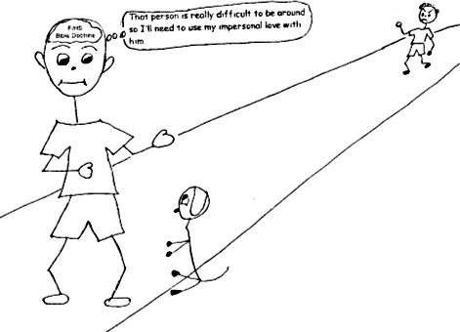
“For God so loved the world [impersonal love] that He gave His one and only Son, that whoever believes in Him shall not perish but have eternal life.” John 3:16

Living without virtue from Bible doctrine in our souls means we don’t use impersonal love. Those who don’t use impersonal love rely on their own power and human viewpoint and feelings. They find it very difficult to get along with people. Let’s face it. There are many people who do things that we don’t like, including ourselves!
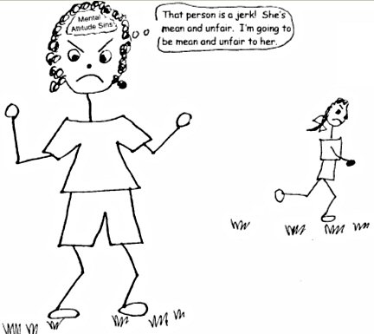
“Bear with each other and forgive whatever grievances [complaints] you may have against one another. Forgive as the Lord forgave you. And over these virtues put on love [impersonal love], which binds them all together in perfect unity.” Colossians 2:13-14

Living with our integrity means we use the Bible doctrine in our souls. When we use our integrity (honor, virtue, good character, or righteousness) it means we are thinking like Christ and His Word and doing as Jesus asked us to do…to love one another as He loves us.
Integrity comes from the spiritual strength we have in the power of the Holy Spirit and the doctrine in our souls in every situation. It is especially necessary to use it in pressure situations. Integrity is walking in the pre-designed plan of God for your life, and allowing doctrine to speak to you and guide you in your mind, which is your thinking. It means trusting in God’s Word in ANY situation, and trusting in the Lord without having doubts about it. It means having the spiritual strength to apply Bible doctrine in your soul in every situation in life, and also having the “faith-rest” to leave them in the hands of our Father in the Supreme Court of Heaven especially when you are being mistreated.
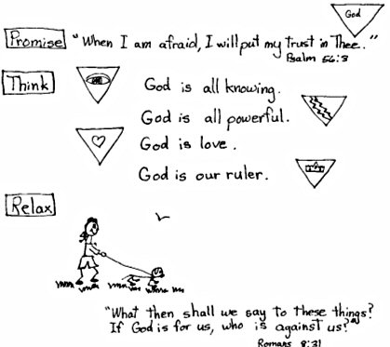
“Vindicate me [clear me from blame], O Lord, for I have walked in my integrity; and I trusted in the Lord without hesitating [indecision].” Psalm 26:1
“He who walks with integrity, and produces divine righteousness (good), speaks truth [or doctrine] in his heart [mind].” Psalm 15:2

When we live without integrity, we don’t apply Bible doctrine in pressure situations. We panic and get out of fellowship with God and God’s plan for our lives. When we panic and worry it we sin and don’t have the power of the Holy Spirit and it shows that we don’t trust God’s Word in these kinds of situations. We don’t have the spiritual strength to apply Bible doctrine to our problems! We keep them in our hands rather that handing them over to God and using the faith-rest drill. What a mess we make! This kind of thinking only makes the situation or situations worse!
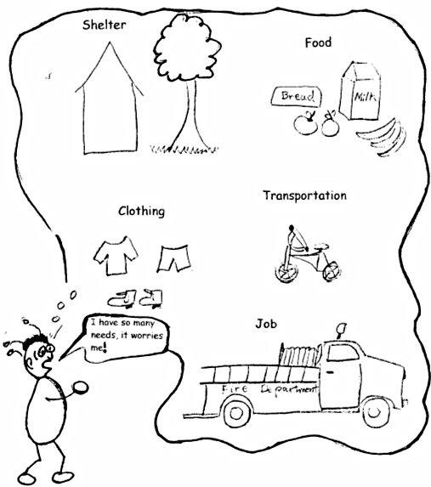
“Lo, God will not reject a man of integrity, nor will He support the evildoers.” Job 8:20
When we live with virtue and integrity, we don’t blame others for our problems. We take the responsibility for our own decisions. We make decisions from a position of strength, which is God’s Word in our souls, and go forward in the plan of God. We replace blaming others with claiming God’s grace, thanking Him for who we are and what we have as a gift of His grace.
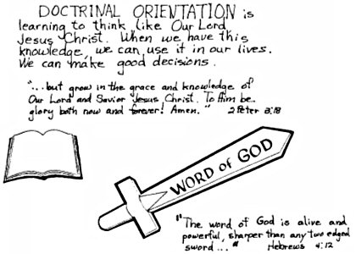
“But by the grace of God I am what I am, and His grace to me was not without effect [result].” 1 Corinthians 15:10
“It is God Who arms me with strength and makes my way perfect.”
2 Samuel 22:33
“I can do everything through Him Who gives me strength.”
Philippians 4:13
Living without Virtue and Integrity
We Play the Blame Game
When we are living without virtue and integrity we play the blame game. Everyone else is the cause of our problems. However, God knows us inside and out, or He can see right through us. We can’t blame others to make ourselves feel better because God can’t be fooled! We don’t need to blame others because it isn’t about our sins. They’ve been judged! It’s about our salvation and deliverance. God wants us to have the best. We may put ourselves down, but He never does. His mercy and grace are abounding, they go on forever!!!

“For the Word of God is alive and powerful. Sharper than any double-edged sword, it penetrates [deep] even to dividing soul and spirit, joints and marrow; it judges the thoughts and attitudes of the heart [mind]. Nothing in all creation is hidden from God’s sight. Everything is uncovered and is laid bare before the eyes of Him to Whom we must give account.” Hebrews 4:12-13
“Set your mind on the things above [God’s viewpoint], not on the things that are on earth [human viewpoint and unfairness].” Colossians 3:2
When we live with virtue and integrity we have the right focus…that is we focus on the good (plan of God), on God and His just treatment of us. Jesus concentrated on the justice of God while He was being treated unfairly. He had the right focus. We focus on the Lord Jesus Christ as our role model. We don’t feel let down because we trust in the Lord. We can count on His constant acceptance and understanding!
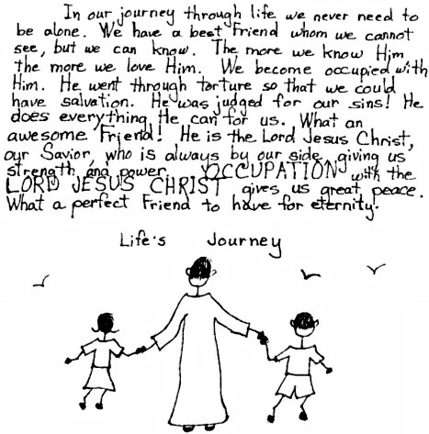
“The Lord is my light and my salvation; whom shall I fear? The Lord is the defense of my life; whom shall I dread?” Psalm 27:1
“Finally, brothers, whatever is true, whatever is noble [respectful], whatever is right, whatever is pure, whatever is lovely, whatever is admirable – if anything is excellent or praiseworthy – think about these things. Whatever you have learned or received or heard from me, or see in me – put it into practice. And the God of peace will be with you.”
Philippians 3:8-9
If we are living without virtue and integrity, we don’t have the right focus. Instead we focus mainly on ourselves and the unjust treatment we think that we receive. We feel that life has let us down when in reality we have let ourselves down. We have put ourselves into a rut of self pity and selfishness. Then we may say, “life is the pits!” We feel that life is unfair and we get into self-pity…a dead end with God who gives us all things freely. What a pity if we have the wrong focus!
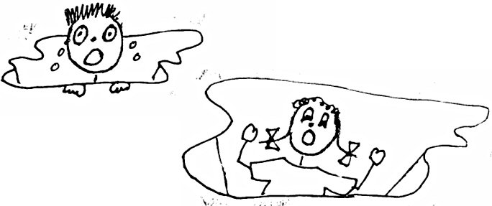
“Remember the word that I said to you, ‘A slave is not greater than his master.’ If they persecuted Me, they will also persecute you…”
John 15:20
“…Who redeems your life from the pit and crowns you with love and compassion…” Psalm 103:4
When we live with virtue and integrity, we live in God’s righteousness. God is awesome! His love for us is magnificent! At salvation, He gave us His righteousness, +R, which is divine integrity. Since we have +R, God is able to bless us. It was freely given to us; we don’t have to earn it. When we understand, believe and use Bible doctrine, we build up capacity (room in our souls) for blessing. Then God blesses the +R in our souls…that’s the target for blessing NOT OUR WORKS. We are living in the perfect righteousness of God. We are living in the righteous Word of God, the fair and honorable Word of God and in HIS GRACE, which blesses us through the +R in our souls and the power of the H. S.
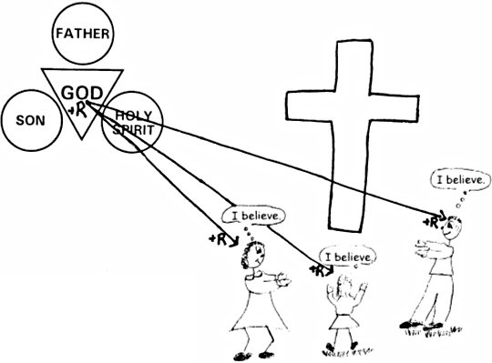
“For surely, O Lord, You bless the righteous; You surround them with Your favor as with a shield.” Psalm 5:11
“Lo, God will not reject a man of integrity, nor will He support the evildoers.” Job 8:20
Living without virtue and integrity means we reject God’s way of living in His righteousness. Sometimes we don’t live in +R. Sometimes we fail to understand, believe, and use Bible doctrine. We don’t let God bless us as much as He could because we don’t have the capacity or room in our souls. We are not living in the righteous Word of God, the fair and honorable Word of God. In that case we forget to rebound or confess our sins and we lose out on His blessings now and in eternity. What a downer for us!
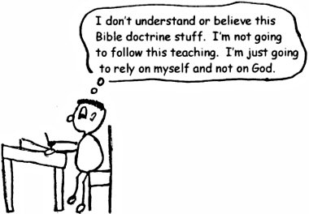
“Woe [trouble, sorrow] to him who builds his house without righteousness and his upper rooms without justice.” Jeremiah 22:13a
Let’s summarize: Living with virtue and integrity means:
We use impersonal love.
We use Bible doctrine.
We don’t play the blame game.
We have the right focus.
We live in God’s righteousness.
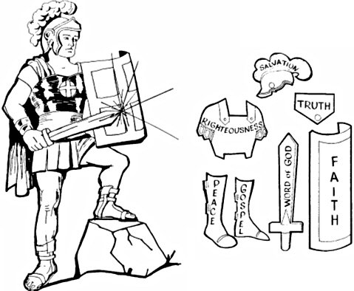
“Stand firm therefore, having girded your loins [made yourself strong] with truth and having put on the breastplate of righteousness (+R)…”
Ephesians 6:14
2 Peter 1:3-11
“His divine power has given us everything we need for life and godliness [spiritual living…Plan of God] through our knowledge of Him Who called us by His own glory and goodness [virtue, excellence]. Through these [His glory and virtue] He has given us His very great and precious promises, so that through them you may participate in the divine nature and escape the corruption in the world caused by evil desires.
For this very reason, make every effort to add to your faith [doctrine] goodness [virtue]; and to virtue, knowledge; and to knowledge, self-control; and to self-control, perseverance (staying with it); and to perseverance, godliness [spiritual living in the Plan of God]; and to godliness, brotherly kindness; and to brotherly kindness, love [virtue love or impersonal love]. For if you possess these qualities in increasing measure, they will keep you from being ineffective and unproductive in your knowledge of our Lord Jesus Christ. But if anyone does not have them, he is nearsighted and blind, and has forgotten that he has been cleansed from his past sins.”
Robert McLaughlin Bible Ministries
www.gbible.org
R. B. Thieme, Jr.’s Book: Christian at Ease
&
Lighthouse Christian Youth Ministries
www.lighthousechristianyouth.org
&
lcyministry@comcast.net

From the Jr. Tree of Life

2 Pet 1:2 “Grace and peace be yours in abundance through the knowledge of God and of Jesus our Lord.”

