Lighthouse Christian Youth Ministry
Lesson 54d Addendum 4

God has Ten Problem Solving Devices
PSD # 5 in the Line of Battle is

Doctrinal Orientation – “Who’s In Charge-God?”

February 23, 2007

The Authority of God – His Sovereignty
God makes all the rules for us to follow because He wants the best for us.
Psalm 119:105 “Your Word is a lamp to my feet, and a light to my path.”

If we don’t follow God’s rules, in His perfect justice He disciplines us because He loves us. God wants us to get on the right path!
Heb 12:6 “For those whom the Lord loves He disciplines and He scourges (whips) every son whom He receives."

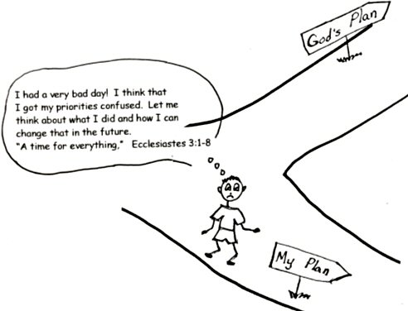
1 John 1:9 “If we confess our sins, He is faithful and just, and will forgive our sins and cleanse us from all wrongdoing.”
Authority of Dad and Mom: God gave us parents to help us learn.

Ephesians 6:1-3 “Children, obey your parents in the Lord, for this is right. “Honor your father and mother… that it may be well with you and that you may live long on the earth.
Others Who Have Authority Over us
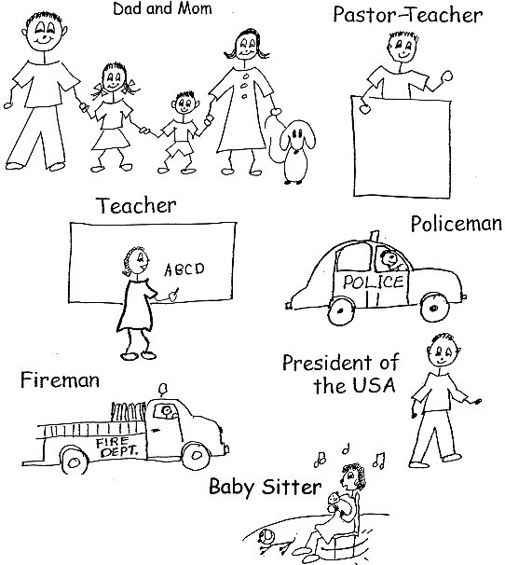
God Has Authority Over the Universe
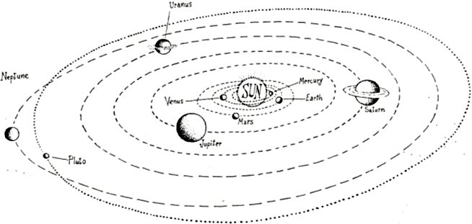
Deuteronomy 4:39 “Know therefore today, and take it to your heart, that the Lord, He is God in heaven above and on the earth below; there is no other.”

The Authority of Sovereignty of God
God is first of all…sovereign…that is, God has the highest authority. He is Ruler over all creation and HE has the highest volition. His volition has always existed, and there is no higher volition in the universe. It is SUPREME! As Sovereign, God is the Supreme Being and Ruler of the universe:

1 Sam 2:6-8 "The Lord brings death and makes alive; He brings (them) down to the grave and raises (them) up”. (7) “The Lord sends poverty and wealth; He humbles and He exalts.” (8) “He raises the poor from the dust and lifts the needy from the ash.”
1 Chronicles 29:11 “Yours, O Lord, is the greatness and the power and the glory and the majesty and the splendor, for everything in heaven and earth is yours. Yours, O Lord, is the kingdom; you are exalted as head over all.” 2 Chronicles 20:6 “and said: "O Lord, God of our fathers, are you not the God who is in heaven? You rule over all the kingdoms of the nations. Power and might are in your hand, and no one can withstand you.” Psalm 83:18 “Let them know that you, whose name is the Lord…that you alone are the Most High over all the earth.” Isa 45:5-6 “I am the Lord, and there is no other; apart from me there is no God. I will strengthen you, though you have not acknowledged me, (6) so that from the rising of the sun to the place of its setting men may know there is none besides me. I am the Lord, and there is no other.” Acts 17:24 “The God who made the world and everything in it is the Lord of heaven and earth and does not live in temples built by hands.”

He is the King of heaven and earth. Ps 47:2 “ How awesome is the Lord Most High, the great King over all the earth!” Ps 93:1 “ The Lord reigns, He is robed in majesty; the Lord is robed in majesty and is armed with strength. The world is firmly established; it cannot be moved.”

In this verse the Bible speaks about the Sovereignty of our Lord, Jesus Christ.
Heb 8:1 “The point of what we are saying is this: We do have such a High Priest, who sat down at the right hand of the throne of the Majesty in heaven.”

Rev 4:2-3 “and ‘At once I was in the Spirit, and there before me was a throne in heaven with someone sitting on it. (3) And the One who sat there had the appearance of jasper and carnelian. A rainbow, resembling an emerald, encircled the throne.’ ”

As our sovereign (Ruler), He is eternal (no beginning and no end) and infinite (everywhere). The Bible teaches us about God’s will for us and it is perfect. Isa. 46:10 “My counsel shall stand, and I will do all my pleasure.” Eph 5:1 “Be imitators of God, therefore, as dearly loved children.” God’s pleasure results in a plan for all mankind…that’s you! Psa 24 and John 3:16 “For God loved the world so much He gave is uniquely born Son, that whoever believes in Him shall never die.” Heb 6:17 “ Because God wanted to make the unchanging nature of His purpose very clear (provide salvation for everyone) to the heirs of what was promised (Jesus Christ the Savior), He confirmed it with an oath.” God guaranteed it!

God will never use His absolute sovereign will to force anyone to obey Him. He can’t do that because HE gave us freedom to choose on our own…otherwise we’d all be His robots. God didn’t want that. He wants us to choose Him and His plan for our lives because we want to! If HE made us choose Him, this would not be in harmony with His “Divine Decree.” That’s a fancy way of saying God’s rules. In eternity past, God had and “Eternal Life Conference.” That’s when He, Jesus, and the Holy Spirit decided that they would create mankind with total free will just like the angels. In fact He did this to solve the Angelic conflict or war.

God honors your decisions, whether they are for Him or against Him (positive or negative). He took all of mankind’s decisions and put them into the “Divine Decree” (Eternal Life Conference). That’s right. He put only those decisions we make of our own free will…our choices. And He used that free will in His supreme genius to see that His plan goes exactly the way HE wants it to go. As far as the believer is concerned, God has a plan for each of our lives…to study Bible doctrine, under the grace He provides through a Pastor/Teacher, the filling of the Holy Spirit, and positive volition (wanting to study His Word and believing what you have studied). When you believe His Word, it transfers into your human spirit and the mentality of your soul so you can use it in any situation you have in your life. You can choose to accept His will and move on into a fantastic “Super Grace” life in which God pours out His blessings.

James 4:6 “But He gives us super abundant grace. That is why Scripture says: "God opposes the proud but gives grace to the humble (those believers who obey His Plan)."

Or you can choose to go against that will and wind up under divine discipline. Heb 12:6 “…because the Lord disciplines those He loves, and He punishes everyone He accepts as a son (believers in Christ)."

As far as mankind is concerned, God’s authority and sovereign will is that all mankind should be saved. 2 Pet 3:9 “The Lord is not slow in keeping His promise, as some understand slowness. He is patient with you, not wanting anyone to perish, but everyone to come to repentance (a change of mind about the Lord Jesus Christ).”
Rev 22:17 “The Spirit…says, "Come!" And let him who hears say, "Come!" Whoever is thirsty, let him come; and whoever wishes, let him take the free gift of the water of life.” Those who obey God’s will for salvation and believe in Jesus Christ receive eternal life, those who reject Him, receive punishment after they die forever and ever. John 3:36 “He that believes on the Son has eternal life: and he that does not believe does not have life but the wrath of God abides on him.” So it is necessary for man to put his trust in Christ to be saved. The fact that God knows already who will believe in Christ and who will not, does not change the fact that man is free to choose. It is also true that God that God will continue to some point to work on human thinking to accomplish His will. Philip 2:13 “…for it is God who works in you to will and to act according to His good purpose (plan).” However, He only urges or shows us the need for salvation but never goes so far as to force a person to believe in Jesus as Savior. That would totally go against His integrity (that is His perfect righteousness and His justice…His perfect Holiness). Even though God permits mankind to choose his own way, whether good or evil, His authority always rewards the believer for every work of divine good that he or she produces from the filling of the spirit and punishes every wicked act (human good produced out of fellowship). All human good will be burned at the evaluation seat of Christ and all divine good will be rewarded.

What will it be for you? Are you going to obey the God’s authority in every way, stay filled with the Holy Spirit and produce divine good? OR are you going to disobey God’s authority and produce human good and evil that will be burned at the big bonfire at the evaluation seat of the Lord Jesus Christ?

DIVINE GOOD or HUMAN GOOD Check one box.
Robert McLaughlin Bible Ministries
www.gbible.org
R. B. Thieme, Jr.’s Book: Christian at Ease
&
Lighthouse Christian Youth Ministries
www.lighthousechristianyouth.org
&
lcyministry@comcast.net

From the Jr. Tree of Life

2 Pet 1:2 “Grace and peace be yours in abundance through the knowledge of God and of Jesus our Lord.”

