Lighthouse Christian Youth Ministry Lesson 54f
God Gave Us Ten Problem-Solving Devices
PSD # 7 in the Line of Battle Is

Personal Love for God the Father

March 18, 2007

I John 1:9 “If we confess our sins, he is faithful and just and will forgive us our sins and purify us from all unrighteousness.”

We have a Father in Heaven who loves us with a perfect and infinite love. That means this love never ends…it goes on forever! In fact, the Father’s love is like Him, it has no beginning and no end. We can’t even imagine how much love that is! When we were unbelievers though, God loved us with “impersonal” love NOT personal love because sin put a barrier between us. This means that God loved us when we were unbelievers this way because of His perfect righteousness or goodness. But with this impersonal love, the Father gives all unbelievers the Gospel to believe in our LJC and then once they believe they receive His PERSONAL love. So now that we are believers, He loves us with His PERSONAL love. He loves us because of what we have in our souls…HIS righteousness (+R) and goodness. When we believed in Jesus Christ as our Savior, God gave us HIS righteousness (+R). Now that we have God’s perfect righteousness or goodness in our souls God made each of us a new man because of His +R and goodness.
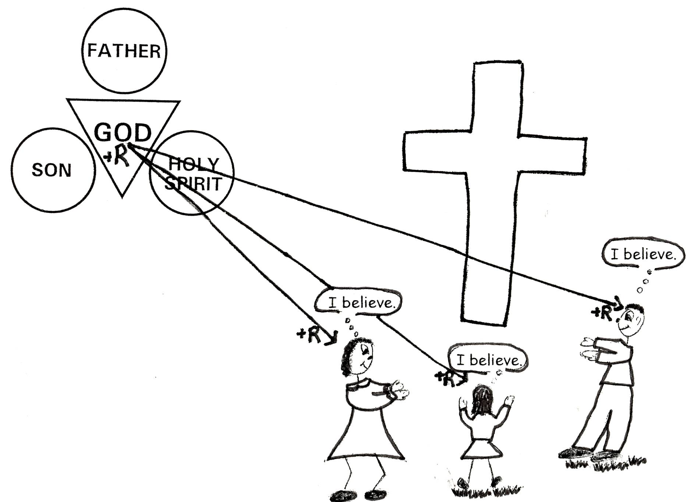

Romans 5:5 “And hope does not disappoint us, because God has poured out His love into our hearts [minds] by the Holy Spirit, Whom He has given us.” (He gives us the Holy Spirit who teaches us Bible doctrine and makes us understand it.) Rom 4:5 “But to the one who does not work (human works for salvation), but believes in Him who justifies the ungodly (unbelievers), his faith is credited as righteousness (+R)…” 2 Cor 5:21 “He made Him (the LJC) who knew no sin to be sin on our behalf, so that we might become the righteousness (+R) of God in Him.”

We love God because He first loved us! There is so much in God the Father for us to love. In order to love HIM personally, we have to study His Word. When we get to know Him through His Word, we learn about His nature or character. As we grow spiritually we know lots and lots about Him and we begin to love Him because of WHO HE IS and for ALL He has done for us. When you love someone personally it is usually because you got to know that person and loved the things about that person. In other words that person becomes worthy of your love and they are the object of your love. So, too, with God…we begin to love God with personal love when we get to know all about His character or nature. We learn that He has awesome qualities and awesome virtues! * These qualities and virtues are called His *attributes, *character, *nature, or *essence and He directs them toward us!

He is so worthy of our love! He has done everything to deserve our love. He gave His Son, the Lord Jesus Christ, to be our Savior! He is the Author of the predesigned plan for our lives, and gives us everything that we need to live and grow in His plan. He wants us to grow in His grace and knowledge. God loves us personally, and He wants us to know and love Him personally.

Before we believed in Jesus, He loved us impersonally and gave us the Gospel. That’s so we would believe in His Son and receive His +R and then also at the same moment we receive His personal love because we are now His children. Look at the following verses and see how he loved us before we became believers.
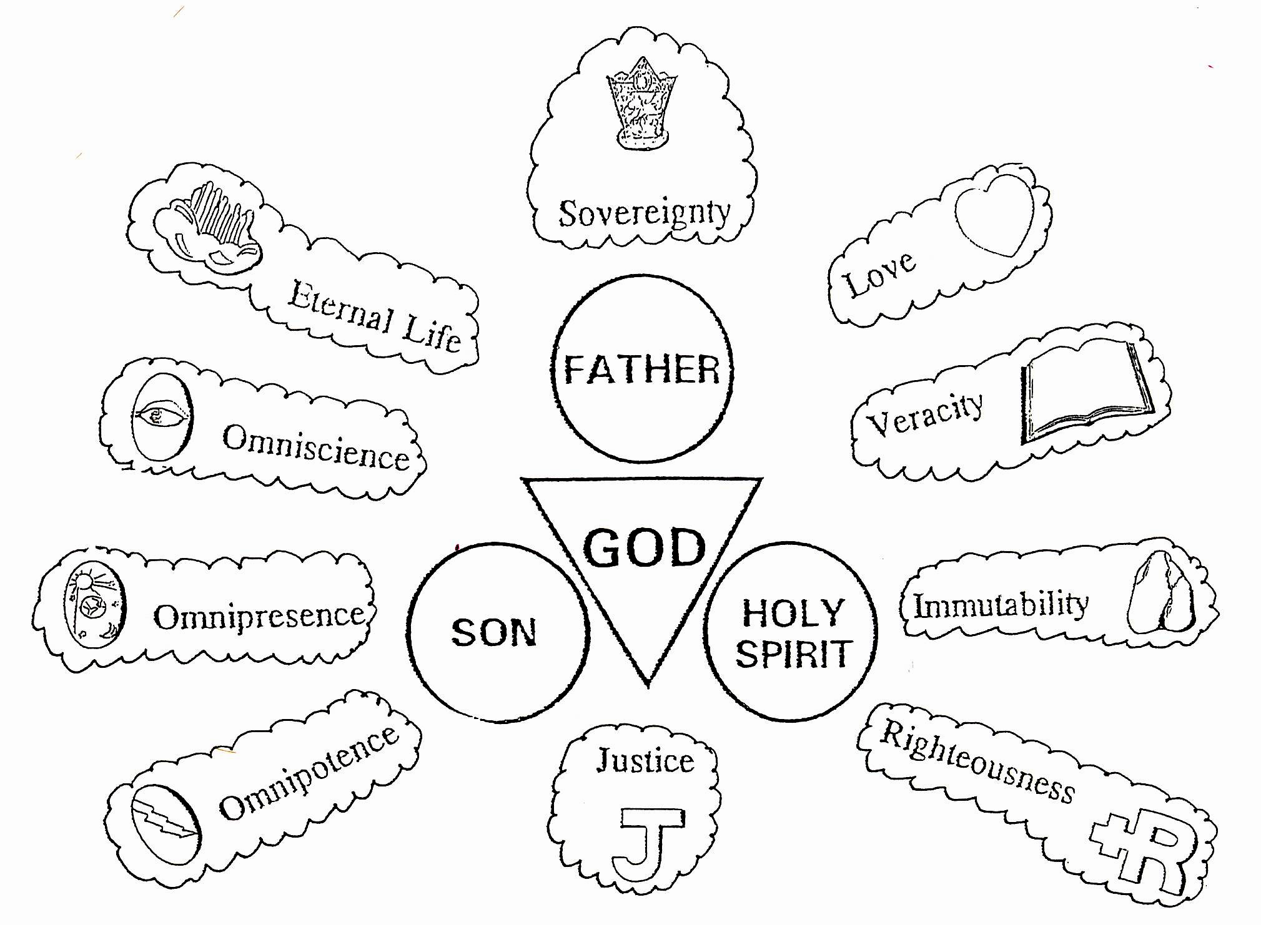
1 John 4:19 “We love Him because He first loved us.”

John 3:16 “For God so loved the world, that He gave His only begotten Son, that whosoever believeth in Him should not perish, but have everlasting life.”

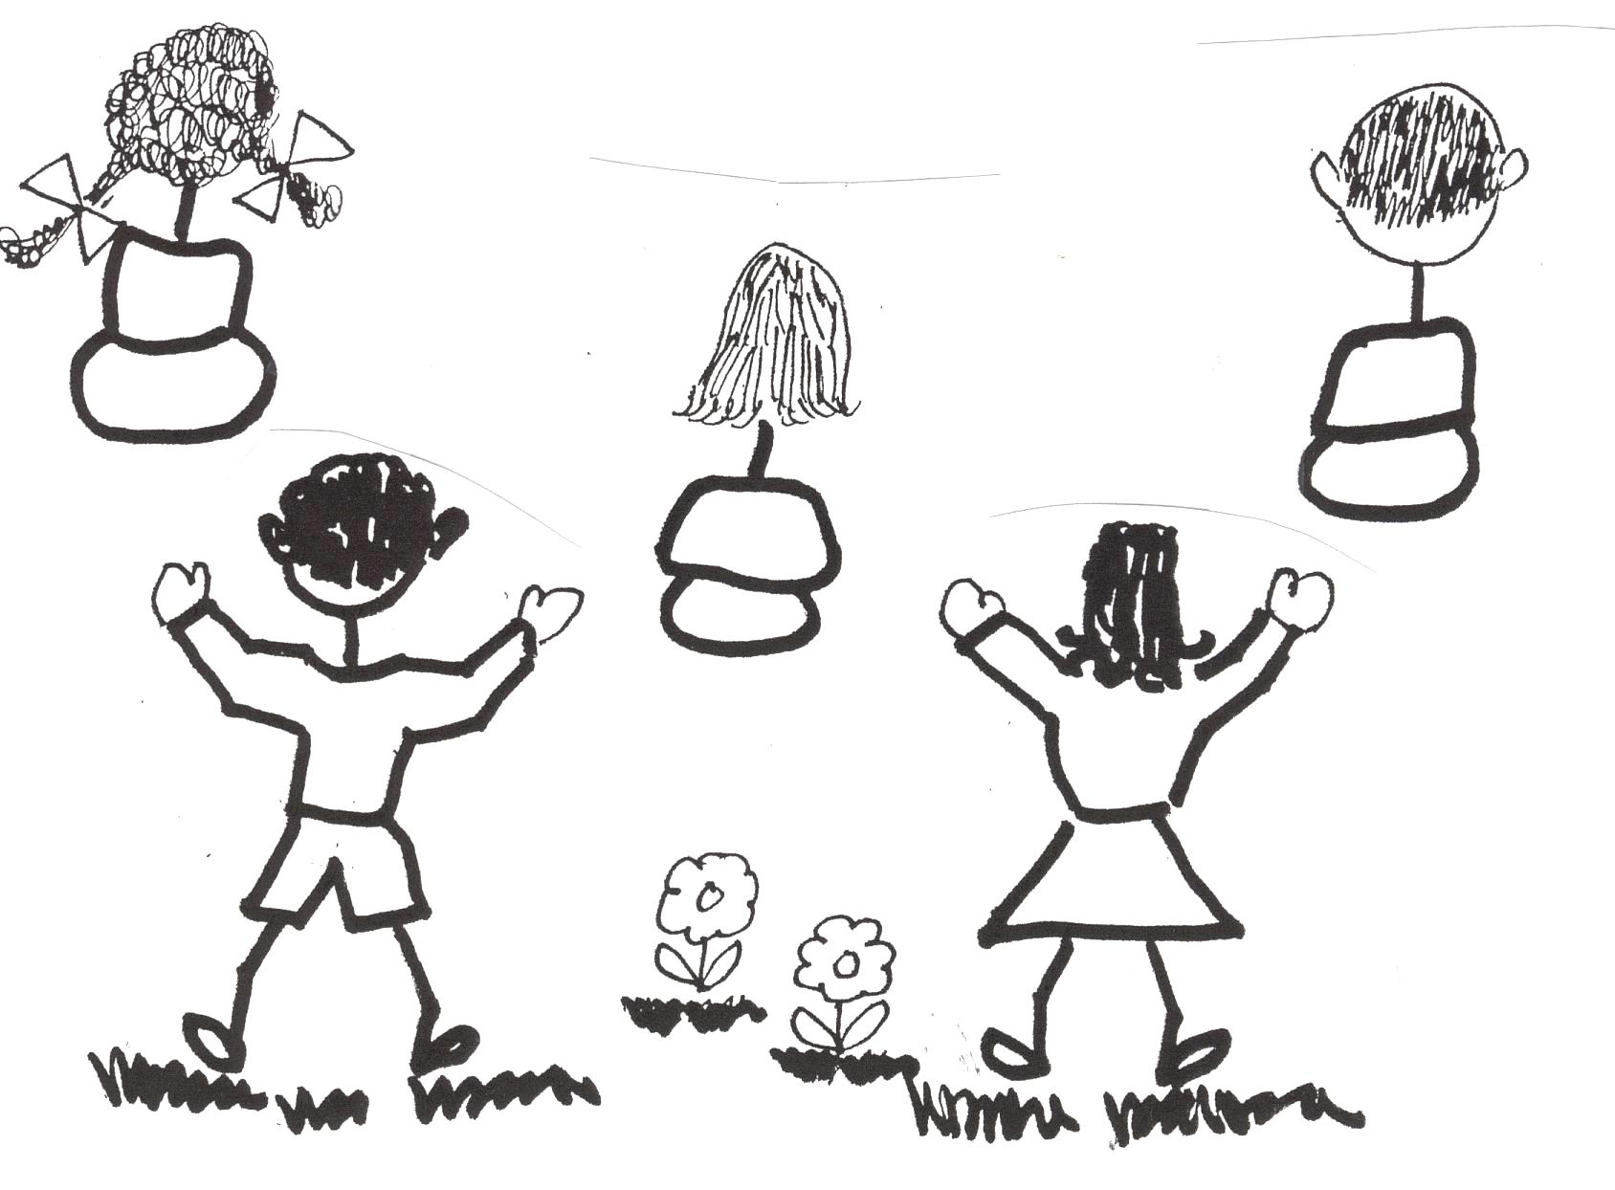
Once we have accepted God’s grace gift of salvation through our LJC, we became His children. And as His children we are now set apart (sanctified) for God so that we can live in His plan that He has for each of us. We’re in UNION with His Son, the Lord Jesus Christ and part of the body of the Lord Jesus Christ. We are IN HIM and have a new nature because of +R in our souls from believing in HIM.

We still have our old sin nature and we will struggle with it until the day we die. But it is our “new” nature that we want to enjoy.

Let’s live in God’s gracious plan for our lives and grow in personal love for God the Father. We can NEVER love Him the way we are supposed to love Him personally until we KNOW Him and the ONLY way to know Him is through KNOWLEDGE of His Holy Word.

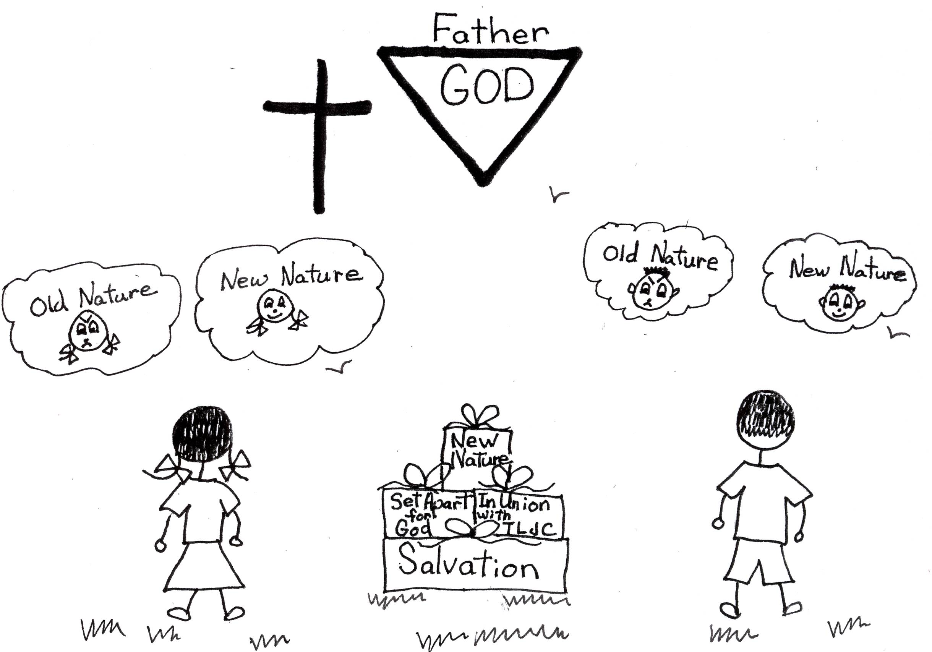

John 17-17 “Sanctify them (set them apart) by the truth; your word is truth.”

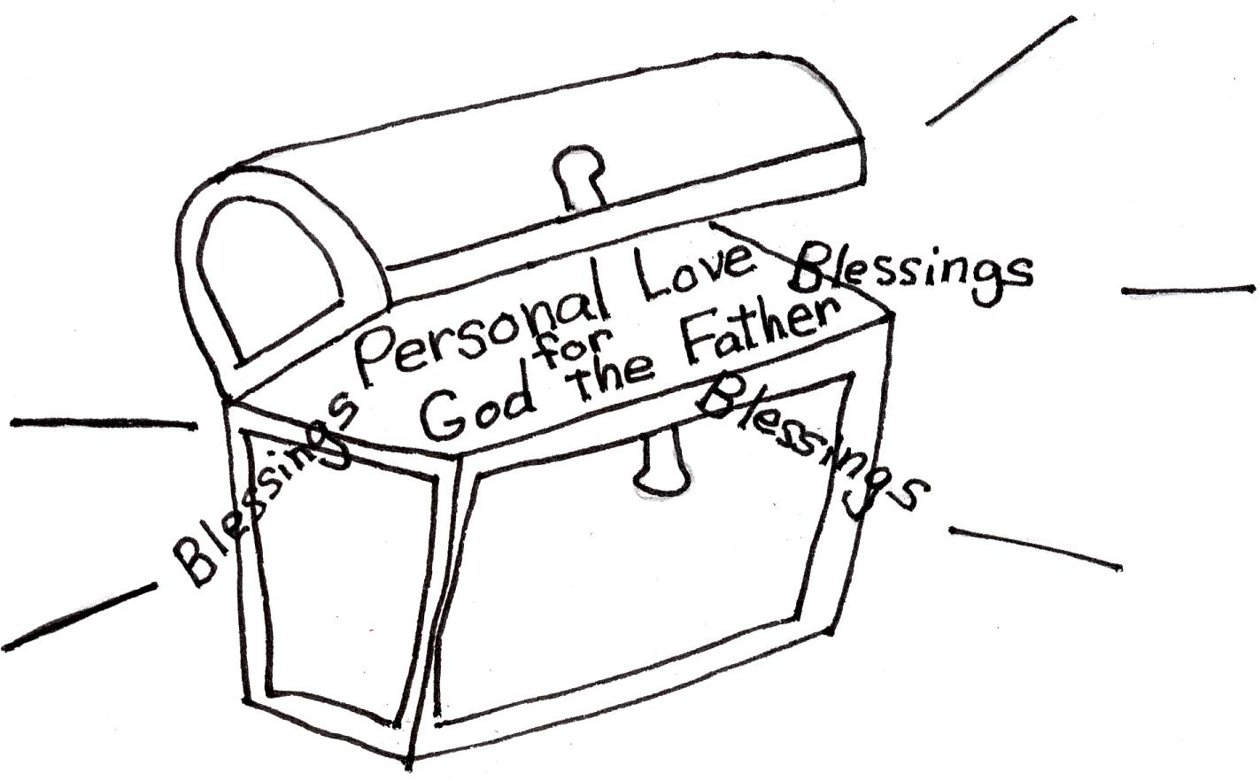
In our new nature, we are perfect (+R), and we can’t make our new nature anymore perfect than it was when we got it. However, we can increase our capacity or ability to enjoy and give thanks for all of the blessings God has waiting for us. Our old sin nature will always be with us. It will try to get us out of God our Father’s plan so that we won’t receive the blessings He has waiting for us. We can look at it this way. God has our blessings waiting for us in a big treasure chest. We just have to open the treasure chest by learning, believing, and using Bible doctrine. The more doctrine we believe and use, the more capacity or ability we will have to enjoy God’s grace blessings. We will be more grateful to Him. We will also learn about Him and grow in our appreciation and love for Him. We will have a special love, personal love for God the Father. What a treasure!


Romans 8:28 “And we know (through Bible doctrine) that God works all things together for good to those who love God, to those who are called according to His purpose (Plan of God).”

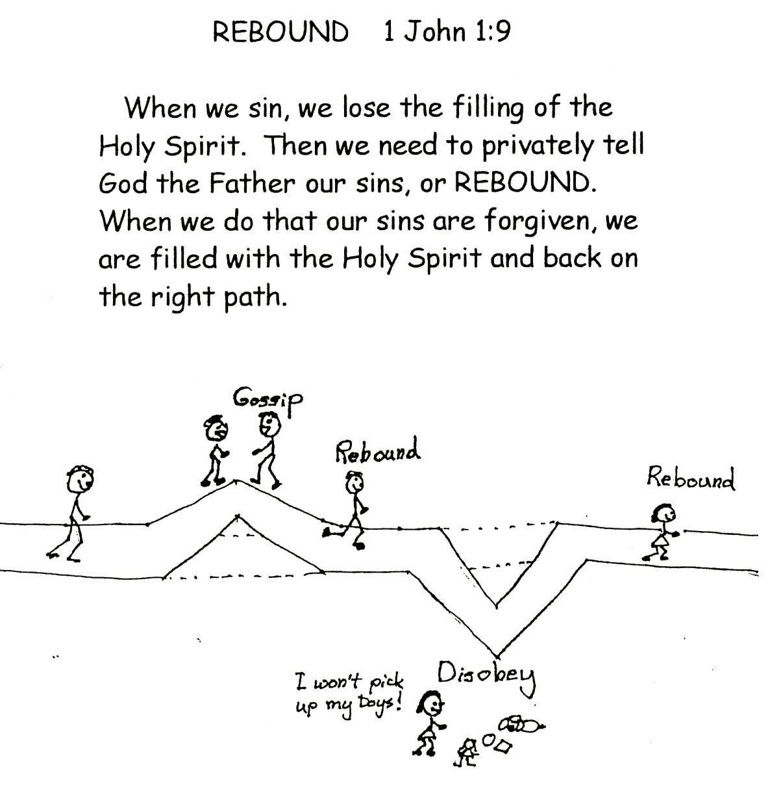
The Holy Spirit is the power we need to make us grow in the spiritual life. He is the One who teaches us about the personal love God has for us through the Word and then that eventually brings us to personal love for God the Father. God throws the ball of love to us, and then we learn to throw it back to Him. What a great game of catch! Since the Holy Spirit is our Teacher, we must be filled with Him. When we sin, we must rebound. Then we will be able to learn, believe, and use Bible doctrine. We will use the divine power that lives in us forever!

Romans 5:5 “Hope (confidence) does not disappoint us, because the love for God has been poured out in our minds by means of the Holy Spirit who was given to us.”

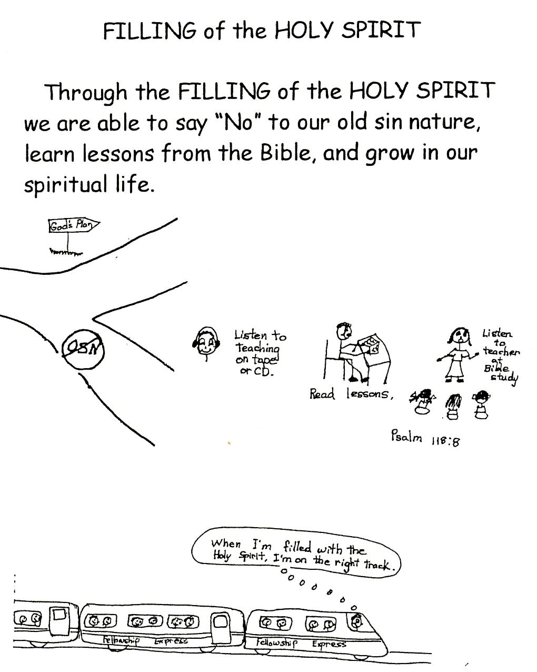
Personal love for God the Father can only exist through learning, believing, and using Bible doctrine. Therefore, God the Holy Spirit is the ONLY one who can teach us how to love God the Father. We can’t see God the Father. So, we have to learn about Him through His written Word, the thinking of Jesus Christ, Bible doctrine. Remember the more we learn and believe about God the Father, the more we will have personal love for Him.

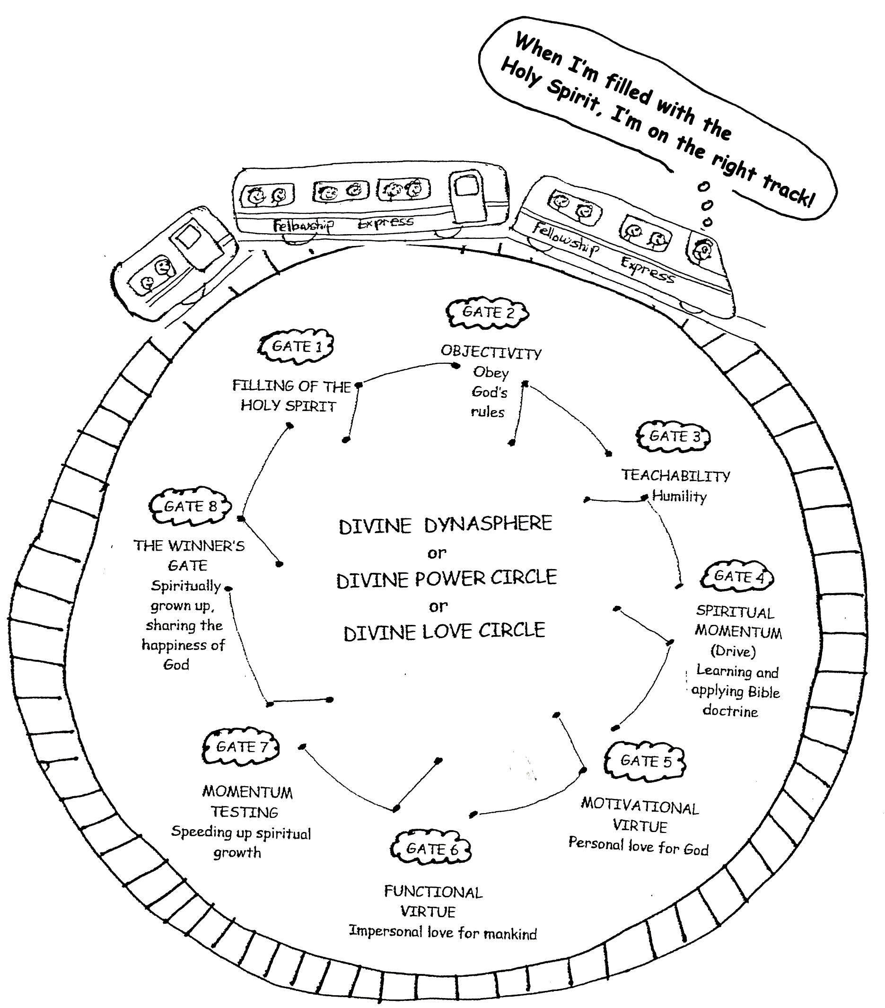
John 14:26 “But the Counselor, the Holy Spirit, whom the Father will send in my name, will teach you all things and will remind you of everything I have said to you.”

Personal love for God the Father is a wonderful problem solving device or tool. When we are having difficulties, we can think about God our Father. We can focus on His love, justice, goodness, faithfulness, and all of His other characteristics…His nature…which is perfect. We know that our Father wants the best for us, that He is able to give it to us, and that He has given us everything we need to get His best blessings. We can’t even imagine the wonderful things God has awaiting us! We just need to obey His rules so we can keep growing in His knowledge, the Word, so that we can enjoy His gracious gifts and have personal love for God the Father!

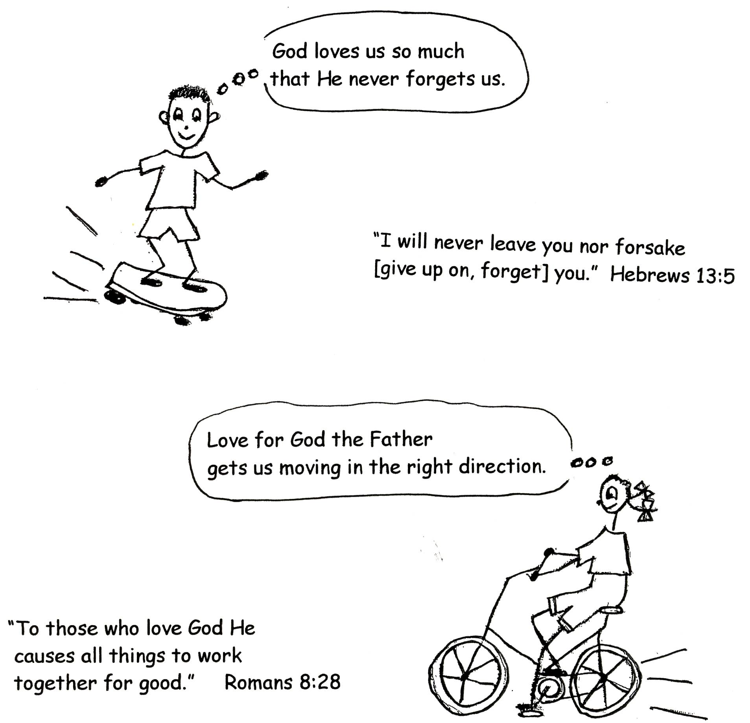

1 Corinthians 2:9 “However, as it is written: “No eye has seen, nor ear has heard, no mind has conceived what God has prepared for those who love Him…”

Robert McLaughlin Bible Ministries
www.gbible.org
R. B. Thieme, Jr.’s Book: Christian at Ease
&
Lighthouse Christian Youth Ministries
www.lighthousechristianyouth.org
&
lcyministry@comcast.net

From the Jr. Tree of Life

2 Pet 1:2 “Grace and peace be yours in abundance through the knowledge of God and of Jesus our Lord.”

