Lighthouse Christian Youth Ministry
Lesson 54g
God Gave Us Ten Problem-Solving Devices
PSD # 8 in the Line of Battle Is
Impersonal Love for All Mankind

April 22, 2007

John 13:34 “I [Jesus Christ] give you a new command, that you love one another; just as I have loved you, you also love [impersonal love] one another.”

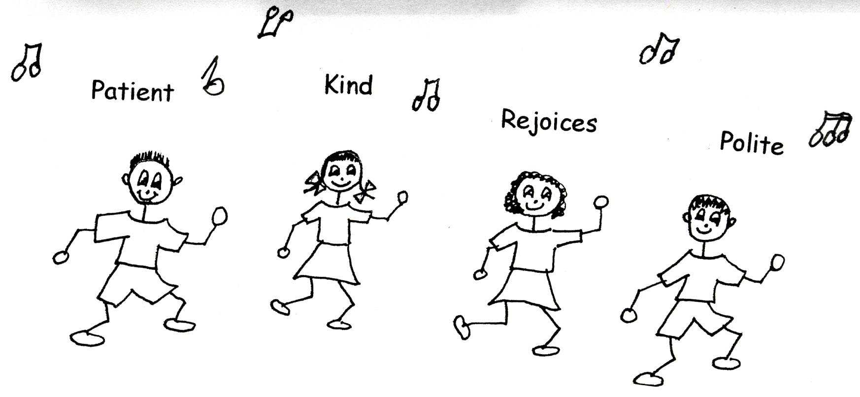

Impersonal love is our eighth problem solving device. Impersonal love means that we treat everyone the way Jesus Christ would treat them because we have the filling of the Holy Spirit and the thinking of Jesus Christ from Bible doctrine living in our souls. Impersonal love does not depend on what we think of the other people, you know whether we like them or not. It does not depend on how they act towards us or treat us. So it is unconditional. It doesn’t depend on what other people are like or how they treat you. It does depend on us being filled with the Holy Spirit and using the thinking of the Lord Jesus Christ…Bible doctrine. It does depend on us being humble.

So, we must rebound when necessary, and learn, believe, and use Bible doctrine. Then, through the power of the Holy Spirit, our impersonal love will grow! The Holy Spirit will do the work! He will bring to our mind exactly how we should act toward others. We can relax!
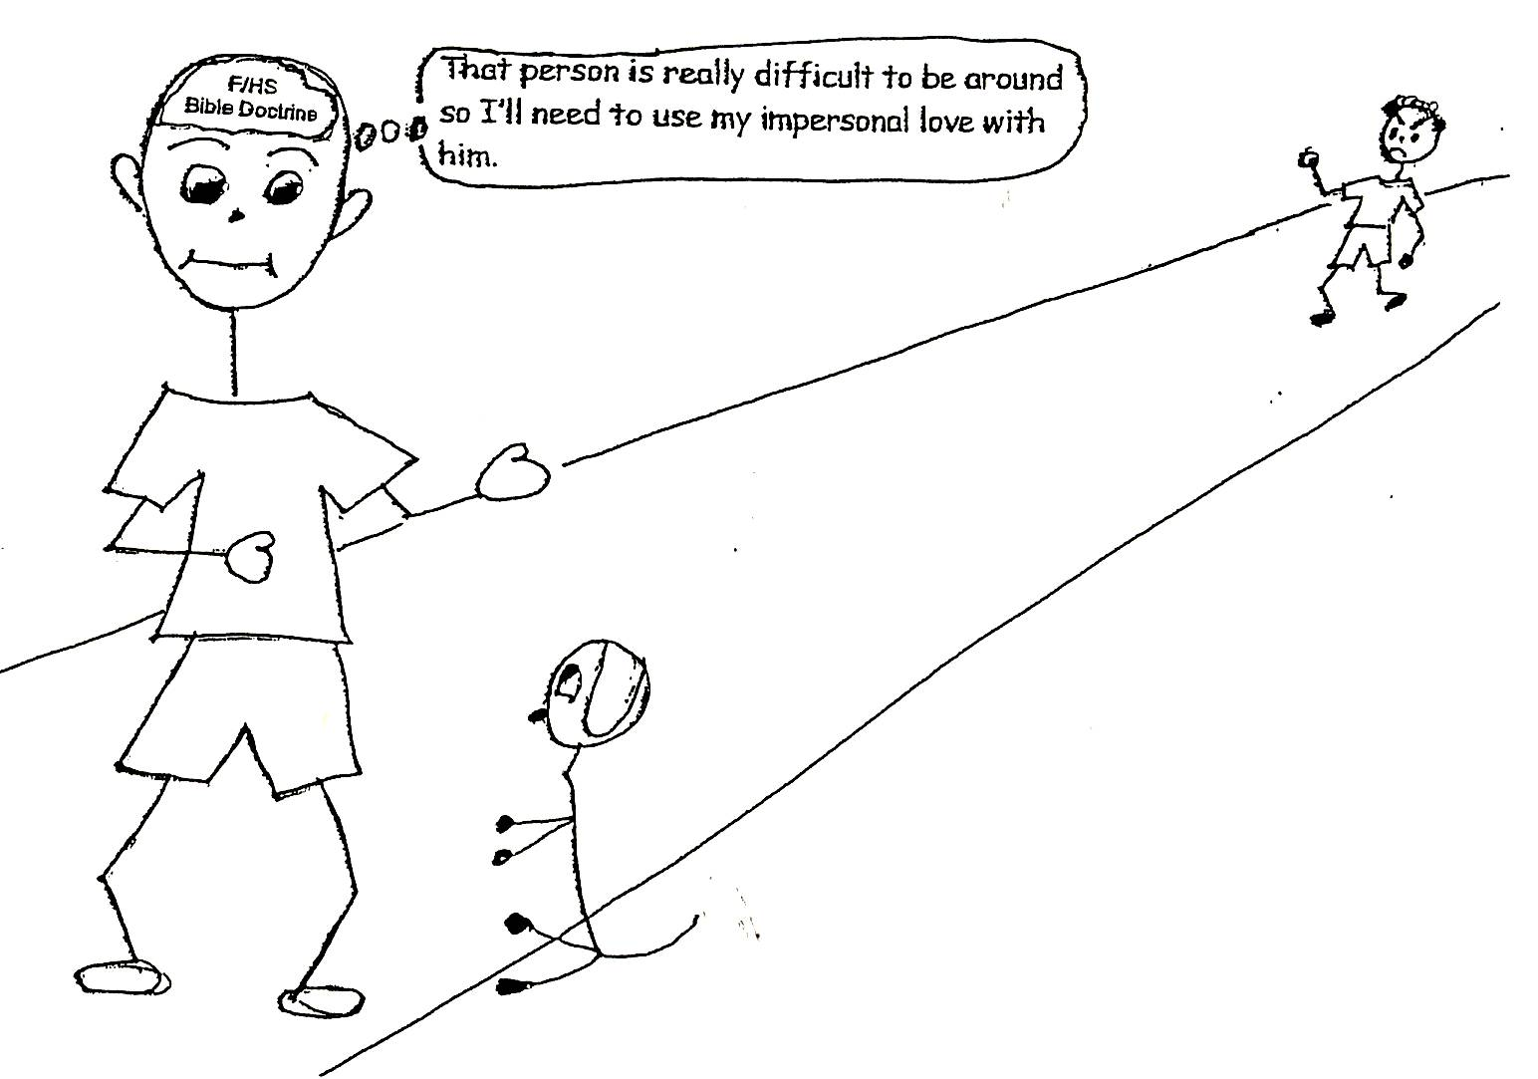

Romans 5:5 “And hope does not disappoint us, because God has poured out His love into our hearts by the Holy Spirit, Whom He has given us.”

We are to have impersonal love for all mankind. “What?’ you say. “That’s impossible!” Not so when the Holy Spirit is changing us spiritually as we learn, believe and use Bible doctrine. We will become less selfish and arrogant. Ignorance causes arrogance. Divine viewpoint causes humility. Therefore, the more doctrine we have in our souls, the more we will have the thinking of Jesus Christ, and the more we will love Him. Remember we learn to have personal love for God the Father, God the Son, and God the Holy Spirit by learning Bible doctrine. The more we have the more we love God. The more we love God, the more impersonal love we will have for mankind…everyone we come in contact with. So in the filling of the Holy Spirit, we will be concentrating on Jesus, thinking like Him, and acting like Him! The more we love Jesus, the more we will be motivated to have impersonal love for all mankind!



Luke 6:27-28 “But I say to you who hear; love your enemies, do good to those who hate you, bless those who curse you, pray for those who mistreat you.”

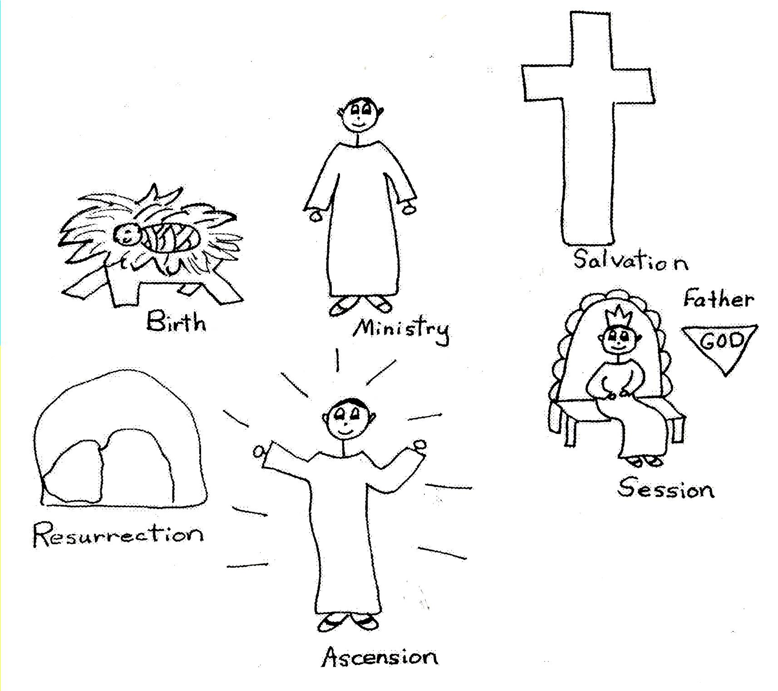
Jesus Christ is our best Example of that verse. He’s the best example of all in using impersonal love. He was always filled with the Holy Spirit and had tons of Bible doctrine in His soul. He always had the power and the right thinking to use impersonal love. When He went to the cross, He didn’t have one bad thought toward those who treated Him so cruelly or toward any person’s sins. He put aside His needs and lived and died for others. He had a great mental attitude. Jesus Christ had impersonal love for all mankind! If He didn’t, we wouldn’t have been saved!!

When we use impersonal love, we stay away from mental attitude sins. Mental attitude sins are thoughts that don’t line up with the thinking of Christ, Bible doctrine. An example would be being angry with someone and wanting to get even. Instead of getting even, we ignore the hurt and forgive the offender by using impersonal love. With impersonal or unconditional love we are thoughtful of others, have good manners, and avoid sins of the tongue. We relax and don’t judge others. We have a relaxed mental attitude toward people.
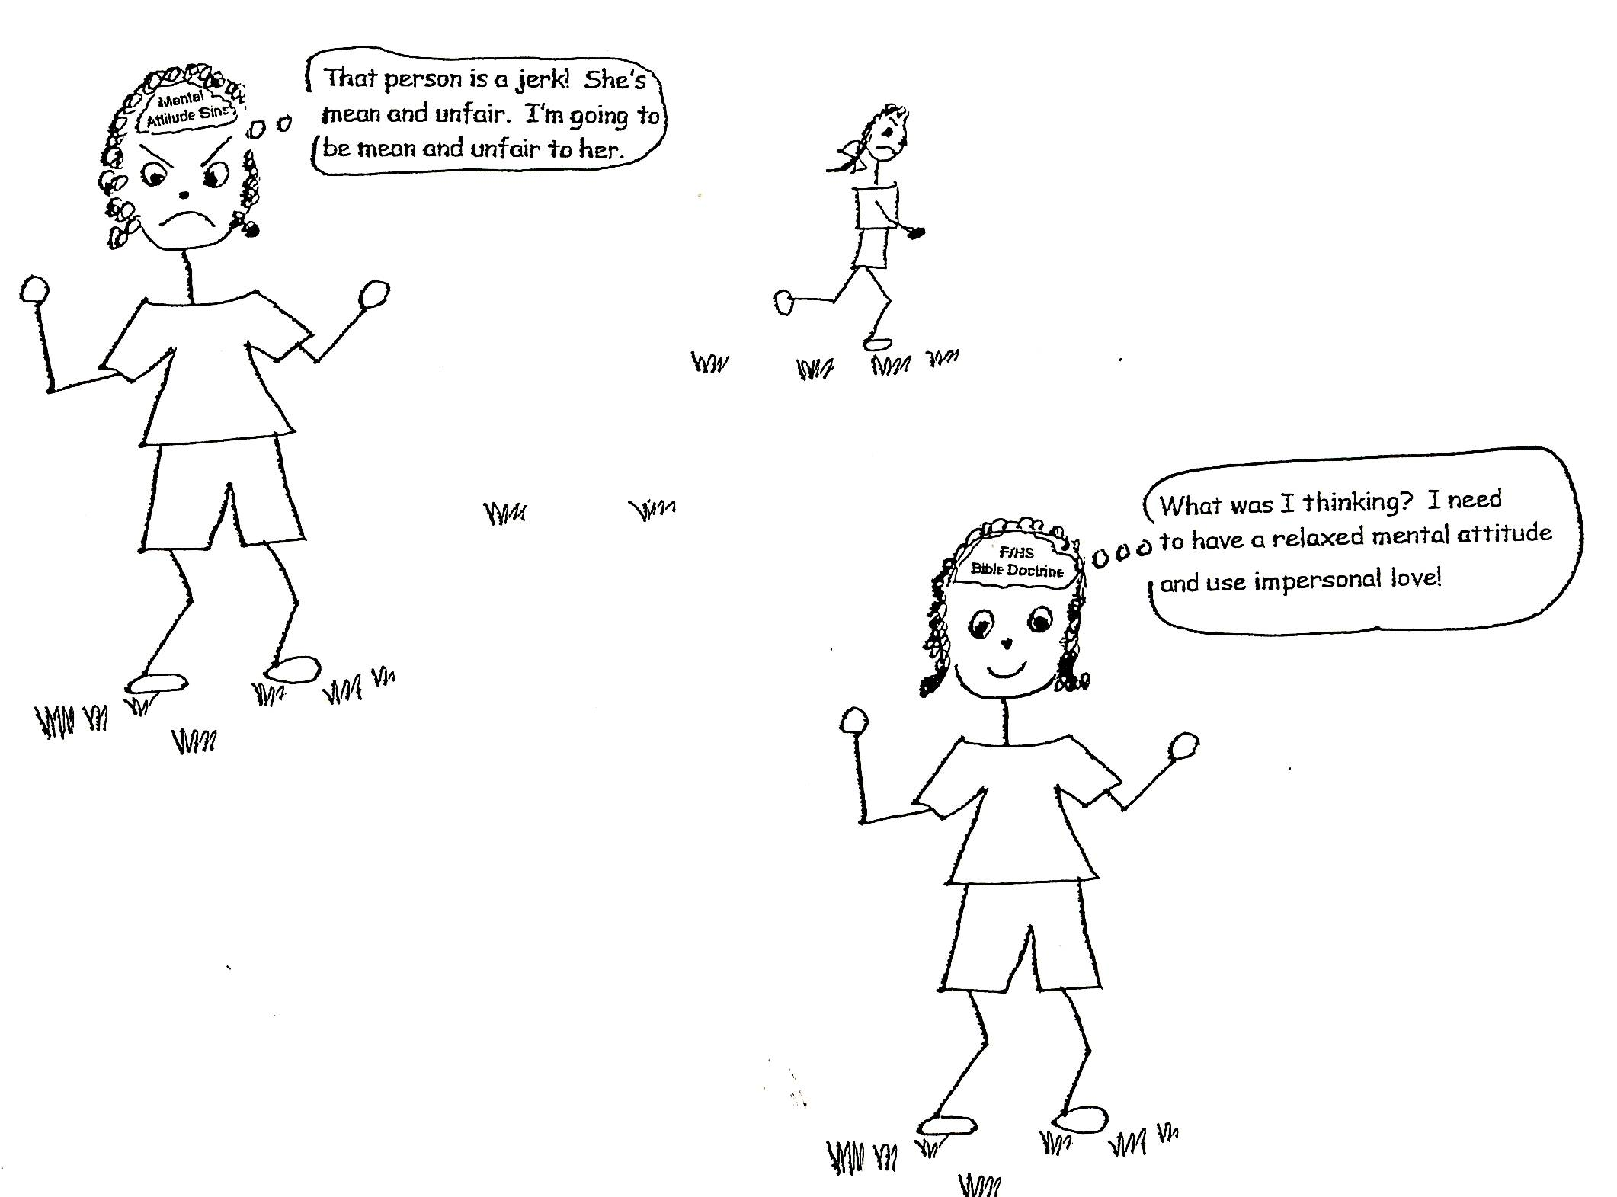

1

Corinthians 2:16 “For who has known the mind of the Lord that he may instruct Him? But we have the mind of Christ.”

When we use impersonal love we accept and tolerate people as we find them and in all situations we find ourselves in with them. We don’t judge people and put them down. We encourage them and build them up! In some cases if they are being difficult we have to avoid them or ignore them but never retaliate or get even.
As you can see, impersonal love is very important to have if we want good friendships. Remember, it takes learning, believing, and using Bible doctrine to get impersonal love. In fact, God commands us to have this kind of love called impersonal love. Mark 12:31 “"The second is this, 'You shall love your neighbor (those around you) as yourself.' There is no other commandment greater than these." So, let’s keep on studying and gaining divine wisdom so that we can have impersonal love for all mankind, at least most of the time!
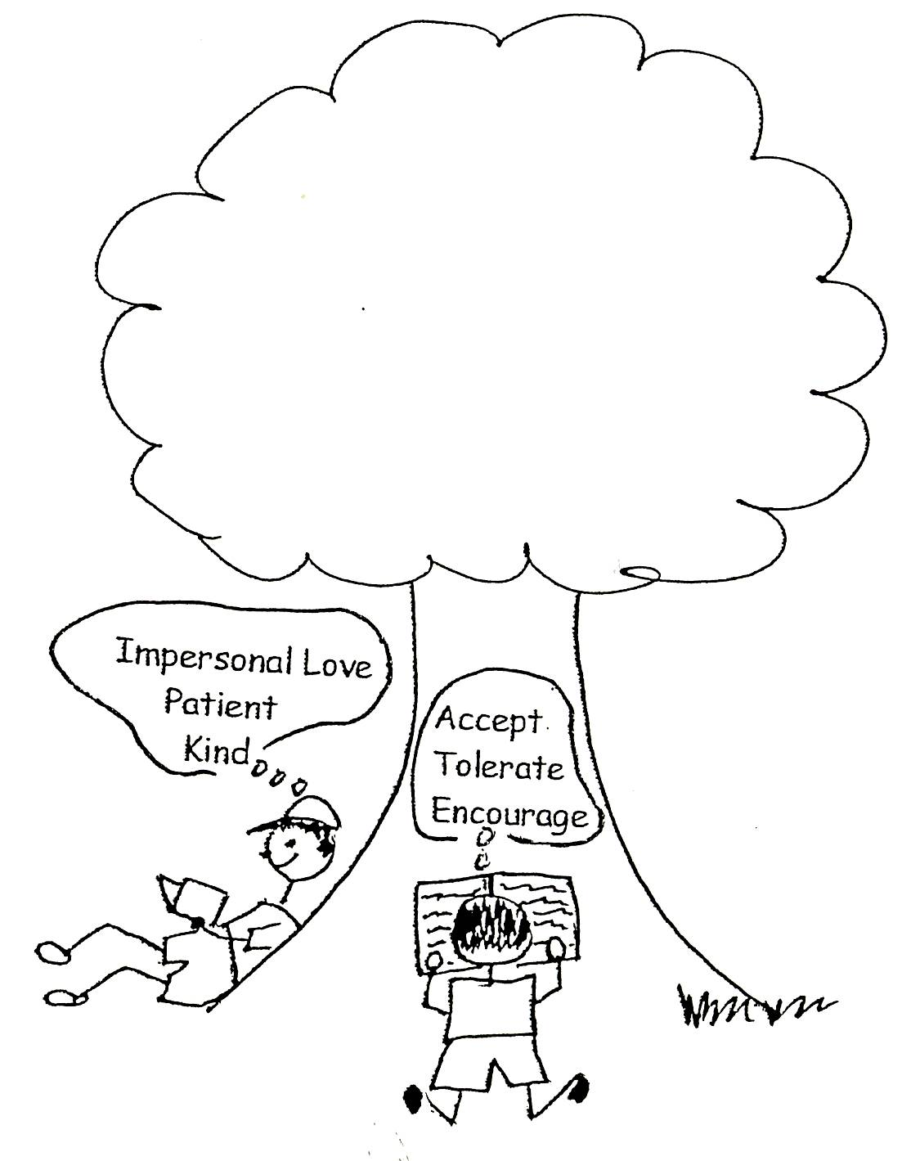

1 Corinthians 13:4-8 “Love is patient, love is kind. It does not envy [have jealousy], it does not brag, it is not proud [arrogant]. It is not rude, it is not self-seeking, it is not easily angered, and it keeps no record of wrongs. Love does not delight in evil but rejoices with the truth.”

Robert McLaughlin Bible Ministries
www.gbible.org
R. B. Thieme, Jr.’s Book: Christian at Ease
&
Lighthouse Christian Youth Ministries
www.lighthousechristianyouth.org
&
lcyministry@comcast.net

From the Jr. Tree of Life

2 Pet 1:2 “Grace and peace be yours in abundance through the knowledge of God and of Jesus our Lord.”

