Lighthouse Christian Youth Ministry Lesson Lesson 54h

God Gave Us Ten Problem-Solving Devices
PSD # 9 in the Line of Battle is

Sharing the Happiness of God

May 6, 2007

Heb 12:2 “Fixing our eyes on Jesus, the author and finisher of our faith, who for the joy set before Him endured the cross, despising the shame, and has sat down at the right hand of the throne of God.”

Jesus is always there for you. He is God and God has perfect happiness, (+H). He wants to give it to us! He wants us to share His happiness which lasts forever! What we need to do is reject human viewpoint, the world’s way of thinking, and accept divine viewpoint, Christ Jesus’ way of thinking. To do that, we need the filling of the Holy Spirit and a lot of Bible doctrine, the thinking of Jesus, in our souls. We need to learn His thoughts daily so that we can use them daily in every situation. This will bring us +H, sharing the happiness of God.
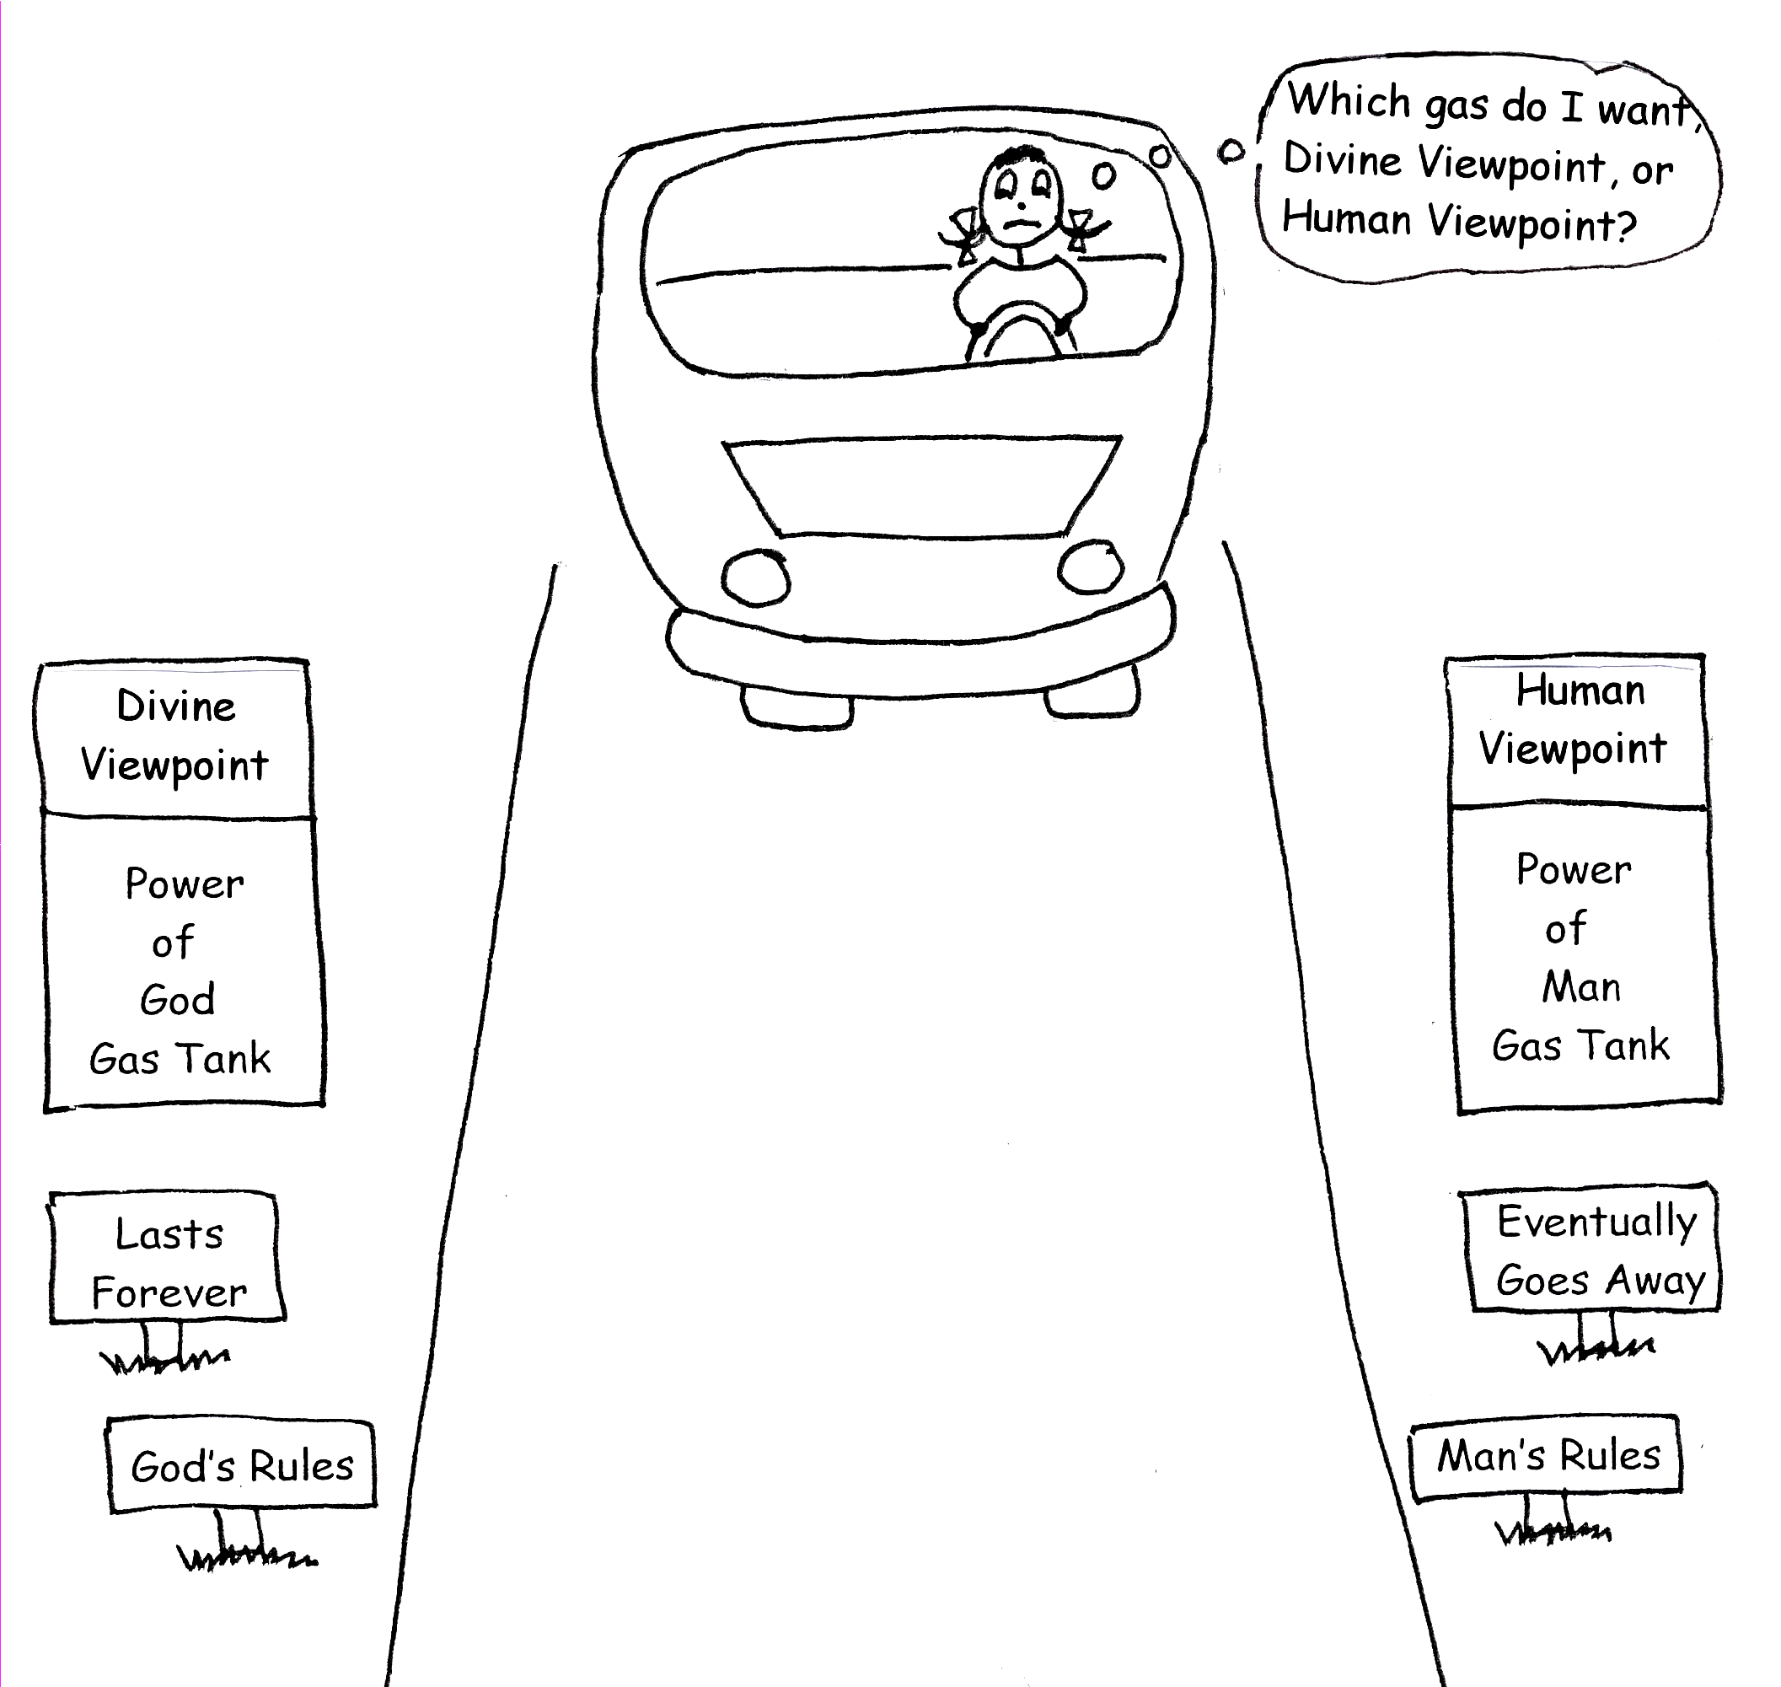

Psalm 112:1 “How happy is the man who respects the Lord, who greatly delights in His doctrines [Bible doctrine, Jesus’ thinking].”

God’s happiness is a problem solving device or tool. When we have it, we can focus on God’s happiness in us, His thinking and therefore, get the help we need to get through our problems. When we have +H, we don’t focus on ourselves. We focus on the Lord Jesus Christ and others. We have a relaxed mental attitude!

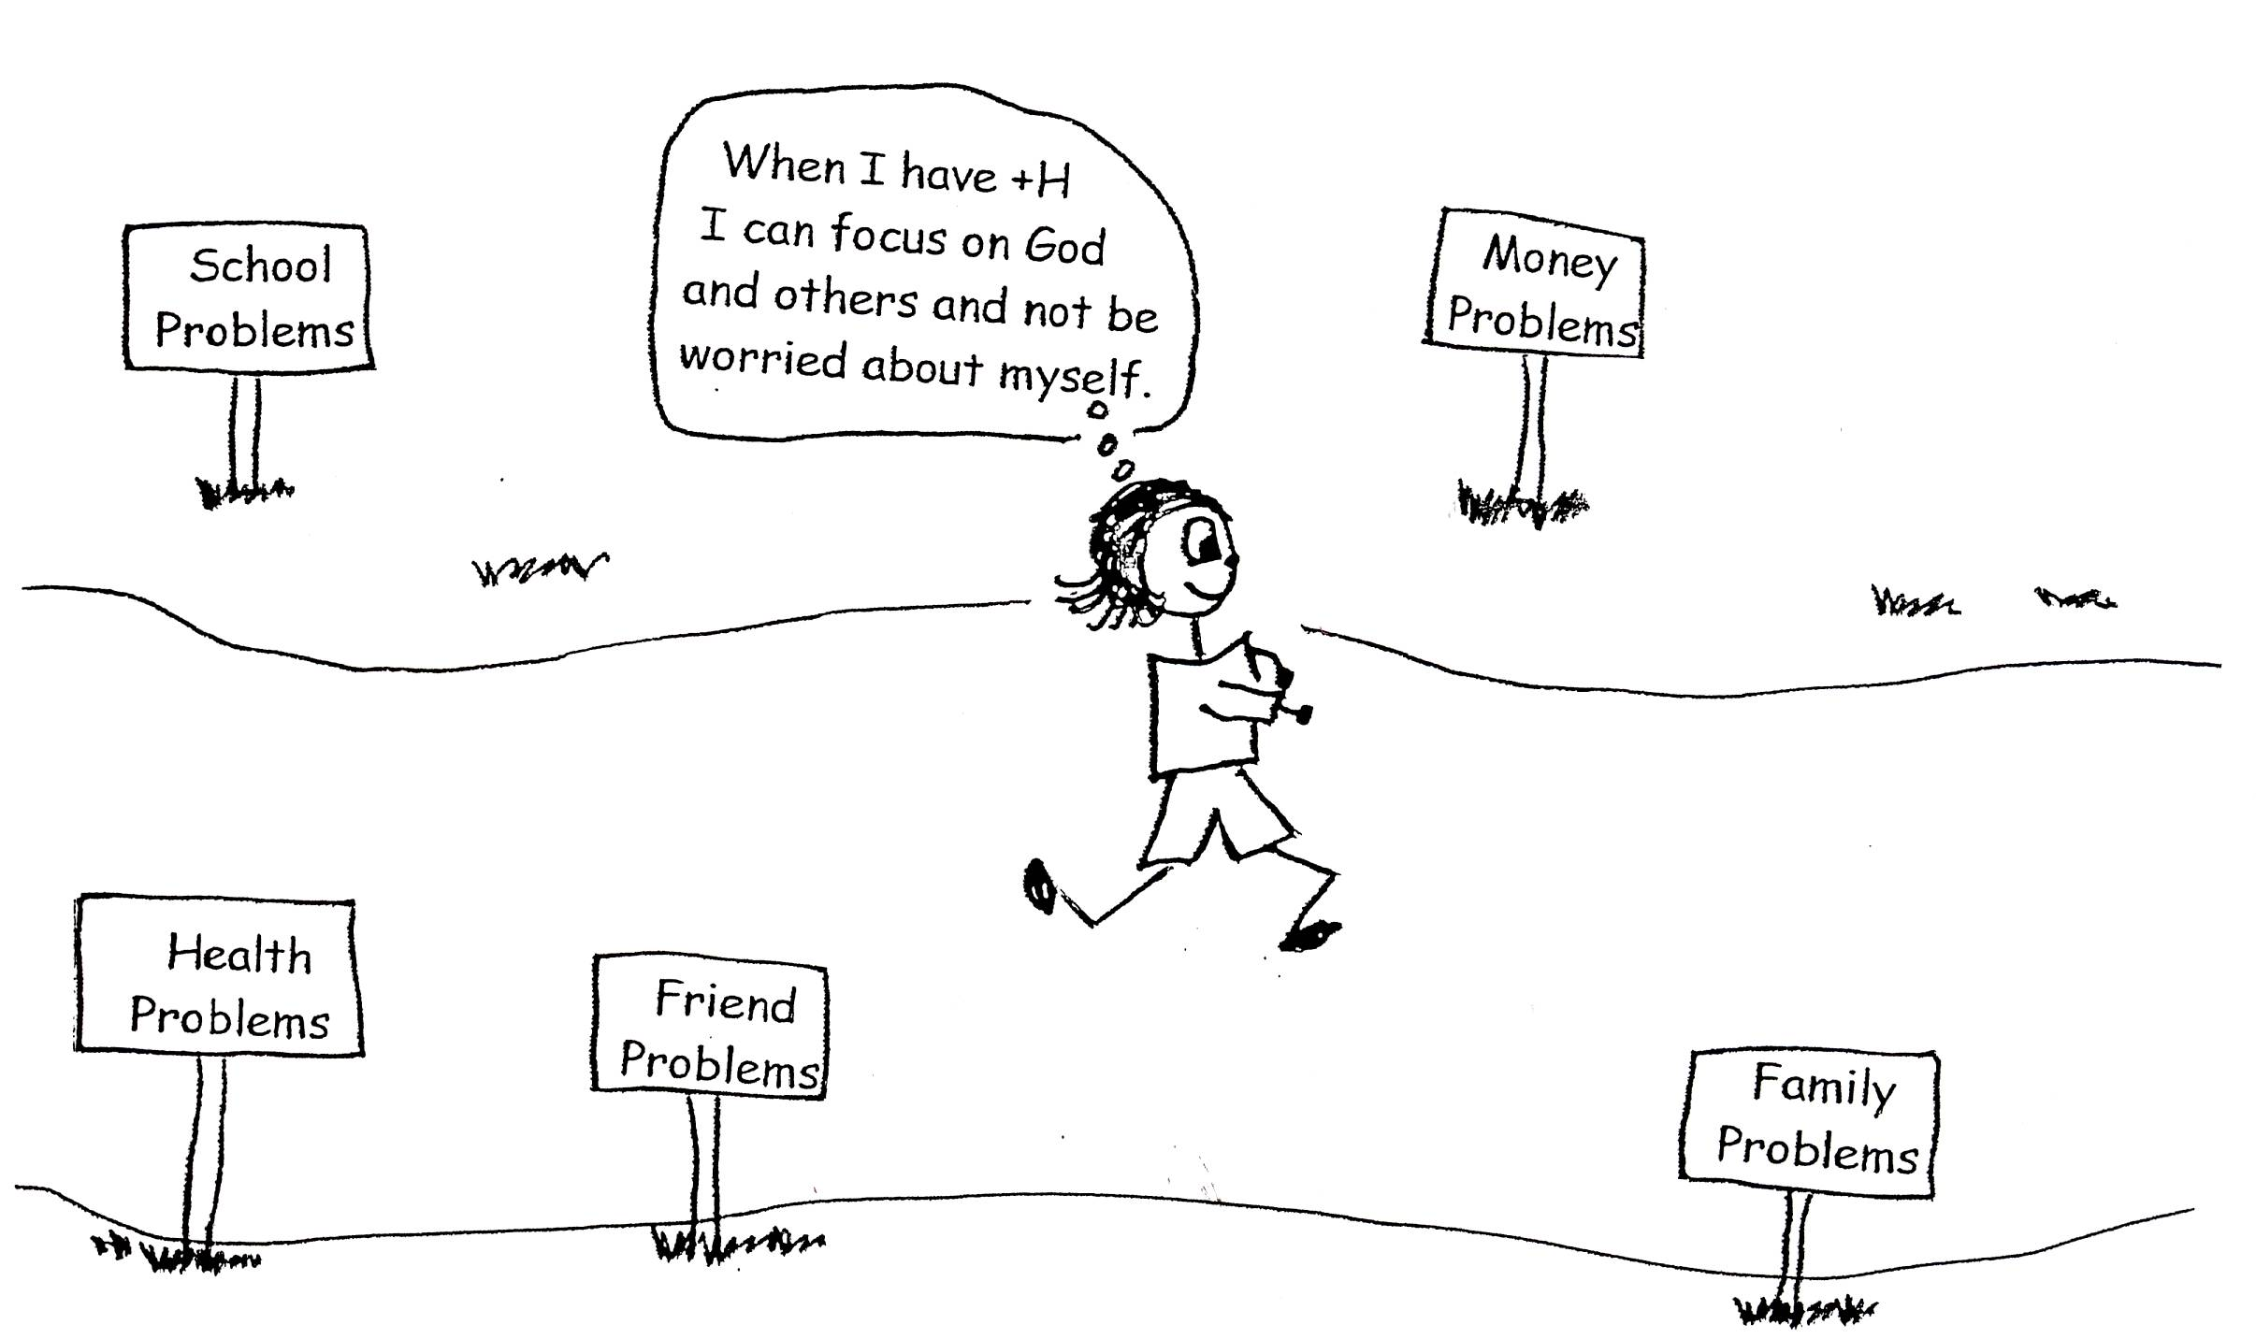

Psalm 128:1 “How happy is everyone who respects the Lord, who walks in His ways.”

We will want to express God’s happiness with our friends. Hopefully, we have chosen friends that think like we do, that have the thinking of Christ. Having relaxed minds because of divine viewpoint, we can have meaningful conversations with them. We will sometimes need to encourage them, and sometimes they will need to encourage us. This can be done when we share the happiness of God!




2 Chronicles 32:7-8 “Be strong and courageous. Do not be afraid or discouraged because of the king of Assyria and the vast [large] army with him, for there is a greater power with us than with him. With him is only the arm of flesh, but with us is the Lord our God to help us and fight our battles.”

However, we are not to be too occupied with our friends. We are not to think more of them than we do of the Lord Jesus Christ. Friends can be a distraction to us. We can get too busy with them and not learn Bible doctrine. We need to be occupied with our best Friend, the Lord Jesus Christ, and His thinking! Then, more and more, we will be sharing the happiness of God. And, when we are with our friends, we will have the ability to enjoy their company. It’s a win, win way to go!

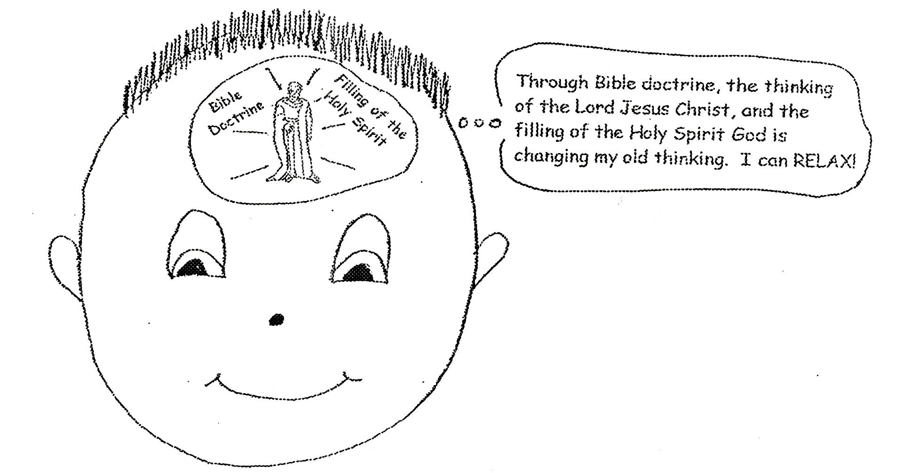

Hebrews 12:2 “Be concentrating on Jesus [occupation with Christ], the author and perfecter of our doctrine, who because of His exhibited happiness He endured the cross, having disregarded the shame, and He sat down at the right hand of the throne of God.”

True happiness comes from spiritual wealth in our souls, not material wealth and people. Satan wants us to think that being popular, having brand name clothes, having the newest toys and games, and other things will make us happy. WRONG! Remember, Satan is the father of all lies. These things might make us happy for little awhile, but true lasting happiness comes from thinking the way the Lord Jesus Christ thinks. That’s when we are sharing the happiness of God!


1 Timothy 6:17 “Command those who are rich in this present world not to be arrogant [think too highly of themselves] nor to put their hope in wealth, which is so uncertain, but to put their hope in God, Who richly provides us with everything for our enjoyment [happiness].”
Anything that is of true value is valuable in troubled times as well as in good times. Learning, believing, and using Bible doctrine can get us through troubled times and good times. We can have a relaxed mental attitude through both. When we rely on the thinking of the Lord Jesus Christ we will have something of true value, joy, sharing the happiness of God!

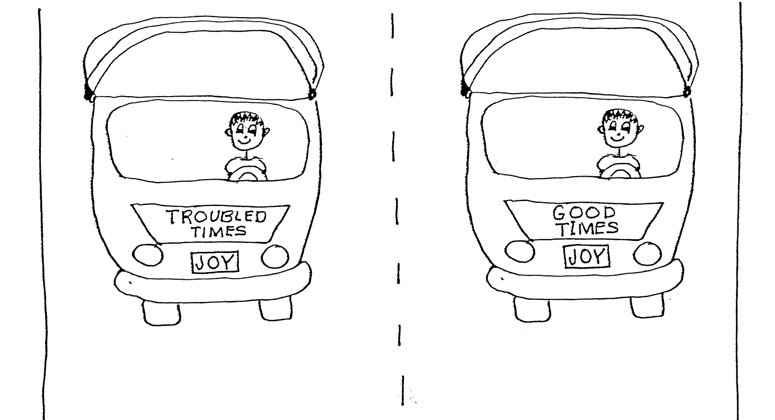

Jeremiah 15:16 “Your words were found and I ate them, and Your doctrines became happiness for me and the delight of my heart…”

Joy or sharing the happiness of God, gives us the ability to enjoy life! When we focus on the Lord Jesus Christ, we won’t focus on our problems. We can relax! We know a solution is right there for us. We will be branches that are living in the Vine (Jesus), which means that we will have the thinking of the Lord Jesus Christ. We all want to be happy, but only God’s happiness will do the job. In His perfect grace, we don’t earn it or deserve it. God has given us everything we need to have His happiness. So, let’s learn and follow God’s plan. Let’s be filled with the Holy Spirit, learn, believe, and apply Bible doctrine, and enjoy life!

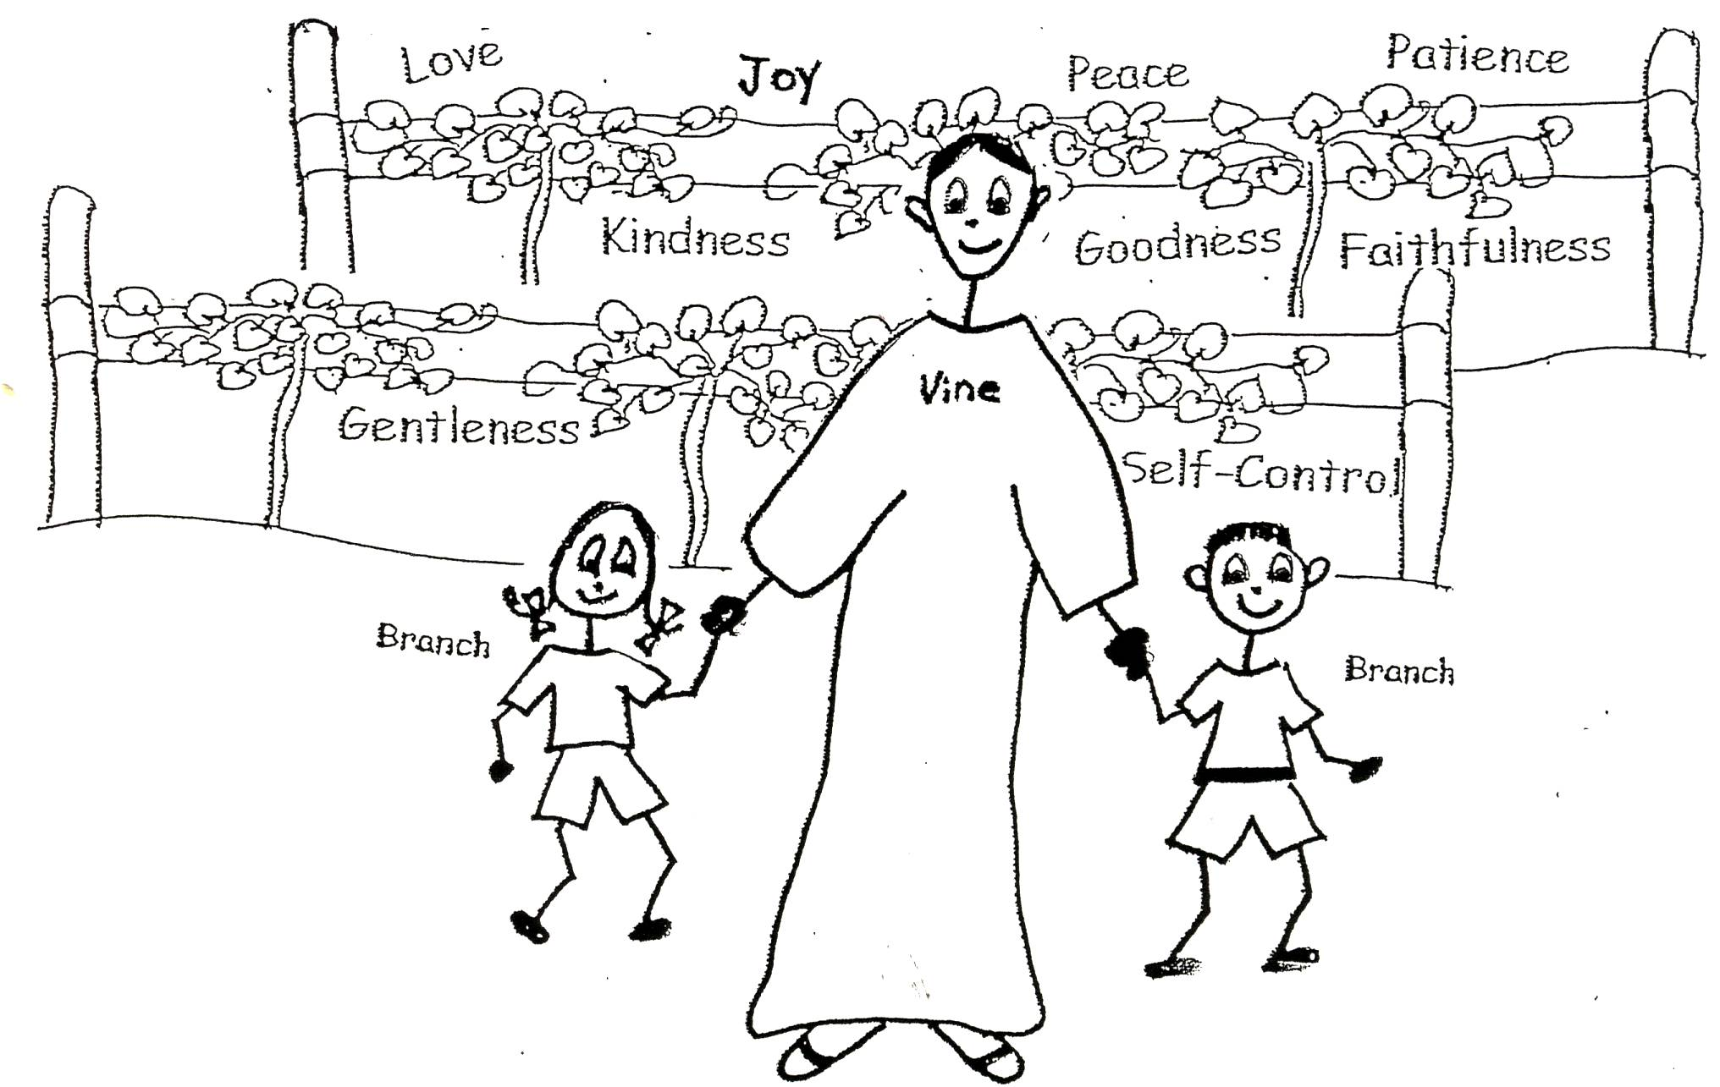

Psalm 31:7 “I will rejoice and be happy in the provision of your grace.”

Robert McLaughlin Bible Ministries
www.gbible.org
R. B. Thieme, Jr.’s Book: Christian at Ease
&
Lighthouse Christian Youth Ministries
www.lighthousechristianyouth.org
&
lcyministry@comcast.net

From the Jr. Tree of Life

2 Pet 1:2 “Grace and peace be yours in abundance through the knowledge of God and of Jesus our Lord.”

