Lighthouse Christian Youth Ministry
Lesson 54i
God Gave Us Ten Problem-Solving Devices
PSD # 10 in the Line of Battle is

Occupation with Christ

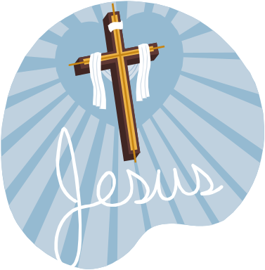

May 20, 2007

2Th 3:3 “But the Lord is faithful, and He will strengthen and protect you from the evil one.”

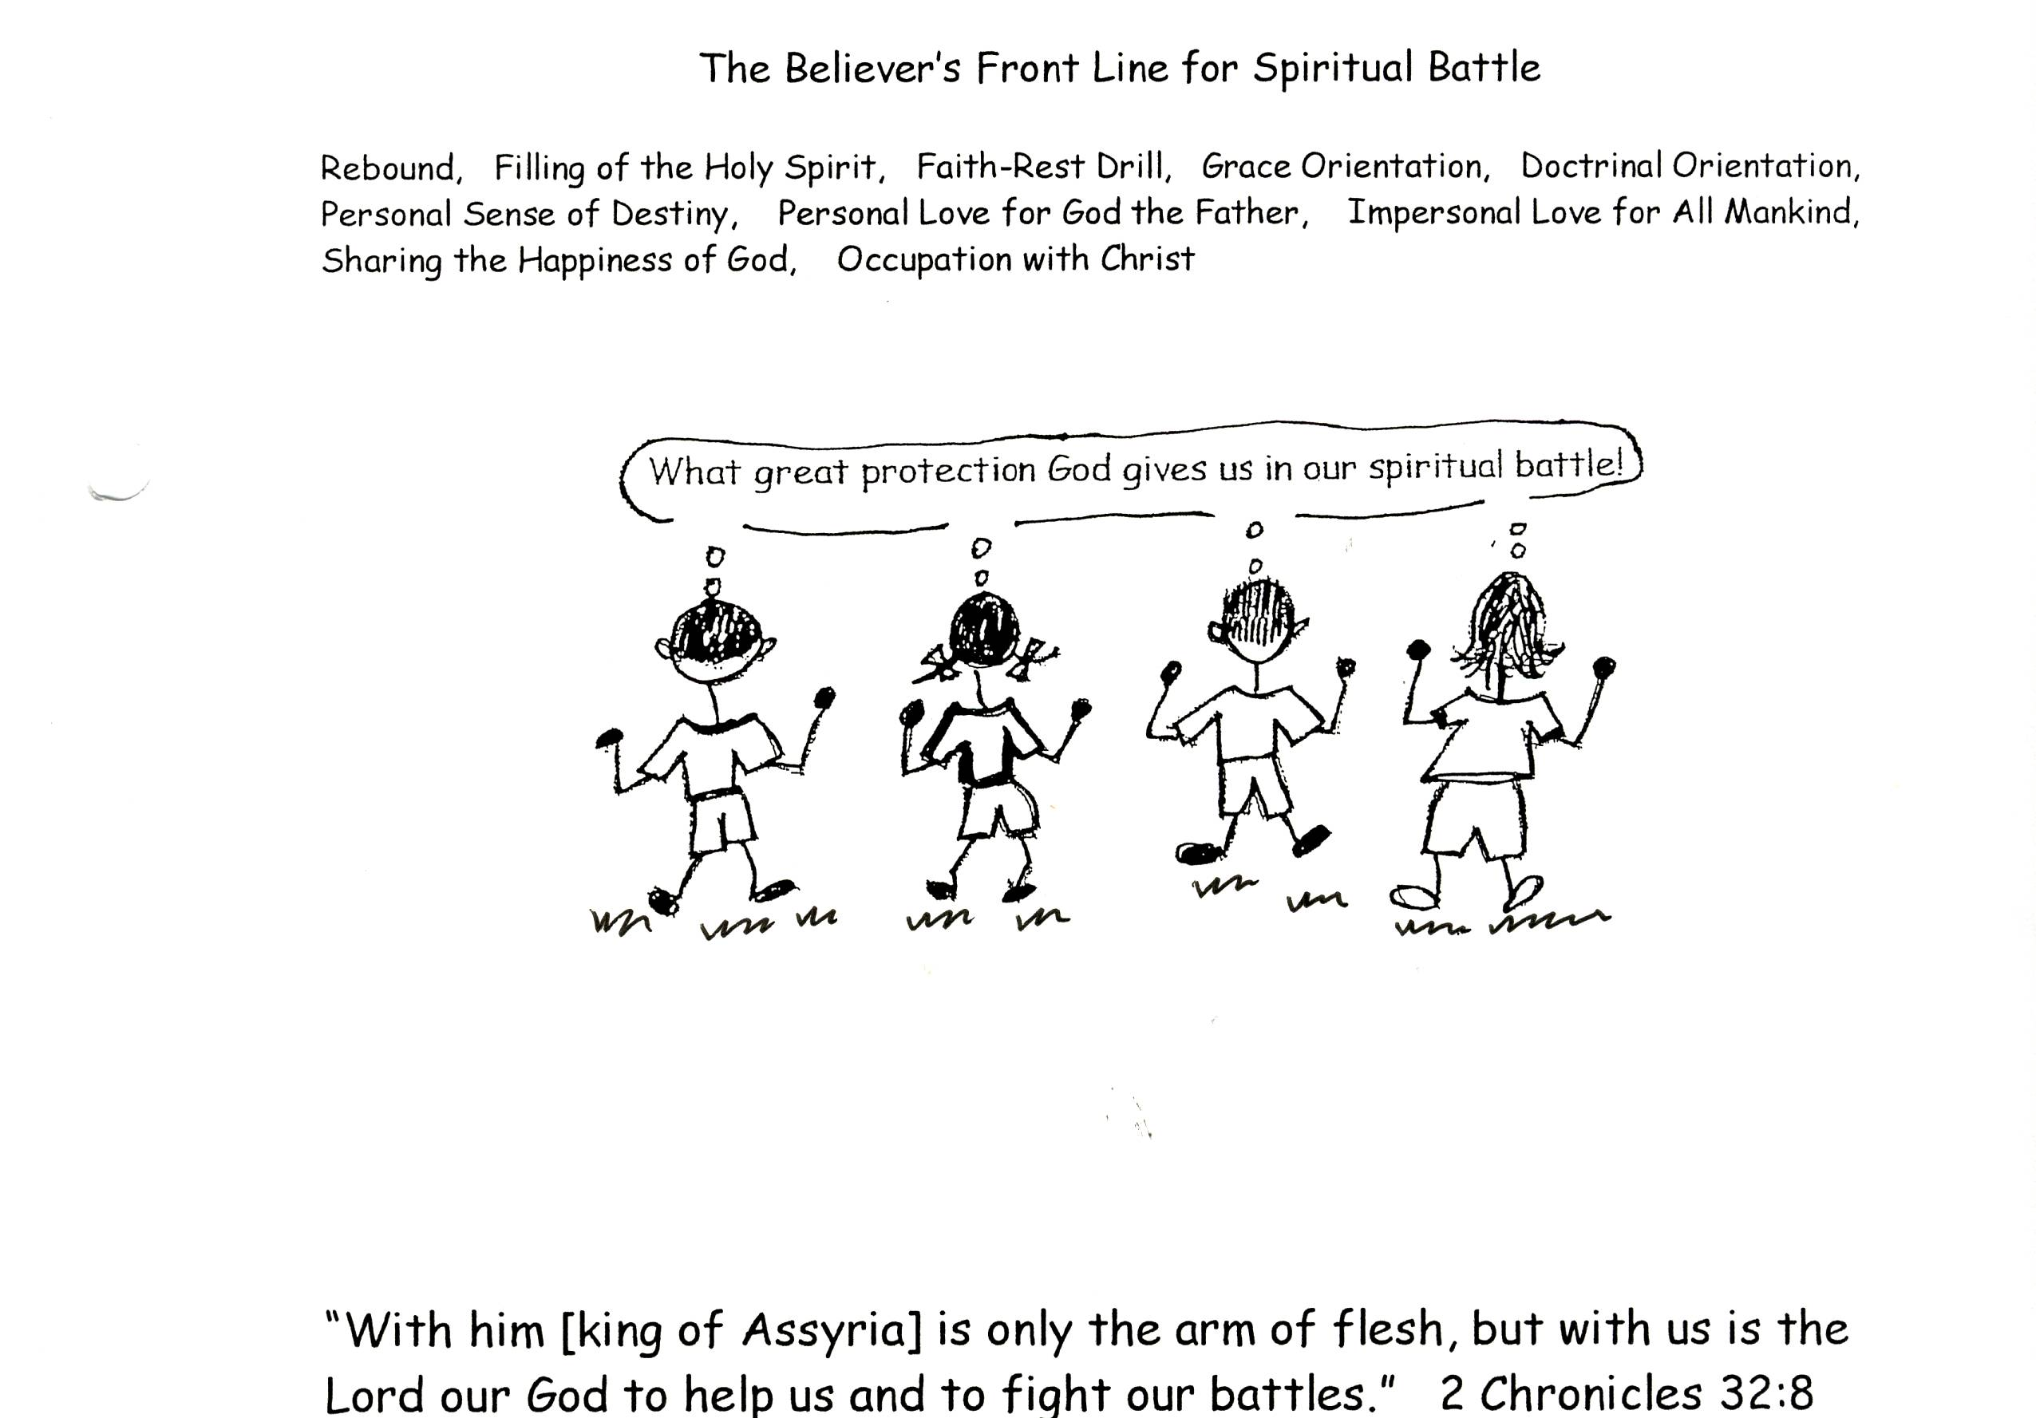

Lord Jesus Christ has always been and will always be our best Friend. We have to learn about Him through Bible doctrine so that we can truly realize what a friend He is. The more we learn and believe about Jesus, the more we will see how amazing He is. We will come to see how great His thinking is and we will want to think like He does. He thinks Bible doctrine. We’ll want to be occupied with Jesus and His thoughts. We will want to have occupation with Christ!

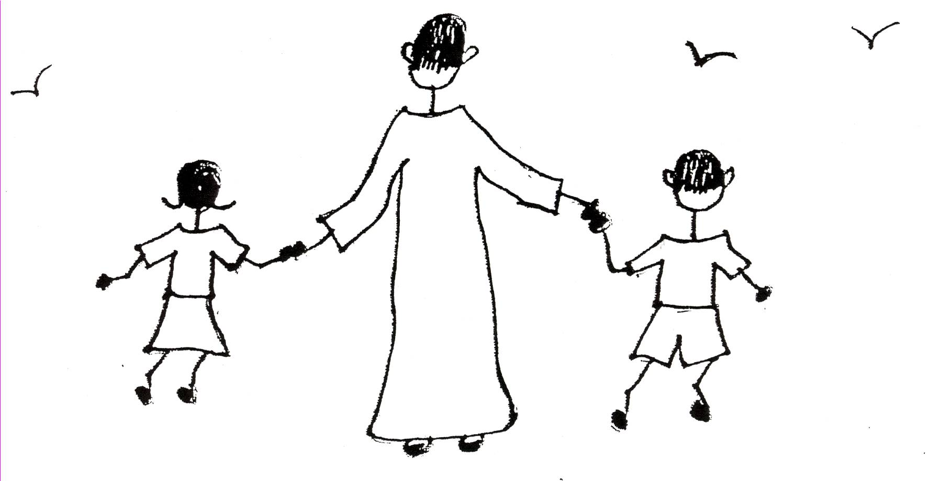

2 Peter 3:18 “But grow in the grace and the knowledge of our Lord and Savior Jesus Christ. To Him be all glory both now and forever! Amen.

As believers, we start out as babies. We’ll have just “milk” for our spiritual nourishment or soul food. However, this milk is the best “milk”. Let’s call this milk our Problem Solving Devices.” There’s only 3 when we are babies. We’ll grow up through these 3 problem-solving tools just like babies grow up on real milk. The first 3 PSDs are basic doctrines we learn so we can have fellowship with God as we grow spiritually. They are: Rebound, Filling of the Holy Spirit, and the Faith-Rest Drill. Rebound keeps us filled with the Holy Spirit and in fellowship with God and the Holy Spirit teaches us what we need to know in Bible doctrine. Then we can put our faith and trust in what God teaches us in His Word. We will be motivated to learn and use His promises. As we take in this wonderful nourishment, the Holy Spirit will change our point of view to God’s point of view. We will be growing up spiritually!



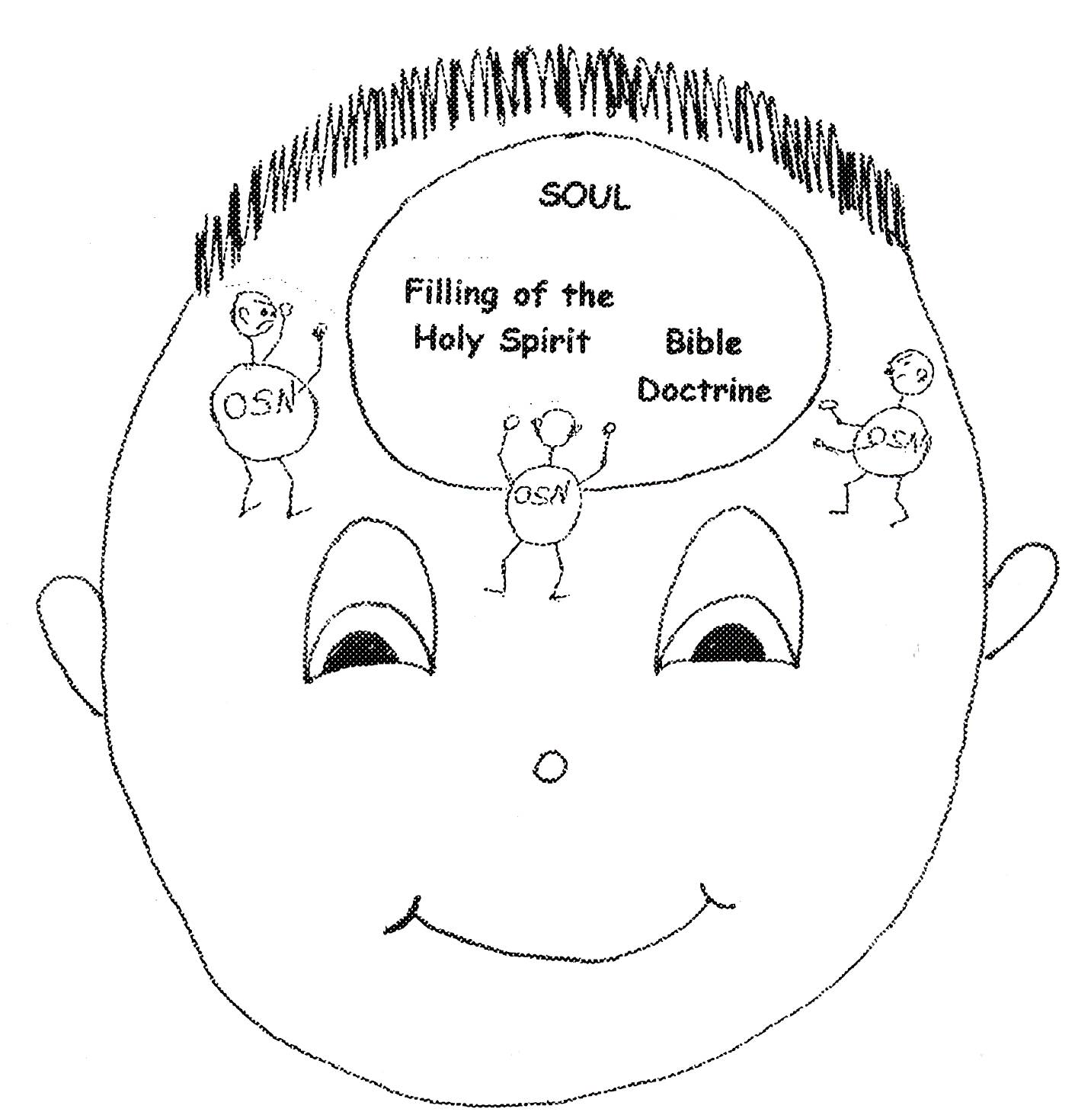

Peter 2:1-3 “Therefore, rid yourselves of all malice and all deceit, hypocrisy, envy, and slander of every kind. Like newborn babies, crave pure spiritual milk, so that by it you may grow up in your salvation, now that you have tasted that the Lord is good.”

As we grow in our spiritual life, we’ll get to a point where we are ready for more solid soul food like “mashed bananas and cream cereal”. Then after a little while, some “mashed meat and mashed vegetables” will be on our plate. We’ll be at the place where we are using the problem-solving devices of Grace Orientation and Doctrinal Orientation. As we keep developing in our spiritual life, we’ll get to the point of having solid food! What a treat! We’ll be using the problem-solving devices of Personal Sense of Destiny, Personal Love for God the Father, and Impersonal Love for All Mankind! Now we will be ready to progress to a gourmet meal! We’ll be experiencing some of the Sharing of the Happiness of God. We’ll want to develop that even more and come to the peaceful place of having Occupation with Christ!
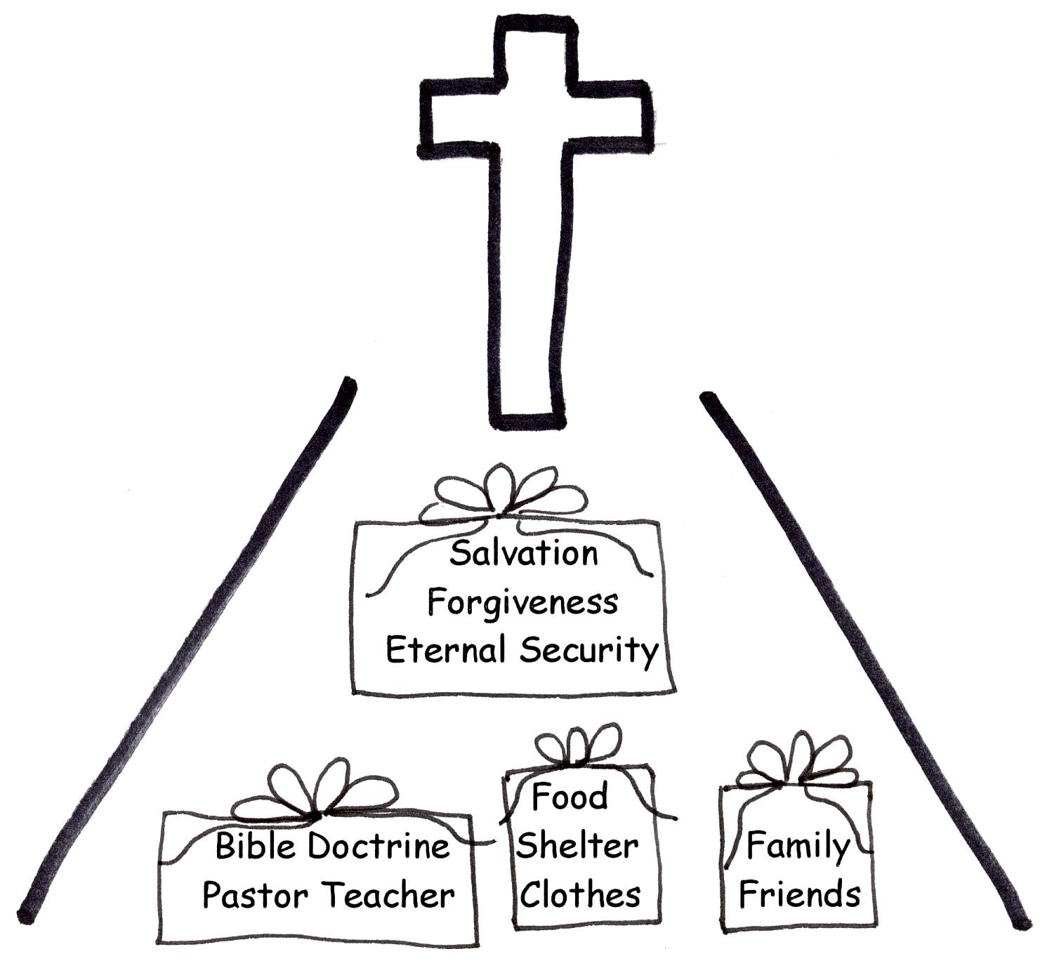
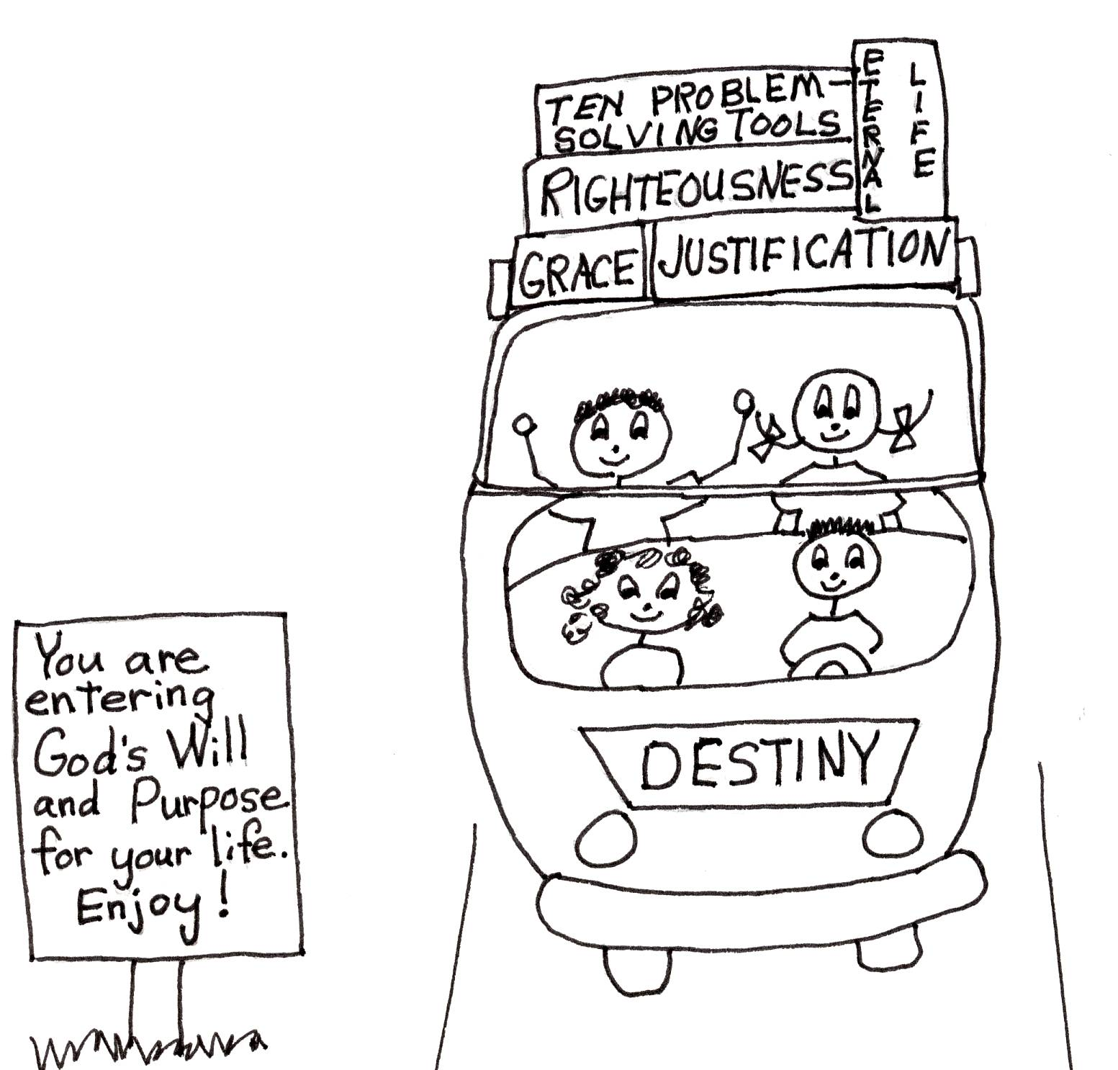



2 Peter 3:17-18 “Therefore dear friends, since you already know this [people will distort the truth], be on your guard so that you may not be carried away by the error of lawless men and fall from your secure position. But grow in the grace and knowledge of our Lord and Savior Jesus Christ. To Him be all glory both now and forever! Amen.”
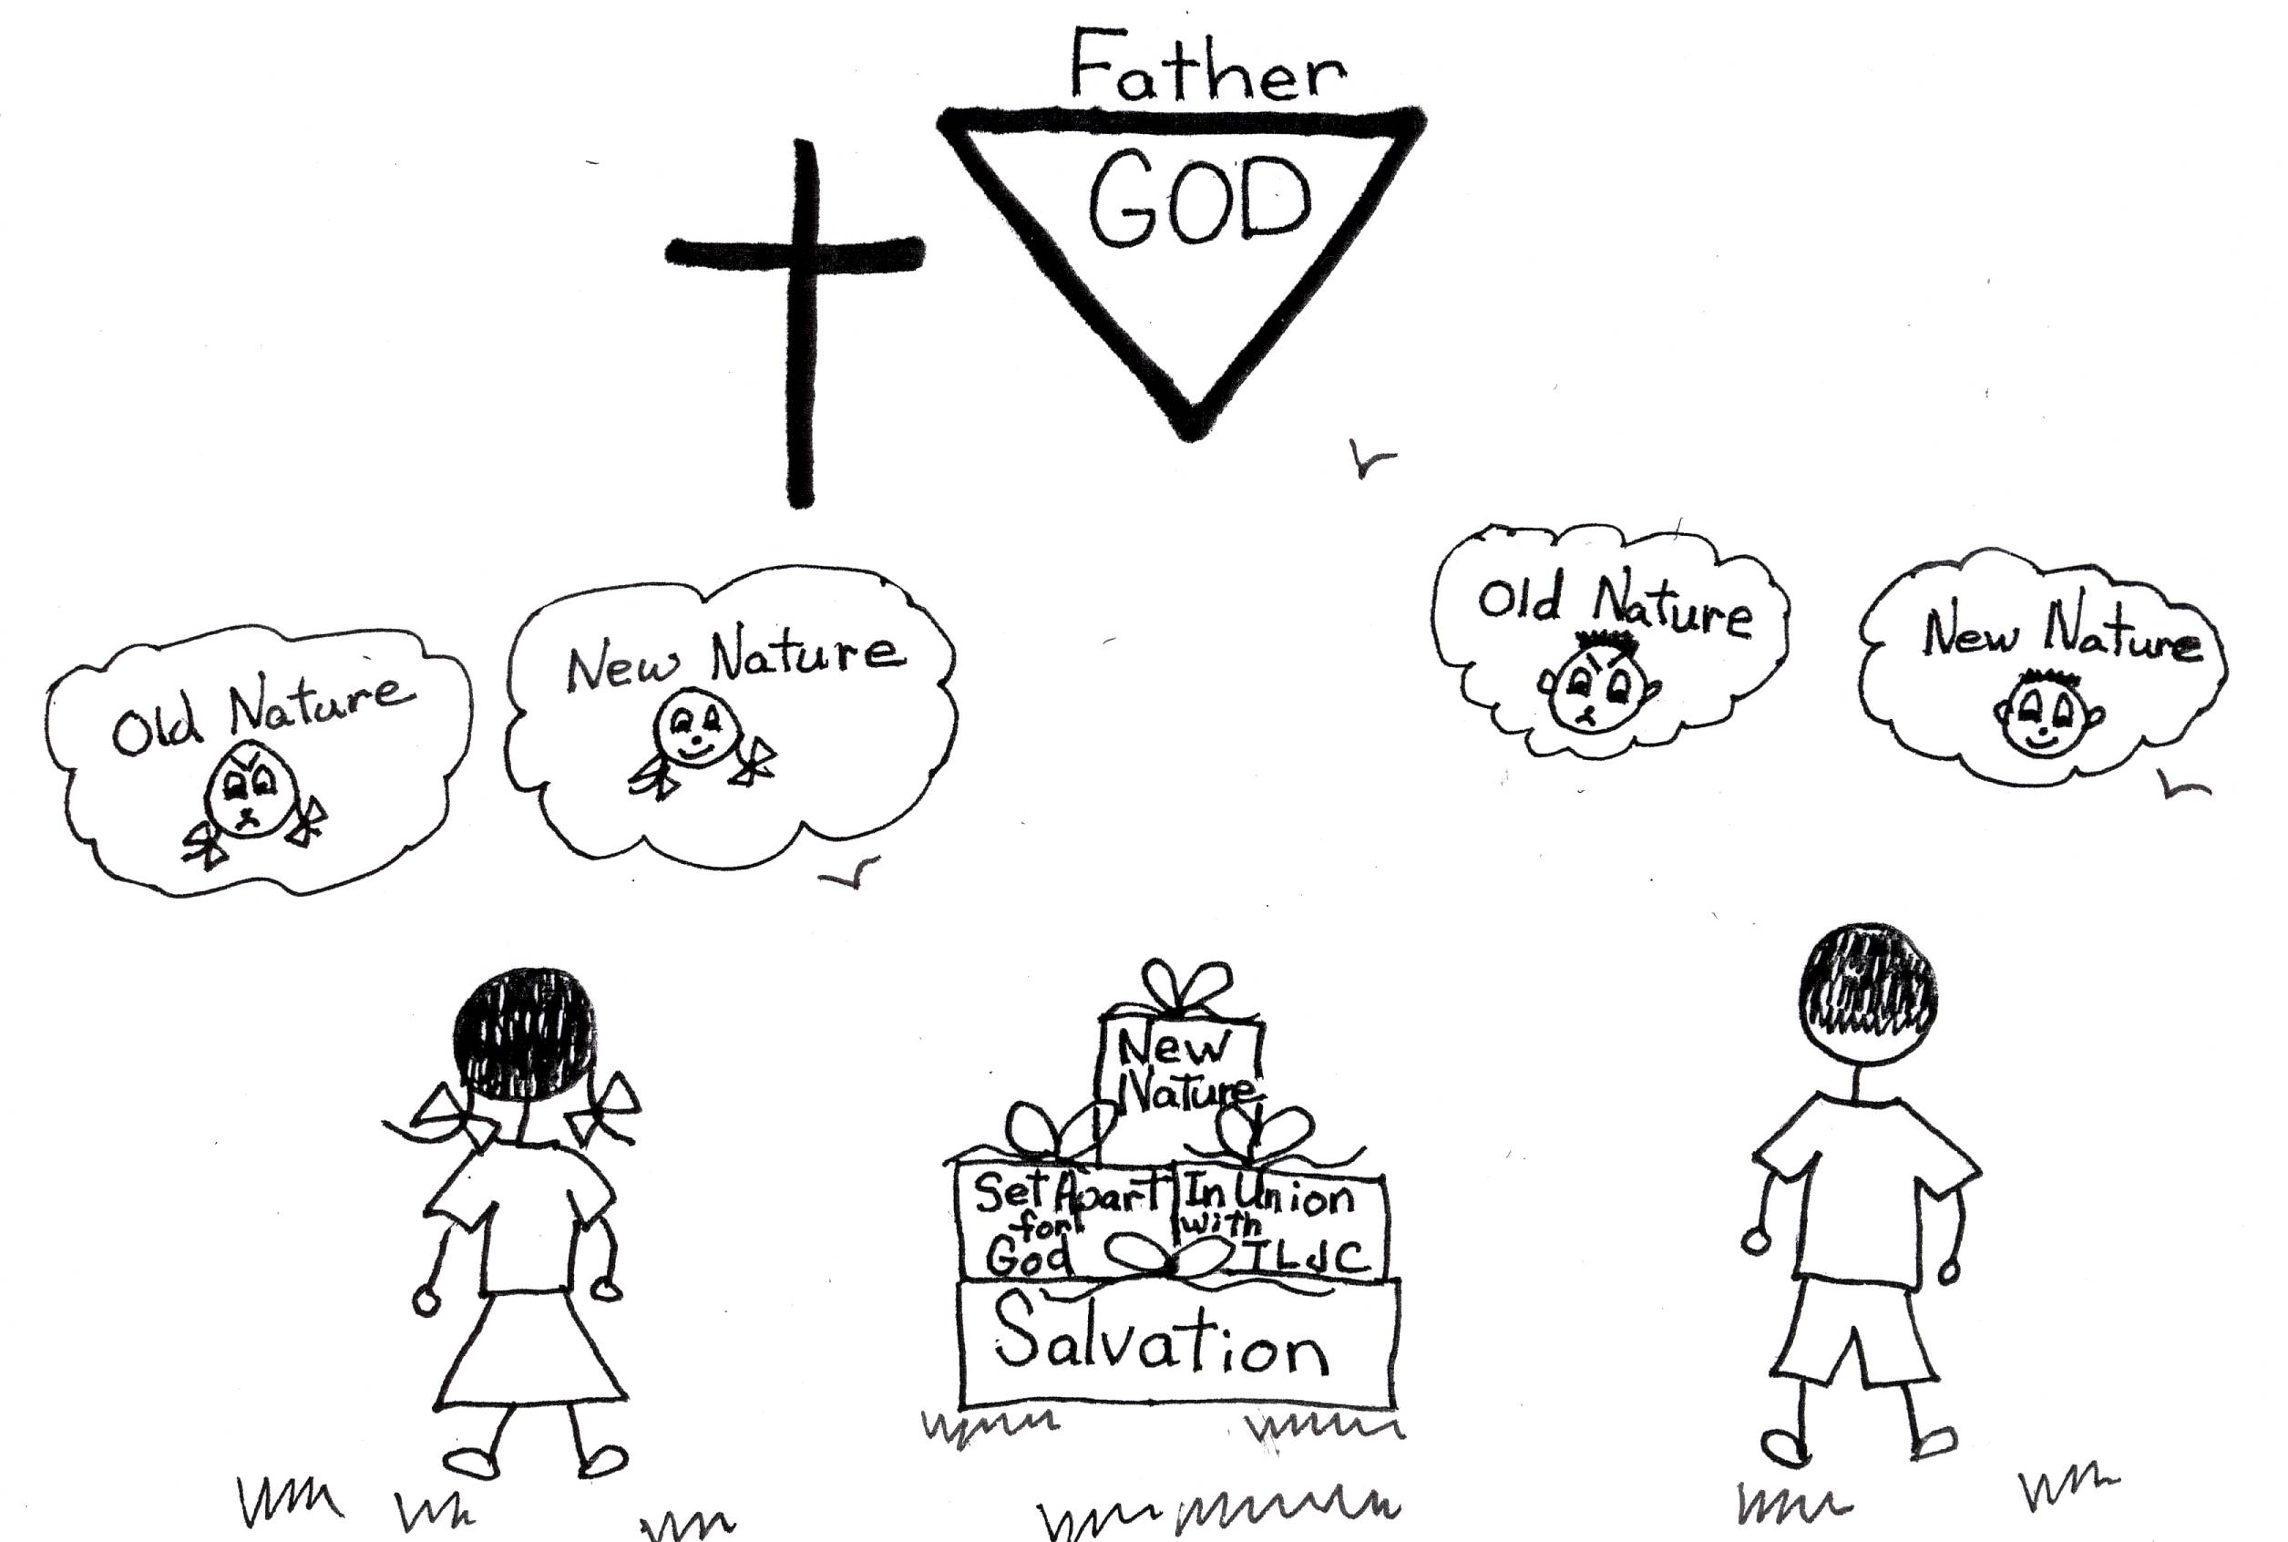

Let’s take a look at our perfect nourishment in the spiritual life, Occupation with Christ. When we are occupied with Christ, we live in our new nature. We think with divine viewpoint. Sure, there are going to be times that we will slip into our old nature and use human viewpoint. We’ll just rebound! When we live in our new nature, we have the thinking of Christ. We are able to look at ourselves and others for what we are in our old natures: corrupt, wicked, hypocrites, and liars. I could say more, but I think you get the picture. We are able to see ourselves and others in our new natures: perfect in God’s eyes. Now that is a good sight! Through learning, believing, and using Bible doctrine, the thinking of Christ, we can all come to occupation with Christ. We can all have fantastic soul food and nourishment for our spiritual growth in our new nature!!

Luke 9:23-24 “Then He said to them all: ‘If anyone would come after me, he must deny himself and take up his cross daily and follow me. For whoever wants to save his life will lose it, but whoever loses his life for me will save it.’”
God knows that we can’t get to know Him and have occupation with Christ without going through sufferings or tests. We learn many commands and promises from God through studying Bible doctrine. We say that we believe them. Then God tests us to see if we really believe them. For instance, let’s say that a friend acts unkind to us. We are told not to repay him or her for the unkind act. We are told that God will be just and that friend if he or she is a believer will be disciplined by God. We never are to take revenge. God knows the best way to discipline all of us and get us back on the right track. We are told to have impersonal love for all. If we believe these commands, we’ll trust God and have a relaxed mental attitude. Now I’m not saying this is easy to do. But, the more we use the power of the Holy Spirit, and the more we trust in God’s ways, the easier we’ll get through the sufferings or tests. We will be thinking more like Jesus. We will be on our way to occupation with Christ.
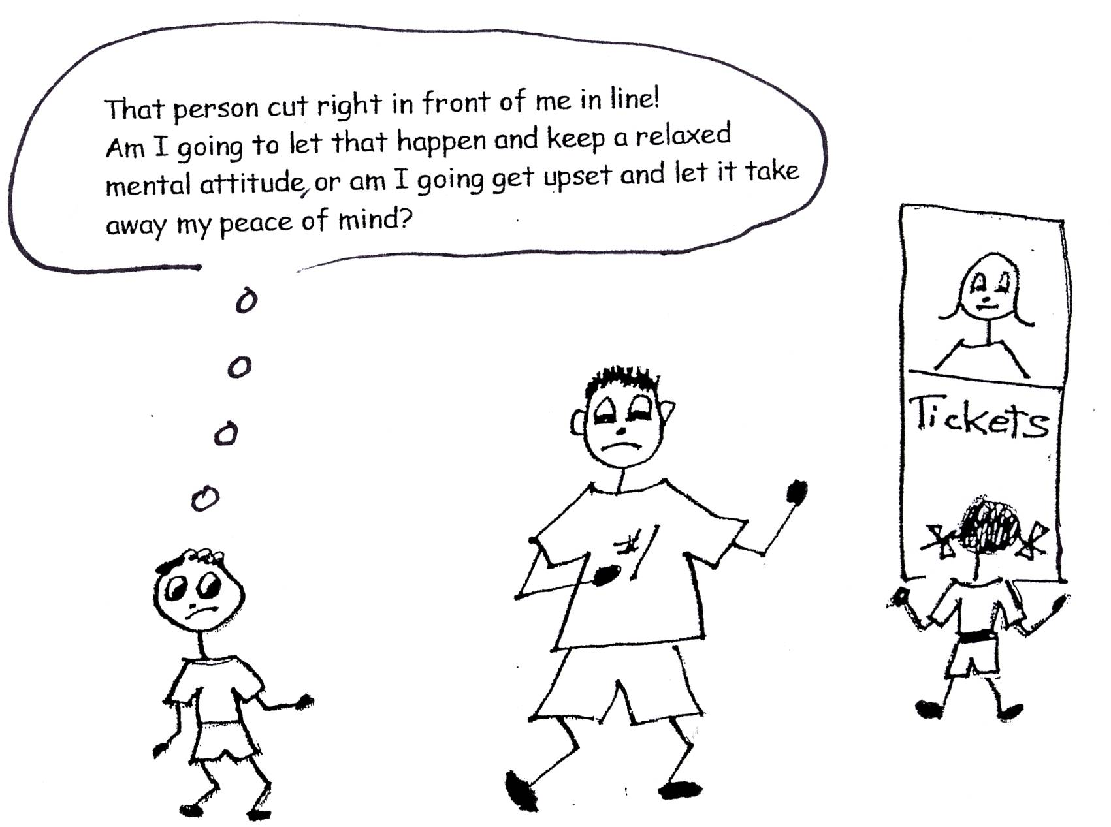

Philippians 3:10-11 “I want to know Christ and the power of His resurrection and the fellowship of sharing in His sufferings, becoming like Him in His death, and so, somehow, to attain to the resurrection from the dead.”

We’ll go through three stages of growth and suffering to reach maximum occupation with Christ. First, we’ll have spiritual self esteem. That’s when we get a personal sense of destiny. We’ll be confident in life because of learning, knowing, and using Bible doctrine. We’ll have undeserved suffering from God during this time to keep us humble. It is amazing how easy it is to think that we are fantastic and forget Who made us the way we are. We had nothing to do with it! God reminds us!
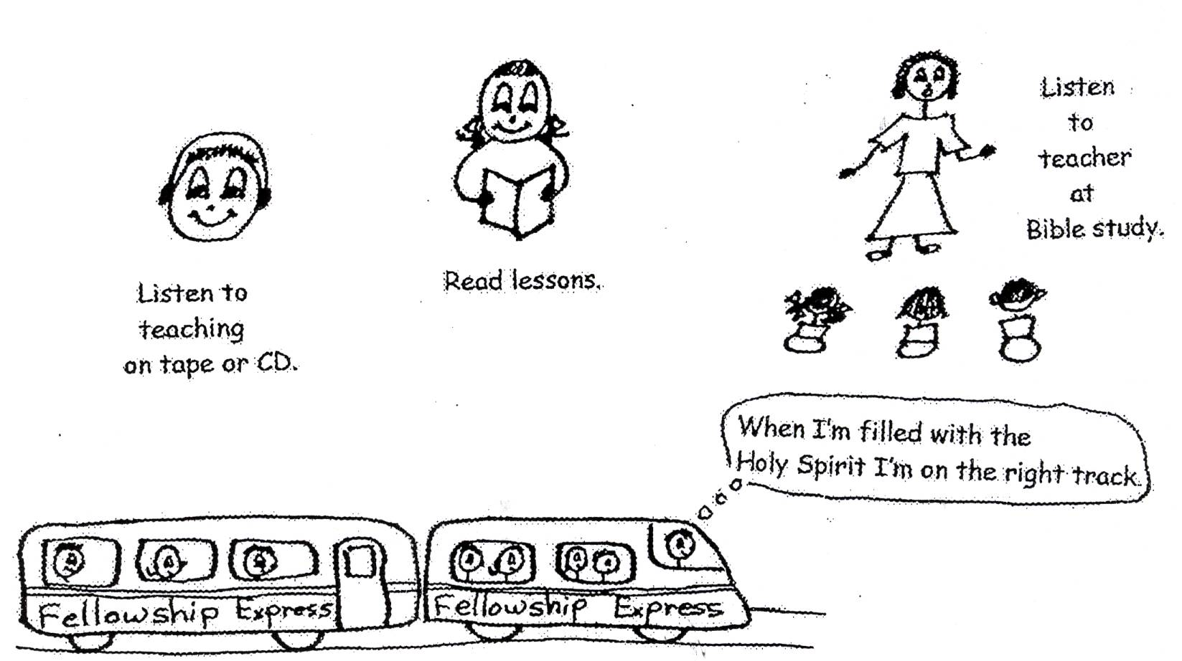
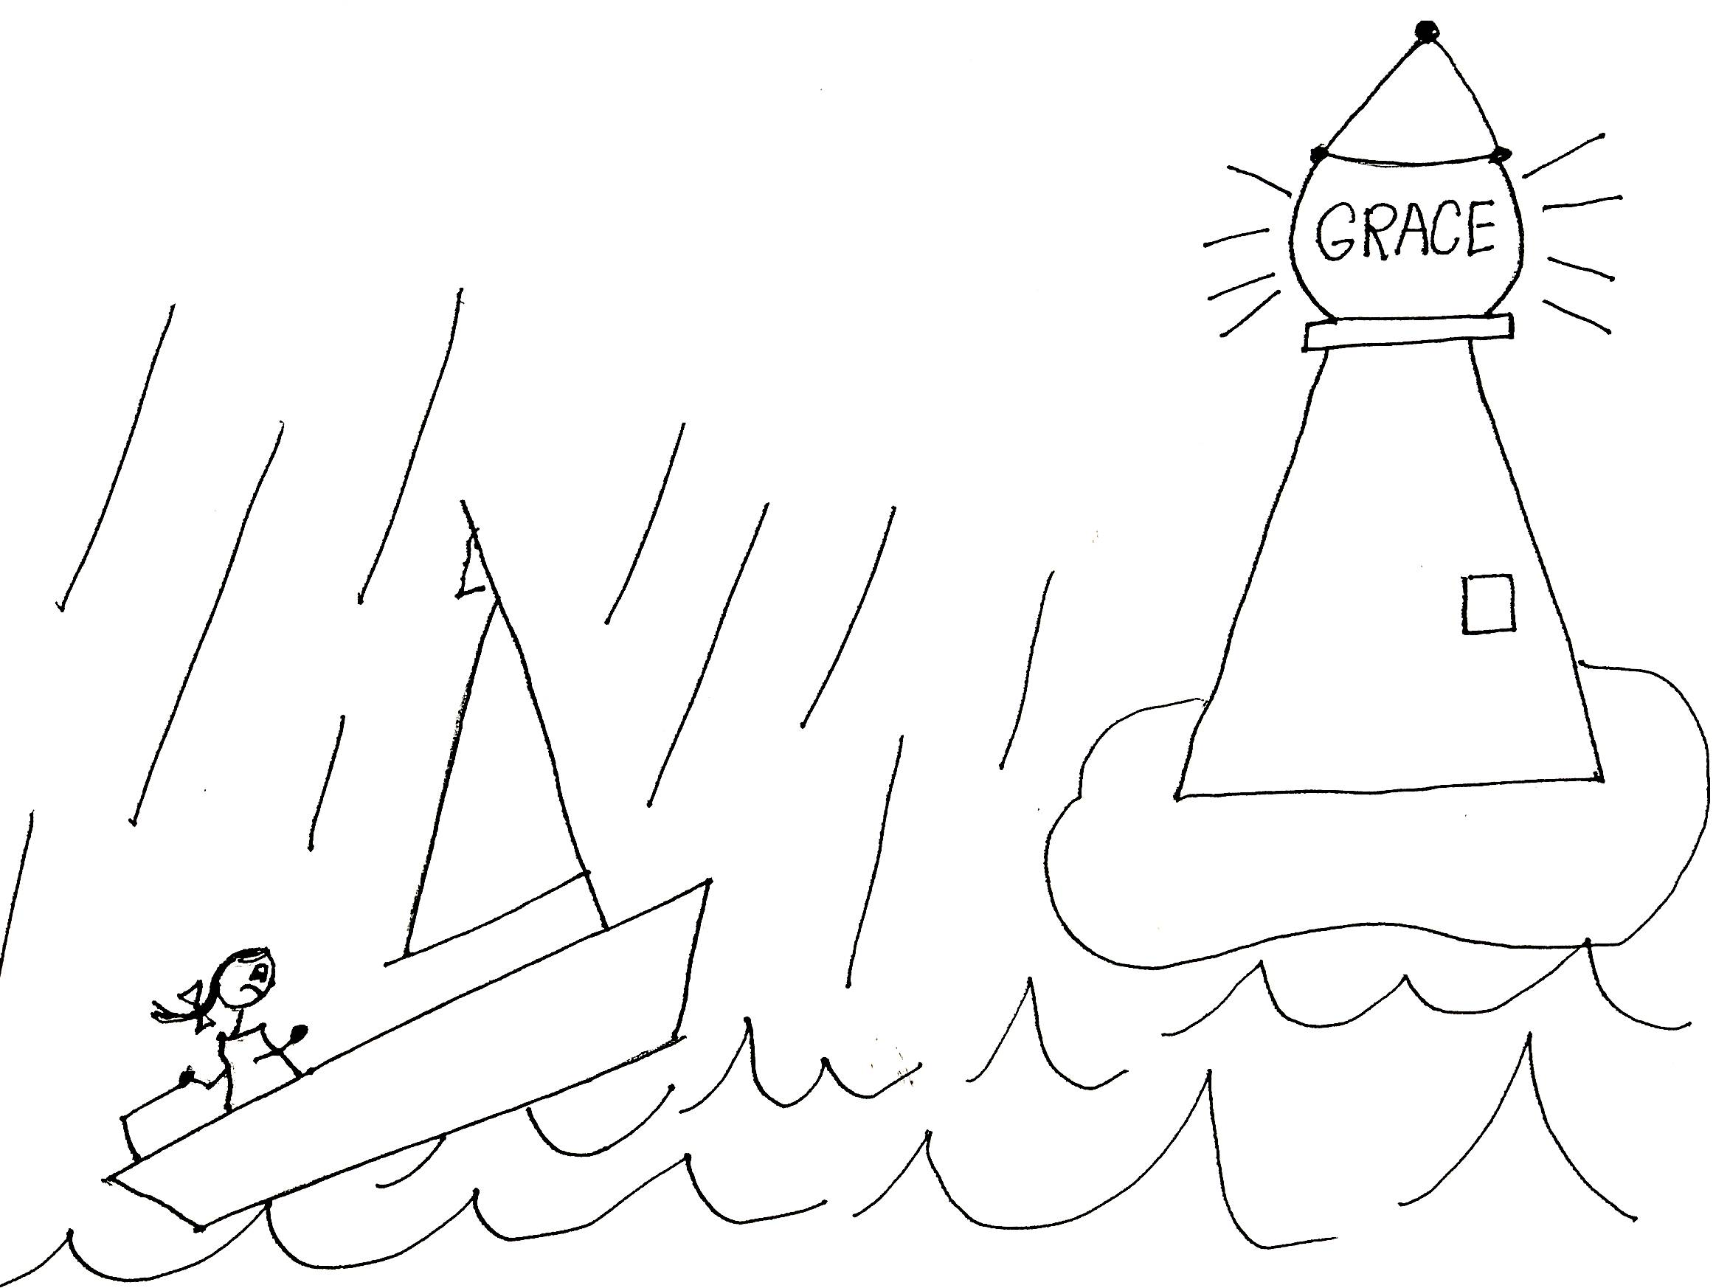

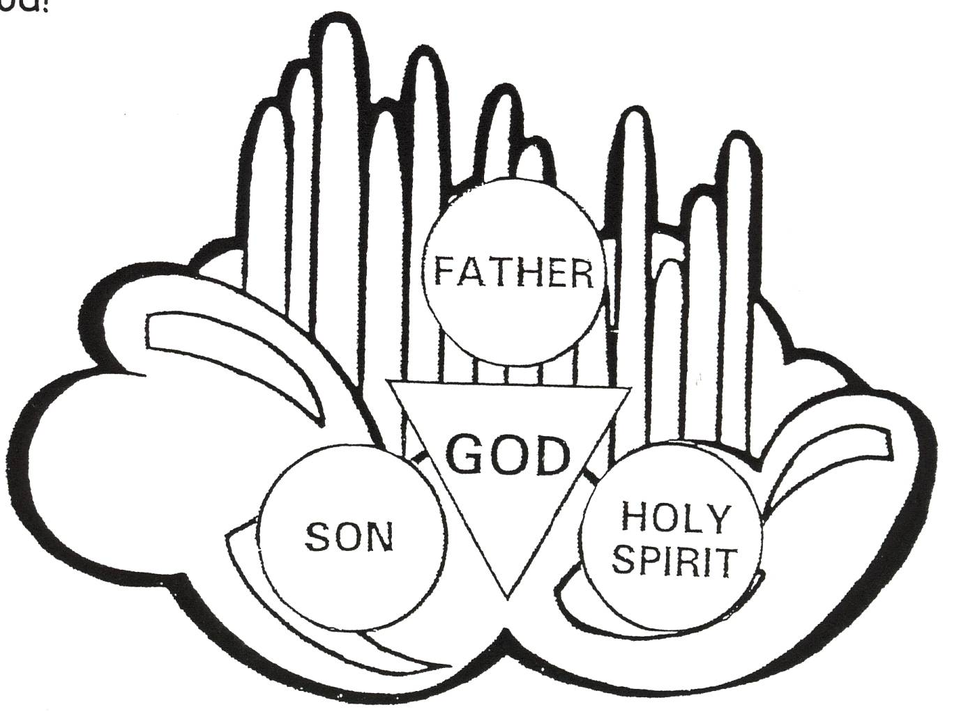

Romans 12:3 “For by the grace given me I say to every one of you: Do not think of yourself more highly than you ought, but rather think of yourself with sound judgment, in accordance with the measure of faith God has given you.”

Then we’ll get to spiritual autonomy, or spiritual independence. This means that we’ll be independent of human viewpoint and dependent on divine viewpoint. We’ll become independent of people and more dependent on God. During this time, we’ll get suffering or testing to make us grow even more. It is called momentum testing. It helps us to grow to spiritual maturity! God and Jesus are always “cheering” for us and helping us along the way!

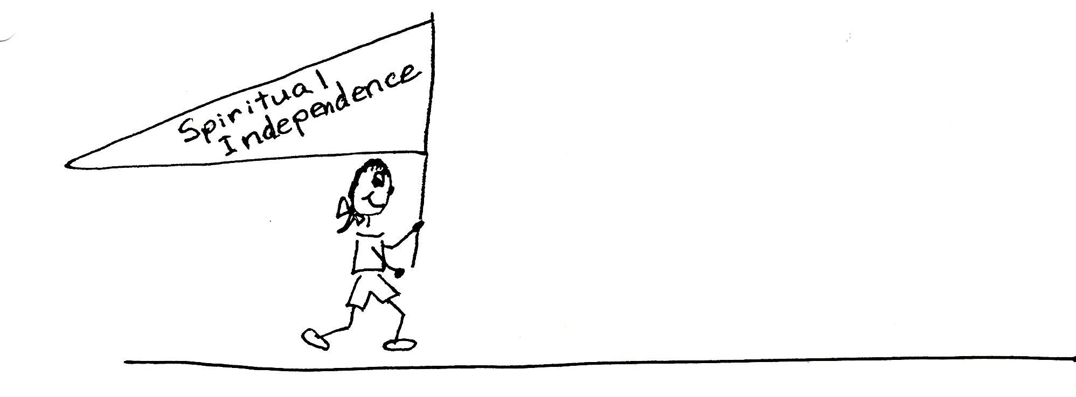

Colossians 3:1 “Since, then, you have been raised with Christ, set your hearts [minds] on things above, where Christ is seated at the right hand of God. Set you minds on things above, not on earthly things.”

And then when we reach the last stage of spiritual maturity, God will give us evidence testing. This is suffering or testing that will show the angels and people that God’s plan works! By going through the suffering and staying positive to Bible doctrine, and having a relaxed mental attitude, we give evidence that it works! It gives God all the glory because He gives us everything that we need to get to spiritual maturity. He gives us salvation, the indwelling of God the Father, the Son, and the Holy Spirit, Bible doctrine, and the ten problem-solving devices. We all have equal opportunity and equal privilege to pass the tests. We can all pass them with flying colors!

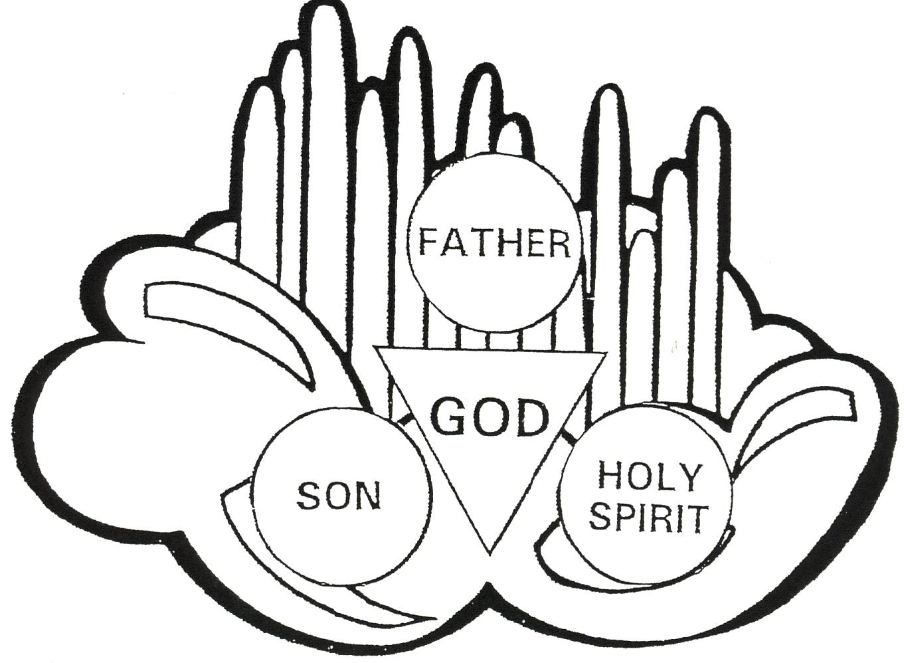

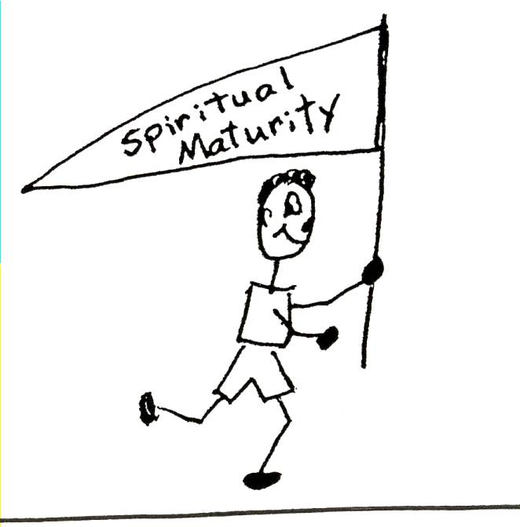
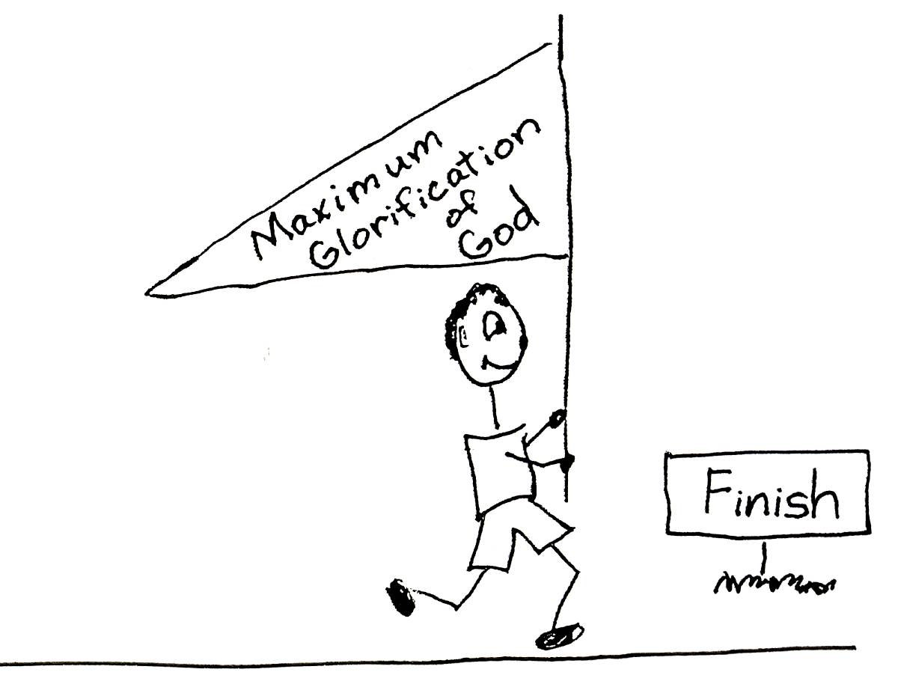

Job 36:15 “But to those who suffer He delivers in their suffering; He speaks to them in their affliction.” Hebrews 2:18 “Because He Himself suffered when He was tempted, He is able to help those who are being tempted.”

When we’re occupied with Christ, our minds are busy with His thinking in ANY situation we find ourselves. We are able to keep stress out of our minds. Our minds are relaxed. We have a relaxed mental attitude! We can focus on the Lord Jesus Christ’s love for us, and our love for Him. Christ will be at home and comfortable in our minds. We can be at home and comfortable with our best Friend. Let’s be occupied with Christ and relax!

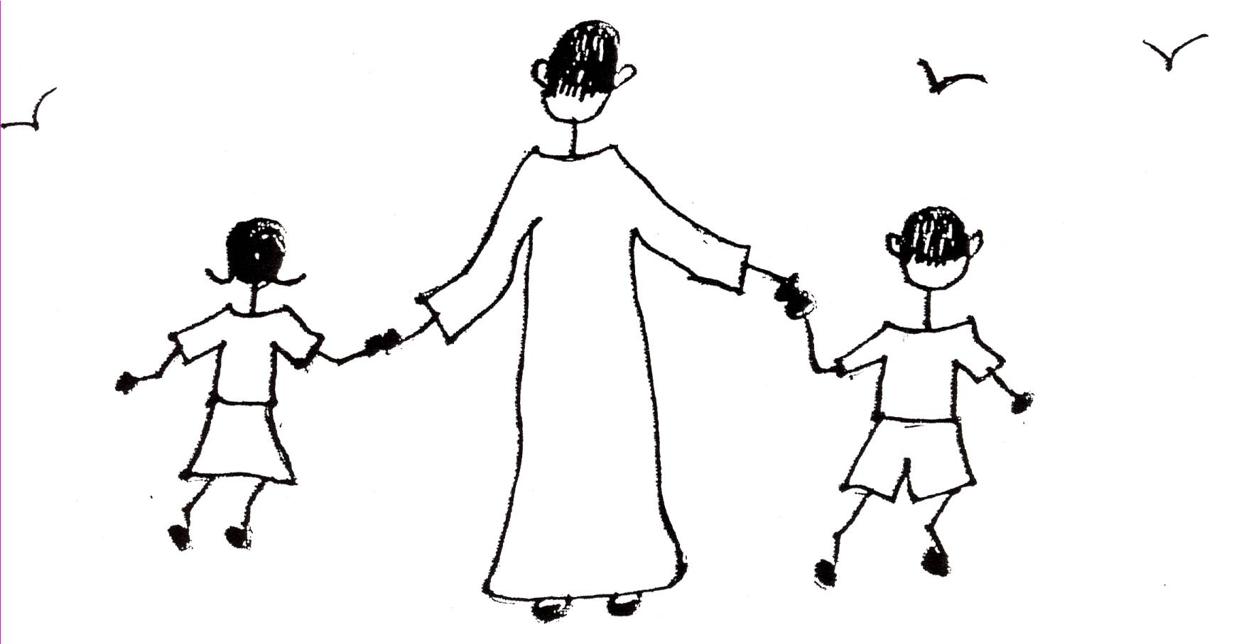

Ephesians 3:16-19 “I pray that out of His glorious riches He may strengthen you with power through His Spirit in your inner being, so that Christ may be at home in your hearts [minds] through faith [Bible doctrine]. And I pray that you, being rooted and established [grounded] in virtue-love, may have power, together with all the saints, to grasp how wide and long and high and deep is the love of Christ, and to know this love that surpasses knowledge – that you may be filled to the measure of all the fullness of God.”

Robert McLaughlin Bible Ministries
www.gbible.org
R. B. Thieme, Jr.’s Book: Christian at Ease
&
Lighthouse Christian Youth Ministries
www.lighthousechristianyouth.org
lcyministry@comcast.net

From the Jr. Tree of Life



2 Pet 1:2 “Grace and peace be yours in abundance through the knowledge of God and of Jesus our Lord.”

