Lighthouse Christian Youth Ministry
Lesson 55

NO EXCUSES!

July 8, 2007

How many times have we all said to ourselves, “I would have done that if I ….” We have many excuses for why we don’t do certain things. There are NO EXCUSES for not living in the plan of God. Billions of years ago, God designed everything that we would need to live in His plan. He designed equal privilege and equal opportunity for all of us. We all have the same chance! God wants us to have His highest and best!

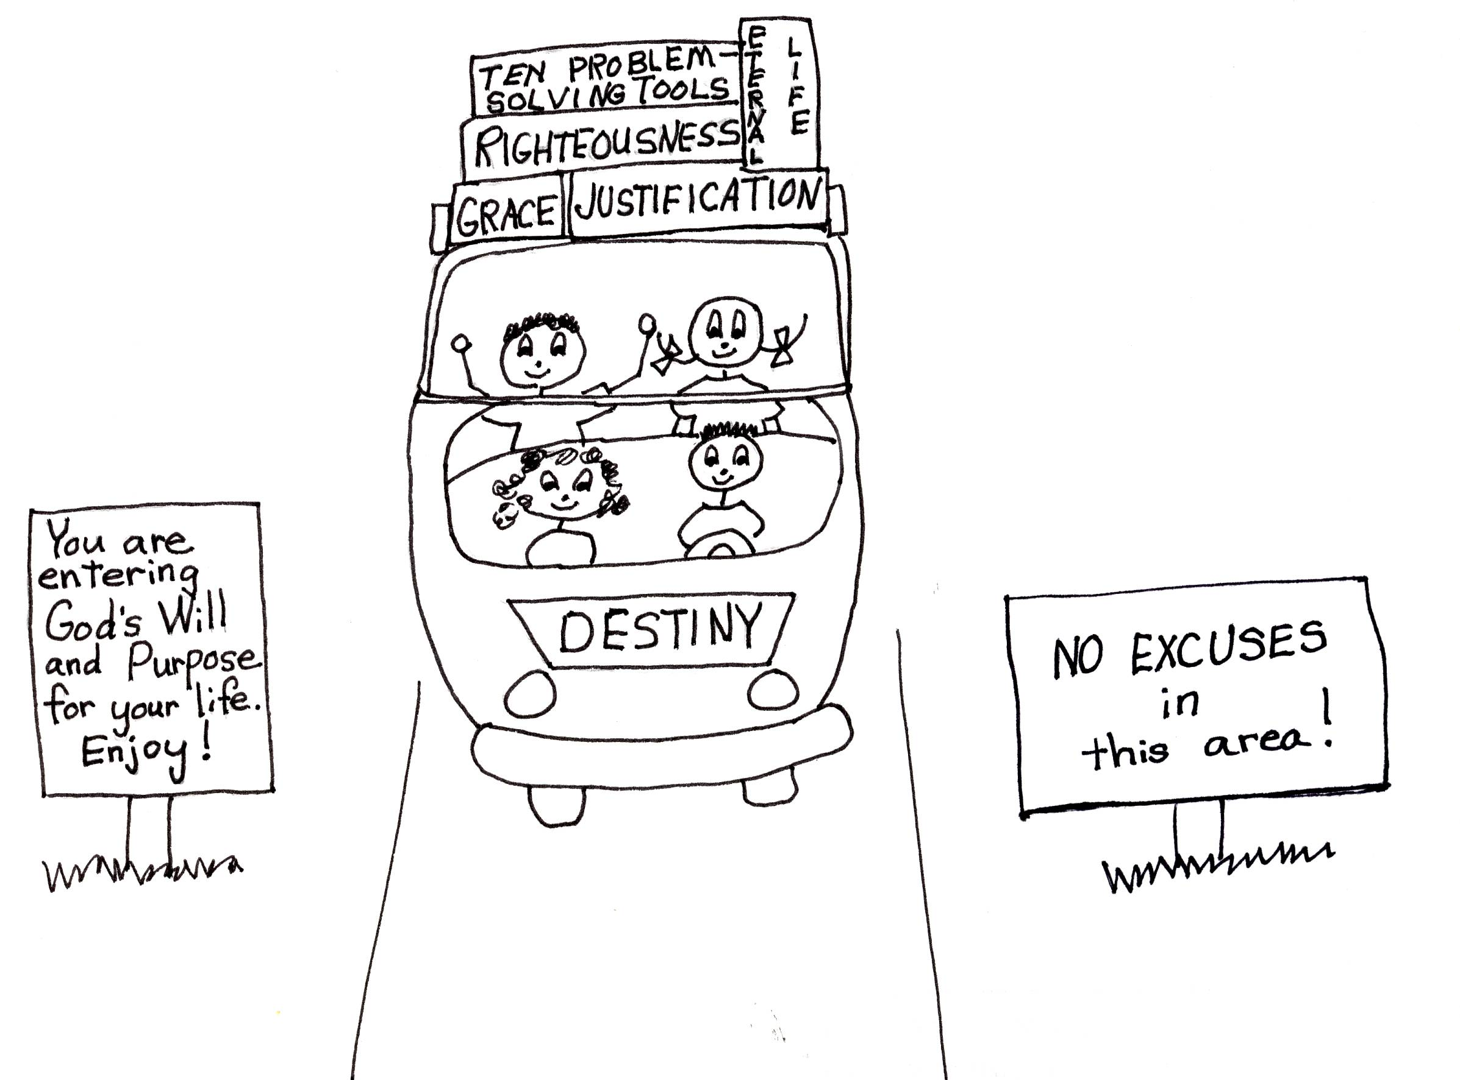


First of all, under equal privilege and equal opportunity, Jesus Christ’s work on the cross paid the penalty for the sins of all humanity. All mankind has the privilege and opportunity to accept Jesus as their Savior. God has put a desire in the hearts of all humans to know Him. We have free volition to say “yes” or “no” in accepting Jesus Christ as our Savior. God makes His Son known to us through the power of the Holy Spirit in common grace; the Holy Spirit uses His power to make the gospel clear to us. Once we understand the gospel, God the Father invites us to believe in Jesus Christ. That is the best invitation we will ever receive!!! If we don’t choose to believe, we have NO EXCUSES when we come to the Great White Throne Judgment of God to say that we didn’t know about the way for salvation! We all have available to us equal privilege and equal opportunity!

Romans 1:16 “I am not ashamed of the gospel, because it is the power of God for the salvation of everyone who believes…”

Billions of years ago, God decided on this equal privilege for Church-age believers: to have their own priesthood! This means that we can represent (stand for) ourselves before God. We can pray to God the Father, tell Him our sins (rebound), or carry on a conversation with Him. He is always there to listen. He never gets tired of listening to us. We don’t have to have someone else be our priest or represent us (take our place) before God! We have NO EXCUSES not to keep in touch with God! We all have just as many privileges as any other person, no one has more or less. All believers were chosen to have equal privilege!
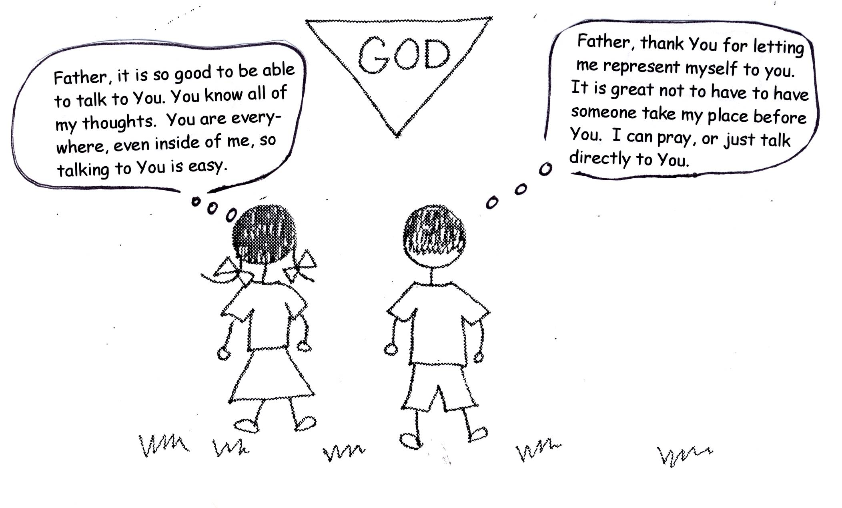

1 Peter 2:9 “But you are a chosen people, a royal priesthood, a holy nation, a people belonging to God, that you may declare the praises of Him Who called you out of darkness into His wonderful light.”

Also, billions of years ago, God decided that we should have equal opportunity; logistical grace support and blessings for winner and loser believers. This means that we have everything that we need in the natural life and in the spiritual life. In the natural life, God knew that we would need food, shelter, and clothing. In the spiritual life, He knew that we would need Bible doctrine and a way to learn it. God chose, or called, all believers in eternity past to have equal opportunity.
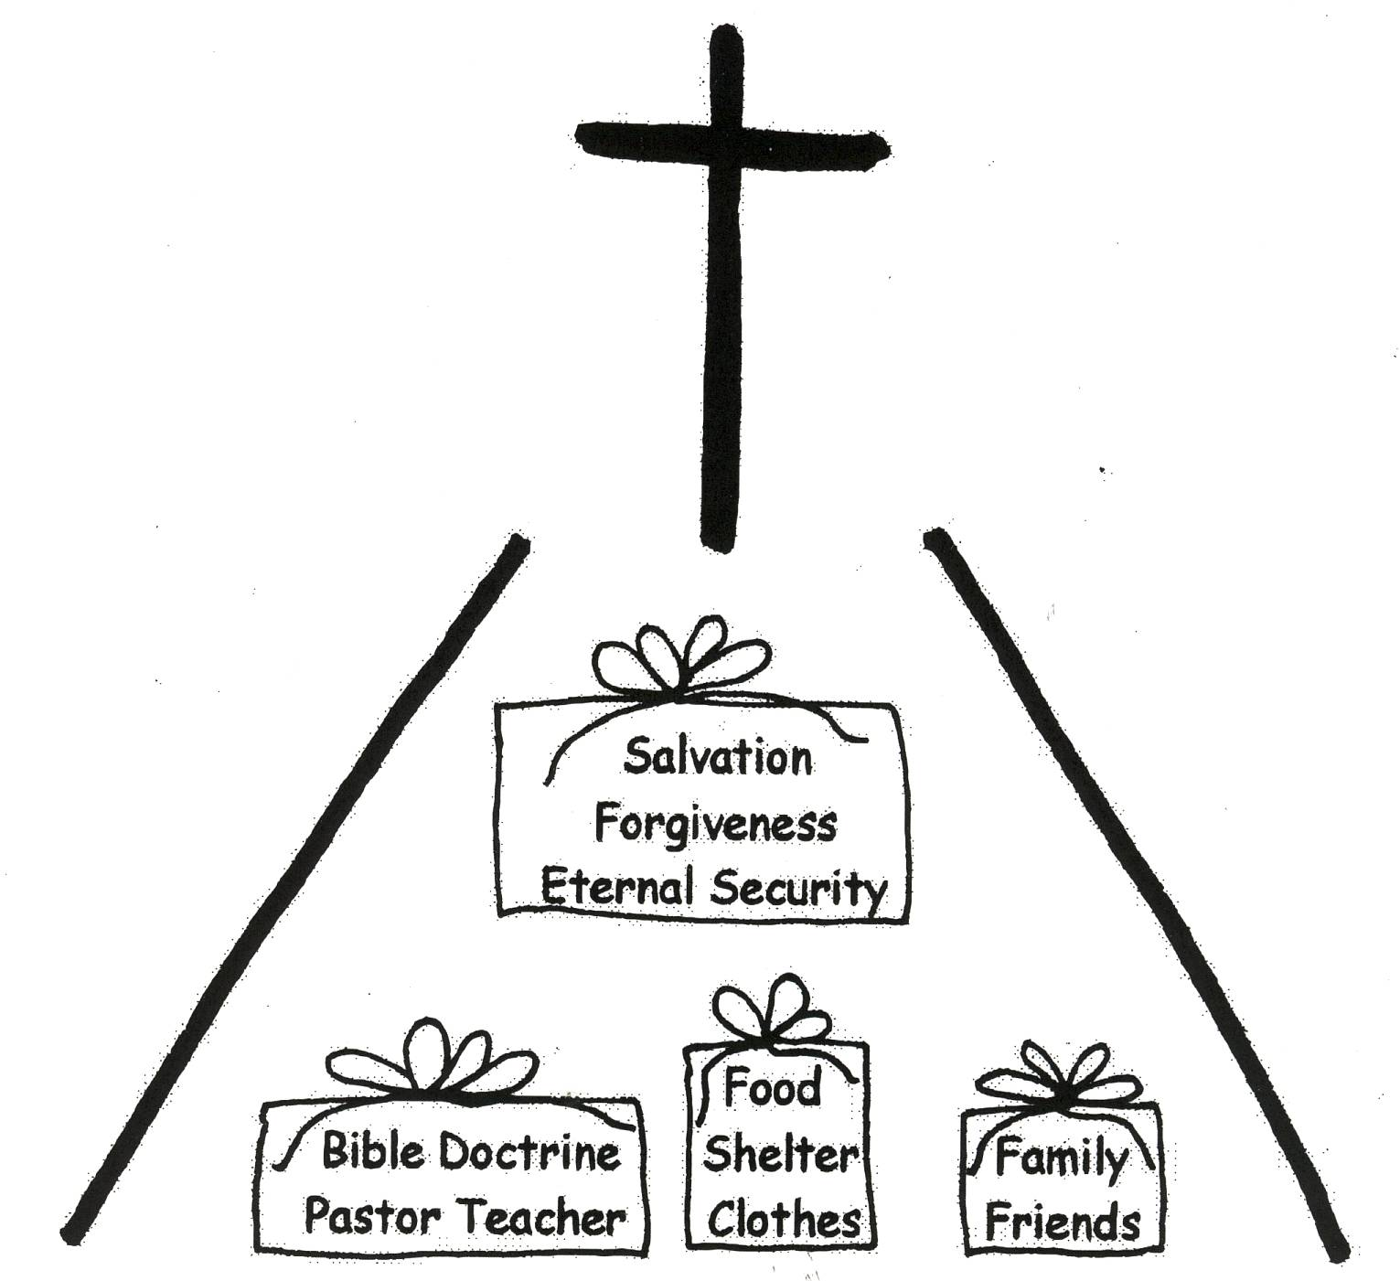

2 Peter 1:3 “His divine power has given us everything we need for life [natural life] and godliness [spiritual life] through our knowledge of Him Who called us by His own glory and goodness [virtue].

When we learn and believe Bible doctrine through the filling of the Holy Spirit, we will be motivated to use it! We will not put off learning about God, but we will go forward in His plan for our lives. There is only one book that has the right motivation for us, THE BIBLE. The Bible is the thinking of the Lord Jesus Christ. What great thinking!!! It will get us through good times and bad times! What great motivation!!!
Psalm 40:8 “I delight to do your will, Oh my God; Your doctrine is in my heart [mind].”

We can have the wrong motivation in life and it will take us in the wrong direction! If we are not motivated by the Word of God, we have wrong motivation! So, it is easy to tell when we are on the wrong track. When we are on the wrong track, we will get into mental attitude sinning and be miserable. What a downer!!! It always comes back to what we are thinking!
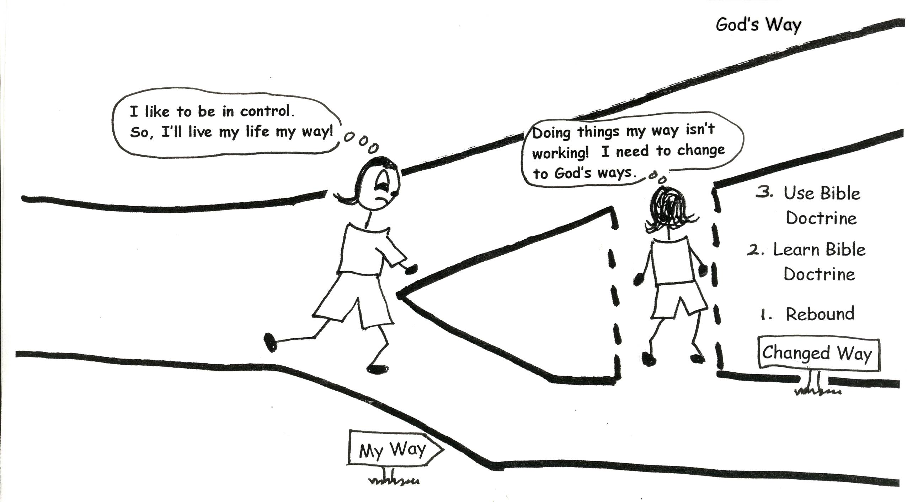

Mathew 7:18 “A good tree cannot produce bad fruit, nor can a bad tree produce good fruit.”

With the wrong thinking, we’ll get into self-justification. We’ll try to give excuses for our wrong way of living. We’ll be in self-deception, lying to ourselves! And we will be self-absorbed. We’ll be thinking so much about ourselves that we won’t have time for others, and most important, we won’t have time for God. We’ll be in self-caused misery, the ME, ME, ME attitude. What an attitude! Our arrogance will cause us blindness to God’s way. How blind can we be? VERY!
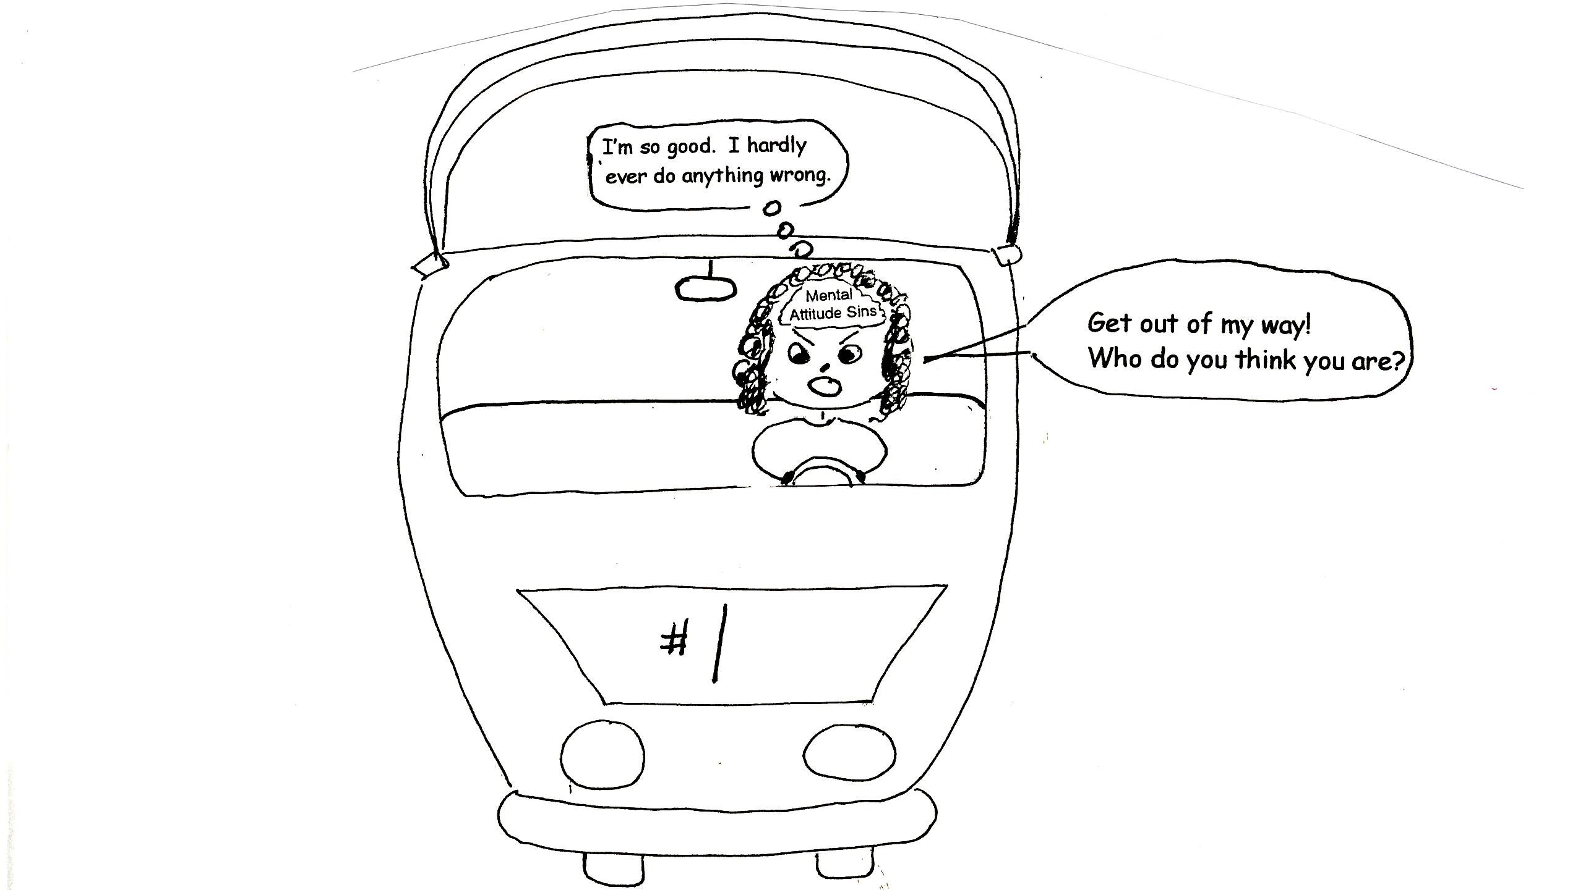

Jeremiah 49:16 “As for the terror of you, the arrogance of your heart has deceived you.”

This arrogance, which deceives us, leads to all kinds of mental attitude sins. We want to have it our way all the time and when we are so absorbed with ourselves, we blame everyone else (even our parents) for our unhappiness. We become bitter and jealous. We want to get even with those who do bad things to us. We want to be their judge. We don’t let God handle these people. We start having thoughts of fear, guilt, worry, anger and hatred. What a messed up mind! This all happens because of the wrong motivation in life.
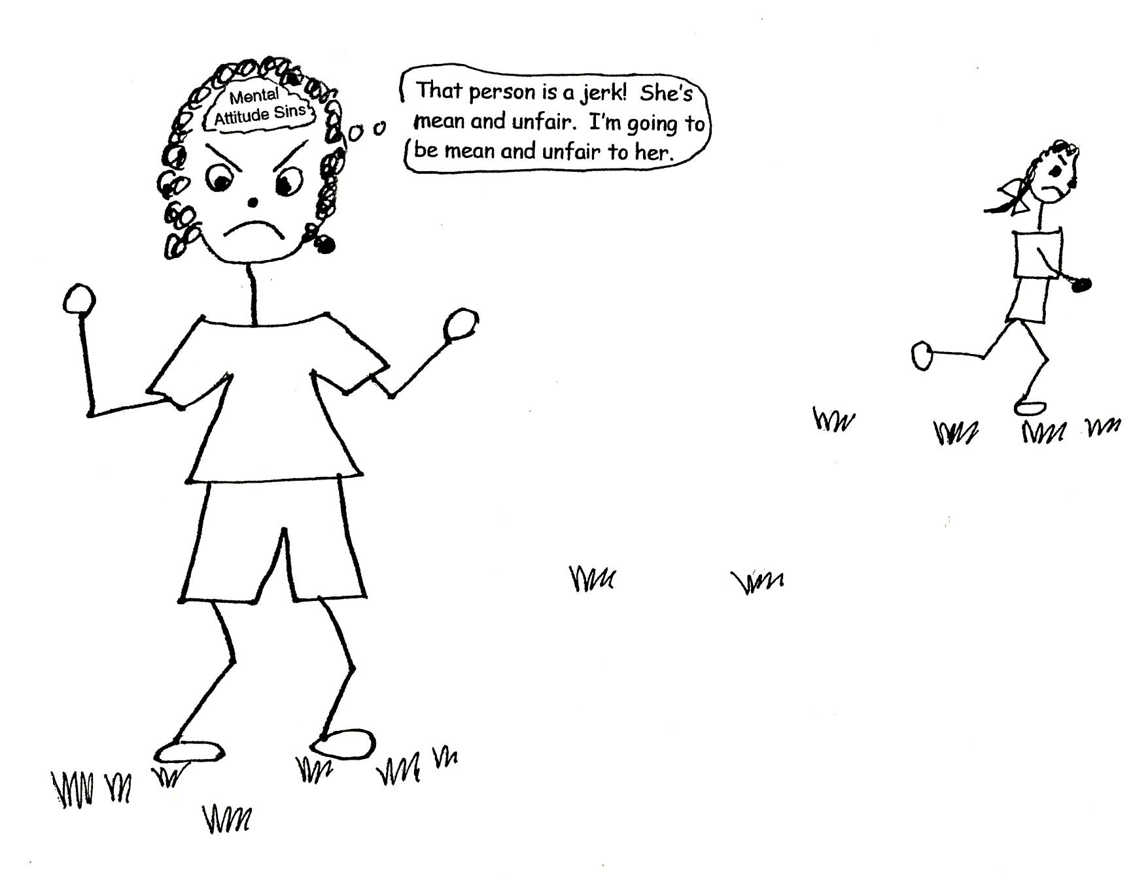

Proverbs 27:19 “As water reflects a face, so a man’s heart [mind] reflects the man.” Isaiah 44:20 “He feeds on ashes; a deceived heart has turned him aside. And he cannot deliver himself…”

Using wrong motivation in life will take us away from what God has planned for us in equal privilege and equal opportunity. If we go down that road, we won’t have all of the wonderful blessings God has waiting for us. We won’t bring glory to God. So, let’s go where God has called us, to His predesigned plan for our lives. Let’s not use any silly excuses to keep us from receiving God’s best. We don’t need excuses. God accepts us the way we are. In our new man we are perfect in His eyes, and all of the sins that we commit in our old sin nature have been judged at the cross. WE HAVE NO EXCUSES!
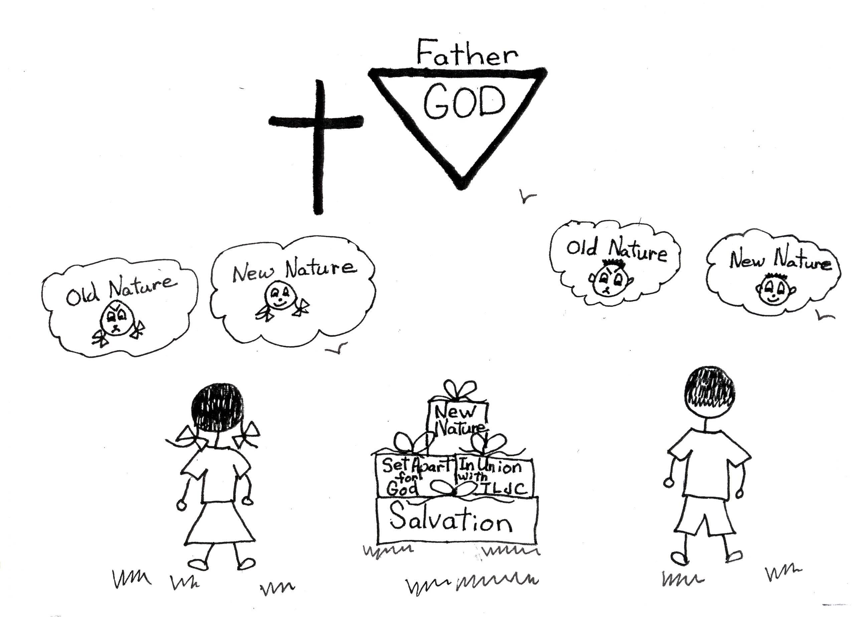

Romans 8:1 “Therefore, there is now no condemnation [guilt] for those who are in Christ Jesus, because through Christ Jesus the law of the Spirit of life set me free from the law of sin and death.”

In the spiritual life, no one is better or smarter than anyone else. In God’s eyes we are all the same, perfect, because we have +R, God’s righteousness. As was said before, God doesn’t judge our sins committed in our old sin nature. They have already been judged on the cross! How freeing is that? We don’t have to compete with others or feel badly about our lives. In our new nature, God couldn’t love us more than He already does. He couldn’t love us less, either. Now what is our excuse?

Galatians 3:28- 29 “There is neither Jew nor Greek, slave nor free, male nor female, for you are all one in Christ Jesus. If you belong to Christ, then you are Abraham’s seed, and heirs according to the promise.”

SINS THAT WILL KEEP US AWAY FROM EQUAL PRIVILEGE, EQUAL OPPOUTUNITY, AND ENJOYING GOD’S BEST FOR US.

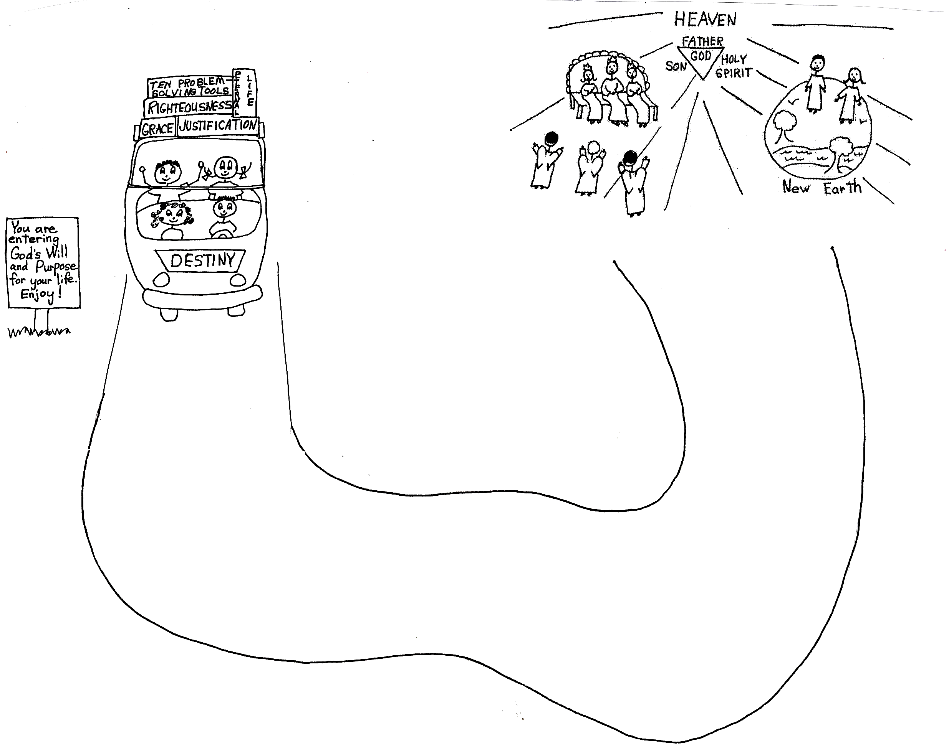

ARROGANCE: Blindness to the grace of God. Excessive desire to be noticed. Great need for approval or praise from others. Thinking too highly of what one has accomplished or owns.

PRIDE: Pre-occupation with self. Don’t care about others. Reject authority. Think too highly of what one has accomplished or owns.

JEALOUSY: Causes anger and revenge. It is self-destructive. Care too much what others think of us. Will cause instability and disorder in the life of the believer.

IMPLACABILITY: Impossible to be pleased or satisfied.

BITTERNESS: Severe temper, cruel sarcasm, troubled mind.

VINDICTIVENESS: Want to cause suffering to others to get even for an evil or an injury, real or imagined.

GUILT: Putting ourselves down because of doing something wrong. This is a form of arrogance because we think that we have to do more to get God’s forgiveness. We insult God by saying that He hasn’t done all the work. We do not accept that God treats us in grace. Guilt takes us away from God and His grace.

WORRY: To be troubled or uneasy in our mind. We are so worried about not having what we need. We forget that God has and will supply all of our needs!

DON’T MAKE ANY OF THESE SINS A LIFESTYLE!

