Lighthouse Christian Youth Ministry
Lesson 56

The Right Power

September 23, 2007

We have the availability of super power! We sure do! We can use the power of the Holy Spirit to learn, believe, and use God’s Word…Bible doctrine. The Holy Spirit will make our souls able to hold the Word in our souls for permanent blessings while we live on earth and then those same blessings that continue into eternity! We will be using God’s credit card instead of our human credit card and this praises God because God’s credit is valuable and human credit is worthless! It’s like God gave us a credit card with an unlimited amount of power. We can use the power when we are filled with the Holy Spirit. That’s a lot of power! We never have to pay God back either…never! God gets all of the praise and glory, and we get His power! And to think that all believers can have this power if they choose to!

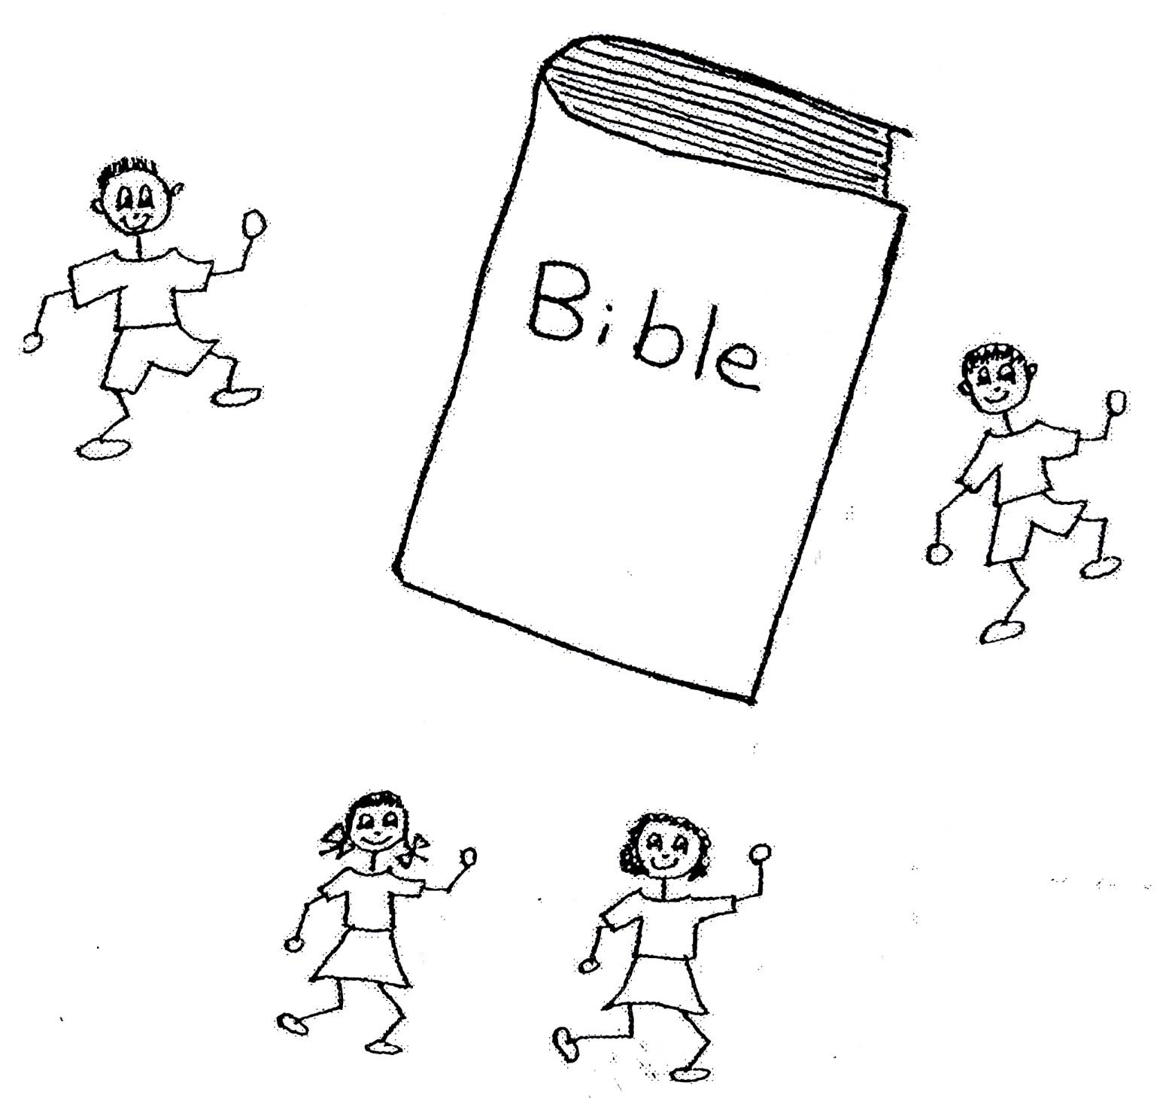

We need to use the power of the Holy Spirit to learn, believe, and use Bible doctrine in everyday life…at home, school, and anywhere else we go. That way, Jesus Christ will live in us and we’ll think just like Him. His thinking will rule us. We need to live in Christ, the Vine because we are His branches. He feeds us so we can produce good fruit…fruit of the Holy Spirit. Gal 5:22 “But the fruit of the Spirit is love, joy, peace, patience, kindness, goodness, faithfulness, (23) gentleness, self-control; against such things there is no law.” That way, we will trust in God for our happiness, not in others, ourselves, or things. We’ll be using our minds, not our emotions. Remember!! Emotions can’t think…they just feel…good or bad! We’ll be using God’s divine viewpoint and that’s permanent and helpful and it never goes away unless we choose to use our destructive human viewpoint instead. We need to let the Holy Spirit do His job, making the Word of God clear to us. He has the power to teach us and to make us use God’s Word!



John 14:26 “But the Counselor, the Holy Spirit, whom the Father will send in my name, will teach you all things and will remind you of everything I have said to you.”

We are able to live in God’s plan and have permanent blessings, blessings that go on forever, because they are from God’s power, not on our human power. Isn’t that cool? Think of the strongest person that you know. That person’s strength is nothing compared to the strength of the Holy Spirit. We need to be filled with the Holy Spirit in order to take advantage of His power. So, when we sin and lose the filling of the Holy Spirit, we need to confess or rebound and get back the filling of the Spirit and His power!
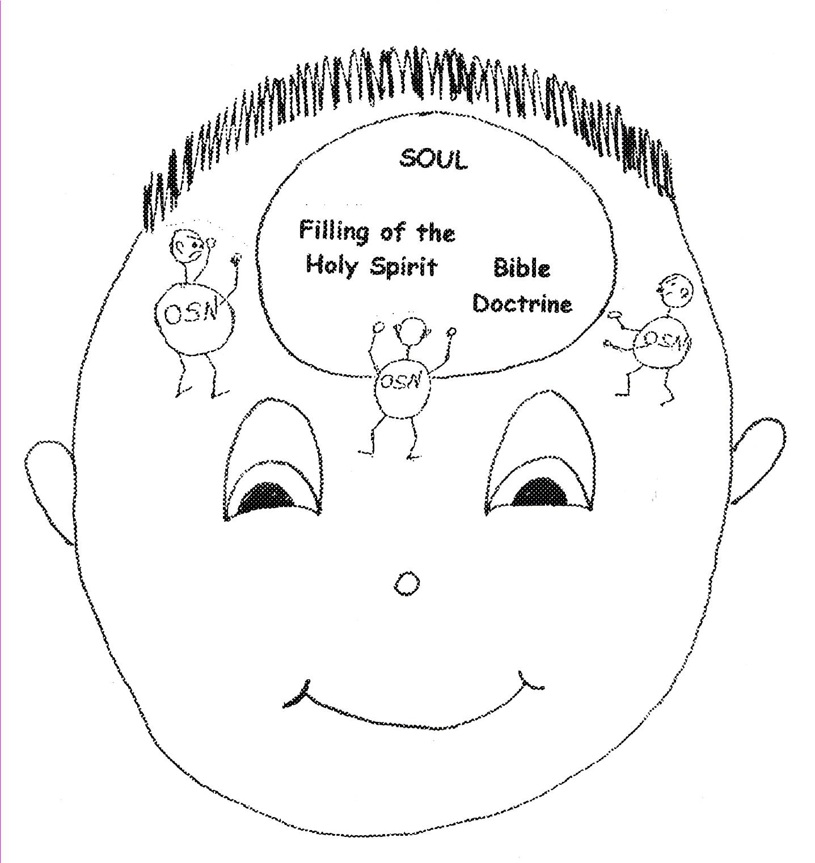

Ephesians 3:20 “Now to Him Who is able to do much more than we could ask or imagine, according to His power that is at work inside of us, to Him be glory in the church and in Christ Jesus throughout all generations…”

As Church–age believers, we need to learn God’s plan, will, and purpose for our lives. We need to know how wide God’s plan is. The width refers to the defense line that we have for our spiritual battle in the angelic war. We have the ten problem-solving devices for our defenses. They are for us to use so that we keep stress and unhappiness out of our souls. We’ll be in difficult situations, but we can choose to use the problem-solving devices and not let situations get us all flustered! We can live in the kingdom of Jesus’ light instead of the kingdom of Satan’s darkness! We are able to have the Power in the Holy Spirit!
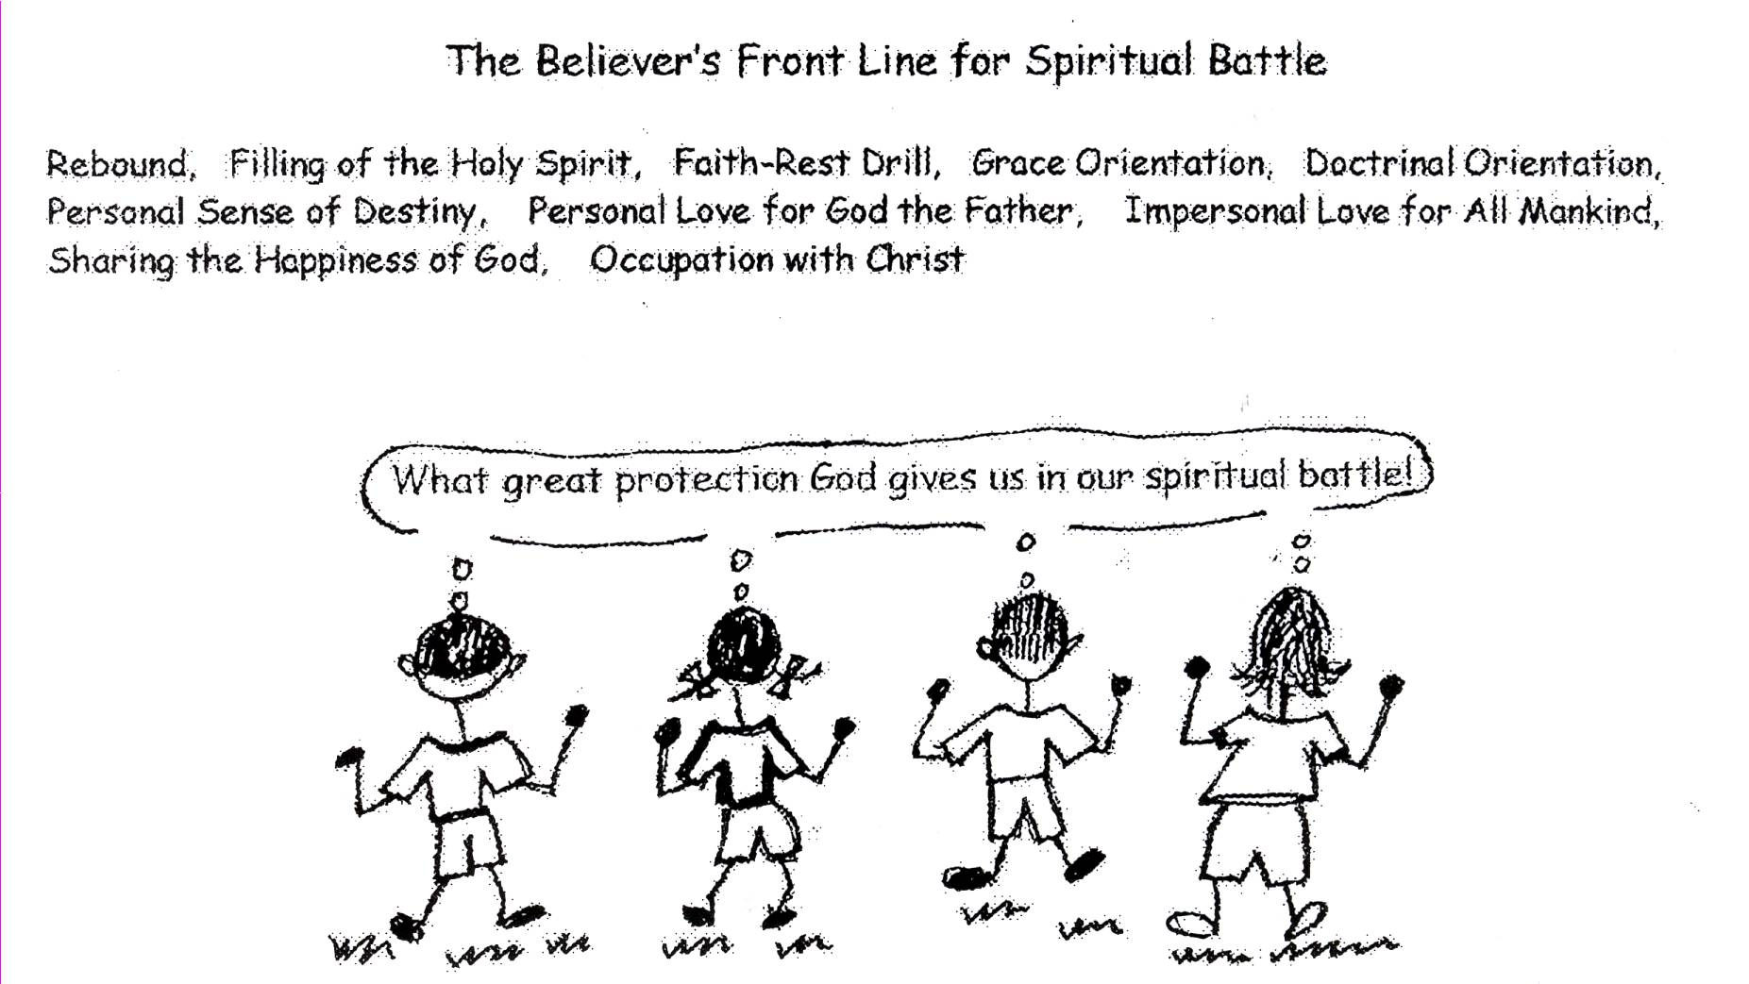

Ephesians 3:18 “That you may be able to comprehend or grasp the idea in the presence of all the saints (all believers) what is the width and length and height and depth of the love of Christ.”

We need to know how long God’s plan is. This means that we need to know the greatness of His plan. God pre-designed the plan especially and personally for each of our lives and He did it in eternity past before He created us. He knew that we would be in the angelic conflict or war. He knew that we would live in the Church age. Therefore, He gave us the power of the Holy Spirit, His omnipotent supernatural power, so that we could learn, believe, and live the Bible doctrine in our souls. How great is that?

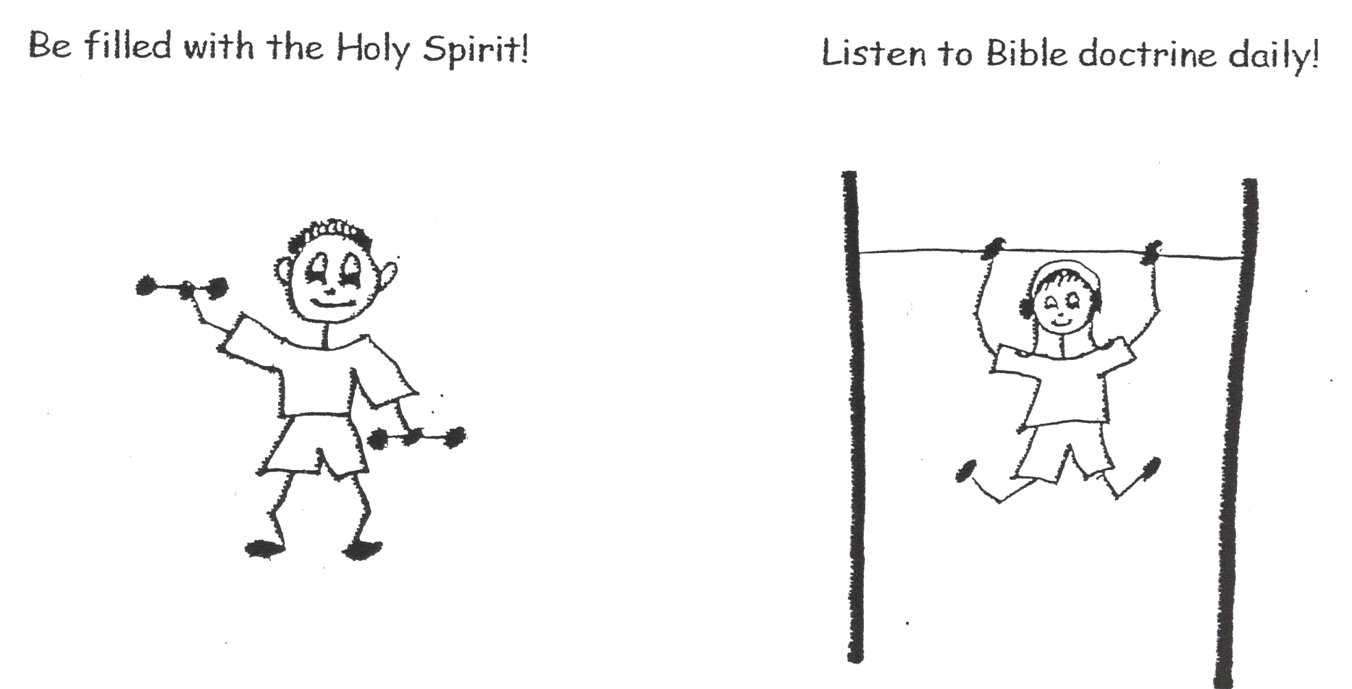

We need to know how high God’s plan is. The height of His plan means that we can live in the pre-designed plan of God. We can reach the height of super grace, become invisible heroes, and have an impact on those around us. We can glorify God and reach the “high ground” of spiritual maturity. Remember, we have the power, the supernatural power of the Holy Spirit! We are in union with Christ and will be seated with Him at the right hand of God the Father. Can you just picture that? AWESOME!
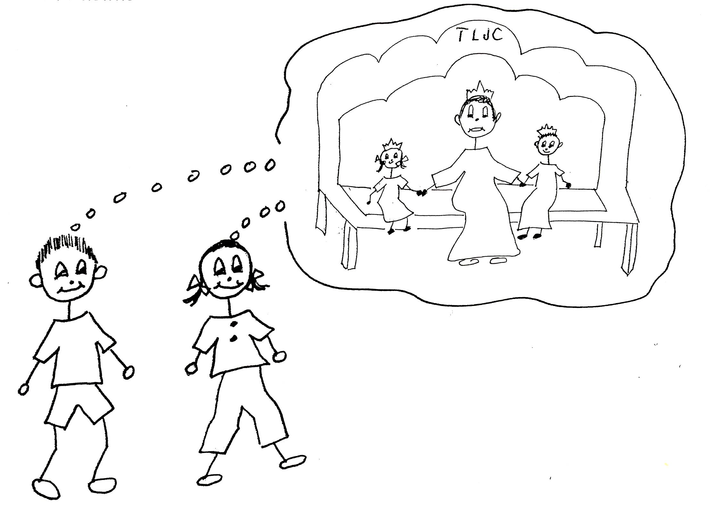

Ephesians 2:4-7 “But because of His great love for us, God, who is rich in mercy, made us alive with Christ even when we were spiritually dead in transgressions…it is by grace you have been saved. And God raised us up with Christ and seated us with Him in the heavenly places in Christ Jesus, in order that in the coming ages He might show the most wonderful riches of His grace…”

We also need to know how deep God’s plan is. He has given us our very own folder of invisible assets or blessings, which include: the baptism of the Holy Spirit, positional sanctification, equal opportunity in our own pre-designed plan of God, equal privilege in the royal priesthood, and the indwelling of the Trinity. These are some of the fantastic riches of God. He has given us everything that we need to grow in our spiritual life: the filling of the Holy Spirit, Bible doctrine, and the ten problem-solving devices. God has put in the Bible everything that we need to know for our spiritual warfare. The Holy Spirit, with His supernatural power, will help us to understand the deep things of God. That’s powerful! And God does it all…not us.



1 Corinthians 2:10 “For to us God revealed them (Scriptures) through the Spirit; for the Spirit searches all things even the depths of God.”

It is difficult to even imagine how wide, long, high, and deep the plan of God is. Since God is all powerful, all knowing, all loving, etc., His plan is all powerful, all knowing, all loving, etc. Mind boggling, isn’t it? When we start to understand these sides of God’s plan, we will start to know about the love Christ has for us. We have to understand the love from Christ before we can love Him back. To understand the love from God, we need to understand His character. When we have Bible doctrine circulating in our souls, we will come to understand the love of Christ for us. The more we have Bible doctrine circulating; the more we will understand God and His love. Our love for God the Father and occupation with Christ will grow! It will become wide, long, high, and deep! What great power we can have!
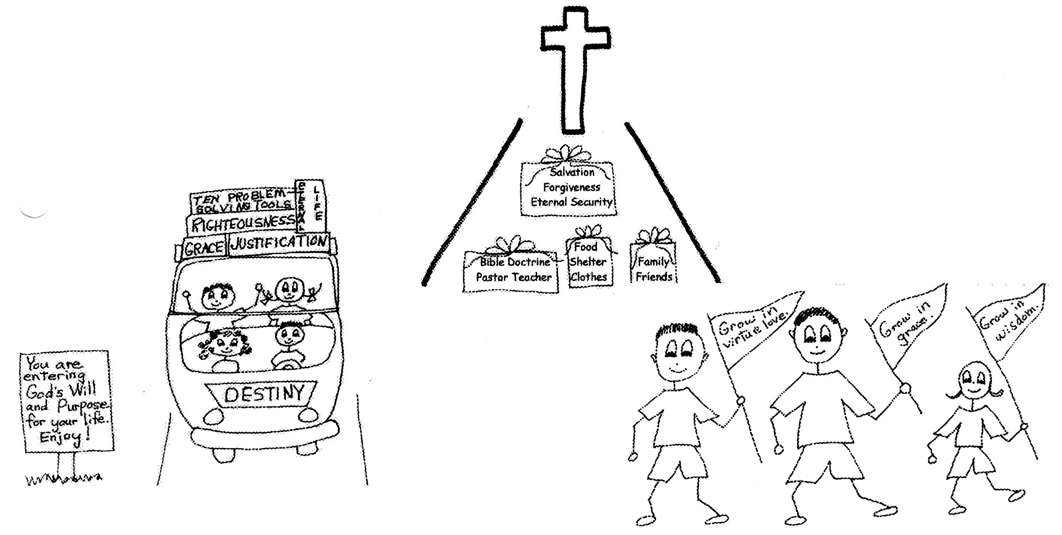
Ephesians 3:18 “…that you may be able to comprehend or grasp the idea in the presence of all the saints what is the width and length and height and depth of the love of Christ.”

www.lighthousechristianyouth.org
Prep@gbible.org

