Lighthouse Christian Youth Ministry
Lesson 57
The Pre-designed Plan of God
Predestination



February 20, 2009
(August 24, 2007)

URGENT INFORMATION...
BEFORE we begin our Bible study, if you are a believer in the Lord Jesus Christ, take a moment to NAME any sins that you committed today to God the Father. This will allow you to be filled with the power of God the Holy Spirit who teaches us spiritual things of the Bible that is in our lesson today. (Eph 5:18) and (I John 1:9) are the verses from the Bible that teach us about this. Let’s read them together in our Bibles... |  | 
But, if you have NEVER believed in the Lord Jesus Christ as your personal Savior, you have that opportunity right now. Here’s what we mean by that. God tells us in the Bible that the ONLY way into heaven after we die is to know Jesus Christ. He’s the only way to get into heaven or simply He’s the only way to be saved. (Act 16:31) “Believe in the Lord Jesus, and you will be saved, you and your household." (John 3:16) "For God so loved the world, that He gave His one and only Son, that whoever believes in Him shall never die, but have eternal life.” (John 14:6) “Jesus said, "I am the way, and the truth, and the life; no one comes to the Father but through Me.” So you see Jesus is God’s Son and he became a man for us…a perfect man so He could save us from our sins. Every human being EXCEPT JESUS has a sinful nature when we are born. Jesus was born perfect because God is His father. Since we are all sinful God can have NOTHING to do with us. But God LOVES US and wants us to live in heaven with Him forever so He sent His Son to solve the sin problem and to save us. Isn’t that great? Not only did Jesus become a perfect man but He lived His entire life without committing one sin! He did this so He could take our place and pay the penalty for all of our sins. He did this by being hung on a Cross and taking all our sins in His own body. He was separated from God the Father and God the Holy Spirit for 3 hours on the cross paying the penalty for all the sins of every human being. This was so terrible for Him but He loved us so much that He was willing to suffer in our place so we could be in heaven with Him forever after we die. Then you know what happened after he died on the cross? He rose again from His grave and is lives right now and forever in heaven. And He wants you to believe in Him and trust Him for salvation.
So if you have never believed in Jesus, you can do so right now…simply tell God the Father that you believe in His son Jesus Christ as your Lord and Savior. If you make that decision, you are now a believer and will always be a child of God. When you die, you will spend eternity with Him.
"He who believes in the Son has eternal life but he who does not obey the command to believe the Son shall not see life, but the wrath of God abides on him." (John. 3:36)
(John 20:31) “…but these have been written so that you may believe that Jesus is the Christ, the Son of God; and that believing you may have life in His name.”
Today you’ll see just how special you are as God’s children. You’ll see that God knows every single detail about you and He took all the things He knew about you and designed the most exciting plan for your life down to the tiniest detail! Once you believed in Jesus Christ as your savior, the Holy Spirit “SEALED” you into eternal life with the seal of God.
In the Roman days, people who were wealthy wore a “signet” ring and it had their family’s mark of insignia engraved on that ring so they can make a mark with it that is a seal. Instead of licking their envelopes they sealed them with this signet ring! Then everyone knew the letter was from that family.
 | When they would want to buy something or sign a contract of sale they would pour hot wax and press the ring into the wax and that was their seal or their promise to pay for what they bought or a promise to keep their word.  The Holy Spirit sealed us on the day that we believed in Jesus as our Savior…our way into Heaven. He put all the promises of God into that seal and we are “FOREVER GOD’S CHILD”. (Ephesians 1:13) “In Whom also, when you heard the message of truth, the gospel of your salvation, in Whom also, when you believed, you were sealed by the Holy Spirit with reference to the promise (of salvation).”
(Ephesians 4:30) says, “Do not grieve the Holy Spirit by Whom you were sealed for the day of redemption.” The day of redemption means eternity! That means that you are sealed forever!
Now that we have that clear, let’s see what God has for us AFTER we have believed in His Son. We live in a very special and unique time period for us to live in called a dispensation. Our time period or dispensation is called the “Church Age.” God had special rules called the “Mystery” doctrine that are just for us…believers in the Church Age! God knows exactly what point in human history is the best time for each and every human that is born. He knows that WE will have the highest and best opportunities living today in the Church age or He would have allowed us to be born at another time.
 | As believers we are members of the Royal Family of God…we are His children forever! We’re called Royal Family because we believe in Jesus our King and we are His special family in the Church Age…NOW. And as believers in Jesus, there is an exact precise and accurate plan for us to follow. We have been given clear directions on how to follow this plan and a perfect LEADER, Jesus, as an example. The Lord Jesus Christ is our LEADER and PATTERN for us to follow. We must imitate Him and learn to think just like Him.  (Ephesians 5:1-2) “Therefore, be imitators of God, as beloved children; and walk in virtue love, just as Christ also loved you, and gave Himself up for us, an offering and a sacrifice to God as a fragrant aroma.”
(I John 2:6) “The one who says he lives in Him ought himself to walk in the same manner as He walked.” Now Jesus was perfect and didn’t make one mistake. We do and will continue to make mistakes or sin but our plan includes failure and that’s why we were given REBOUND…that’s when we confess or name our sins to God!!! God has an exact code for us to follow and we are told, as His royal family, we are to follow that code. Only a right thing, done the right way is RIGHT in God’s plan! Like praying…praying is right, but it must be done, to the Father, in the filling of the Holy Spirit based on the merits of our Lord Jesus Christ. Giving is a right thing but it must be done with proper reason and motivation. The most important thing we must learn as royal family in the Church Age is how to live inside God’s plan, function in it, and do everything for the right reasons in God’s perfect plan for our life! We believers in the Church will always be under attack because we live in enemy territory! We are God’s representatives in the devil’s world. Jesus is invisible now but He can be seen through us…His Royal family when we follow God plan. Then unbelievers will see Jesus in our actions and the way we treat each other with love. Jesus Christ is always in control of history, but Satan has been given the earth to rule when Adam and Eve sinned in the perfect Garden of Eden. We believers have been under attack ever since Jesus went back into heaven.
There were people in the early church that were teaching that “believing” wasn’t enough. They were adding HUMAN WORKS or ACTIONS to salvation. They were saying that you had to be good and you had to follow certain rituals to be saved and not just believe! Rituals were tools used in the Old Testament times to teach the people about the Messiah (Jesus Christ) to come. So when Jesus finally arrived on earth they would recognize Him and maybe say, “Hey, that’s who we learned about in rituals.” Rituals like Baptism and circumcision were practices back then were just symbols that stood for the peoples’ belief in the Messiah, the Savior. Once Jesus Christ showed Himself and was revealed to be the true Messiah, there was no need for any more rituals from the Old Testament times…the people just had to BELIEVE to be saved now that Jesus was present on earth! But “religious” people in the early church wanted to hold onto these rituals also called traditions today that they perform in their Sunday services. They don’t really want to know the Truth of the Bible they just like doing the traditional ritual stuff at church not because they believe God’s Word but because it feels good or because their parents and grandparents did this all the time so they are following their traditions. Usually for the rest of the week they forget all about God. They don’t have faith or belief in God’s Truth…His Word…which is the thinking of Jesus! As humans we always want to add our works to God’s plan! NO IT WILL NEVER BE ACCEPTED BY GOD if we do that. Salvation and God’s plan for our life is 100% God and 0% man or it won’t work! It is a perfect plan and requires God’s perfection for it to work! And it’s a simple plan that anyone can follow because God made it that way!!! Seeing that NONE of us is perfect, we need to get out of the way and let God do His work! We need to obey God’s rules and be blessed!
The more we learn about God’s perfect plan the more we see clearly when we are under attack. You see, Satan knows the Scriptures and he can twist them to say things out in a wrong way to confuse us and if you don’t KNOW GOD who WROTE THE BOOK, you could be easily fooled. Today these types of attacks continue. There are churches that add baptism, speaking in tongues, confessing with your MOUTH and walking to the front of a church to ask Jesus Christ into their hearts. Acts 16:31 clearly tells us how to be saved we must BELIEVE!! That’s all…Faith alone in Christ alone!
Learning about the Word of God…Bible Doctrine…every day and confess or rebound every time you sin, and live inside God’s plan for you life. This is the key to becoming a winner believer and invisible hero in God’s plan. This is the key for the protection of your soul from Satan’s quiet but powerful tricks.
Our letter to God the Father
Dear God the Father,
Thank you for giving us the Bible…your Word. It has wonderful and perfect directions for our adventure through life. In your divine viewpoint, which is Bible doctrine…your Word, you have given each of us a perfect plan and perfect solutions just for us and for our problems here on earth. You made the plan before we were born!!! You called it predestination! When we look at the plan in time it is called PRE-DESIGNED PLAN OF GOD (PPOG). The plan you made billions of years ago, in eternity past, is PERFECT for our lives. You always want and do the best for us!

(2 Timothy 1:9) “He has saved us, and called us with a holy calling, not according to our works, but according to His own purpose [pre-designed plan] and grace which was granted us in Christ Jesus from all eternity…”

Some people think that predestination means that you pre-designed everything that has happened and will happen in our lives and that we have no choices. That IS NOT TRUE!!!! We know that is not true. You would never design a plan where we don’t have free choice or volition! God gave us free will…our decider to make our own choices. We know through your Word that predestination means you, sovereign God, prepared a plan billions of years ago. And at that time, you made available for us the plan and everything that we need to live in it. You want us to have great happiness in this life and forever. It is up to us to use or not to use the plan. It’s our choice…we have free will.
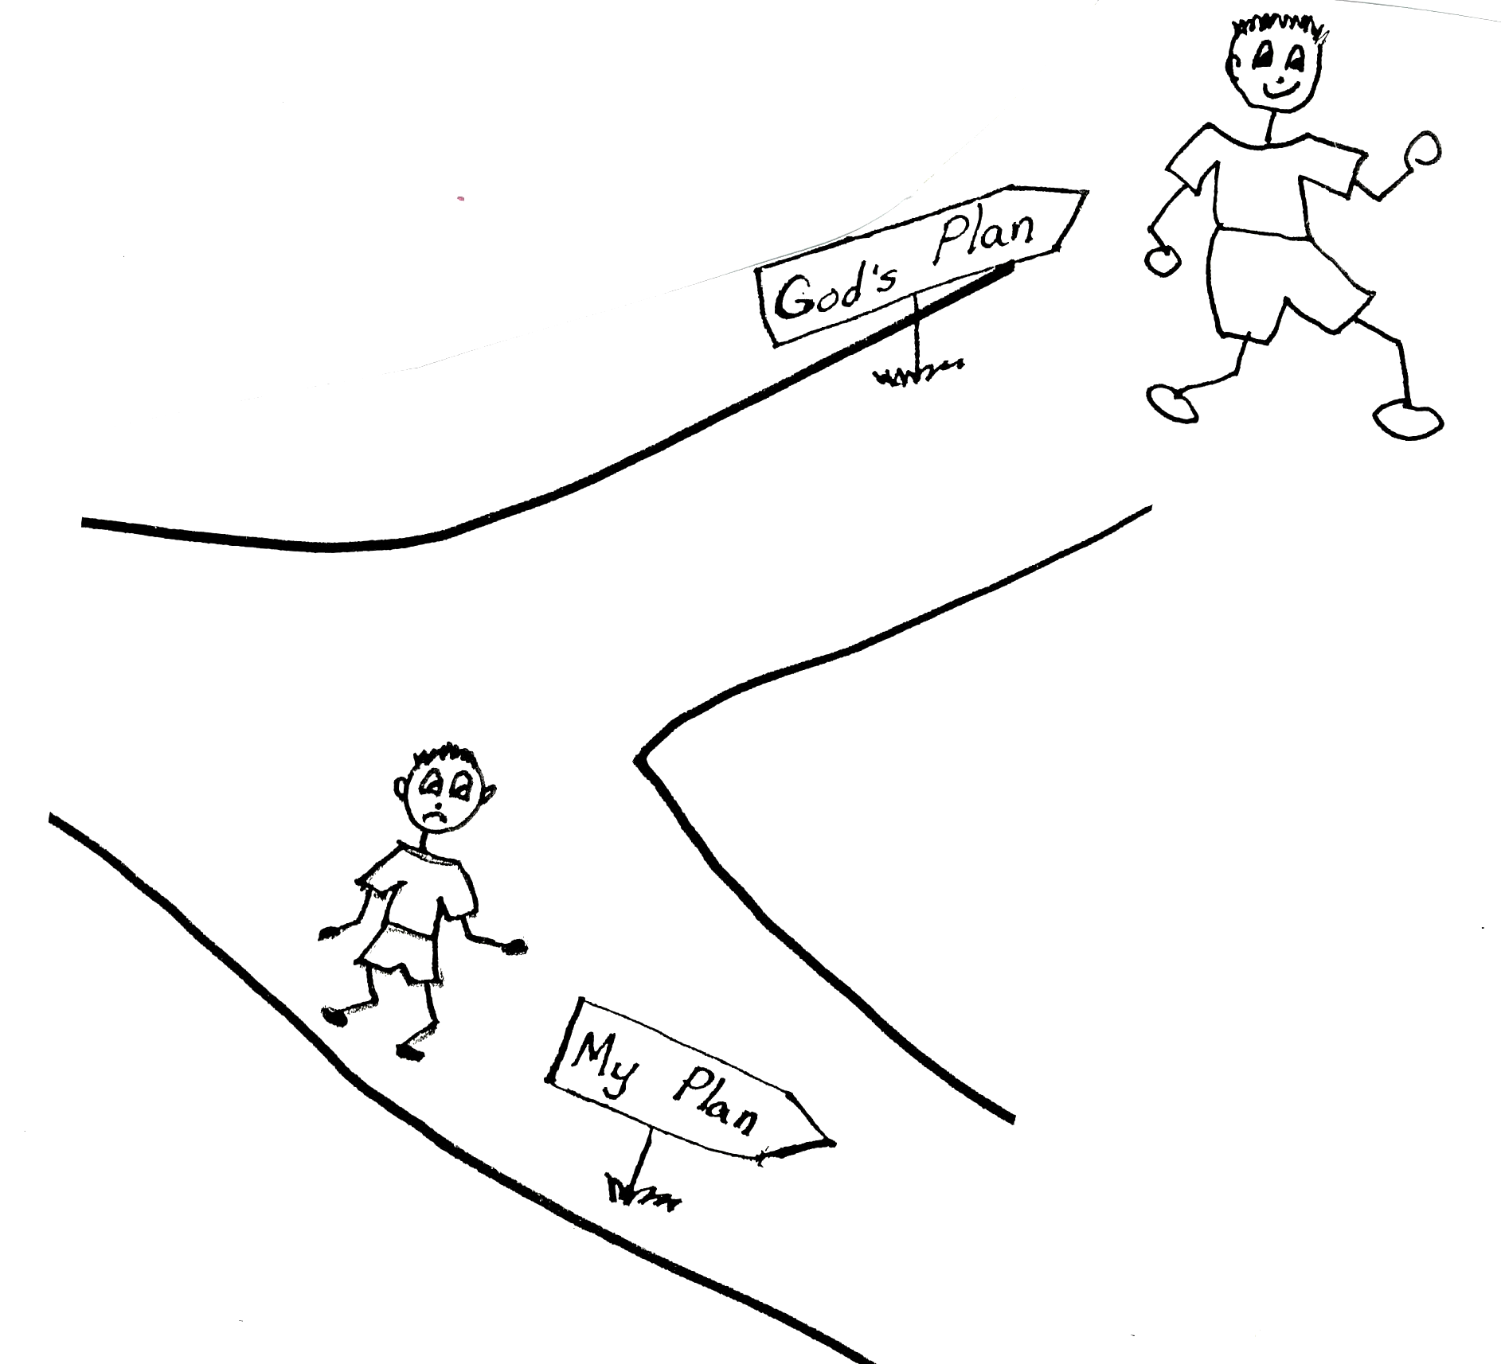

(Ephesians 1:11) “Also we have obtained an inheritance, having been predestined according to His purpose who works all things after the counsel of His will…”

If we follow your pre-designed plan, we will receive the great rewards and blessings that you pre-designed for us to have. If we don’t, we won’t receive the rewards and blessings. They will just remain in your storeroom. What a pity that would be!! Because of your grace, we believers all have equal privilege and equal opportunity to follow your design for our lives. We have equal privilege because we are Royal Family in union with Christ. We have equal opportunity because you designed it perfectly for all believers, our very own plan. The Holy Spirit will give each believer the power and the spiritual I.Q. to follow his or her plan. The only way that we can know your pre-designed plan is to learn and believe your Word…Bible doctrine. Then we can use it or apply it in our daily life. We need to get with the plan!
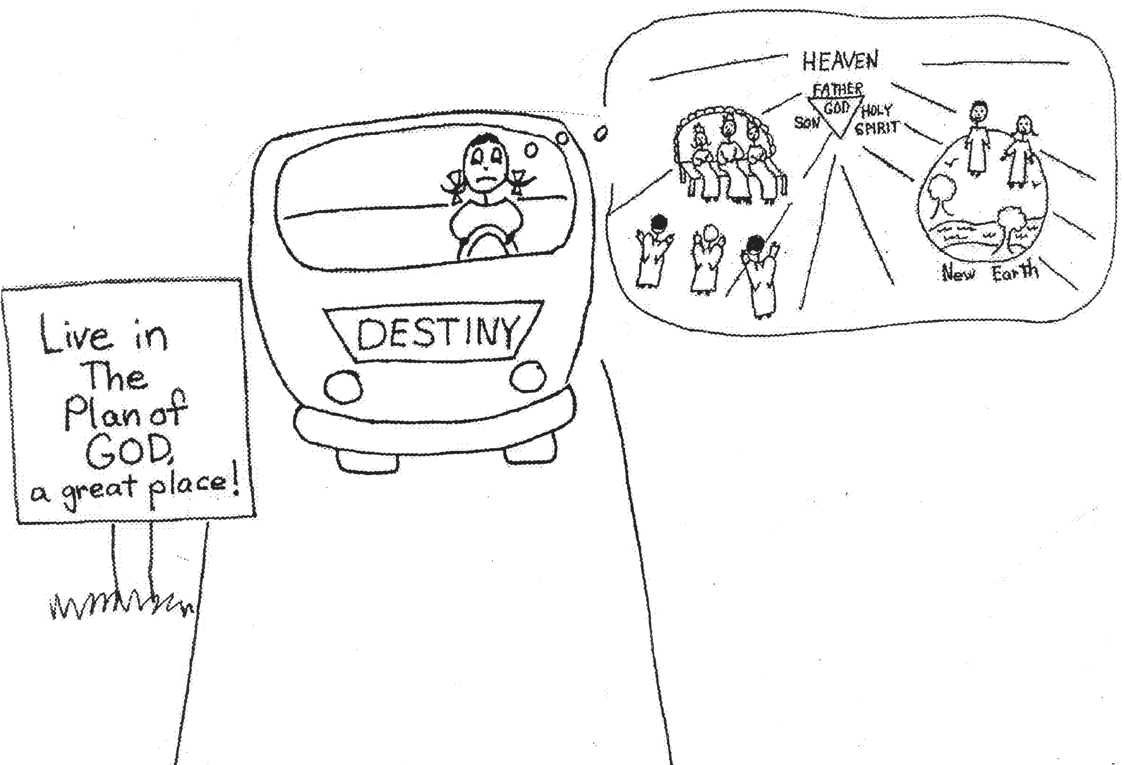

(Ephesians 1:5) “He predestined us to adoption as sons through Jesus Christ to Himself, according to the kind intention of His will...”

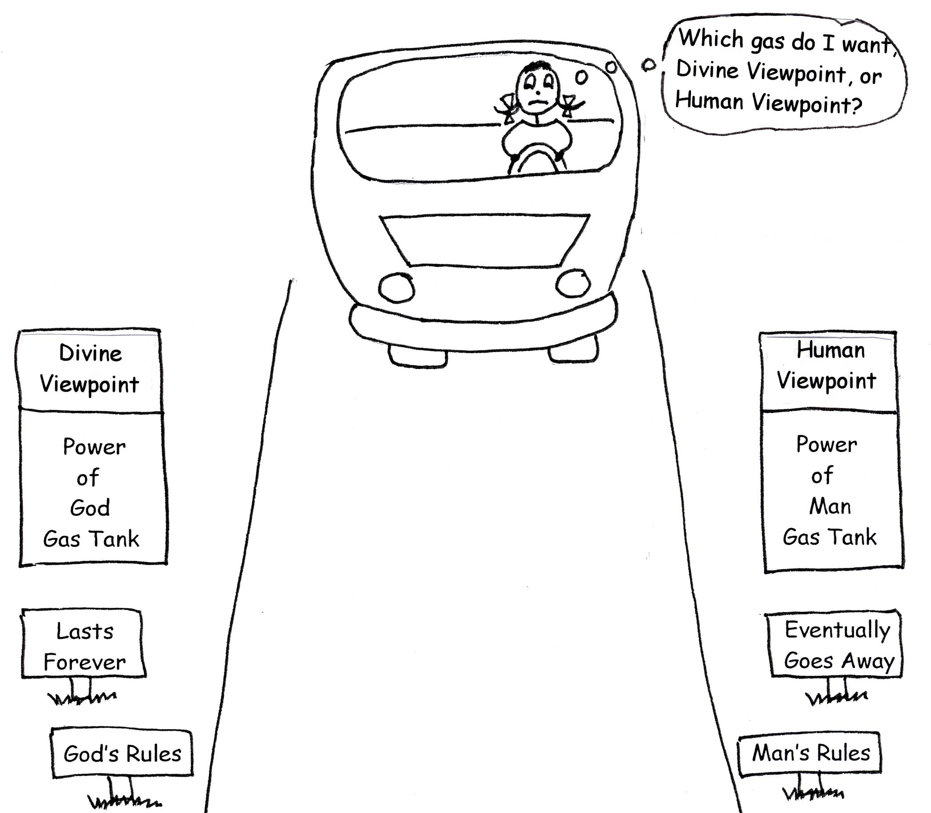
God, I know that you will give each of us your best. The bad thing is that most believers reject your perfect plan. They don’t learn about it in the Bible, or believe it, or use it. Then they can’t learn how you want them to live. We all want happiness, success, and material things. But we won’t be truly happy, successful, or prosperous unless we use your divine thinking and stay in your pre-designed plan. To do this, we have to use divine power, the power of the Holy Spirit. Human power won’t cut it! And we know that.

Hebrews 11:6 “But without faith it is impossible to please Him: for He that comes to God must believe that He is, and that He is a rewarder of those that diligently seek Him.”

Father, it is wonderful how you made this plan even before the world was made! That was a long, long time ago. Then, ten days after the Lord’s rose into heaven at His Ascension, the Church Age began. This is when you gave us the power of the Holy Spirit. You didn’t expect us to live in your plan unless you gave us this great power! It’s the same power Jesus had to use while He lived on earth and to get Him through the torture of the cross. With the power of the Holy Spirit and Bible doctrine in our souls, we can live in your perfect plan. Our minds can be controlled by your thinking, Father, not by emotions. I have to remind myself that emotions can’t think; they can only respond or react! We need the Holy Spirit to control our thinking!
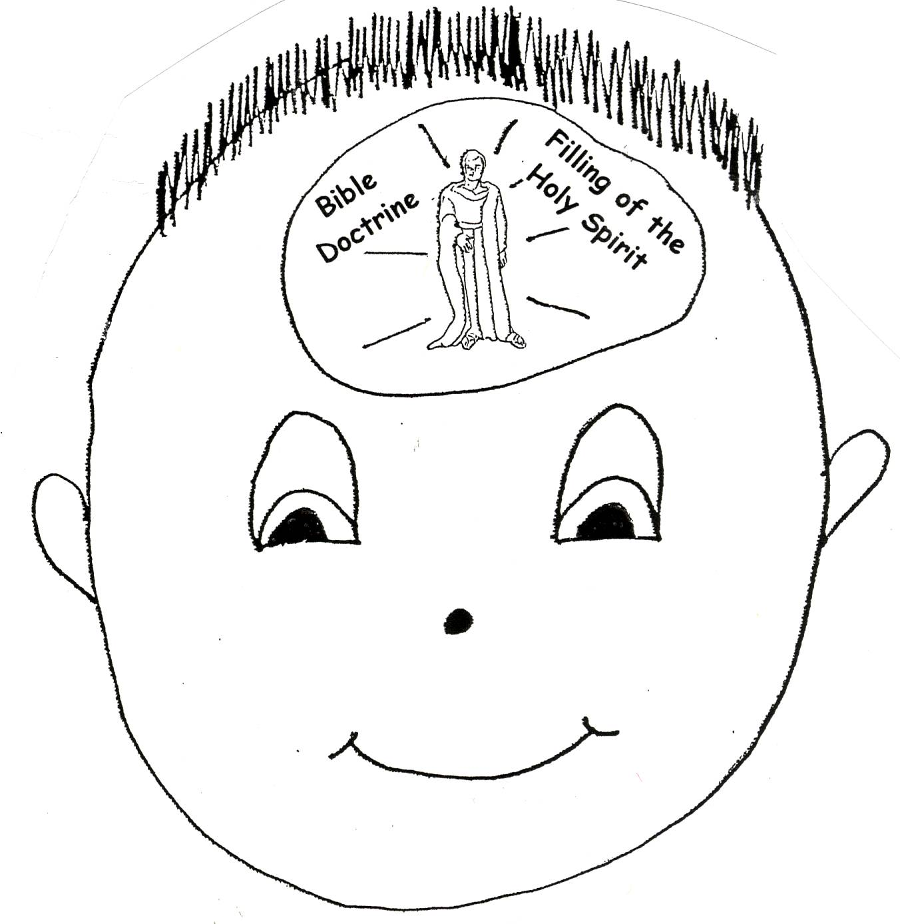
Galatians 6:16 “So I say, walk by means of the Spirit, and you will not give into the desires of the sinful nature.”

God, you have given each of us the equal opportunity and equal privilege of having the right pastor-teacher. He is to teach us every part of the mystery doctrine of the Church Age in your Word. We know from your Word that it is “mystery” doctrine because the angels and the other dispensations, or time periods of long ago before us, didn’t know anything about our time in the Church Age. Our pastor-teacher has a big job! He has to do a lot of studying so that he can be accurate in his teaching. It is our responsibility to respect his authority and learn what he has to teach us about you’re your Word, plan, purpose, and will for our lives. We can learn through our parents, Bible school teachers, and when we are old enough, from our right pastor-teacher. How gracious you are to give us our own special pastor-teacher!
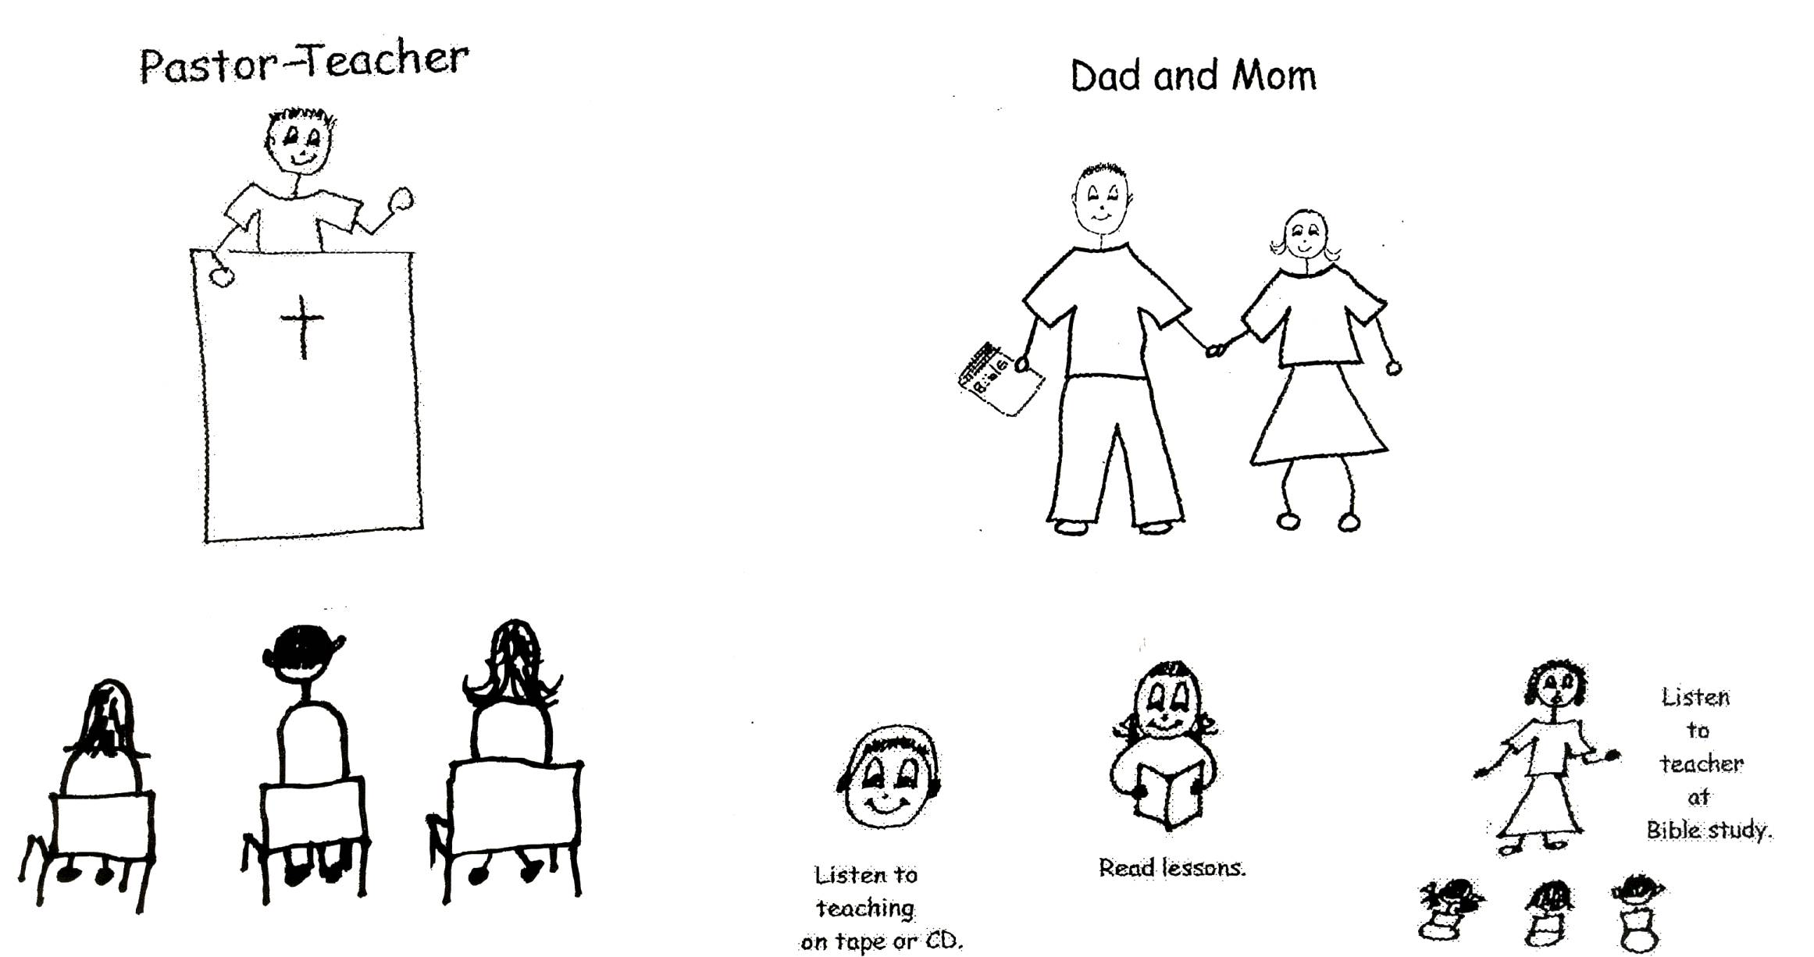

Psalm 119:7 “I shall give praise to you with integrity of heart “when” I learn your doctrines.”

Father, you’ve taught us that your Word…Bible doctrine…must be our #1 priority, or the most important thing in our lives after we believe in Jesus as our Savior. In it you’ve given us every detail that we need to know to live our lives in your pre-designed plan! We’re not to let people or things take us away from your divine viewpoint…that is the thinking of Jesus. When we have right experiences with you, we will have right experiences with people. Your Word must be number one!

2 Corinthians 5:7 “For we walk by means of faith [doctrine in the pre-designed plan of God].”

My God, you want us to become occupied with Christ…think about Him in everything we do and say. This will give us great peace of mind. First, Christ will be formed in our bodies. This means that we will have spiritual self-esteem and imitate Him when we learn His work. We will be confident because of Bible doctrine in our souls. Then, Christ will be at home in our souls. This means that we will have His thoughts. We will have personal love for you, and impersonal love for all mankind. Finally, Christ will be glorified in our bodies. This means, through your grace and power, we will reach spiritual maturity which will result in glorification of the Lord Jesus Christ! He will get ALL the praise!
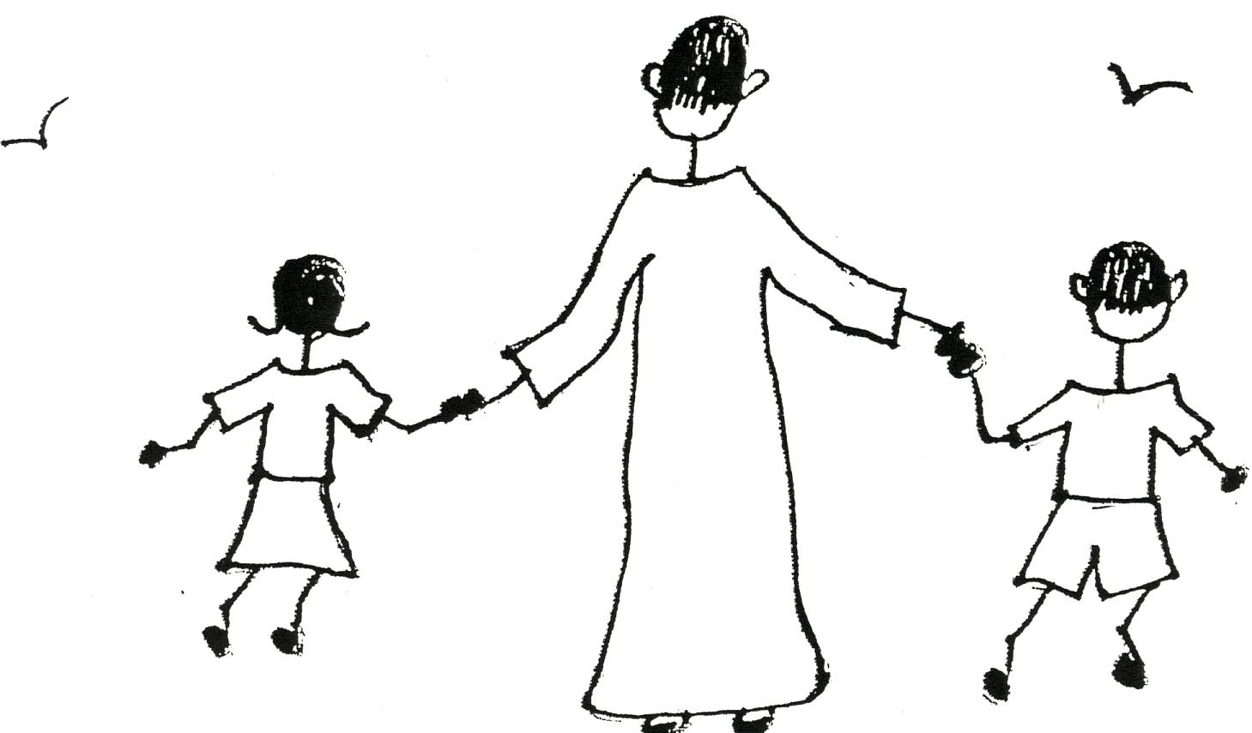
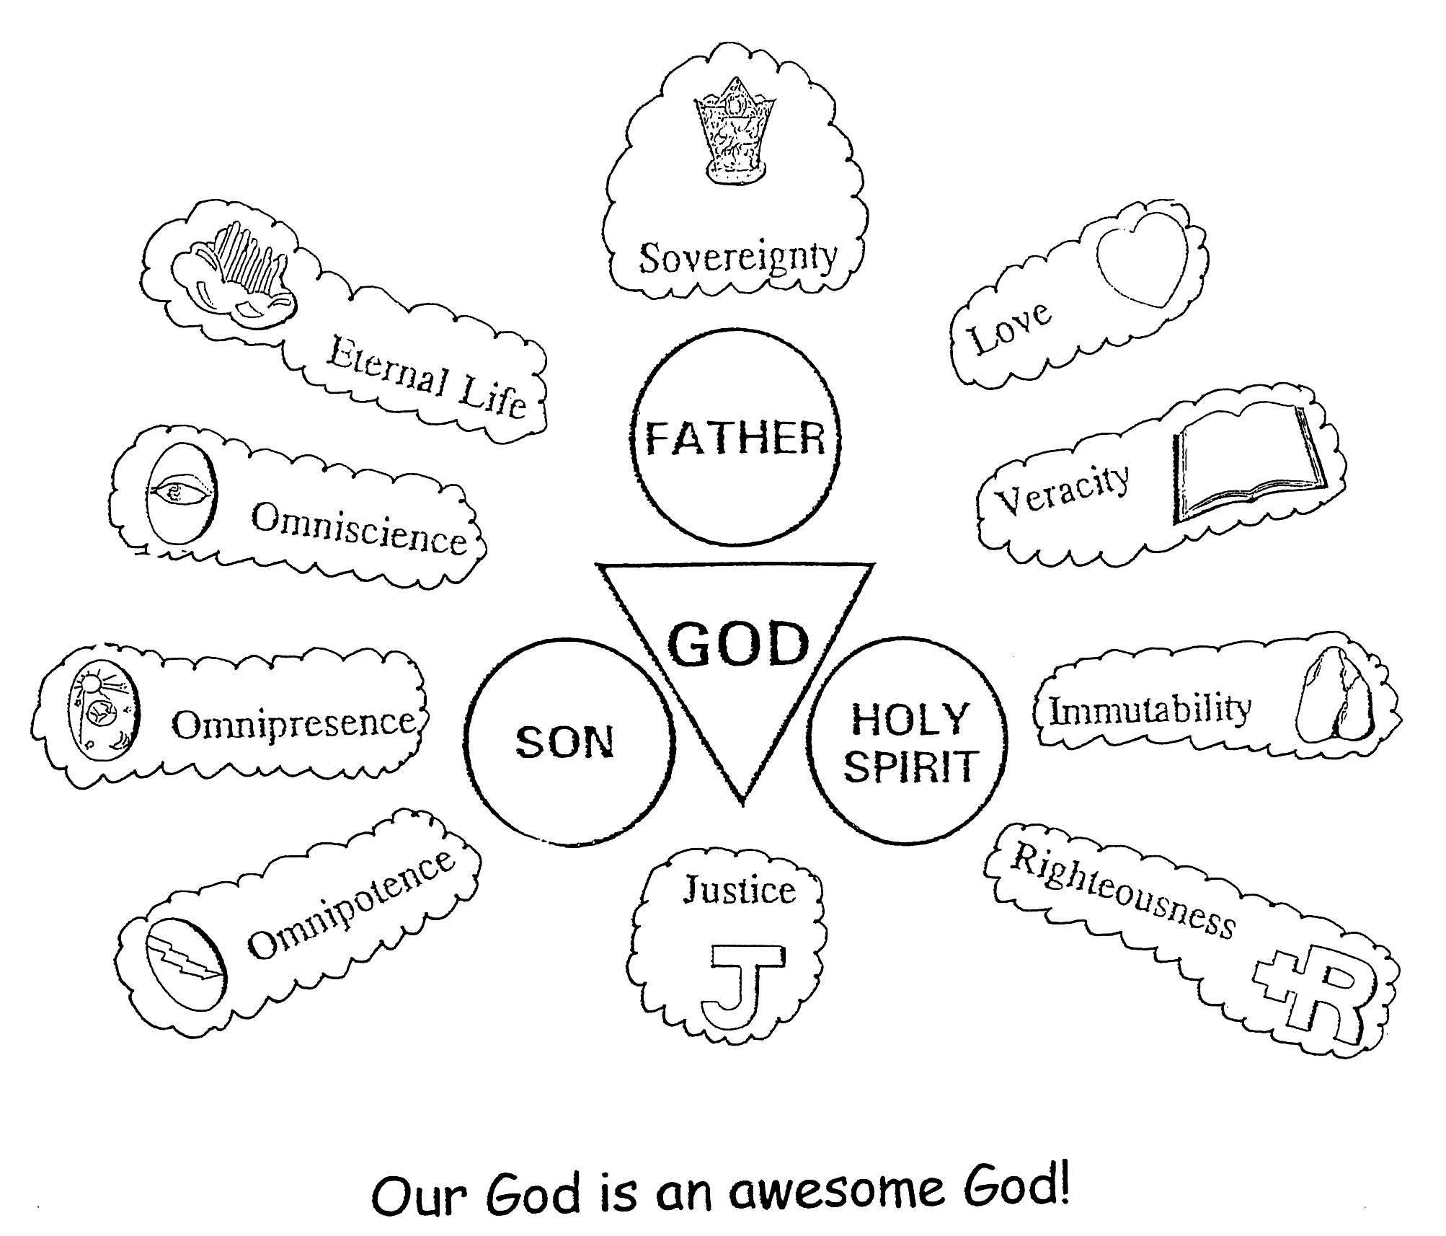
2 John 1:6 “And this is virtue-love: that we walk according to His doctrines. This is the command, just as you have heard from the beginning that you should walk in it [Pre-designed Plan of God].”

God the Son, our Lord Jesus Christ, deserves ALL honor and glory. He, through the power of the Holy Spirit, lived in your pre-designed plan for His life while he was on earth as the God/Man and showed us that it works. He did all of the work at the cross so that we could be saved and live in the plan. Father, you did your work for us in eternity past by making the plan. God the Holy Spirit does His work for us by giving us the power to do your will and live in your pre-designed plan! You are All for us! We have an awesome God who deserves honor and glory forever!!

Romans 8:31 “What, then shall we say in response to this? If God is for us, who can be against us? He who did not spare His own Son, but gave Him up for us all – how will He not also, along with Him, graciously give us all things?”

Father, I’ve written a very long letter, but I love talking with you. You make everything worthwhile. Life isn’t about our successes done in human power, but about our successes done in your divine power…the Holy Spirit provides us. Our plans, goals, talent, and ability are worthless without the power of the Holy Spirit. I ask you in Jesus’ name, to continue to give us the Bible doctrine we need, the thinking of Jesus Christ. Keep us humble (teachable) and not arrogant or proud. Help us stay focused on you. Your pre-designed plan is the best!

With all my love,

Your child and servant,

________________________________ (Put in your name.)

P.S. I know that you already know my thoughts, but in order for me to organize them in my mind, it is good for me to put them down on paper. And as far as the Bible doctrine, it is your Word! Thanks for Your Word!
Close in prayer

