Lighthouse Christian Youth Ministry
Lesson 58

The Love and Mercy of God
Found In PROPHECY

October 12, 2007

2 Corinthians 1:2 “Grace and Peace to you from God our Father and the Lord Jesus Christ.”

We have a God of love and mercy. He gave us the Bible so that we could know that this is true. The media (newspapers, T.V., etc.,) tries to show God as One Who judges and condemns us. This is so far from the truth! Satan tries to blind people to the love and mercy of God the Father. In the Garden of Eden, after Adam and Eve sinned, God told them that He would send a Savior. In His love and mercy, God told them what would happen in the future. He prophesied! In the Bible, God the Father prophecies history, or tells what will happen before it happens. In His love and mercy, He warns and directs us.
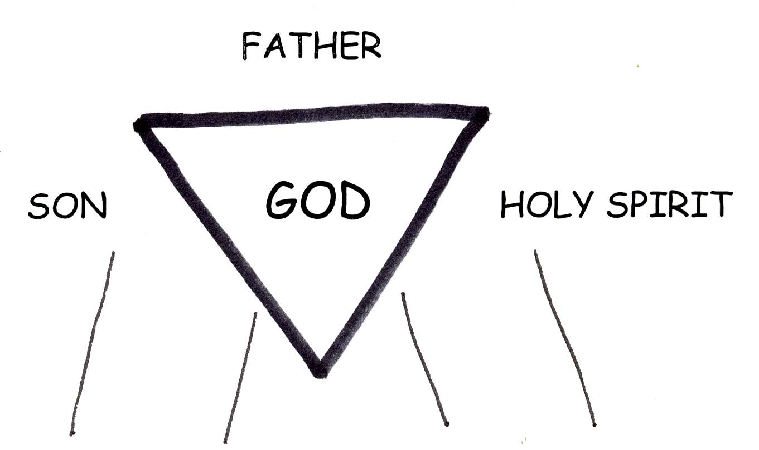


2 Corinthians 4:3-4 “And even if our gospel is hidden, it is hidden to those who are perishing, in whose case the god of this world has blinded the minds of the unbelieving, that they might not see the light of the gospel of the glory of Christ, Who is the [exact] image of God.”
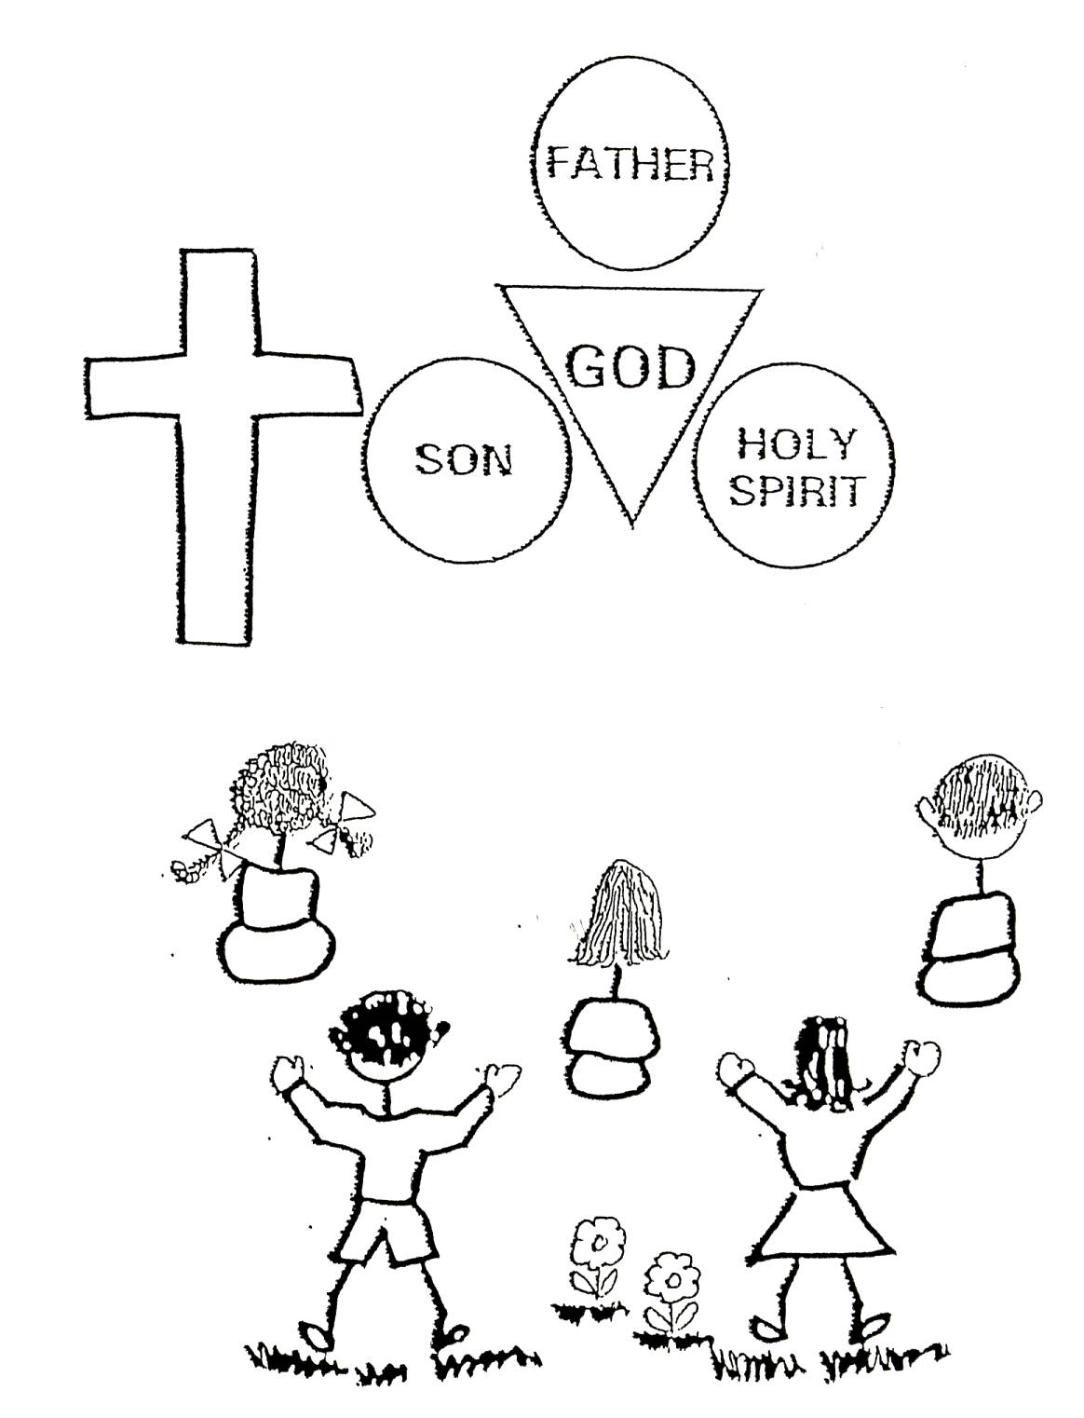
Today we see many unpleasant things going on in the world. If we didn’t have a heavenly Father Who loves us soooo much, we could be in a constant state of panic. We see wars, hunger, and disasters of all kinds. God told us in the Bible that all of these things would happen. They are consequences of people constantly turning away from God. God would like them to wake up so that they can have a change of mind. He wants them to see their Deliverer! We know that God is our Deliverer! However, some people will never wake up to God’s plan for their lives, and they will suffer the consequences.

Mathew 24:6-8 “You will hear of wars and rumors of wars, but see to it that you are not alarmed. Such things must happen, but the end is still to come. Nation will rise against nation, and kingdom against kingdom. There will be famines and earthquakes in various places. All these are the beginning of birth pains [end times].”

The more we know and understand Jesus Christ, the more we will know and understand God the Father. Jesus Christ is the exact image of God the Father. Jesus is compassionate, loving, kind, patient, faithful, a great listener, our best friend, and has a great sense of humor. I could keep the list going, but you get the picture! Well, God the Father is just like that! He is our Comforter! In all of our times of trouble, now and in the future, God has our best interests in mind!! He gave us the Bible so that we could know His thinking and to warn and comfort us about the future. He sent us His son as our Savior! He sent His son to teach us about Him, God our Father.


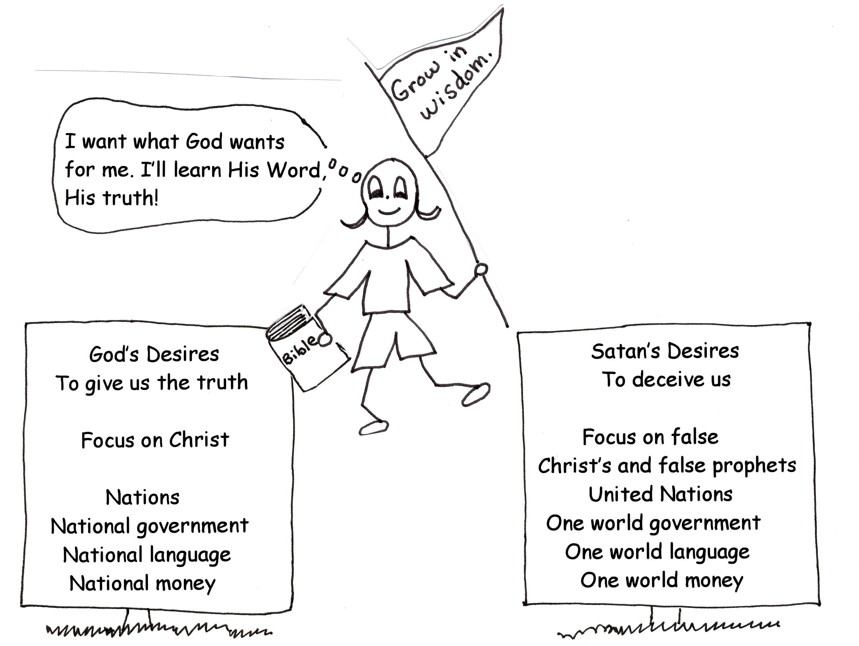

2 Corinthians 1:3 “Praise be to the God and Father of our Lord Jesus Christ, the Father of compassion and the God of all comfort, Who comforts us in all our troubles…”

As our Comforter, God has given us promises. He will never leave us; He will always be faithful to us. However, we have to stay with God and His plan and be faithful to Him. For those who keep rejecting God and His plan, disasters will come. Those who keep their eyes on Christ will be protected. Our Deliverer and Comforter will NEVER let us down!!!

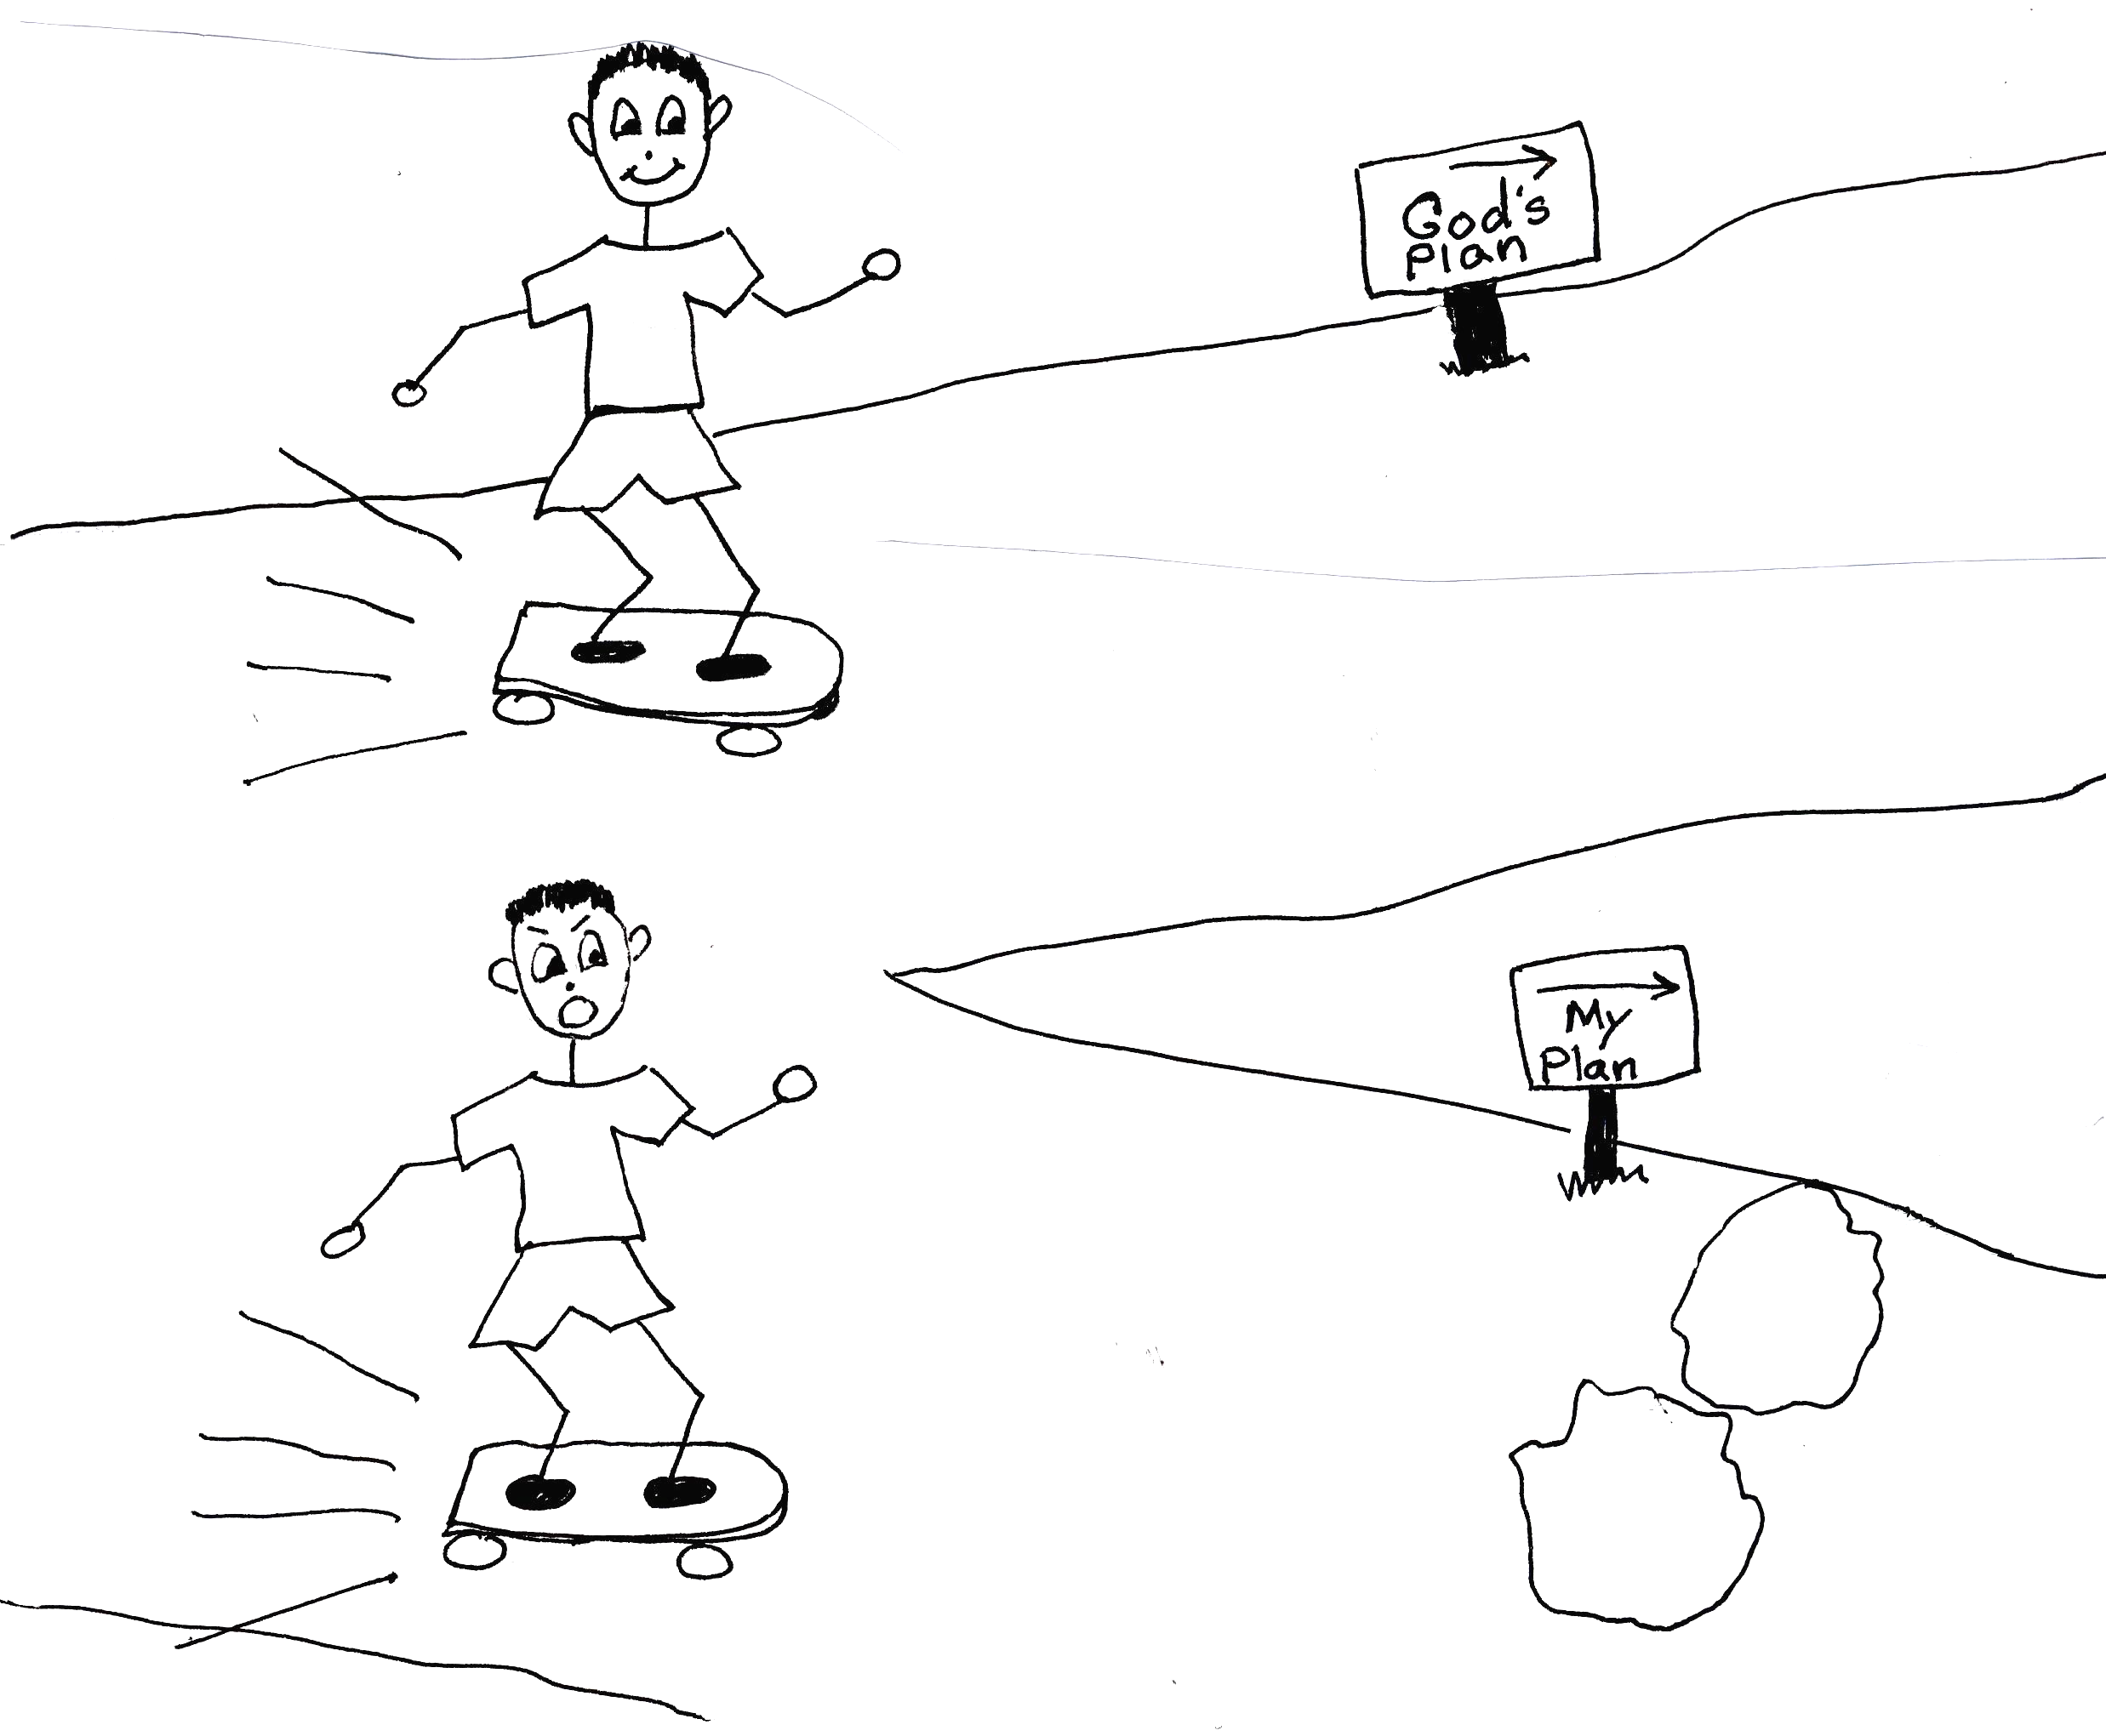
Psalm 56:3-4 “When I am afraid, I will put my trust in You. In God, Whose word I praise, in God I have put my trust; I shall not be afraid. What can [mere] man do to me?”

Again, prophecy is telling what lies ahead. God, in His love and mercy, warns us in the Bible of problems that lie ahead. One of these problems is that some men would say that they are prophets or Christs. These people are liars influenced by Satan. He wants people not to focus on Jesus Christ. Another problem is that some people want to have a one world government, language, and money. They want every nation to work together as one nation. Satan wants it that way also. He wants to make us think that working as one nation would be the best for us. God wants us to have different nations with different governments, languages, and money. We know that God’s way is the best for us because God has perfect wisdom. He wants His best for us. That is why it is so important for us to learn, believe, and use Bible doctrine. We don’t want to be deceived! God is for us, not against us!

Matthew 24:4-5 “Jesus Answered: “Watch out that no on deceives you. For many will come in my name, claiming, ‘I am the Christ,’ and will deceive many.”

Through prophecy, God is also warning us that our days on this earth are numbered. That means that we have a certain length of time on earth. We need to make the best use of this time. God could take us home at any moment, either through death or the Rapture. Remember, the Rapture is when believers will be taken from the earth to meet the Lord Jesus Christ in the sky. Before the Rapture takes place, or the last days of the Church Age, godlessness and falling away from the faith will take place. This can clearly be seen today. Many people act as if there is no God. Others don’t believe anymore in God’s ways or His plan. These people need a warning!!!

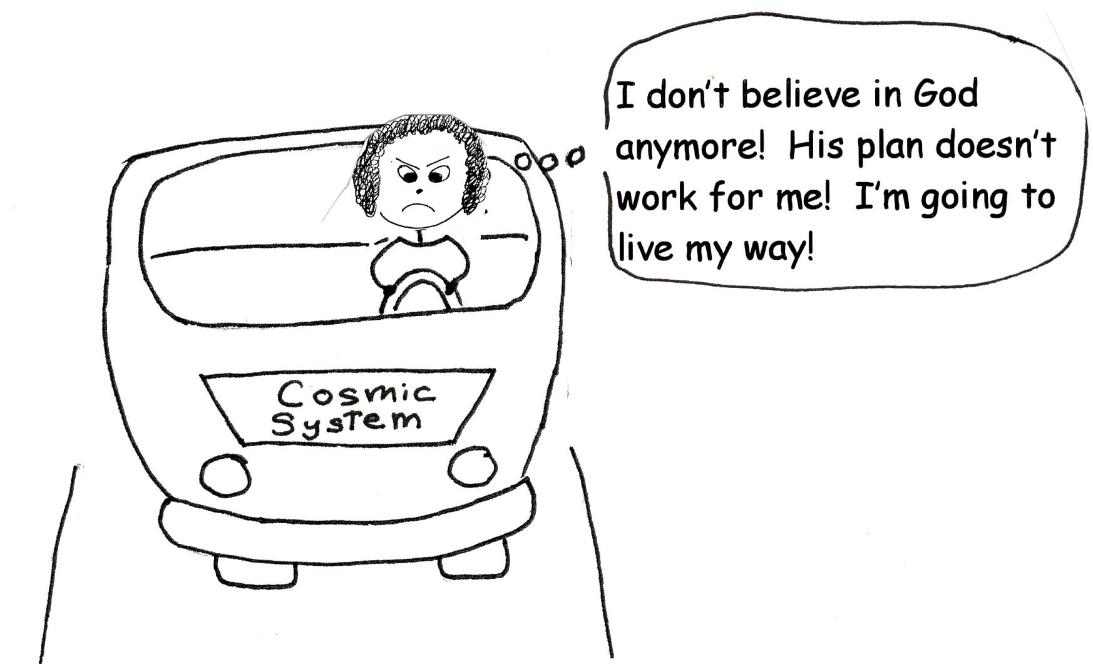

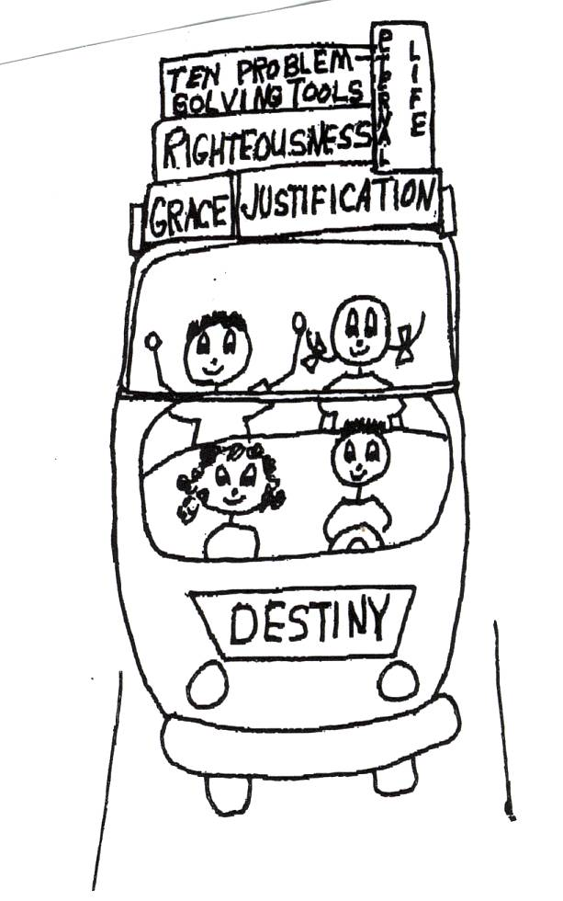

2 Timothy 3:1-5 “But mark this: There will be terrible times in the last days. People will be lovers of themselves, lovers of money, boastful, proud, abusive, disobedient to their parents, ungrateful, unholy, without love, unforgiving, slanderous, without self-control, brutal, not lovers of the good, treacherous, rash, conceited ones, lovers of pleasure rather than lovers of God – having a form of godliness but denying its power. Have nothing to do with them.”

In ages past, God knew that it was good to tell us some of the future, or prophesy. Only God can accurately predict the future because only God is all knowing, omniscient. He told some of the future in the Bible, and everything always happens just the way that He said it would. The odds, or chances, of all of these things just happening is impossible. Therefore, only God could predict them. For God in His omniscience, it was easy to tell us future events. The events were and are in His perfect, predesigned plan. God is a super, super Genius!

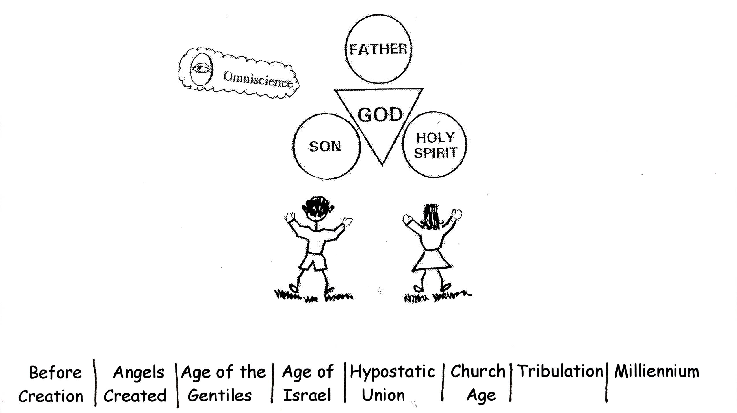
Isaiah 46:9-10 “Remember the former things, those of long ago; I am God, and there is no other; I am God, and there is none like me. I make known the end from the beginning, from ancient times, what is still to come.”

Here are eleven of God’s predictions about the our Savior, Jesus, found in the Bible, and the scriptures where they were predicted and fulfilled. They were prophesied by different prophets many years before they happened.

Prophecy Predicted Prophecy Fulfilled
Would be born in Bethlehem Micah 5:2 Matthew 2:1
Chances: 1 in 200
Preceded by a messenger Isaiah 40:3 Matthew 3:1-3
Chances: 1 in 20
Enter Jerusalem on a colt Zechariah 9:9 Luke 19:35-38
Chances: 1 in 50
Be betrayed by a friend Psalm 41:9 John 13:18
Hands and feet would be pierced Psalm 22:16 Luke 23:33
Chances: 1 in 100
Wounded and whipped by His
enemies Isaiah 53:5 Matthew 27:26
Chances: 1 in 25
Would be sold for 30 pieces
of silver Zechariah 11:12 Matthew 26:15
Chances: 1 in 50
Be spit upon and beaten Isaiah 50:6 Matthew 26:67
Chances: 1 in 10
His betrayal money would be
thrown in the Temple and given
for a potter’s field Zechariah 11:13 Matthew 27:3-7
Silent before His accusers Isaiah 53:7 Matthew 26:63
Chances: 1 in 100
Crucified with thieves Isaiah 53:12 Mark 15: 27-28
Chances: 1 in 100

After multiplying the combined chances, the possibility that one man could fulfill just 11 of these prophecies is equal to one chance in 10,000,000,000,000,000,000. It was impossible for these events to happen by chance. God was, and is, in charge!

What a loving and merciful God we have! He warns us, delivers us, and comforts us! Because He is omniscient, He can tell what will happen in the future. That is why He had the signs of the last days of the Church Age written in the Bible. He wants us to know what will happen and to trust in Him. God does not want us to be worried and fearful. When we have our eyes focused on the Lord Jesus Christ, there is no fear. God wants us to obey His commands so that He can bless us. God understands us completely. We need to better understand His thinking, and follow His predesigned plan for our lives. Then we can enjoy life and relax! God knows the end from the beginning! We need to learn, believe, and use Bible doctrine so that we can see what a loving and merciful God we have!

Isaiah 46:8-10 “Remember this, fix it in mind, take it to heart, you rebels. Remember the former things, those of long ago; I am God, and there is no other; I am God, and there is none like me. I make known the end from the beginning, from ancient times, what is still to come.”
www.lighthousechristianyouth.org
Prep@gbible.org Grace Bible Church

