Lighthouse Christian Youth Ministry
Lesson 59

A Thank You Letter
To Our
Wonderful Savior/Redeemer

November 2, 2007

Dear Savior Jesus,

You have given us so much more than we could ever truly understand. So, I’d like to start out by saying “THANK YOU” for the wonderful things that you have done for us. One of those things was REDEMPTION…your saving work on the cross where God the Father charged you for our sins. This meant Adam’s original sin and all other sins where charged to you. That means instead of us paying the penalty for sin, Jesus paid it for us!!!! Thank you so much. I know that mankind was born into the slave market of sin because of Adam’s original sin. We were all condemned at birth because of Adam’s original sin. When the Father condemned us at birth that made us all need a Savior. You are that Savior who redeemed us from the slave market of sin! None of our personal sins was ever charged to us because you paid for them all on the cross. By believing in you, we get all the benefits that you purchased for us at the cross.

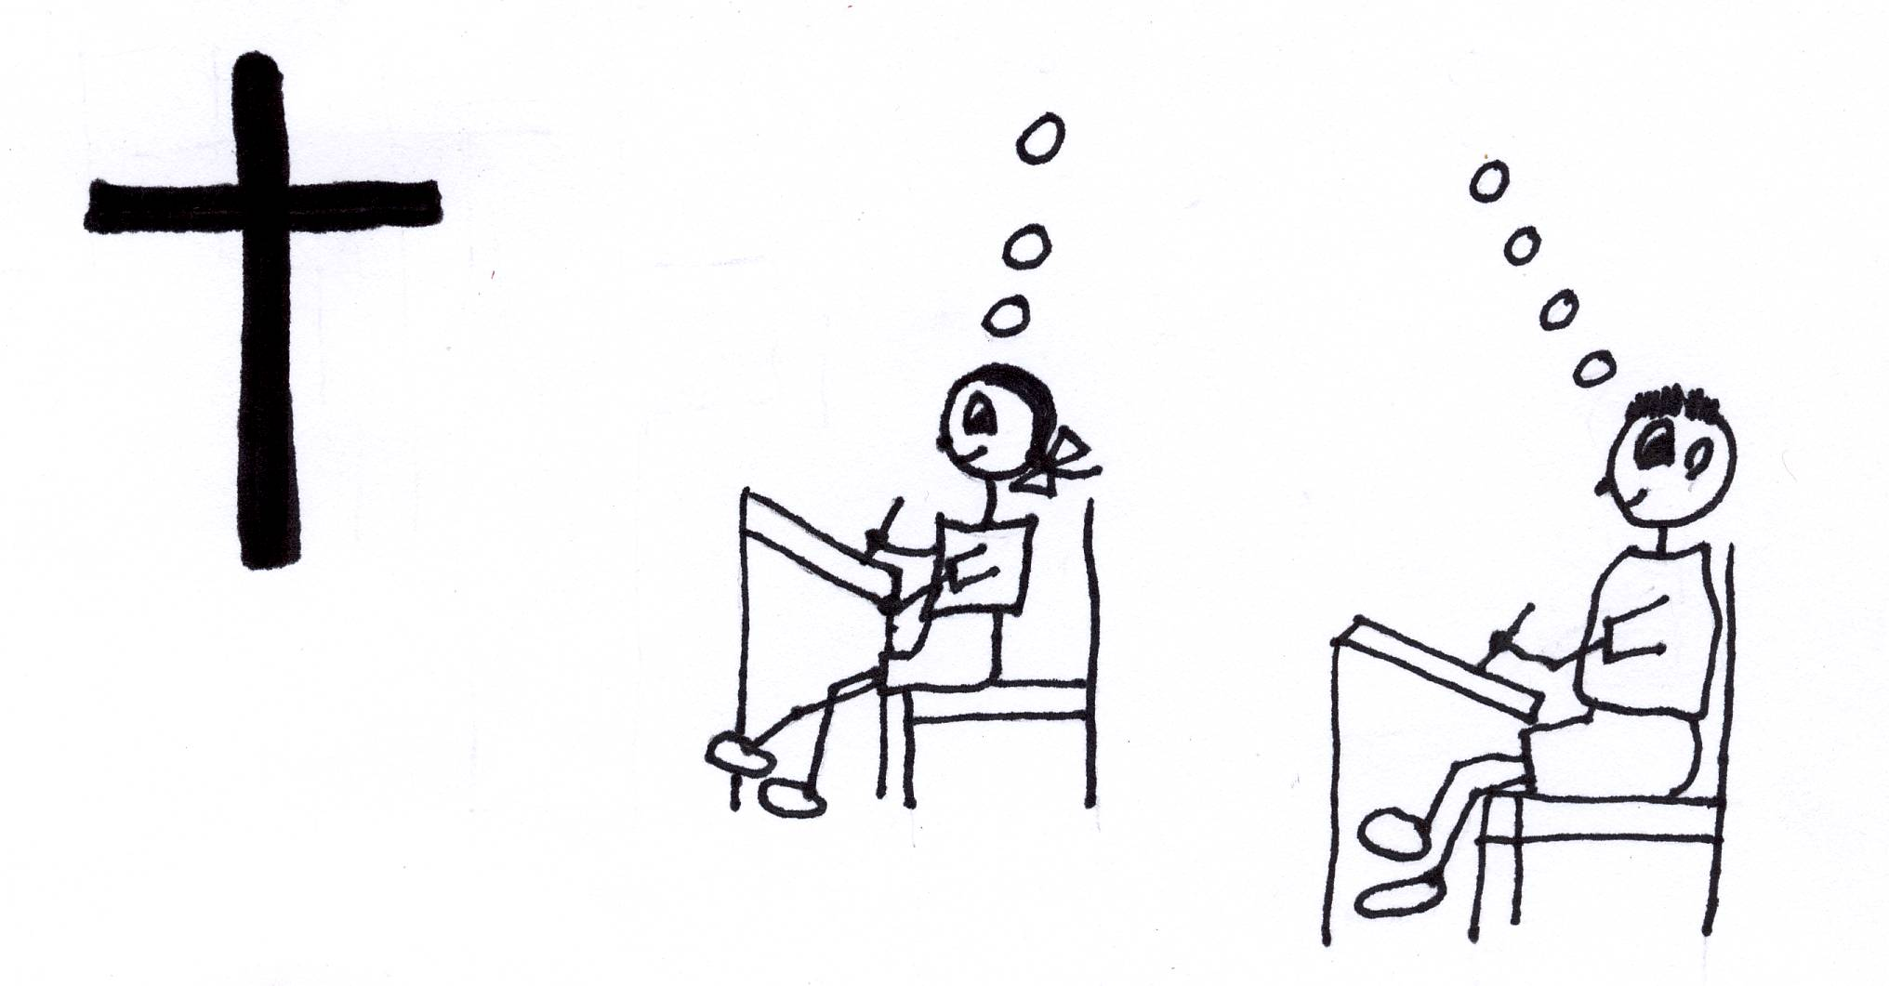
1 John 2:2 “He is the atoning sacrifice (propitiation) for our sins, and not only for ours but also for the sins of the whole world.” (NIV)

Sometimes we think that we would have done a better job than Adam did in the garden. We think that we wouldn’t have sinned. Since you gave us free will, you knew that eventually all of us would have done the same thing as Adam. You turned Adam’s fall into a blessing for all mankind. You condemned all mankind so that all mankind could be saved. You provided a way to save us from the slave market of sin. You paid the price! You redeemed us with your blood…your spiritual death!

Colossians 1:13-14 “For He delivered us from the domain of darkness, and transferred us to the kingdom of His beloved Son, in whom we have redemption, the forgiveness of sins.”

Jesus, you were the only one who was qualified to be our Redeemer. You had to become a man because as God you could not be judged for sins and you are God also. Therefore, you could be our Mediator with God the Father. In other words, you could settle the sin issue between man and God because you are 100% man and 100% God…that’s called the hypostatic union. You also had to be without sin the entire time you were here present on earth as the God/man. Therefore, you were born without an old sin nature…the virgin birth…you had no earthly father so you didn’t have Adam’s original sin either. You were impeccable, and you chose to stay that way. You were willing and qualified to go to the cross. You are our Redeemer!

John 1:1 “In the beginning was the Word (Jesus Christ), and the Word was with God, and the Word was God.”

We are not condemned for our own sins. You were condemned on the cross for our sins as well as Adam’s original sin. You paid the price, which was spiritual separation from God the Father and God the Holy Spirit. You had NEVER before been spiritually separated from the Father because you never sinned! You have no sin but you were willing to be a substitute for all of us and you took on our sins in your own perfect body on the cross. This spiritually separated you from God the Father and God the Holy Spirit while God the Father judged our sins in your perfect body on the cross. That was horrible torture! However, you had the power of the Holy Spirit before and after spiritual death so you could do it. You made everything okay between God the Father and us. You made peace or RECONCILIATION with God the Father for us. We’ve been bought for a great price! We can all be freed from our prison of sin!

Rom 5:10-11 “For if, while we were enemies, we were reconciled to God through the death of his Son, much more, being reconciled, shall we be saved by his life (11) and not only so, but we also rejoice in God through our Lord Jesus Christ, through whom we have now received the reconciliation (peace with God).” (ASV)

1 Peter 1:18-20“…knowing that you were not redeemed with perishable things like silver or gold from your futile way of life inherited from your forefathers (Adam), 19 but with precious blood (spiritual death), as of a lamb unblemished and spotless, the blood of Christ. (NASU)

You put aside your deity…that’s called KENOSIS…and relied on the power of God the Holy Spirit. You showed us how to rely on that same power. You were always filled with the Holy Spirit. You showed us how to live in the predesigned plan of God. You were the First to use it and approve it for us and you gave us incredible love and taught us how to love personally and impersonally. Thank You for showing us the right Power!

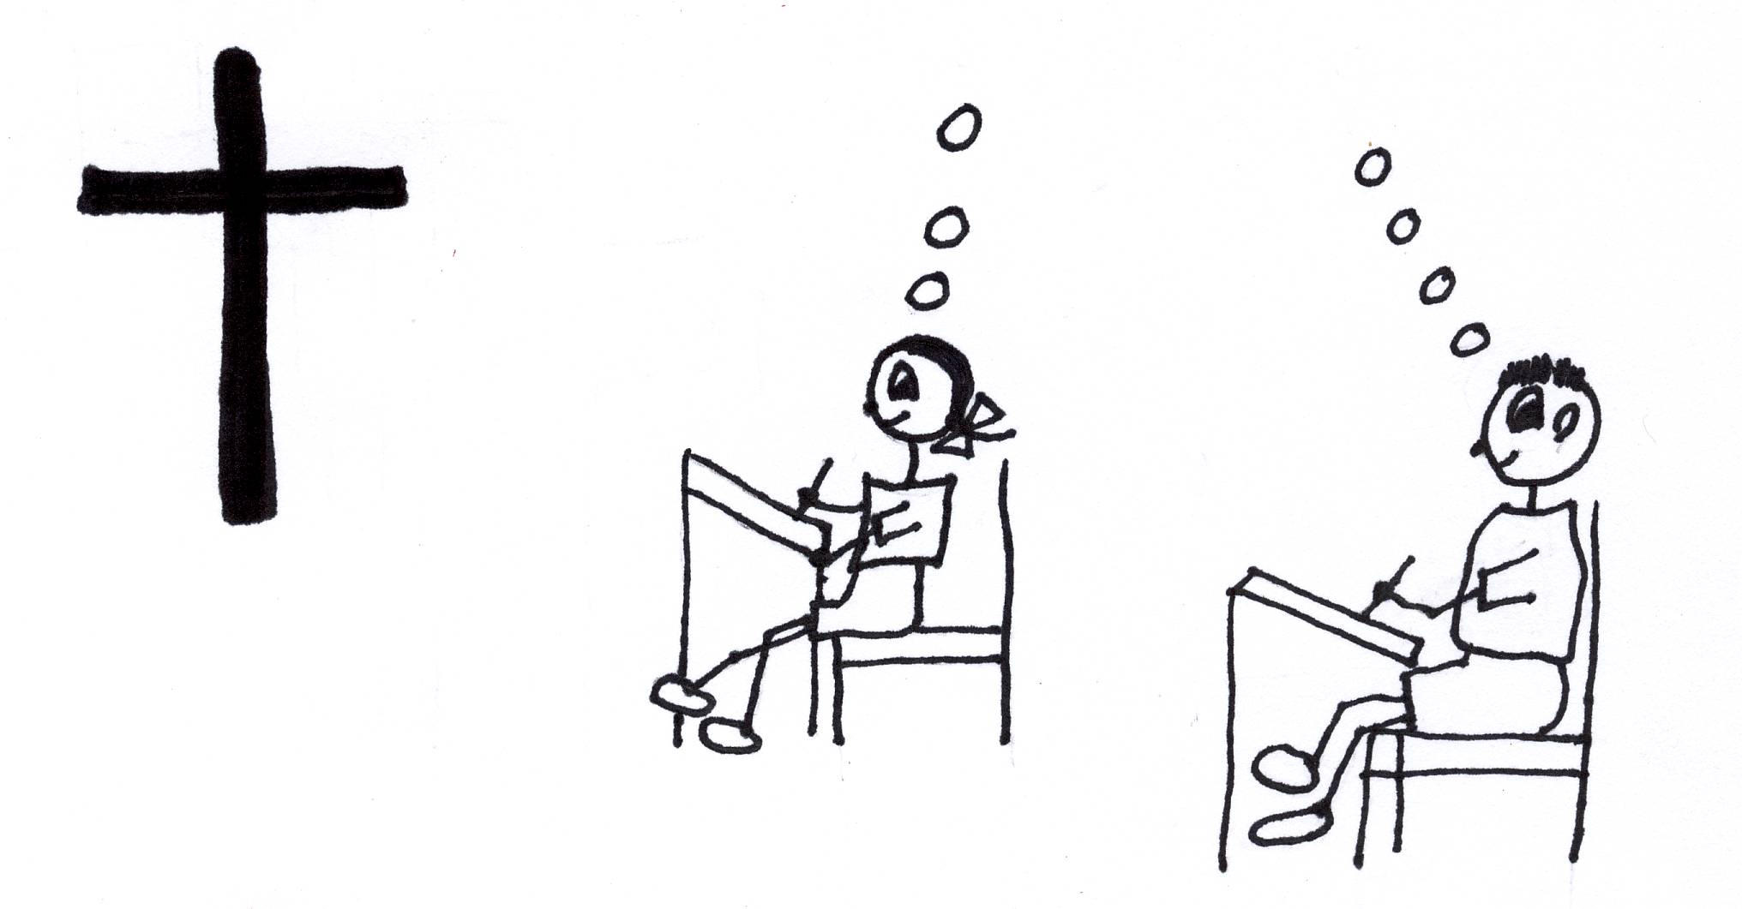
1 Timothy 4:10 “For it is for this we labor and strive, because we have fixed our hope on the living God, who is the Savior of all men, (provided salvation for all), especially of believers (when we believe in Jesus, God gives us all the benefits).”

You are our High Priest. You pray to God the Father for us. Your prayers must be awesome because you know all about us. You know just what we need. As believers, we are priests also. We can pray directly to God the Father now because of you. However, we don’t always know what we should ask the Father. It is great to have you praying for the things that we don’t know about or don’t realize that we need. Thank You for always standing by us and representing us to God the Father!

Hebrews 7:23-24 “Now there have been many of those priests, since death prevented them from continuing in office; but because Jesus lives forever, He has a permanent priesthood.”

1 Peter 2:9-10 “But you are A CHOSEN RACE (Church Age believers), A royal PRIESTHOOD, A HOLY NATION, A PEOPLE FOR God's OWN POSSESSION, so that you may proclaim the excellencies of Him who has called you out of darkness into His marvelous light; (10) for you once were NOT A PEOPLE, but now you are THE PEOPLE OF GOD; you had NOT RECEIVED MERCY, but now you have RECEIVED MERCY.” (NASU)

The only thing that we have to do to receive the benefits of redemption is to believe in you as our Savior. Unbelief is the only sin that will condemn us to the Lake of Fire. You paid the price for everyone’s freedom so no one has to go there unless they don’t believe in you. You paid a huge price so that we could go to heaven. We get the benefit if we choose to believe. We don’t have to make points or work our way to get to heaven. You made all the points! You’ve done all the work! We just have to accept you as our Redeemer.
Romans 3:27-28 “Where then is boasting? It is excluded. By what kind of law? Of works? No, but by a law of faith (believing). For we maintain that a man is justified by faith and not from works of the Law.” 1 Timothy 2:5-6 “For there is one God, and one Mediator also between God and men, the man Christ Jesus, who gave Himself as a ransom for all, the testimony given at the proper time.”

Because of redemption, all sins have been forgiven. Sin is not the issue; the issue is what do we think of you, Lord Jesus? Because of you God does not look at our failures. He has been satisfied by your work…that’s propitiation. You made peace for us with God…that’s reconciliation. He looks at sin as being completely paid for…that’s redemption. Our debt has been cancelled…that’s expiation. This gives all mankind the option to believe in you for eternal life. We can all be justified which means that we can receive God’s +R…His perfect goodness…if we simply believe in your saving work on the cross. We can all take advantage of the equal privilege and equal opportunity that you supplied for us after we believe also to live in the special plan you have for each and everyone who believes…that’s AMAZING GRACE!

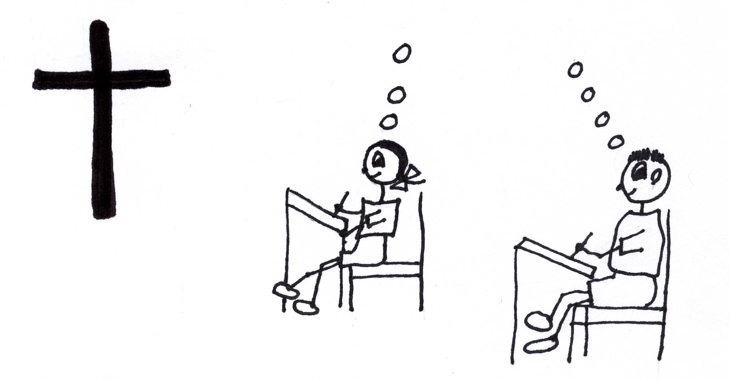
2 Corinthians 5:19 “…namely, that God was in Christ reconciling the world to Himself (made a peace treaty with the entire human race), not counting their (personal) sins against them, and He has committed to us the word of reconciliation (peace and the sin barrier between God and man has been removed).”

Thank You, Jesus, for the peace we can all have. Thank You for satisfying (propitiation) God the Father so that He canceled our debt for sin. You made it possible for us to have a “direct line” to God the Father. How awesome is that? You made it possible for us to be justified, or to receive God’s righteousness (+R). You even showed us how to live the spiritual life and gave us the Bible that has all of the directions we need. The Holy Spirit gives us the power to learn and follow the book of directions. We can’t lose if we do it your way…the GRACE way! It’s up to us to make the right choices. We all send you a heartfelt “THANKS!” All the glory to You, Lord Jesus!

Your adoring and ever grateful friend,

_____________________________
(Put in your name.)

1 Corinthians 6:20 “For you have been bought with a price; therefore, glorify God in your body.”

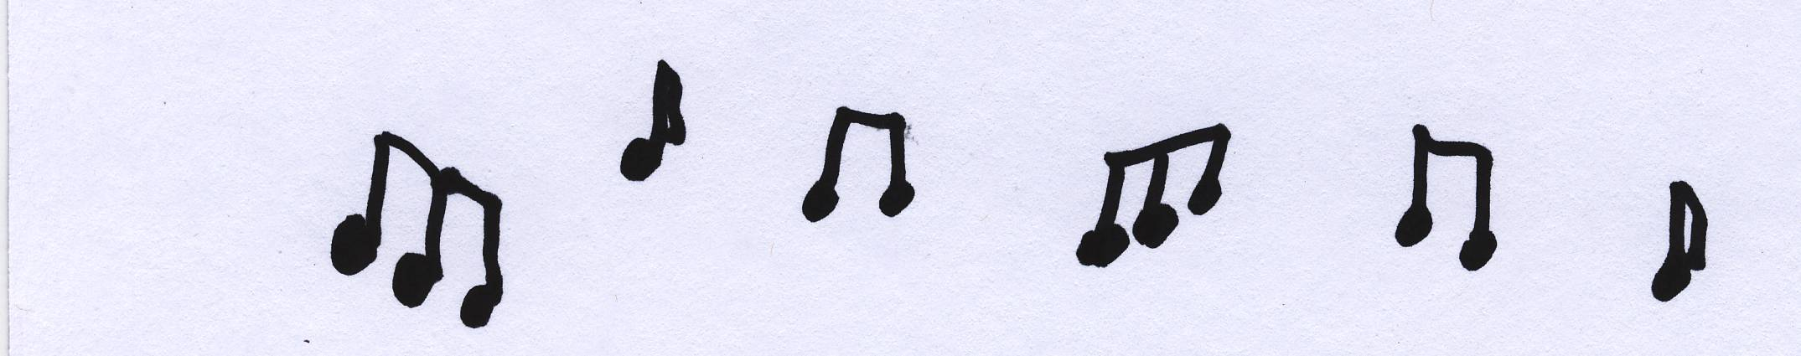
Song:
I’ve been redeemed…I’ve been redeemed.
By the blood of the Lamb*… By the blood of the Lamb.
I’ve been redeemed… I’ve been redeemed.
By the blood of the Lamb…
I’ve been redeemed by the blood of the Lamb
Saved and sanctified I am
All my sins are washed away, I’ve been redeemed.

“Blood of the Lamb” refers to the blood of Christ. The blood of Christ stands for Christ’s spiritual death on the cross. Remember, Jesus Christ died spiritually for our sins. When He had finished paying for our sins, then of His own will, He died physically. And He said, ”It is finished” just before he died physically to let us know that salvation was completed for all mankind. This meant that His work of salvation on the cross was finished! That’s a lot to sing about.

Close in prayer

