Lighthouse Christian Youth Ministry
Lesson 60

Spiritual Self-Esteem
Or
Spiritual Self-Respect

1 Corinthians 15:10 “But by the grace of God I am what I am…”

November 8, 2007
&
August 30, 2009
Members of the Royal Family, listen up! How would you like it if someone told you that you could have all the confidence and all ability to deal with every single stress and every single problem in life? Well, God has promised us just that! We can have spiritual self-confidence by learning, believing, and using Bible doctrine. We can learn to have spiritual self-esteem, or spiritual self-respect…love ourselves! We can rely on Christ’s thinking and His power to give us confidence and self-assurance!

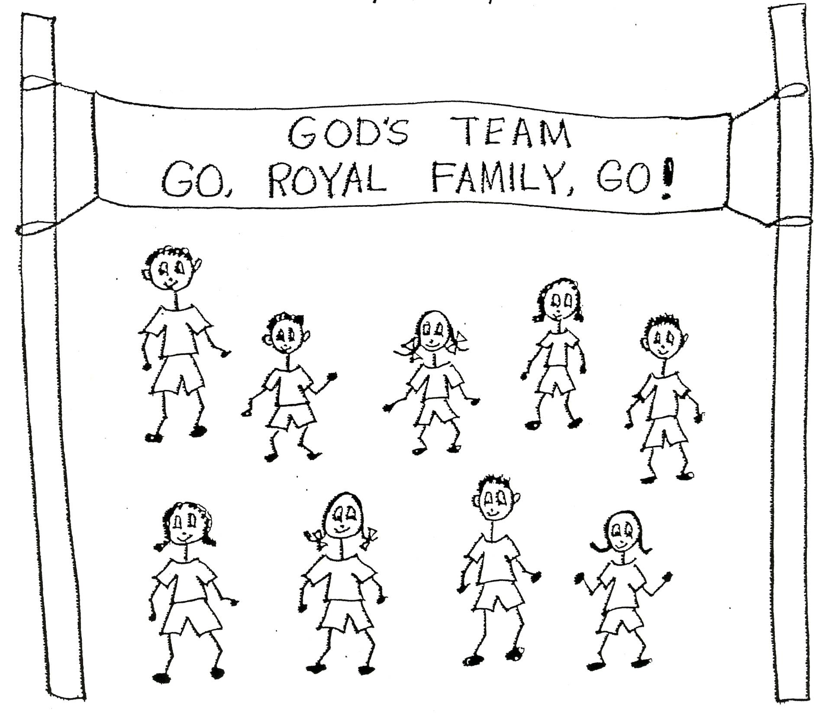
Ephesians 3:12 Eph 3:12”In him and through faith in him we may approach God with freedom and confidence.” NIV

Self-esteem means to have respect for self, satisfaction with self, or a good opinion of self. In spiritual self-esteem, our confidence is based on Bible doctrine…the Word of God, the thinking of the Lord Jesus Christ. We recognize that we are what we are by the grace of God. We depend on God’s grace gifts to go forward in His pre-designed plan. We have confidence in God. What a great spiritual place to be…and what peace and freedom we will have!

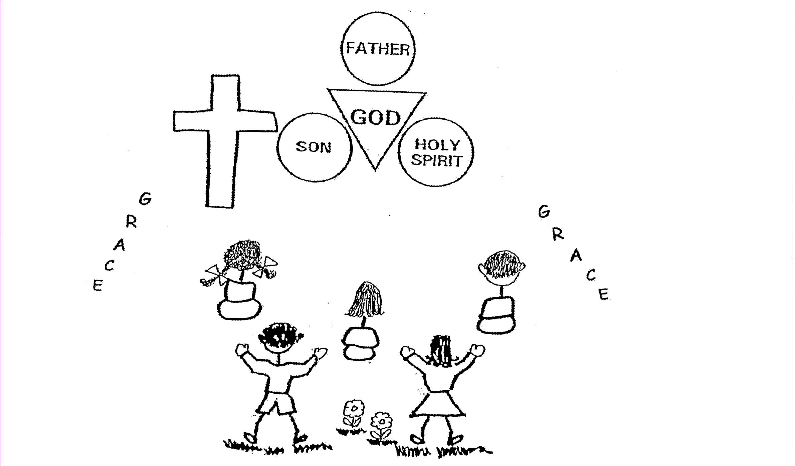

When we reach spiritual self-esteem, we have arrived at the first stage of spiritual adulthood. It doesn’t matter how old we are either to be a spiritual adult. We can be spiritual adults at any age. What matters is how much Bible doctrine we learn, believe, and use in the filling of the Spirit. The more we learn, believe, and use Bible doctrine, the more we grow spiritually. Bible doctrine is the spiritual food we need to handle stress and become spiritual adults! Spiritual adults have cool heads on their shoulders.

Proverbs 19:8 “He who gets wisdom (Bible doctrine) loves his own soul; he who loves understanding [believing Bible doctrine] prospers.”

The Characteristics and Picture of Spiritual Self-Esteem

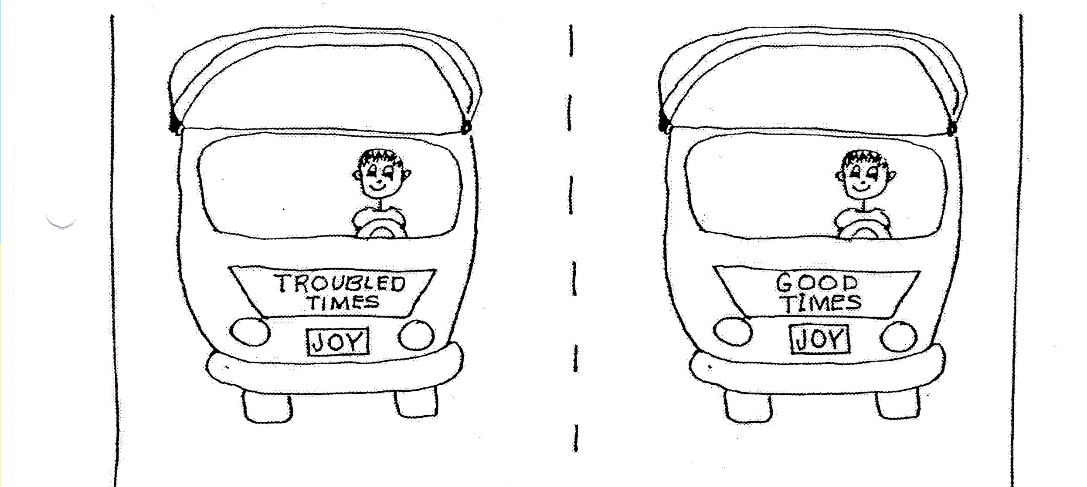
- Spiritual self-esteem is self-confidence from Bible doctrine in our souls. We become courageous because we have the thinking of the Lord Jesus Christ.
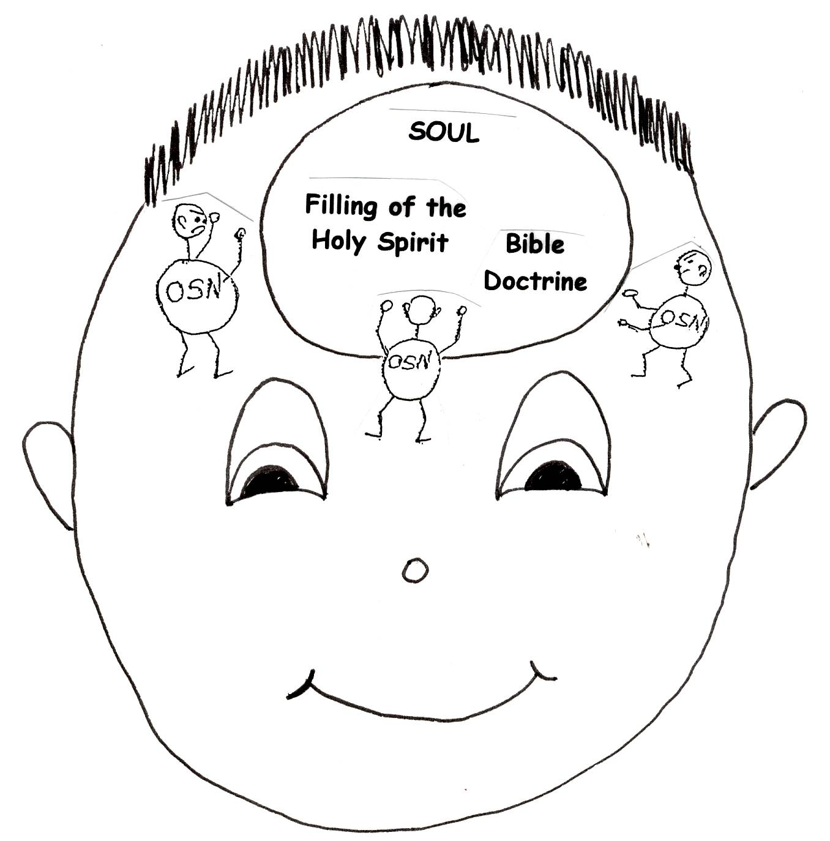

- Spiritual self-esteem is self-realization from the process of learning, thinking, and using Bible doctrine. We start to realize why we are here…to bring glory or praise to God. We begin to understand what God has provided for our spiritual life, like the ten problem-solving devices. We start to understand why we have difficulties and suffering.

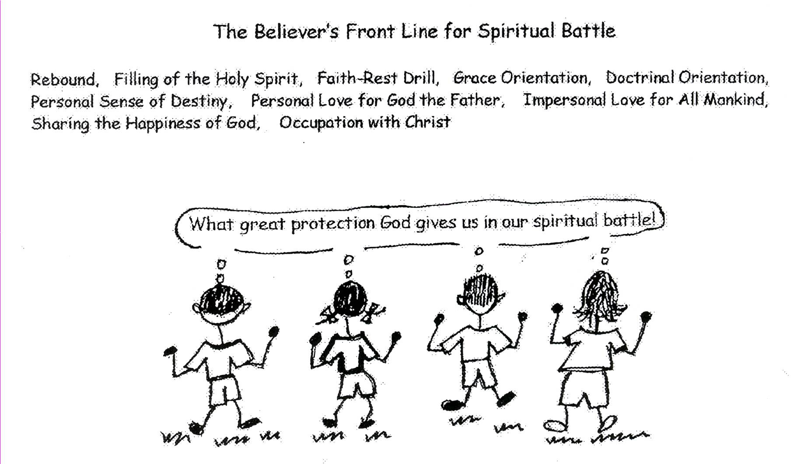

- Spiritual self-esteem is self-direction or spiritual momentum from living in the pre-designed plan of God under the enabling power of the Holy Spirit that is the filling of the Spirit. We know the path that we should follow from the Bible and the more doctrine we have, the more precise our self-direction will be.

- Spiritual self-esteem is self-identity, which is grace orientation combined with doctrinal orientation to produce a personal sense of destiny. We know what grace is all about and combine it with doctrine. We know that we are members of the Royal Family of God and headed for heaven for all eternity.

- Spiritual self-esteem is self-motivation from personal love for God the Father, from occupation with Christ, and from knowing the unique characteristics of the Church Age.

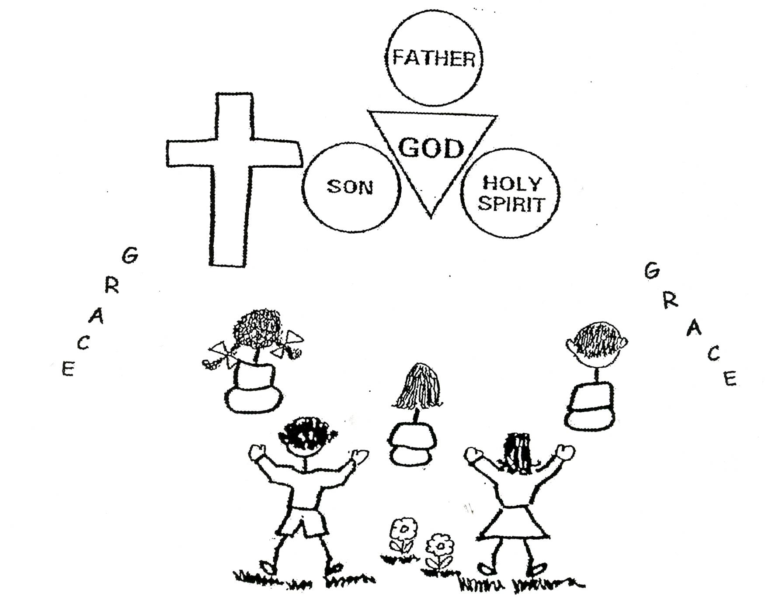

- Spiritual self-esteem is self-vindication, or proof of the value of self because of using the pre-designed plan of God through the power of the Holy Spirit. We become winner believers….invisible heroes. We become members of the pivot of the client nation. In other words, because of our positive faith in God, He protects our nation. We receive blessings that God has been holding until we have the capacity for them…spiritual adulthood; God blesses us beyond what we can imagine! We glorify God in the angelic conflict when we grow spiritually!
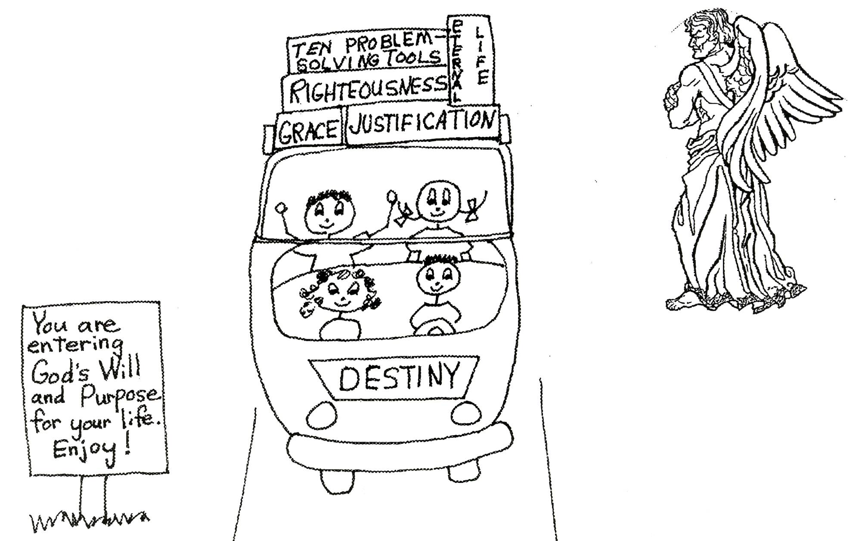

Evidence of Spiritual Self-Esteem

- When we have spiritual self-esteem, we have a lifestyle of peace in our soul. There are times when our emotions will go a little haywire or off course, but we will rebound and get right back on course. We have a relaxed mental attitude most of the time.

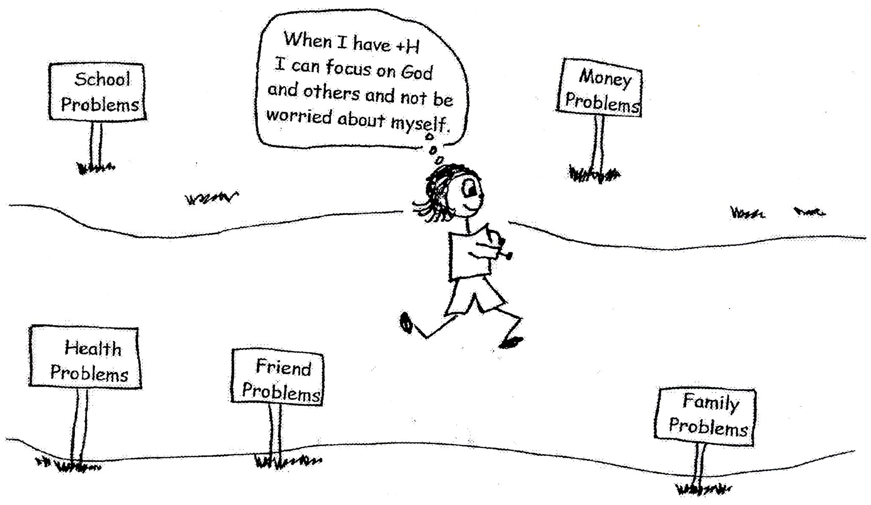

- We have a stability of mental attitude…in other words we don’t feel threatened by others. We avoid being too competitive. We control our emotions and think our way through tough situations. We lose our fears.
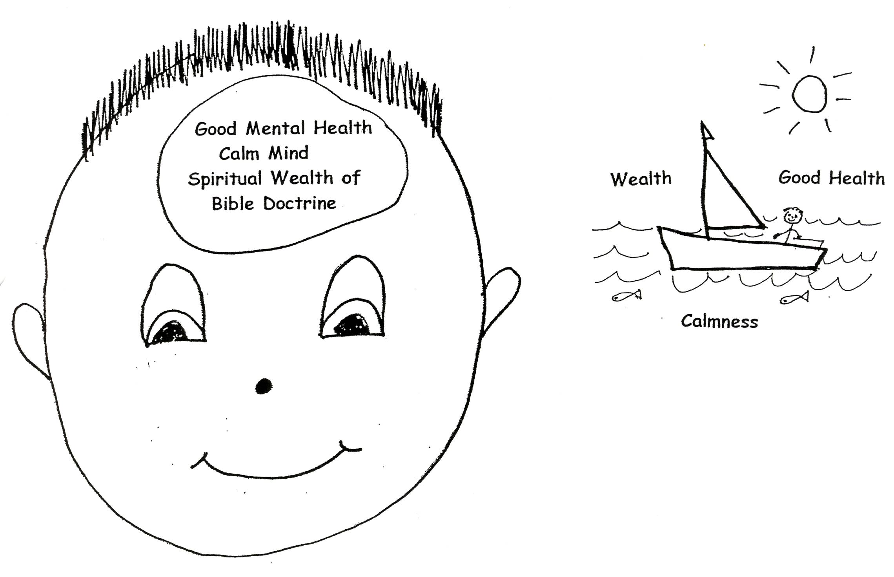
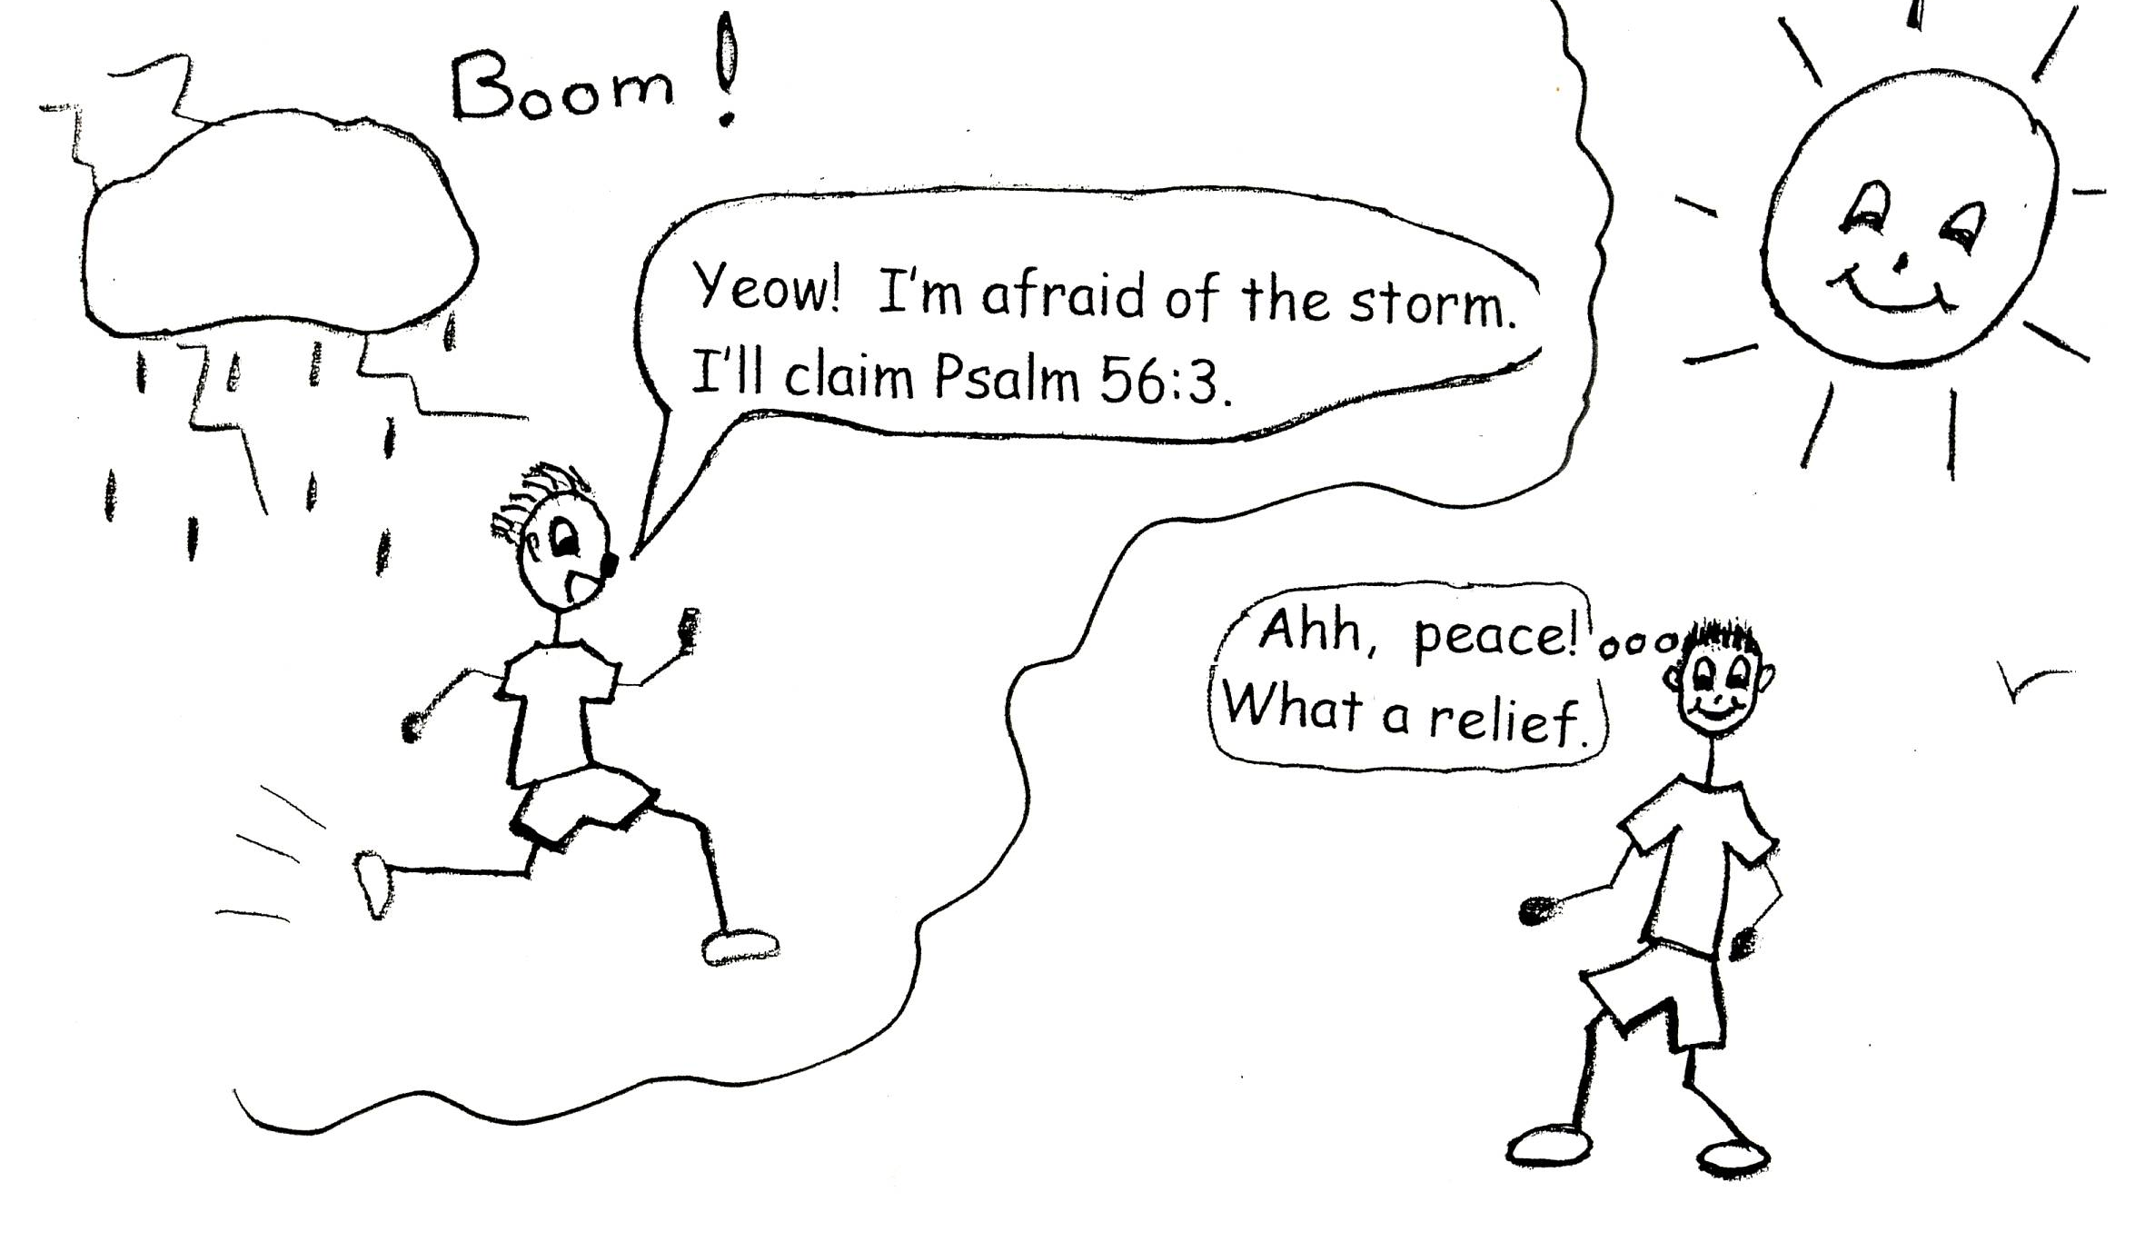

- We have composure with self-assurance when faced with a problem. We apply correct Bible doctrine to our every situation in life.
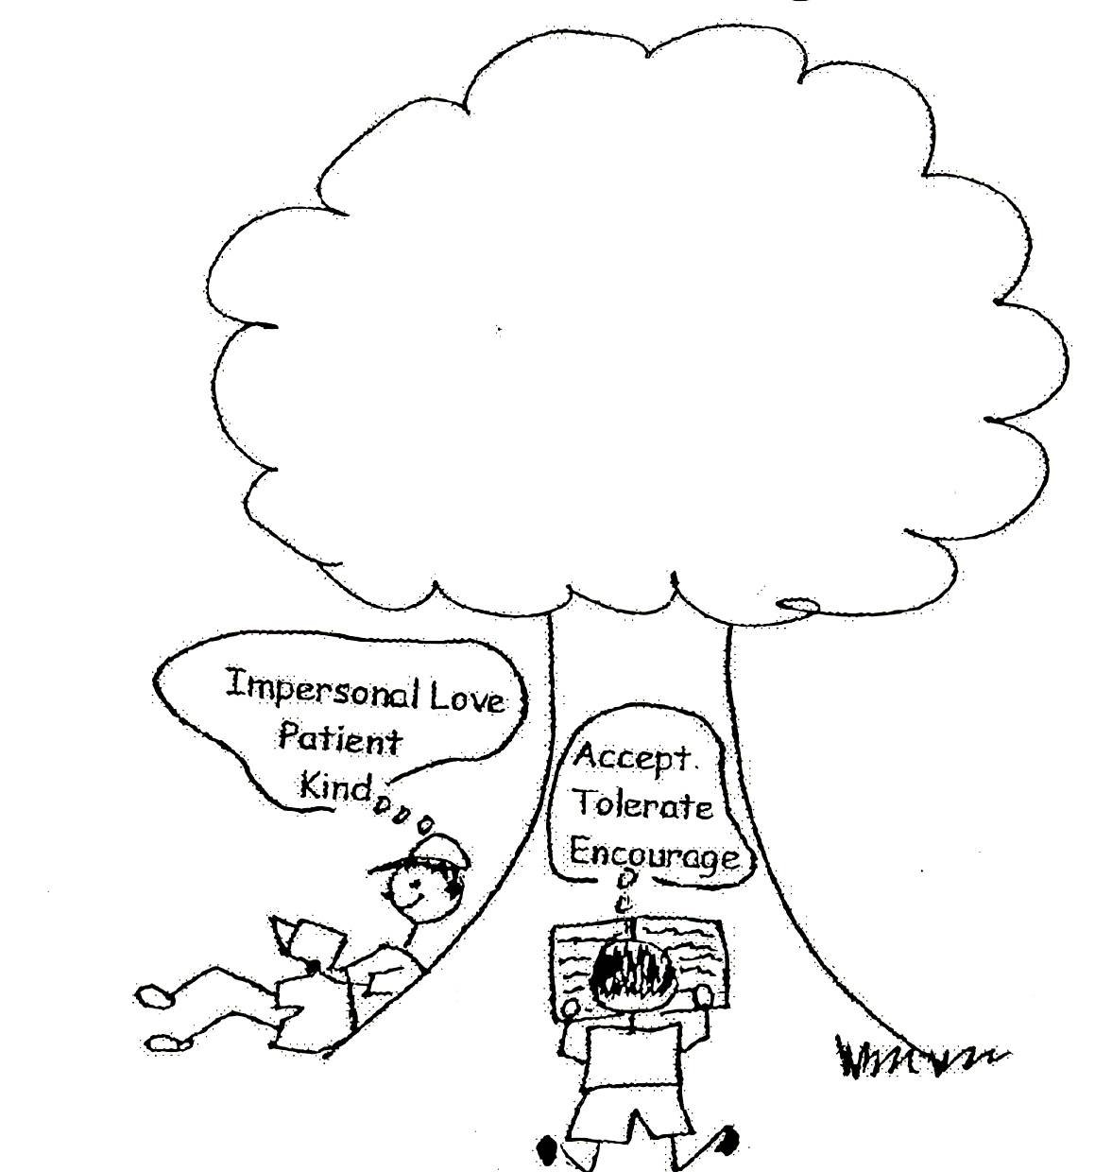

- We have grace orientation in life. We know that God treats us with grace. We treat ourselves graciously and others graciously. We know God will give us everything we will need to do it right.

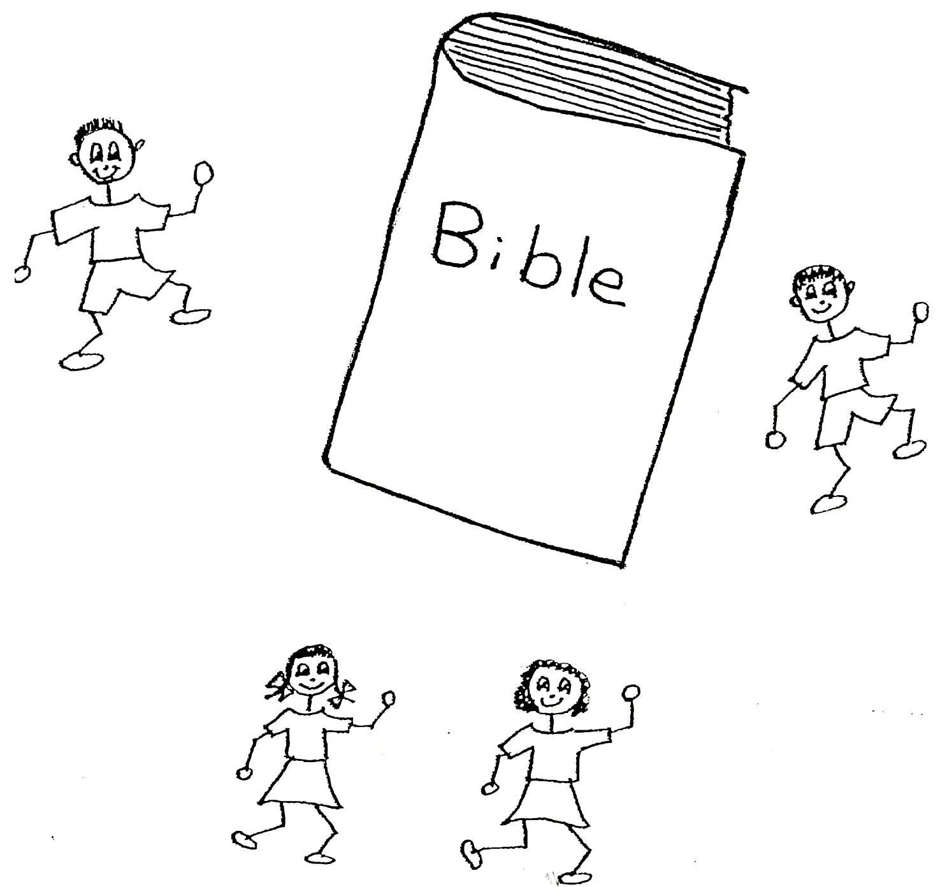
- We have doctrinal orientation in life. We live our lives using the Bible doctrine in our souls. We are humble and teachable and we aren’t sensitive when others hurt us. We use common sense and avoid being too competitive. We don’t let Satan cause division among our family members and friends in the Royal Family of God.

- We make good decisions from a position of strength (Bible doctrine in our souls). This means we do it because we have personal love for God the Father plus His divine-viewpoint thinking. We see the value of the Word of God and have our priorities straight.

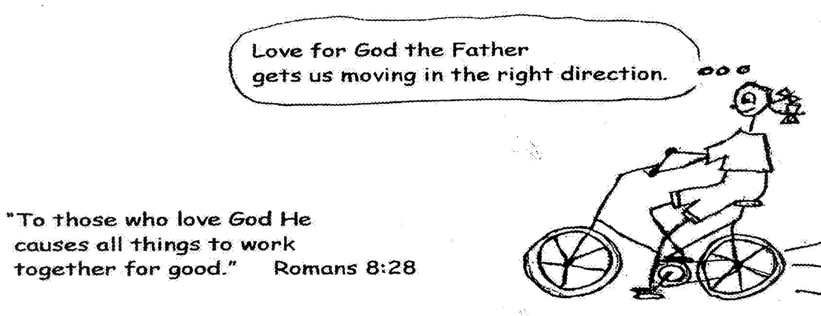
- We have personal control of our lives through understanding Bible doctrine. It makes sense to us to use it in all of our thinking and circumstances. We lean on our relationship with God, not our relationship with people. We don’t let the details of life control us.

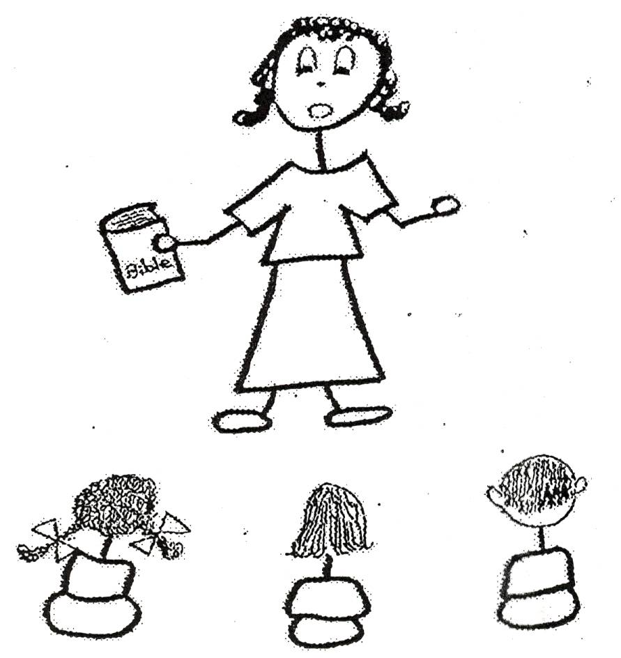
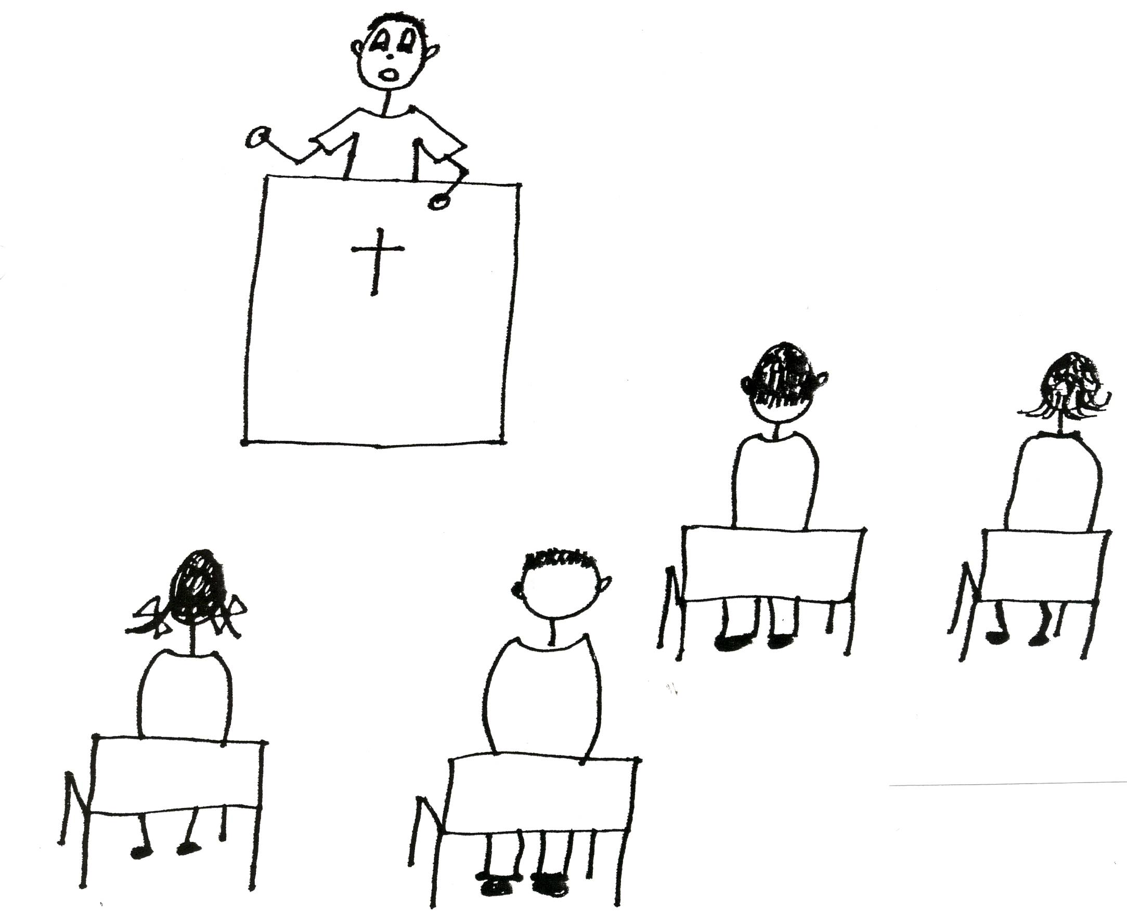

- We have a personal sense of destiny. We know why we have been created. We know that God guides us in certain directions and when we give ourselves to Him completely He will make it all work our perfectly.

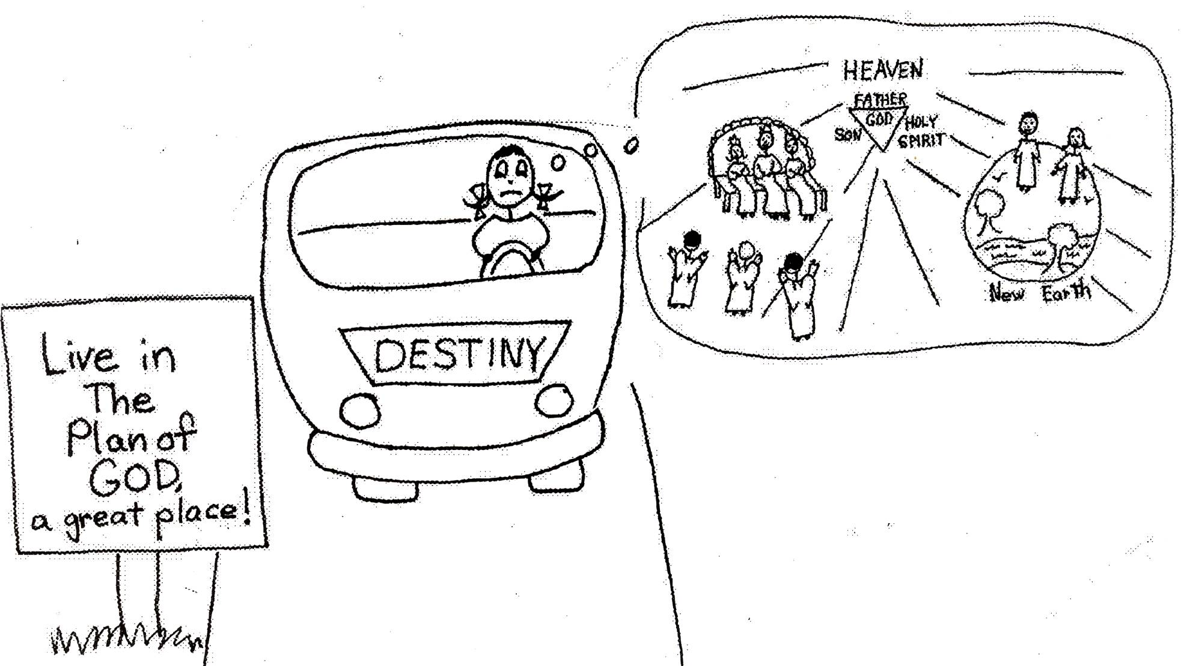

- We have self-confidence from wisdom. This wisdom is from the Bible doctrine in our souls. Since Bible doctrine is the thinking of the Lord Jesus Christ, we have the best thinking and wisdom to use!

- We have poise…calmness in any situation to be able to think it through. This is the believer under spiritual self-command. When we are in a bad situation, we step back and get control of our emotions through Christ’s thinking. Then we apply God’s Word to the situation. We know that our sufferings will eventually be turned into blessings. God is molding us to the image of His Son. He wants us to be like Jesus!

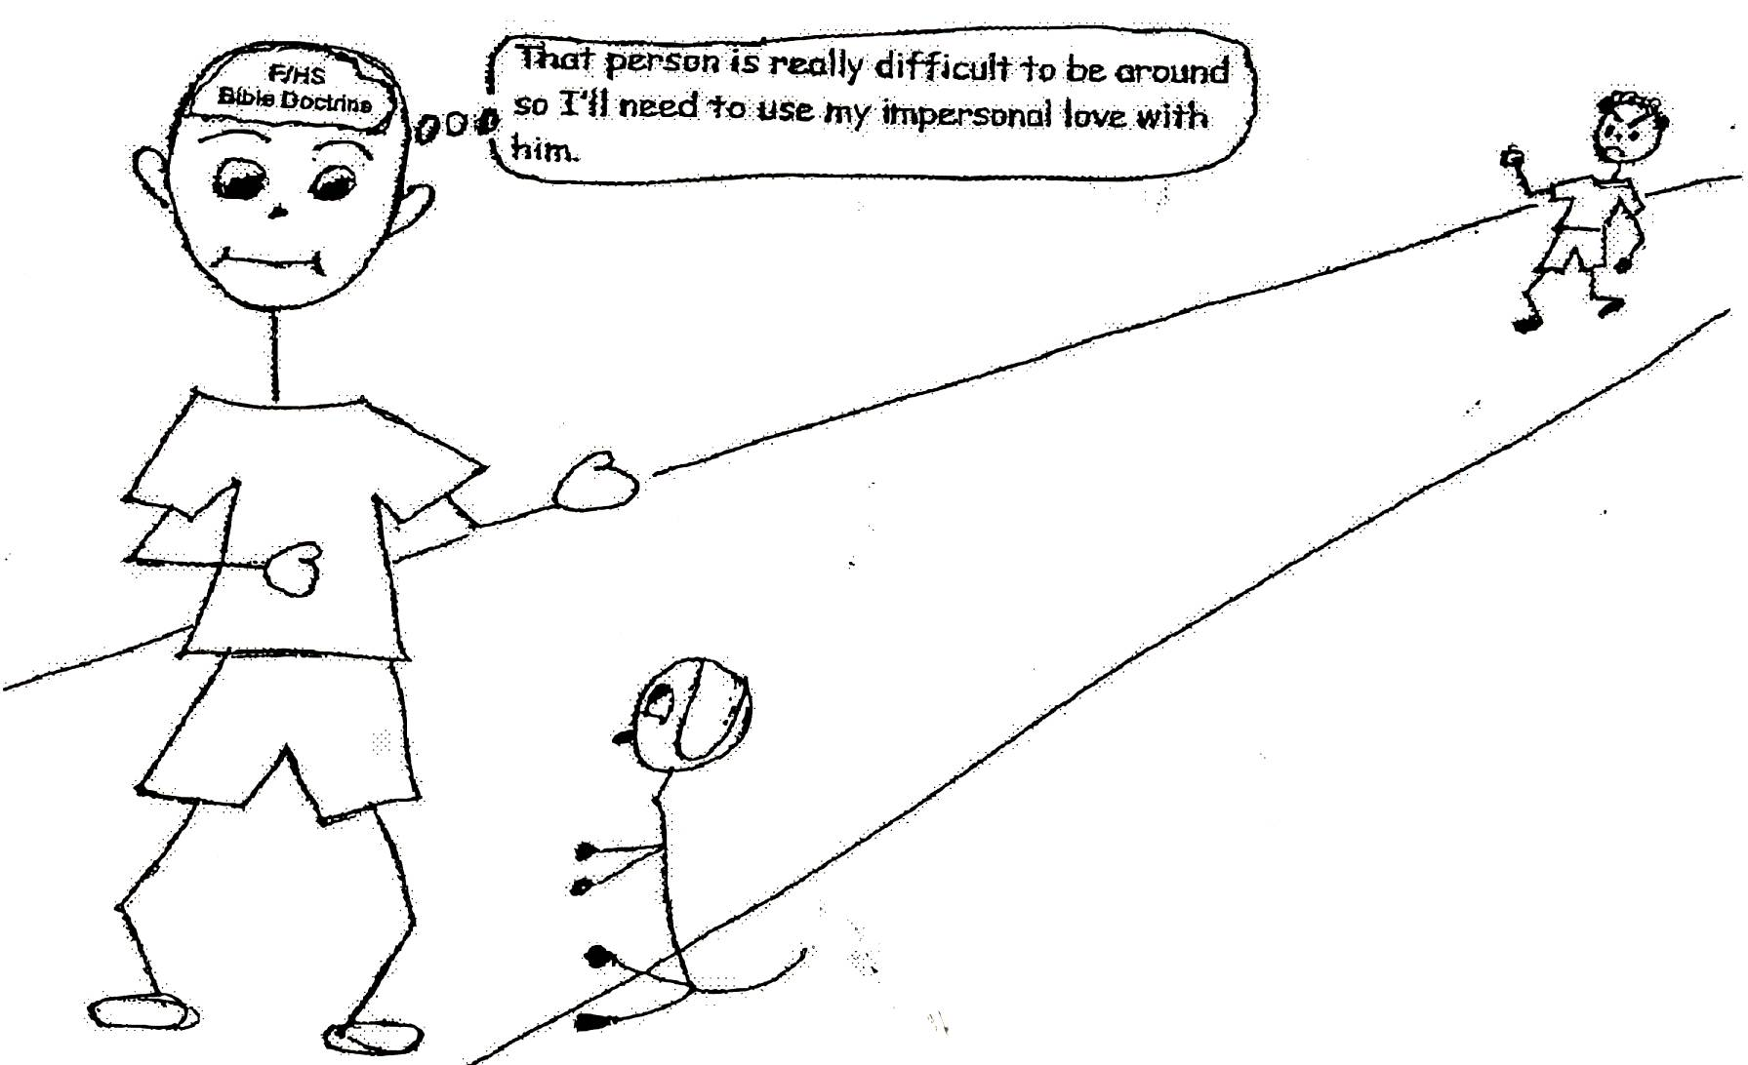
Gal. 4:19 “My dear children, for whom I am again in the pains of childbirth until Christ is formed in you…” NIV

When we have spiritual self-esteem, we begin to have momentum in the spiritual life. We are grateful for all of our problems because after we overcome each problem through Bible doctrine, we become stronger and more able to meet those problems that are still to come. Mistakes are not failures in life. They are a way to learn from experience for handling more problems that will come along in the future. Our successes can be measured by the problems we overcome through Christ while trying to succeed. We can choose our own direction! God gives us the energy and the way to be victorious. Through the filling of the Holy Spirit, we will have the energy; through Bible doctrine, God will show us the right way! We have no excuses not to have spiritual self-esteem!

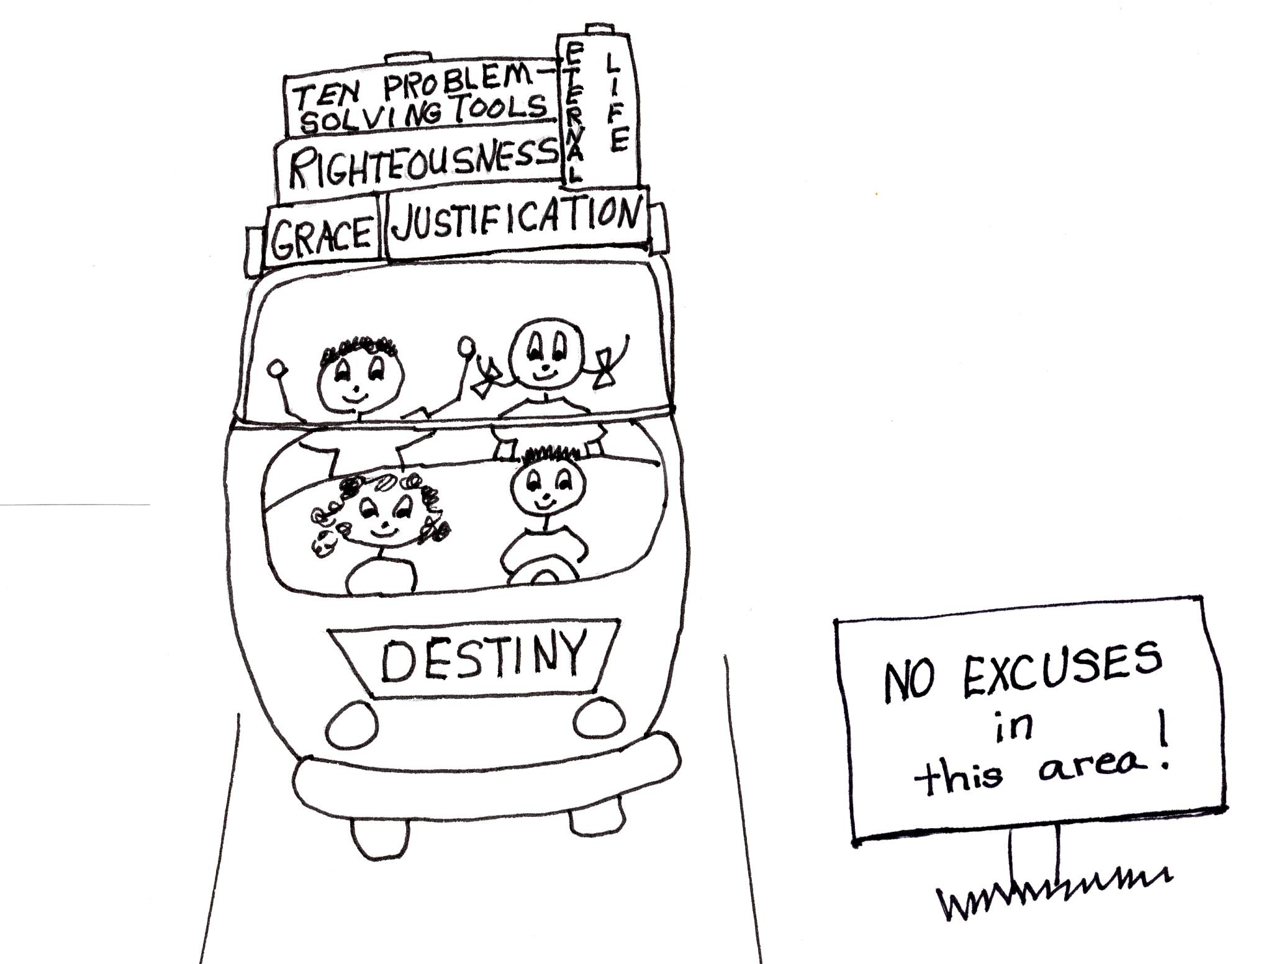

1 Cor 15:10-11 “But by the grace of God I am what I am, and his grace to me was not without effect. No, I worked harder than all of them — yet not I, but the grace of God that was with me.” NIV

Close in prayer

