Lighthouse Christian Youth Ministry
Lesson 61
Spiritual Autonomy
Or
Spiritual Independence
The Second Stage of Spiritual Growth

December 14, 2007

In our last lesson we learned about the first stage of spiritual growth…spiritual self-esteem. From spiritual self-esteem we now move onward to the second stage of spiritual growth…spiritual autonomy or spiritual independence! Spiritual independence is when we have enough spiritual self-confidence* from our spiritual self-esteem and impersonal love** in our souls so that we don’t depend on others for strength and support. We depend on Bible doctrine, the power of the Holy Spirit, and the ten problem-solving devices! Therefore, learning, believing, and using Bible doctrine must still be our #1 priority! In this stage of growing up spiritually, our personal love for God and our impersonal love for all mankind will increase. God will throw in some undeserved suffering to prevent us from getting out of the plan for our lives or off course; it is called providential preventative suffering. That just means God prevents us from straying too far away from Him and His plan for our lives. Providential means God designed it for us. With all of these things in place, we will reach spiritual autonomy, or spiritual independence…the second stage of spiritual growth!

*Spiritual self-confidence is confidence in God and His plan for our lives.
**Impersonal love is how we treat others because of the Bible doctrine in our souls; it does not depend on how others act or treat us or how we feel about them.
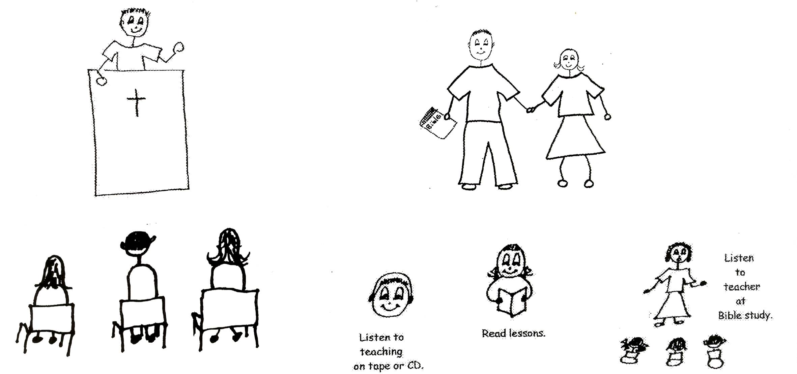

Proverbs 8:10-11 “Choose my instruction [Bible doctrine] rather than choice gold, for wisdom is more precious than rubies, and nothing you desire can compare with her [doctrine].”

When we love Bible doctrine and study it everyday, we will love the thinking of our Lord Jesus Christ, and we’ll grow even more in personal love for God. Then our impersonal love for all mankind will grow more, too. Remember impersonal love depends on what is in our souls; it doesn’t depend on what other people do or say or how we feel about them. We can be content with them or without them. We’ll be able to act the same whether faced with obnoxious people or loving people. This will make us spiritually independent of others. We’ll even be independent of ourselves…our human viewpoint from our sin natures...or how we feel about them. We will depend on Bible doctrine…divine viewpoint…in our souls! We’ll be thinking like the Lord Jesus Christ!! This only works IF you’re in fellowship with God and filled with the Spirit.

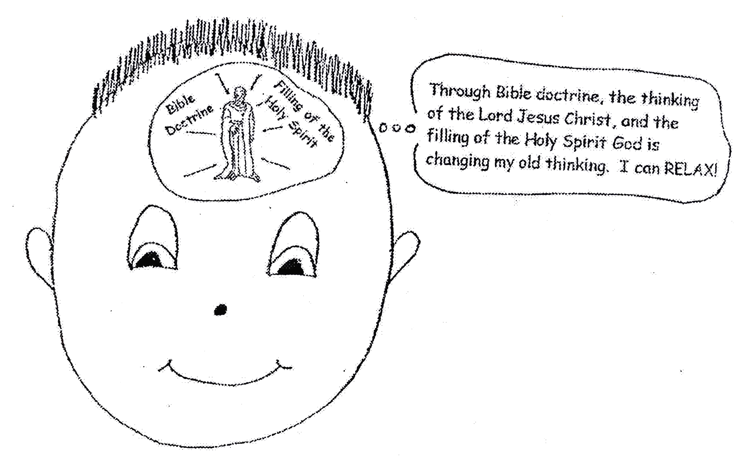

Isaiah 55:8-9 “For My thoughts are not your thoughts, neither are your ways my ways,” declares the Lord. ‘As the heavens are higher than the earth, so are my ways higher then your ways and my thoughts than your thoughts.’”

God is always gracious to us. He treats us with grace…we don’t earn or deserve what He gives us. He has taught us to be gracious to others just as He is gracious to us. By the mental attitudes we have formed from Bible doctrine in our souls we treat others graciously even if they don’t deserve it. He has taught us how to have impersonal love. Through the power of the Holy Spirit, we can use impersonal love…we can be courteous, thoughtful, sensitive to others’ feelings, and tolerant. Before personal love can work in our lives, we have to have impersonal love. The person we love with personal love is not always loveable! Therefore, we have to switch to impersonal love and treat that person with grace and mercy, just like God always treats us!
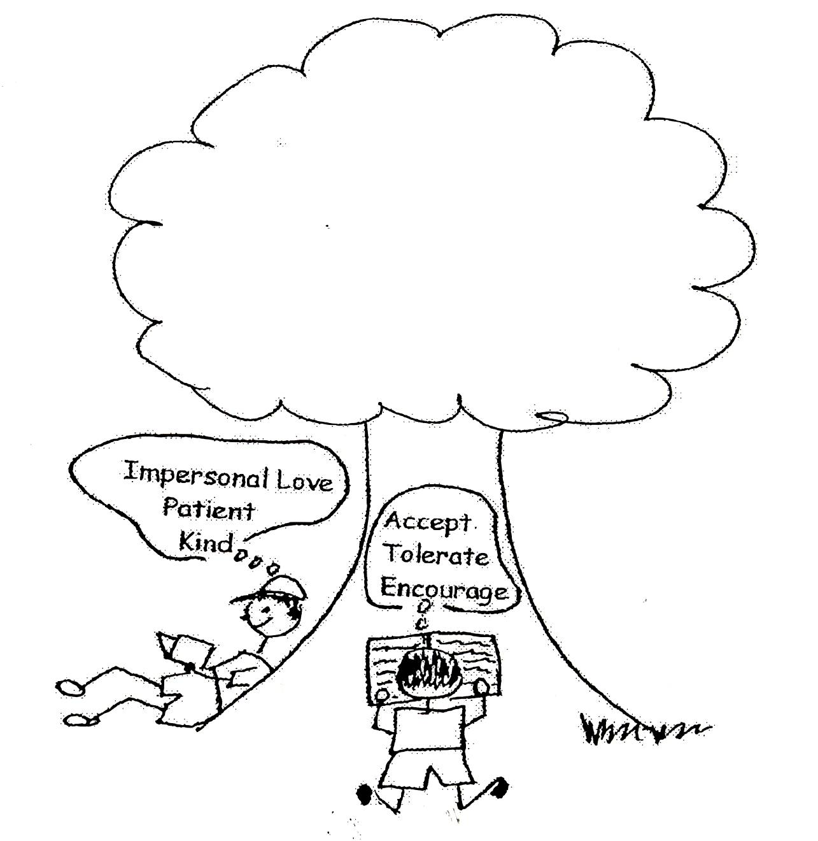

John 13:34-35 Jesus said, “A new command I give you: Love one another. As I have loved you, so you must love one another. (35) By this all men will know that you are my disciples, if you love one another." NIV

Sometimes we will have to switch from personal love to impersonal love very quickly! Someone might say something that hurts us. Another might do something that hurts us. We may be treated unfairly. These will be good tests to see if we respond to the doctrine in our souls or if we react to our old sin natures!

You have to pass these tests that come in order to remain in spiritual adulthood or spiritual autonomy. But don’t worry (that’s a sin), God will help you pass the test by means of the Holy Spirit. The Holy Spirit will help you recall or remember the doctrine in your soul to apply to any situation or test. There’s no reason to fail or not pass the test, we need to rebound and keep moving forward in God’s plan. He always gives us other chances to pass the same tests and then we’ll grow even more.

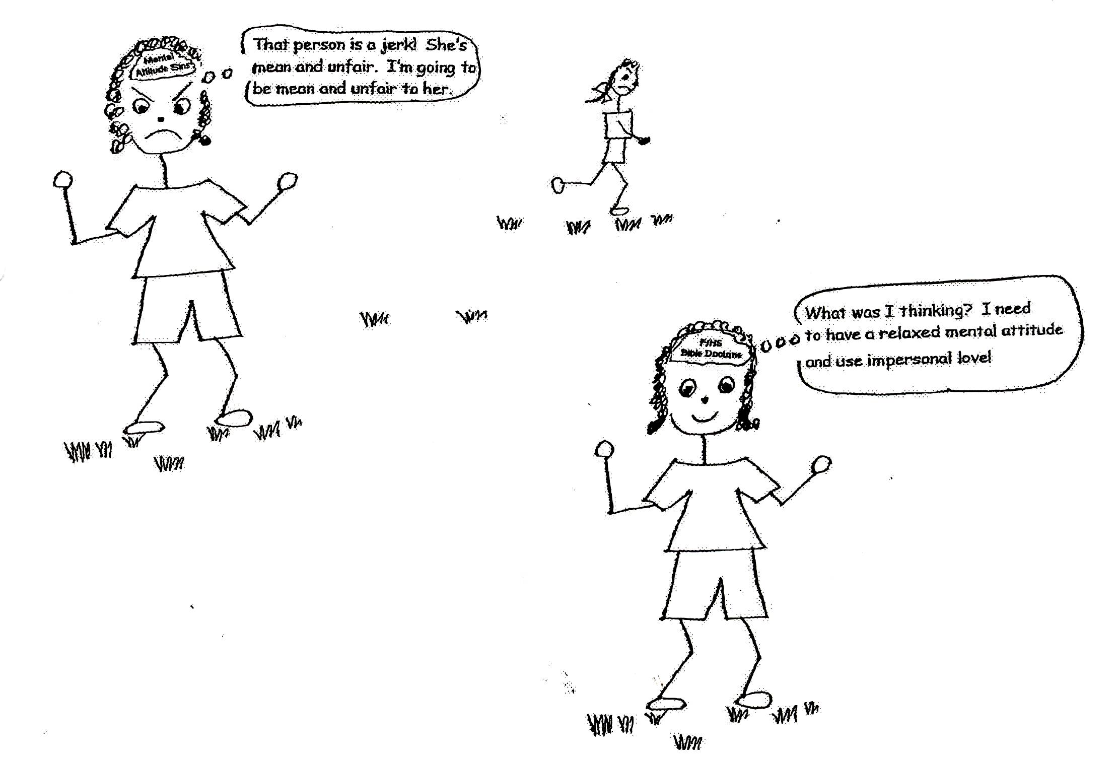

Luke 6:27-28 “But I tell you who hear Me; Love [impersonal love] your enemies, do good to those who hate you, bless those who curse you, pray for those who mistreat you.”

Bible doctrine in our souls along with the filling of the Holy Spirit will give us wisdom and strength to live our lives according to God’s plan. We won’t be so quick to react to bad situations when we’re in spiritual autonomy. It will be easier for us to respond to the situations with the thinking of Jesus Christ. We won’t be controlled by what others think, say, or do. People won’t be able to make us do what they want by complimenting us or patting us on the back or making us feel guilty. We won’t depend on the advice of others. However, at times we will share certain situations with a friend who has lots of Bible doctrine in his or her thinking. God will know when we need this and He will supply the friend for us. This friend will give us the thinking of Jesus Christ. This will help us to go on in God’s plan, using God’s wisdom and strength! We must always encourage one another in Christ.

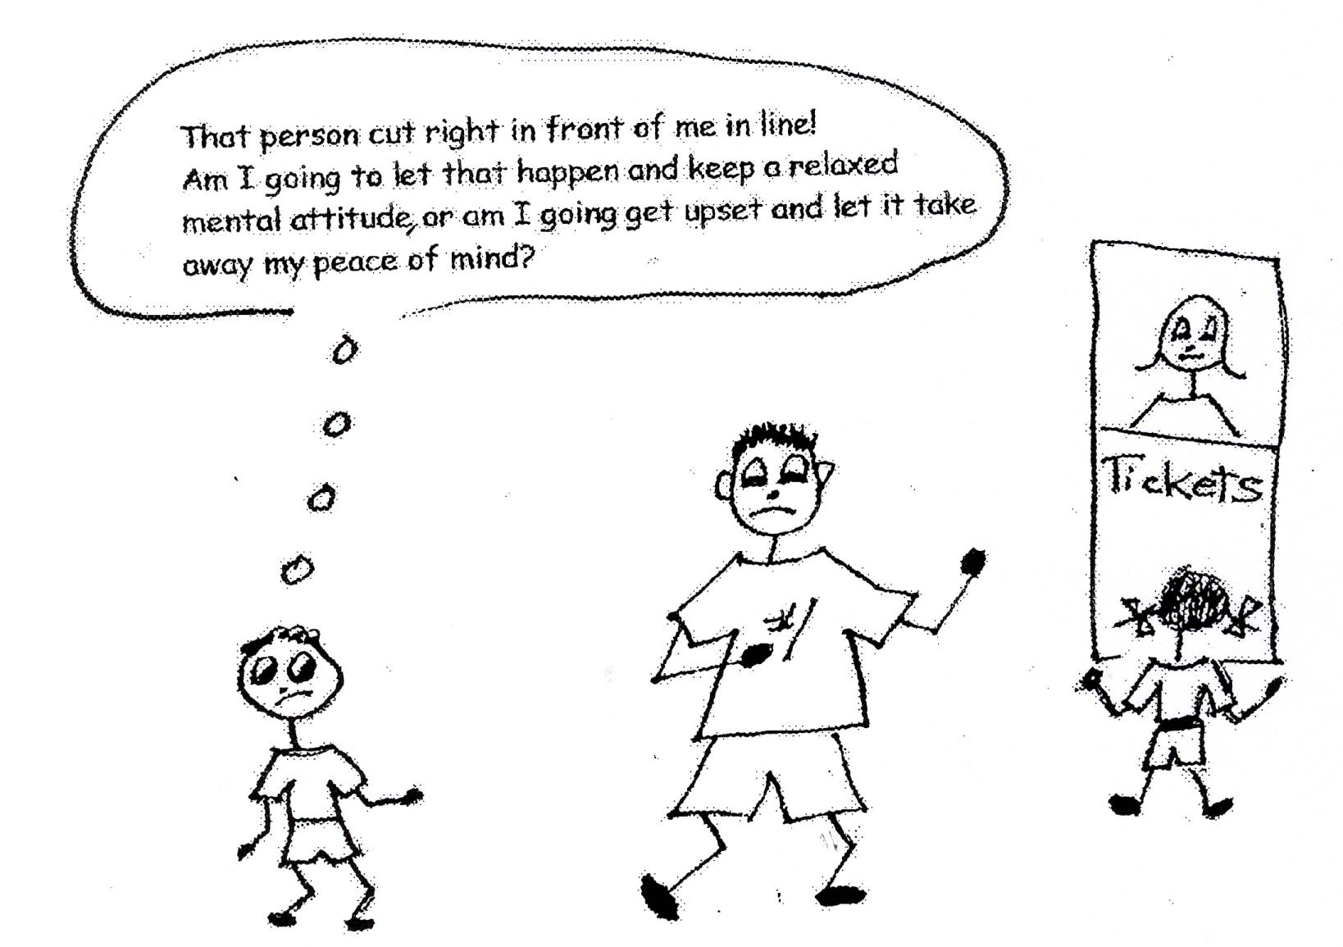
Philippians 4:8-9 “Finally, brothers, whatever is true, whatever is noble, whatever is right (just, fair), whatever is pure, whatever is lovely (worthy of personal love), whatever is admirable (virtue…doing the right thing in God’s eyes) – if anything is excellent or praiseworthy – think about those things. Whatever you have learned or received or heard from me, or have seen in me, put it into practice. And the God of peace will be with you.”

Now during this time of spiritual growth from spiritual self-esteem to spiritual autonomy or independence God will put in suffering. It is called providential (meaning from God) preventative (meaning to prevent us from becoming arrogant) suffering. Wow! That’s a mouthful! For us to reach spiritual self-esteem we had to use lots of positive volition. Now our positive volition will be tested by our suffering. What’s interesting is that everyone in life suffers. What’s important is how we handle that suffering: do we use human viewpoint or divine viewpoint? Do we accept it as coming from God or get angry that it happened to us? To get to spiritual independence we must use divine viewpoint or divine thinking.

Romans 5:3 “Not only so, but we also are happy in our sufferings, because we know that suffering produces perseverance (endurance); perseverance, character; and character, hope (confidence in God).”
God uses providential preventative suffering to speed up the believer’s spiritual momentum from spiritual self-esteem to spiritual autonomy, or spiritual independence. He also uses it to prevent us from being arrogant and leaving the plan for our lives. In spiritual self-esteem, we are likely to start thinking that our strength comes from ourselves rather than from the Word of God and His plan. Providential preventative suffering reminds us of our dependence on the pre-designed plan of God. It reminds us to use divine power rather than human ability. God gives us the ten problem-solving devices to change all suffering into blessing! In grace, God gets us moving forward in His plan!
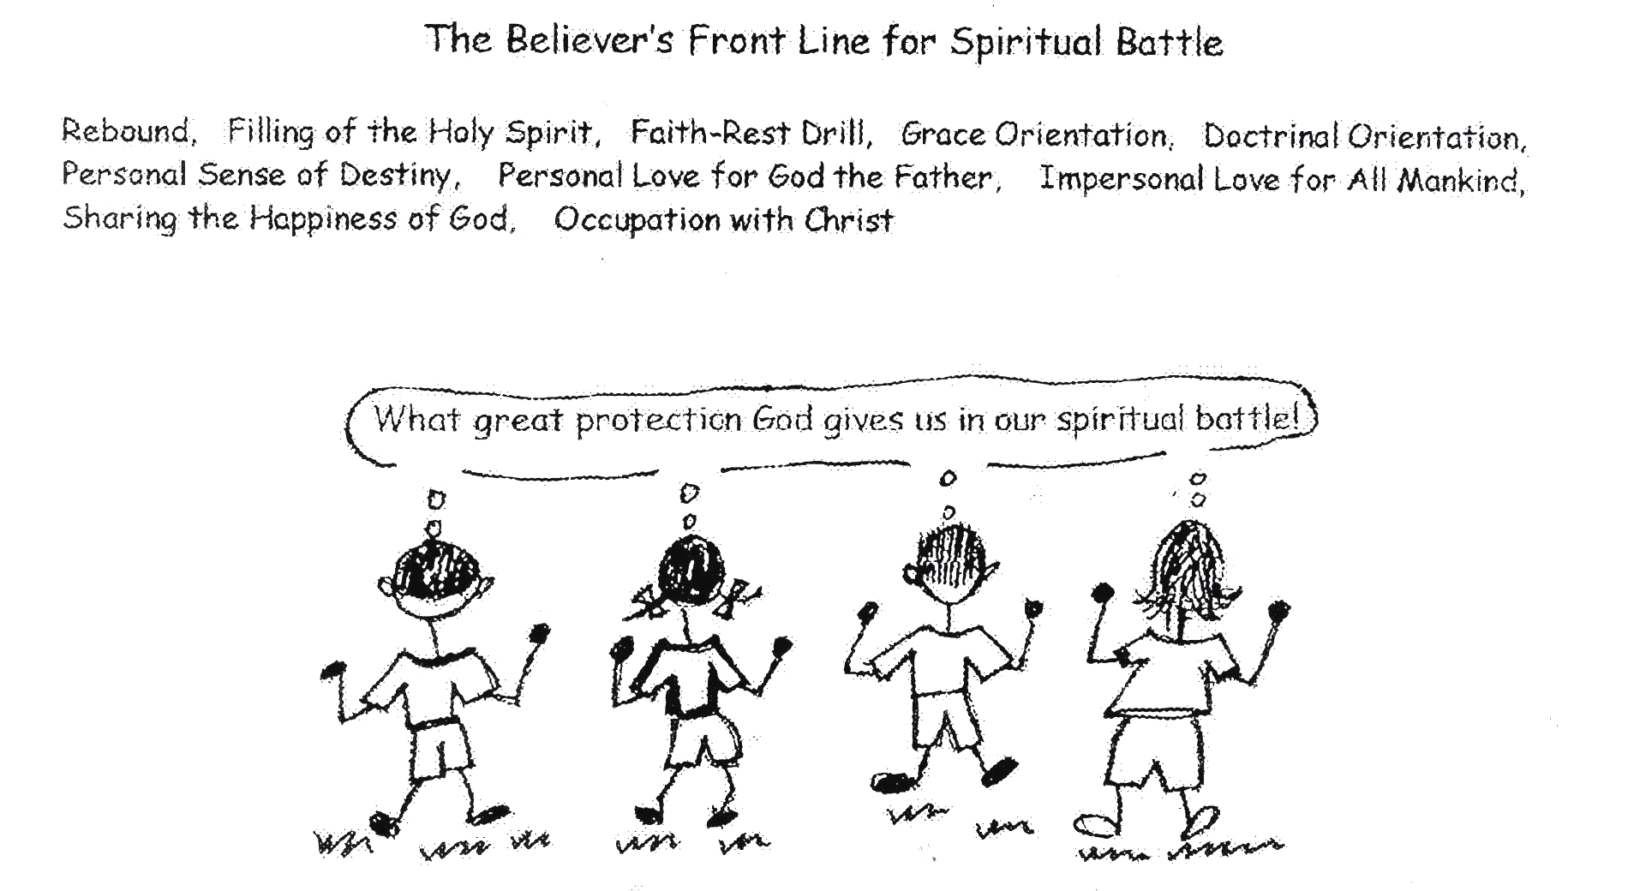

James 4:6 “But He gives us more grace. That’s why Scripture says: ‘God is against the proud but gives grace to the humble.’”

Trials, tests, temptations, disappointments…sufferings of any kind…are helpful to us if we use divine viewpoint while going through them. If we fight against these things, it will be worse on us but if we accept it for spiritual growth, we will be stronger and we can see how weak we are without God’s power. The victories in overcoming these sufferings will give us new spiritual strength. God has given us everything we need to overcome sufferings. He has given us the ten problem-solving devices, the power of the Holy Spirit, and His pre-designed plan for our lives. Every triumph over suffering represents a new supply of God’s energy! We’ll be depending more and more on God’s power. We can boast in our weaknesses and God’s grace that keeps us strong and going forward!
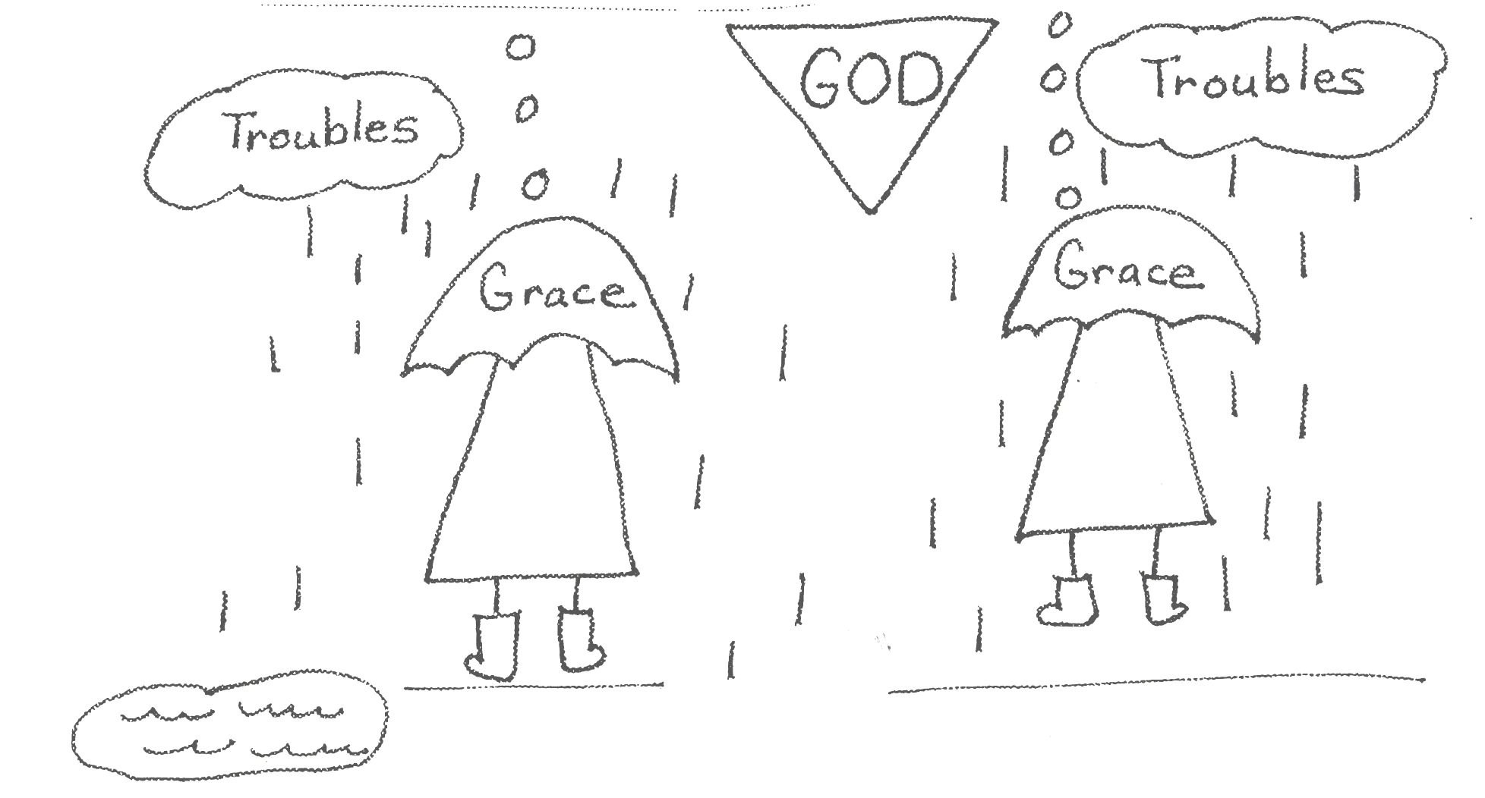
2 Cor 12:7-10 “To keep me from becoming conceited because of these surpassingly great revelations, there was given me a thorn in my flesh, a messenger of Satan, to torment me. (8) Three times I pleaded with the Lord to take it away from me. (9) But he said to me, ‘My grace is sufficient for you, for my power is made perfect in weakness.’ Therefore I will boast all the more gladly about my weaknesses, so that Christ's power may rest on me. (10) That’s why, for Christ's sake, I delight in weaknesses, in insults, in hardships, in persecutions, in difficulties. For when I am weak, then I am strong.” NIV

If we learn from our sufferings the lessons God tries to teach us, we will be able to help others who may be going through the same experiences. And God will make you available to help others that experience the same pain you have experienced. We are a family and families stick together and help each other in all situations. In our pain, God gives us grace and mercy. Because of this, we will be more compassionate toward others. Through the power of the Holy Spirit, we can give grace and mercy to others. Our impersonal love for others will be stronger. We will use the ten problem-solving devices to move along in the plan of God.
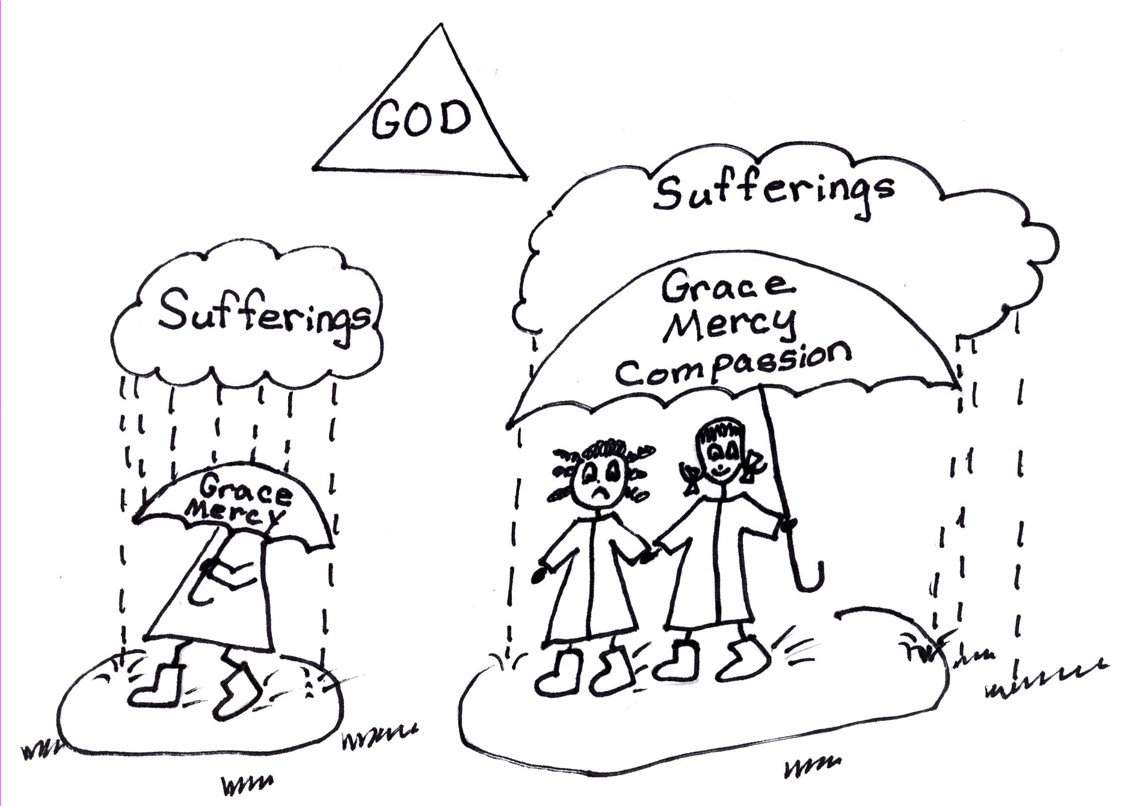
2 Corinthians 1:3-4 Praise be to the God and Father of our Lord Jesus Christ, the Father of compassion and the God of all comfort, Who comforts us in all our troubles, so that we can comfort those in any trouble with the comfort we ourselves have received from God.

Spiritual self-esteem + providential preventative suffering (undeserved suffering) = spiritual autonomy (the 2nd stage of spiritual adulthood).

We can have complete confidence in God’s plan for our lives. We know that in grace, God takes steps to prevent actions that we might take that will hurt us. He prevents us from hurting ourselves by sending us suffering for blessing, or providential preventative suffering. On our way to spiritual autonomy, or spiritual independence, the 2nd stage of spiritual adulthood, trials and sufferings will come to us. They are all for our benefit though so don’t get upset. We just have to rely on our confidence in God…that HE’S doing the right thing for us and rely on His plan, and use the problem-solving devices. Daily, we have to learn, believe, and use Bible doctrine. God will do the rest!
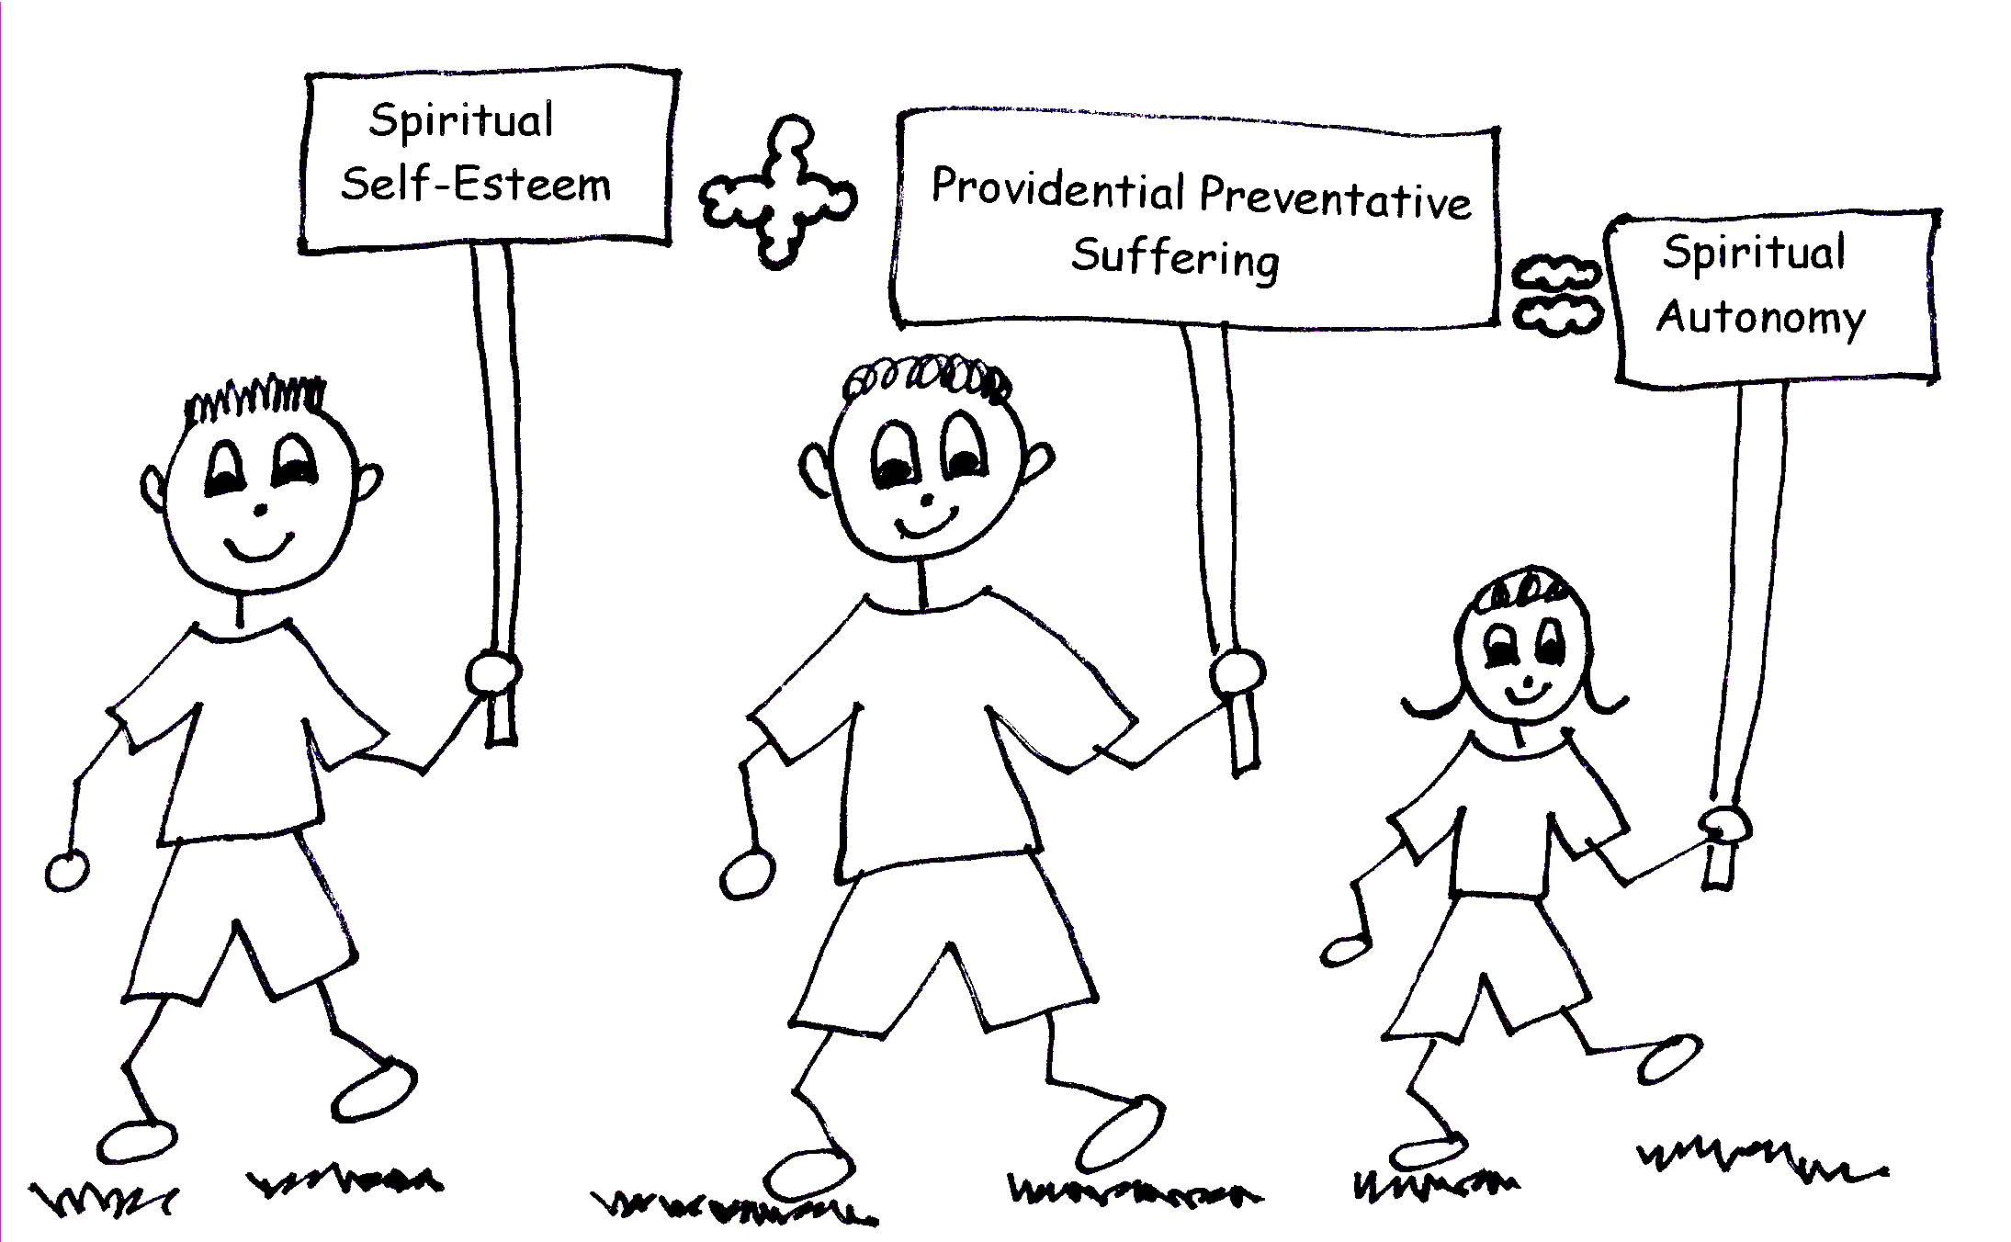

Isaiah 64:8 “Yet, O Lord, you are our Father. We are the clay, you are the potter; we are all the work of your hand.”

References: Robert McLaughlin Bible Ministries
www.gbible.org
Lessons: 10-20-06, 10-22-06, 11-15-06,
11-16-06, 11-19-06

Christian Integrity, by R.B. Thieme, Jr.
&
www.lighthousechristianyouth.org.

