Lighthouse Christian Youth Ministry
Lesson 62
Spiritual Maturity
The Third Stage of Spiritual Growth

January 20, 2008

There are 3 stages of spiritual growth: spiritual self-esteem, spiritual autonomy or independence, and spiritual maturity. The third stage of spiritual growth in God’s plan for our lives is spiritual maturity. We studied about the first 2 stages and I want you to remember that when we reach the second stage of spiritual growth…spiritual autonomy…or spiritual independence…God gives us a test: providential preventative suffering (underserved suffering) so that we’ll stay in the plan and on our course to reach the last stage of spiritual growth…spiritual maturity. Another name for the suffering we get in stage two is momentum testing. Momentum means speed of motion. Therefore, momentum testing is speeding up our motion towards spiritual maturity…our goal. God wants His highest and best for us so He helps us in every way to reach our goal. He wants us to go forward in His predesigned plan for our lives. He wants us to become spiritually mature! God will speed up the process for us if we let Him!
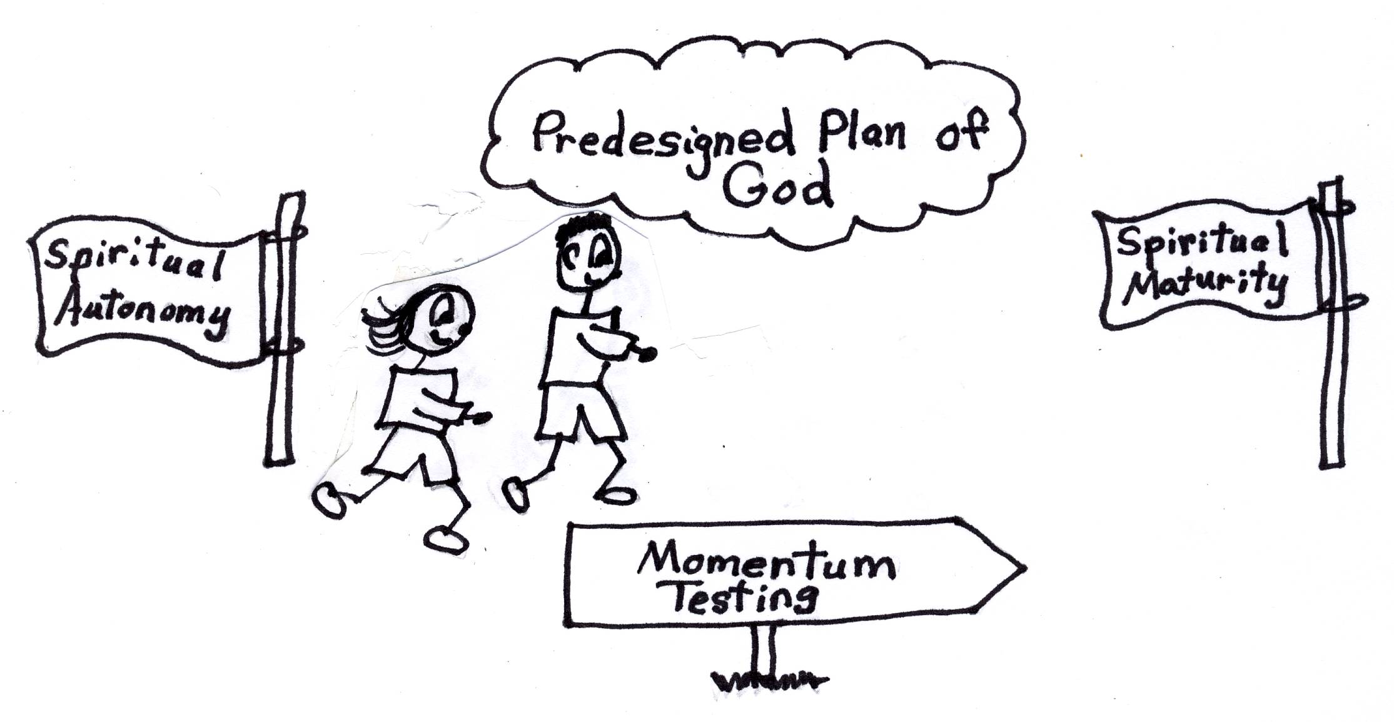
James 1:2-4 “Consider it pure joy, my brothers, whenever you face trials of many kinds, because you know that the testing of your faith develops perseverance [endurance]. Perseverance must finish its work so that you may be mature and complete, not lacking anything.”
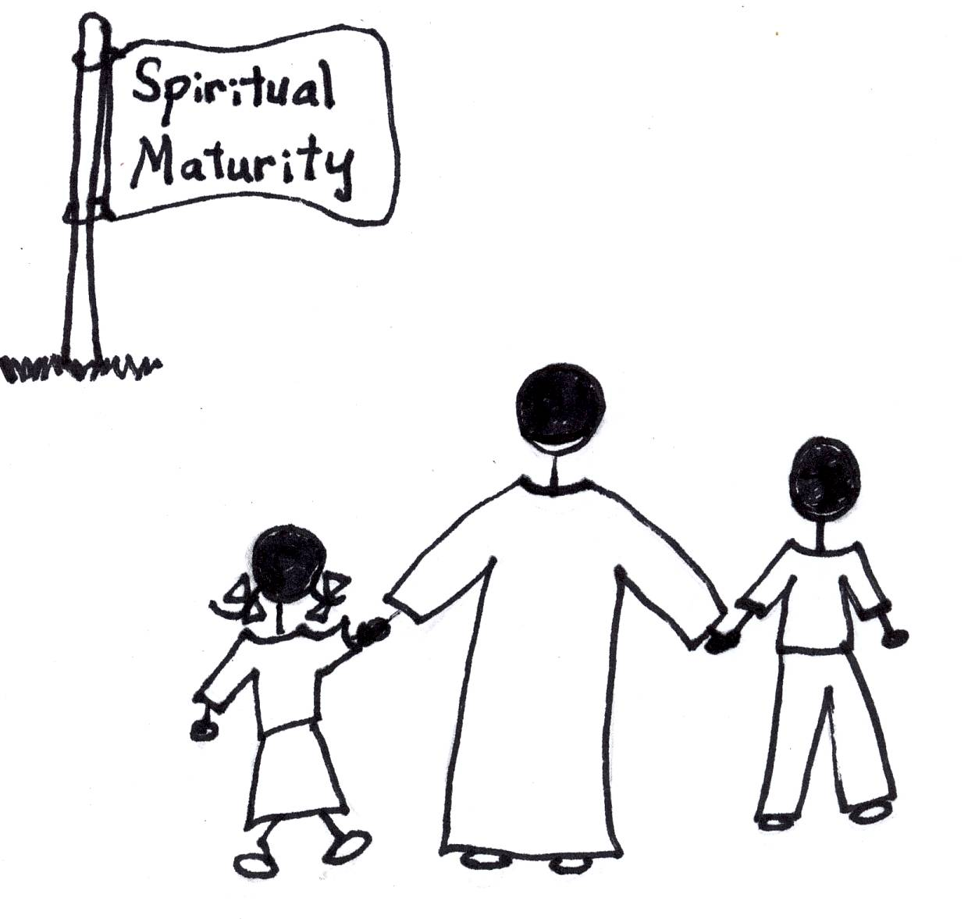
To get to spiritual maturity we have to learn, believe, and apply Bible doctrine just the same as we did in the first and second stage of spiritual growth and we must be willing and available for God to continue to change us spiritually. We have to be willing to go through momentum testing. Our Hero, Jesus, had to grow to spiritual maturity Himself. He had to go through momentum testing or underserved suffering, too. Therefore, Jesus knows exactly what we go through when we are being tested to speed up our spiritual growth. If we want to get to spiritual maturity, and if we are willing to go through momentum testing, God will see that we get there! He will give us the grace to pass these tests. God will give us the energy, Bible doctrine, and the power of the Holy Spirit, too. Isn’t that great? He does it all. We only bring our faith and believe He can.

James 1:25 “But the man who looks intently into the perfect law that gives freedom [Bible], and continues to do this [use Bible doctrine], not forgetting what he has heard, but doing it…he will be blessed in what he does.”

Spiritual autonomy, or spiritual independence (the second stage of spiritual growth), plus momentum testing will get us to spiritual maturity. We have all categories of testing throughout our spiritual growth. However, this momentum testing, or the speeding up of our spiritual growth, will include more intense people, system, thought, and disaster testing. God will only give it to us when we are spiritually ready. So, we don’t have to worry. God, in His grace, has all the bases covered!
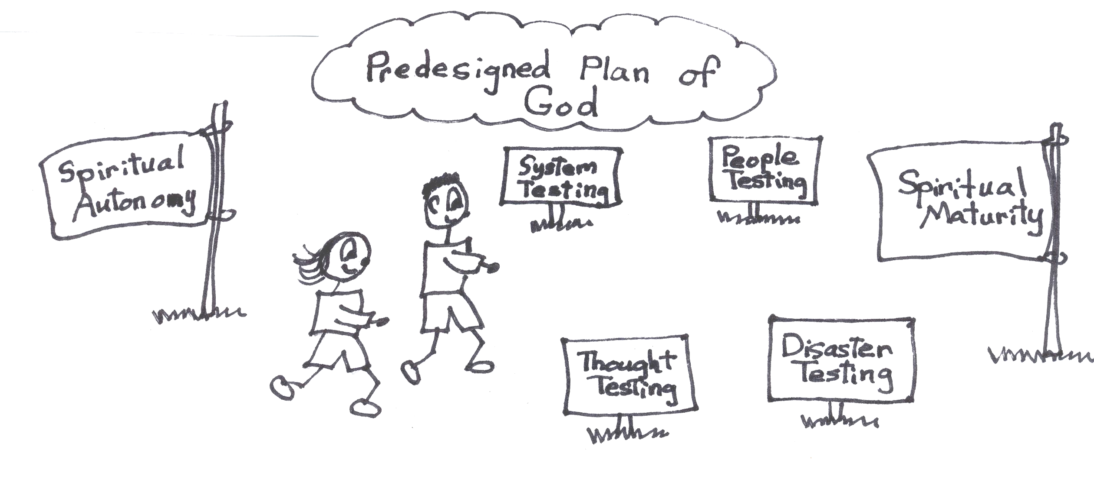

Isaiah 48:10 “See, I have refined [washed, polished] you, though not as silver; I have tested you in the furnace of affliction [pain, suffering].”

Momentum Testing - Disaster Testing
Let’s check out some disaster tests that could come to us on our way to spiritual maturity. God could send either personal disasters or national disasters. Some personal disasters would be pain (mental and physical), hunger, handicaps, disease or loss of loved ones. Some national disasters would be that we would be a victim or violence, terrorism, war, and extremely bad weather conditions. During these tests we are not to get all emotional or fearful and concentrate on ourselves. We are to concentrate on Jesus and God’s promises and solutions. God has given us all of the tools we need; He has given us Bible doctrine or the thinking of Jesus Christ, His predesigned plan, the power of the Holy Spirit, and the ten problem-solving devices. Jesus used these tools during His life and showed us that they work! He passed them on to us. Of course, He never had to use rebound or occupation with Christ. Jesus showed us how to handle personal disasters and national disasters.
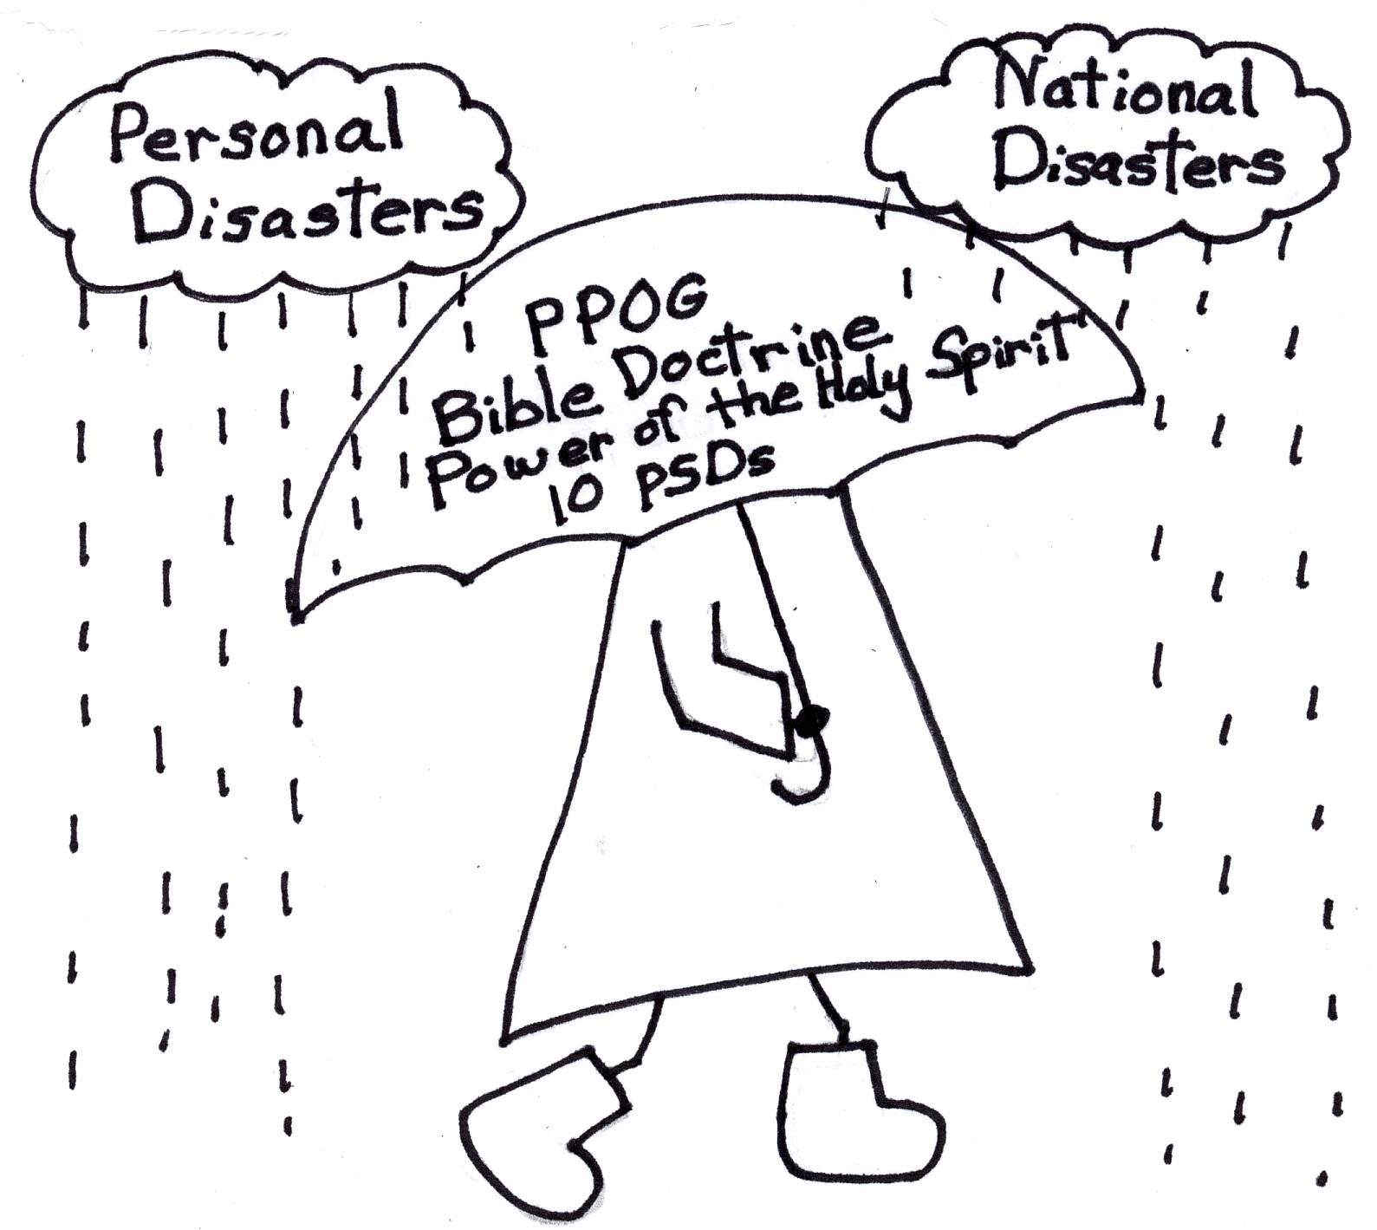

James 1:12 “Blessed (happy) is the man who perseveres under trial, because when he has stood his test, he will receive the crown of life that God has promised to those that love Him.”

Momentum Testing - People Testing
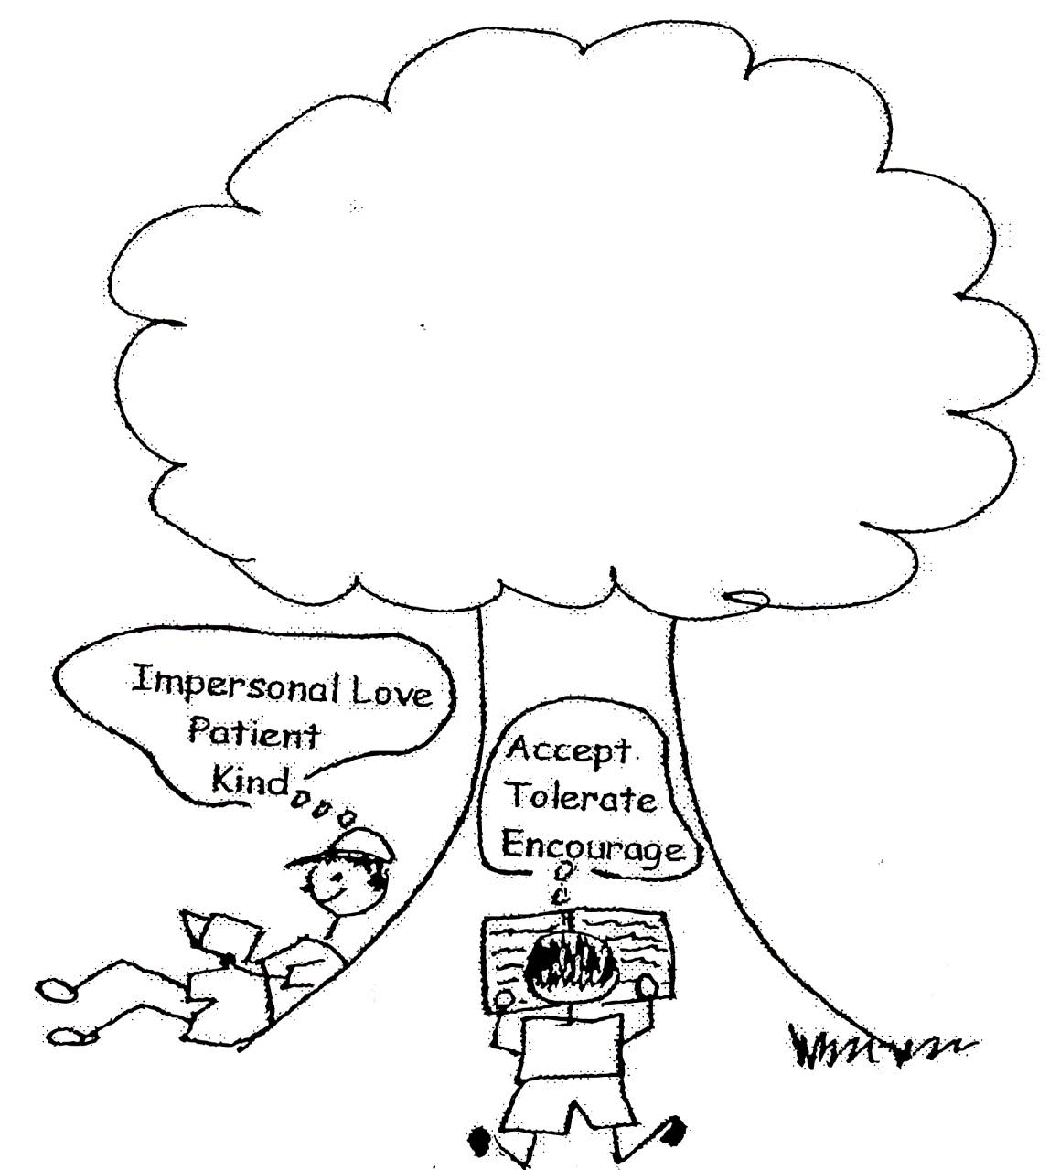
God has designed His plan so that our happiness will always be inside of us no matter how much testing we have. He wants us to have His happiness (+H). We are not to depend on people or things for our happiness. People can be pains in the neck! That includes people we love and people we can’t stand. It also includes you and me! It includes all kinds of people. We will be put in situations where we have people testing. We can let them make us angry and hurt our feelings and we can also try too hard to please them when it is God Whom we need to please. We can let them take away our happiness. The solution for this testing is found in having personal love for God and impersonal love for all mankind, which is virtue love from the Word in our souls. Then, through the thinking of Jesus Christ and the power of the Holy Spirit, we will have control of our own lives and control of our own happiness. Our happiness must come from God and His predesigned plan for our lives.
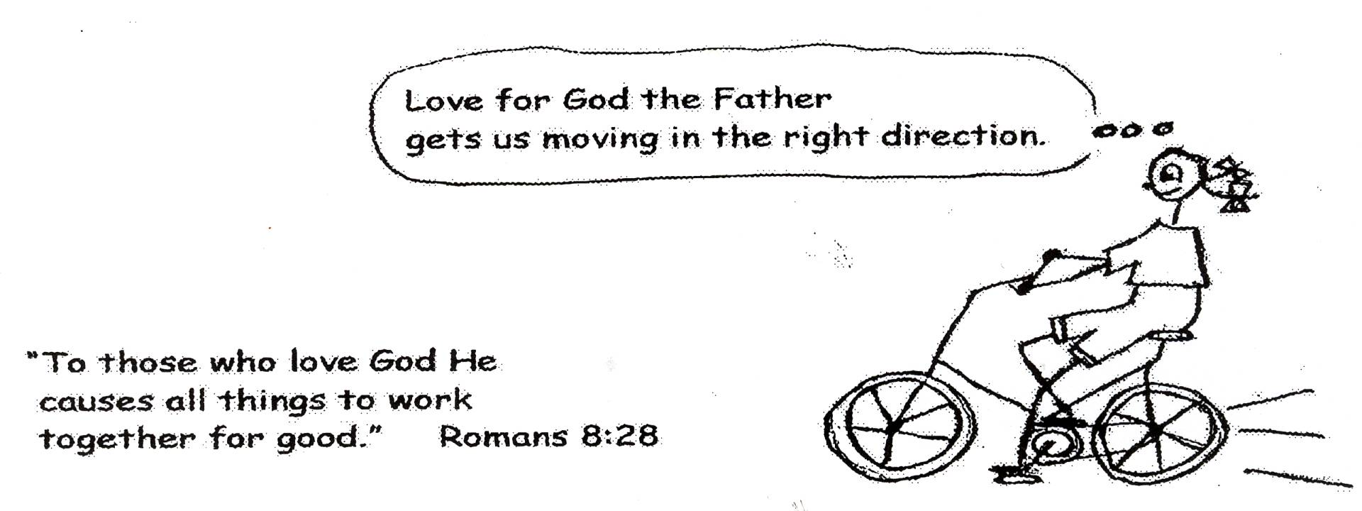
1 Corinthians 13:4-7 “Love is patient, love is kind. It does not envy [not jealous], it does not boast, it is not proud [arrogant]. It is not rude, it is not self-seeking, it is not easily angered, and it keeps no record of wrongs. Love does not delight in evil but rejoices with the truth. It always protects, always trusts, always hopes, always perseveres [endures].”

Momentum Testing – System Testing
A “system” can be defined as people under the authority of other people. They work together using a plan or policy of action to reach a goal. An example of this would be a company where employees would be under the authority of a boss and a board of directors. It could also be one person under the authority of another person, like a wife under the authority of her husband or it could be a group of people under the authority of one person, like students under the authority of a teacher. Someone is always in charge! All authority is from God. He made it and expects us to obey it. Since people are not perfect, and we all have old sin natures, we will not always obey it and there will be personality conflicts. There will also be disagreements concerning the course of action to be taken and the goals which are to be reached. There will be unfair treatment. However, when we are in spiritual autonomy our motivation in life is personal love for God and occupation with Christ. When we use these to solve our problems, we will have the attitude of doing our job as to the Lord. We’ll do a good job regardless of any unfair treatment, unjust system, or silly rules. Remember, Jesus had lots of unfair treatment! God gave Him the tools to handle it, just like God gives us the tools to handle it. God is always the One Who has the top authority and is in charge of everything!

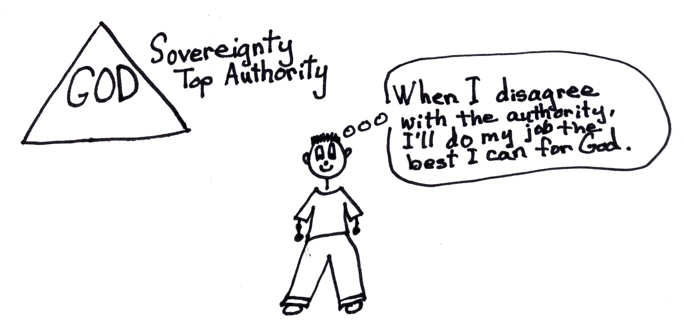
Colossians 3:23 “Whatever you do, work at it with all your heart [mind], as working for the Lord, not for men, since you know that you will receive an inheritance from the Lord as a reward. It is the Lord Christ you are serving.”

Momentum Testing - Thought Testing
Thought has a powerful effect on our success or failure in the Christian life. The Christian way of life is more what we think than what we do. What we think is what we are, and our thinking will constantly be tested. Human viewpoint will conflict with divine viewpoint. False ideas will challenge Bible doctrine. Arrogance will try to push out humility. Self benefits of all kinds will compete with the predesigned plan of God. We can see that there is a real mental battle of the soul going on here. The good thing is that if we keep learning, believing, and using Bible doctrine, the thinking of the Lord Jesus Christ, we will go forward in the predesigned plan of God. We will reach spiritual maturity!
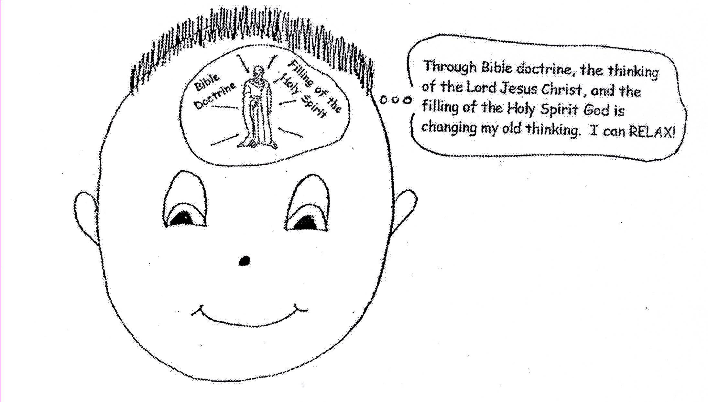

Romans 12:2 “Do not conform any longer to the pattern of this world, (Satan’s cosmic system) but be transformed by the renewing of your mind (with Bible doctrine). Then you will be able to test and approve what God’s will is…His good, pleasing and perfect will.”

All of this momentum testing will be putting the spotlight on God’s power and our weaknesses. We will be examples of God’s power. Suffering for blessing turns boasting away from self and focuses on the glorification, worship, love, and appreciation for God. Satan hates this. He wants us to rely on human solutions instead of divine solutions. Suffering takes away our human ways of solving problems and makes us face our total dependence upon the grace of God. The removal of suffering might deny us a special blessing only available to us through the suffering. God will not send suffering for blessing until we are confident in our relationship with Him and in our own ability to use the assets that He has given us! God is gentle and patient with us. He wants us to succeed in His plan for our lives. He wants us to reach spiritual maturity.

Spiritual Self Esteem + Providential Preventative (Underserved) Suffering = Spiritual Autonomy and Spiritual Autonomy + Momentum Testing = Spiritual Maturity

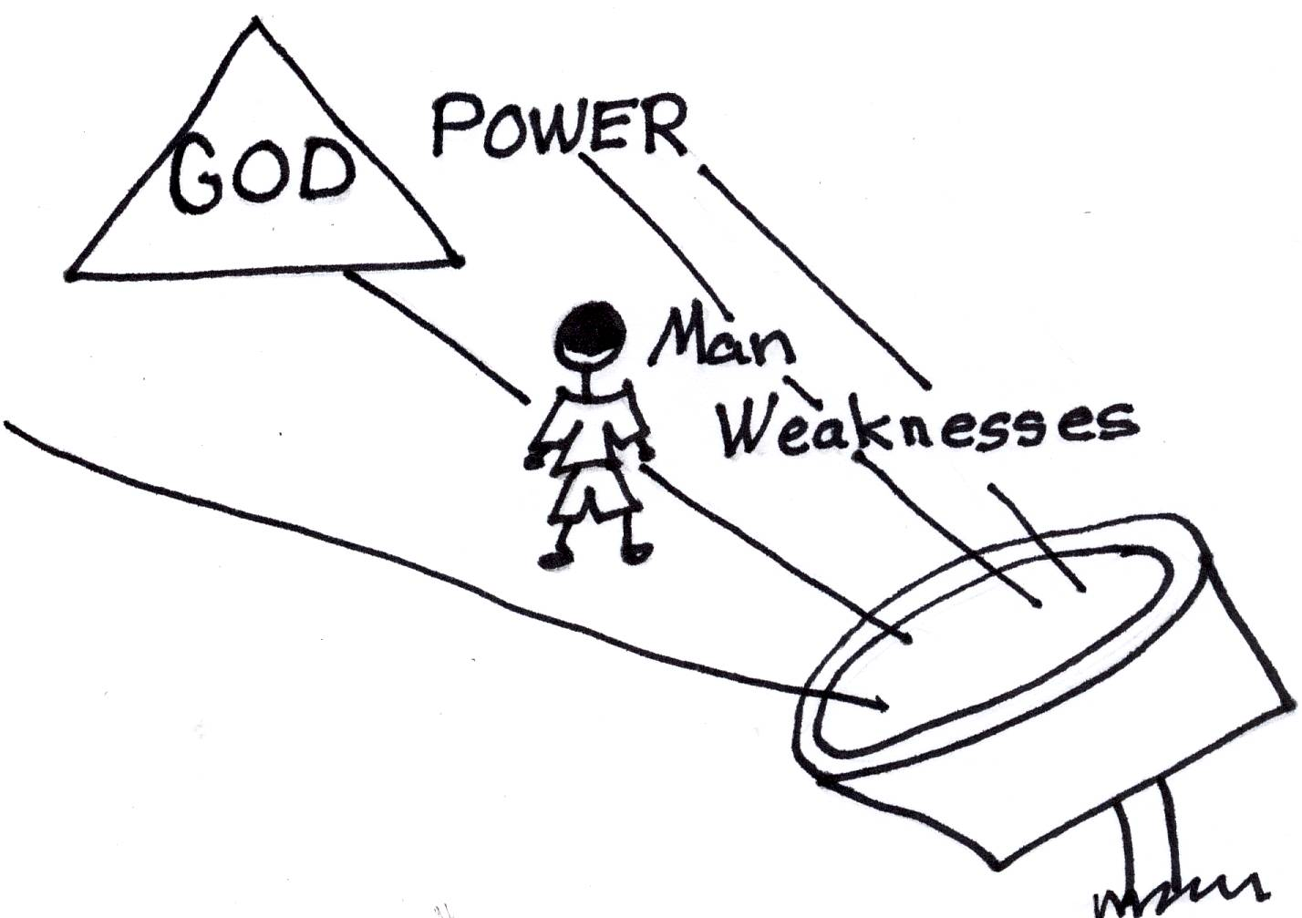
Corinthians 12:9-10 “My grace is sufficient for you, for my power is made perfect in weakness. Therefore I will boast all the more gladly about my weaknesses, so that Christ’s power may rest on me. That is why, for Christ’s sake, I delight in weaknesses, in insults, in hardships, in persecutions, in difficulties [people, thought, disaster, and system testing]. For when I am weak, then I am strong.”

God loves us sooooo much! It’s even hard to imagine how much He loves us because His love is infinite. He doesn’t want to see us mentally squirm and struggle here on earth. God gives us the privilege and opportunity to grow in His grace and wisdom. He wants us to be mentally strong through Bible doctrine in our souls. His will is for us to go from spiritual babies to spiritual adults and have perfect inner peace and happiness. If we don’t allow God to make this happen in our lives, it is our own fault because we choose not to grow spiritually in His plan. God gives us all of the tools we need to reach spiritual maturity: Bible doctrine, His predesigned plan for our lives, the power of the Holy Spirit, and the ten problem-solving devices. What are we waiting for? Let’s use them and grow up!!
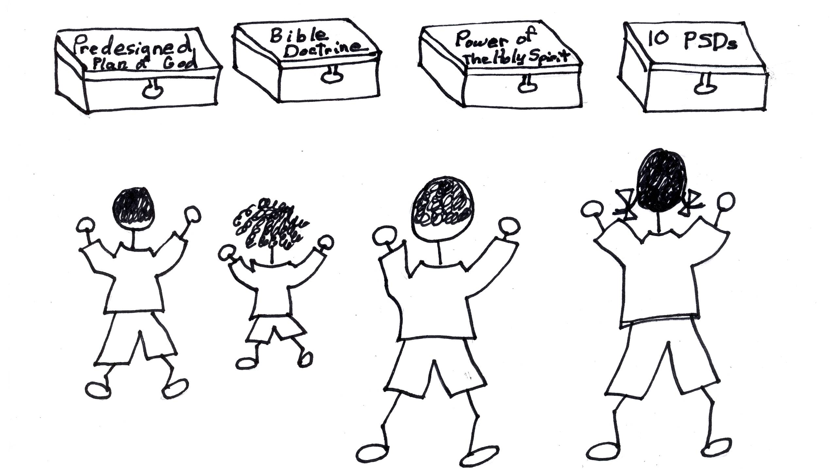

References:
Updated by Lighthouse Christian Youth Ministry, Inc.
www.lighthousechristianyouth.org

Robert McLaughlin Bible Ministries
www.gbible.org
Lessons: 10-20-06, 11-15-06, 11-16-06, 11-17-06

Christian Integrity, by R.B. Thieme, Jr.

If you would like to see more Bible study booklets for children, go to:
www.allaboardgodstrain.org

