Lighthouse Christian Youth Ministry
Lesson 63

The Best Assets (Treasures)
We Will Always Have Our Invisible Assets from God

June 22, 2008

Mat 6:20 "But store up for yourselves treasures in heaven, where neither moth nor rust destroys, and where thieves do not break in or steal…”

Our lesson is about the assets or treasures that God is just waiting to give us. An asset is something a person owns that is valuable…a treasure! God had all the BEST spiritual assets or treasures that we could ever have stored up for us billions of years ago before we were even created! He did all this for us from His perfect character or nature…actually from His sovereignty, love, and omniscience! These treasures are INVISIBLE because we live in the Church Age and this is the great age of mystery doctrine. Our assets or treasures are part of the mystery doctrine of the church age. We just have to know what they are and how to use them. The Bible gives us all of the necessary information to know our spiritual invisible assets or treasures. Picture them in your very own suitcase or portfolio just waiting to be used. They are no good just sitting in our invisible portfolio, or suitcase! God gave them to us to use on our trip to heaven! They’re to make our journey easier and worthwhile! They’re part of our equal privilege and equal opportunity we have as children of Jesus’ royal family. Our assets are very valuable! They will make us WINNERS and INVISIBLE HEROES in God’s plan for our lives.

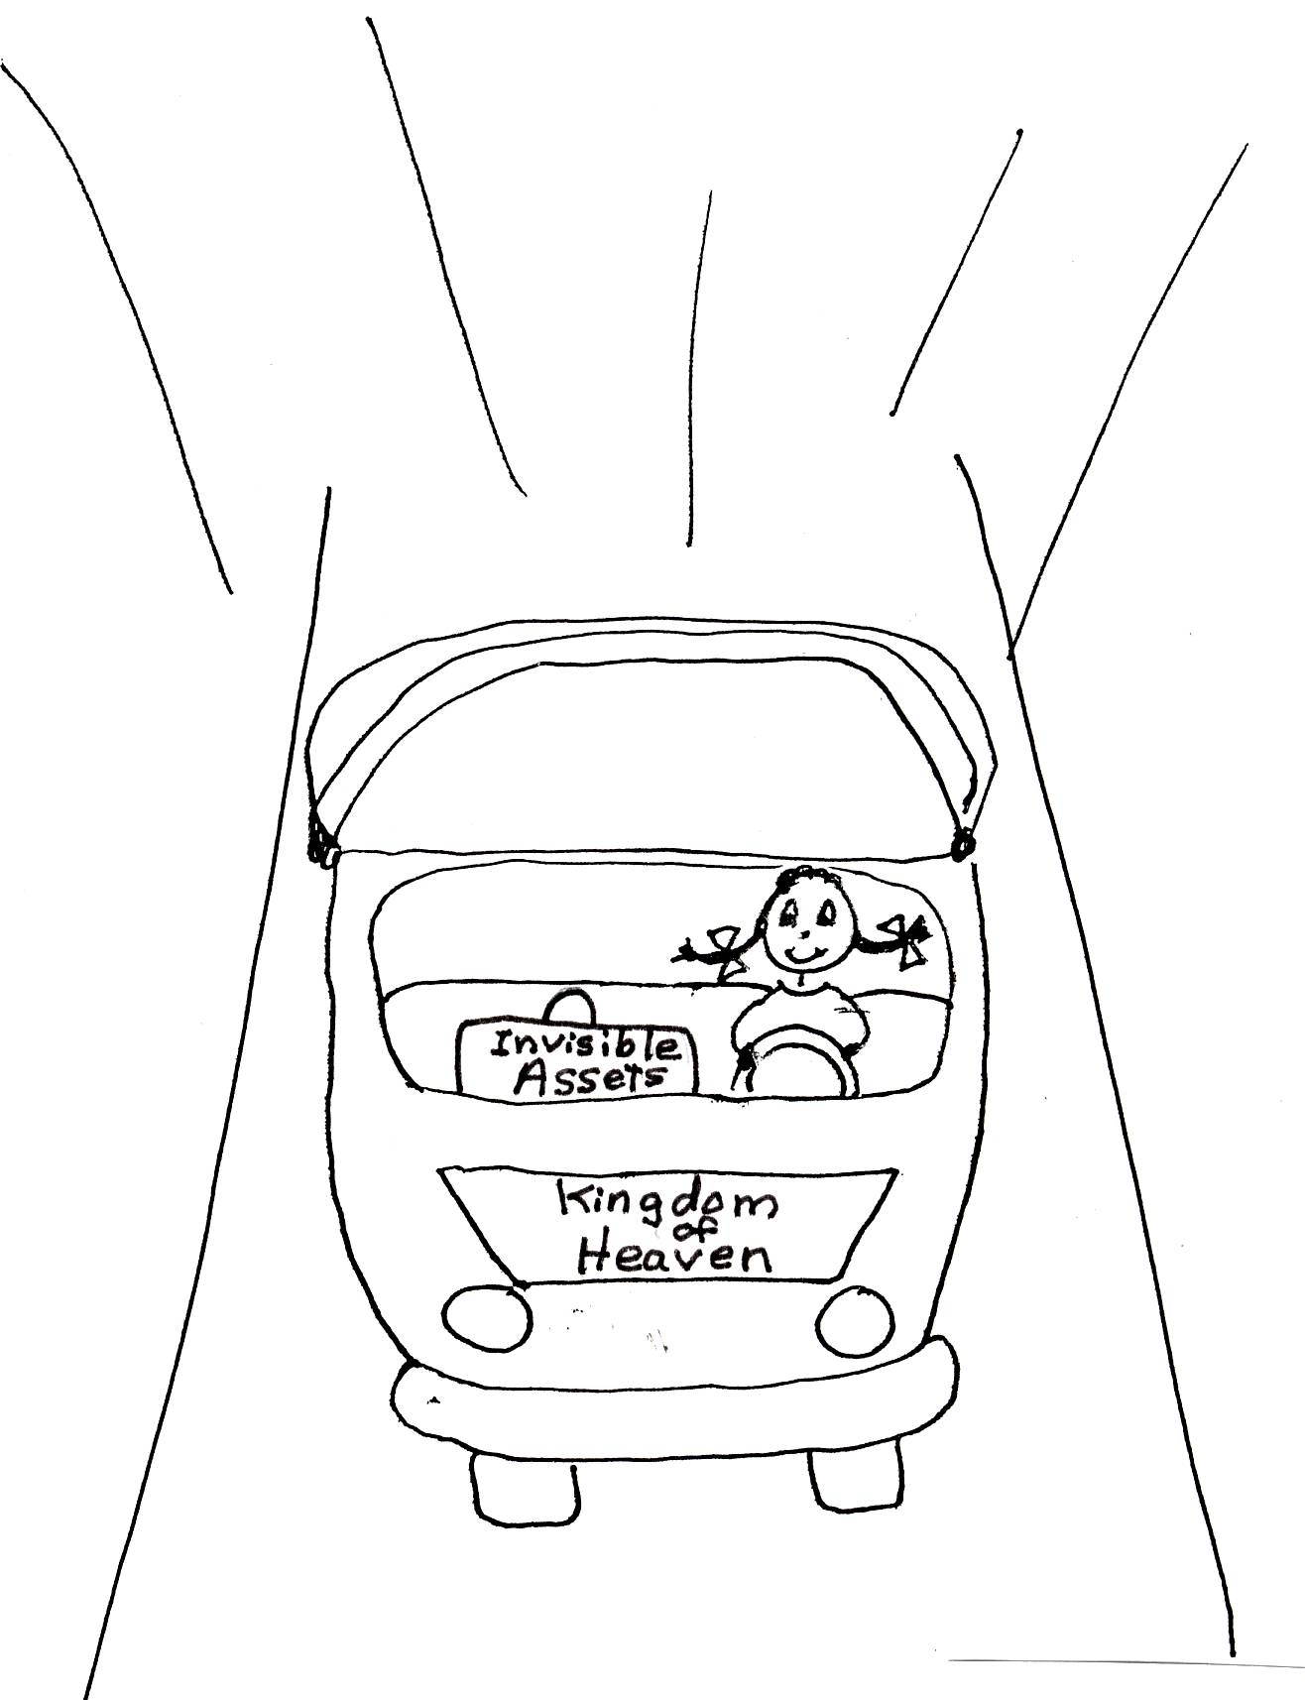

1Ti 6:17-19 “Instruct those who are rich in this present world not to be conceited or to fix their hope on the uncertainty of riches, but on God, who richly supplies us with all things to enjoy. (18) Instruct them to do (divine) good, to be rich in good works, to be generous and ready to share, (19) storing up for themselves the treasure (invisible assets) of a good foundation for the future, so that they may take hold of that which is abundant life.”
Before we talk more about our spiritual assets, let’s talk about the Source of our assets…GOD. First, we’ll talk about God’s SOVEREIGNTY. This means that God is in charge of everything! He is the Top Ruler…the KING! With God being in charge of everything, HE rules with an unlimited (no one can stop Him) and perfect will. He can do all good things, and He can do all good things perfectly! God desires for us, and gives us, the best choices in life IF we want them. Awesome! It’s His will that we live in the plan He has for our lives. However, God gives us free will to choose His plan or to choose our own plan. Since God is absolute best supreme ruler to all creation, His plan is the absolute best supreme plan. Therefore, it would be wise to choose His plan rather than our own. It would be wise to use the invisible assets (treasures) He gives us through His sovereignty, or rulership!

Ephesians 1:11 “In whom (the Lord Jesus Christ) also we have received a share [spiritual invisible assets or treasures], having been predestined for a pre-designed plan (a plan made just for us before we were even born) from Him.”

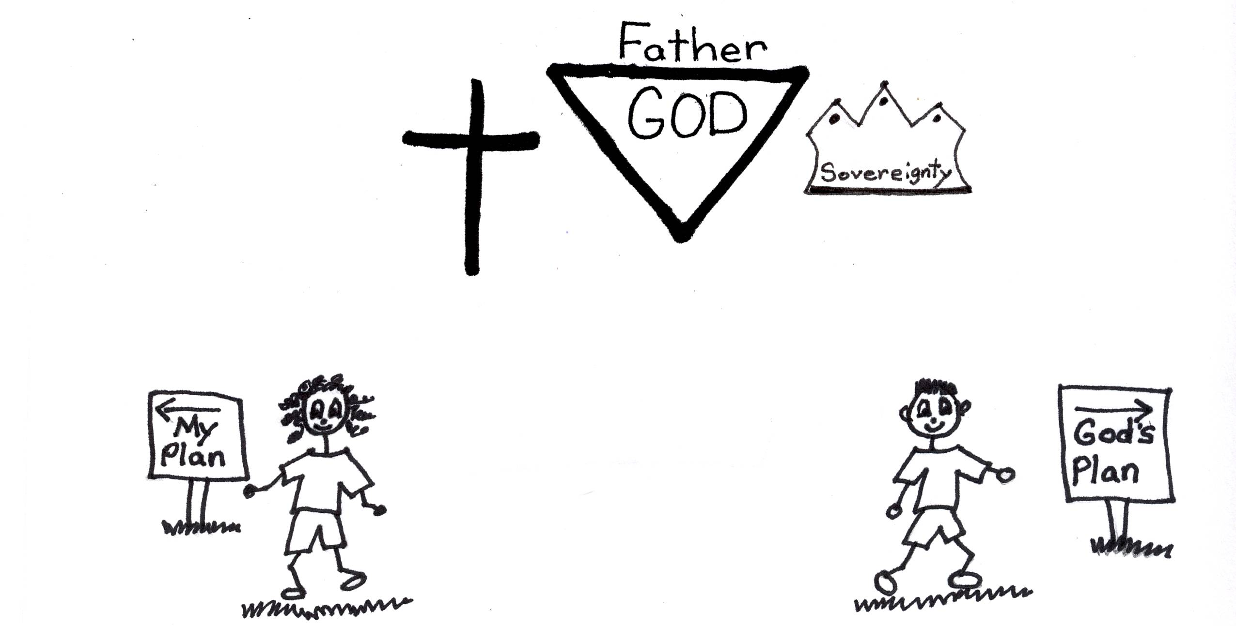

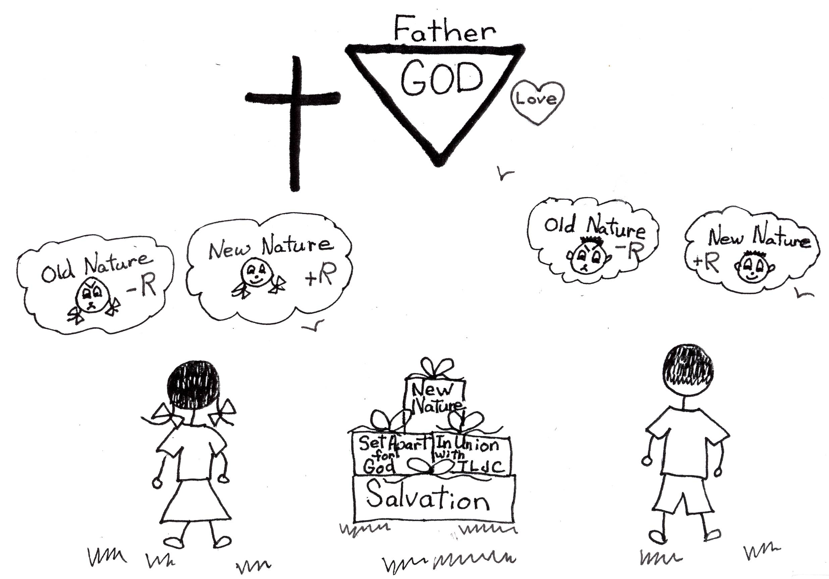
Another way that our invisible assets come to us is through God’s JUSTICE. God’s justice is also perfect. He cannot do anything unfairly or sinful…EVER. God is JUST or RIGHT when He gives us these invisible assets when we live in His plan for our lives. At the time of our salvation, the very moment we believed in His Son, Jesus…He gave us +R or His RIGHTEOUSNESS that is Jesus’ PERFECTION. Since God has perfect justice and righteousness and we do not, He gave us HIS righteousness so we can not only get into heaven with it but also so we can be blessed thought it! THAT’S GREAT! Now, in His eyes, our new nature is perfect because we have His +R! Isn’t that wonderful and encouraging? God loves us the same way He loves His Son, Jesus because His Son’s +R (RIGHTEOUSNESS or PERFECTION) is IN us! It doesn’t matter if we are pretty or ugly, rich or poor, king or slave, girl or boy. What matters is whether or not we accepted Jesus Christ as our Savior! Then because we have +R, God’s righteousness, we have God’s personal love and guarantee of eternal life and invisible assets!

Job 34:19 “God shows no partiality to princes, nor regards the rich above the poor, for they all are the work of His hands.”

God’s invisible assets or treasures also come to us through His OMNISCIENCE. Omniscience means that God knows perfectly all that there is possible to know whether it is real or possible and He’s known it forever even before man was created! That’s hard to understand, isn’t it? God the Holy Spirit will make it real to you. Just keep believing and you’ll see. That’s how awesome God is! God is in control at all times. Not only that, He knows everything there is to know, all the good and all the evil, all the true things and all the lies. He doesn’t have any wrong information! He knows all about each one of us. Therefore, God knows exactly what is best for each one of us. In His omniscience, He provided all of our invisible spiritual assets specially designed for every believer! That takes a lot of knowledge, a lot of omniscience! God has ALL knowledge.

Job 21:22 “Can anyone teach knowledge to God, since He judges even the highest?”

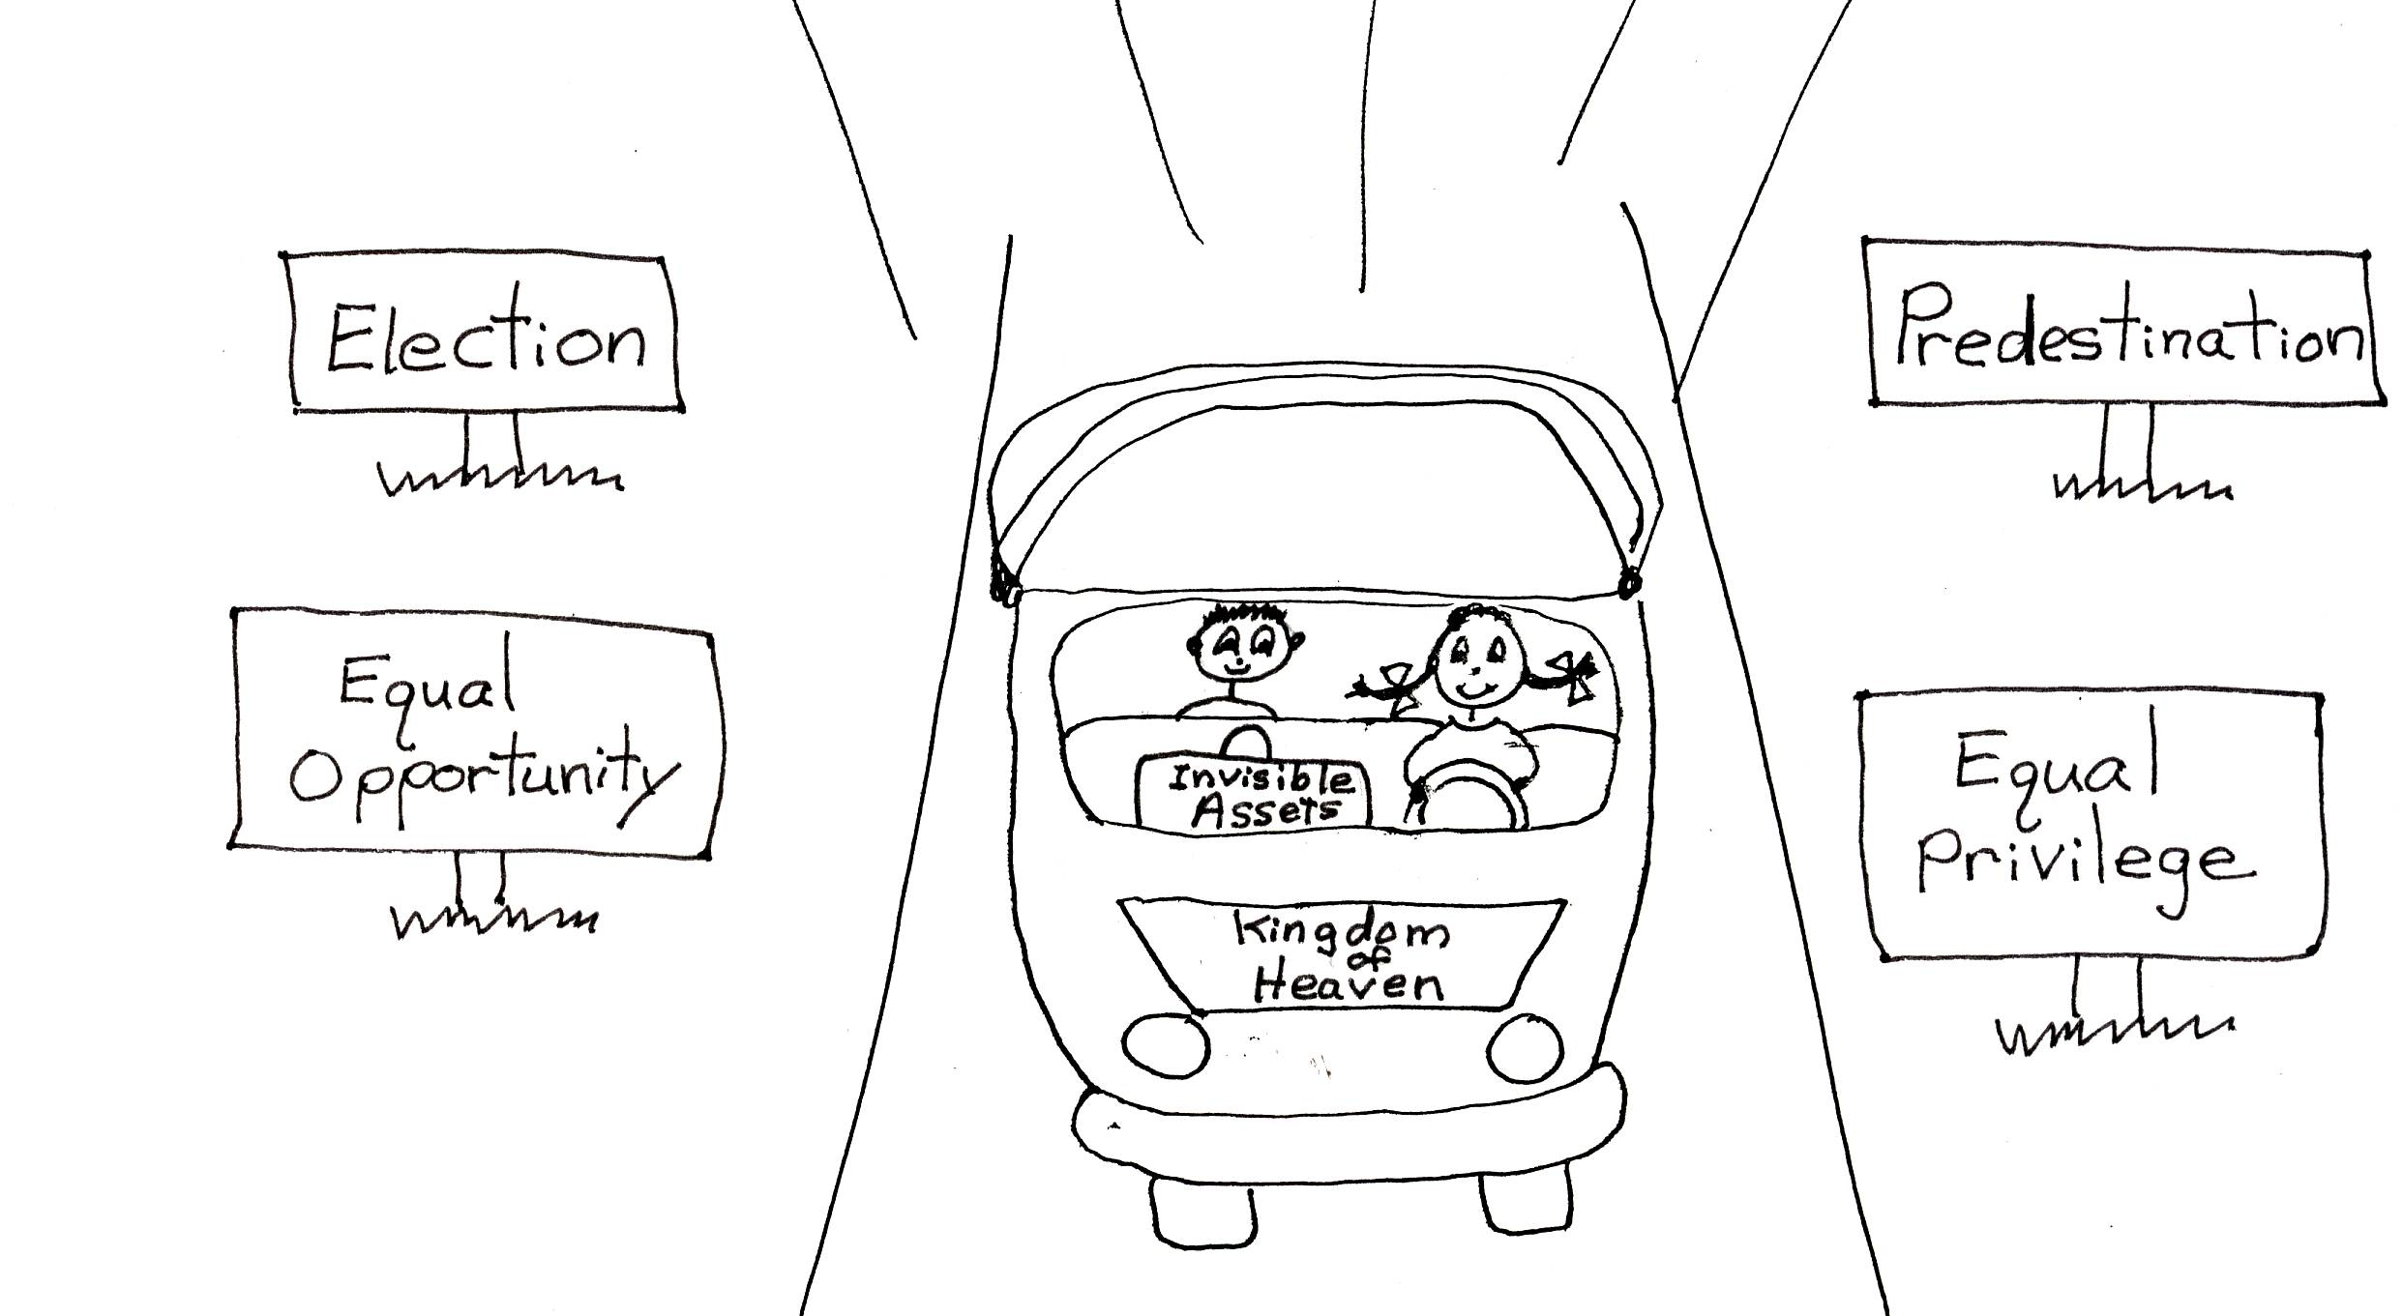
Our suitcase or portfolio holds four kinds of assets…PRIMARY and SECONDARY, and PERSONAL and UNIQUE assets. We’ll learn about our primary assets in this lesson. The “primary” assets are the “first” assets we receive. The primary invisible assets are election (He knew you would believe in Jesus and elected you to privilege) and predestination (He has a special pre-designed plan just for you). This means that before anything was created by God He planned all your (believers) privileges and opportunities and made plans for your lives. He created the invisible assets or blessings for you and me way before mankind was created. Before we can receive these primary assets, we have to use our volition or free will to become believers…that is to believe in the Lord Jesus Christ as our very own Savior. Then we will be baptized by the Holy Spirit. This is invisible, too!! This means that we will be put in union with Jesus Christ. We are identified with Him. We are in the same place and position as Jesus seated right next to God the Father in heaven. Then we can answer God’s calling to these equal privileges and equal opportunities as His children. This means that all believers have the same opportunity and the same privileges to grow up and reach spiritual maturity! We are all given the exact same way to do it. Then we can use God’s predesigned unique plan for our lives. You do it by learning Bible doctrine first and then eventually we can know what God’s personal plan is for each of our lives. We can learn more about who God is, too. We can learn what our invisible assets are. The assets are already in our spiritual suitcases, but we have to know about them before we can use them. We all have the same privileges and opportunities to know and use our invisible spiritual assets, our valuable grace gifts from God.

Galatians 3:26-28 “You are all sons of God through faith in Christ Jesus, for all of you who were baptized [baptism of the Holy Spirit] into Christ have clothed yourselves with Christ. There is neither Jew nor Greek, slave nor free, male nor female, for you are all one in Christ Jesus.”

After Adam and Eve sinned in the Garden of Eden, mankind needed a Savior. God prophesied (told us long ago through His prophets) and promised that He would send His Son, the Lord Jesus Christ, to be our Savior. He will take the penalty for all of our sins. God gave us a magnificent asset right there in Jesus! We were never judged for our sins. Jesus was judged for everyone’s sins, believers AND unbelievers. Since He is 100% God and 100%man, He could pay the price to God the Father for everyone’s sins. God the Father accepted the perfect work of Jesus Christ on the cross as payment for everyone’s sins. We have a Redeemer! He paid for us. Once we believe in Jesus as our Savior, we are redeemed, saved, and we will never loose our salvation! Remember we have eternal security. God never let’s go of us! What an awesome God we have!

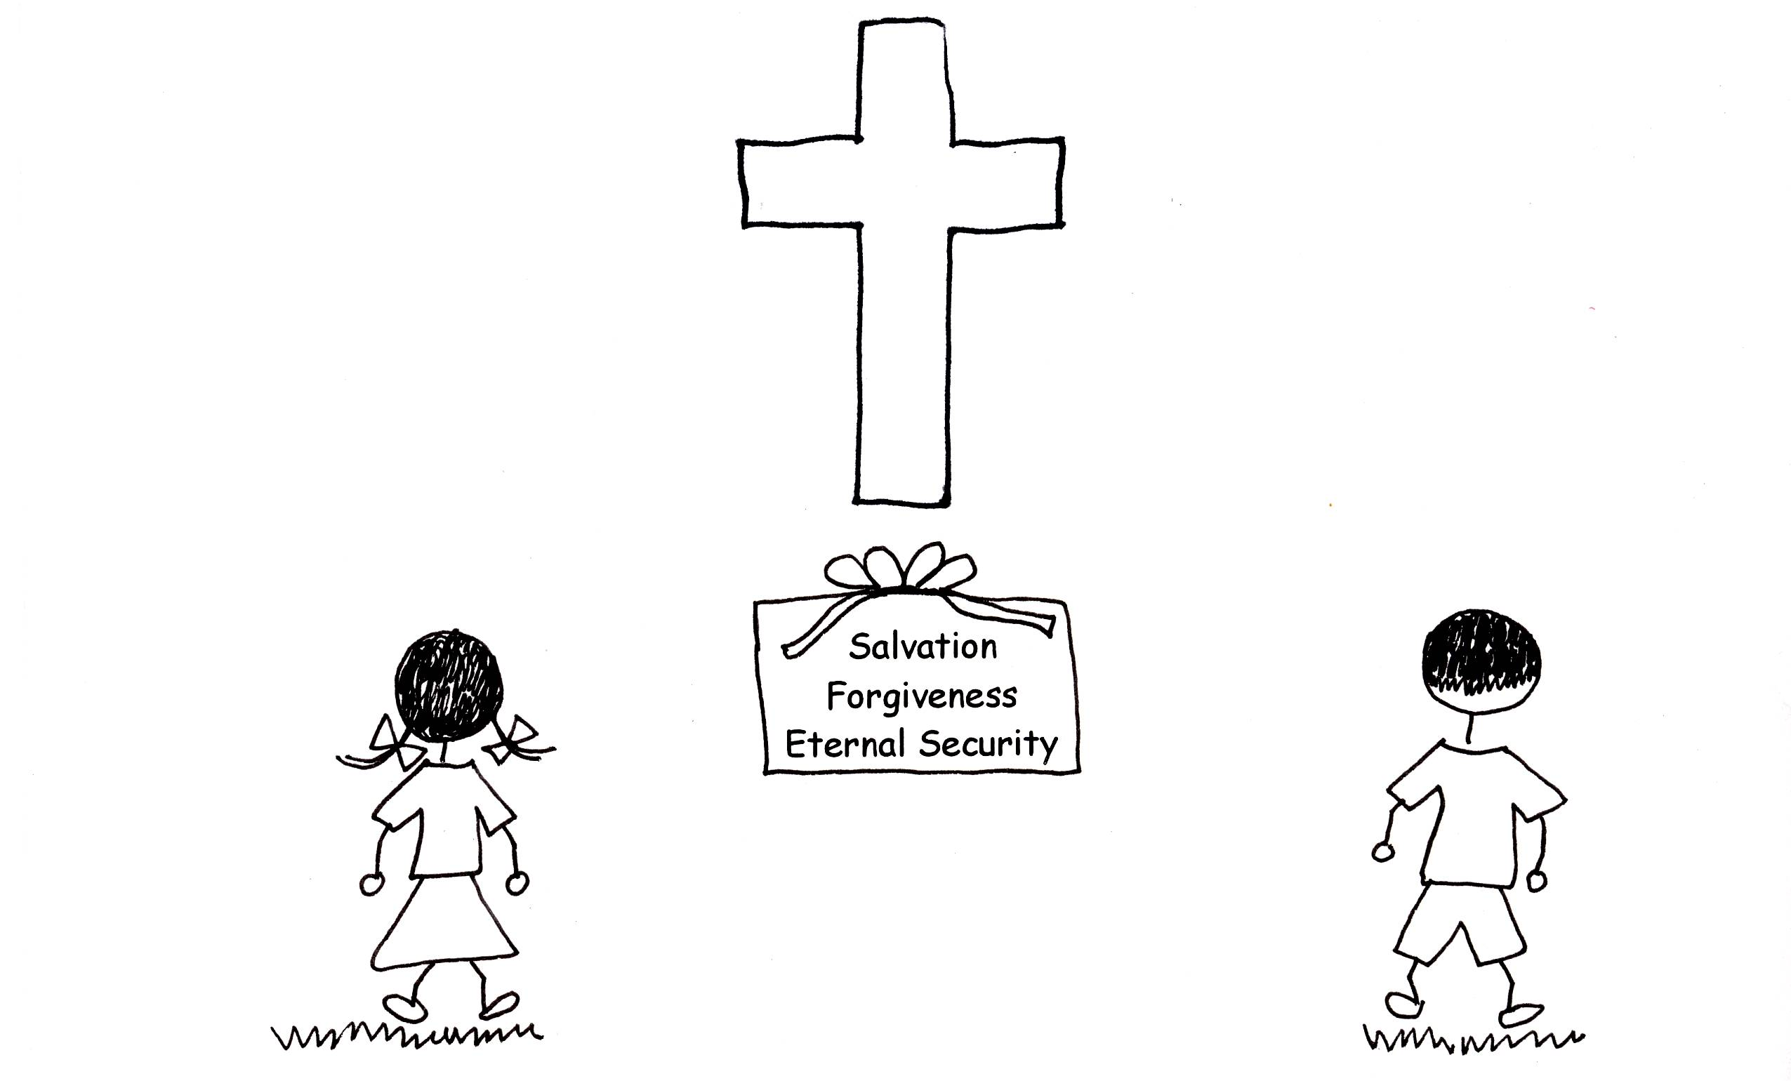

Colossians 1:13-14 “For He has rescued us from the power of darkness and brought us into the kingdom of the Son that He loves, in Whom we have redemption, the forgiveness of sins."

Jesus Christ not only saved us, but He stays in our bodies! He helps us to want to keep going on in God’s plan. He paid such a big price for us, and He wants us to feel safe and to learn about the Father’s plan for us. He is our security and He will keep us forever. He even prays for us! When we want to give up, we can think of Him and that we are on a journey to heaven to be with Him and God the Father forever. Jesus is going on that journey with us! He never condemns us, but He encourages us! He wants us to grow in knowledge and grace. God promises that we will be with Him in heaven. At that time, we will see the Lord Jesus Christ face to face. What valuable invisible assets we have!

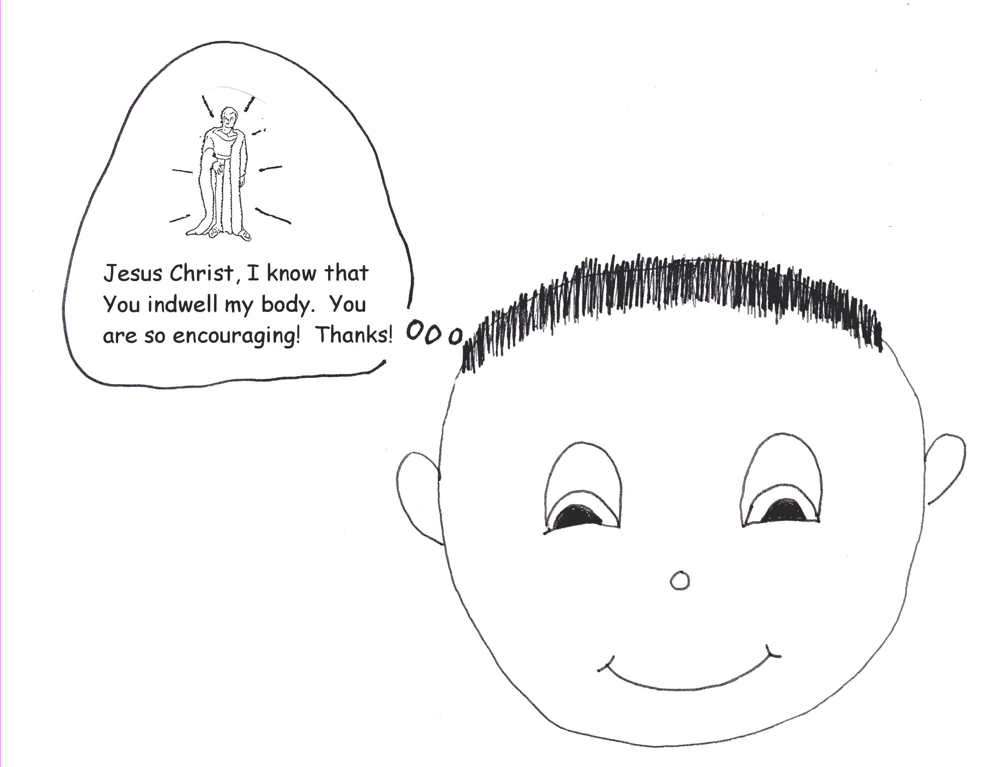

John 5:24 “Truly, truly, I say to you, whoever hears My word and believes Him Who sent Me, has eternal life and will not be condemned; he has passed out of death [spiritual death] to [eternal] life.”
Another asset that God has given us is the Bible, the thinking of Jesus Christ. 1 Cor 2:16 “For who has known the MIND of the LORD, that he will instruct HIM? But we have the MIND of CHRIST.” The Bible IS the mind of Christ! It is HIS THINKING. The Bible has an answer for every problem we will ever face in life. God supplies each one of us with a pastor-teacher to teach us the Bible. Our pastor-teacher spends many hours studying the Word of God in the original languages used to write the Bible…that is the Hebrew (Old Testament) and the Greek (New Testament). He has the gift of pastor-teacher, and therefore, the authority from God to teach us. He has a supernatural gift. The Holy Spirit guides him as he studies and teaches. We are to respect his authority and support him by coming to class. This might be by learning from a Bible teacher in someone’s home or by a Bible teacher in Sunday school in your church or listening to the teaching of our pastor-teacher in church. The Bible, the thinking of Jesus Christ, and the teaching of our pastor-teacher are two very special assets from God. We must not let them sit in our spiritual suitcase. We must let them help us on our journey to heaven!

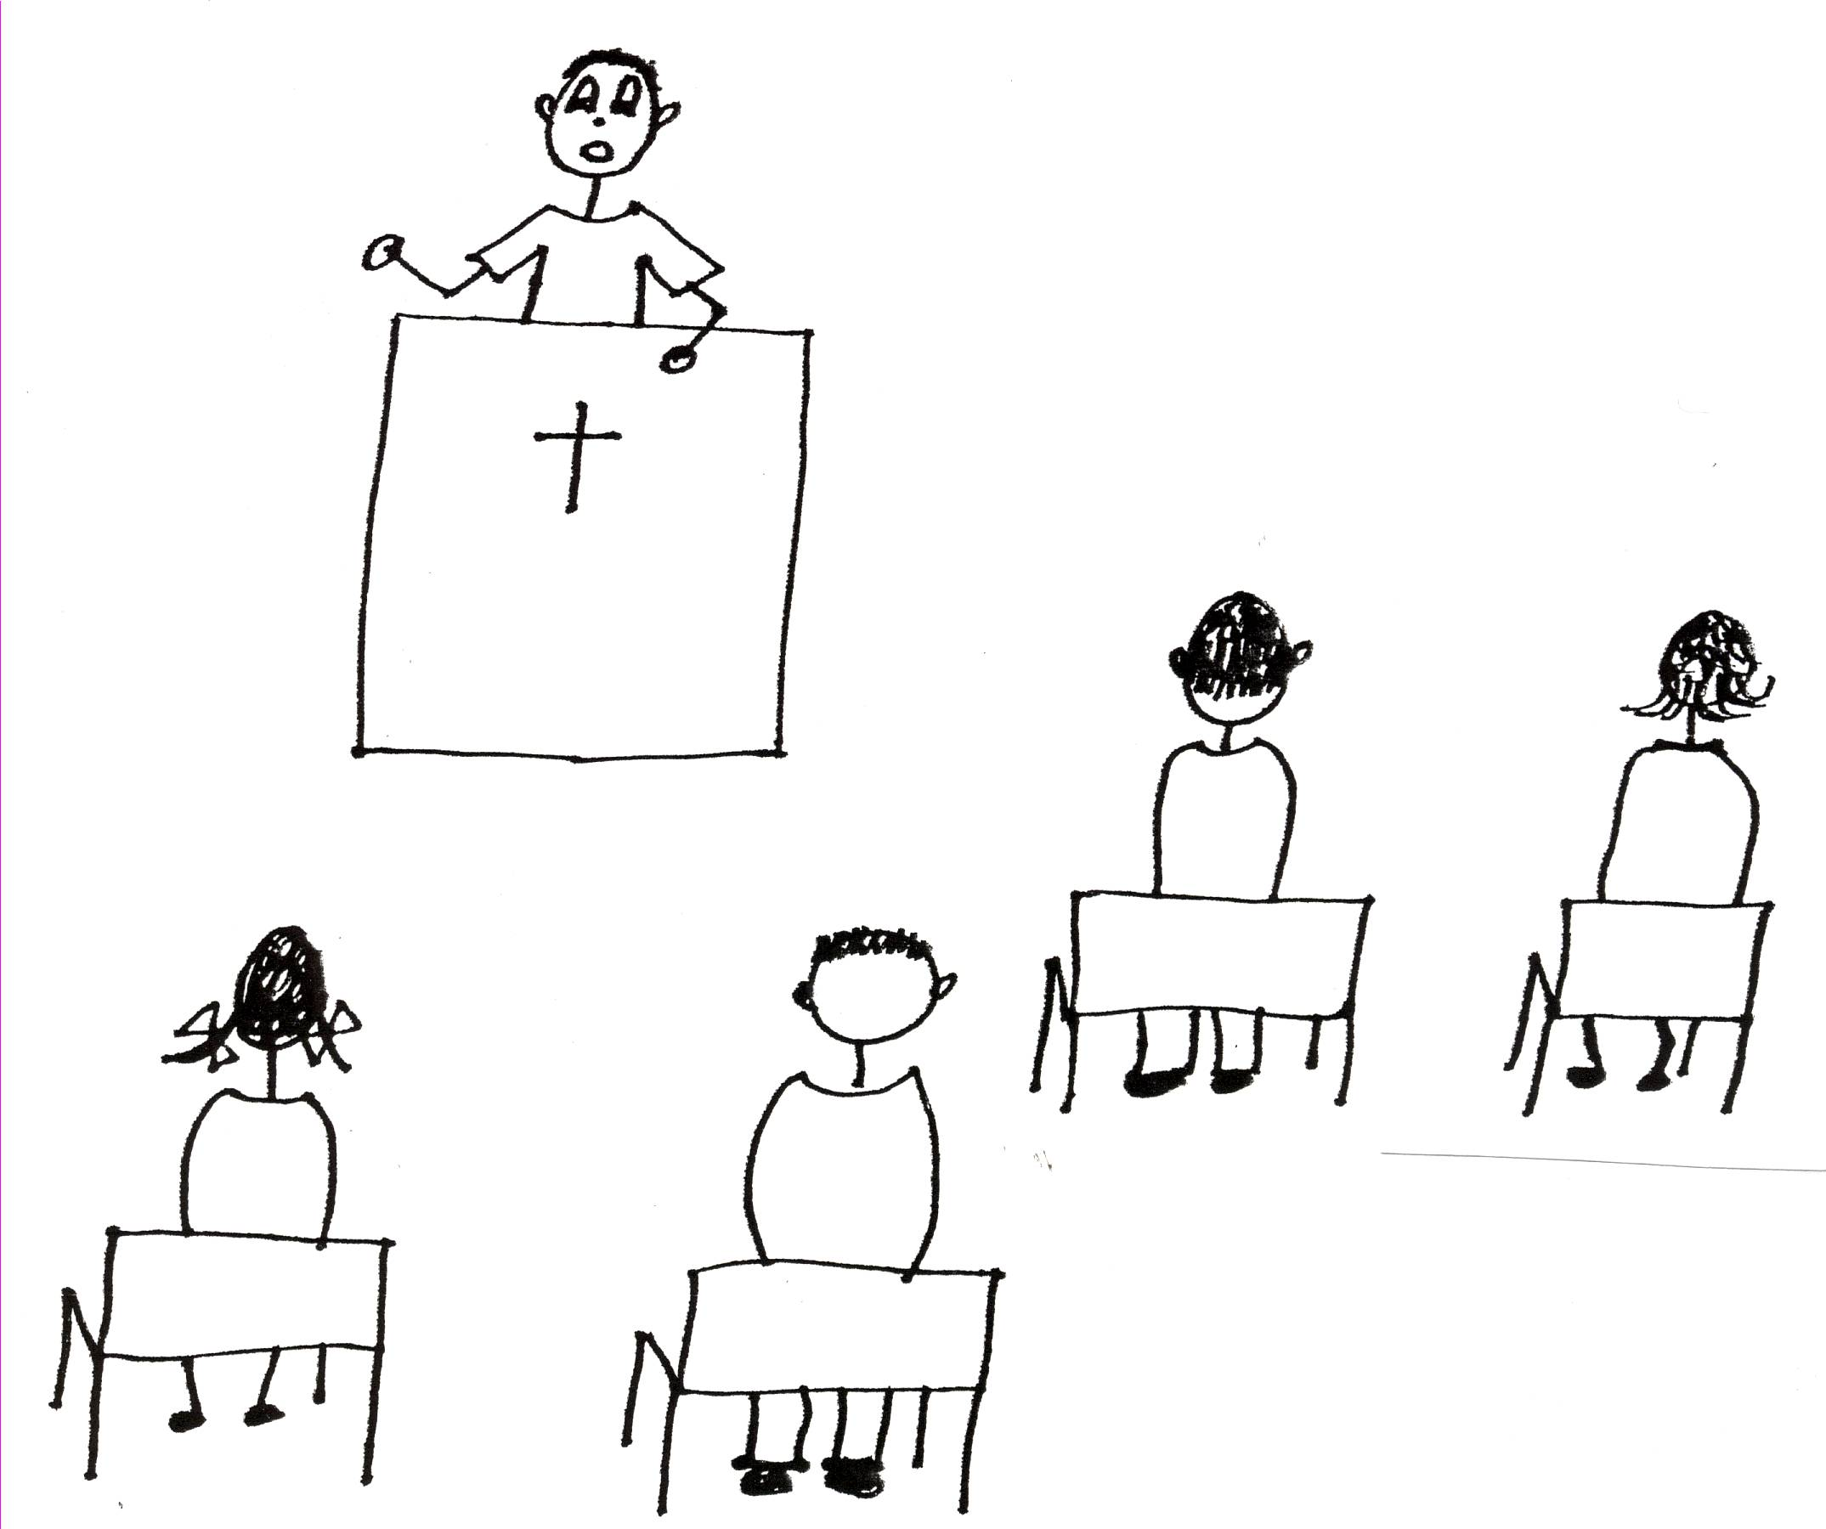

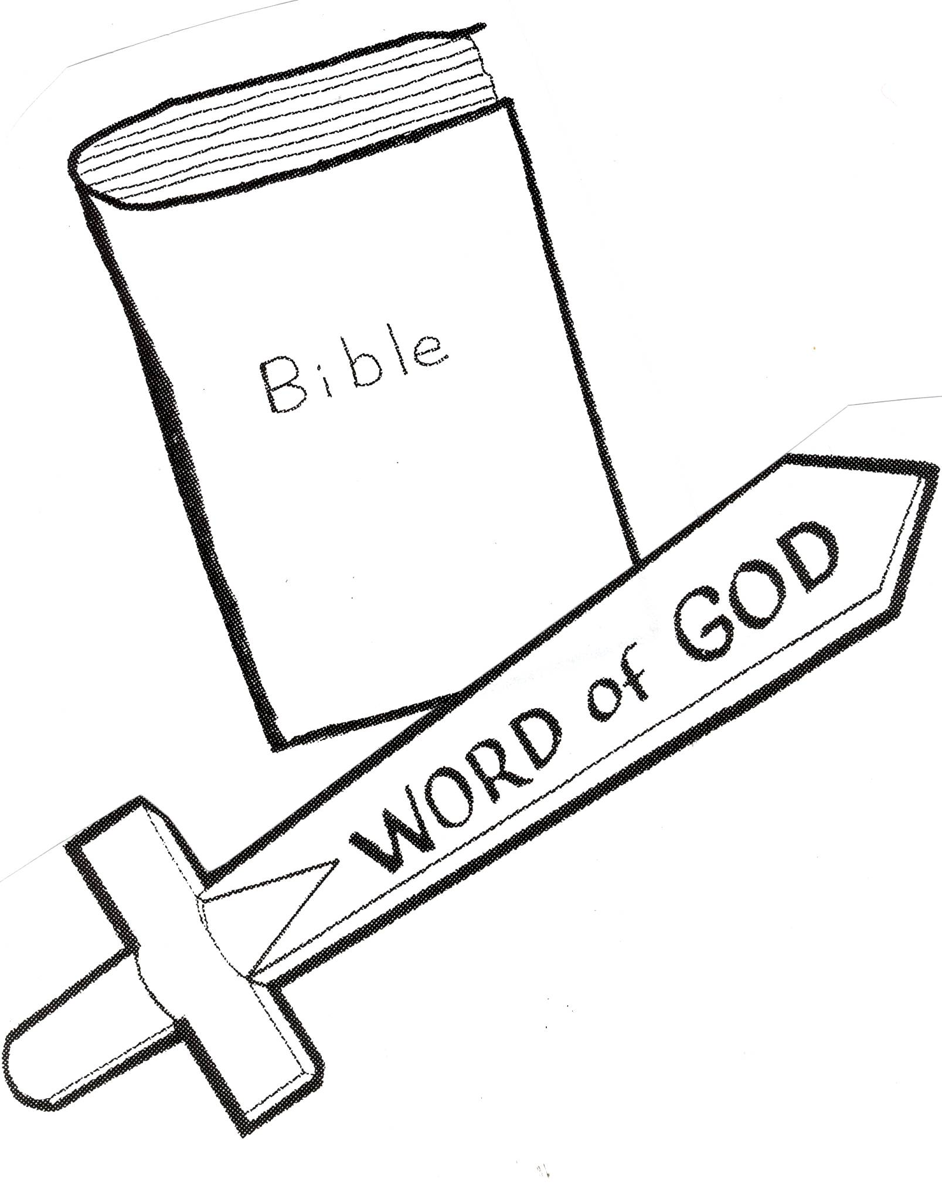

2 Timothy 3:16 “All Scripture is God-breathed and is profitable for teaching, for reproof, for correction, for training in righteousness.”

In the Church Age (that is God’s time period we live in today), God gave us the invisible asset of being our own priests and Jesus is our High Priest. Remember we are in union with Him. Remember all believers have this equal privilege! We have been elected (one of our primary assets) to be priests and to pray for ourselves and others. What a great asset or value (treasure) that is to us! We can pray directly to God the Father! The more we know about God, the more we will know what to ask of Him. We’ll get to the point where we don’t ask for ridiculous things. God won’t give us ridiculous things anyway. God the Father knew billions of years ago what we would ask in prayers. He already has answered the prayers sitting in our invisible suitcases. All we need to do is to pray to God the Father to get our prayers answered. We need to go into our suitcase of invisible assets. It is amazing what God our Father has done for us!
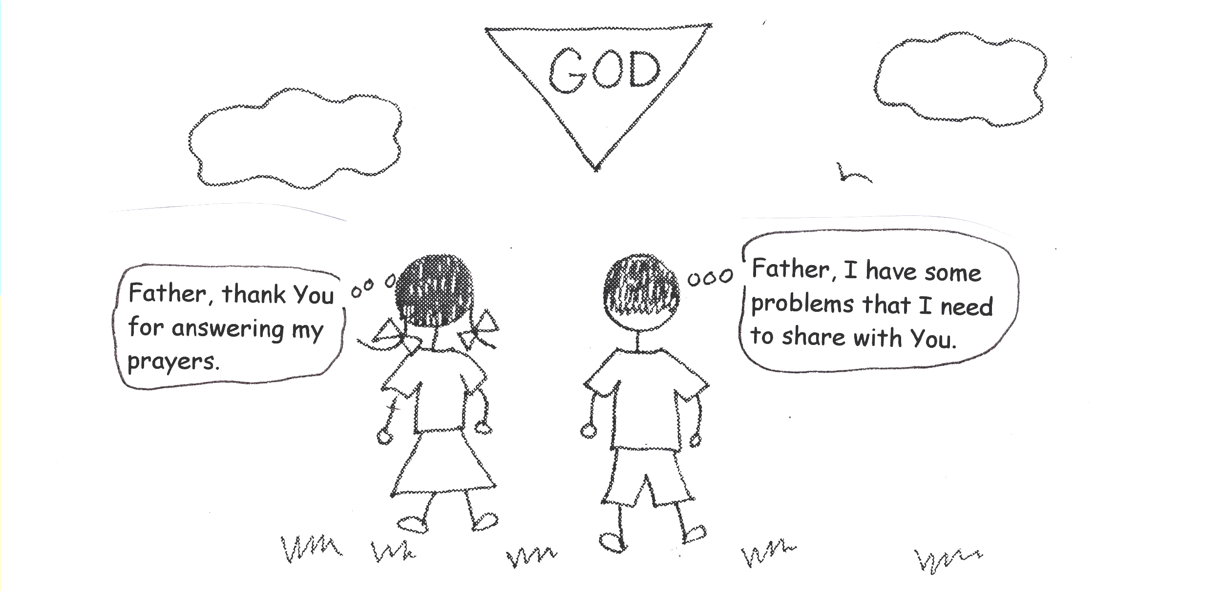

1 Peter 2:9 “But you are a chosen people, a royal priesthood, a holy nation, a people belonging to God, that you may declare the virtues of Him Who called you out of darkness into His wonderful light.”

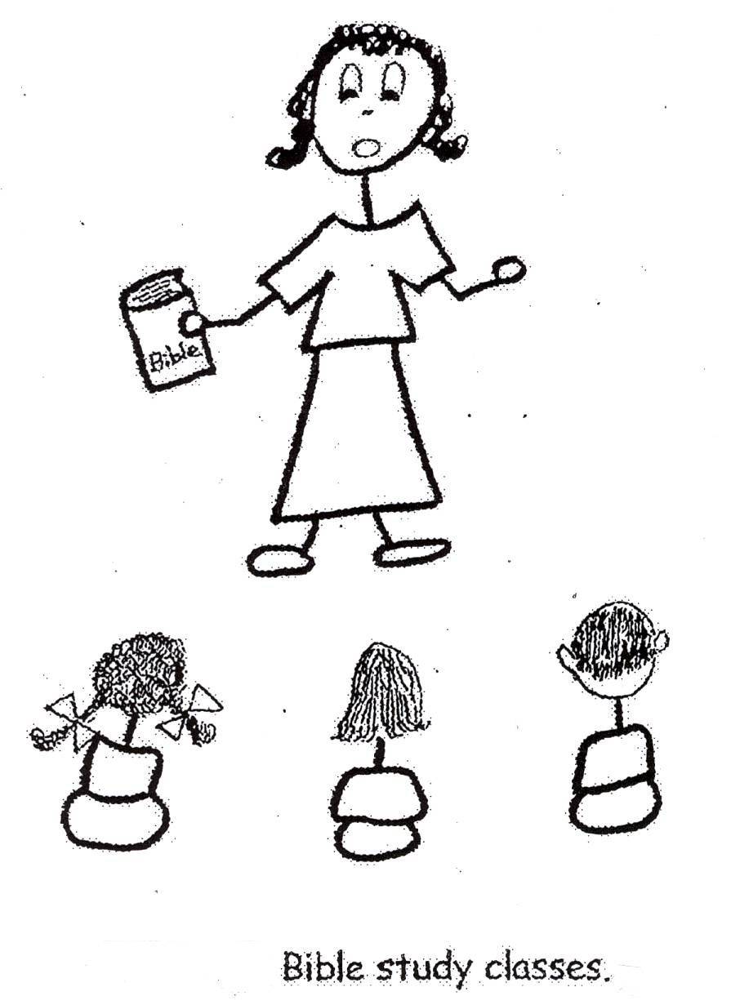
Another part of our PRIMARY assets is that believers in the Church Age have equal opportunity also. This means that God gives us all the grace support we need to remain in God’s plan for our lives and to live in the plan until we die and go to heaven. This is grace and it is particularly called logistical grace support and blessings…the basics...everything we need each day to live in His plan. The more we hear, learn, believe, and use Bible doctrine, the more we will learn about logistical grace support and blessings…our assets. We will see the love God has for us and we will learn to know and love God personally. God is so loveable! But to love someone you must know them and the only way to know God is to learn about Him in the Bible. Also, we will discover and use more assets. The more assets we use the more blessings God will give us. When we are faithful to His Word, He rewards us here on earth and when we get to heaven! He just keeps giving to those who love Him! All the glory to God!!
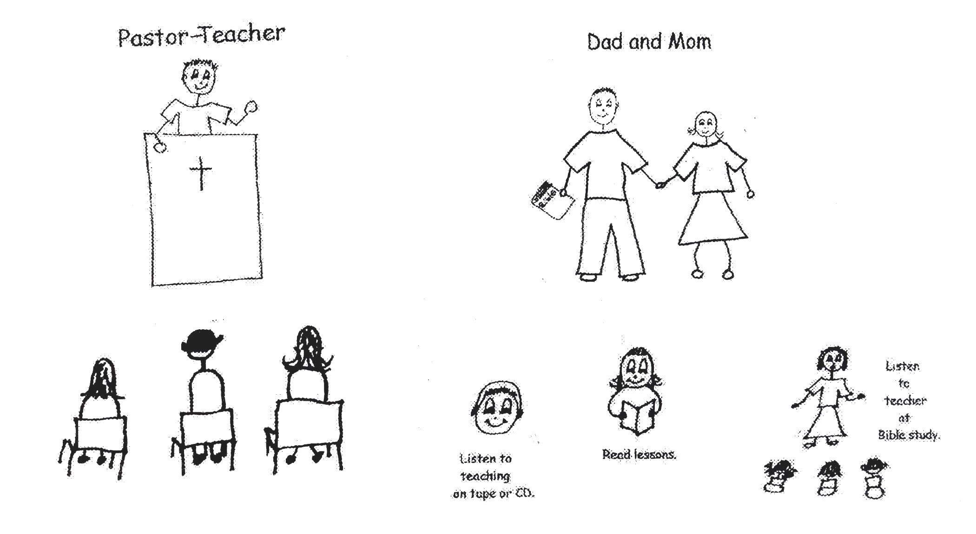



Psalm 115:1 “Not to us, O Lord, not to us, but to your name give glory because of your grace, because of your doctrine.”

God has given each of us a certain amount of time for our journey to heaven. He has given us EVERYTHING that we need in life for the trip to become spiritually mature believers and to receive the BEST that He has for us. We just have to open our suitcases everyday and take out the valuable gifts God has given us. We don’t want to get to heaven, the end of our journey, and look into our suitcases and see many valuable assets that we never used! We can’t use them in heaven! They are only for her on earth during our trip to heaven! So, let’s make sure that we hear, learn, believe, and use Bible doctrine. Then we’ll be using God’s valuable gifts, or assets, and we’ll have capacity or the ability to enjoy God’s blessings. We can become mature believers! We can be invisible heroes and WINNERS! When we finish our journey on earth and reach heaven, we’ll receive more treasures that God has ready for us!!! How wonderful is that?? What’s holding you back?? Let’s make good use of our time!

Matthew 6:19-21 “Do not store up for yourselves treasures on earth, where moth and rust destroy, and where thieves break in and steal. But store up for yourselves treasures in heaven, where moth and rust do not destroy, and where thieves do not break in and steal. For where your treasure is, there your heart will be also.”

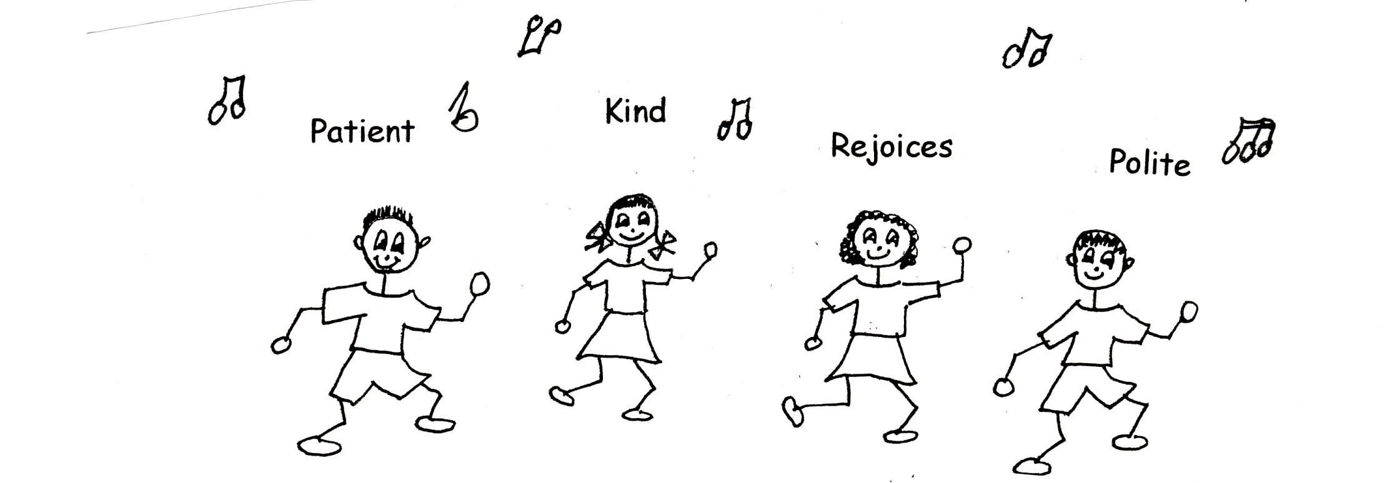

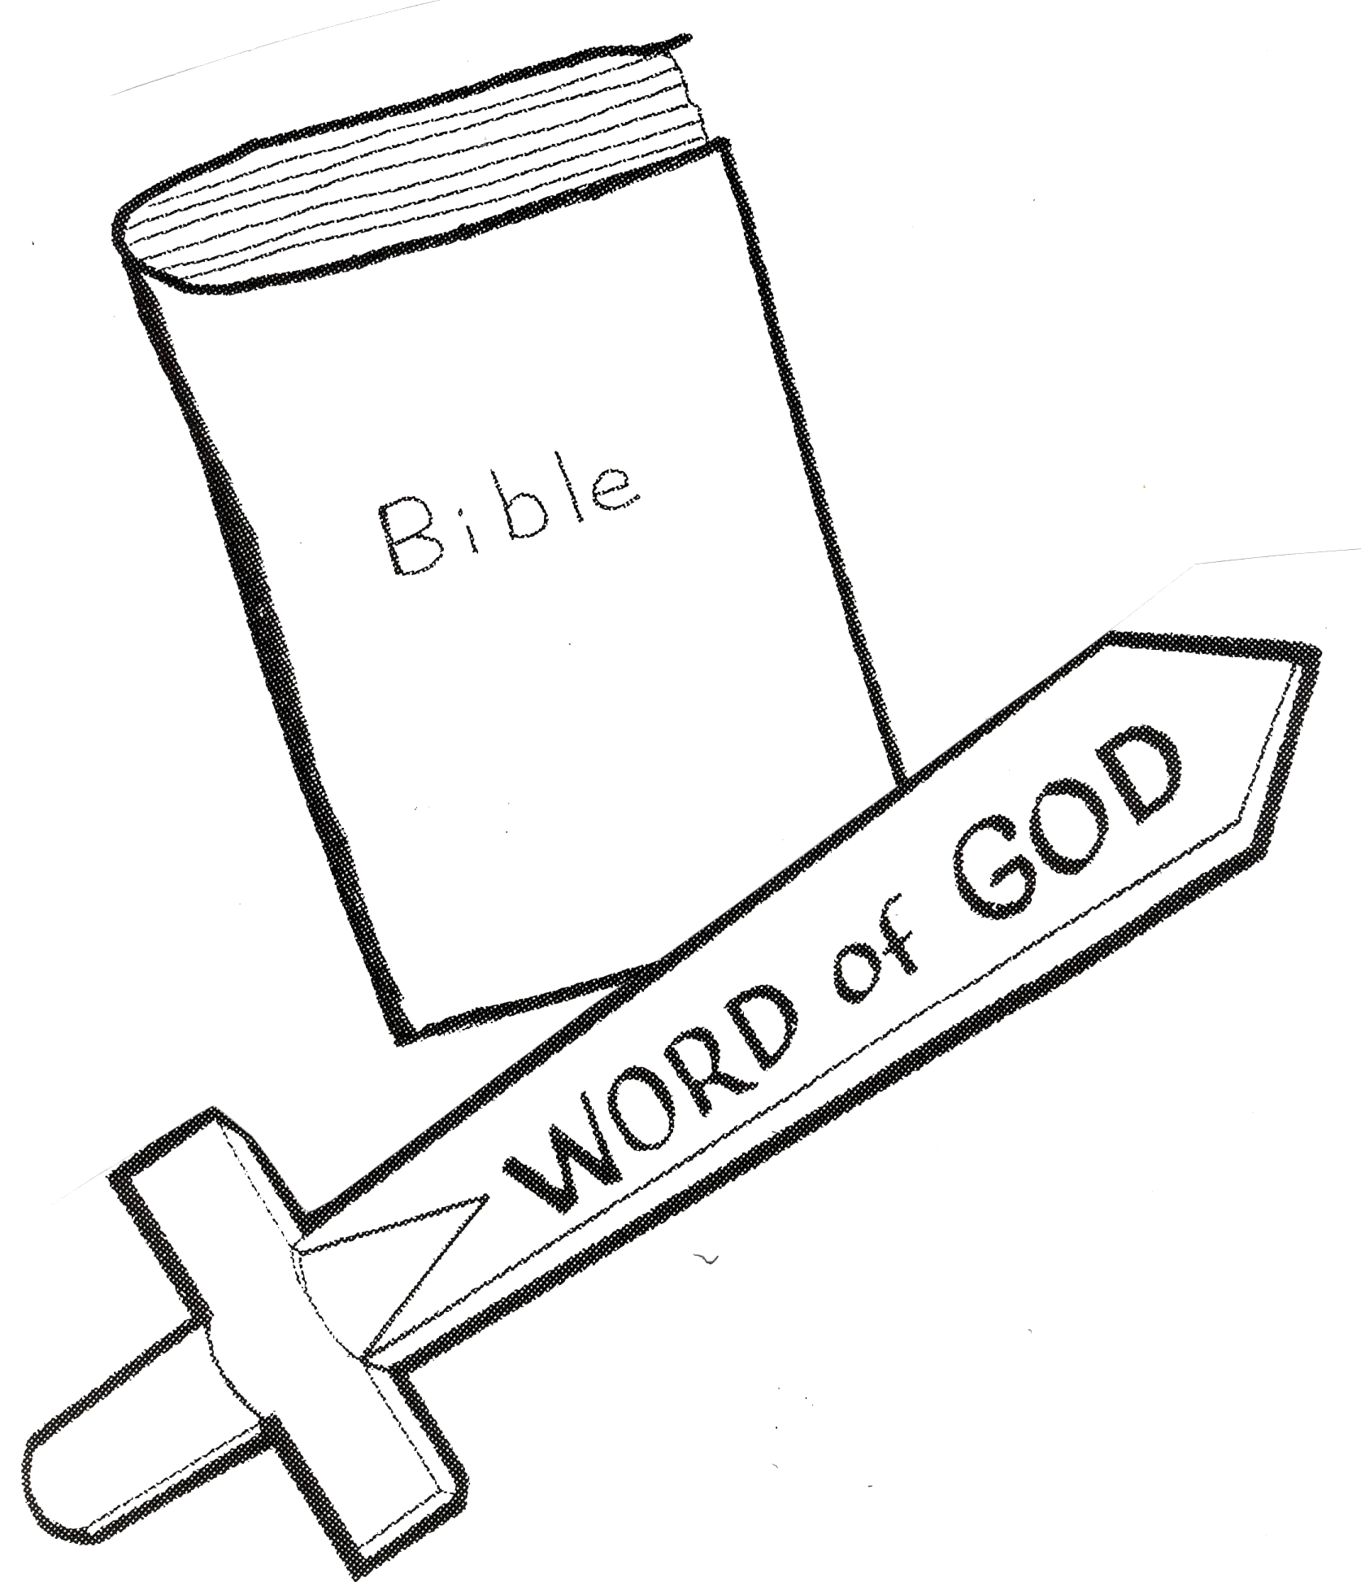

Robert McLaughlin Bible Ministries www.gbible.org

Lighthouse Christian Youth Ministries www.lighthousechristianyouth.org & lcyministry@comcast.net

