Lighthouse Christian Youth Ministry
Lesson 64
The Best Assets (Treasures)
We Will Ever Have Are Our Invisible Assets from God
Part 2

October 10, 2008

Mat 6:20 "But store up for yourselves treasures in heaven, where neither moth nor rust destroys, and where thieves do not break in or steal…”

Omniscient God designed for each one of us in His Royal Family our very own personal briefcase (portfolio) of invisible assets but as we discussed in our previous lesson, let’s call them spiritual treasures. Picture a briefcase that’s holding your invisible spiritual assets or treasures…of great value. These invisible treasures are a part of our support or supplies from the GRACE of God. We can also call them blessings from God. In our briefcase God gave us primary, secondary, personal, and unique assets. That’s a lot of valuable treasures! We’re going to review our primary assets and also learn about our secondary assets in this lesson.

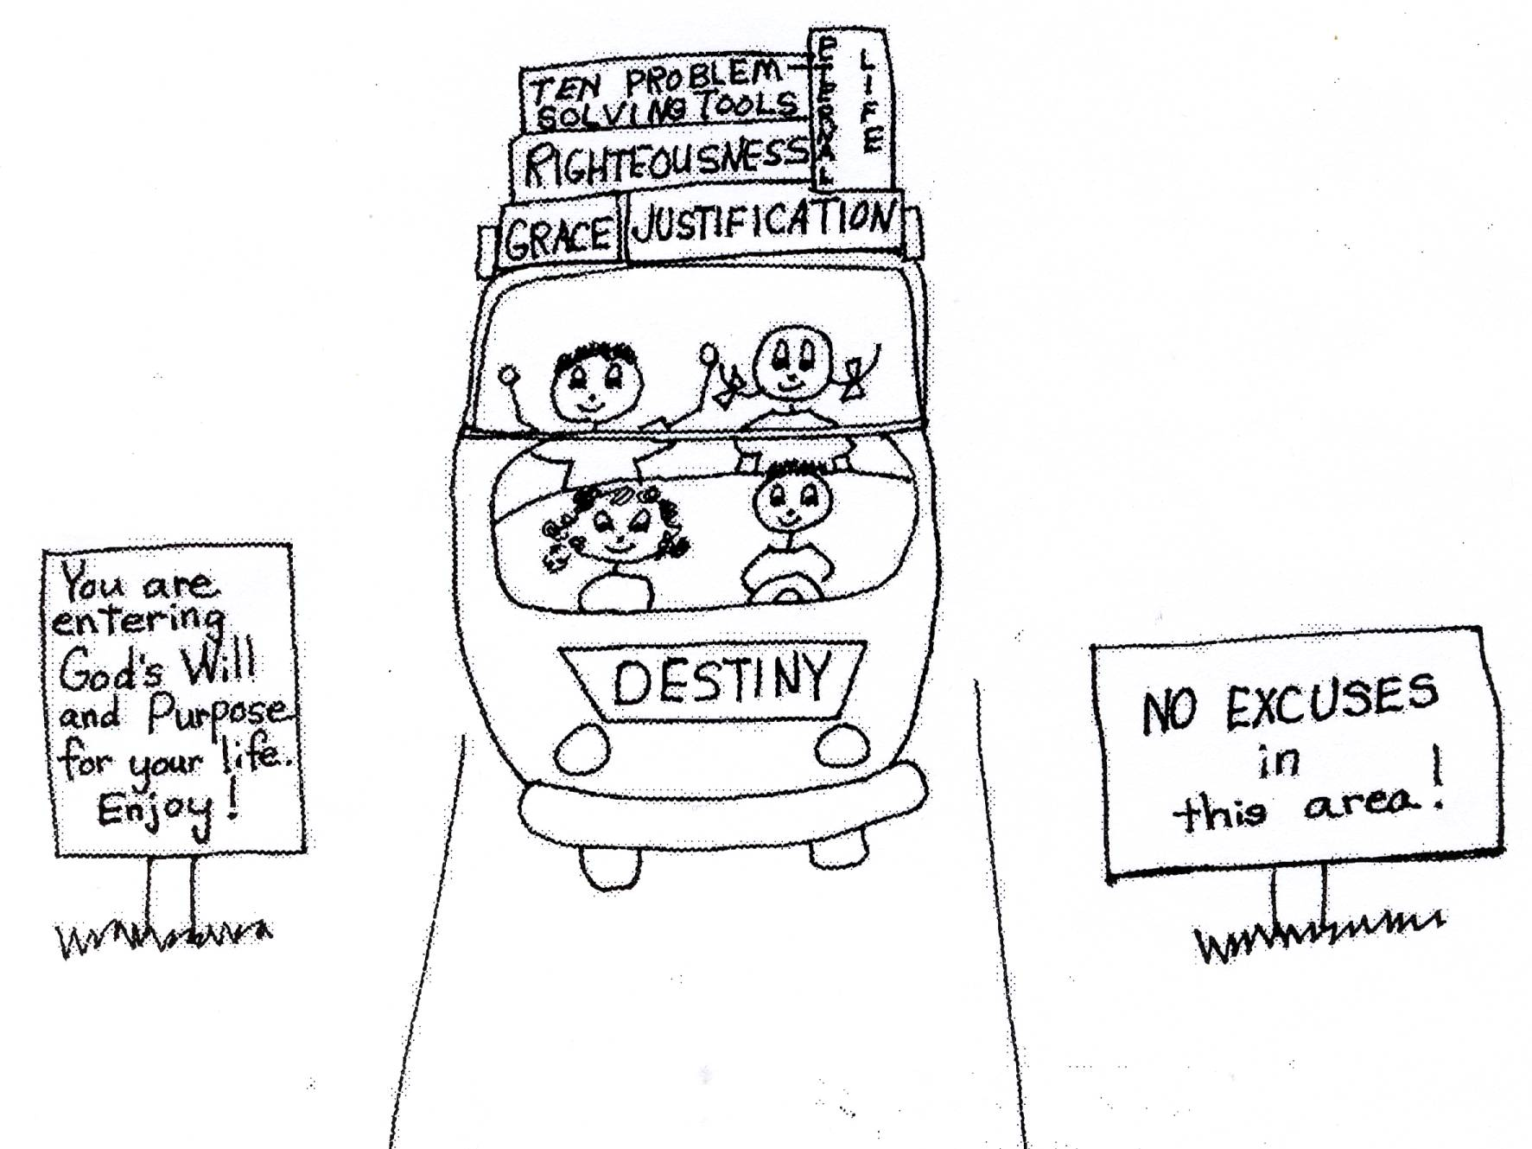

Philippians 4:19 “And my God will meet ALL of your needs, according to His glorious riches in Christ Jesus.”

He planned and made these treasures for us billions of years ago before we even existed. There is nothing that we can do to earn or deserve them. He starts us out right after we are saved with the primary assets of election and predestination. In other words, God knew that you would use your free will to believe in His Son, Jesus, to be saved and get into heaven. So because He knew you would believe, God elected you as a BELIEVER in Jesus Christ. This election means you have equal privilege and equal opportunity as a Royal priest to live in His plan. In election you get the same primary assets as every other believer in order to live in His plan. You get logistical GRACE support. This GRACE is EVERYTHING we will need to live in His plan and obey Him.

He also predestined all believers to have the equal privilege of the baptism of the Holy Spirit and the equal opportunity of a pre-designed plan for our lives. It’s the best election and plan for our lives that we will ever receive and we don’t have to ask for it! God gives us equal privilege and equal opportunity to live in His plan! All believers have the same things to use in this life to grow up spiritually and reach spiritual maturity. He gives all of us the POWER, the power of the Holy Spirit and the power of His Word, to live in His plan! All we have to do is to learn, believe, and use or apply Bible doctrine. All believers have the same spiritual I.Q. to learn and use Bible doctrine.

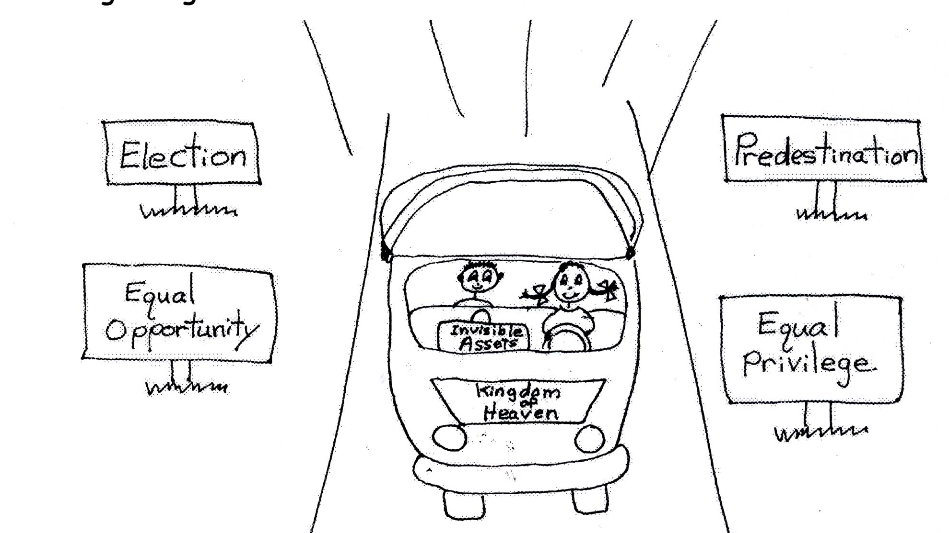

In election, God gives us the equal privilege of being in a Royal priest in Jesus. We are Royal priests because Jesus Christ is our High Priest and He is our King! We are all His little priests. A priest is someone who represents people before God. Jesus represents us before God the Father as our High Priest. So God has given believers this privilege to represent ourselves before God. As a royal priest we have a direct line to God, and He is always available to listen to us IF we are living in His plan. We can pray for ourselves and others and examine our own lives by confessing our sins, and then correcting our behavior as we need to according to the Word of God. You see we learn how to do this from the Word. We are personally responsible for our own behavior! Therefore, we must have privacy and give others privacy so that we all can act as our own priests! To use this equal privilege of election, we need to learn, believe, and use Bible doctrine daily. Royal priests of the Royal Family, let’s get with the program!

1 Peter 2:9 “But you (Church Age believers) are a chosen (elected) people, a royal priesthood, a holy (devoted) nation, a people belonging to God so that you may declare the praises (virtues) of Him (God the Father) who called you out of darkness into His wonderful light.”
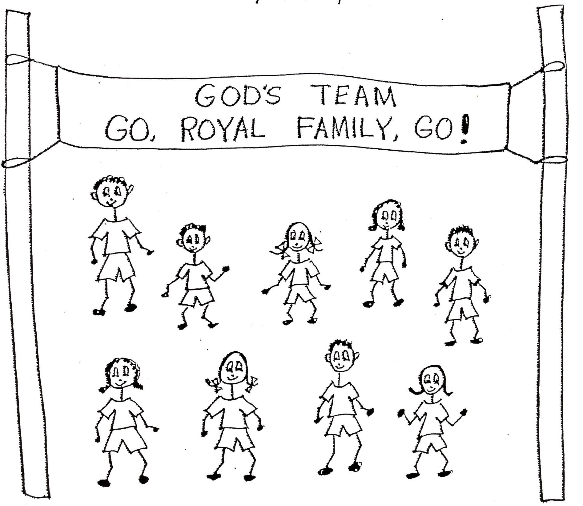

In election, God has given us the equal opportunity for logistical grace support. Again logistical grace is God’s basics for His royal family. That’s all the food, shelter, clothing, transportation, parents, environment, time, jobs, planning, support, and blessing that we’ll need to live in His plan. It is given to us so that we can carry out our own pre-designed plan of God, His will and purpose for our lives. We don’t earn it or deserve it. God supplies us with all of this life support for free! We are given our own portfolio or briefcase of invisible assets, the ten problem-solving devices (remember them?), and Bible doctrine. All Bible doctrine is provided by God through a prepared pastor-teacher. Under our logistical grace support, God keeps us alive until He decides to take us home to heaven. We have a guardian angel that protects us. Our angels have a big job! God takes supper care of us! God gives us His logistical grace support and it doesn’t matter if we are winner or loser believers to get it! ! He gives all believers equal opportunity to grow spiritually! And if we are positive to His plan and love Jesus and His Word, God will give us all the time we need on earth to grow up to spiritual maturity.
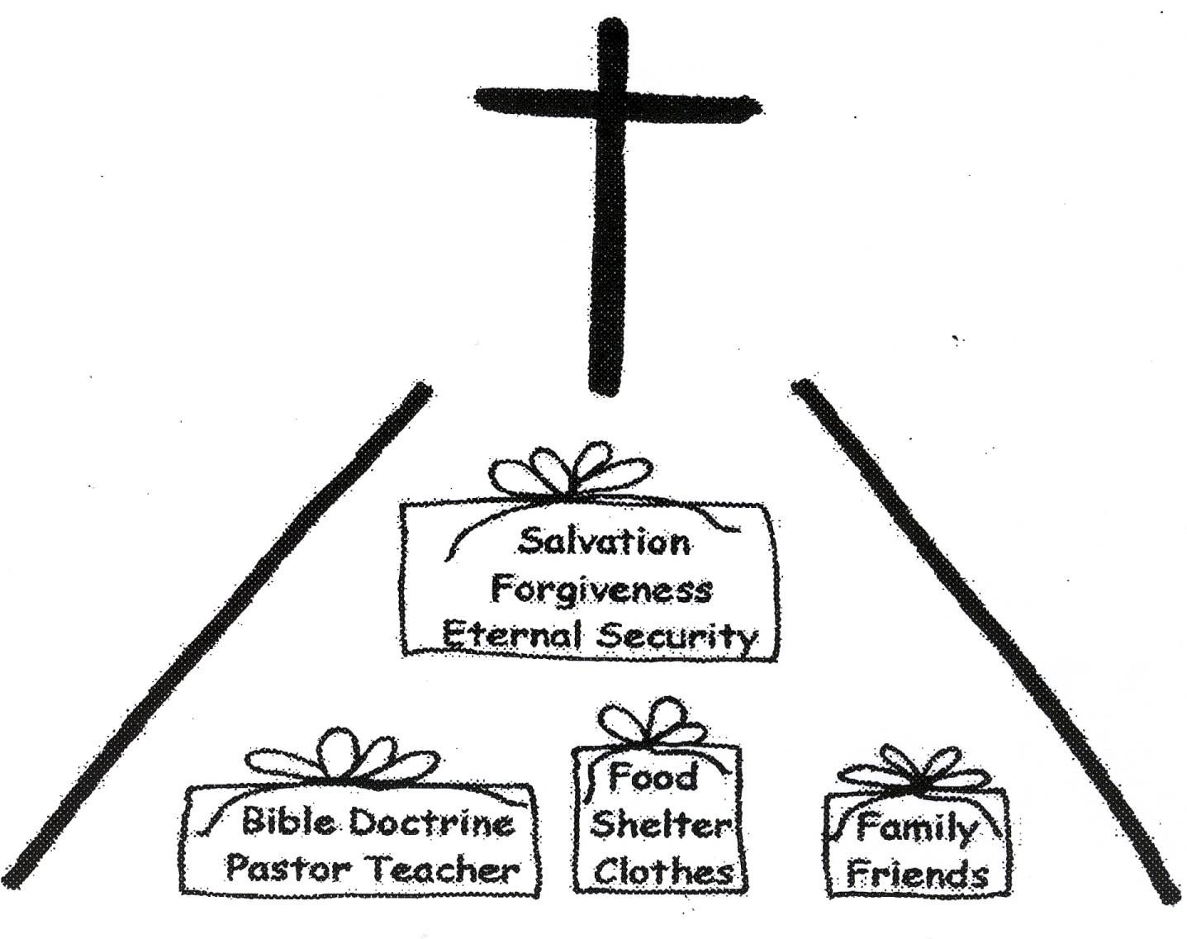

Romans 8:31-32 “So what is the result of this? If God is for us, who is against us? The God who did not even spare His own Son, but on behalf of us all He delivered Him over to judgment (on the cross), how will He not also with Him (Jesus) in grace give to us the all things?”

In predestination God has given us the equal privilege of the baptism of the Holy Spirit. This means that at the moment we believed in Jesus Christ, the power of the Holy Spirit enters us into an eternal union with the Lord Jesus Christ. This guarantees our eternal security. We are identified with Jesus Christ. We are part of His Royal Family! He lives inside of us. Did you ever think that you would be royalty? Through the baptism of the Holy Spirit, we become a new spiritual creation with a new nature in Christ. We can live in newness of life. We have the choice to live in our new nature or our old sin nature. We have the equal privilege of the baptism of the Holy Spirit.

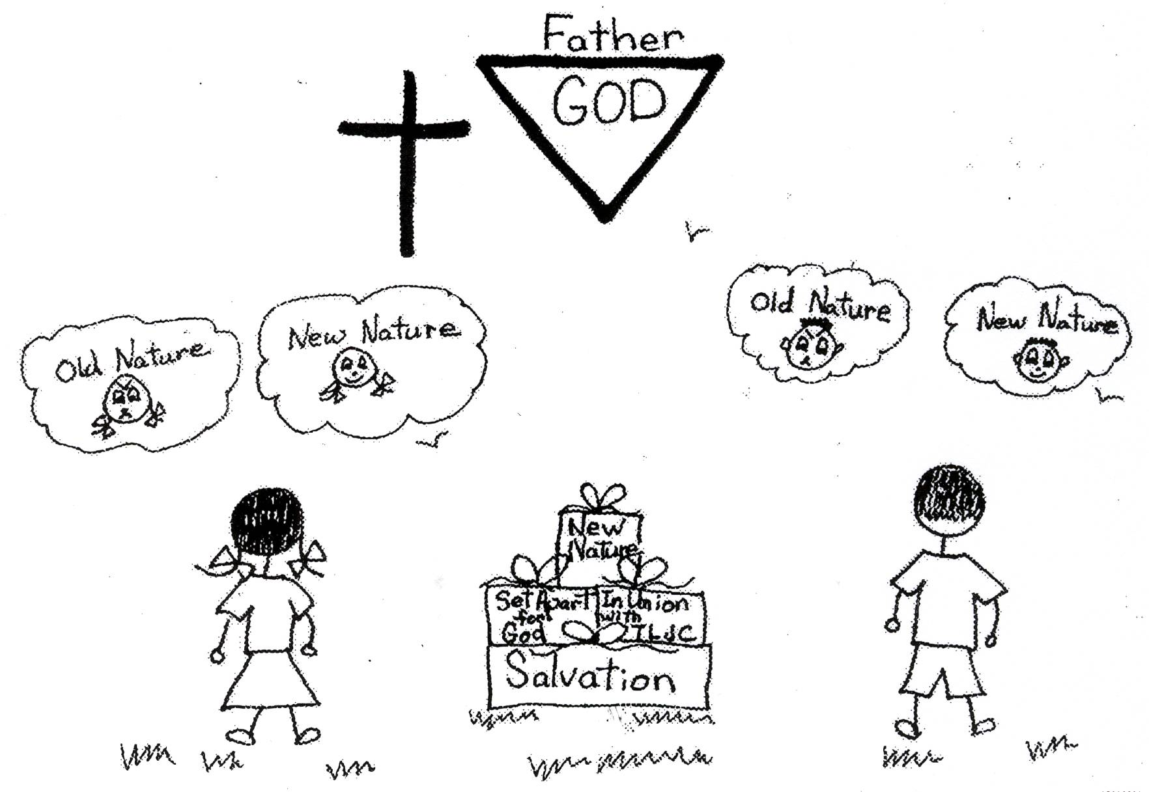

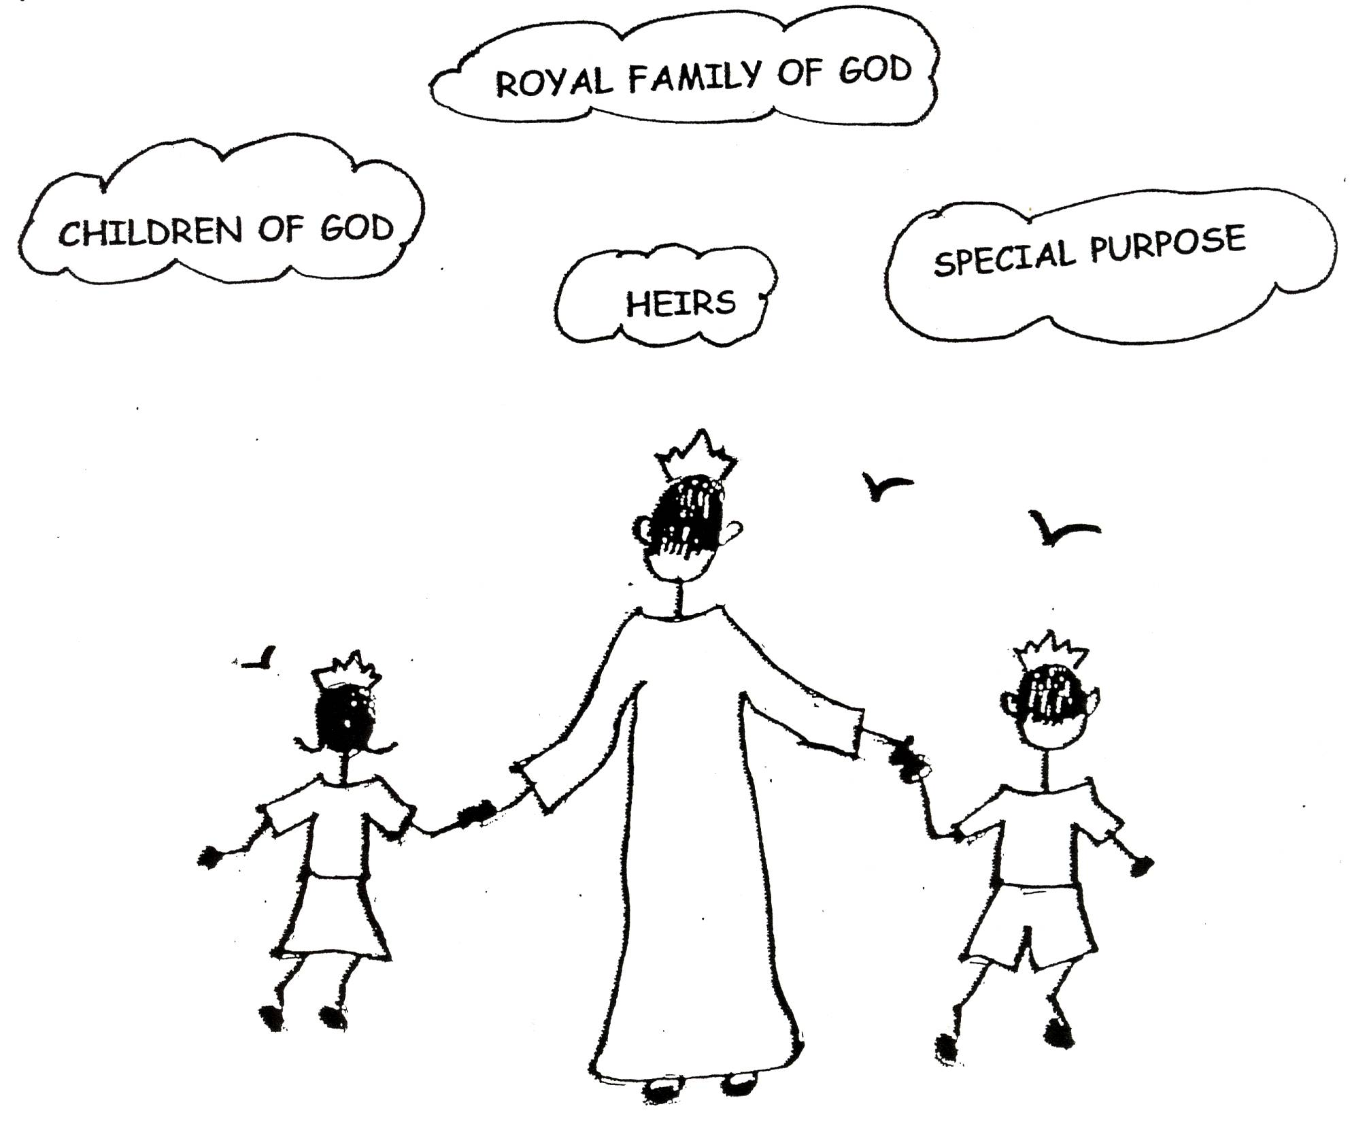

2 Corinthians 5:17 “Therefore, if anyone is in Christ, he is a new (spiritual) species. The old things (the old sin nature) have lost their power; behold, new things have come.”

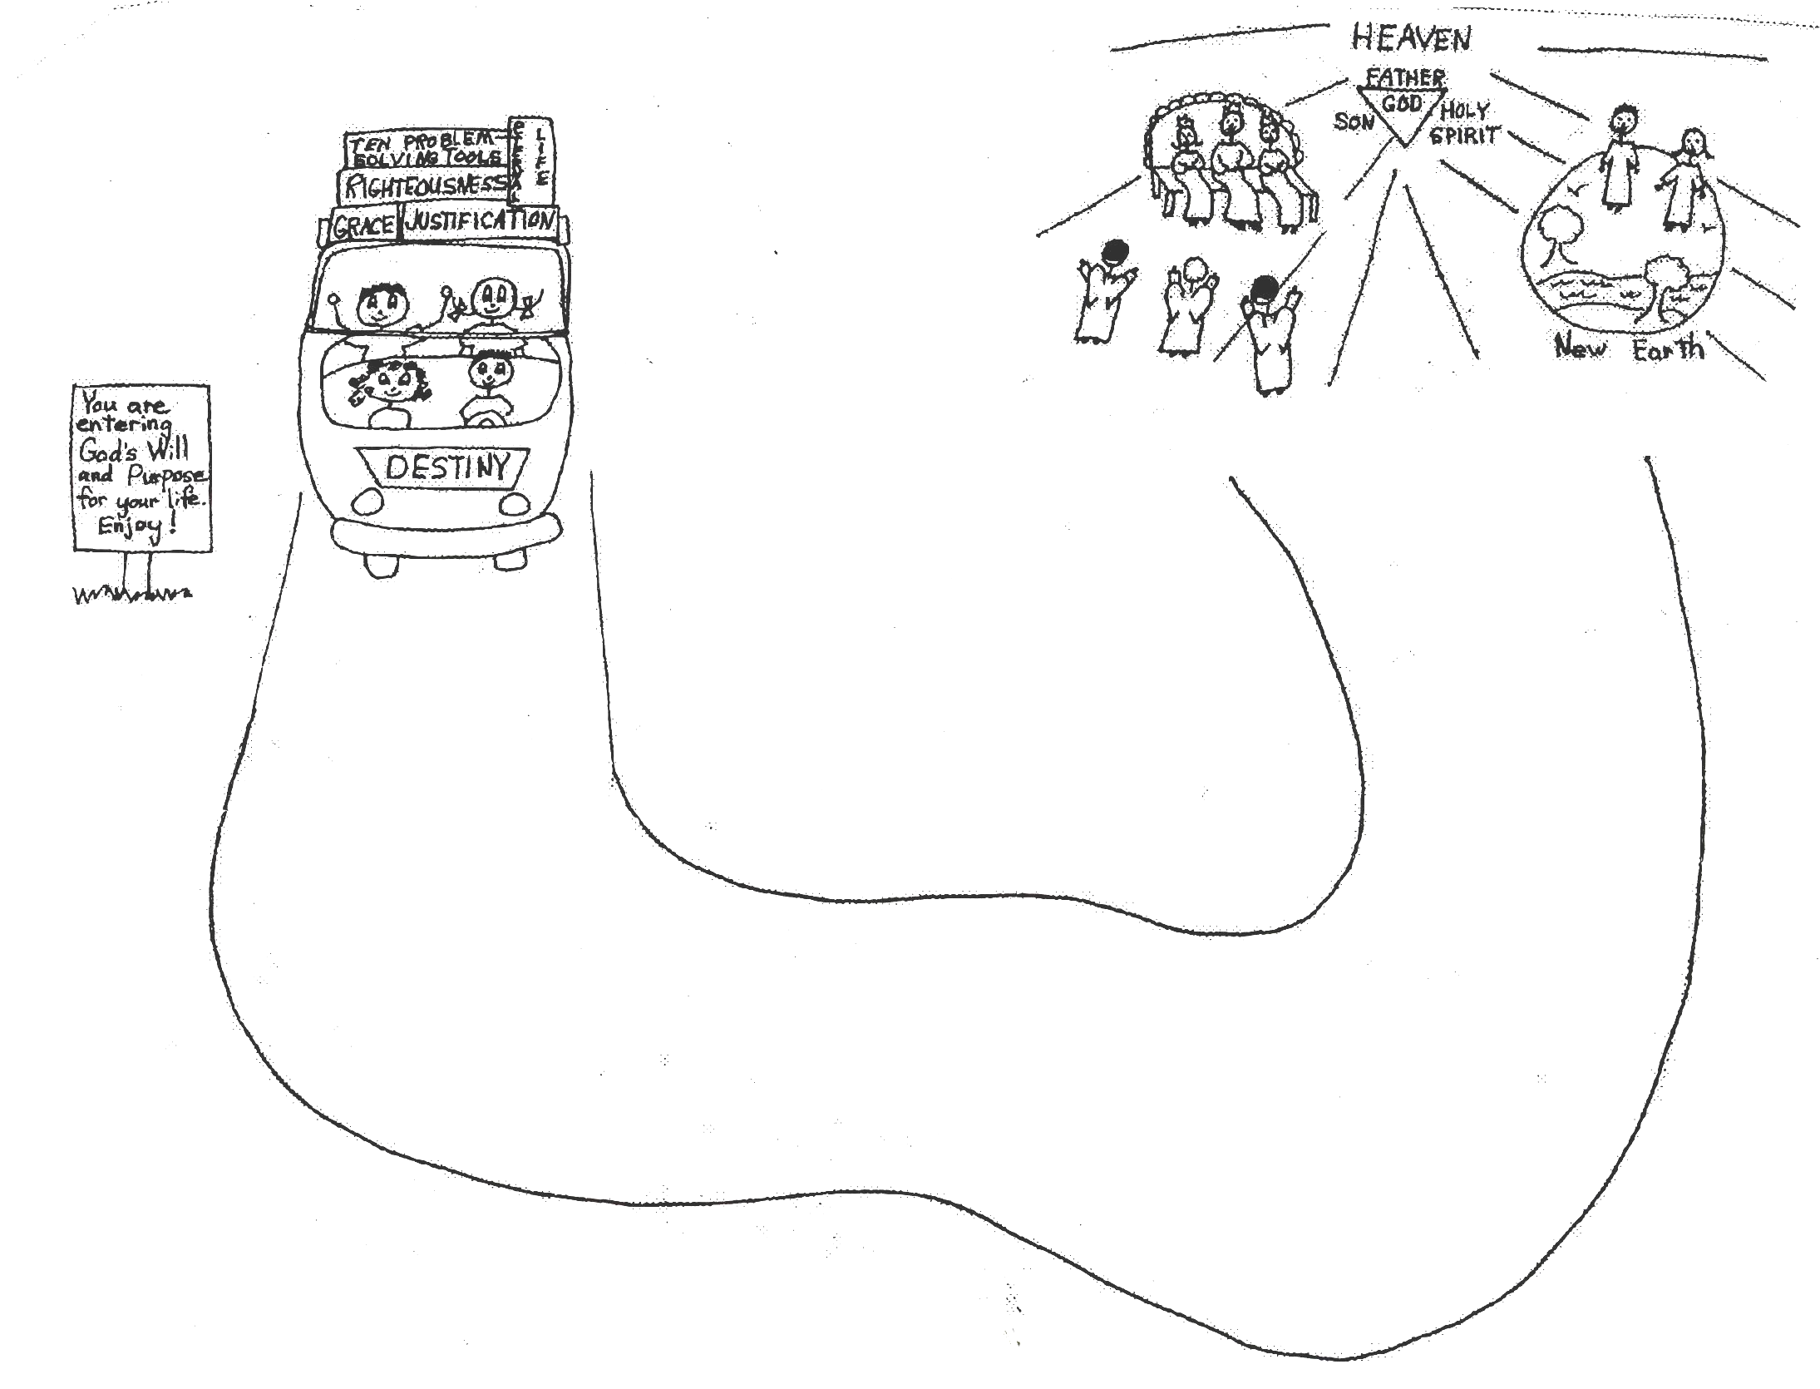

In our predestination, God has given us the equal opportunity to use His pre-designed plan. We all have the same equal opportunity. The pre-designed plan of God is our safe place, which means total safety for the believer in the Church-age. God has set safe boundaries for us. That means He puts a wall of fire around us for protection. It doesn’t matter where we live. We could be in the United States or in any foreign country. What matters is that we stay in the safety of the pre-designed plan of God. If we get out of His plan, we need to rebound or confess and regain the filling of the Holy Spirit. We need to get in the safe boundaries again. We need to continue to learn about God’s plan by learning, believing, and applying God’s Word…Bible doctrine in our lives. God has a great plan for each of our lives! We can live in style, God’s lifestyle!

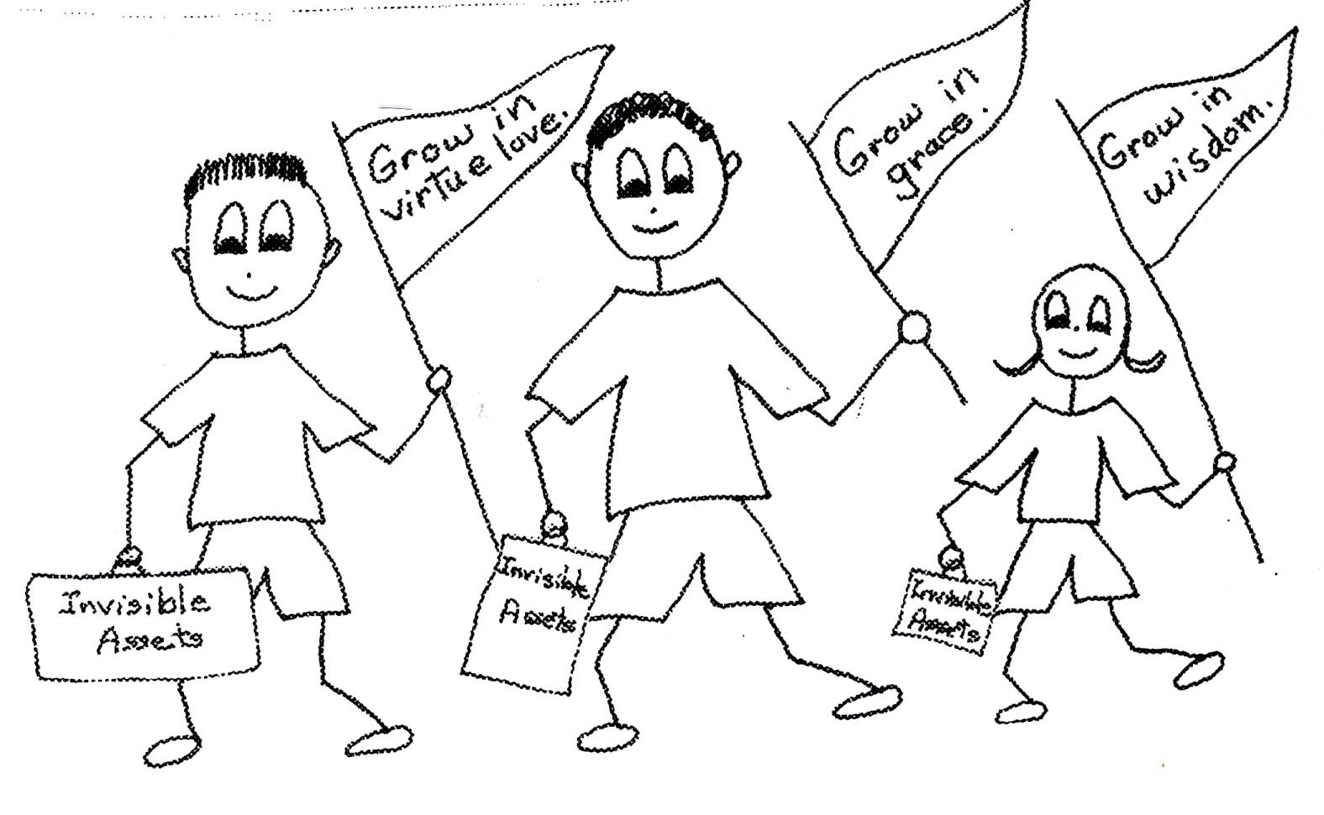

2 Timothy 1:7 “For God has not given us a lifestyle of fear, but (one) of power and love and discipline.”

By understanding, believing, and using the equal privileges and equal opportunities God has given us, we better understand God’s calling on our lives. We learn day by day, more and more about who and what God is and what our invisible assets are. We start relying more on God and His thinking, Bible doctrine. We want to live in His plan for our lives. We see more often that when our thoughts are not based on God’s, we get ourselves into trouble. By using our positive volition toward doctrine, we begin seeing some secondary assets, or the second group of blessings that we can use in our spiritual lives. Secondary assets come from using our primary assets. Through His grace, God keeps on giving us ways to keep our thinking straight and make us grow spiritually! He keeps blessing us!

2 Peter 1:10-11 “Therefore, my brothers, be all the more eager (motivated) to make your calling and election sure. For if you do these things, you will never stumble (doesn’t mean that we won’t sin, but that we won’t go back and live in the cosmic system) and you will receive a rich welcome into the eternal kingdom of our Lord and Savior Jesus Christ.”

Primary assets, election and predestination, are given to us by God through His sovereignty or rulership over us. They express God’s will for our lives. But secondary assets depend on the volition of the believer. They depend on our attitude toward Bible doctrine and the grace of God. When we choose to use the primary assets, or resources that God gave us, we can increase these assets to secondary assets. Our secondary assets give us spiritual growth and we become rich as we grow up spiritually. The 3 stages of spiritual growth are: spiritual self-esteem*, then spiritual autonomy**, and then spiritual maturity***! However, we have to have the right priorities. Are we going to follow God’s plan or the cosmic system? God wants His best for us, and He wants us to reach spiritual maturity. He doesn’t want us to be spiritual babies! Therefore, He wants us to live in His will and plan for our lives. God designed the best plan for each of us! But you have to learn His Word daily, believe it, and use it everyday of your life in every experience. Glory to God our Ruler!

*Spiritual self-esteem is the first stage of spiritual growth and means that we have confidence because of the Word of God in our souls.
**Spiritual autonomy is the second stage of spiritual growth and means a lifestyle of spiritual independence from people. It means that we depend on God.
***Spiritual maturity is the third stage of spiritual growth and means that we have tons of the Word of God in our souls. We have a relaxed mental attitude and a lifestyle of relying on God for everything, and we have great capacity to receive God’s blessings…no worries at all even in personal difficult times.

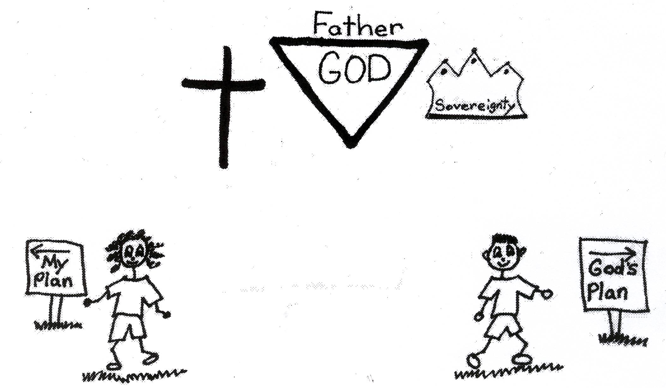

Proverbs 19:8 “He who gets wisdom loves his own soul; he who cherishes understanding prospers.”

Psalm 40:8 “I desire to do your will, O my God; your law is within my heart (soul/mind).

