Lighthouse Christian Youth Ministry
Lesson 65
The Best Assets (Treasures)
We Will Ever Have Are Our Invisible Assets from God
Part 3

October 24, 2008

Mat 6:20 "But store up for yourselves treasures in heaven, where neither moth nor rust destroys, and where thieves do not break in or steal…”

Again your primary assets are election and predestination. God elected or chose all believers to live in His pre-designed plan. He gave us equal privilege and equal opportunity to do this. If we are going to take advantage of our primary assets of election and predestination, and multiply them into secondary assets, we have to begin by admitting that we are powerless and need DIVINE power. We need the power of the Holy Spirit and the thinking of Jesus Christ. Without this divine power we cannot make right decisions in our lives. I’m sure that we’ve all wondered at times why we can’t manage what’s going on in our lives. Well it’s usually because we are relying on our power. We don’t like to admit that we fail, and that we are nothing without God. However, admitting that we are powerlessness is the first step in true freedom. We struggle trying to do things in our power, and the problem doesn’t get solved. Then, when we use divine power, we see that the problem gets solved, and we can have a relaxed mental attitude. It’s God’s power that counts!

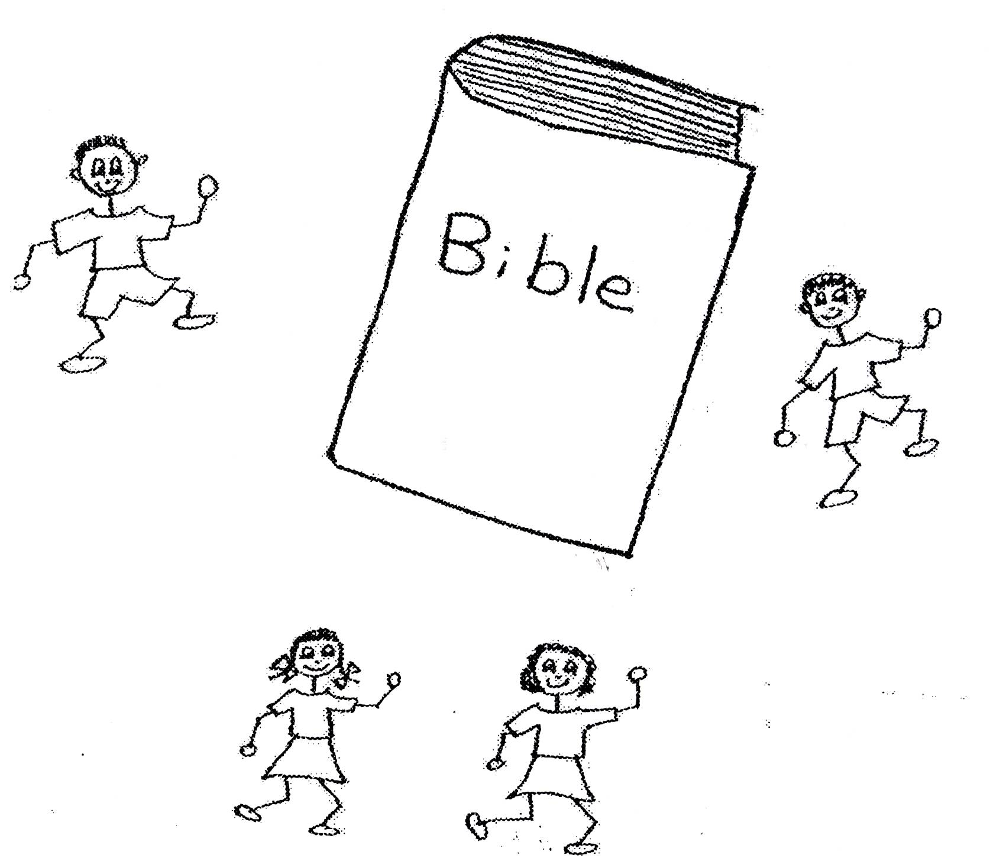

John 15:5 “I am the Vine, you are the branches; he who lives in me, and I in him, he bears much fruit; for apart from me you can do nothing.”

If we are going to take advantage of our primary assets, election and predestination, and multiply them into secondary assets, we have to come to believe that there is a power greater than our power. It is God’s power! And God’s POWER keeps us sane. Sometimes we have negative thoughts where we get mad at ourselves for failing or sinning. Other times we have positive thoughts where we think too highly of ourselves. We put others down because we feel better than them and oh, so self- righteous! This can drive us crazy because we are not dealing in truth. God will bring us to a point where we realize that we are nothing without Him. There will be times when we will fall flat on our faces! God wants us to believe and trust in Him. Then His power can pick us up! He can bring us back to the place where we glorify Him!

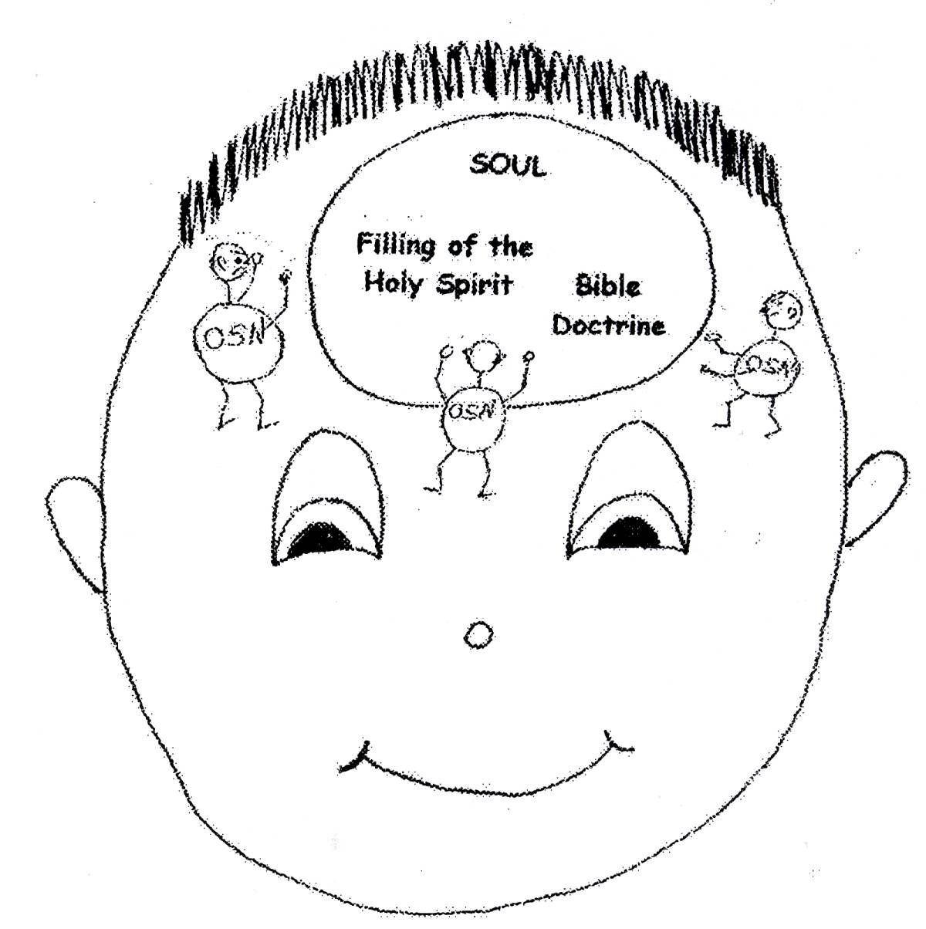

Hebrews 11:1 “Now faith (belief) is being sure of what we hope for and certain of what we do not see.
Hebrews 11:6 “Without faith it is impossible to please God.”
Galatians 6:3”For if anyone thinks he is something when he is nothing, he deceives himself.”

If we are going to take advantage of our primary assets, election and predestination, and multiply them into secondary assets, we must make a decision to turn our wills and our lives over to the care of God. How do we do that? We have to be willing to depend on God. We have to allow God to strip us of all of our own strength so that we rely on His strength. If He takes our wealth, we rely on Him. If He takes away our health, we rely on Him. If He takes away loved ones, we rely on Him. Whatever God takes away from us, we rely on Him. He will never forsake us, or leave us alone. He is just be getting us ready to receive greater blessings! God is our best Caregiver! He knows what we need and He will give us all the grace we need when He takes things away from us.

Philippians 4:13 “I can do everything through Him who gives me strength.”
2 Samuel 22:33 “It is God who arms me with strength and makes my way perfect.”

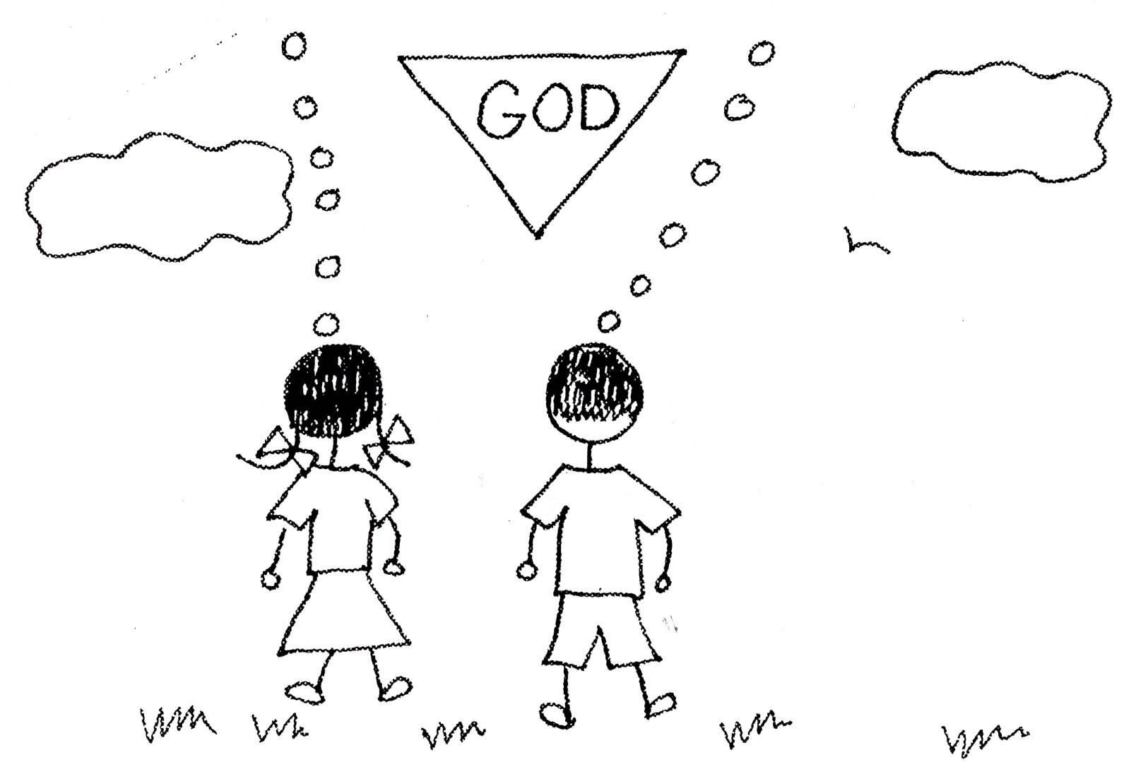

Deuteronomy 31:6 “Be strong and courageous. Do not be afraid or terrified because of them, for the Lord you God goes with you; He will never leave you nor forsake you.”
1 Peter 5:7 “Cast all your anxiety (cares) on Him because He cares for you.”

If we are going to take advantage of our primary assets, election and predestination, and multiply them into secondary assets, we must take a very fearless deep look at ourselves. This means to check out what controls our minds and motivates us to act the way we do. This is something that we don’t like to do. We don’t like to see our weaknesses. We like to think that we are strong and have our act together. We even fake it sometimes! In taking this inventory, we are not to condemn ourselves or to feel guilty. We are not to fear what we might find out about ourselves! God won’t condemn us. He just wants us to wake up and rely on Him! We can grow through our weaknesses if we rely on God and His grace. He will show us how to live in our new nature! When we slip back to our old sin nature, we just need to rebound or confess our sins and live in our new nature again with God the Holy Spirit in control. We need God to control our minds and motivate us! In our deep look at ourselves, we need to see more of God’s thinking and less of worldly thinking.
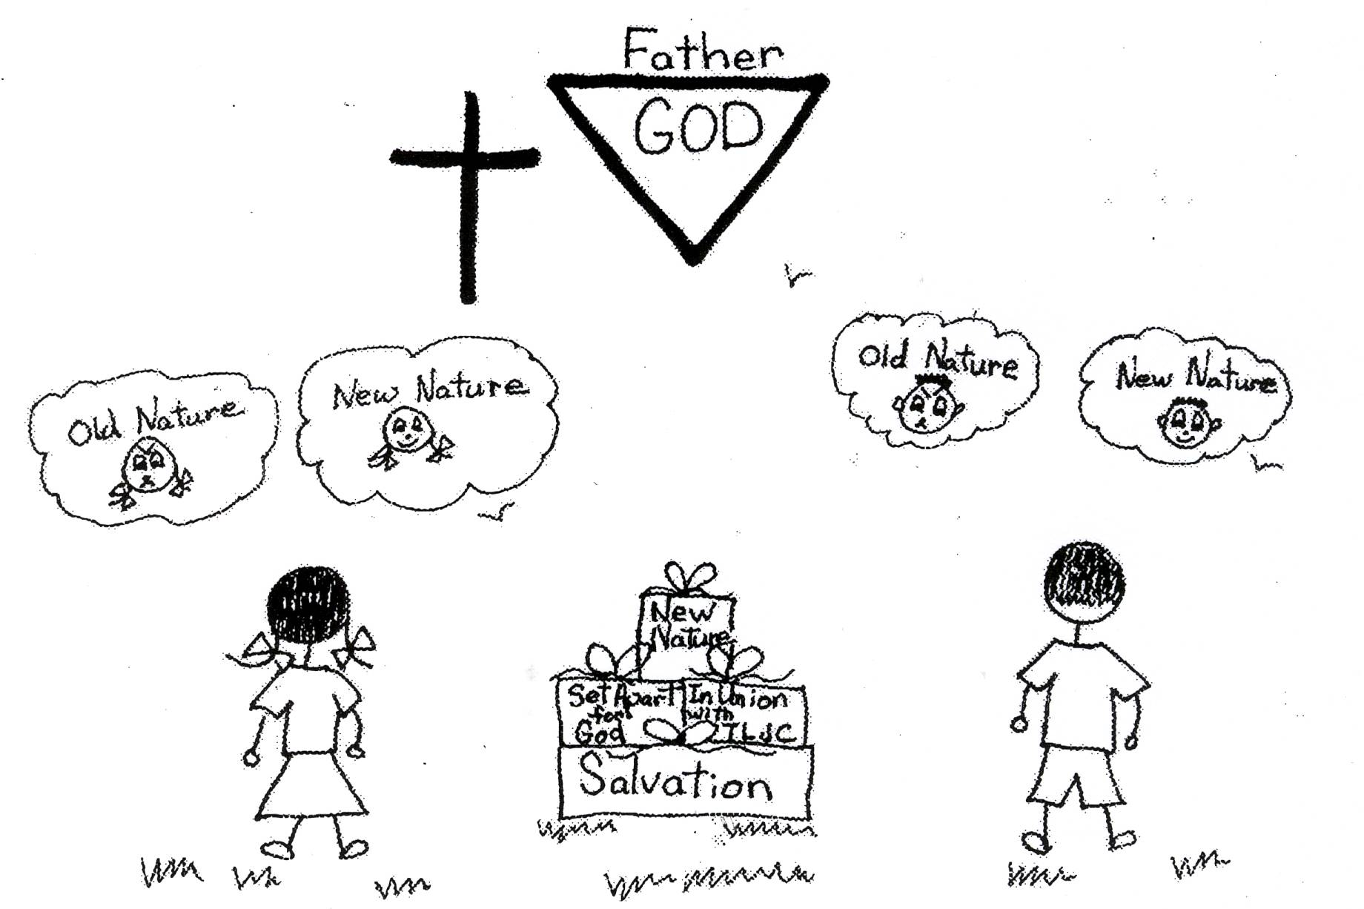

1 Corinthians 11:31 “If we judge ourselves rightly, we shall not be judged. (This means to make a proper evaluation of our lives).”

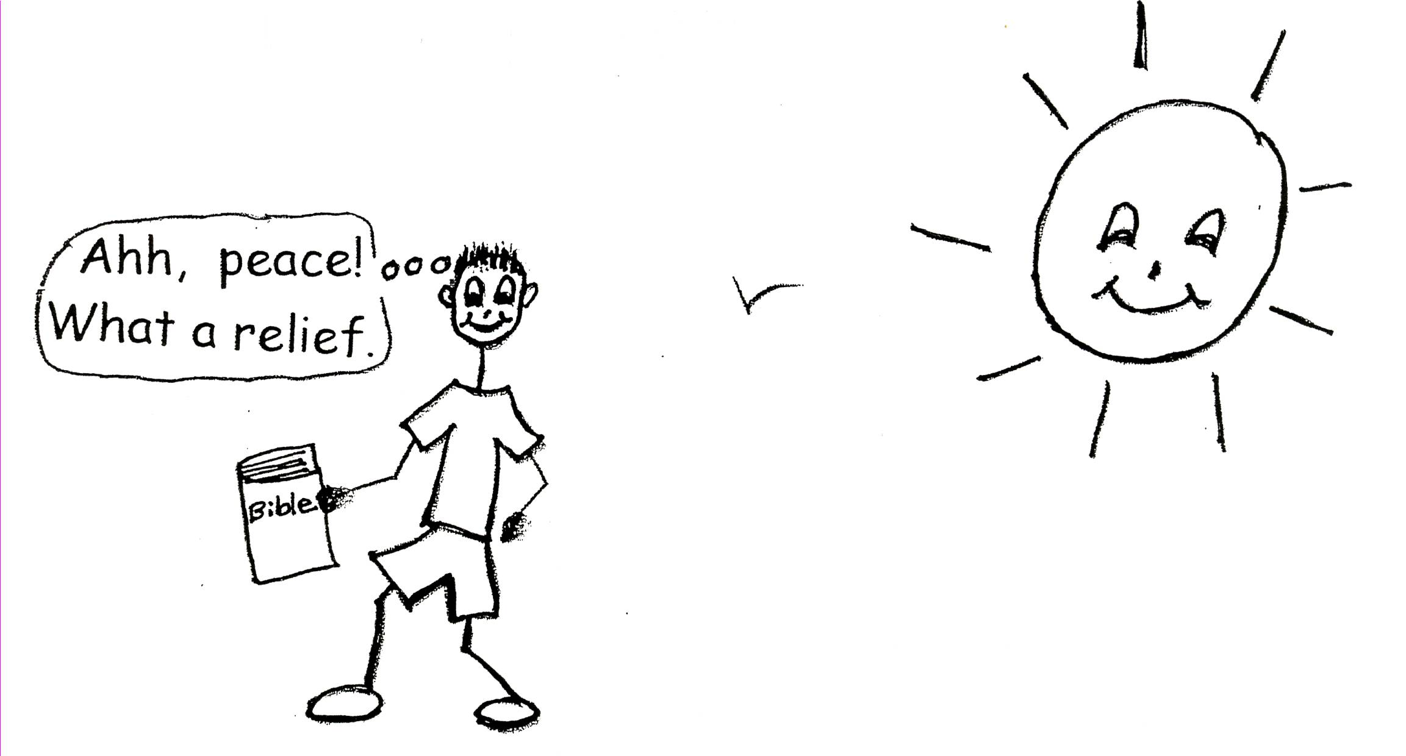
When we are taking a good deep look at ourselves, we can see if we have things like anger, resentments, jealousy, envy, self-pity, hurt, pride, etc. If we have anger in our lives, there is something wrong with our spiritual lives. If we have resentments in our lives, there us something wrong with our spiritual lives. The same is true about any weaknesses we have. Sometimes we are still thinking about our past and feeling guilty. Therefore, we can’t go forward in the plan of God. We need to promptly admit and accept our weaknesses. Then we can patiently let God correct them. When our past is settled as we grow up spiritually we will begin to have a relaxed mental attitude based on the Word of God we can face anything that comes into our lives that are difficult! Let’s take a deep look at ourselves, get with God’s thinking, and meet the challenges He has for us!

Colossians 3:12-14 “Therefore, as God’s chosen people, holy (set apart to God) and dearly loved, clothe yourselves with compassion, kindness, humility, gentleness and patience. Bear with each other and forgive whatever grievances you may have against one another. Forgive as the Lord forgave you. And over all these virtues put on love, which seals them all together in perfect unity.”

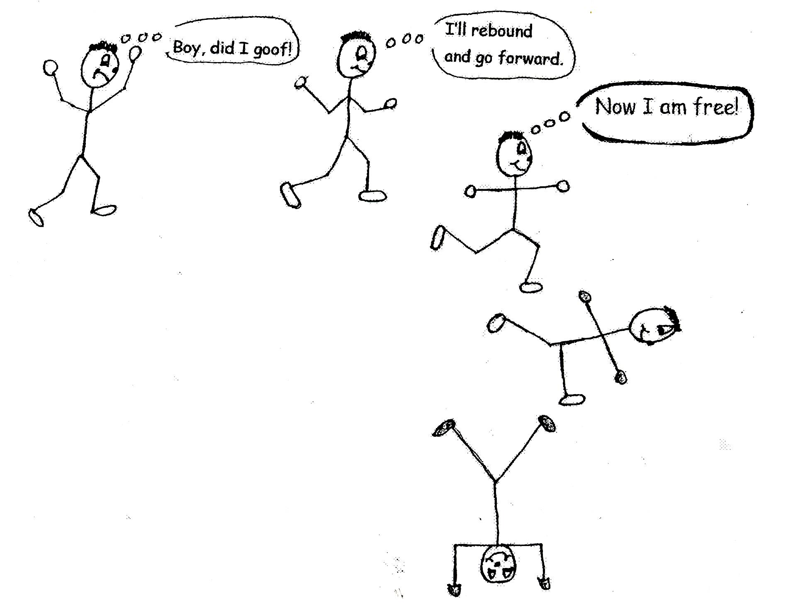

If we want to take advantage of our primary assets, election and predestination, and multiply our primary assets into secondary assets, we must admit to God and to ourselves all the wrong things we do from our sin nature. We have all wronged God, people, and ourselves. We all have things in our lives that are wrong that God needs to change. Without the fearless admission of our weaknesses, we cannot grow in God’s grace and knowledge. That’s what confession is all about. We must be complete honesty about our wrong doing. This is the beginning of true freedom. If we admit our faults, we will have peace and contentment. We will begin to have true relationships with God and humanity. We all have faults. So what? This doesn’t bother God. The cross took care of that. Jesus paid the price for our sins. What bothers God is when we fall and don’t get back up again. In other words, when we sin, we need to rebound and go forward in God’s plan. God knows everything about us anyway and He wants us to stop hiding our weaknesses. We can’t play “hide and seek” with God. He always knows where we are spiritually and physically! God wants us to be honest with ourselves and with Him, have peace of mind, and grow in His grace and wisdom.

Proverbs 28:13 “He who conceals (hides) his transgressions (sins) will not prosper, but he who confesses and forsakes (them) will find compassion. (This means not to hide our faults from ourselves but to admit them and let God change us.)”

If we are going to take advantage of our primary assets, election and predestination, and multiply them into secondary assets, we must be entirely ready to have God remove the faults in our character that are spoiling our relationship with Him. We must be willing to have God point out where we are weak in our emotions and our thinking. God knows the best way to do this. God will help us get rid of our faults. This doesn’t mean that we won’t fail again. We will, but we just need to rebound and go forward in God’s plan again. We are to let God remove our faults! We are to let Him change our attitude through Bible doctrine. God is the best Transformer! We definitely don’t want to spoil our relationship with God!!

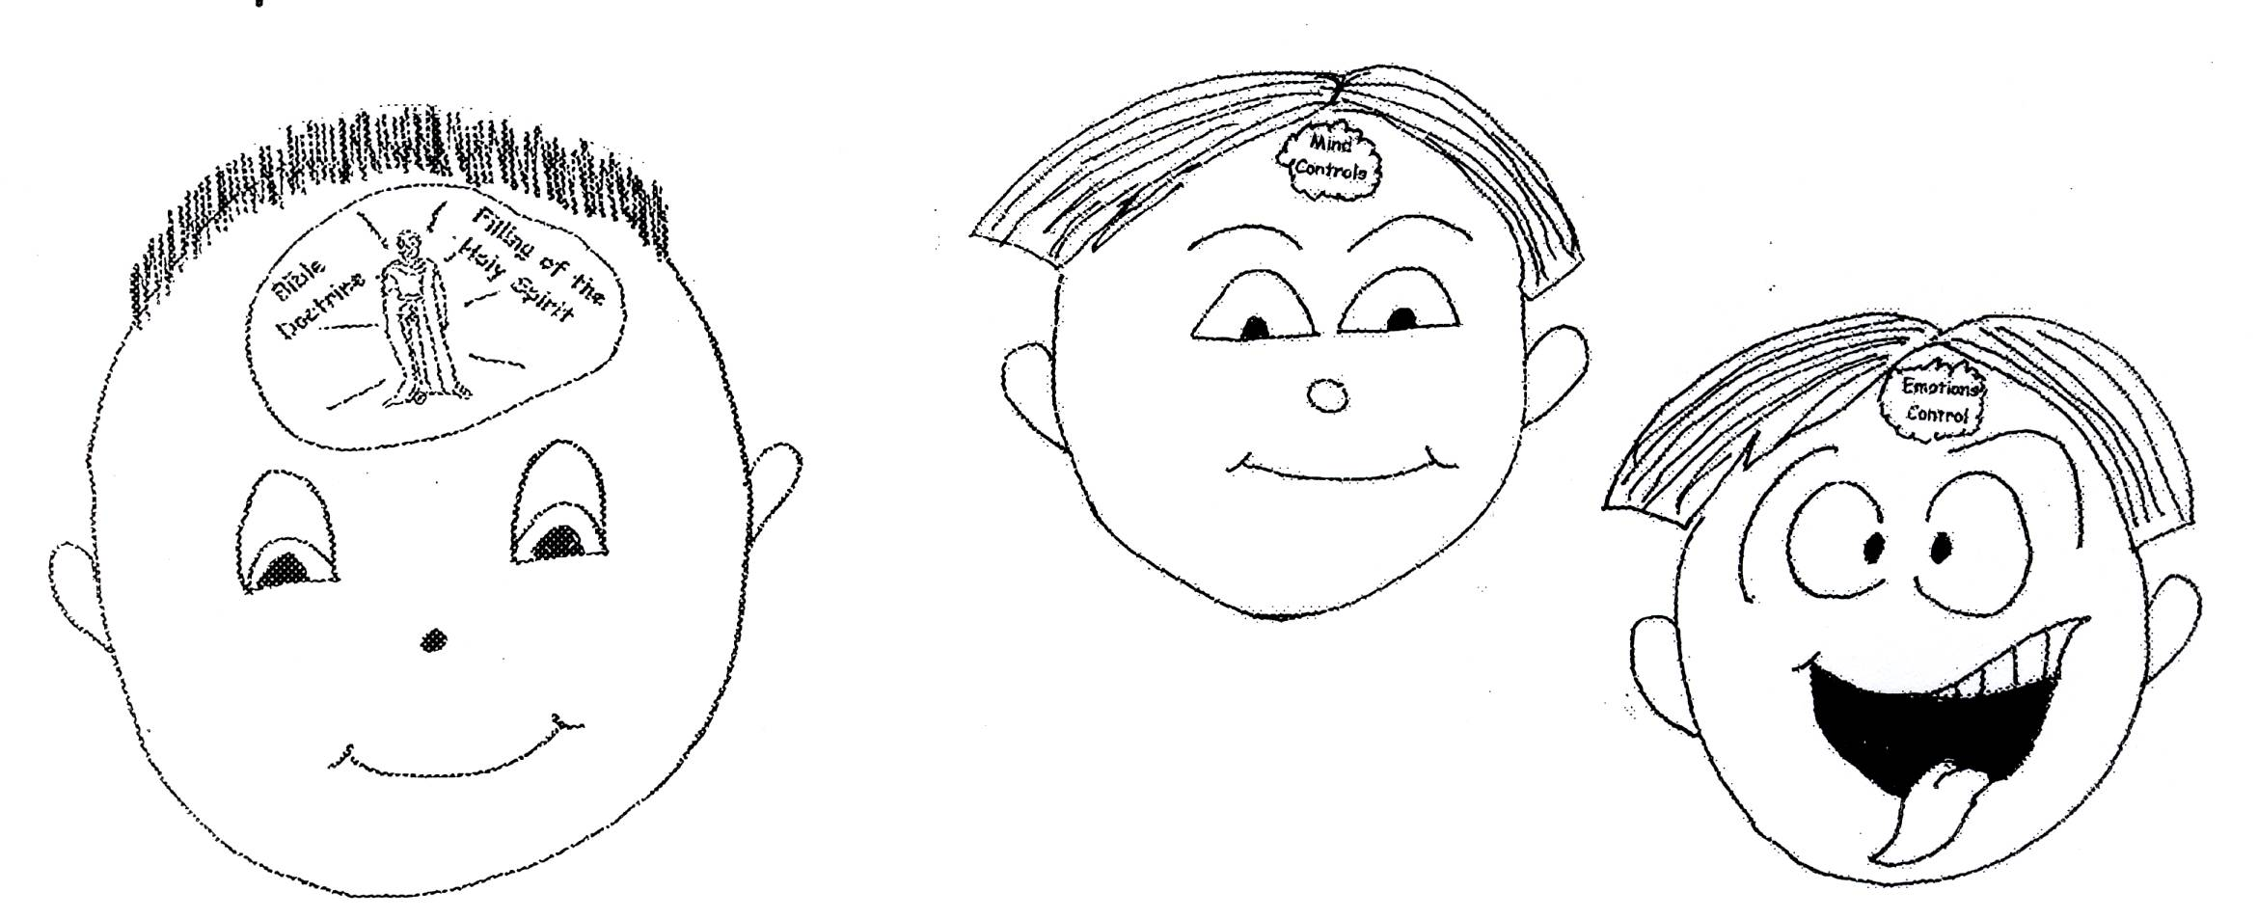

Psalm 26:1-2 “ Vindicate (judge) me, O Lord, for I have led a blameless life (walked in integrity); I have trusted in the Lord without wavering (not being double minded). Test me, O Lord, and try me, examine my heart (right lobe of the mind) and my mind (emotions).”

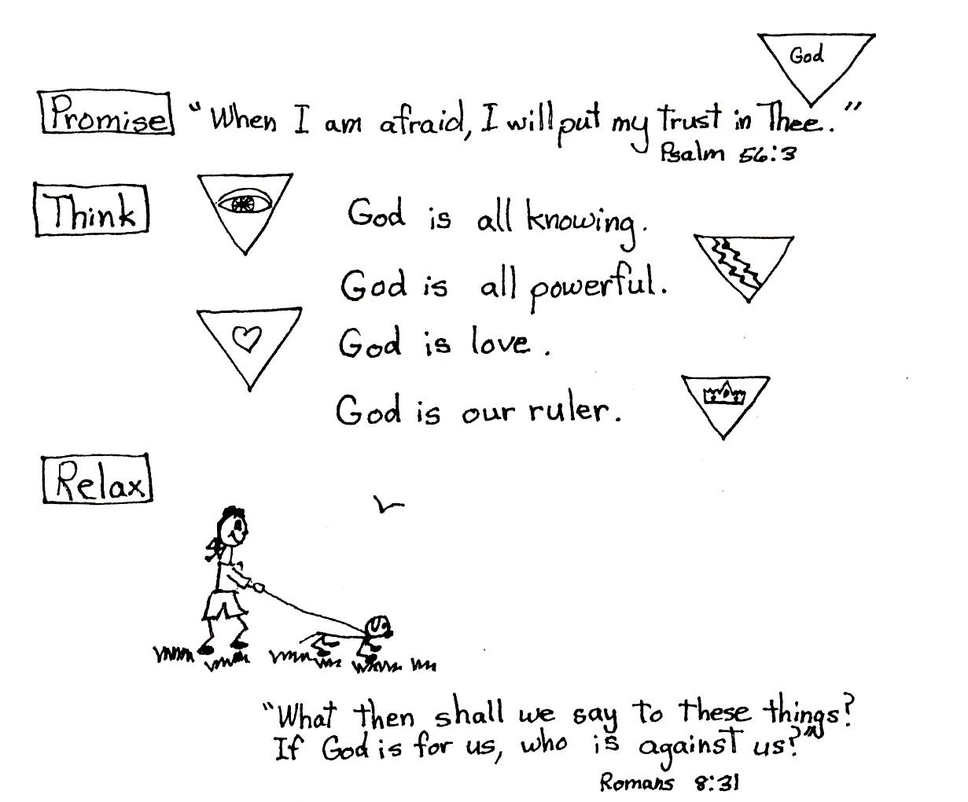
If we are going to take advantage of our primary assets and multiply them into secondary assets, we must humbly ask God to remove our bad sinful habits. This is sometimes difficult. It can be a little scary because sometimes we feel comfortable in our bad sinful habits or weaknesses. When we are fearful of something, sometimes we turn to our bad habits to solve our problems. Let’s say that one of our faults is lying. When we get fearful of what might happen to us if we tell the truth, we lie. We rely on our weakness or bad sinful habit! Not a good thing to do! We need to rely on God’s promises and His will for our lives. Humility, or obedience to God’s will, is the road to true freedom and safety in the spiritual life. Failure and misery can be changed by humility, which is teachability. Some pain, suffering, and humbling experiences will be involved when these sinful bad habits are being removed, but we must rely on God. Therefore, we must humbly ask God to remove our sinful bad habits!

Luke 14:11 “For everyone who exalts (praises) himself will be humbled, and he who humbles himself will be exalted (praised).

If we are going to take advantage of our primary assets and multiply them into secondary assets, we must make direct amends with people wherever possible, except when it would injure them or others. For example, there may be people that we’ve hurt. We need to make up with them, if it is possible. We must take responsibility for our past actions, our weaknesses. We need to work together, not cause problems. We are to forgive and encourage one another. We are not to let Satan cause conflicts. As believers, we are all members of the body of Christ. Just like the parts of our human body work together, the parts or members of the body of Christ need to work together.

Colossians 3:13 “Bear with each other and forgive whatever grievances you may have against one another. Forgive as the Lord forgave you.”

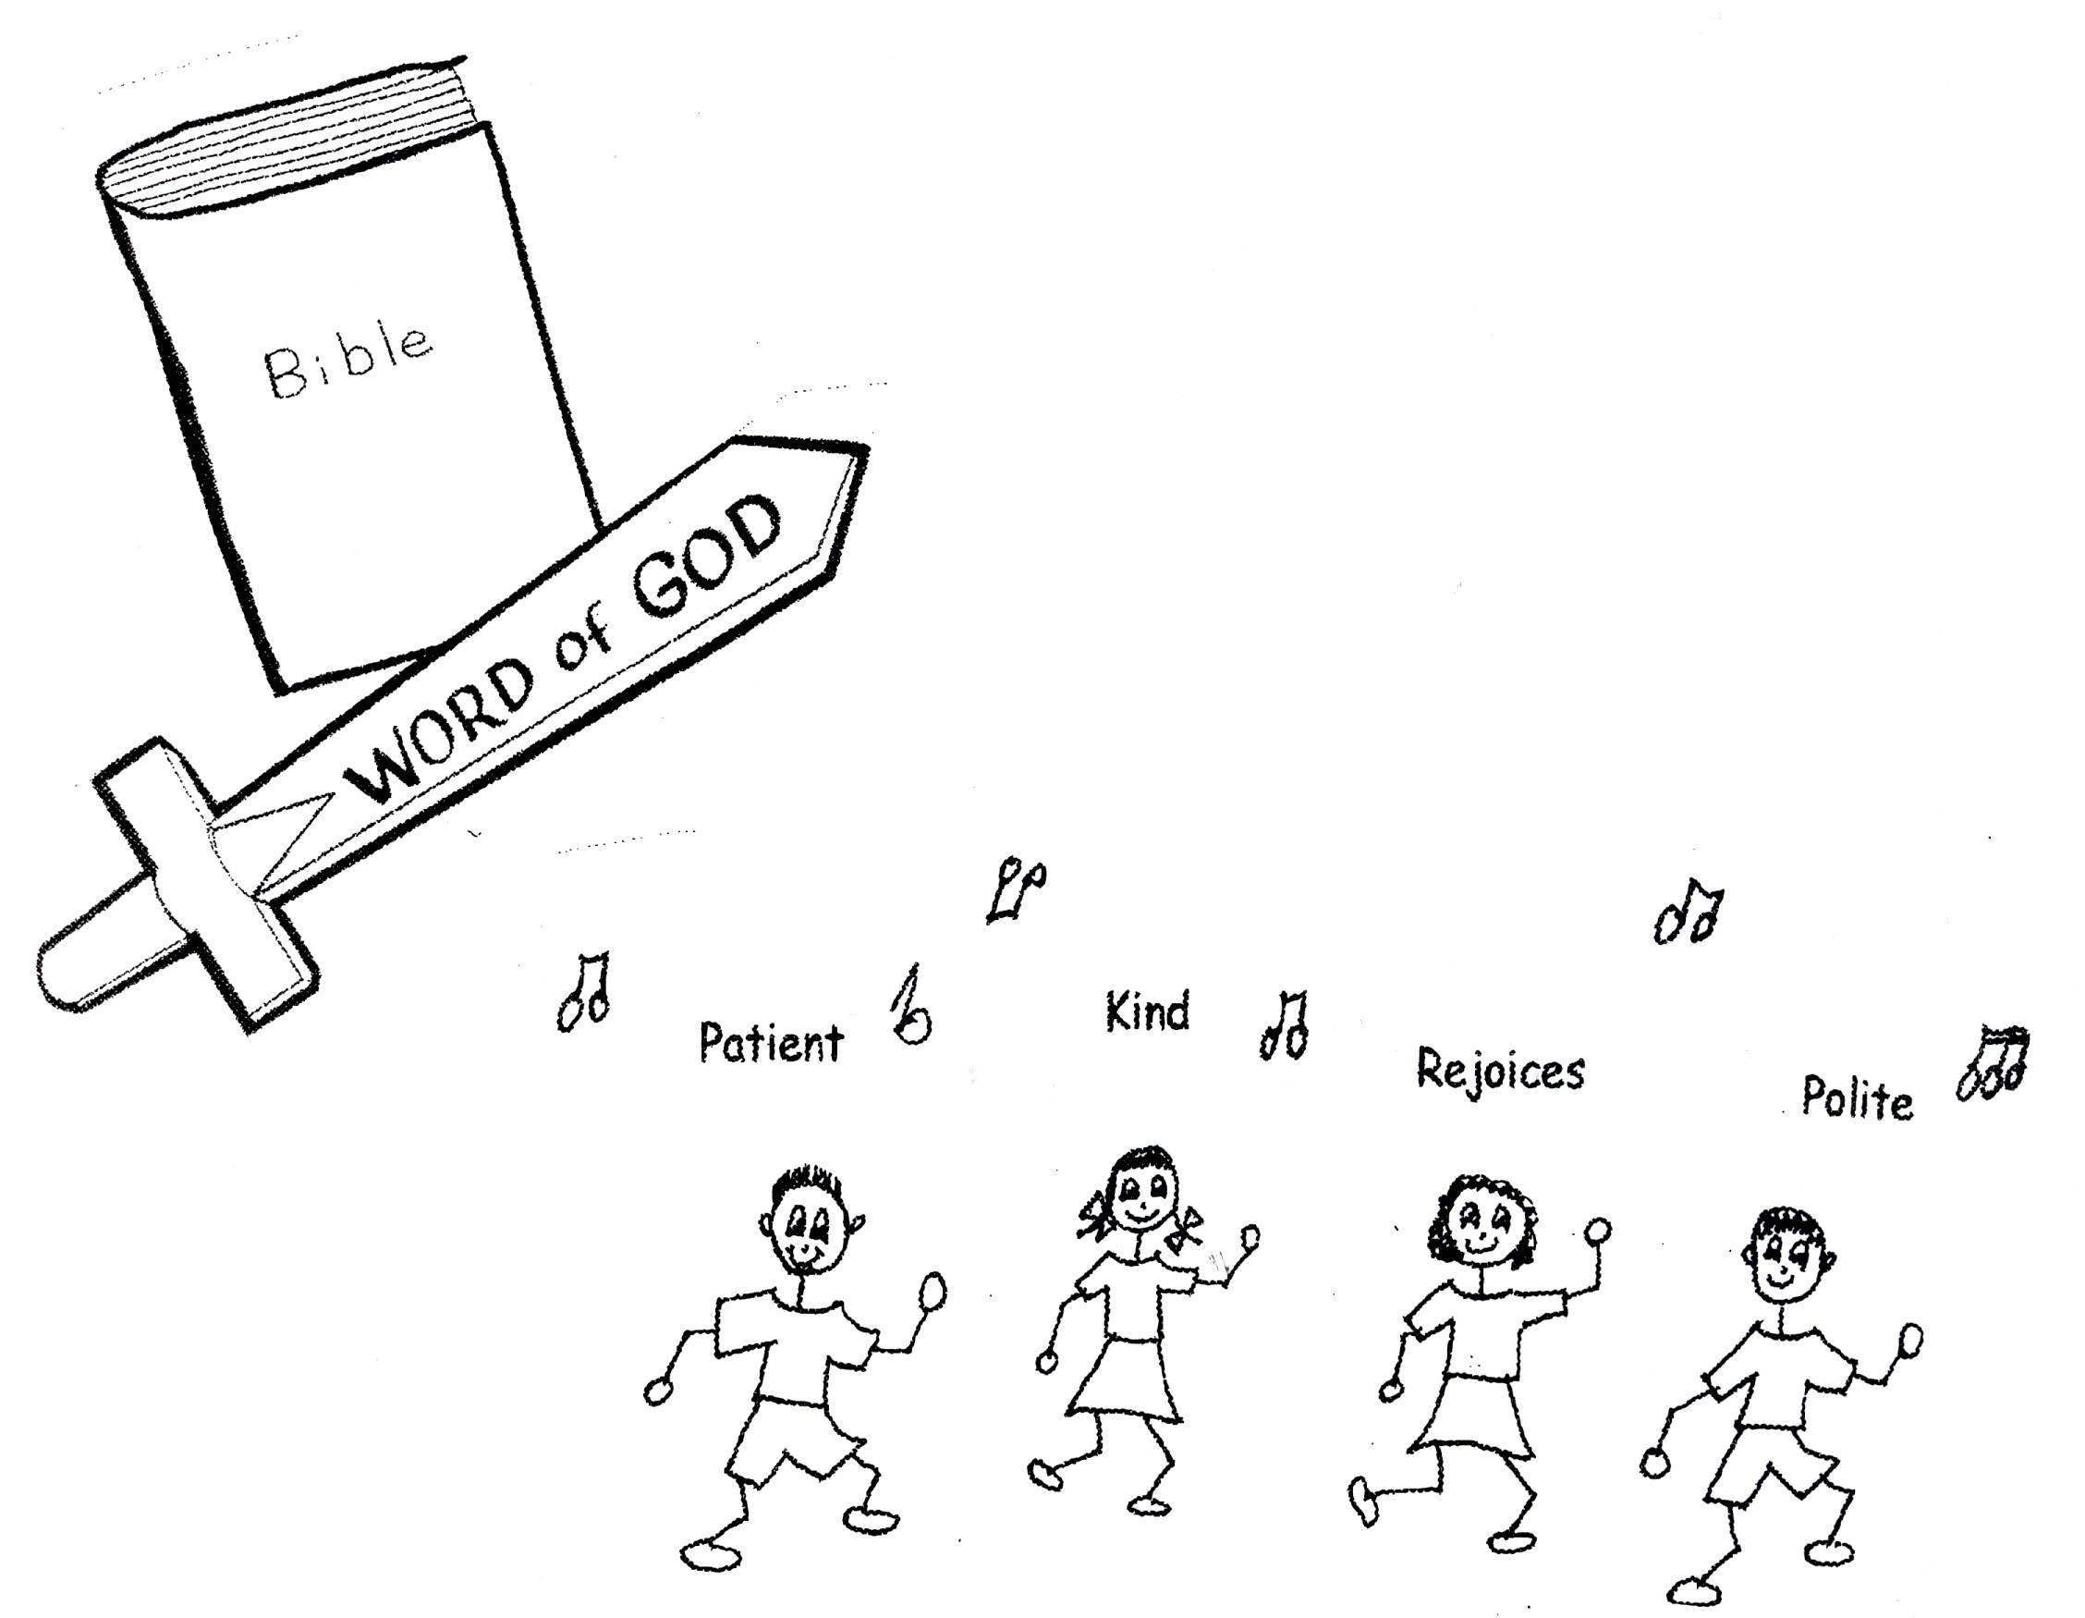

If we are going to take advantage of our primary assets and multiply them into secondary assets, there is something that we must do. We must seek, through prayer and meditation, to improve our relationship and fellowship with God. We can have contact with God anytime we choose. As long as we are filled with the Holy Spirit, we have a direct line to God. There is no interference. We don’t have to say, “Can you hear me now?” God always hears us. We need to keep that line open and thank God for all that He gives us. Sometimes we take God for granted and we forget that He is the One who gives us everything! We need to tell our Father all our desires for others and for ourselves. We need to ask Him if He will fulfill them. We need to pray for knowledge of God’s will for our lives. Then we need to use His power to carry out His will. In meditation, we can think about what an awesome God we have. We can think about our thoughts and see if they line up with His thinking. God has made it easy to keep in touch with Him. We just have to be aware of the fact that we need contact with God and do it!! Don’t keep God on “hold”! He wants us to keep in touch!

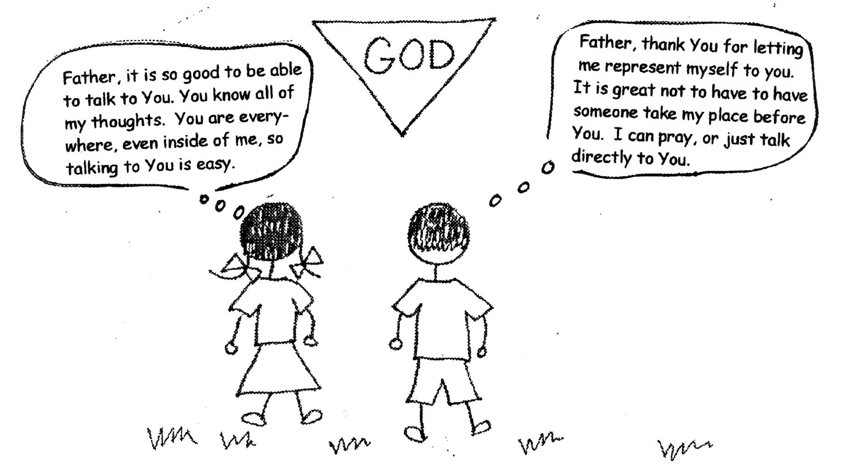

Ephesians 6:18 “And pray in the Spirit on all occasions with all kinds of prayers and requests. With this in mind, be alert (conscious) and always keep on praying for all the saints (believers).”

If we practice these mental exercises, we will have a spiritual awakening! It is definitely time for all of us to wake up! We need to admit our sinful bad habits so that we can grow in God’s wisdom. Depending on God and His wisdom is necessary in our spiritual and physical lives! Coming to an understanding of this will give us a great happiness everyday. We can have a relaxed mental attitude, an attitude based on God’s thinking. We can go forward in God’s plan for our lives. We can use our primary assets, election and predestination, and multiply them into secondary assets! We can bring glory to God! Isn’t that what it’s all about?
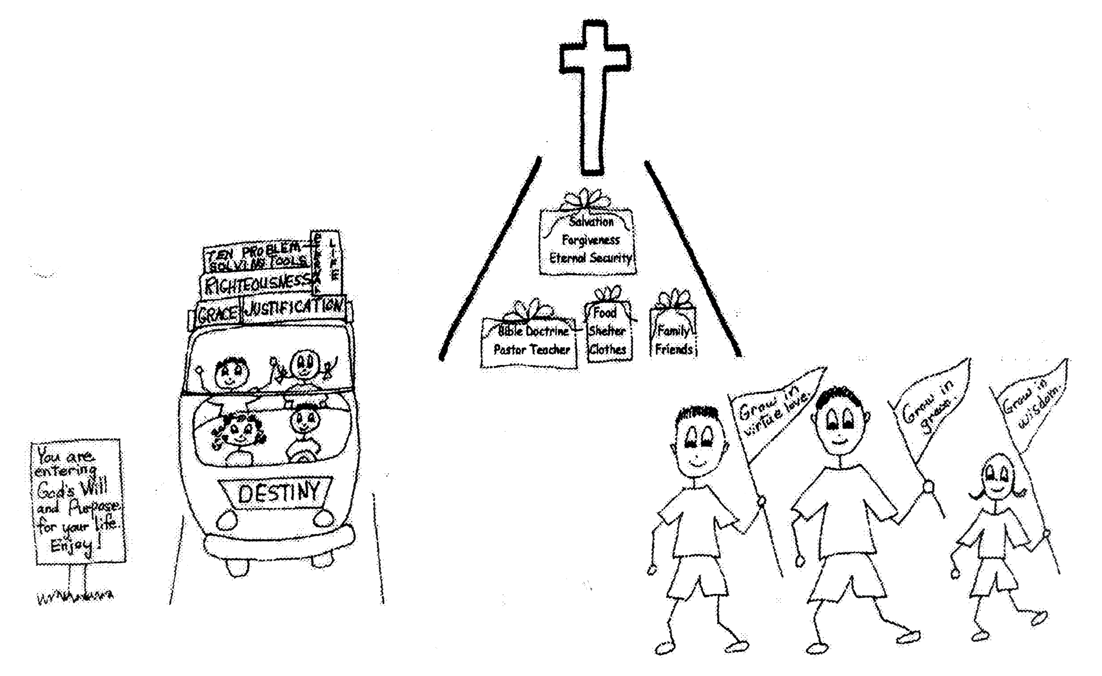

John 3:30 “He must increase, but I must decrease.”

Robert McLaughlin Bible Ministries (www.gbible.org) Lessons: 7-18-03, 5-13-05, 5-11-05, 7-12-06, 7-16-06, 8-4-06, 10-15-06, 10-18-06. Tree of Life: 9-10-06, 9-24-06, 10-22-06, 11-19-06.

www.lighthousechristianyouth.org and www.allaboardgodstrain.org.

