Lighthouse Christian Youth Ministry
Lesson 66

Soteriology
The study of
The Savior, Our Lord Jesus Christ

January 9, 2009

URGENT INFORMATION...
BEFORE we begin our Bible study, if you are a believer in the Lord Jesus Christ, take a moment to NAME any sins that you committed today to God the Father. This will allow you to be filled with the power of God the Holy Spirit who teaches us spiritual things of the Bible that is in our lesson today. (Eph 5:18) and (I John 1:9) are the verses from the Bible that teach us about this. Let’s read them together in our Bibles... | 
But, if you have NEVER believed in the Lord Jesus Christ as your personal Savior, you have that opportunity right now. Here’s what we mean by that. God tells us in the Bible that the ONLY way into heaven after we die is to know Jesus Christ. He’s the only way to get into heaven or simply He’s the only way to be saved. (Act 16:31) “Believe in the Lord Jesus, and you will be saved, you and your household." (John 3:16) "For God so loved the world, that He gave His one and only Son, that whoever believes in Him shall never die, but have eternal life.” (John 14:6) “Jesus said, "I am the way, and the truth, and the life; no one comes to the Father but through Me.” So you see Jesus is God’s Son and he became a man for us…a perfect man so He could save us from our sins. Every human being EXCEPT JESUS has a sinful nature when we are born. Jesus was born perfect because God is His father. Since we are all sinful God can have NOTHING to do with us. But God LOVES US and wants us to live in heaven with Him forever so He sent His Son to solve the sin problem and to save us. Isn’t that great? Not only did Jesus become a perfect man but He lived His entire life without committing one sin! He did this so He could take our place and pay the penalty for all of our sins. He did this by being hung on a Cross and taking all our sins in His own body. He was separated from God the Father and God the Holy Spirit for 3 hours on the cross paying the penalty for all the sins of every human being. This was so terrible for Him but He loved us so much that He was willing to suffer in our place so we could be in heaven with Him forever after we die. Then you know what happened after he died on the cross? He rose again from His grave and is lives right now and forever in heaven. And He wants you to believe in Him and trust Him for salvation.
So if you have never believed in Jesus, you can do so right now…simply tell God the Father that you believe in His son Jesus Christ as your Lord and Savior. If you make that decision, you are now a believer and will always be a child of God. When you die, you will spend eternity with Him.
"He who believes in the Son has eternal life but he who does not obey the command to believe the Son shall not see life, but the wrath of God abides on him." (John. 3:36)
(John 20:31) “…but these have been written so that you may believe that Jesus is the Christ, the Son of God; and that believing you may have life in His name.”

SOTERIOLOGY. WOW that’s a big word! It means “savior” in Greek. A savior is someone who saves or rescues people from something really bad and gives them something good. In Christianity, SOTERIOLOGY is the study of THE Savior, our Lord Jesus Christ. It is the study of salvation, which is the work of THE Savior, our Lord Jesus Christ. He rescued us from something really bad and provides believers something so fantastically good!
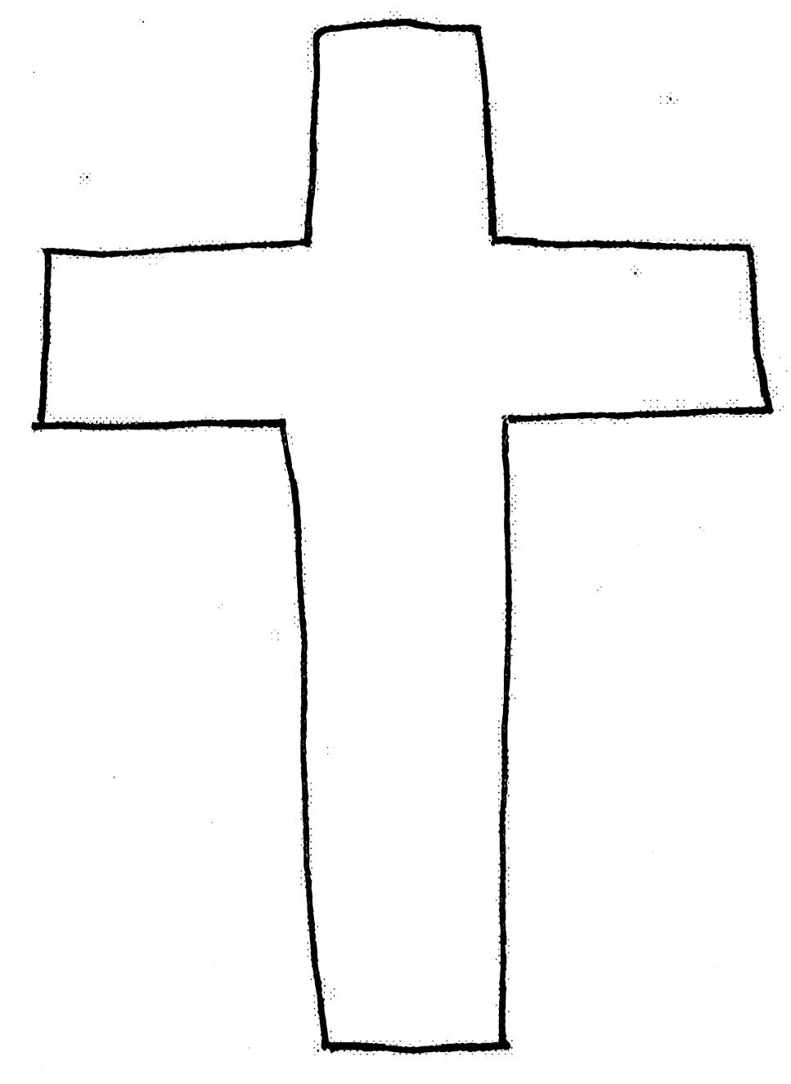
Psalm 27:1 The Lord is my light and my salvation – whom shall I fear?
The something really bad that Jesus Christ rescued us from is sin and the penalty of sin...the Lake of Fire. Sin started before man was created. It started with Satan. He wanted to be independent from God. He was a rebel! All of the other angels rebelled against God also but two thirds of them changed their minds and depended on God again. Then after God created humans to prove Satan wrong, Satan tempted Adam and Eve to sin so they would be independent from God just like him. And guess what? They fell for it and decided to sin. Then they lost their perfect condition and environment. Life changed drastically for them! They were thrown out of the perfect Garden of Eden.

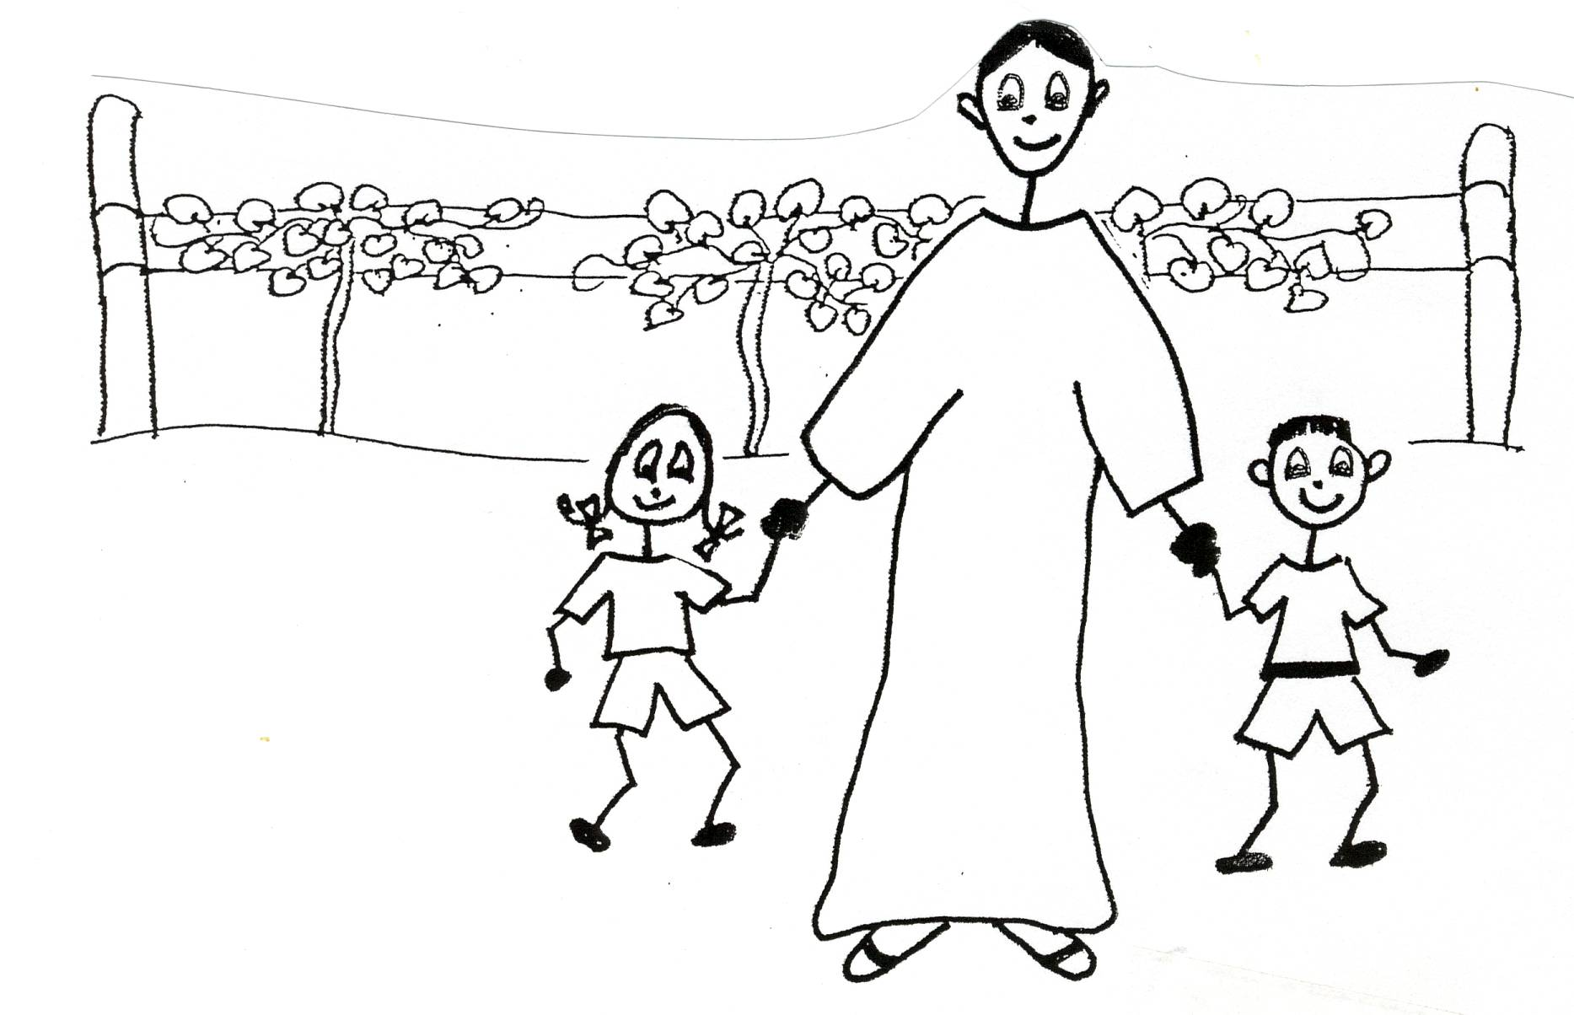

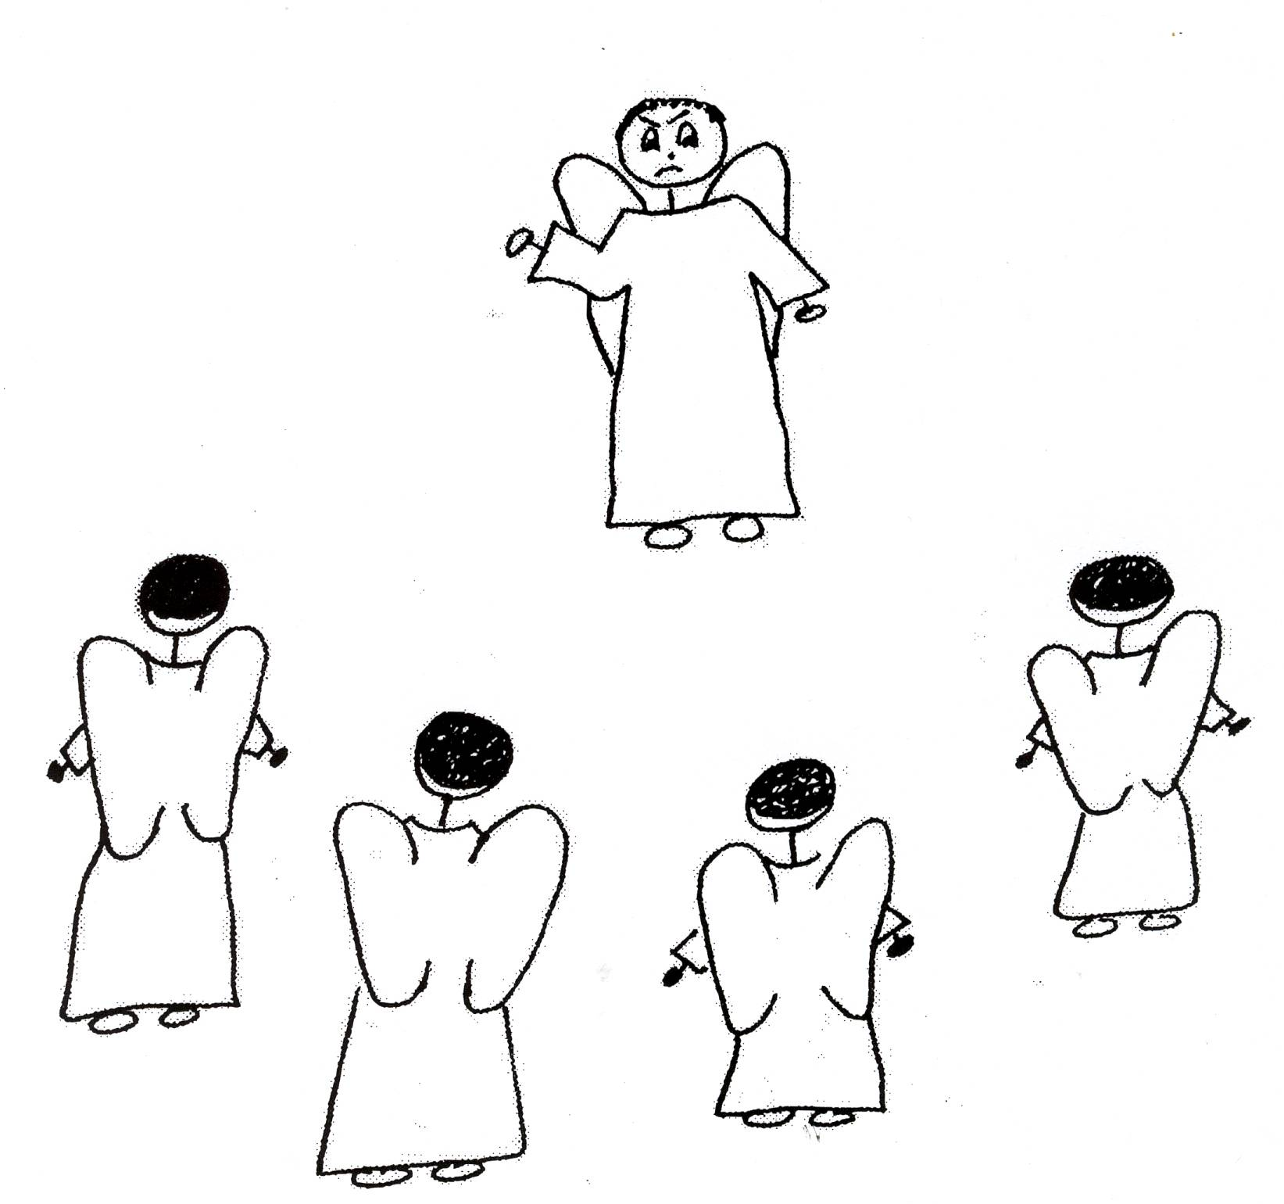

Peter 2:4 “For if God did not spare angels when they sinned, but sent them to Hades (in the compartment called Tartarus) putting them into gloomy dungeons (pits of darkness) to be held for judgment…”

Romans 5:1 “Therefore, just as sin entered the world through one man (Adam) and death (spiritual death) through sin and in this way death came to all men because all sinned…for before the law was given…sin was in the world.”

The drastic changes in Adam and Eve’s lives were that now they were dead spiritually, their souls were separated from God. Their nature was totally depraved or rotten! Their environment suffered decay and imperfection. Then one day they had to die physically. They were slaves to sin! From then on all of Adam and Eve’s descendants (that includes us) would be born with rotten old sin natures and would be slaves to sin. Their souls would be separated from God…that’s spiritual death. They would live in an imperfect environment. They would die physically. They were in need of a Savior! If there was no Savior, Adam, Eve, and their descendants would all have to suffer the second death. This is eternal separation from God and banishment from His presence forever in the Lake of
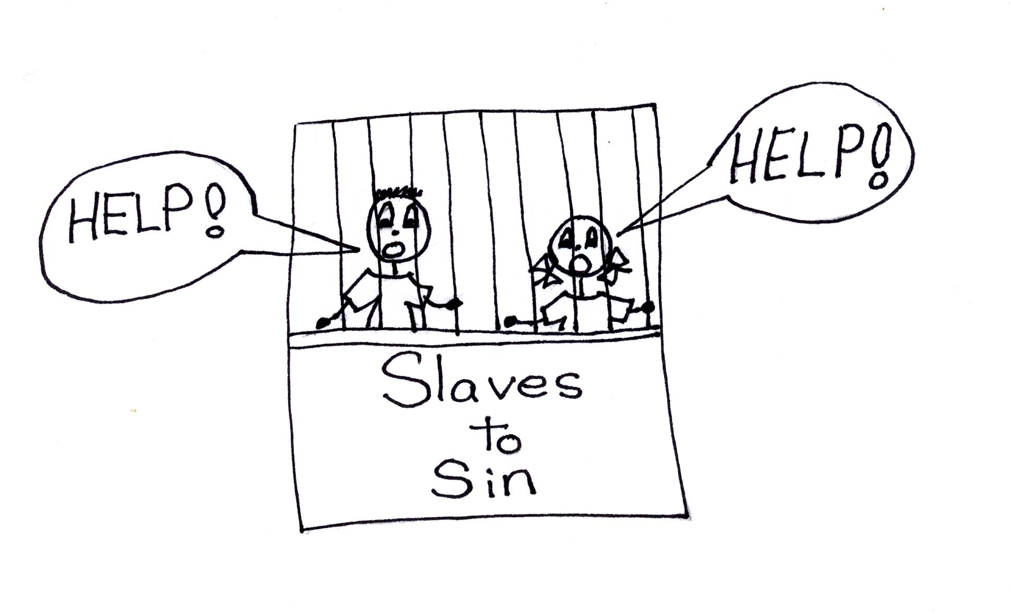
Fire! HELP!

Isaiah 59:2 “But your sins have separated you from your God…”

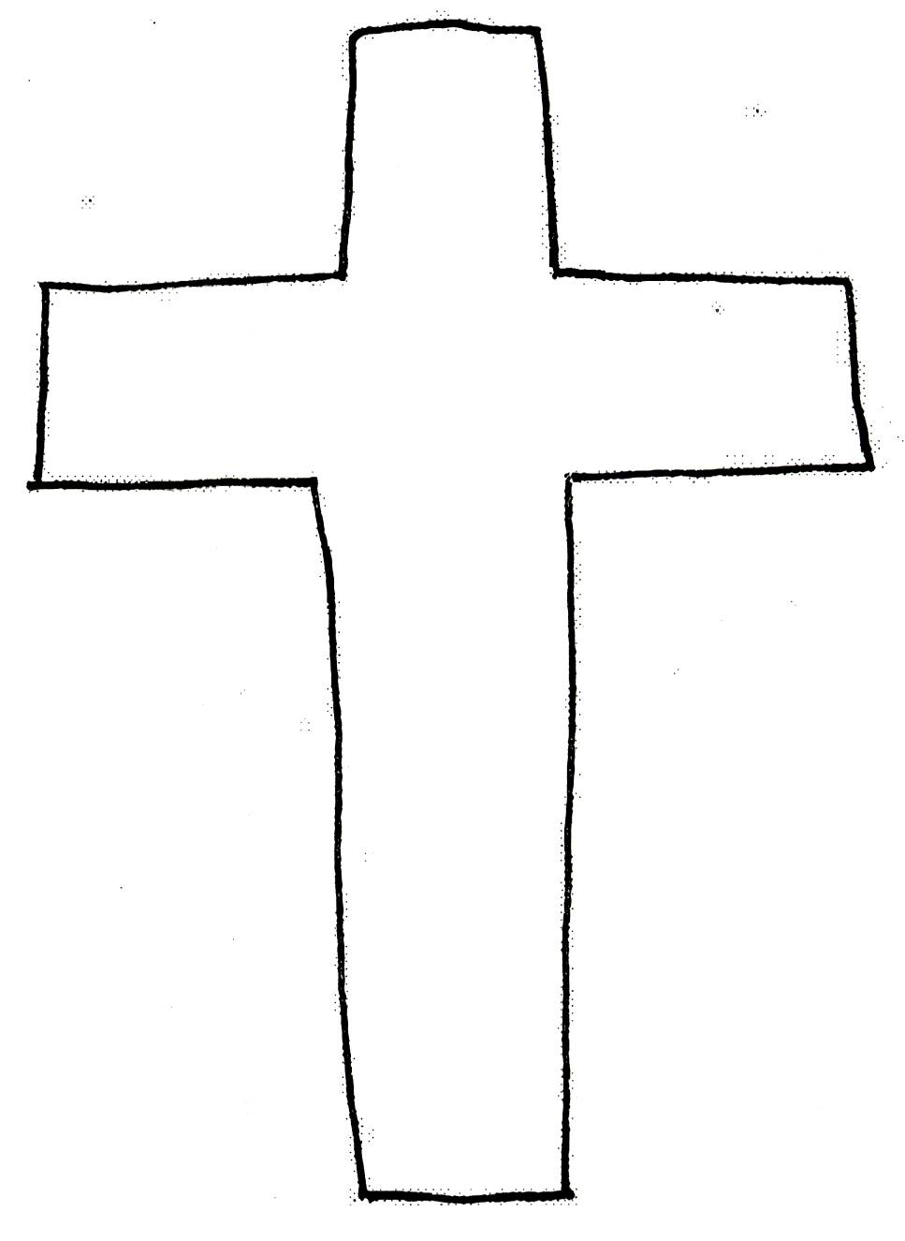
GOOD NEWS!!! No one needs to suffer the second death! No one needs to continue to suffer spiritual death, or separation from God. We have a Savior! JESUS CHRIST is our Savior! He was our substitute. He suffered spiritual death on the cross in our place. He was separated from God the Father in our place. He died spiritually so that we could live spiritually with and in God. Sin and its deadly effects were taken away by the “shed blood” of Jesus Christ. “Shed blood” refers to His spiritual death as our substitute on the cross. All we need to do is to believe in the Lord Jesus Christ and His work alone on the cross, and we will be SAVED! We do not need to be slaves to sin! What a blessing and relief that is!!!

1 Peter 2:24 “And He Himself bore our sins in His body on the cross, so that we might die to sin and live to righteousness (His perfection); for by His wounds you were healed.”

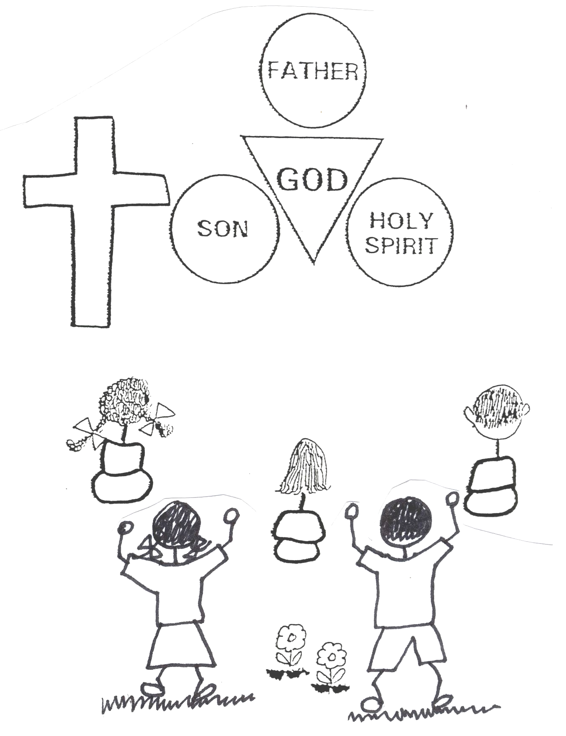
This is a beautiful verse in our Bible and you should all love what it is telling you! The work of our Lord Jesus Christ on the cross repaired all of the damage caused by sin. He rescued all mankind…us from the eternal suffering and doom of sin. Jesus’ work on the cross freed the God’s nature…His character…to grace us all out! God is now free to give us things that He had never given anyone before except to His Son, Jesus Christ. He can give believers the riches of His grace, including eternal life now and eternal glory in heaven! God restored what was lost by Adam in the fall, and He went way beyond that in giving great new things to believers in Jesus Christ. Believers are not slaves to sin any longer!!! Now we are God’s children and share EVERYTHING WITH HIM.

Ephesians 1:7-8 “In Him we have redemption (from the slave market of sin), through His blood (spiritual death on the cross), the forgiveness of sins, in accordance with the riches of God’s grace that He poured out on us with all wisdom and understanding.”

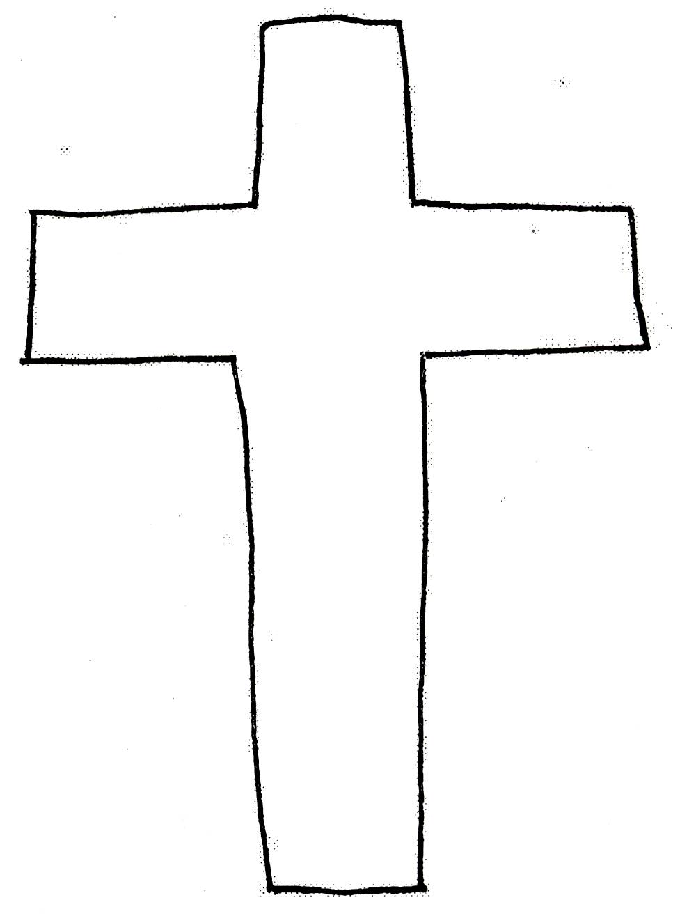
The great sin issue between God and man was is OVER because it was taken care of on the cross. The blood of Christ, His substitutionary, spiritual death, is effective for healing all sides of the sin problem. The work of Jesus on the cross is the “medicine” that cures all of the sickness of sin. His work on the cross completely satisfied the righteousness and justice of God (God’s perfect nature). God said, “That (the cross) is enough. “Tetalesti” in Greek means “IT IS FINISHED!” The only question that remains is whether man is satisfied with Jesus’ sacrifice that completely satisfied God. Sin is no longer an issue. The issue is: “What do you think of Jesus Christ?”

Acts 16:31 “Believe in the Lord Jesus, and you will be saved.”
All of the work of Jesus Christ on the cross that involves getting rid of negative things was done for ALL of the people in the world. The blood of Jesus Christ, which refers to His substitutionary, spiritual death on the cross, provided all of us with the following:
- Redemption for ALL. He paid the price for us and ransomed ALL of us from the slave market of sin. We are free and no longer a slave to our old sin nature.
- Propitiation for ALL! God the Father was propitiated or His justice was satisfied by Jesus’ work on the cross as payment for our sins.
- Expiation for ALL. Expiation means that the debt for sin was canceled. An end was put to our guilt…JESUS paid for it.
- Reconciliation for ALL. This means that there is a peace treaty between God and the entire human race. The sin barrier was removed. Man is restored to peace with God.
- Sanctification for ALL. God the Holy Spirit put us in union with Jesus forever. We are His and He is ours…We are ONE with HIM!

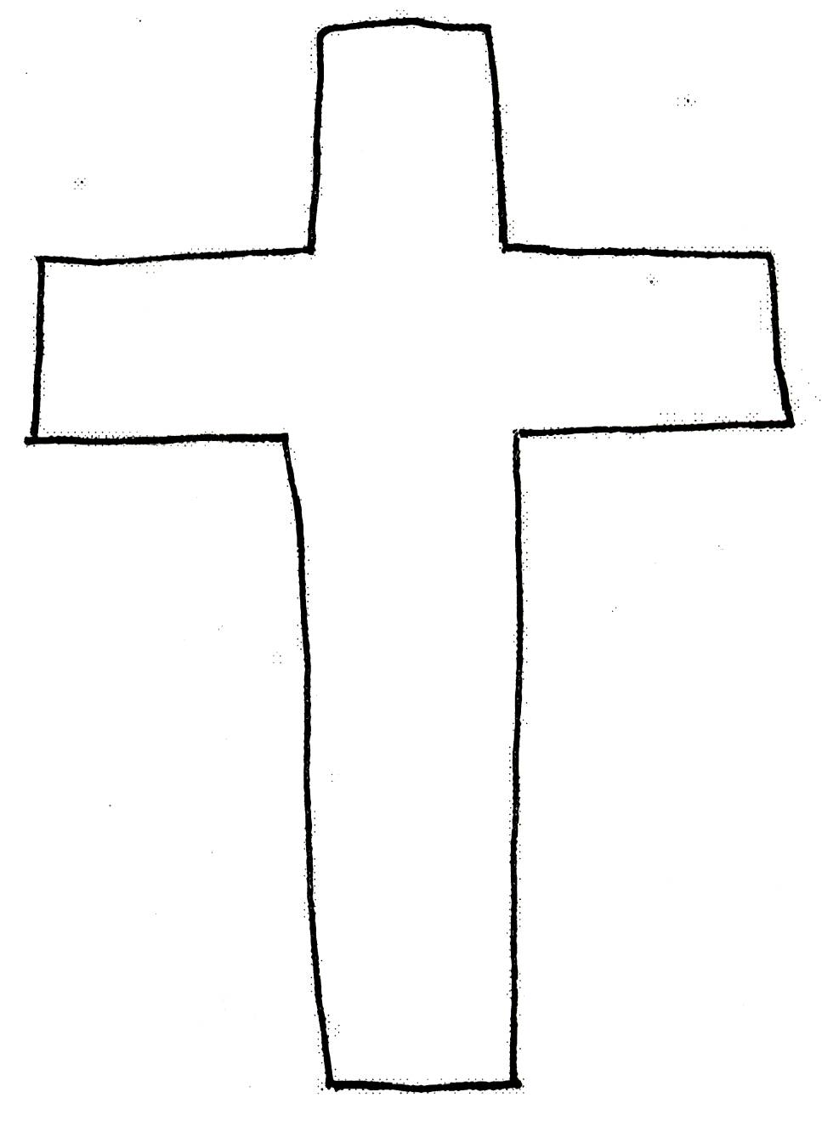
“It is finished” is the last recorded words of Jesus Christ before His physical death. He was referring to the finished work of salvation that He had just completed on the cross. This was for ALL of mankind…US!

Hebrews 2:9 “But we do see Him Who was made for a little while lower than the angels, namely, Jesus, because of the suffering of death crowned with glory and honor, so that by the grace of God He might taste death for everyone.”

All of the work of Jesus Christ on the cross that involves giving positive things was done only for believers. JUSTIFICATION is one of those things. This means we are no longer condemned to the Lake of Fire. Justification is the legal act of God that states that all believers are perfectly righteous because He has imputed (given as a gift like a brand on our soul) to every believer, or given him, His perfect righteousness, +R. The believer receives the verdict from God of “righteous”. Jesus Christ paid a HUGE price for this gift, but it is a FREE gift to us, a gift of grace. We don’t earn it or deserve it. As believers, we are now free from the slave market of sin! Now comes the commitment on the believer’s part of living in that gift of salvation! Are you committed or dedicated to Jesus?
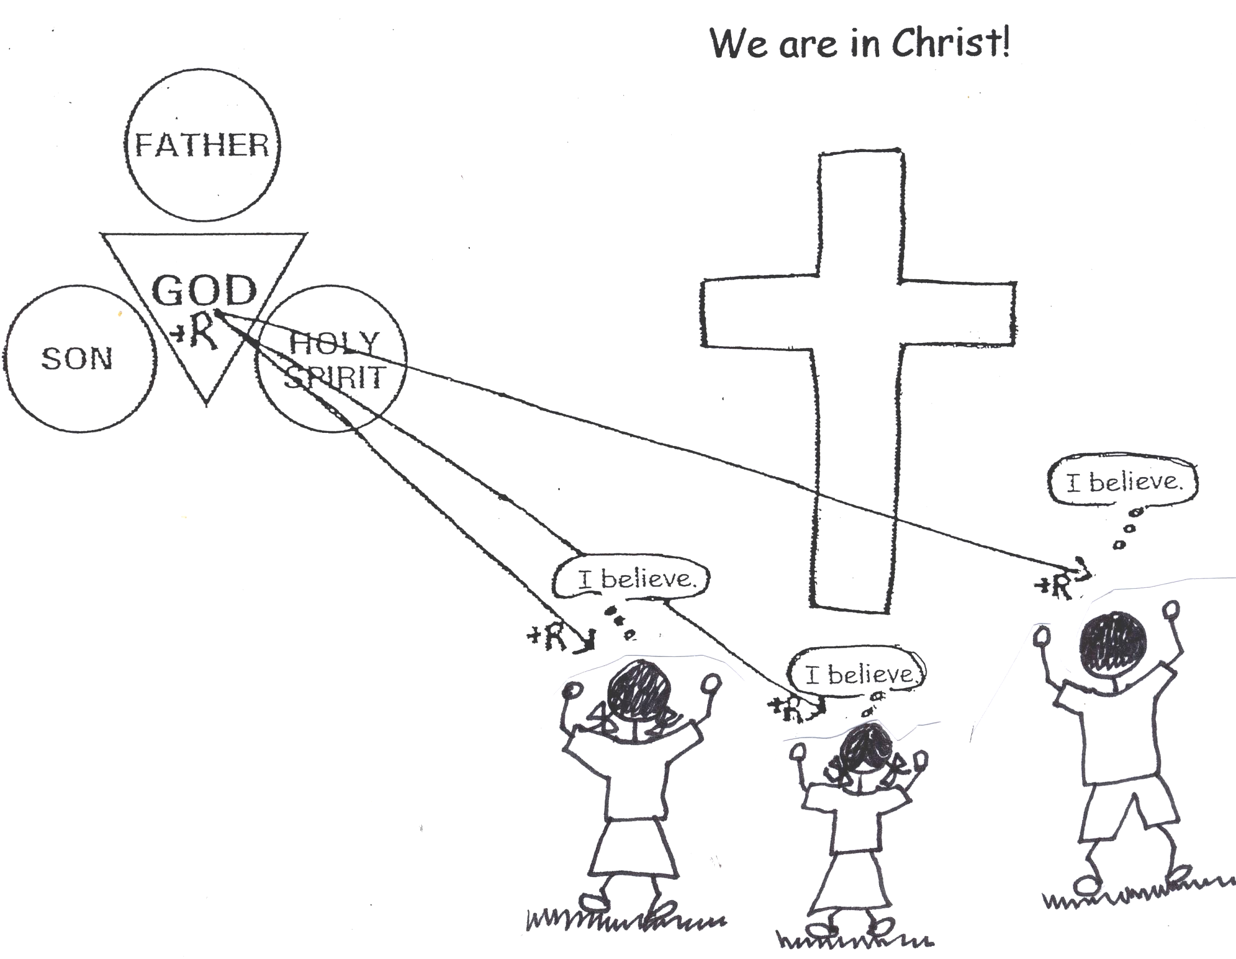

Romans 3:26-28 “He did it to demonstrate His justice at the present time, so as to be just and the One Who justifies those who have faith in Jesus. Where, then, is (our) boasting? It is excluded. By what kind of law? Of works? No, but by a law of faith (believing). For we say that a man is justified by faith NOT from (human) works of the law.”

www.lighthousechristianyouth.org
Prep@gbible.org
Grace Bible Church
Lessons: Basic Series, 9-19-06, 9-26-06

