Lighthouse Christian Youth Ministry
Lesson 67

Expiation
The Price Paid for Sin
by
Our Lord Jesus Christ

January 30, 2009

Remember we are studying Soteriology. That’s our big word from our last lesson. It means the study of our Lord, Jesus Christ…the study of the Savior. Now in this lesson we’re going to study some more about our Savior. We’re going to study who He is and what He did for us with EXPIATION up next.

EXPIATION is another big word! It means paying for a wrong by suffering the penalty for that wrong. Adam and Eve were the first humans to go against God and they committed a wrong called sin. After that, their entire world changed. They no longer lived in perfect environment. They were kicked out of the Garden and they were spiritually separated from God, which means that they were dead spiritually. They received old sin natures. They would eventually die physically. These things were all passed on to the rest of us and all human beings. Mankind needed to pay for the penalty of their wrong, which was sin. We needed HELP!

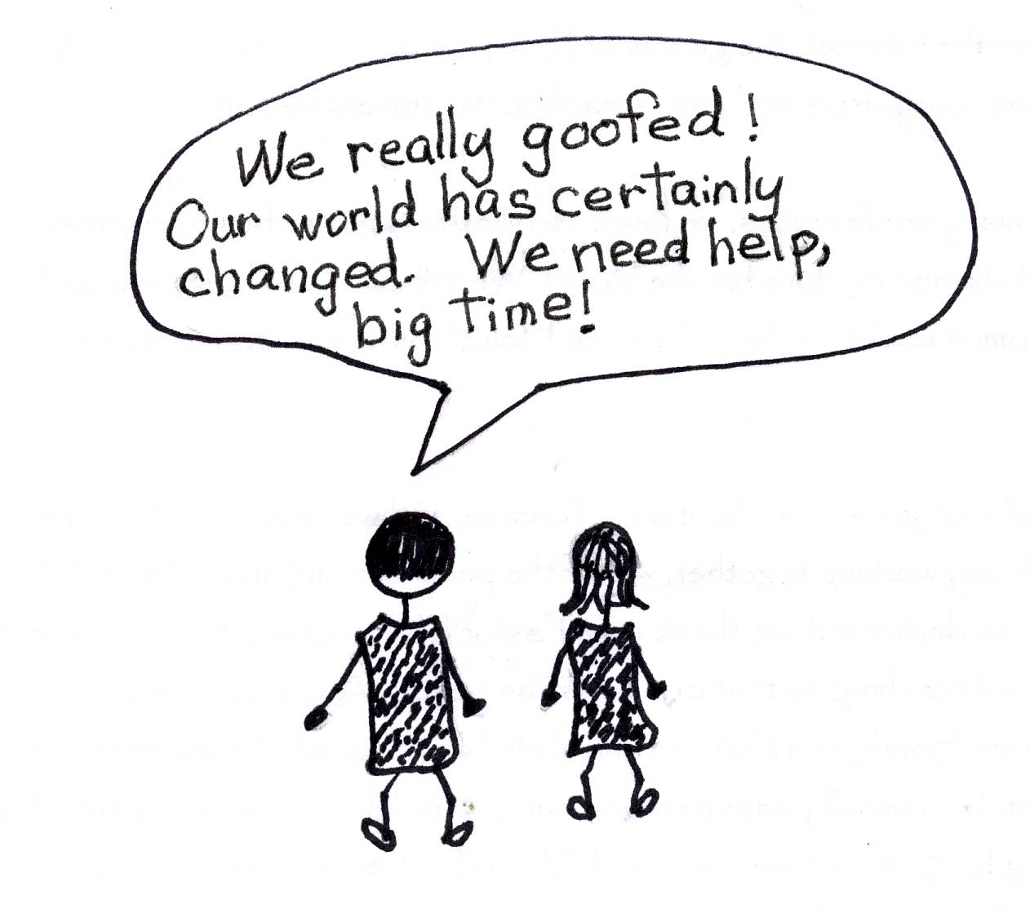

Romans 3:9-10 “What shall we conclude then? Are we any better? Not at all! We have already made the charge that Jews and Gentiles alike are all under sin. As it is written: ‘There is no one righteous, not even one…’”

Who always steps in to save us? GOD! God the Father planned for His Son, Jesus Christ, to come to pay the price, the expiation, for everyone’s sins. We don’t qualify!!! That’s because God is just and only a mediator…ONE who never sinned…could go between God and us to take our place to pay the price! It had to be done by someone who was a perfect man. The Lord Jesus Christ was that perfect man and it had to be God also in one person. And the good news is that when Jesus came to earth and went to the Cross, He set us all free from the slave market of sin, because of the payment that only Jesus Christ could have made. The payment was the Blood of Christ, His spiritual death on the cross. His was a substitute payment for all. He took our place. What a great price Jesus Christ had to pay for us. What EXPIATION!

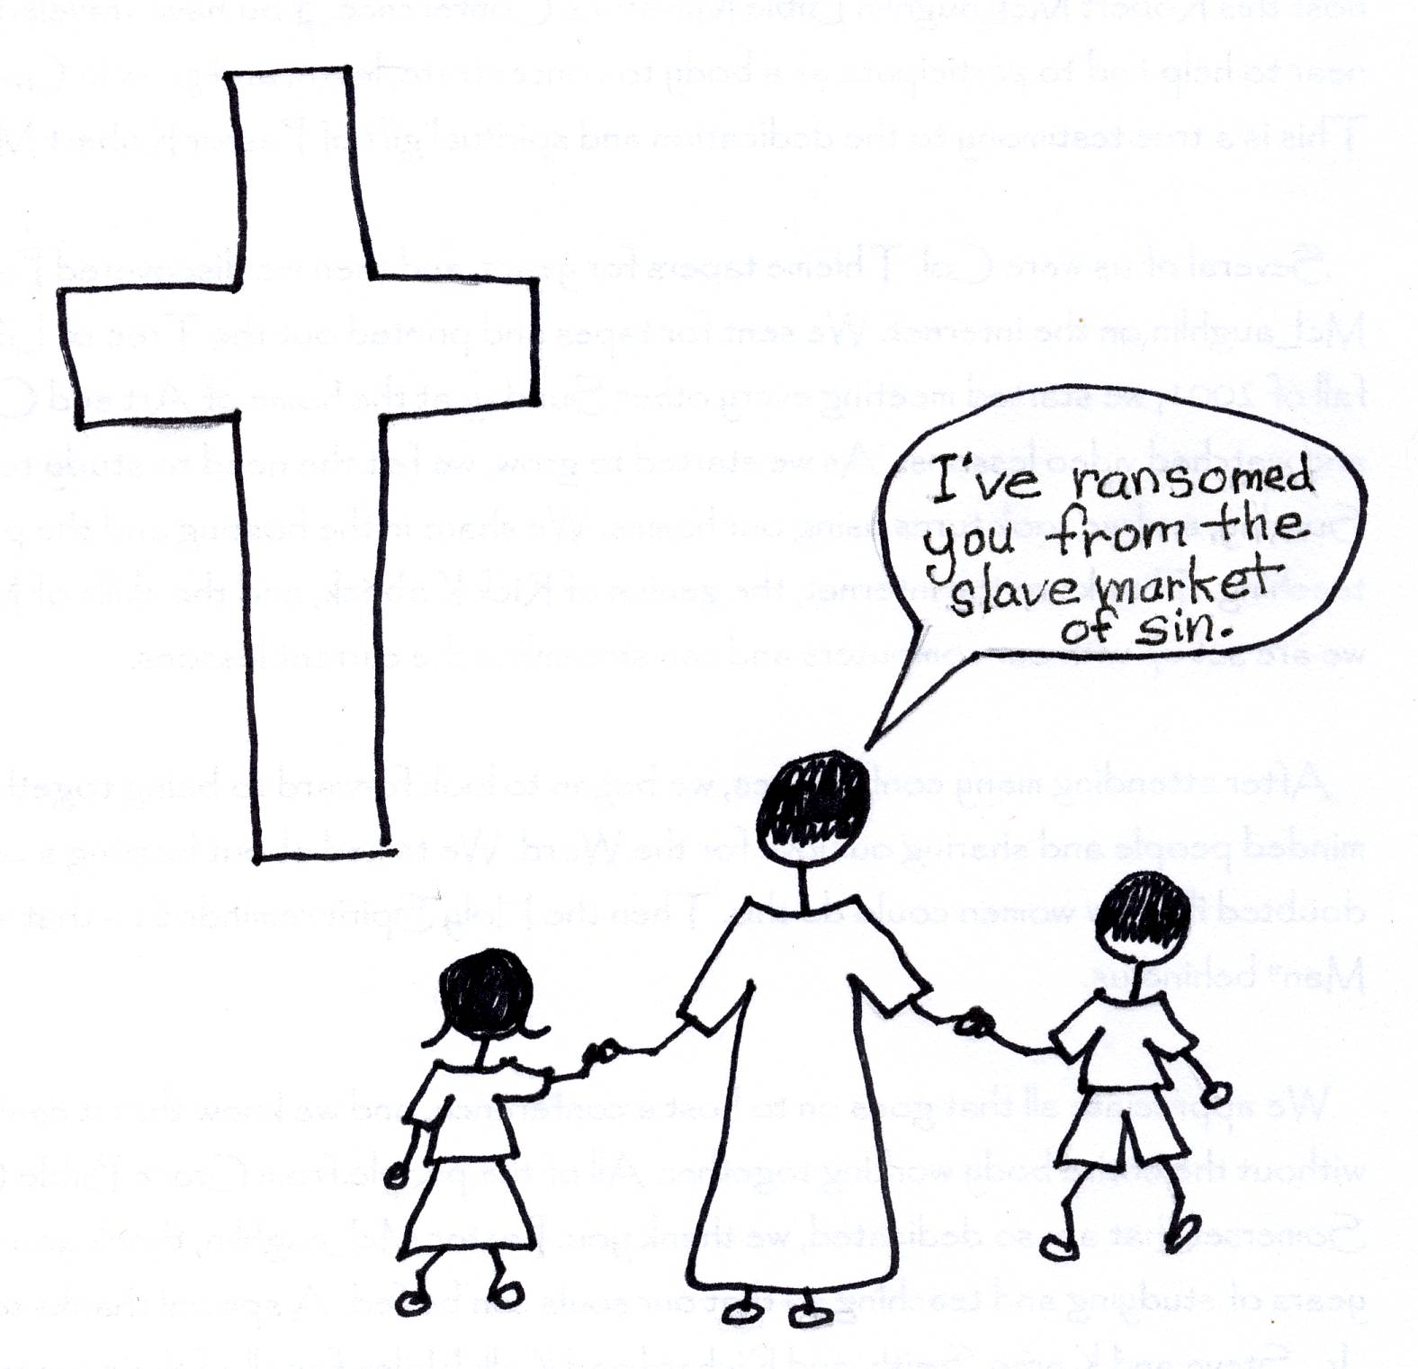

1 Timothy 2:5-6 “For there is one God, and one mediator also between God and men, the man Christ Jesus, who gave Himself as a ransom for all, the testimony given at the proper time.”

Before the cross, God had special training aids for people to teach them about salvation and rebound or confession. Many of the people in the Old Testament times could not read or write. They needed to see an example of what they were being taught. So, from Adam to the cross, innocent animals were sacrificed as sin offerings. The rich people used bulls, the middle class used goats or sheep, and the poor used doves. An animal’s life is in his blood. When the animal was on an altar and his neck was cut, blood spurted out everywhere and he died. Ewwww! This was very graphic or gory and easily understood! God wanted to make sure that they got the picture! They saw what the Messiah or Savior would do for them.
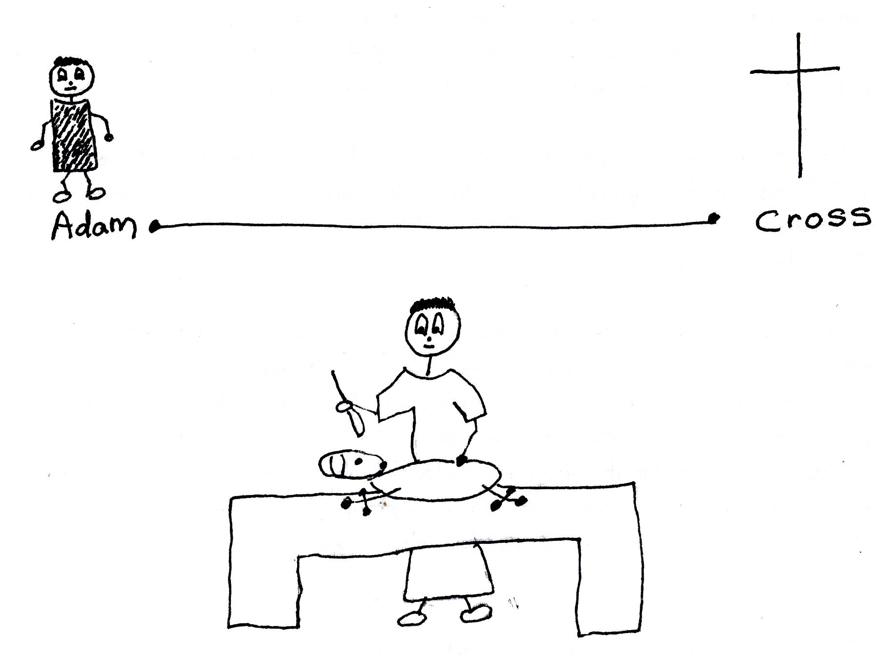

Hebrews 9:13-14 “The blood of goats and bulls and the ashes of a heifer sprinkled on those who are ceremonially unclean sanctify them so that they are outwardly clean. How much more, then, will the blood of Christ [His spiritual death on the cross] Who through the eternal Spirit offered Himself sinless to God, cleanse our consciences from acts that lead to (spiritual) death, so that we may serve the living God!”

Now man’s life is in his soul. Innocent Jesus took our place as a sin offering. Jesus’ soul was separated from God the Father for three hours on the cross…from noon until 3:00 PM. This is when He died spiritually and paid the price for our sins. The “blood of Christ” refers to His spiritual death on the cross, or His soul being separated from God the Father. This was extremely painful for Jesus! We can’t even imagine how painful. He had never been separated from His Father. He knew no sin. Jesus Christ’s spiritual death was the EXPIATION for our sins. What a price He paid for us! He loves us so.

Colossians 2:14 “Having canceled out (wiped out, erased) the certificate of debt (handwritten IOU consisting of decrees against us in the Old Testament Law), which was hostile to us; and He has removed it, having nailed it to the cross (Christ’s substitutionary spiritual death on the cross).”

The gory animal sacrifices were to teach the people about the salvation work of Jesus on the cross…the Messiah or Savior to come. These sacrifices were never the way to salvation and forgiveness. Only Jesus’ spiritual death on the cross is the true way of salvation. His sacrifice is the EXPIATION…HE PAID THE PRICE! He is the only One that could satisfy the justice of God. Jesus did all of the work. All mankind has to do is BELIEVE in Jesus Christ as their Savior and His work on the Cross.
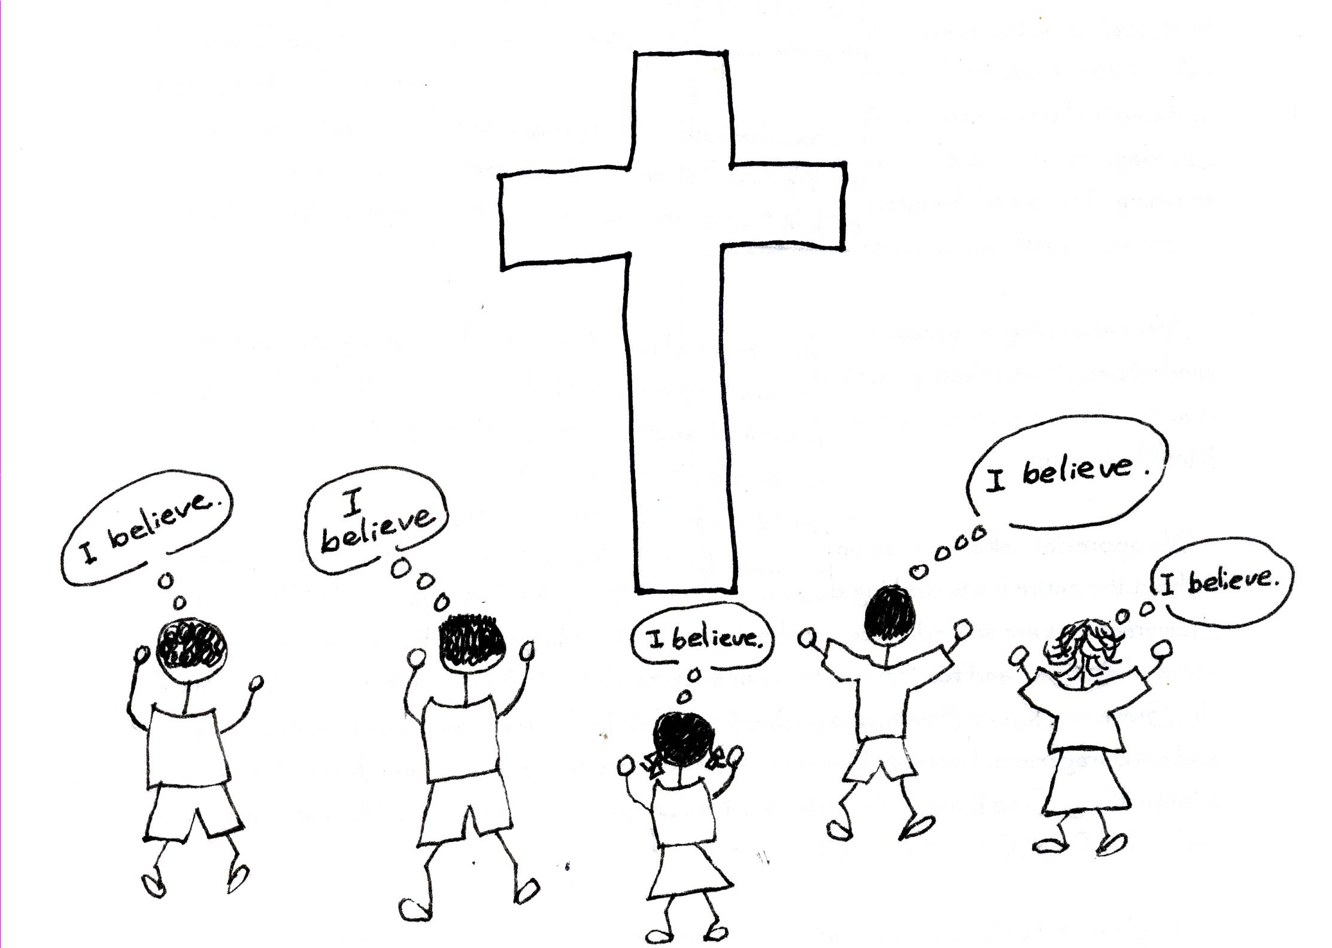

Acts 16:31 “Believe in the Lord Jesus Christ and you will be saved.”

Some people believe that it was the real shedding of Jesus’ blood and physical death that saved us. However, we know from the Bible that this is not true. After Jesus had suffered and died spiritually for our sins, He said out loud in John 19:30 “Therefore when Jesus had received the sour wine, He said, "It is finished!" This meant that salvation was finished, once and for all. Jesus Christ was now back in fellowship with God the Father. Then He bowed His head and said, “Into Your hands I commit my spirit; you have delivered Me, O Jehovah, God of doctrine.” (Psalm 31:5; corrected translation) Jesus breathed His last breath and died physically AFTER salvation was completed. EXPIATION had been completed before Jesus died physically.

Luke 23:46 (this is the corrected translation of this verse) “And when Jesus had shouted with a loud voice He said, “Father (this shows Jesus was back in fellowship with God after salvation was complete), into your hands I deposit my spirit,” and having said this, He breathed His last breath. (He died.)”

References: Robert McLaughlin Bible Ministries
www.gbible.org

Lessons: 9-26-06, 10-03-06, 10-10-06, 10-17-06

The Blood of Christ, R.B. Thieme, Jr.

Lesson 67 - Activity Sheet for Expiation or the Price Paid for Sin

Unscramble the words:

mAad _ _ _ _
ins _ _ _
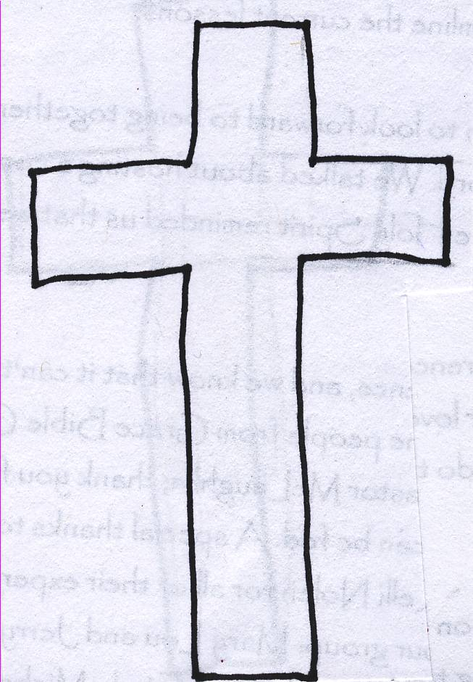
eid _ _ _
veE _ _ _
nioexpait _ _ _ _ _ _ _ _ _
ytalnep _ _ _ _ _ _ _
recip _ _ _ _ _
ooldb _ _ _ _ _
vaes _ _ _ _
lsaev _ _ _ _ _
eiveebl _ _ _ _ _ _ _
sJseu _ _ _ _ _
yastsif _ _ _ _ _ _ _
eciusjt _ _ _ _ _ _ _
