Lighthouse Christian Youth Ministry
Lesson 68

PROPITIATION
God the Father Was Satisfied
by
Jesus Christ’s Work on the Cross.

February 20, 2009

Listen up! Listen up! We’re still studying Soteriology…all about who our Lord Jesus is and what HE did for us on the cross. We call it the cup when we have communion! We drink the grape juice and we celebrate all the wonderful things our Savior did for us. This is the “Blood of Christ” that we remember when we drink from the cup.

So our next part of the study is called propitiation! We have an awesome God who has taken care of our sin problem! We don’t, in fact, we can’t, make up to God the Father for our sins! We can’t satisfy His holiness. But don’t worry! Our Lord Jesus Christ satisfied or propitiated God’s holiness for us! His holiness is His righteousness (goodness) and justice. God is 100% good and 100% just. What a Friend we have! What a God we have! Propitiation frees the justice of God to give anyone who believes in Christ one-half of divine holiness, the righteousness (+R) of God. Believers have the very righteousness of God because God the Father has been propitiated (satisfied) with Jesus’ work on the Cross!
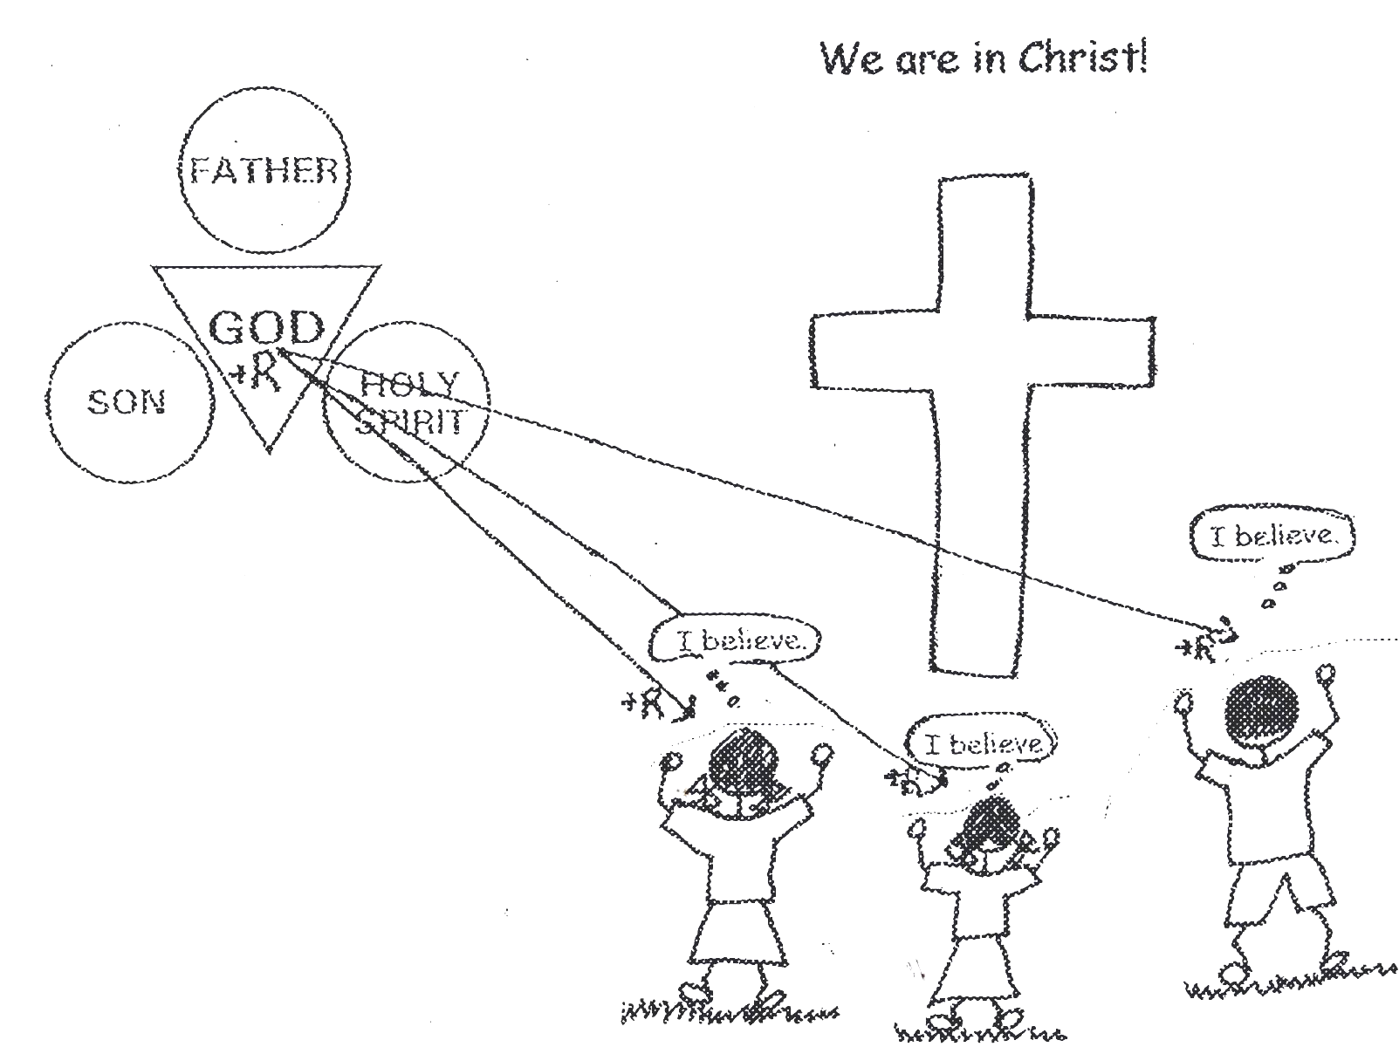

-

Romans 3:23 “For all have sinned and fall short of the glory of God.”

God’s holiness is perfect and totally separates Him from all that is evil or sinful. His righteousness condemned sin and approved the work of Jesus Christ on the cross. In His justice, God the Father imputed or charged all the sins that any human being would ever commit to Jesus Christ on the cross and judged them all at that time in Jesus’ body on the Cross. Jesus Christ’s substitutionary spiritual death on the cross has completely satisfied God the Father…TOTALLY! God the Father has been PROPITIATED!
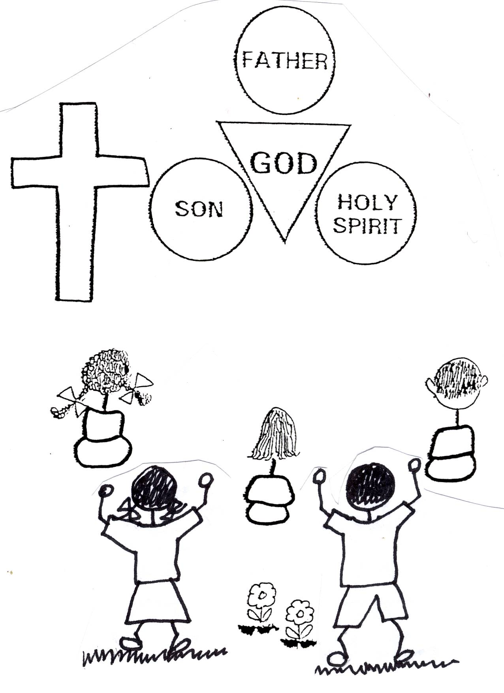

Romans 3:24 “Being justified as a gift by His grace through the redemption which is in Christ Jesus”

Propitiation is the God-ward side of the work of Christ in salvation. Jesus Christ satisfied God the Father’s holiness. Reconciliation, peace, which we will study next, is the man-ward side of the cross. We can now have peace with God. Redemption is the sin-ward side, for all sin has been paid for, or we’ve been redeemed. God no longer looks at our sins!! We’ll study these in the next lessons coming up.
Romans 3:24-25 “…being justified as a gift by His grace through the redemption which is in Christ Jesus; (25) whom God displayed publicly as a propitiation in His blood (spiritual death) through faith. This was to demonstrate His righteousness, because in the patience of God He passed over the sins previously committed (by mankind).”

Because at salvation we receive the righteousness (+R) of God, God’s justice is now able to give us blessings. Divine justice must judge sinful man before divine justice is free to bless sinful man. Jesus Christ was judged in our place for our sins, even though He had no sin. He was our substitute. He died a spiritual death on the cross. His spiritual death was when He was separated from the Father. God the Father cannot have contact with sin. Therefore, He had to be separated from Jesus while Jesus was being judged for the sins of all sinners. God the Father had to forsake Jesus! Mark 15:34 “And at the ninth hour Jesus cried with a loud voice, saying, “Eloi, Eloi, lama sabachthani?” Which is, being interpreted, My God, my God, why have you forsaken me?” After it was all over, God was and is still free to bless us. What a blessing! However, we must believe in Jesus Christ’s substitutionary spiritual death on the cross in order to be in His family and to receive these blessings.

Romans 3:22 “This righteousness (+R) from God comes through faith in Jesus Christ to all who believe.”

God’s wrath, or divine punishment, fell upon Christ carrying our sins on the cross NOT ON US!!!! If divine wrath had not fallen upon Christ, it would have to have fallen on us! However, we would not have been able to take it nor could we pay the price for sin. God knew that. So, He had Jesus Christ be a substitute for us. God is holy, meaning that He is righteous (good) and just. He wants the BEST for all of us. He cannot let sin pass though. He was not angry at Christ, because Jesus Christ was impeccable…PERFECT…He had no sin. God was not angry at sinners, for God so loved the world that He gave His only beloved Son as a sacrifice for our sins. God’s wrath or anger was against sin! Do you see?
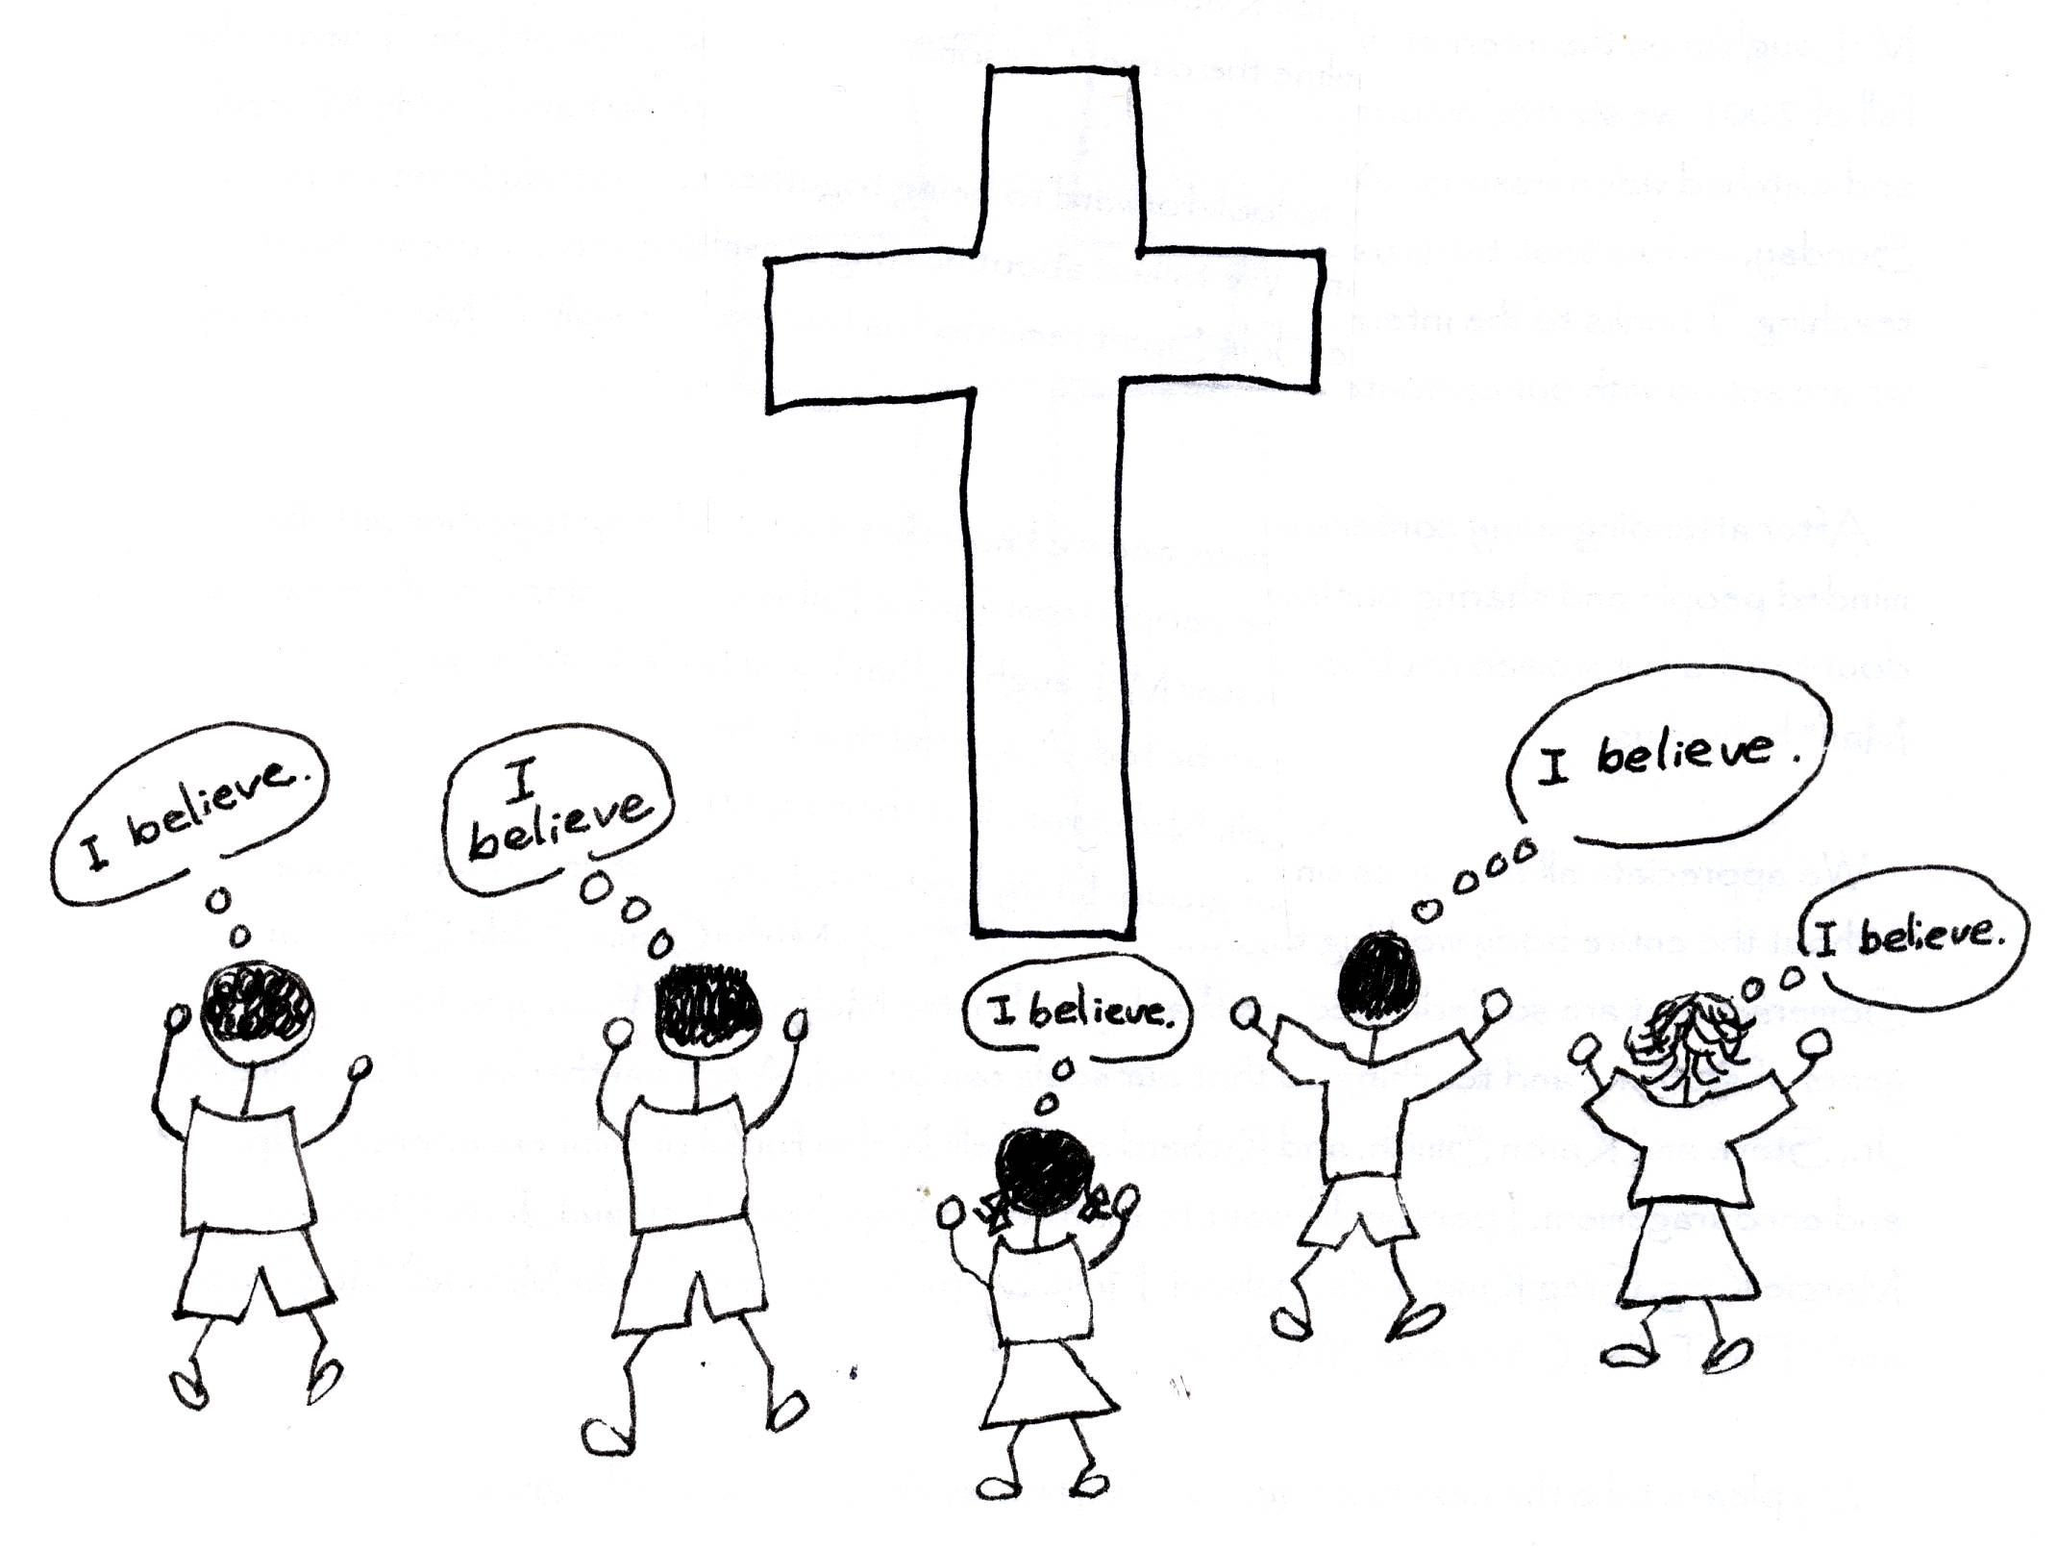

1 John 2:2 “And He is the propitiation for our sins, and not for ours only but also for the sins of the whole world.”

1 John 4:10 “This is love: not that we loved God but that He loved us and sent His Son to be the propitiation for our sins.”

Romans 8:31-32 “What then shall we say to these things? If God is for us, who is against us? He who did not spare His own Son, but delivered Him over for us all, how will He not also with Him freely give us all things?”

We sometimes forget the main reason for the cross, and that is the holiness of God, or His justice and righteousness, or goodness. His justice and righteousness had to be satisfied. Sin is outrageous to God…a vicious act against His holiness, and challenges His rulership. On the cross, Jesus Christ glorified or honored God where sin had so dishonored Him. Jesus Christ’s work on the cross glorified God publicly before the universe. The blood of Christ, His spiritual death, showed the infinite holiness of God. It showed His endless love and grace. We need to train our spiritual eyes to look upon the cross as first of all glorifying God! God was glorified and propitiated.
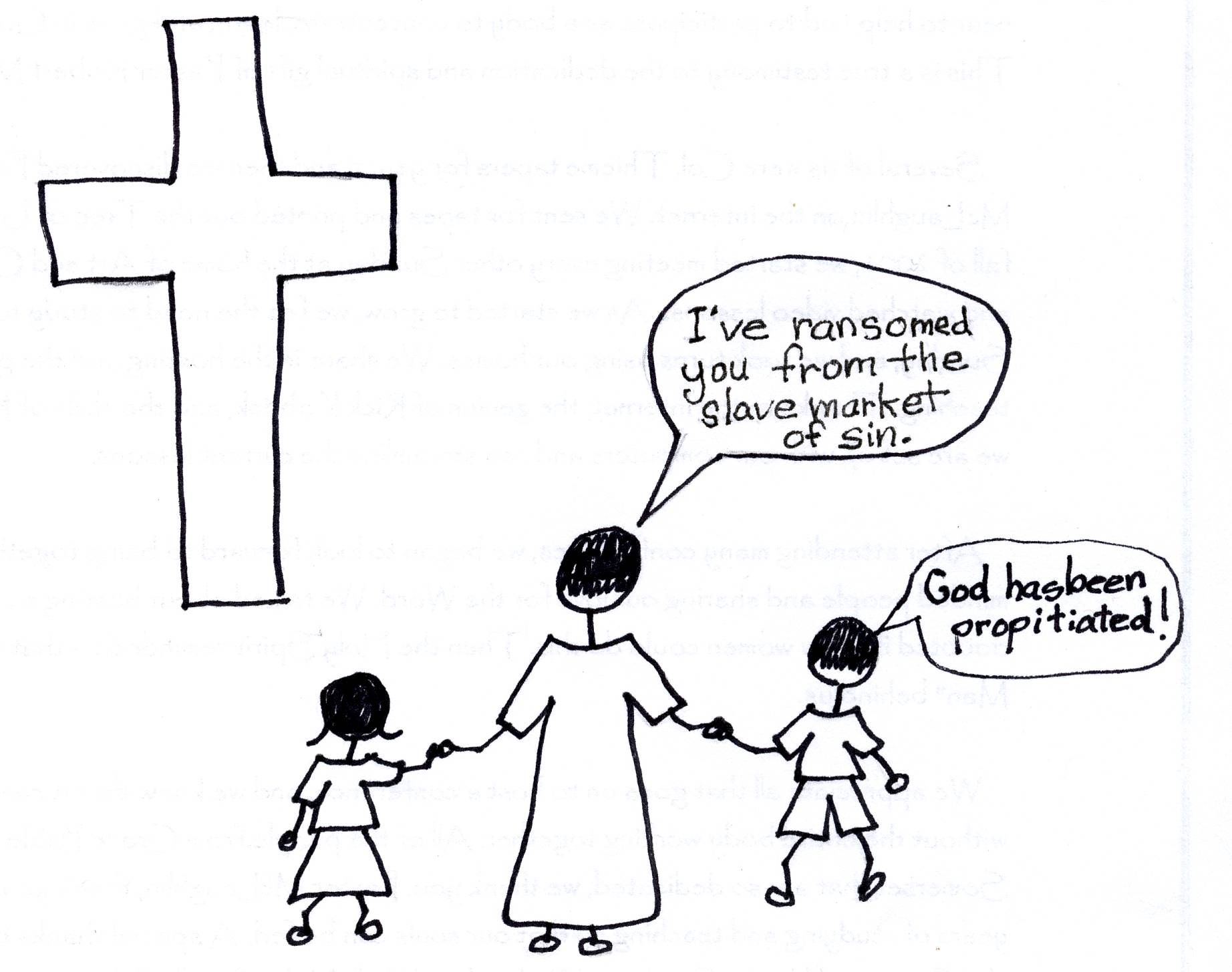

Romans 3:22b-24 “There is no difference, for all have sinned and fall short of the glory of God, and are justified freely by His grace through the redemption that came by Christ Jesus.”

The blood of Jesus Christ propitiated the Father. God the Father can now give us mercy and grace and many blessings. The Son of God has come to earth, sent by the God of Love. Jesus Christ has carried our sins for us so that we who believe will not come into judgment but can draw near to God by Christ’s blood, by His spiritual death on the cross. We are in the eternal, all loving arms of God our Father! He is completely satisfied with the awesome, substitutionary work or Jesus Christ on the cross. We now have the very life of Christ, the Son of God, with God as our Father! What a good, just, and loving God and Father we have!!!

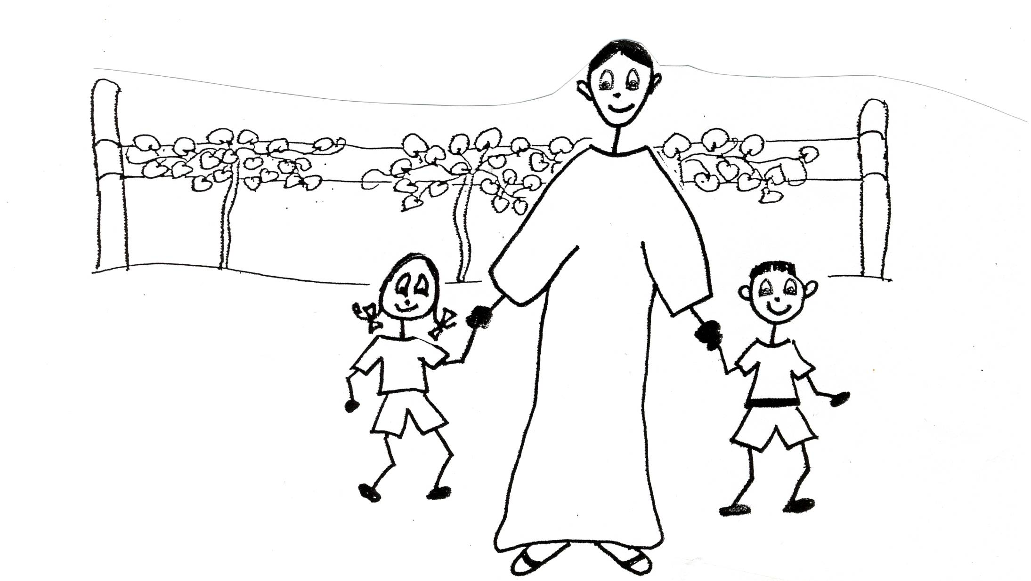

Romans 3:25-26 “Whom God displayed publicly as a propitiation in His blood through faith. This was to demonstrate His righteousness, because in the forbearance of God He passed over the sins previously committed; for the demonstration, I say, of His righteousness at the present time, so that He would be just and the justifier of the one who has faith in Jesus.”

Robert McLaughlin Bible Ministries
www.gbible.org
R. B. Thieme, Jr.’s Book: Blood of Christ
&
Lighthouse Christian Youth Ministries
www.lighthousechristianyouth.org
&
lcyministry@comcast.net

From the Jr. Tree of Life

Pet 1:2 “Grace and peace be yours in abundance through the knowledge of God and of Jesus our Lord.”

