Lighthouse Christian Youth Ministry
Lesson 69

Reconciliation or Peace

From God the Father

October 23, 2009

Dear Heavenly Father,
Thank you for reconciling or making a peace treaty with us. Because of Adam’s sin in the
Garden, all mankind was spiritually dead at birth…condemned by you. We were all charged with Adam’s sin and there was a wall put up between you and us. We can’t get around this wall by ourselves. We don’t have the power. However, you loved us so much that you sent your Son, Jesus Christ from heaven down to earth and He paid the penalty for all our sins on the cross and this beautiful act reconciled us to you. He had the power. The salvation work of our Lord Jesus Christ on the cross removed the barrier or wall between you and us. All that we have to do to take advantage of this reconciliation or peace treaty is to believe in Jesus and His salvation work on the cross. Then we can have peace!!

2 Corinthians 5:18 “Now all these things are from God Who has reconciled us to Himself through Christ, and has given to us the ministry of reconciliation, namely, that God was in Christ reconciling the world to Himself, not counting their trespasses (sins) against them, and He has committed to us the word of reconciliation (every man has been changed; they went from no hope to great hope).”

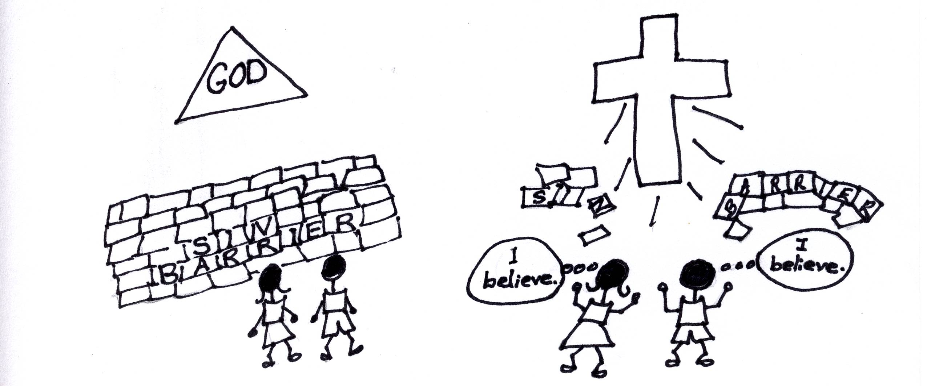
Father, at birth you gave human life to the human soul. You have a purpose for each of us all members of the human race! Also at birth, you gave to our old sin nature Adam’s original sin which made us spiritually dead and condemned to the Lake of Fire. Spiritual death means that we are totally helpless to have a relationship with you, God the Son, and God the Holy Spirit. What a catastrophe! Adam’s original sin, our old sin natures, and spiritual death form a barrier between the Members of the Trinity and us. However, as always, you solved the problem!

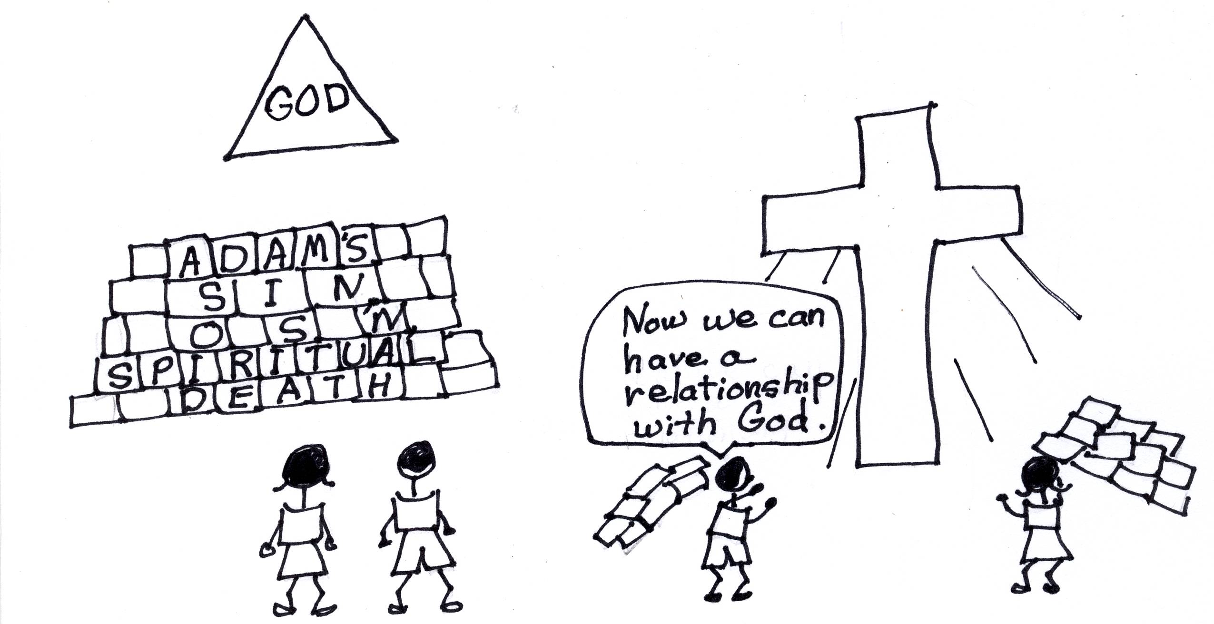
Romans 6:23 “For the wages (payment) of sin is (spiritual) death, but the free gift of God is eternal life in Christ Jesus our Lord.”

You solved the problem of real spiritual death by the substitutionary spiritual death of Jesus Christ on the Cross. This means that Jesus Christ, in His humanity, received the penalty for ALL of our sins when He was charged with them and judged by you. He paid the price! That’s expiation, remember? Jesus Christ removed the barrier between God and man!! He did what no other human being could do; He reconciled all mankind to you, Father!

2 Corinthians 5:14 “For the love of Christ controls us, having concluded this, that One (Jesus) died for all, therefore all died (the old sin nature…old self); and He died for all, so that they who live (believe in the Lord Jesus Christ) might no longer live for themselves, but for Him (Jesus) Who died and rose again on their behalf.”
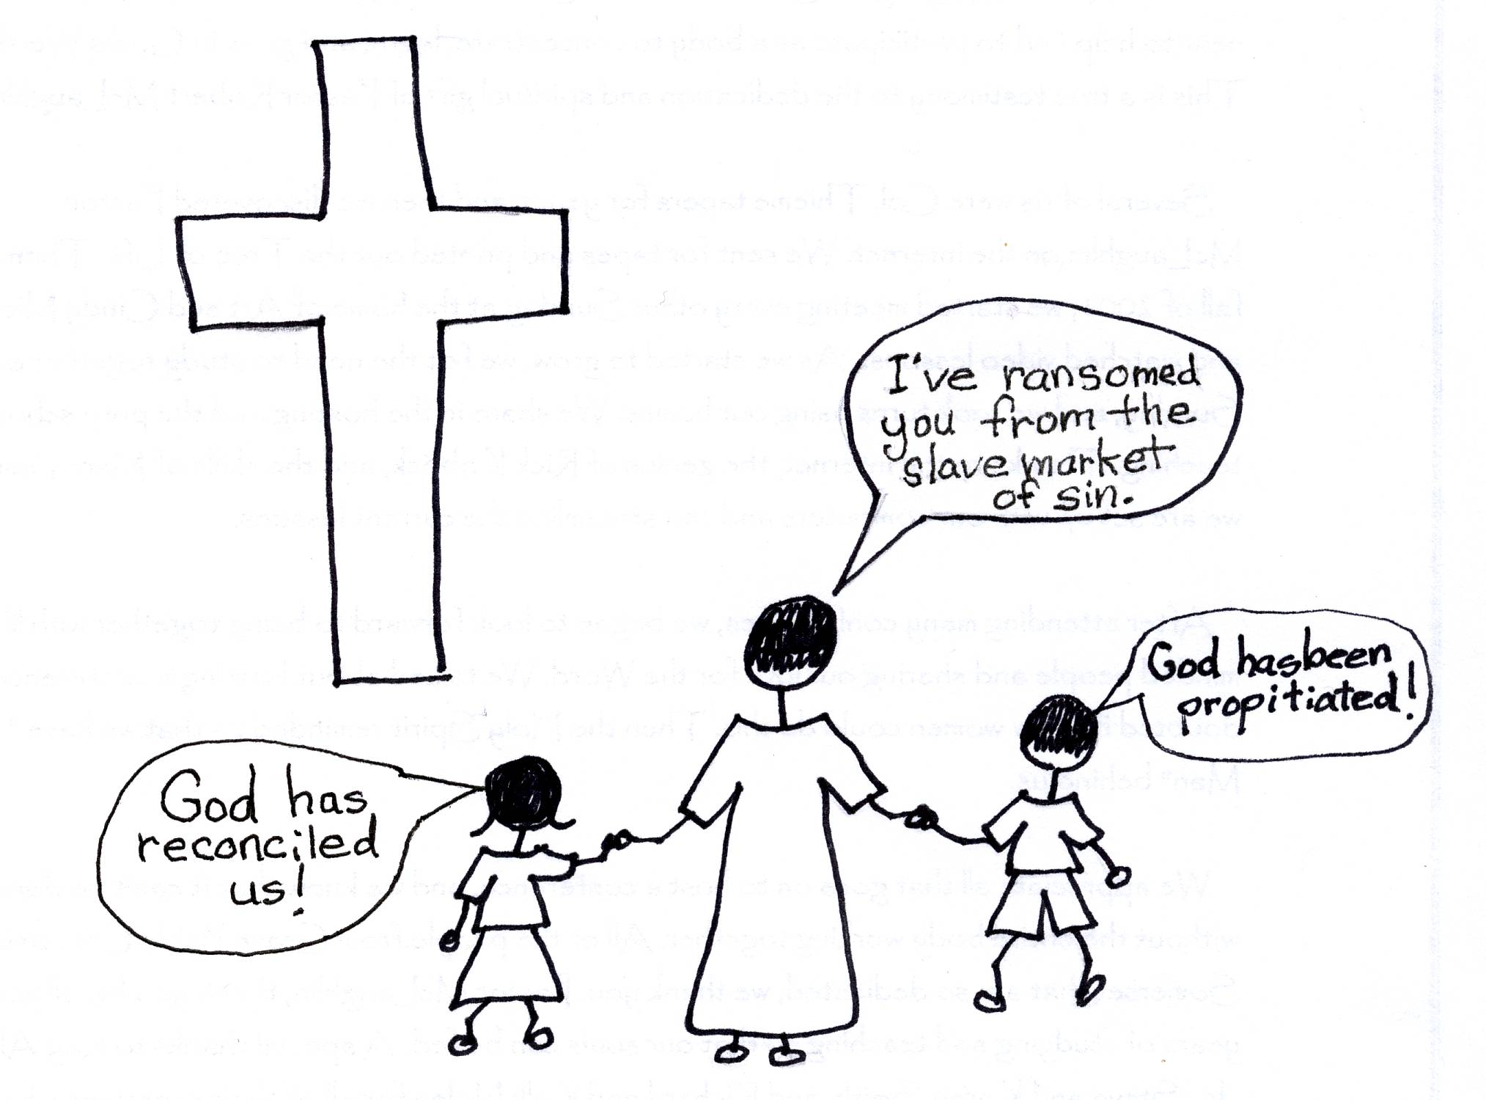
The barrier or wall that sin put up is now down, and it is down forever! Jesus made sure of that. Sometimes in our arrogance we think that there is something that we have to do to keep the wall down. We think that we have to use our human power. Our human power couldn’t move a pebble of the sin barrier! It has all been done through your supernatural divine power! There is nothing that we do that will cancel reconciliation or our peace with you. There is nothing that we need to do. You have done all of the work! We can be at peace knowing that you have taken care of the sin problem!!

Ephesians 2:14 “For He Himself is our peace, who made both groups into one, and broke down the barrier of the dividing wall (the wall between God and fallen man)…”

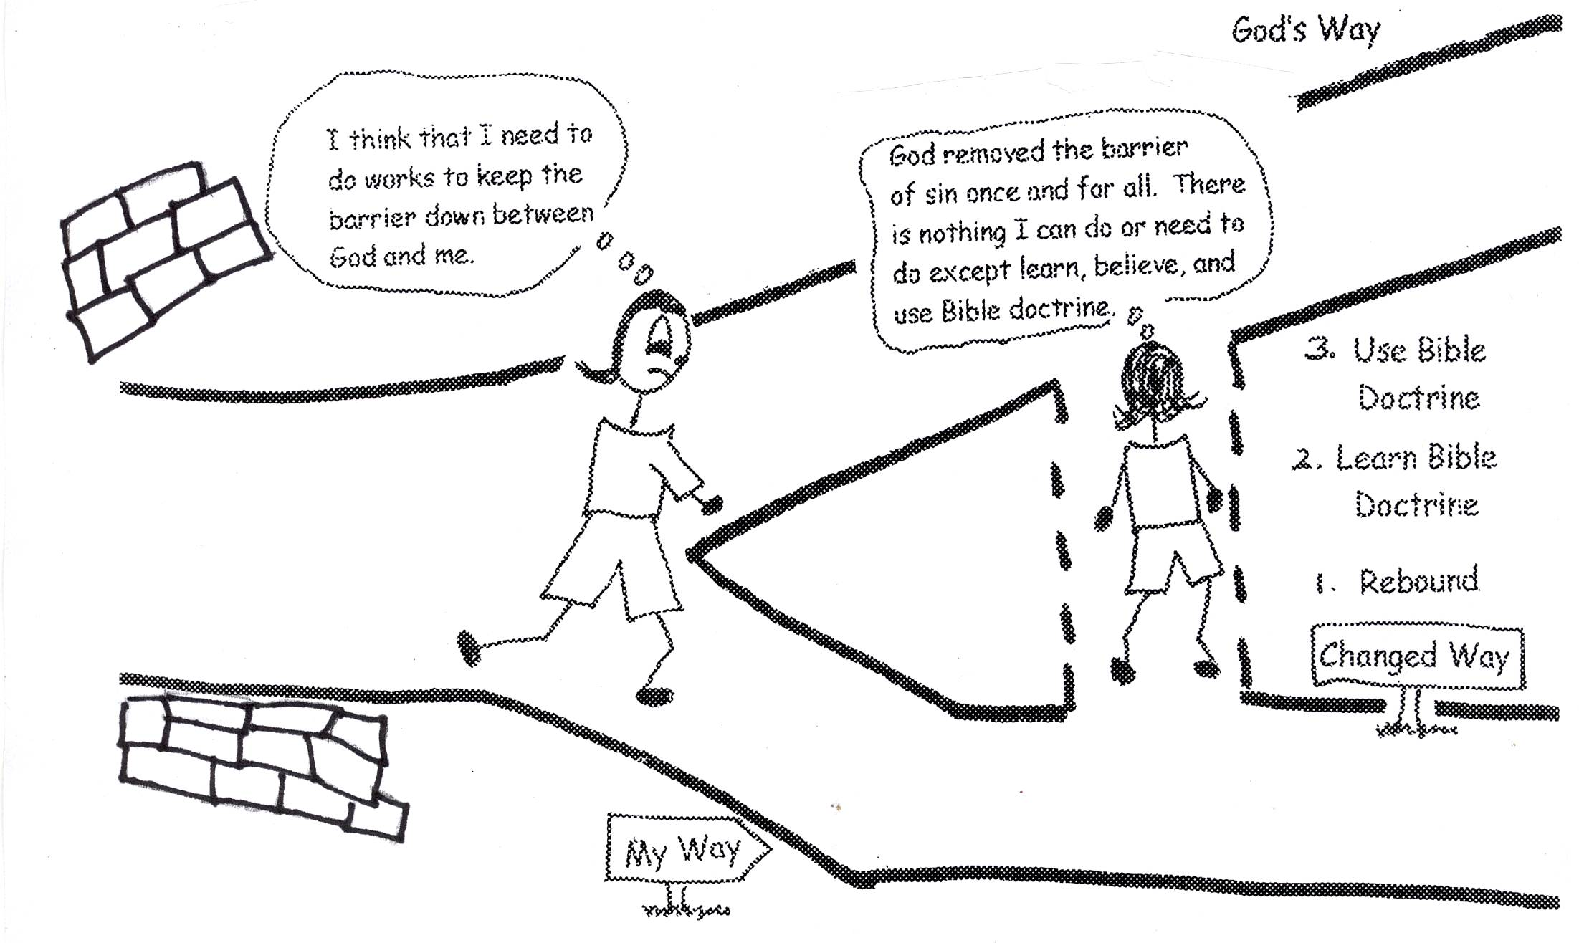
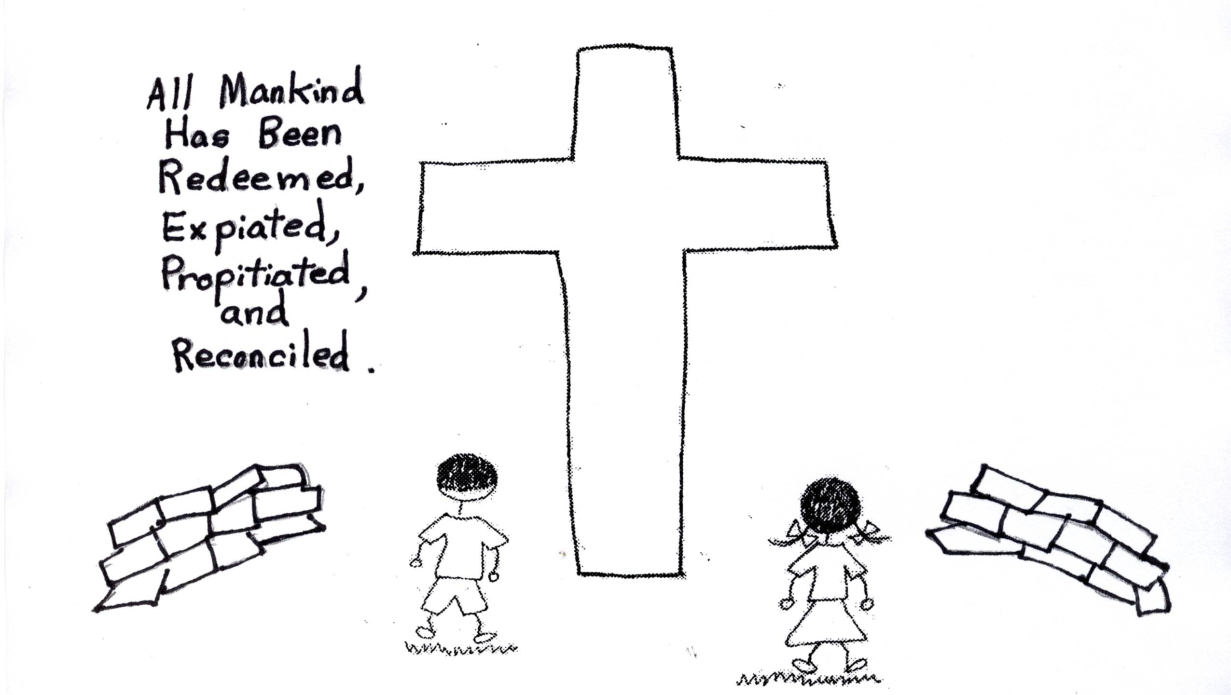
Father, at the cross all mankind was redeemed or bought out from the slave market of sin. Jesus Christ expiated, or paid the penalty or canceled the penalty of sin, which was spiritual death…separation from God, for all mankind. You were satisfied or propitiated with His payment. Unlimited atonement (payment) was made for all! The entire human race has been reconciled!! You have made peace with us all. No one is left out. Now it is up to us to accept the peace offering and believe in the Lord Jesus Christ as our Savior. The question is, “What do we think of Jesus Christ?”

Ephesians 2:8-9 “For by grace are you saved through faith, and that not of yourselves; it is a gift of God, not of works so that no man can boast.”

Father, once we believe in Jesus Christ as our Savior, we are placed in union with Jesus through the baptism of the Holy Spirit. What a place to be! We are in Christ forever! Also we are justified…you give us your righteousness, or goodness, +R the moment we believe. We don’t earn it or deserve it. It’s a grace gift. We have a new nature…we are “born again” or regenerated. So, as believers, we are in union with the Lord Jesus Christ! We receive justification, divine righteousness, and regeneration! What wonderful gifts!

Romans 3:22 “This righteousness (+R) from God comes through faith in Jesus Christ to all who believe.”
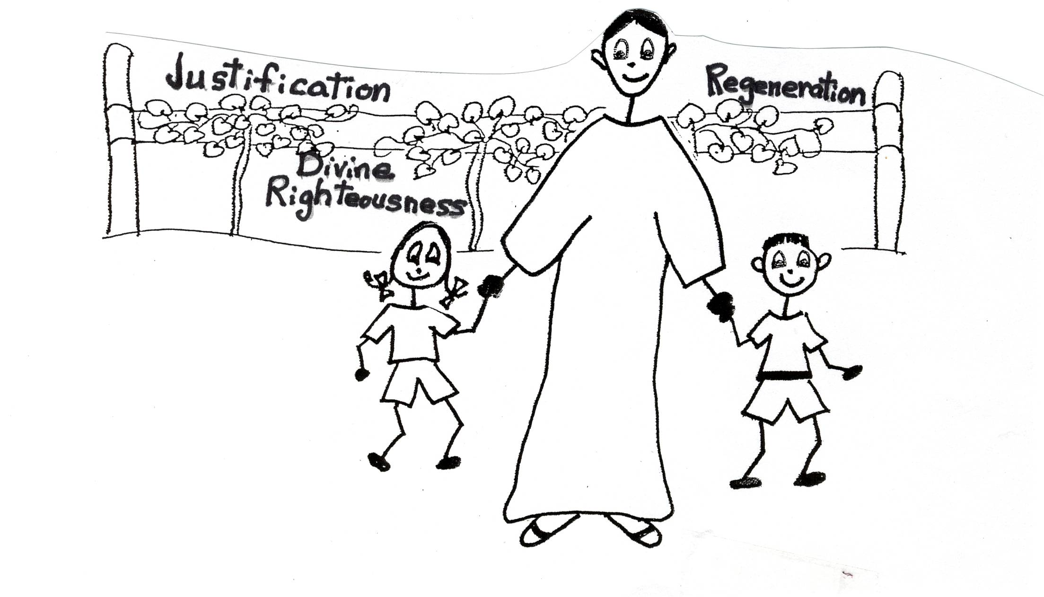
Father, at physical birth, we also have barriers with people. Because of spiritual death, which is spiritual separation from you, we are completely depraved (that means really bad) and helpless because of our old sin natures. And we develop flaws and weaknesses from it if we let it run our lives. We also have either inferiority or superiority complexes which put us in the state of arrogance…a terrible state to be in! Always bad weather! However, you also took care of that problem at the cross. Through the work of Jesus Christ, you removed that barrier.
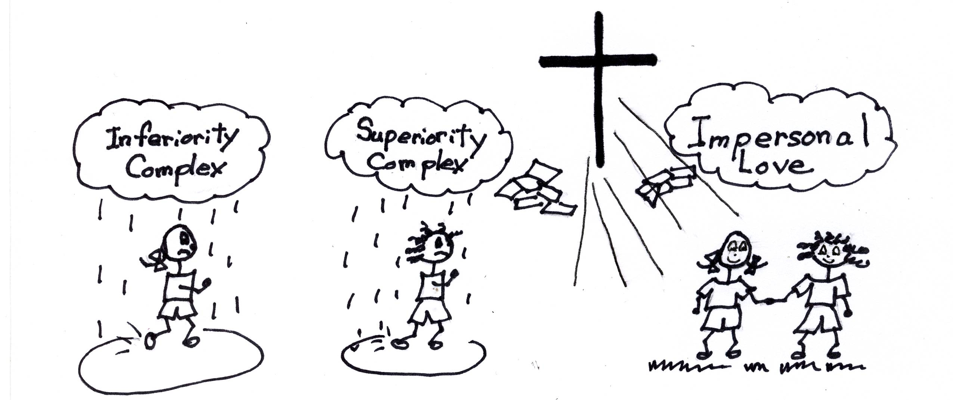
Colossians 1:20 “And through Him (the Son), to reconcile all things to himself (the Father), having made peace through the blood of the Cross (spiritual death of Jesus) through Him (the Son), whether things on earth or things in heaven.”

Once we believe in Jesus Christ as our Savior, we need to learn Bible doctrine so that we can grow in divine knowledge and thinking. Jesus Christ, Who was treated the worst that anyone could be treated, showed us the way! He always had impersonal love for others! Bible doctrine will give us the capacity to know you and love you. Once that is accomplished, we can treat others with grace because of what is in our souls, not on how they treat us. We will have impersonal love for mankind. With Bible doctrine in our souls the barriers with others will be removed, too!

John 13:34 “A new command I give you: Love one another [with impersonal love]. As I have loved you, so you must love one another. By this all men will know that you are my disciples, if you love one another.”
You want us to keep growing in your grace and knowledge (God’s Word) so that we can reach spiritual self-esteem, which is the first stage of our spiritual growth. Then we’ll be able to accept ourselves for who you made us to be. You forgave us our sins and you constantly give us grace. With spiritual self-esteem we can recognize our flaws, accept them, and give grace to ourselves. This helps us to accept other people’s flaws and give grace to them (impersonal love). We are to forgive ourselves and others. The barrier has been removed between man and God, and man and man. What Jesus Christ accomplished on the cross is reconciliation. All glory be to you, Father! Thank You, Father!
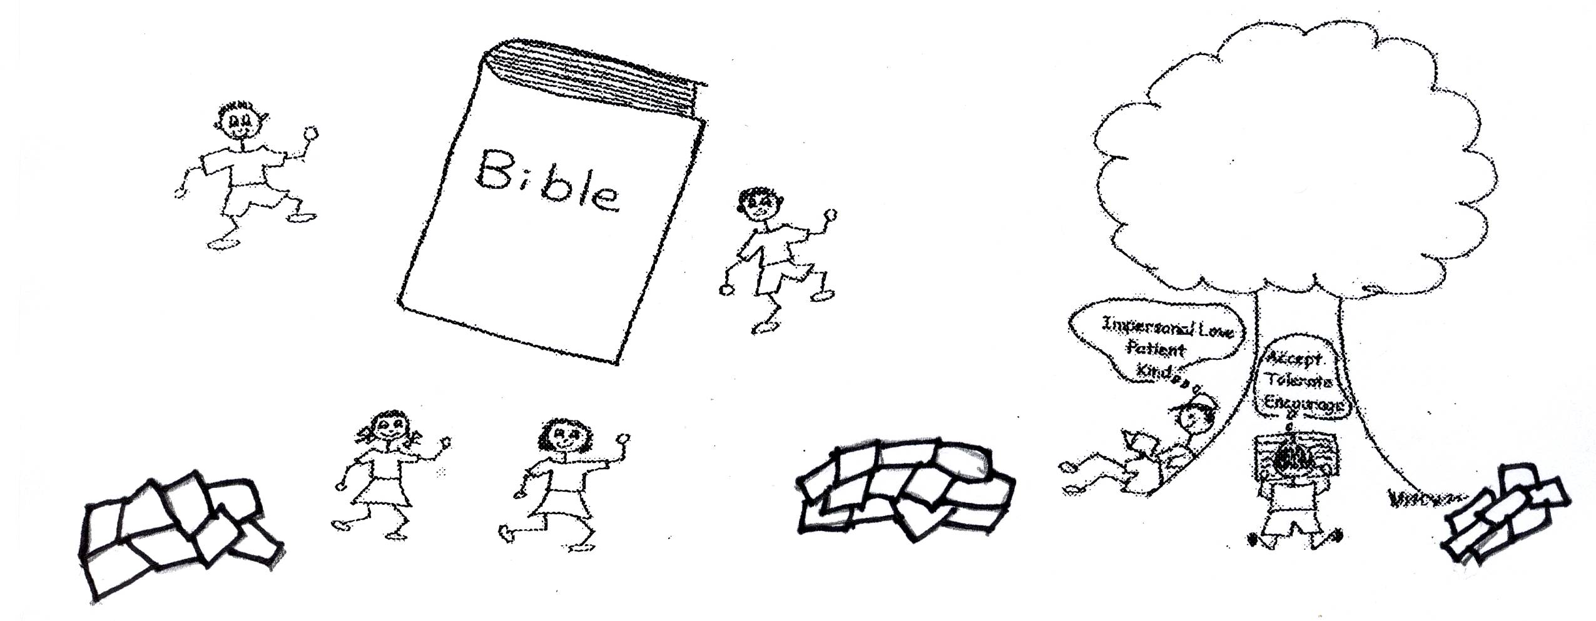

Romans 5:10 “For if while we were enemies, we were reconciled to God through the death (or by means of the death) of His Son, much more, having been reconciled, we shall be delivered by His life.”
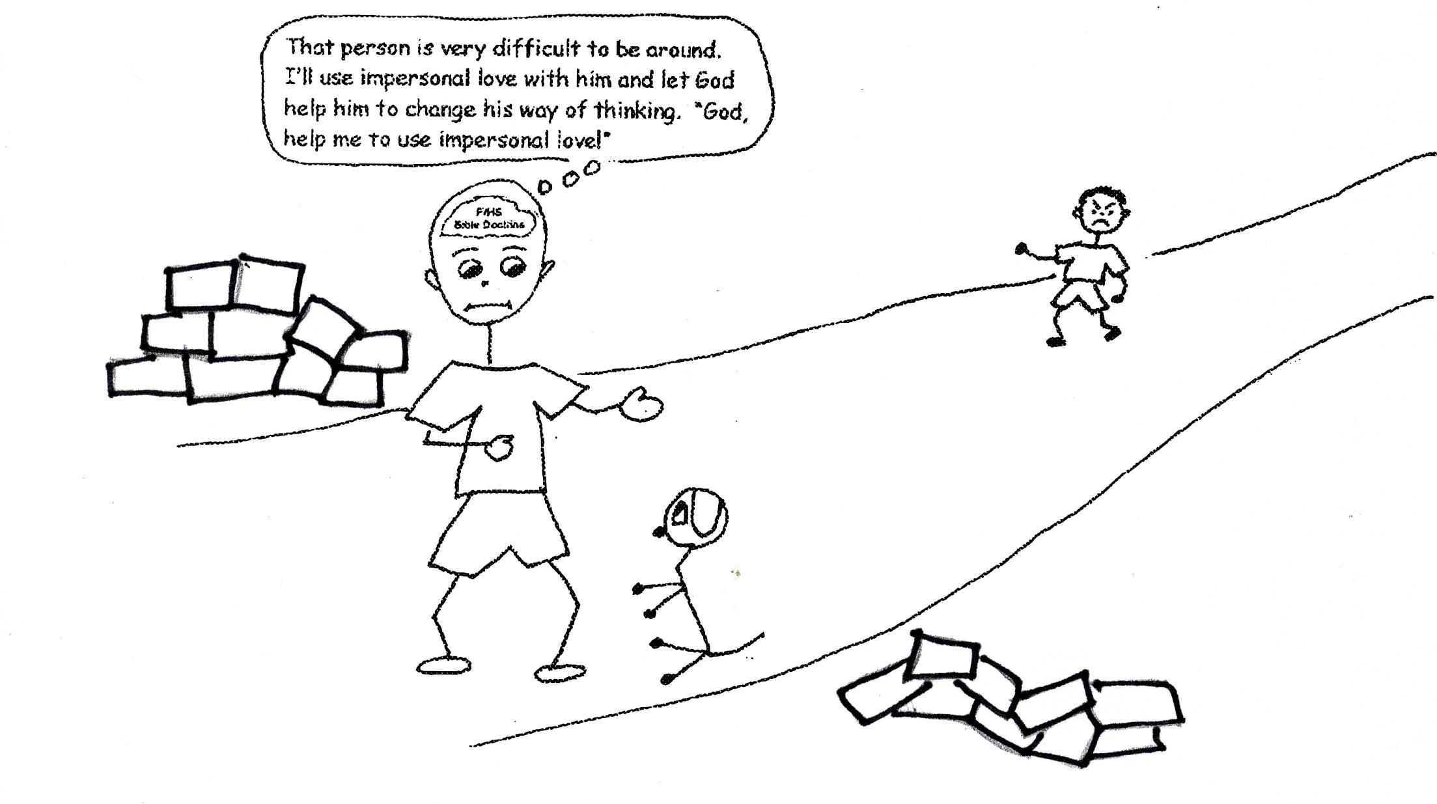

Matthew 6:14 “For if you forgive men when they sin against you, your heavenly Father will also forgive you. But if you do not forgive men their sins, your Father will not forgive your sins.”

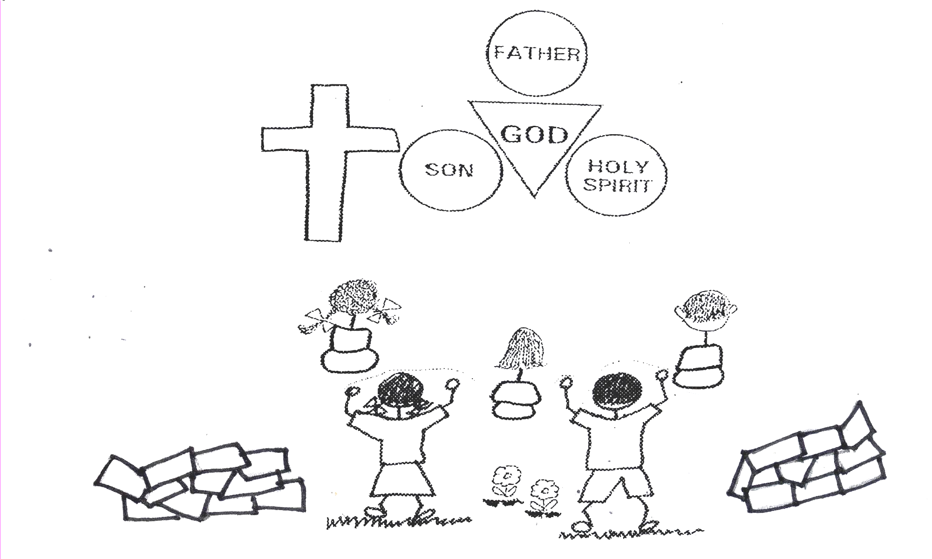
You have given us the privilege to tell others about reconciliation. We have the great news about the solution to the sin problem. Christ, your Son, became a man. This was a step downward for Him. His substitutionary, spiritual death on the cross was the price He paid (expiation) for our reconciliation. This is the news that can set us free! We can tell others about the peace you have for all who believe in the Lord Jesus Christ. Jesus took a step downward so that we could take a step across the barrier of sin. What a joy it is to tell others of this reconciliation or peace! Glory to You God, our Father, Son and Holy Spirit!

2 Corinthians 5:19-21 “Namely, that God was in Christ reconciling the world to Himself, not counting their sins against them, and He has committed to us the word of reconciliation. Therefore, we are ambassadors for Christ, as though God were entreating (asking) through us; we beg you on behalf of Christ, be reconciled to God. He made Him who knew no sin to be sin on our behalf, that we might become the righteousness (+R) of God in Him.”

Close in prayer

Lesson 69 - Activity Sheet for Reconciliation or the Peace from God

Unscramble the words:

mAad’s ins _ _ _ _ _ _ _ _ _
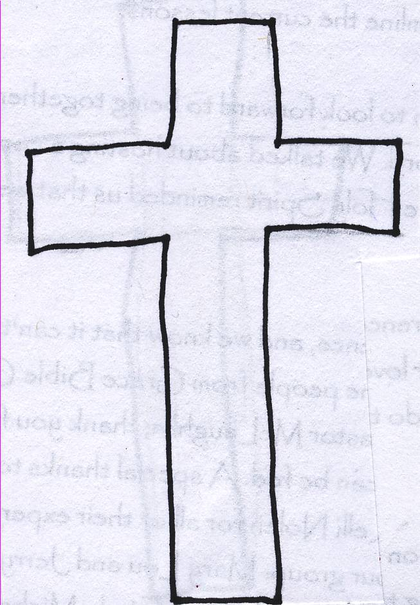
eid _ _ _
nceaarrog _ _ _ _ _ _ _ _ _
nicorecl _ _ _ _ _ _ _ _ _
tispruial _ _ _ _ _ _ _ _ _
aecep _ _ _ _ _
ooldb _ _ _ _ _
vaes _ _ _ _
mihutylil _ _ _ _ _ _ _ _ _
eiveebl _ _ _ _ _ _ _
sJseu _ _ _ _ _
raribeir _ _ _ _ _ _ _ _
deconmnde _ _ _ _ _ _ _ _ _
